Closed-Loop Recycling System For Solar Panel And Ev Batteries

## **D.Jagadeesh1, K.Naveen2, S.Parthasarathi3, S.Naveen Kumar4**

1Head of the Department, Mechanical Engineering, Kongunadu College of Engineering & Technology,Trichy, Tamil nadu, India

2Student, Mechanical Engineering, Kongunadu College of Engineering & Technology, Trichy, Tamil nadu, India

3Student, Mechanical Engineering, Kongunadu College of Engineering & Technology, Trichy, Tamil nadu, India

4Student, Mechanical Engineering, Kongunadu College of Engineering & Technology, Trichy, Tamil nadu, India

**ABSTRACT**

A closed-loop recycling system for solar panels and EV batteries involves collecting and reprocessing used panels and batteries to recover valuable materials like lithium, cobalt, and silicon. This process reduces the need for raw material extraction, which is often energy-intensive and environmentally harmful. The system begins with the collection of end-of-life solar panels and EV batteries, followed by efficient dismantling, where materials are sorted and purified. The recovered materials are then reused in manufacturing new panels or batteries, completing the cycle. Closed-loop recycling minimizes waste, reduces carbon footprint, and ensures a sustainable supply of critical materials. This approach fosters the circular economy, promoting environmental conservation while supporting the growing demand for renewable energy technologies. It also mitigates the challenges of e-waste disposal, ensuring that resources are continually reused rather than ending up in landfills.

**Keywords*-*** Sustainability, Reuse, Efficiency, Circular, Recovery, Reprocessing.

1. **INTRODUCTION**

A closed-loop recycling system for solar panel and electric vehicle (EV) batteries is an innovative approach designed to enhance sustainability and resource efficiency. As the demand for renewable energy and electric vehicles continues to grow, the lifecycle of key components, such as solar panels and EV batteries, becomes increasingly important. These systems are designed to minimize waste and ensure that valuable materials used in these technologies, such as lithium, cobalt, and silicon, are recovered and reused.In a closed-loop system, the end-of-life solar panels and EV batteries are collected, dismantled, and processed to extract raw materials that can be reused in the manufacturing of new products. This process not only reduces the need for mining and resource extraction but also helps lower carbon emissions, thus contributing to environmental protection. Additionally, it mitigates the risks of pollution from improper disposal of hazardous materials.

This approach fosters a circular economy, where materials remain in use for as long as possible, supporting the longevity of renewable energy technologies. By closing the loop, industries involved in solar and EV technologies can significantly reduce their environmental footprint and promote the sustainable growth of green energy solutions, ensuring a more eco-friendly future for generations to come.

1. **METHODOLOGY:**

A closed-loop recycling system for solar panel and electric vehicle (EV) batteries is designed to efficiently recover and reuse the materials from these products at the end of their life cycle. This ensures that resources are not wasted and reduces the environmental impact of disposal. Below is a methodology for implementing a closed-loop recycling system for these two key components in the renewable energy sector.

## **2.1 Collection and Transportation**

* **Solar Panels**: Retired or damaged solar panels are collected from residential, commercial, or industrial sites. This can include end-of-life panels, damaged panels from installations, or panels replaced during maintenance.
* **EV Batteries**: Used EV batteries, including those that have reached the end of their useful life or are no longer efficient for vehicle use, are gathered from various sources (e.g., car dealerships, repair centers, recycling facilities).

Both solar panels and batteries are transported to specialized recycling centers.

## **2.2 Pre-Treatment:**

* **Solar Panels**:Panels are disassembled manually or with automated machinery. The glass, silicon cells, metals (aluminum, copper), and plastics are separated for further processing.
* **EV Batteries**: Batteries are checked for safety and any remaining charge is safely discharged. The batteries are then disassembled to separate the casing, electrodes, electrolyte, and other components.

**2.3Material Recovery :**

* **Solar Panels**: The main materials recovered from solar panels include.

**1.Silicon**: Recovered through chemical processes or mechanical techniques, and purified for reuse in new solar panels.

**2**.**Glass**: Cleaned and reused in new solar panels or in other industries.

**3**.**Metals (Aluminum, Copper):** Extracted using mechanical separation or smelting for reuse in new products.

* **EV Batteries**: Materials recovered from EV batteries include.

**1.Lithium, Cobalt, Nickel, Manganese**: These valuable materials are extracted through chemical processes such as hydrometallurgy or pyrometallurgy and are purified for reuse in new batteries.

**2.Graphite**: Can be reused in the anode of new batteries.

**3.Copper and Aluminum**: These metals are recycled and can be used in various applications, including new batteries and electrical wiring.

**2.4Purification and Refining:**

Materials like lithium, cobalt, and nickel are purified to remove impurities, ensuring they meet the high standards required for manufacturing new, high-performance solar panels or EV battFor solar panels, silicon is purified to a very high degree using chemical processes, so it can be reused in the production of new solar cells.

**2.5Re-manufacturing:**

* **Solar Panels**: The purified and refined materials (such as silicon, glass, and metals) are reintroduced into the manufacturing process to create new solar panels.
* **EV Batteries**: The recovered and purified materials are used to manufacture new batteries, either for reuse in vehicles or other energy storage applications**.**

**2.6Quality Control and Testing:**

Both the new solar panels and batteries produced are rigorously tested for performance, efficiency, and safety. Solar panels undergo tests like efficiency, electrical performance, and weather resistance. EV batteries are tested for energy density, charge/discharge cycles, and lifespan.

* 1. **Distribution and Reuse :**

The new solar panels and EV batteries are ready to be distributed for sale, installation, or use in new applications**.**

**2.8 Extended Lifecycle:**

A key feature of the closed-loop system is the recycling of these products at the end of their new life cycle, ensuring that they can be reused multiple times. This reduces environmental impact and dependence on mining for raw materials.

**3.MEASUREMENT FOR SOLAR PANEL:**

A measurement system was designed to determine the electrical parameters of a PV cell. The following parameters can be measured: I-V curve, short circuit current (IOC), open circuit voltage (VOC).

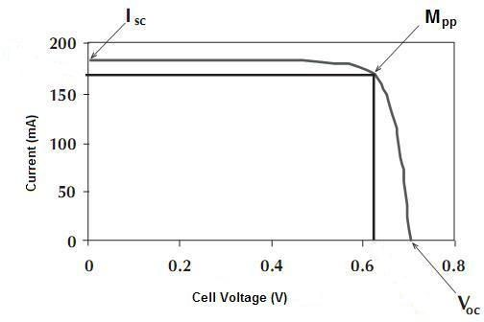

Characteristics of a PV cell

**The system contains the following components:**

* Laptop computer for portable measurements with two USB ports
* NI LabView based application software
* NI USB-6009 data acquisition unit
* Digital multimeter (DMM) with serial interface + USB-serial converter
* Dummy load (resistance can be controlled by the application)
* Light source (optional)

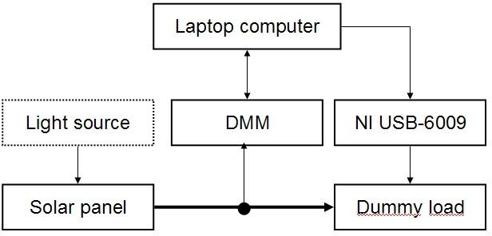

**4.TEST FOR EV BATTERY:**

The examined temperatures of 28°C, 40°C, 50°C and 60°C, leaching at 60°C seen to be an optimal temperature the leaching efficiencies not being much different from the one at 60°C. It was observed that at a leaching time of 30min that almost all the metals reached their maximum efficiency.The optimal solid-liquid ratio for leaching was indicated to be 1/20 g/ml.The effect of concentrations was studied by using 0.5M, IM, 2M and 3M of H,SO, show that the optimal concentration for leaching was 2M H₂SO₄ in this study.

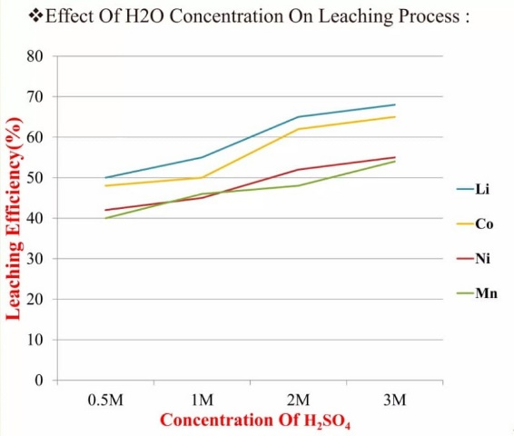 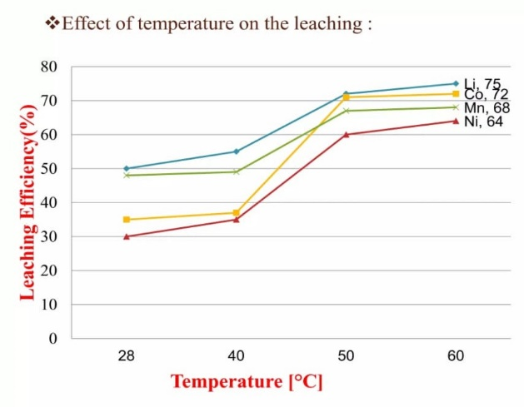

**5.CONCLUSION:**

A closed-loop recycling system for solar panels and EV batteries presents a sustainable and efficient solution to managing the growing waste from these technologies. By recovering valuable materials like lithium, cobalt, and silicon, these systems not only reduce environmental impact but also lower the demand for mining new resources. Implementing such systems would promote a circular economy, where materials are reused, and waste is minimized. Moreover, it can contribute to the reduction of carbon emissions, energy consumption, and landfill waste. However, to realize its full potential, further innovation in recycling technologies, investment in infrastructure, and supportive policy frameworks are essential. Ultimately, a closed-loop recycling approach will be key in ensuring the long-term sustainability of both solar energy and electric vehicles, aligning economic growth with environmental responsibility.

**6.ACKNOWLEDGEMENT:**

A closed-loop recycling system for solar panels and EV batteries focuses on collecting, reprocessing, and reusing materials from end-of-life products, reducing waste and conserving valuable resources. By extracting and purifying metals like lithium, cobalt, and silicon, this system ensures the sustainability of renewable energy and electric vehicle industries. It minimizes the need for mining, supports circular economy practices, and reduces the environmental impact of disposal. This recycling method fosters a continuous supply of critical materials, contributing to the development of eco-friendly technologies and promoting a sustainable, resource-efficient future.

**7.REFERENCE:**

1. J. Mizsei, V. Tímár-Horváth, „Napelemek (PV cells)”, Budapest University of Technology and Economics, 2003.
2. W. Durisch, J. Urban, G. Smestad, “Characterization of solar cells and modules under actual operating conditions”, WREC 1996.
3. Földváry Á., “Napelem karakterisztika mérő mőszer készítése (Construction of a PV cell tester)”, 2008.
4. X. Zheng et al., "A Mini-Review on Metal Recycling from Spent Lithium Ion Batteries," Engineering, vol. 4, no. 3, pp. 361-370, 2018.
5. W. Gao et al., "Comprehensive evaluation on effective leaching of critical metals from spent lithium-ion batteries," Waste Manag., vol. 75, pp. 477-485, 2018.
6. P. Meshram, B. D. Pandey, and T. R. Mankhand, "Extraction of lithium from primary and secondary sources by pre-treatment, leaching and separation: A comprehensive review," Hydrometallurgy, vol. 150, pp. 192-208, 2014.
7. SAE International, Electric and Hybrid Electric Vehicle Rechargeable Energy Storage System (RESS) Safety and Abuse Testing, J2464, Date Published: 2009-11-06.
8. P. Roth, Battery abuse testing at SNL in Annual progress report 2009 for energy storage R&D by D. Howell (ed.), U.S. Department of Energy, Washington, 2010. P. 102-105.
9. D.H. Doughty, C.C. Crafts, FreedomCAR Electrical Energy Storage System Abuse Test Manual for Electric and Hybrid Vehicle Applications, Sandia report SAND2005-3123, Sandia National Laboratories 2006.
10. D.D. MacNeil, Z. Lu, Z. Chen, J.R. Dahn, A comparison of the electrode/electrolyte reaction at elevated temperatures for various Li-ion battery cathodes, Journal of Power Sources vol 108 (2002) p. 8-14.