**Machine Learning Approaches to Predict the Progression of Alzheimer's Disease**

**1.Ms.A. KAMATCHI**

Research Scholar, Department of Computer Science,

A.V.V.M.Sri Pushpam College(Autonomous),Poondi,Thanjavur(Dt),Affiliated to Bharathidasan University,Thiruchirappalli,Tamilnadu(Mail Id- kamatchia06@gmail.com)

**2.Dr. V. MANIRAJ**

Associate Professor, Research Supervisor, Head of the Department,

Department of Computer Science,

A.V.V.M.Sri Pushpam College(Autonomous),Poondi,Thanjavur(Dt),Affiliated to Bharathidasan University,Thiruchirappalli,Tamilnadu(Mail Id- manirajv61@gmail.com)

**Abstract**

This study utilizes machine learning techniques to predict Alzheimer's disease, a neurodegenerative disorder that starts with subtle symptoms but gradually worsens over time. Alzheimer's is a prevalent form of dementia, and various cognitive factors, including age, frequency of medical visits, Mini-Mental State Examination (MMSE) scores, and educational background, can provide valuable insights for predicting the onset of the disease.

***Key words****:* *Brain degeneration condition,* *Initial cognitive impairment ,* *Predictive analytics approaches,* *Mental factors*

**1.INTRODUCTION**

Alzheimer's Disease (AD) is a progressive neurological disorder characterized by symptoms like short-term memory loss, paranoia, and delusions. Often mistaken for normal aging or stress, it affects approximately 5.1 million individuals in the United States. Despite its prevalence, AD frequently goes undiagnosed or is not adequately treated. Consistent medication is crucial for managing AD, as it is a chronic condition that can persist for years or even a lifetime. Timely intervention is essential to minimize significant brain damage. However, early diagnosis of AD is both a time-intensive and costly process, requiring extensive data collection, advanced predictive techniques, and consultation with medical experts.

**1.1 Motivation**

Innovative methods like machine learning are gaining popularity for providing proactive and personalized treatment recommendations. Relying solely on medical reports may result in radiologists overlooking other potential conditions, as it often focuses on a limited set of causes and factors. The objective here is to identify knowledge gaps and uncover opportunities related to the use of machine learning and data derived from Electronic Health Records (EHR).

**1.2 Objectives**

This initiative aims to predict Alzheimer's disease and obtain more precise and reliable outcomes. It will utilize Convolutional Neural Networks (CNN) and Support Vector Machine (SVM) algorithms. The Python programming language will be used for implementing machine learning techniques to carry out this task.

**1.3 Problem Statement**

There is a lack of sufficient awareness about Alzheimer's Disease. As individuals age, they may experience gradual changes in their physical abilities, affecting activities like walking, sitting, and eventually swallowing. As memory and cognitive functions decline, they may require significant help with everyday tasks. At this point, individuals may need round-the-clock support for personal care and daily routines. As dementia progresses, it impairs the ability to communicate, adjust to surroundings, and move, making it increasingly difficult for them to express pain through words or gestures.

**1.4 Machine Learning Using Python**

Python is a versatile and widely adopted programming language, created by "Guido van Rossum" in 1991. It supports a wide range of libraries, such as pandas, numpy, SciPy, and matplotlib. Python is compatible with packages like Xlsx, Writer, and X1Rd, making it highly effective for complex tasks. There are several powerful Python frameworks available. Machine learning, a subfield of artificial intelligence, enables computer systems to acquire new skills and improve performance using data. It focuses on developing algorithms that allow computers to make predictions based on data. The first step in machine learning is to provide data, followed by training the system using various algorithms to build models. As a branch of software engineering, machine learning has revolutionized how data is analyzed.

**2. RELATED WORKS**

Research [1] indicates that Alzheimer's disease (AD) is the most common and widespread form of dementia. While AD can be clinically diagnosed through physical and neurological assessments, there is a significant need for more advanced diagnostic tools. Magnetic Resonance Imaging (MRI) scans are processed using Free Surfer, a robust tool that effectively handles and normalizes brain MRI images. The multistage classifier presented in this study demonstrated superior performance in AD detection when compared to previous standalone machine learning techniques, such as SVM and KNN.

According to [2], this paper introduces a novel classification framework combining Convolutional Neural Networks (CNN) and Recurrent Neural Networks (RNN) to conduct longitudinal analysis of structural MR images for Alzheimer's disease (AD) diagnosis. The CNN model was designed to extract spatial features from each time point and provide a classification result for individual time instances. Meanwhile, an RNN with cascaded Bidirectional Gated Recurrent Units (BGRU) was used to capture temporal variations and extract longitudinal features, enhancing disease classification. Experimental results on the ADNI dataset validate the effectiveness of the proposed classification approach. Future work will incorporate additional imaging features, including structural and functional connectivity networks of the brain, for RNN-based longitudinal analysis. The proposed method achieved a classification accuracy of 91.33% for AD vs. NC and 71.71% for pMCI vs. sMCI, demonstrating its promising potential for longitudinal MR image analysis.

As described in [10], the authors created a system aimed at enhancing the prediction of Alzheimer's Disease (AD) progression in older adults with mild cognitive impairment. The ADNI dataset was utilized to predict the progression of AD. The prediction models incorporated the PHS, Atrophy score, and MMSE algorithms. The highest accuracy of 78.9%, along with a sensitivity of 79.9%, was achieved when all three predictor algorithms were combined.

**3. IMPLEMENTATION AND WORKING**

**3.1 Architectural Diagram**



The structural basic working methodology is based on the flowchart given above.

**3.2 Data Collection and Data Cleaning**

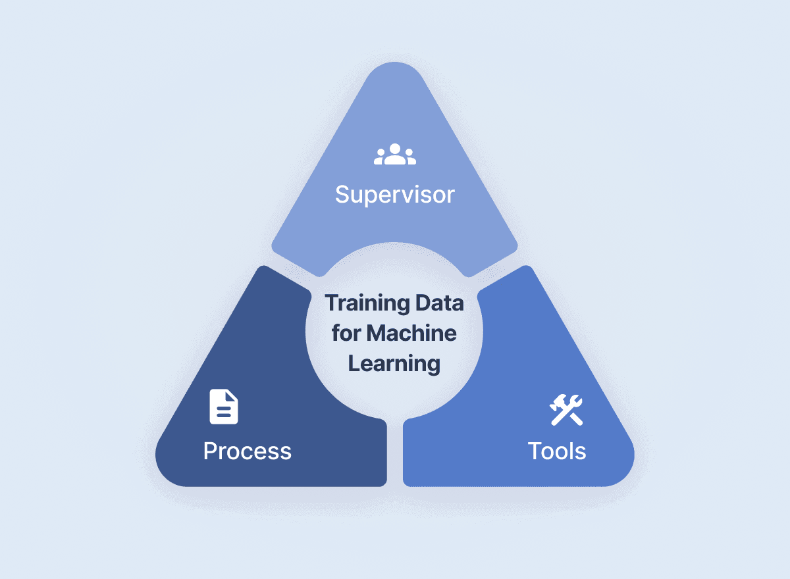

A decision tree is a supervised learning model that applies a series of rules to determine a solution. The prevalence of Alzheimer's Disease (AD) varies across different age groups in the United States. Naturally, the image analysis process involves two distinct stages.

In the first step, features are generated, and the query image is reproduced. Subsequent steps then compare these features with those stored in the database [2]. The Particle Swarm Optimization (PSO) algorithm is used for feature selection, identifying the most relevant biomarkers for Alzheimer's Disease (AD) or Mild Cognitive Impairment (MCI). Data is sourced from the Alzheimer's Disease Neuroimaging Initiative (ADNI) database. Control-based image retrieval is employed to extract images from the database, with feature selection focusing on measurements such as volume and thickness. The best feature set is obtained using the PSO algorithm [2]. Control-based image search is then applied to retrieve the images. A 3D Convolutional Neural Network (CNN) is used for feature learning, followed by a pooling layer. There are various methods for pooling, which involves extracting the maximum value or selecting specific neuron sequences within a region.

**3.3 Data Preprocessing and Analysis of Data**

First, pre-processed MRI images are generated after the database is recorded. Ruoxuan Cuia et al. proposed a model that conducts longitudinal analysis, which is performed sequentially and is essential for designing and calculating IRM. The analysis helps track disease progression over time for more accurate diagnosis [3]. The process involves extracting features related to brain morphological abnormalities and longitudinal changes in MRI, followed by building a classifier to differentiate between various groups. The classification model includes early diagnosis, with the initial step being the preprocessing of raw resting-state fMRI (r-fMRI) data.

**3.4 Data Visualization**

Data visualization involves presenting data using visual elements like charts, graphs, infographics, and even animations. It plays a crucial role in creating clear and effective visual representations of complex information.

**3.5 Cross Validation and Training the Model**

Cross-validation is used to train a machine learning model by utilizing a subset of the dataset. Proper training is essential for achieving accuracy when splitting the dataset into "N" sets for model evaluation. The model must first be trained because the data is divided into two parts: a test set and a training set, with the target variable included in the training set. The training dataset is processed using the decision tree regression method, where a single decision tree is used to create the regression model. To avoid overfitting when working with a limited amount of data, k-fold cross-validation is implemented.

**3.6 Testing and Integration with UI**

A web framework such as Flask offers the necessary tools, technologies, and libraries to build web applications. Another popular framework, Bottle, is commonly used to integrate Python models due to its simplicity in setting up routes. Alzheimer's disease is predicted using a trained model and test dataset. The front-end is then linked to the trained model using Python's Flask framework. Once the model is developed and provides the desired results, it is integrated with the user interface (UI) phase, with Flask being used for this integration.

**4.Progression of AD**



**5. CONCLUSION**

This study shows that combining the age-sensitive PHS and structural neuroimaging can enhance the accuracy of predicting clinical progression to Alzheimer's Disease (AD) in patients with Mild Cognitive Impairment (MCI) and basic cognitive function. Improved assessments of AD risk in elderly patients with subjective memory complaints could be valuable in clinical settings to help inform treatment decisions. These evaluations are also critical for intervention studies, as identifying high-risk individuals in the early stages of the disease is essential for assessing the effectiveness of new disease-modifying treatments.

**5. REFERENCES**

[1] K.R.Kruthika,Rajeswari,H.D. Maheshappa, “Multistage classifier-based approach for Alzheimer’s Disease prediction and retrieval”, Informatics in Medicine Unlocked, 2019. https://doi.org/10.1016/j.imu.2018.12.003

[2] Ronghui Ju , Chenhui Hu, Pan Zhou , and Quanzheng Li, “Early Diagnosis of Alzheimer’s Disease Based on Resting-State Brain Networks and Deep Learning”, IEEE/ACM transactions on computational biology and bioinformatics, vol. 16, no. 1, January/February 2019. https://doi.org/10.1109/TCBB.2017.2776910

[3] Ruoxuan Cuia, Manhua Liu “RNN-based longitudinal analysis for diagnosis of Alzheimer’s disease”, Informatics in Medicine Unlocked, 2019.

https://doi.org/10.1016/j.compmedimag.2019.01.005

[4] Fan Zhang, Zhenzhen Li, Boyan Zhang, Haishun Du , Binjie Wang , Xinhong Zhang, “Multi-modal deep learning model for auxiliary diagnosis of Alzheimer’s disease”, Neuro Computing, 2019. https://doi.org/10.1016/j.neucom.2019.04.093

[5] Chenjie Ge , Qixun Qu , Irene Yu-Hua Gu , Asgeir Store Jakola “Multi-stream multi-scale deep convolutional networks for Alzheimer’s disease detection using MR images”, Neuro Computing, 2019.

https://doi.org/10.1016/j.neucom.2019.04.023

[6] Tesi, N., van der Lee, S.J., Hulsman, M., Jansen, I.E., Stringa, N., van Schoor, N. et al, “Centenarian controls increase variant effect sizes by an average twofold in an extreme case extreme control analysis of Alzheimer's disease”, Eur J Hum Genet. 2019; 27:244–253

https://doi.org/10.1038/s41431-018-0273-5

[7] J. Shi, X. Zheng, Y. Li, Q. Zhang, S. Ying, "Multimodal neuroimaging feature learning with multimodal stacked deep polynomial networks for diagnosis of Alzheimer’s disease", IEEE J. Biomed. Health Inform., vol. 22, no. 1, pp. 173- 183, Jan. 2018.

https://doi.org/10.1109/JBHI.2017.2655720

[8] M. Liu, J. Zhang, P.-T. Yap, D. Shen, "View aligned hypergraph learning for Alzheimer's disease diagnosis with incomplete multi-modality data", Med. Image Anal., 2017 vol. 36, pp. 123- 134.

https://doi.org/10.1016/j.media.2017.10.005

[9] Hansson O, Seibyl J, Stomrud E, Zetterberg H, Trojanowski JQ, Bittner T, “CSF biomarkers of Alzheimer’s disease concordwith amyloid-bPET and predict clinical progression: A study of fully automated immunoassays in BioFINDER and ADNI cohorts”. Alzheimer’s Dement 2018; 14:1470–81.

https://doi.org/10.1016/j.jalz.2018.01.010

[10] Van der Lee SJ, Teunissen CE, Pool R, Shipley MJ, Teumer A,Chouraki V, “Circulating metabolites and general cognitive abilityand dementia: Evidence from 11 cohort studies”, Alzheimer’s Dement2018;14:707–22 . https://doi.org/10.1016/j.jalz.2017.11.012