**Abstract**

This project aims to develop a web-based system for collecting and analyzing feedback on faculty performance from students and peers. The goal is to improve teaching quality, student learning, and overall institutional excellence.This project aims to develop a web-based system for collecting and analyzing feedback on faculty performance from students and peers. The goal is to improve teaching quality, student learning, and overall institutional excellence.

A faculty feedback system is a platform or mechanism used by educational institutions to gather feedback from students about their experiences with faculty members. It typically involves surveys or questionnaires where students can anonymously provide feedback on various aspects of teaching, such as effectiveness, communication, and responsiveness. This feedback helps faculty members improve their teaching methods and fosters a culture of continuous improvement within the institution. Additionally, it can also serve as a tool for performance evaluation and professional development for faculty members.

Improvement of Teaching: To provide constructive feedback to faculty members to enhance their teaching effectiveness. Quality Assurance: To ensure that the educational standards and quality of instruction meet the expectations of students and the institution. Accountability: To hold faculty accountable for their performance and encourage continuous professional development. Student Satisfaction: To gauge student satisfaction with the teaching methods, course content, and overall learning experience. Institutional Development: To collect data for institutional planning and decision-making, such as curriculum updates or faculty training needs. Engagement: To foster a culture of open communication between faculty and students, encouraging dialogue and collaboration for mutual benefit. Recognition: To recognize and reward outstanding teaching practices and contributions to student learning. Compliance: To comply with accreditation standards and regulatory requirements related to teaching evaluation and feedback processes.

Overall, this faculty feedback system project has the potential to be a valuable tool for promoting continuous improvement in teaching and learning.

**Table of Contents**

|  |  |  |
| --- | --- | --- |
| **Acknowledgements** |  | **iii** |
| **Abstract** |  | **iv** |
| **List of Figures** |  | **ix** |
| **1 Introduction** |  | **1** |
| 1.1 Background of Project | . . . . . . . . . . . . . . . . . . . . . . . . . . . . . . . . | 1 |

* 1. About Impact On Students 1
  2. About Impact On Faculty 2
  3. Statement of the Problem 2
  4. Aim and Objectives of the study 2
  5. Scope of Study 2
  6. Organization of Chapters 3

**2 Literature Survey** **4**

|  |  |  |  |
| --- | --- | --- | --- |
| 2.1 | Paper 1 | . . . . . . . . . . . . . . . . . . . . . . . . . . . . . . . . . . . . . . . . | 4 |
| 2.2 | Paper 2 | . . . . . . . . . . . . . . . . . . . . . . . . . . . . . . . . . . . . . . . . | 5 |
| 2.3 | Paper 3 | . . . . . . . . . . . . . . . . . . . . . . . . . . . . . . . . . . . . . . . . | 5 |
| 2.4 | Paper 4 | . . . . . . . . . . . . . . . . . . . . . . . . . . . . . . . . . . . . . . . . | 6 |
| 2.5 | Paper 5 | . . . . . . . . . . . . . . . . . . . . . . . . . . . . . . . . . . . . . . . . | 7 |
| 2.6 | Paper 6 | . . . . . . . . . . . . . . . . . . . . . . . . . . . . . . . . . . . . . . . . | 7 |

|  |  |  |  |  |
| --- | --- | --- | --- | --- |
| 2.7 | | Paper 7 | . . . . . . . . . . . . . . . . . . . . . . . . . . . . . . . . . . . . . . . . | 8 |
| 2.8 | | Paper 8 | . . . . . . . . . . . . . . . . . . . . . . . . . . . . . . . . . . . . . . . . | 8 |
| 2.9 | | Paper 9 | . . . . . . . . . . . . . . . . . . . . . . . . . . . . . . . . . . . . . . . . | 9 |
| 2.10 | | Paper 10 | . . . . . . . . . . . . . . . . . . . . . . . . . . . . . . . . . . . . . . . . | 9 |
| 2.11 | | Paper 11 | . . . . . . . . . . . . . . . . . . . . . . . . . . . . . . . . . . . . . . . . | 10 |
| 2.12 | | Paper 12 | . . . . . . . . . . . . . . . . . . . . . . . . . . . . . . . . . . . . . . . . | 11 |
| 2.13 | | Paper 13 | . . . . . . . . . . . . . . . . . . . . . . . . . . . . . . . . . . . . . . . . | 11 |
| 2.14 | | Paper 14 | . . . . . . . . . . . . . . . . . . . . . . . . . . . . . . . . . . . . . . . . | 12 |
| 2.15 | | Paper 15 | . . . . . . . . . . . . . . . . . . . . . . . . . . . . . . . . . . . . . . . . | 12 |
| 2.16 | | Paper 16 | . . . . . . . . . . . . . . . . . . . . . . . . . . . . . . . . . . . . . . . . | 13 |
| 2.17 | | Paper 17 | . . . . . . . . . . . . . . . . . . . . . . . . . . . . . . . . . . . . . . . . | 13 |
| 2.18 | | Paper 18 | . . . . . . . . . . . . . . . . . . . . . . . . . . . . . . . . . . . . . . . . | 14 |
| 2.19 | | Paper 19 | . . . . . . . . . . . . . . . . . . . . . . . . . . . . . . . . . . . . . . . . | 14 |
| 2.20 | | Paper 20 | . . . . . . . . . . . . . . . . . . . . . . . . . . . . . . . . . . . . . . . . | 15 |
| **3** | **Analysis / Software Requirements Specification (SRS)** | | | **16** |
|  | 3.1 Introduction . . . . . . . . . . . . . . . . . . . . . . . . . . . . . . . . . . . . . . | | | 16 |

* 1. Scope 16
  2. Stakeholders 17
  3. Functional Requirements 17
  4. Non-Functional Requirements 18
  5. Assumptions and Dependencies 18
  6. Data Requirements 19
     1. User Information 19
     2. Feedback Data 19
     3. Survey Configuration 19
     4. System Logs 19
     5. Authorization and Access control 19
     6. System Configuration 19
  7. Validation and Verifications 20

1. System Design 21
   1. Introduction to UML 21
   2. Use case Diagram 22
   3. E-R Diagram 23
   4. Sequence Diagram 24
   5. Activity Diagram 26
   6. Class Diagram 28
2. Methodology 29
   1. Project Management Methodology 29
   2. Project Planning 31
   3. Requirement Analysis 32
   4. Development Approach 32
   5. Testing Strategy 32
   6. Poject Monitoring and Controls 33
3. Implementation 34
4. Testing 38
   1. Testing Process 38
      1. Test Cases 38
   2. Manual Testing Results 39
   3. Additional Testing Considerations 39
   4. Conclusion 40

|  |  |  |
| --- | --- | --- |
| **8 Conclusion** |  | **41** |
| 8.0.1 | Response Bias . . . . . . . . . . . . . . . . . . . . . . . . . . . . . . . . | 41 |
| 8.0.2 | Faculty Resistance . . . . . . . . . . . . . . . . . . . . . . . . . . . . . . | 41 |

**9 Future Work** **43**

* + 1. AI-powered Analysis 43
    2. Real-time Feedback and Coaching 43
    3. Multimodal Feedback Integration 43
    4. Feedback Gamification 44
    5. Integration with Learning Management Systems (LMS) 44
    6. Focus on Professional Development 44

**List of Figures**

* 1. usecase diagram of admin user faculty 22
  2. ER diagram of admin student faculty 23
  3. Student Sequence diagram 24
  4. Faculty Sequence diagram 25
  5. Student Activity diagram 26
  6. Faculty Activity diagram 27
  7. Class Diagram 28
  8. Iterative Model 30
  9. Gantt Chart of Faculty Feedback diagram 31
  10. Login 35
  11. Feedback-by-student 35
  12. Feedback 36
  13. studentDashboard 36
  14. Terminal 37
  15. App(js) 37

**Chapter 1**

**Introduction**

* 1. **Background of Project**

In today’s educational landscape, the effective management of faculty feedback plays a pivotal role in enhancing academic performance and institutional quality. Recognizing the significance of constructive feedback in fostering a conducive learning environment, educational institutions are increasingly turning towards digital solutions to streamline and optimize the feedback process.

A faculty feedback system project aims to address this need by providing a platform where students can provide valuable feedback on faculty members’ teaching methodologies, communication skills, and overall effectiveness. By implementing such a system, institutions can facilitate continuous improvement, foster transparency, and ultimately elevate the quality of education they offer.2

# About Impact On Students

The Faculty Feedback System has a significant impact on students by empowering them to voice their opinions, enhancing communication with faculty, and improving the quality of education through personalized learning. It fosters a culture of continuous improvement and collaboration, contributing to a supportive learning environment and facilitating faculty development.

Overall, the impact of the Faculty Feedback System on students is multifaceted, ranging from increased empowerment and engagement to improvements in the quality of education and fostering a culture of collaboration and continuous improvement within the academic community.

# About Impact On Faculty

The Faculty Feedback System positively impacts faculty members by providing valuable insights for professional growth, enhancing teaching practices, fostering communication with students, and encouraging accountability and reflection.

In summary, the Faculty Feedback System positively impacts faculty members by facilitating their professional growth, enhancing teaching practices, fostering communication with students, encouraging accountability and reflection, and providing institutional support for their development.

# Statement of the Problem

Gather feedback from students to identify areas of strength and improvement for faculty members, ultimately enhancing the quality of teaching and learning. Use feedback to refine and update course content, assignments, and teaching methodologies to better meet student needs and learning outcomes. Offer faculty members constructive feedback on their teaching effectiveness, communication skills, and interaction with students. The quality of feedback provided by students may vary significantly, ranging from thoughtful and constructive comments to superficial or irrelevant responses. Inconsistencies in feedback quality can undermine the credibility and usefulness of the feedback system. Timing issues may arise in the faculty feedback system, with feedback being collected at inconvenient times in the academic calendar. For example, end-of-semester evaluations may not capture real-time feedback or allow for timely adjustments to teaching practices.

# Aim and Objectives of the study

The main aim of a faculty feedback system project is typically to gather constructive feedback from students about their experiences with various faculty members. This feedback can be used to improve teaching methods, curriculum design, faculty development, and overall educational quality within an institution.

# Scope of Study

Evaluate different methods for collecting feedback from students. Design clear, specific feedback questions covering various aspects of the student learning experience. Ensure anonymity and confidentiality of student feedback. Develop protocols for analyzing feedback data to identify trends and areas for improvement. Provide training for faculty members to interpret feedback results and implement improvements. Develop strategies to increase student engagement and participation

in the feedback process. Develop a plan for seamless implementation of the feedback system. Establish mechanisms for evaluating and refining the feedback system over time.

# Organization of Chapters

The report consists of chapters

* + - Chapter 1 - Introduction
    - Chapter 2 - Literature Review
    - Chapter 3 - Design Procedure
    - Chapter 4 - Fabrication and Testing
    - Chapter 5 - Result and Discussion

**Chapter 2**

**Literature Survey**

* 1. **Paper 1**

TITLE : Faculty Feedback Mining System using Sentiment Analysis author : Mohammad Sarfraz

Dr Shivani Dubey Prof.Vikas Singhal

In higher education, the continuous improvement of teaching quality is paramount for fostering a conducive learning environment. This study presents a Faculty Feedback Extraction System (FFES) that utilizes state-of-the-art sentiment analysis techniques to derive actionable insights from faculty feedback. The system uses natural language processing (NLP) and machine learning algorithms to analyze and classify emotions, giving schools a better understanding of teachers’ emotions and fostering a culture of continuous improvement. The FFMS employs a multifaceted sentiment analysis approach, considering both textual and contextual features to ensure nuanced interpretation of faculty feedback. Leveraging a diverse dataset of faculty evaluations, the system uses the highest sentiment rating standards to classify emotions into positive, negative or neutral categories. This research focuses on to apply the approach which allows schools to better understand teachers’ views and helps influence professional and overall development. FFMS provides deep learning models such as neural network (RNN) and tracking techniques to improve the accuracy and depth of emotion classification. These models enable the system to capture subtle nuances in feedback, providing a more nuanced understanding of faculty sentiments. Additionally, the FFMS facilitates real-time monitoring and analysis through intuitive dashboards, empowering academic administrators to make informed decisions based on the latest feedback trends14

* 1. **Paper 2**

Title: Analysis of Faculty Teaching Performance Based On Student Feedback Using Fuzzy Mamdani Inference System

Author : Vedna Sharma Sourabh jain

The objective of this study was to develop an Inference System based on the Fuzzy Mamdani system for assessing the teaching skills of faculty members in academic or educational institutions. Nowadays, many academic institutions have adopted web-based methods to gather students’ feedback on faculty members’ teaching effectiveness. Evaluating faculty performance in teaching activities is crucial for establishing a more equitable academic environment. The primary goal of assessing faculty performance is to identify areas of strength and weakness in their professional development. This application of soft computing, specifically the Fuzzy Mamdani Inference System (FMIS), in evaluating faculty teaching performance can be valuable for organizational management in assessing faculty capabilities and their impact on student outcomes15

* 1. **Paper 3**

Title: Students and Faculty Perspective of Effective Feedback Analyzed in an Outcome Based Medical Education System of KSA

Author: Nida Gulzar Zeb Nusrat Zareen

Ahmed Almutairi Sana Malik

Year : 2022

Objective: To evaluate and compare the students’ and faculty’s perspectives of feedback and its values in an outcome-based medical education system. Methods: This was a cross-sectional, self- evaluated questionnaire-based observational study con- ducted on the students (group A) and faculty members (group B) of the College of Medicine, Majmaah University by convenience sampling technique. Prior to taking the feedback, consent was taken from the students and faculty members. The responses were recorded on a scale of 1-5 and the data was analyzed using SPSS version

(25). The relationship between categorical variables was analyzed using the Chi-square test and a p value of 0.05’ was considered significant. Results: The questionnaire responses from the A and B groups were recorded. Three important elements were examined: efficacy, value, and the

technique for recording constructive feedback. Both groups believed that positive feedback is essential. While there was agreement on various aspects, a substantial difference was also noticed between the perceptive of the two groups in a few areas. Generally, students were observed of being responsive and perceptive, but the instructor’s responded oppositely. There was a considerable disparity in the extent/quantity of input supplied. While the teachers thought it was acceptable, the students did not. Conclusion: The observed differences between the two stakeholders could create a barrier in the effectiveness of feedback and hence the learning process. The comparison in perspective helped in to understand that students and faculty members approve and understand the effectiveness and value of feedback. Encouraging and utilizing this mode to improve learning is required to strengthen students’ education and teaching environment. There were a few conflict areas in accepting, encouraging, and utilization of feedback in the learning process. The medical education department may play a role in abolishing these conflicts to best utilize the affectivity of feedback19

* 1. **Paper 4**

Title: Students’ and Faculty Perspective about the Challenges in Feedback Process in an Outcome Based Education System

Author: Nida Gulzar19 Kamran Afzal Ayesha Almas

Syed Nazia kulsum Year: 2022

Background: Effective Feedback process is the running blood for learning in an outcome based teaching system and is a powerful tools for improving the future performance of the medical students. Currently almost all medical institutes seem to grapple with the feedback process but the desired results in form of students’ improvement are not considerable. Keeping in view the aforementioned mismatch a structured evaluation of the challenges in its way is necessary. Objectives: The aim of study was to identify the challenges faced by medical students and faculty in feedback process and to compare the discrepancy between students’ and faculty’s perspective about the factors that impede the process in college of medicine Majmaah University KSA. Materials and methods: This was an observational questionnaire based study conducted in 2020-2021 upon students and faculty of medical college of Majmaah University. The participants filled their response about the barriers they face during the feedback process. The data was scrutinized and analysed on SPSS ver 28. Pearson Chi-square and Fisher Exact tests were applied to compare the different responses between

faculty and students. A Bonferroni adjusted p-value was reported for multiple comparisons. A p-value of less than 0.05 was considered as statistically significant.

* 1. **Paper 5**

author : Shakeel Ahmad year: January 2018

tittle:FACULTY FEEDBACK MANAGEMENT SYSTEM

For efficient and quality improvement of an educational institute, feedback plays a key role in it.With a proper feedback mechanism in place, the growth rate of an institute shows an upward movement. The feedback5mechanism helps in catering the weaknesses and further strengthening the strengths. The SWOT Analysis of an institute can be done by ensuring a strong feedback system is in place. For a large Institute, it is impossible to manually manage a proper feedback system, hence the need for an automated Feedback Mechanism Syste.

* 1. **Paper 6**

student and Faculty Feedback Management System author: SUBA SREE.K

DR.M.MOHANKUMAR

Year : 2024

In this project i have created a website to give feedback for the student and the faculty. college feedback system is a web application which is used to know the feedback of the students and faculty which contains the data about their behaviours and teaching methodology and many other factors. it is a secure system as the user like student and faculty should be authenticating before login to the website. the website contains two diffrent types of feedback13 which can be given by the student and faculty about their respective factors. feedback is used to get suggestion for the improvement and can also report on any factor. the security system is wellmaintained as the result this website can be managed only by the admin of the college. it is a secure system as the user can only be entered if they have proper login authentication. the system consists generation and analysis of the feedback given by the students and faculty. the security of this website is high so feedback can be only viewed by the admin of the college. it is a secure system as the user can only eneterd into this website with proper login authentication, the website contains two types of feedback form wich can be filled by the students and faculty. The security of this websit is so high so only admin can only viwed by the admin this website.

* 1. **Paper 7**

Title : Evaluating teaching quality using data from student online feedback system8 Author :Rosni Abu Kassim; Norlida Buniyamin

Year: 2016

This paper provides an overview of online student feedback systems in tertiary institutions. It is then introduce a student feedback online system (SuFO) developed and used in a public university in Malaysia. Subsequently, this paper describes how data from SuFO is used to observe the quality of teaching between experience and inexperience lecturer. The evaluation is based on students’ response in SUFO that measured the lecturers’ ability based on the lecturer’s professionalism and teaching methods. The results of this preliminary investigation to compare the quality of teaching between experience and inexperience lecturers are included. The results indicated from the student feedback on teaching quality of experience and inexperience lecturers is inconclusive since both categories of lecturers obtained low and also high rating from students.

* 1. **Paper 8**

Title : Student feedback systematic evaluation of teaching and its correlation to learning theories, Pedagogy Teaching skills

Author :Huma Fawad; Irfan Anjum Manarvi Year: 2015

Rapid advances in technology, economic globalization require engineering education to design itself towards an outcome based education module.6 This article reviews the current structure of teaching quality evaluation practices conducted in engineering institutes of Pakistan and focuses on the development of a meaningful Systematic Evaluation of Teaching that would generate meaningful feedback for enhanced effectiveness of the faculty. The design construct areas proposed are evaluated on the basis of Wlodkowski’s theory of adult learning; expertise, relevance of content, choice in application, praxis and group work along with six key areas of Students Perception of Faculty Knowledge; Subject Matter Knowledge, Technological Knowledge, Knowledge of Student Understanding, Technological Pedagogical Content Knowledge along with another construct area Teacher’s Personality Trait for Pedagogy Execution. There is a strong correlation in the Students Feedback for Faculty Performance with the student’s perception of teacher’s personality, their knowledge, skills, knowhow of technology, self confidence, general attractiveness appeal termed as hotness, experience, handling of pedagogical issues, discipline beside the other two key areas

as Subject Matter Knowledge and Knowledge of Student Understanding. This is to ascertain which attribute has the strongest impact factor on student’s perception leading to a positive or a negative perception.In Pakistan Universities have the same SET developed for faculty assessment for engineering, social science humanities whereas the different population group of students can generate different response for a group of faculty member’s results on the basis of ease or complexity of their subject. It is however ascertained that once Faculty is rated in uniformity the Engineering and Sciences subjects enjoy poor feedback. Besides the Feedback instrument lacks assessment of Technological Pedagogical Content especially in Engineering Discipline

* 1. **Paper 9**

Title : Students’ feedback in the continuous quality improvement cycle of engineering education Author :Mohd Sobri Takriff; Siti Rozaimah Sheikh Abdullah; Abu Bakar Mohammad; Nurina Anuar

Year: 2011

Outcome based engineering education (OBE) requires continual quality improvement (CQI) to ensure that the students achieved the intended learning outcomes.16 Students are the most important stakeholder in the OBE learning environment and their input in the CQI process is needed to ensure that improvement measures that were put in place as a result of CQI are relevant and suitable. This paper reports the process of obtaining students’ feedback, how the information was processed and the improvement measures that were implemented at the department of Chemical and Process Engineering, Universiti Kebangsaan Malaysia (UKM). Students’ feedback were obtained via an online course assessment system, students dialog session and exit survey among the graduating class. Based on the inputs, improvements were made on the teaching and learning activities such as the introduction of integrated projects in the second and third year curriculum, open-ended laboratory assignments, formalization of industrial visits and lectures as part of the learning activities, Chem- e-car project and poster presentation session. Improvements that were introduced based on the feedbacks from the students have help to the students to achieve the intended learning outcomes and have received positive feedback from the stakeholders

* 1. **Paper 10**

Title : A Student’s Perspective On The Evaluation Of Teaching And Learning Using Student Feedback Online (SuFO)

Author :Zan Azma Nasruddin; Nor Hapiza Mohd Ariffin

Year: 2023

Nowadays, students are the main stakeholders in any educational setting. They actively participate in the transmission of knowledge. The university’s future planning heavily relies on their feedback on the current teaching and learning techniques. The Learning Management System (LMS),10 an i-Learn system, has been used by Universiti Teknologi MARA (UiTM) to implement blended learning in their teaching and learning methods. Student Feedback Online (SuFo), which UiTM has made available to its students, allows them to evaluate the teaching and learning process. However, there are issues with the validity and reliability of the SuFo question in evaluating the course, the lecturer’s performance, the classroom environment, and scepticism in the students’ responses brought up by the previous study. Therefore, this study aims to understand how students perceive SuFo questions and investigate how students feel about SuFo questions and any potential biases in student evaluations. This study analyses data using quantitative methods and a survey along with SPSS. One hundred students from various faculties have fully responded to the survey. The results demonstrate that there are no gender-based biases in student ratings and that the students strongly agree if the SuFo questions are modified and changed. There are also some suggestions for future planning such as changes of SuFo questions and reduced the number of SuFo questions.

* 1. **Paper 11**

Title : Feedback for Faculty on Student’s Asynchronous Learning Based on Classification using Topic Modelling

Author :Radhika Amashi; Sujay Suresh Dandgall; Vijayalakshmi M. Year: 2023

The emphasis on using virtual and, Information and Communication Tools (ICT) is increasing in higher educational institutions to enhance the general education standards for 21 st century students.3 As a part of this, blended learning is emerging as a significant way for course delivery, especially after the hard times of COVID-19. One of the challenges of blended learning is inadequate information for faculty to understand how each student in their class has engaged with the content of the asynchronous video. Reading, assessing, and grading the long and reflective assessments is also tiresome. Therefore, in this study, we aim to provide feedback for faculty by classifying students into different levels based on the reflective answers’ content after the asynchronous learning mode. The site and context of the study are one of the modules named ”Sustainability in Engineering” in the course ”Engineering Exploration,” offered to first-year undergraduate students. We adopted the qualitative text mining approach called Latent Dirichlet Allocation (LDA) widely used topic

modeling technique to understand if the topics discussed by students align with the asynchronous content. The results of the study show that 12 of students have spoken only on sustainability, 25 of students have spoken about only engineering design, 68 of students have tried to establish a relationship between the sustainability and engineering design concept, and 20 of students spoke none of the above three topics.

* 1. **Paper 12**

Title : Online student feedback analysis system Author :Ramachandran S

MagheshKumar D Year: 2019

Online Student Feedback Analysis System is a web based system which collects the feedback from students.18 The admin should provide username and password for eachstudent. The students are permitted to change their password.Forthe purpose of security, the students who give correct usernameand password are allowed to view their details. There are three types of feedback forms used to get details from the students; they are feedback on subject, feedback on institute and feedback on faculty. After filling and submitting the feedback forms, they can visualize it in graphical form. Once in six months, admin will update the entire details.

* 1. **Paper 13**

Title : STUDENT FEEDBACK SYSTEM

Author :Gunda Bhanukiran ; K.N.V. Sree Vastha ; K.Venkata Ravi ; A.Kalavathi ; B.Lakshmi Praveena

Year: 2018

Student Feedback system is used to get the feedback from the students. It generates the reports for the faculty on the basis of given feedback by the students. The staff will be provided with separate usernames and password in order to check the results. The total report is visible to the people like chairman and principal.2 It contains the modules like student, faculty and admin. Admin is the responsible for creating a class and assigning the corresponding faculty to the class. With in short time we can get the performance of the faculty from the student point of view. There are 15 questions to evaluate the status of faculty and each question contains 5 options like Excellent, very good, good, Average and Poor.

* 1. **Paper 14**

Title : Students feedback analysis model using deep learning-based method and linguistic knowledge for intelligent educational systems

Author :Asad Abdi, Gayane Sedrakyan, Bernard Veldkamp, Jos van Hillegersberg Ste´phanie M. van den Berg

Year: 2023

Student feedback analysis is time-consuming and laborious work if it is handled manually.1 This study explores the use of a new deep learning-based method to design a more accurate automated system for analysing students’ feedback (called DTLP: deep learning and teaching process). The DTLP employs convolutional neural networks (CNNs), bidirectional LSTM (BiLSTM), and attention mechanism.

* 1. **Paper 15**

Title : Sentiment Analysis of Students’ Feedback with NLP and Deep Learning: A Systematic Mapping Study

Author :Zenun Kastrati ,Fisnik Dalipi,Ali Shariq Imran ,Krenare Pireva Nuci and Mudasir Ahmad Wani

Year: 2021

In the last decade, sentiment analysis has been widely applied in many domains, including business, social networks and education. Particularly in the education domain,9 where dealing with and processing students’ opinions is a complicated task due to the nature of the language used by students and the large volume of information, the application of sentiment analysis is growing yet remains challenging. Several literature reviews reveal the state of the application of sentiment analysis in this domain from different perspectives and contexts. However, the body of literature is lacking a review that systematically classifies the research and results of the application of natural language processing (NLP), deep learning (DL), and machine learning (ML) solutions for sentiment analysis in the education domain. In this article, we present the results of a systematic mapping study to structure the published information available. We used a stepwise PRISMA framework to guide the search process and searched for studies conducted between 2015 and 2020 in the electronic research databases of the scientific literature. We identified 92 relevant studies out of 612 that were initially found on the sentiment analysis of students’ feedback in learning platform environments. The mapping results showed that, despite the identified challenges, the field is

rapidly growing, especially regarding the application of DL, which is the most recent trend. We identified various aspects that need to be considered in order to contribute to the maturity of research and development in the field. Among these aspects, we highlighted the need of having structured datasets, standardized solutions and increased focus on emotional expression and detection.

* 1. **Paper 16**

Title : Functions and Success Conditions of Student Feedback in the Development of Teaching and Teachers

Author :Benedikt Wisniewski Klaus Zierer Year: 2021

The term “student feedback” is often used synonymously with evaluation, assessment, or ratings of teaching, but can be conceptually delimitated from these concepts, distinguishing formative and summative aspects. Obtaining feedback is a core component of teachers’ professional development.17 It is the basis for critical self-reflection, a prerequisite of reducing discrepancies between one’s performance and set goals, a tool to identify blind spots, and a means of correcting false self-assessments. Student feedback opens up opportunities for teachers to improve on their teaching by comparing students’ perspectives on instructional quality to their own perspectives. Feedback can also help teachers to implement democratic principles, and experience self-efficacy. Conditions are discussed that need to be fulfilled for student feedback to be successful.

* 1. **Paper 17**

Title : Online College Feedback System

Author: Birudeo Sangolkar , Kajal Yadav, Sandhya Shinde, Pranita Jadahv year: 2016

Feedback Analysis System is a web based application that provides platform for the college to get feedback. This is the best place to take feedback report given by the various kinds of people.12 It is efficient place to do feedback analysis and maintain security. Students, teachers and so on will fill feedback using a standard form. In this project, Security is also maintained so that feedback is visible to authenticated user. Feedback is a simplified feature of effective efficient learning. It enhances strengthens student learning and improvement of college. The purpose of feedback system is to gather information on learning as well as on lecturer’s performance. Clients for this application are people who want to give various types of Feedback. Now based on User, the Feedback Form will be display and user will fill the form and submit it.

* 1. **Paper 18**

Title :Making the Grade: Using Instructional Feedback and Evaluation to Inspire Evidence-Based Teaching

Author :Peggy Brickman, Cara Gormally and Amedee Marchand Martella Year:2016

Typically, faculty receive feedback about teaching via two mechanisms: end-of-semester student evaluations and peer observation.4 However, instructors require more sustained encouragement and constructive feedback when implementing evidence-based teaching practices. Our study goal was to characterize the landscape of current instructional-feedback practices in biology and uncover faculty perceptions about these practices. Findings from a national survey of 400 college biology faculty reveal an overwhelming dissatisfaction with student evaluations, regardless of self-reported teaching practices, institution type, or position. Faculty view peer evaluations as most valuable, but less than half of faculty at doctoral-granting institutions report participating in peer evaluation. When peer evaluations are performed, they are more supportive of evidence-based teaching than student evaluations. Our findings reveal a large, unmet desire for greater guidance and assessment data to inform pedagogical decision making. Informed by these findings, we discuss alternate faculty-vetted feedback strategies for providing formative instructional feedback.

* 1. **Paper 19**

Title : Feedback Focused: A Learner- and Teacher-Centered Curriculum to Improve the Feedback Exchange in the Obstetrics and Gynecology Clerkship

Author : Natasha R. Johnson, MD,Andrea Pelletier, MS, MPH,Celeste Royce, MD,Ilona Goldfarb, MD, Tara Singh, MD, Treven C. Lau, MD,and Deborah D. Bartz, MD, MPH

Year: 2021

Learners consistently report insufficient feedback, despite interventions to improve the quantity and quality of feedback. Effective feedback requires a dynamic partnership and a trusting relationship between students and teachers.7

* 1. **Paper 20**

Title : Design and Implementation of Student Feedback System at Education System

Author: Nikhil H.M, Varada Sunitkumar,Shruti S Basapur, R. Vinil Shah, Dr. Veeragangadhar Swamy T M

Year: 2018

The main aim and objective was to plan and program web application for any domain.11 We have to apply the best software engineering practice for web application. As a web application developer, I was asked to develop an “Student Feedback System” using PHP and MySQl. This system is generally used by four kinds of users Student, Faculty, Head of departments, Admin. The application should evaluate the answers given by the students based on the feedback which will be given by the range. 1 – 10 and grade has to be generated to all the staff members of a particular department. These feedback report was checked by the HOD’s. He can view overall grades and view the grades obtained to the lecturers and give this report to the principal and he can give counselling to the college staff. “By using this online system, we make it better and quick way.”

**Chapter 3**

**Analysis / Software Requirements Specification (SRS)**

* 1. **Introduction**

The Faculty Feedback System is designed to streamline the process of collecting feedback from students regarding faculty performance. It aims to provide a user-friendly interface for students to submit their feedback on various aspects of teaching, facilitating efficient data collection and analysis for academic institutions. This document outlines the functional and non-functional requirements of the Faculty Feedback System. [https://www.geeksforgeeks.org/software-requirement-specification-](https://www.geeksforgeeks.org/software-requirement-specification-srs-format/) [srs-format/](https://www.geeksforgeeks.org/software-requirement-specification-srs-format/)

# Scope

Evaluate different methods for collecting feedback from students. Design clear, specific feedback questions covering various aspects of the student learning experience. Ensure anonymity and confidentiality of student feedback. Develop protocols for analyzing feedback data to identify trends and areas for improvement. Provide training for faculty members to interpret feedback results and implement improvements. Develop strategies to increase student engagement and participation in the feedback process. Develop a plan for seamless implementation of the feedback system. Establish mechanisms for evaluating and refining the feedback system over time.

# Stakeholders

**Student**

In a faculty feedback system, students are pivotal in providing valuable insights for enhancing educational quality. Their responsibilities include offering honest and constructive feedback within set deadlines, ensuring anonymity to encourage openness. Students should provide specific examples, maintain professionalism, and strive for balance in their evaluations. Active participation in feedback mechanisms and willingness to engage in dialogue with faculty are crucial. Moreover, students play a role in monitoring feedback implementation and acknowledging faculty’s positive contributions. Overall, their engagement is essential for fostering continuous improvement in teaching and learning processes within the institution.

**Faculty**

create a safe environment for feedback, and respect its confidentiality. They must act on received feedback, seeking clarification when necessary, and demonstrating a commitment to continuous improvement. This involves utilizing feedback for professional development, fostering transparency in the feedback process, and acknowledging positive feedback. Overall, faculty members play a crucial role in integrating student feedback into teaching practices, ultimately enhancing the quality of education provided.

**Developer**

Developers in a faculty feedback system are responsible for creating and maintaining the technical backbone of the system. This involves designing an intuitive user interface, implementing robust security measures to safeguard data, and ensuring scalability to accommodate growing needs. They integrate the system with existing platforms, facilitate data analysis for meaningful insights, and provide ongoing technical support. Developers prioritize accessibility and compliance while continuously seeking user feedback to enhance the system’s functionality and usability over time. Their role is pivotal in ensuring the smooth operation and effectiveness of the feedback system in improving educational processes.

# Functional Requirements

The system shall support three types of users: students, faculty members, and administrators. Students shall be able to register and log in securely using their credentials. Faculty members shall have access to view feedback provided to them. Administrators shall have the authority to manage user accounts, including adding, deleting, and modifying user information.

# Non-Functional Requirements

The faculty feedback system must meet several non-functional requirements to ensure its effectiveness and reliability. It needs to perform efficiently, with quick response times and the ability to handle high volumes of data. Usability is crucial, demanding an intuitive interface and adherence to accessibility standards. Reliability is paramount, necessitating minimal downtime and robust error handling. Security measures must safeguard user data through encryption and role-based access controls. Scalability is essential for accommodating growth, achieved through efficient resource management and interoperability with existing systems. Maintainability is vital for long-term viability, requiring modular design and thorough documentation. Compliance with regulations and industry standards is mandatory, as is the implementation of performance monitoring, logging, and backup procedures to ensure system integrity and availability.

# Assumptions and Dependencies

Assumptions are fundamental beliefs that underpin the successful development and implementation of a faculty feedback system. Firstly, it assumes that faculty members and students will actively engage with the system, providing valuable feedback and utilizing the insights gained for improvement. Additionally, it presupposes strong support from institutional management, ensuring the allocation of resources and the prioritization of the project. Furthermore, assumptions include the stability and reliability of the chosen technology stack, as well as the confidentiality of feedback data through appropriate security measures. Lastly, there’s an assumption of a culture of continuous improvement within the institution, where feedback collected is not only valued but actively utilized to enhance educational experiences. Understanding and addressing these assumptions are crucial for effective planning and execution of the feedback system, ensuring its alignment with institutional goals and objectives.

Dependencies are external factors and conditions upon which the successful development and deployment of a faculty feedback system rely. Firstly, the availability and readiness of IT infrastructure, including servers, databases, and network connectivity, are critical dependencies for system operation. Compliance with regulatory frameworks and institutional policies regarding data protection, accessibility, and security represents another key dependency. Seamless integration with existing institutional systems, such as student information and learning management systems, is also crucial to ensure data consistency and streamline workflows. Collaboration with software vendors or third-party service providers for technical support and maintenance adds another layer

of dependency. Lastly, providing adequate training and support resources to faculty and students to effectively utilize the feedback system is essential for its successful adoption. Identifying and addressing these dependencies early in the project lifecycle is vital to mitigate risks and ensure a smooth implementation process.

# Data Requirements

## User Information

Faculty Data: Information about faculty members, including their names, contact details, academic qualifications, department, and teaching assignments.Details about students participating in feedback, such as their names, IDs, courses enrolled, and academic program.

## Feedback Data

Feedback Responses: Responses provided by students regarding various aspects of faculty performance, such as teaching effectiveness, communication skills, availability for assistance, and course materials.Feedback Timestamps: Timestamps indicating when feedback submissions were made to track the timing of responses.

## Survey Configuration

Survey Questions: Questions designed to gather feedback from students, including both quantitative (e.g., rating scales) and qualitative (e.g., open-ended questions) formats. Survey Settings: Configuration settings for surveys, such as survey periods, frequency, anonymity options, and access permissions.

## System Logs

Audit Logs: Records of system activities, including user logins, feedback submissions, and system configurations, for security and accountability purposes. Error Logs: Information about system errors or failures encountered during operation for troubleshooting and debugging.

## Authorization and Access control

User Roles and Permissions: Data defining different user roles (e.g., administrators, faculty, students) and their corresponding permissions to access and manage system functionalities.

## System Configuration

System Settings: Configuration parameters for the feedback system, such as email templates, notification settings, and language preferences. Integration Settings: Configuration details for

integrating the feedback system with other institutional systems or external services.

# Validation and Verifications

Validation and verification processes are crucial for ensuring the effectiveness and reliability of a faculty feedback system. Validation involves confirming that the system meets user requirements, accurately captures feedback, maintains data integrity, anonymity, and scalability. Verification, on the other hand, entails ensuring functional, usability, performance, security, integration, and compliance requirements are met. Through these processes, stakeholders can be confident that the system functions as intended, is user-friendly, performs well under various conditions, maintains data security, integrates seamlessly with existing systems, and complies with relevant regulations. Overall, these steps ensure the system’s accuracy, effectiveness, and alignment with institutional goals in a concise manner.

**Chapter 4**

**System Design**

Software design is an interactive process through which requirements are translated into a Blue Print for constructing the software. The design is represented at high level of abstraction, a level that can be directly translated to specific data, functional and behavioral requirements. Preliminary design is concerned with the transformation of requirements into data and software architecture. Detained design focuses on refinements to the architectural representation that lead to detailed data structure and algorithmic representation for software. [https://www.geeksforgeeks.org/what-is-system-design-](https://www.geeksforgeeks.org/what-is-system-design-learn-system-design/) [learn-system-design/](https://www.geeksforgeeks.org/what-is-system-design-learn-system-design/)

# Introduction to UML

proposed to the OMG in January 1997.

OMG is continuously putting effort to make a truly industry standard. UML stands for Unified Modeling Language.

UML is different from the other common programming languages like C++, Java, COBOL etc. UML is a pictorial language used to make software blue prints.

So UML can be described as a general purpose visual modeling language to visualize, specify, construct and document software system. Although UML is generally used to model software systems but it is not limited within this boundary. It is also used to model non software systems as well like process flow in a manufacturing unit etc.

UML is not a programming language but tools can be used to generate code in various languages using UML diagrams. UML has a direct relation with object oriented analysis and design. After some standardization UML is become an OMG (Object Management Group) standard.

# Use case Diagram

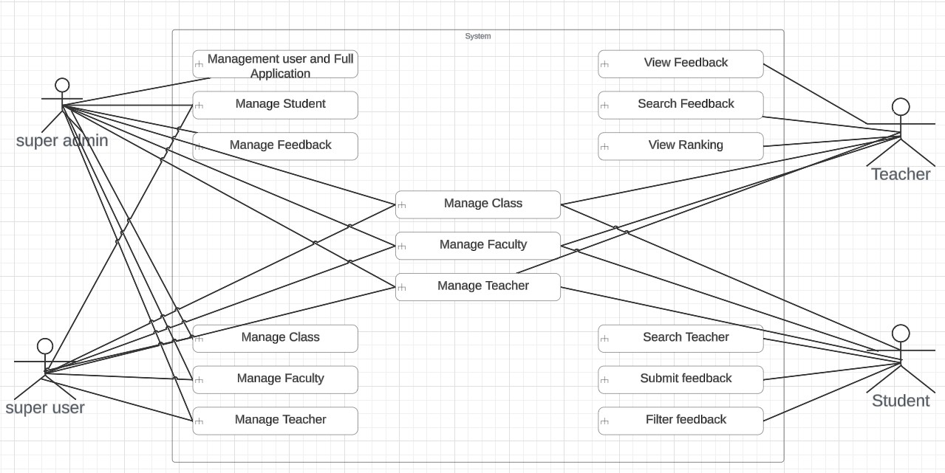The use case diagram for the Faculty Feedback System illustrates the various interactions between actors and the system to achieve specific goals or functionalities. In this system, there are typically three primary actors: students, faculty members, and administrators. Each actor interacts with the system to perform specific tasks or actions. The use case diagram provides a high-level overview of these interactions, helping to visualize the system’s functionality and its users’ roles. <https://www.wrike.com/blog/what-is-a-use-case/>

Figure 4.1: usecase diagram of admin user faculty

# E-R Diagram

The Entity-Relationship (E-R) diagram for the Faculty Feedback System illustrates the various entities, their attributes, and the relationships between them within the system. It provides a visual representation of the data model, helping to understand the structure of the system’s database and how different entities are related to each other.

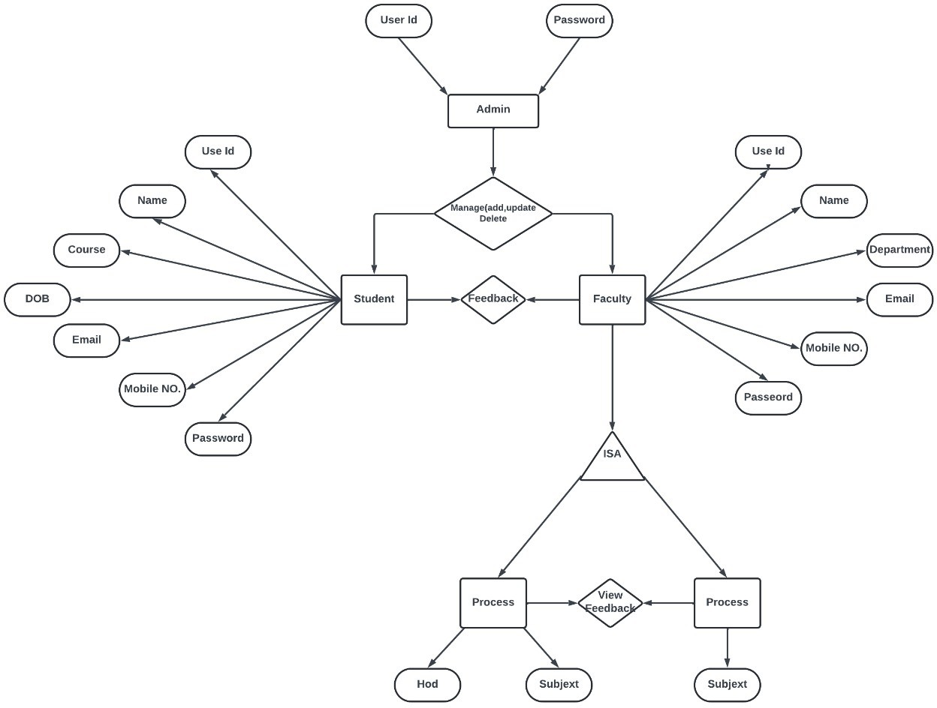

Figure 4.2: ER diagram of admin student faculty

# Sequence Diagram

The Sequence Diagram for the Faculty Feedback System illustrates the interactions between various components or objects within the system over time. It shows the sequence of messages exchanged between these components to accomplish specific functionalities or use cases. The Sequence Diagram provides a dynamic view of the system, focusing on the flow of control and data during the execution of a particular scenario.

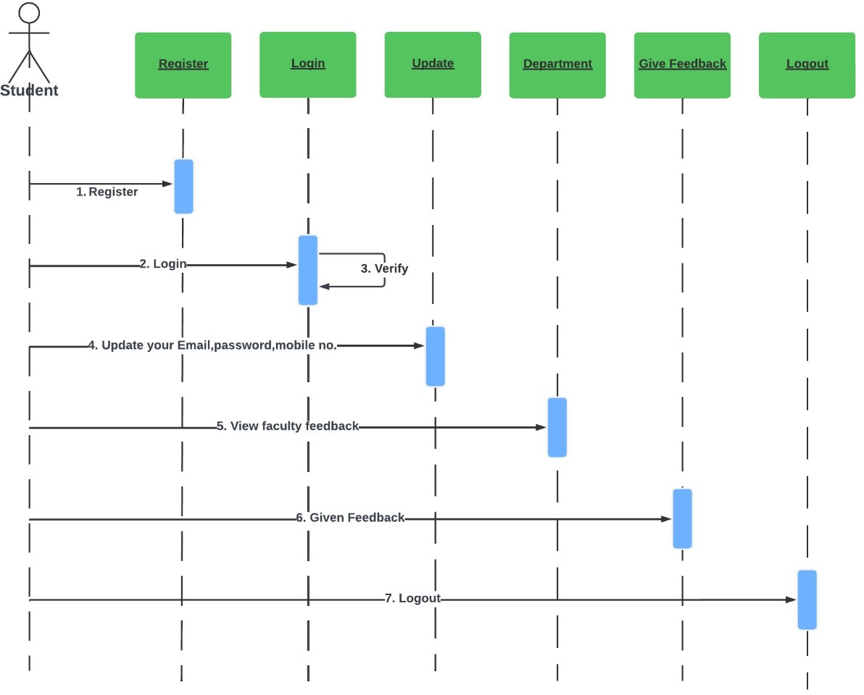

Figure 4.3: Student Sequence diagram

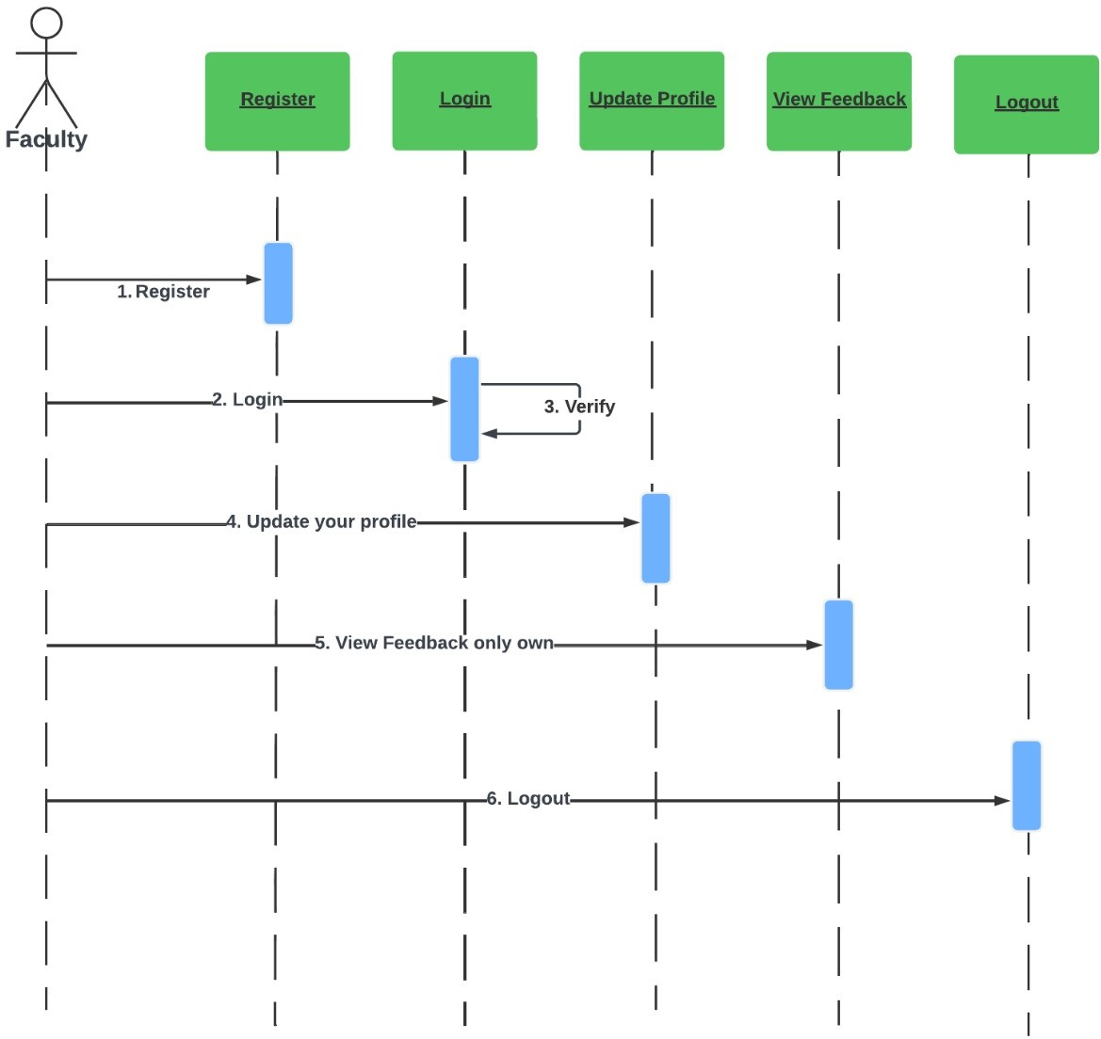

Figure 4.4: Faculty Sequence diagram

# Activity Diagram

The Activity Diagram for the Faculty Feedback System illustrates the flow of activities or processes within the system, showcasing how different tasks are performed and the transitions between these tasks. It provides a visual representation of the system’s workflow, emphasizing the sequence of actions, decision points, and concurrency in executing various functionalities.

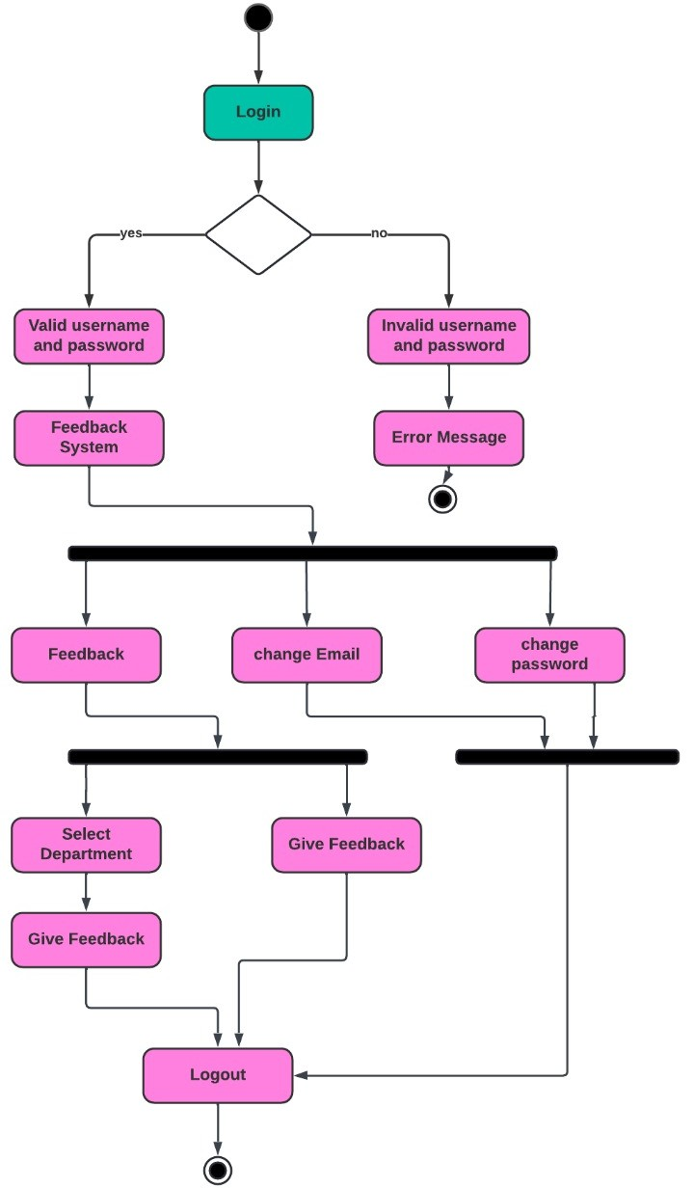

Figure 4.5: Student Activity diagram

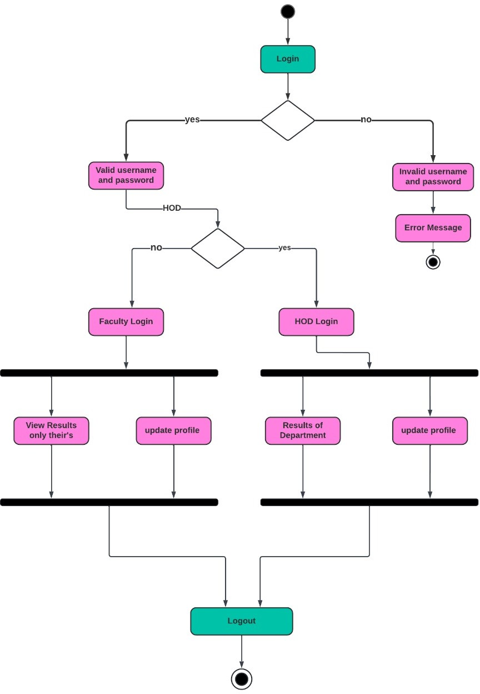

Figure 4.6: Faculty Activity diagram

# Class Diagram

The Class Diagram for the Faculty Feedback System illustrates the static structure of the system, depicting the classes, their attributes, methods, and relationships between them. It provides a blueprint for the system’s design, showcasing the entities and their interactions in an object-oriented fashion.

<https://www.visual-paradigm.com/guide/data-modeling/what-is-entity-relationship-diagram/>

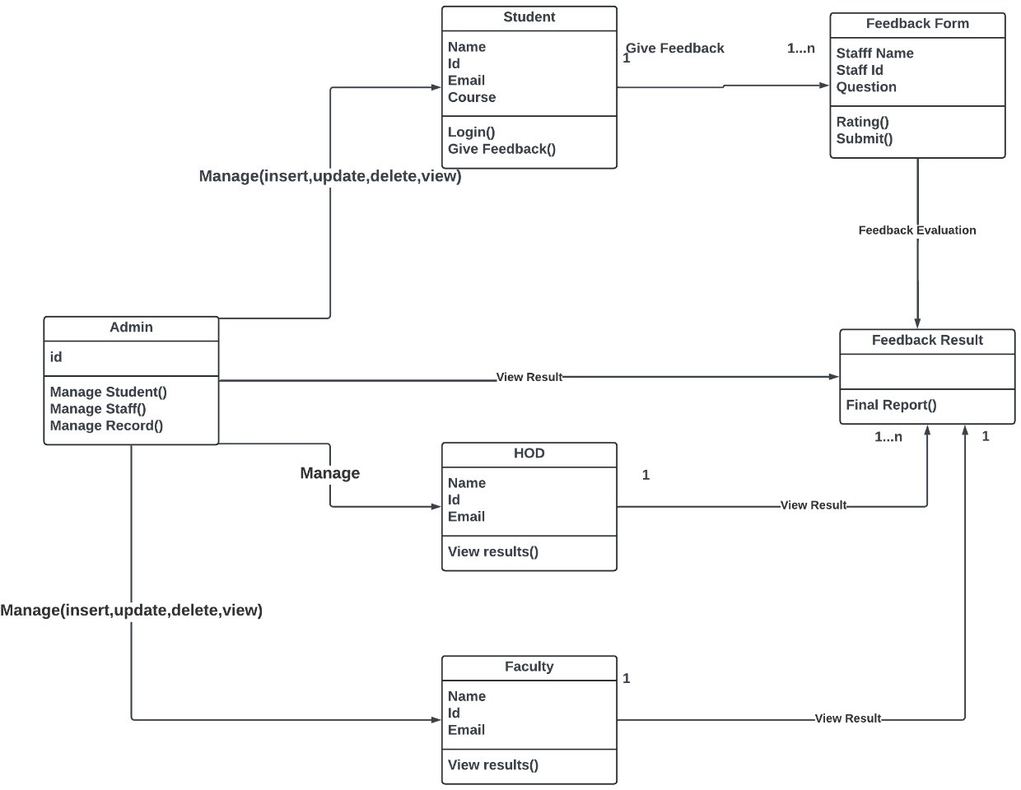

Figure 4.7: Class Diagram

**Chapter 5**

**Methodology**

In the Methodology section of your final year project report, you will describe the approach, processes, and techniques used to conduct the project. This section helps readers understand how you planned and executed the project from inception to completion.

# Project Management Methodology

In this Model, you can start with some of the software specifications and develop the first version of the software. After the first version if there is a need to change the software, then a new version of the software is created with a new iteration. Every release of the Iterative Model finishes in an exact and fixed period that is called iteration.

The Iterative Model allows the accessing earlier phases, in which the variations made respectively. The final output of the project renewed at the end of the Software Development Life Cycle(SDLC)process.

The various phases of Iterative model are as follows:

1. Requirement gathering analysis: In this phase, requirements are gathered from customers and check by an analyst whether requirements will fulfil or not. Analyst checks that need will achieve within budget or not. After all of this, the software team skips to the next phase.
2. Design: In the design phase, team design the software by the different diagrams like Data Flow diagram, activity diagram, class diagram, state transition diagram, etc.
3. Implementation: In the implementation, requirements are written in the coding language and transformed into computer programmes which are called Software.
4. Testing: After completing the coding phase, software testing starts using different test methods. There are many test methods, but the most common are white box, black box, and grey box test methods.
5. Deployment: After completing all the phases, software is deployed to its work environment.
6. Review: In this phase, after the product deployment, review phase is performed to check the behaviour and validity of the developed product. And if there are any error found then the process starts again from the requirement gathering.
7. Maintenance: In the maintenance phase, after deployment of the software in the working environment there may be some bugs, some errors or new updates are required. Maintenance involves debugging and new addition options.

<https://eduprojects.ng/post/how-to-properly-reference-when-developing-final-year-project-topics>

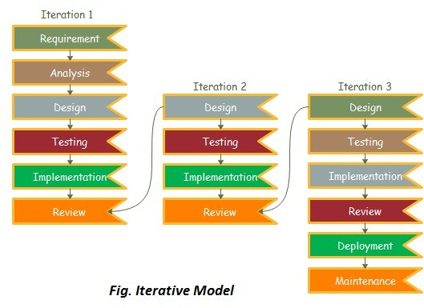

Figure 5.1: Iterative Model

# Project Planning

The project timeline outlines a ten-week development cycle for the faculty feedback system. It begins with a one-week project planning phase followed by a concurrent research and requirements gathering stage, also lasting one week. System design and database design will then take place over a two-week period each. Frontend development is allocated three weeks, while backend development occupies a similar timeframe. Following these development phases, rigorous testing and debugging will occur over a two-week period. User acceptance testing will then be conducted for twelve days, ensuring the system meets user expectations. The final week will be dedicated to final adjustments, deployment, and user documentation and training. This structured timeline provides a clear roadmap for the development process.

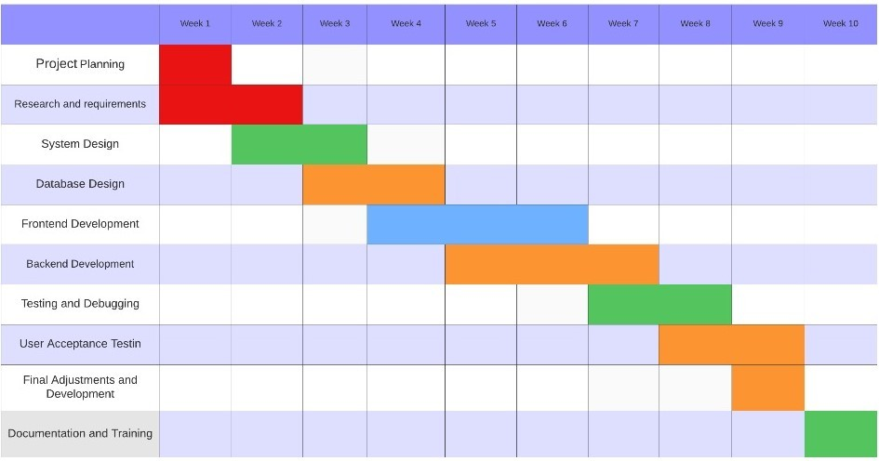

Figure 5.2: Gantt Chart of Faculty Feedback diagram

# Requirement Analysis

In order to develop an effective faculty feedback system, a thorough requirement analysis is crucial. This analysis should identify the needs of all stakeholders: students, faculty, and administrators. It should determine the types of feedback to be collected (e.g., course content, teaching style, communication), the desired anonymity level for students, and the reporting features needed for faculty and administrators. Additionally, the system’s accessibility for various devices and user- friendliness for both providing and viewing feedback must be considered.

# Development Approach

The faculty feedback system can be built using an iterative development approach. This means creating a basic version with core functionalities first, gathering user feedback, and then refining the system based on that input. This iterative process would involve faculty and students testing prototypes, providing feedback on clarity, ease of use, and desired features. The development team would then incorporate this feedback into subsequent versions, ensuring the final system meets the needs of all stakeholders. This approach allows for flexibility and adaptation throughout the development cycle, resulting in a more user-friendly and effective feedback system.

# Testing Strategy

A multifaceted testing strategy is essential for a faculty feedback system. Here’s a breakdown of key approaches:

Usability Testing: Involve faculty and students in testing prototypes to assess ease of use, navigation, and overall user experience. This can be done through individual sessions with screen recording software or group workshops. Functionality Testing: Rigorously test all system functionalities, like submitting feedback, anonymity features, reporting tools, and data security. This ensures the system operates as intended and meets pre-defined requirements. Load Testing: Simulate real-world usage scenarios with a high number of users to assess system performance under stress. This helps identify potential bottlenecks and ensures scalability to handle peak usage periods. Security Testing: Conduct penetration testing to identify and address any vulnerabilities that could expose sensitive data. This protects the privacy of both students and faculty using the system. By implementing a combination of these testing strategies, you can ensure the faculty feedback system is user-friendly, functional, reliable, and secure for all stakeholders.

# Poject Monitoring and Controls

A successful faculty feedback system hinges on a well-defined development process. This starts with a thorough requirement analysis that considers the needs of students, faculty, and administrators. An iterative development approach is ideal, allowing for user testing and feedback to be incorporated throughout the process. Multifaceted testing strategies ensure the system is user-friendly, functional, secure, and can handle real-world use. Finally, effective project monitoring and control practices keep the project on track through regular status meetings, performance measurement, risk management, and a clear change management process. By following these steps, you can develop a faculty feedback system that fosters continuous improvement and enhances the educational experience for all stakeholders.

**Chapter 6**

**Implementation**

[https://www.w3schools.com/whatis/whatis *f ullstack.asp*](https://www.w3schools.com/whatis/whatis_fullstack.asp)

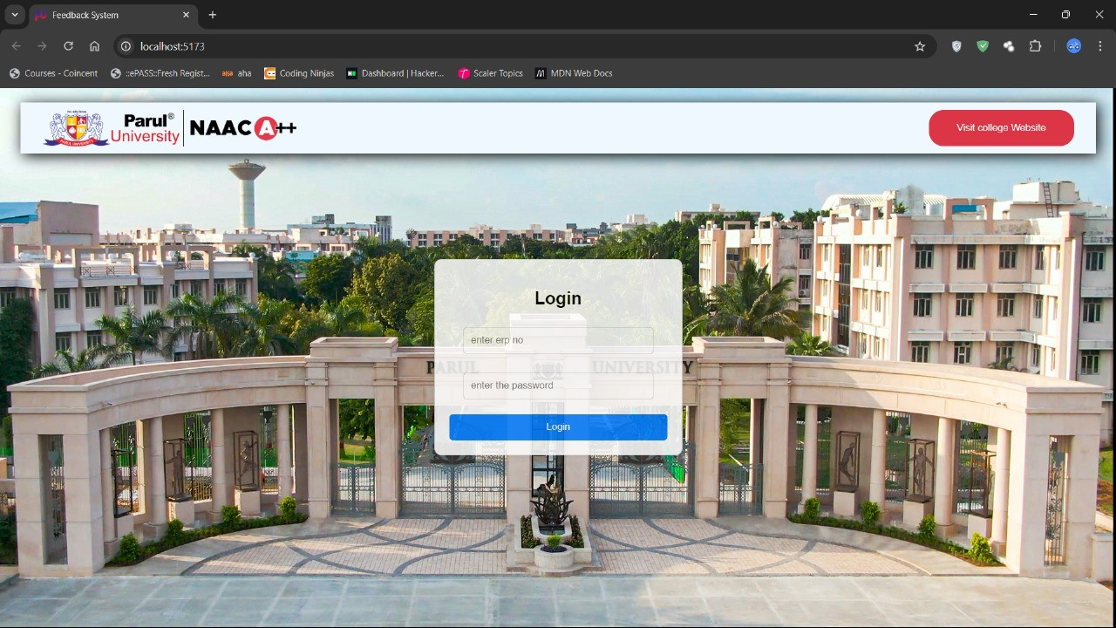

Figure 6.1: Login

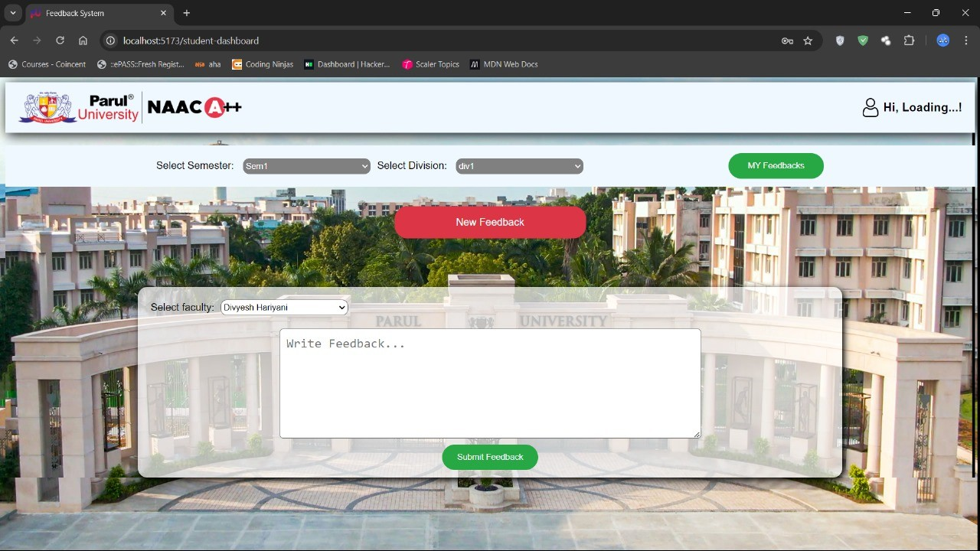

Figure 6.2: Feedback-by-student

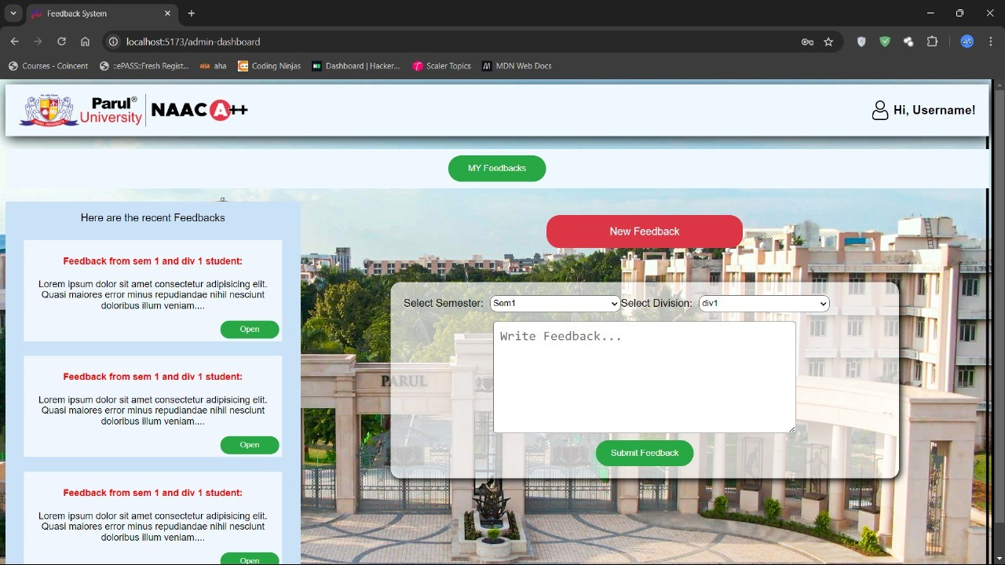

Figure 6.3: Feedback

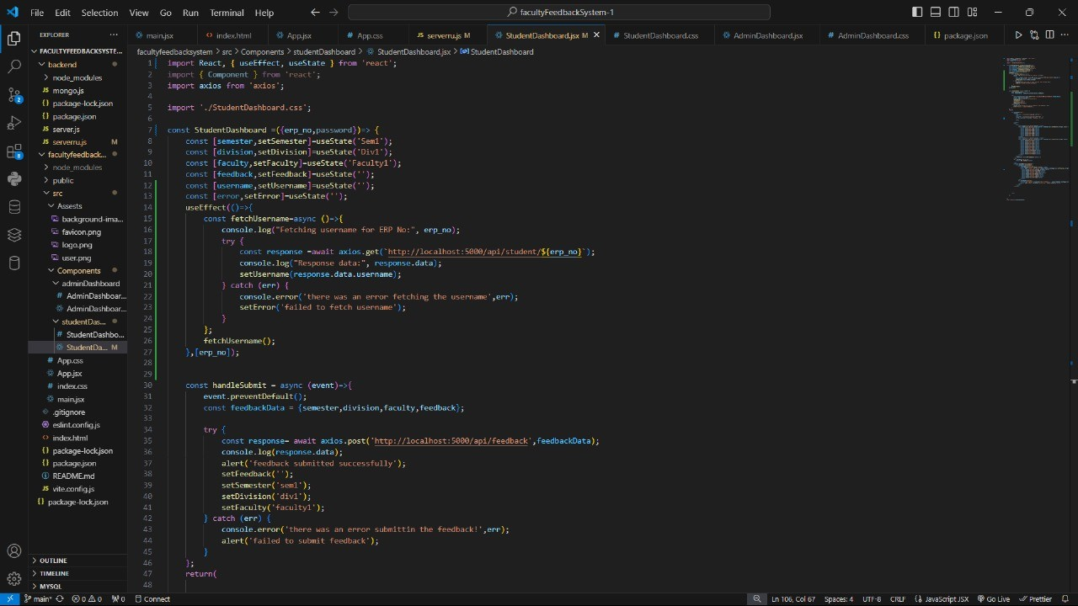

Figure 6.4: studentDashboard

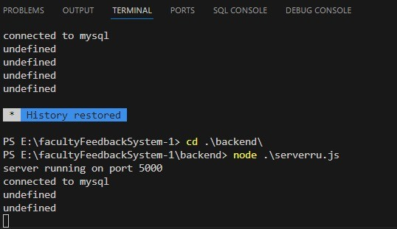

Figure 6.5: Terminal

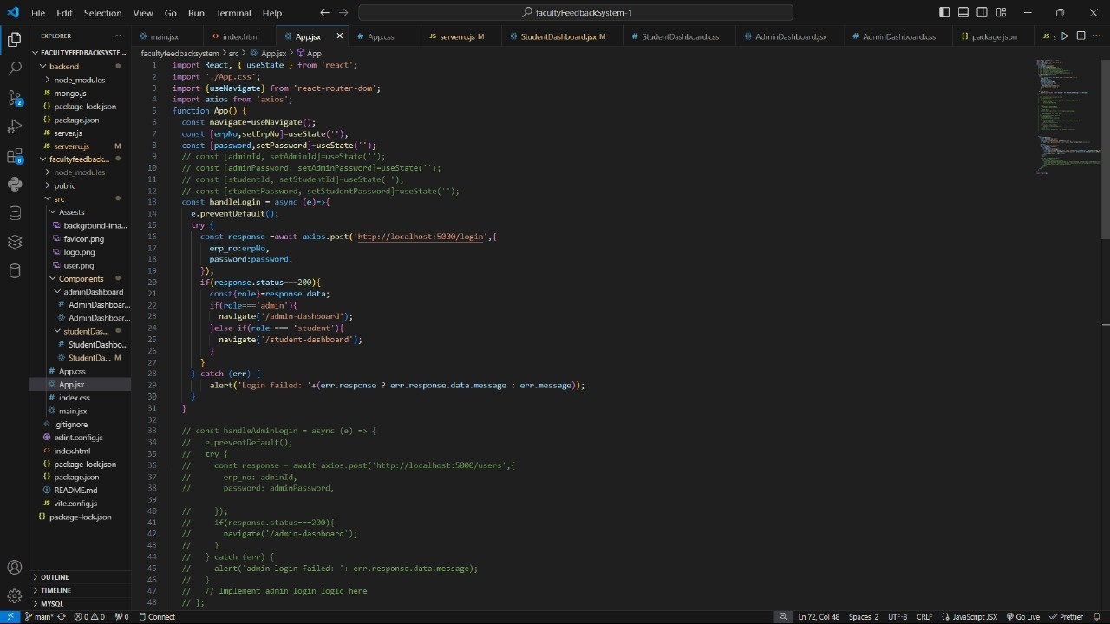

Figure 6.6: App(js)

**Chapter 7**

**Testing**

This chapter outlines the testing procedures followed to ensure the functionality, reliability, and performance of the Faculty Feedback System. The testing phase involved both manual and automated testing techniques. These techniques ensured that the system met its functional requirements, provided accurate feedback collection, and ensured a seamless user experience. The goal was to identify and resolve any issues before the system’s deployment.

# Testing Process

The testing process was designed to verify that each feature of the Faculty Feedback System functions as intended. Testing was divided into two main phases:

* **Phase 1: Unit Testing** - Focused on testing individual components of the system in isolation, such as feedback form submission, login, and report generation. Unit testing aimed to catch errors at the function level to ensure that each module behaves as expected.
* **Phase 2: Integration Testing** - Ensured that the components, such as the front-end forms, back-end processing, and database, worked together smoothly. Integration testing helped detect issues that arise when multiple components interact.

Regression testing was performed to ensure that recent changes did not disrupt existing features. Automated test scripts were written for critical functions such as feedback form submission and report generation to ensure consistent performance over time.

## Test Cases

The following table outlines the test cases that were executed during the testing phase. Each test case was designed to verify the core functionality of the Faculty Feedback System. Table 7.1: Test Cases for Faculty Feedback System

|  |  |  |
| --- | --- | --- |
| **Test Case No.** | **Test Case Description** | **Expected Result** |
| 1 | User Login: Ensure users (students, faculty) can log in successfully. | Users should be able to log in and access their respective dashboards. |
| 2 | Feedback Submission: Validate students can submit feedback. | Students should be able to successfully submit feedback for faculty. |
| 3 | Feedback Report Generation: Ensure that feedback reports are generated. | The system should generate accurate reports based on feedback submitted by students. |
| 4 | Faculty Password Reset: Ensure faculty can reset passwords using ”Forgot Password.” | Faculty should receive an email with password reset instructions. |
| 5 | Data Security: Ensure sensitive data (passwords, feedback) is encrypted. | All sensitive information should be encrypted and securely stored. |

Table 7.1: Test Cases for Faculty Feedback System

# Manual Testing Results

Manual testing was conducted to validate the main workflows of the Faculty Feedback System. This included both student and faculty journeys. The following features were tested manually and yielded the expected outcomes:

* **User Login:** Both students and faculty could log in successfully, accessing their respective portals without issues.
* **Feedback Submission:** Students could submit feedback for their courses and faculty, and the feedback was recorded in the system accurately.
* **Feedback Report Generation:** Reports based on student feedback were generated correctly and displayed the required metrics and comments.
* **Password Reset:** Faculty could reset their passwords using the ”Forgot Password” feature. The reset emails were sent as expected, and users were able to reset their passwords.

# Additional Testing Considerations

In addition to manual testing, performance and security testing were also performed:

* **Performance Testing:** Load tests were conducted to ensure that the system could handle multiple users submitting feedback simultaneously. The system performed well under expected user loads.
* **Security Testing:** The application was tested for security vulnerabilities such as SQL injection, cross-site scripting (XSS), and unauthorized access. Proper encryption was verified for user credentials and feedback data.

Through comprehensive testing, the Faculty Feedback System was confirmed to meet the required standards for functionality, performance, and security. <https://www.webpagetest.org/>

# Conclusion

In conclusion, the Faculty Feedback System effectively streamlines the collection and processing of student feedback for faculty performance evaluation. By providing an intuitive interface for both students and faculty, the system ensures a smooth and reliable process for submitting, storing, and reporting feedback data. The Faculty Feedback System offers the potential to enhance the quality of teaching by providing faculty members with timely and accurate feedback. As a result, the system contributes to the continuous improvement of the educational experience and fosters a culture of accountability and excellence in teaching. The successful deployment of the system demonstrates its scalability, security, and reliability, making it a valuable tool for institutions seeking to optimize faculty evaluation processes.

**Chapter 8**

**Conclusion**

Encouraging Participation: Motivating students to actively participate and provide feedback can be difficult. Anonymity Concerns: Students might hesitate to give honest feedback if they fear being identified.

* + 1. **Response Bias**

Positive or negative experiences might be overrepresented, skewing the overall feedback picture. Actionable Insights: Extracting actionable insights from the collected data requires careful analysis and interpretation.

* + 1. **Faculty Resistance**

Some faculty might be resistant to receiving feedback or perceive it as criticism. Despite these challenges, a well-designed and implemented faculty feedback system can be a powerful tool for improving teaching quality and fostering a culture of continuous improvement within your institution.

a well-designed and implemented faculty feedback system offers a multitude of benefits for educational institutions. It fosters a culture of continuous improvement by providing valuable insights into teaching effectiveness and student experiences.

This requires a comprehensive development process, starting with a thorough requirement analysis that considers the needs of all stakeholders. An iterative development approach allows for user feedback to be incorporated throughout the process, ensuring the final system is user-friendly and meets everyone’s needs.

Rigorous testing across various aspects like usability, functionality, performance, and security is paramount to guarantee a robust and reliable system. Once deployed, ongoing monitoring and user feedback analysis help identify areas for improvement, leading to a system that continuously

*CHAPTER 8. CONCLUSION*

evolves to meet the needs of the institution.

Security measures like user authentication, authorization, data encryption, and regular updates safeguard sensitive information and foster trust within the educational community.

While challenges exist, such as encouraging participation, addressing anonymity concerns, and extracting actionable insights, a well-planned faculty feedback system can overcome these hurdles. By effectively navigating these challenges, institutions can leverage faculty feedback to enhance teaching quality, improve student learning outcomes, and ultimately create a more enriching learning environment for all.

**Chapter 9**

**Future Work**

The Future of Faculty Feedback Systems: Advancing the Conversation Faculty feedback systems have become a cornerstone of educational improvement, offering valuable insights into teaching effectiveness and student experiences. However, as technology and educational needs evolve, so too should these systems. Here’s a glimpse into potential areas for future development:

## AI-powered Analysis

Integrating Artificial Intelligence (AI) can unlock deeper insights from feedback data. AI can analyze large datasets to identify trends, patterns, and potential biases that might be missed by human analysis alone. This can help educators target specific areas for improvement and personalize instruction based on student needs.

## Real-time Feedback and Coaching

Moving beyond static feedback cycles, future systems could provide real-time or near real-time feedback. This could involve in-class student response systems or wearable technology that gauges student engagement. Such data, coupled with faculty expertise, could enable more immediate course adjustments and personalized coaching for students.

## Multimodal Feedback Integration

Current systems often rely on text-based feedback. Future iterations could incorporate multimedia elements like audio or video recordings. This could allow students to provide more nuanced feedback and showcase specific teaching moments that resonated with them. Faculty could then use these recordings for self-reflection and improvement strategies.

*CHAPTER 9. FUTURE WORK*

## Feedback Gamification

Gamification elements like points, badges, or leaderboards could be introduced to incentivize student participation and make the feedback process more engaging. However, careful consideration is needed to ensure gamification doesn’t compromise the integrity or authenticity of the feedback provided.

## Integration with Learning Management Systems (LMS)

Seamless integration with existing Learning Management Systems (LMS) used by many institutions would streamline the feedback process. This could involve automatic data transfer between systems, reducing redundancy and simplifying data analysis.

## Focus on Professional Development

Faculty feedback systems can evolve beyond simply evaluating teaching. They can be integrated with professional development resources, suggesting relevant workshops or training materials based on the feedback received. This would empower faculty to continuously develop their teaching skills and address areas identified by students.

By exploring these potential advancements, faculty feedback systems can move beyond simple data collection and become dynamic tools that empower educators to continuously improve their craft, personalize student learning experiences, and ultimately contribute to a thriving educational environment.

**Reference**

1. Asad Abdi, Gayane Sedrakyan, Bernard Veldkamp, Jos van Hillegersberg, and Ste´phanie M van den Berg. Students feedback analysis model using deep learning-based method and linguistic knowledge for intelligent educational systems. *Soft Computing*, 27(19):14073– 14094, 2023.
2. Lyn Alderman, Stephen Towers, and Sylvia Bannah. Student feedback systems in higher education: A focused literature review and environmental scan. *Quality in Higher education*, 18(3):261–280, 2012.
3. Radhika Amashi, Sujay Suresh Dandgall, and M Vijayalakshmi. Feedback for faculty on student’s asynchronous learning based on classification using topic modelling. In *2023 2nd Edition of IEEE Delhi Section Flagship Conference (DELCON)*, pages 1–7. IEEE, 2023.
4. Peggy Brickman, Cara Gormally, and Amedee Marchand Martella. Making the grade: Using instructional feedback and evaluation to inspire evidence-based teaching. *CBE—Life Sciences Education*, 15(4):ar75, 2016.
5. Shakeel Ahmad Dar. Faculty feedback management system. *Development*, 5(01), 2018.
6. Huma Fawad and Irfan Anjum Manarvi. Student feedback & systematic evaluation of teaching and its correlation to learning theories, pedagogy & teaching skills. In *2014 IEEE International Conference on Teaching, Assessment and Learning for Engineering (TALE)*, pages 398–404. IEEE, 2014.
7. Natasha R Johnson, Andrea Pelletier, Celeste Royce, Ilona Goldfarb, Tara Singh, Treven C Lau, and Deborah D Bartz. Feedback focused: a learner-and teacher-centered curriculum to improve the feedback exchange in the obstetrics and gynecology clerkship. *MedEdPORTAL*, 17:11127, 2021.
8. Rosni Abu Kassim and Norlida Buniyamin. Evaluating teaching quality using data from student online feedback system. In2015 IEEE 7th International Conference on Engineering *Education (ICEED)*, pages 64–68. IEEE, 2015.
9. Zenun Kastrati, Fisnik Dalipi, Ali Shariq Imran, Krenare Pireva Nuci, and Mudasir Ahmad Wani. Sentiment analysis of students’ feedback with nlp and deep learning: A systematic mapping study. *Applied Sciences*, 11(9):3986, 2021.
10. Zan Azma Nasruddin and Nor Hapiza Mohd Ariffin. A student’s perspective on the evaluation of teaching and learning using student feedback online (sufo). In *2022 IEEE International Conference on Computing (ICOCO)*, pages 330–334. IEEE, 2022.
11. HM Nikhil, Varadha SunitKumar, Shruti S Basapur, R Vinil Shah, and TM Veeragangadhar Swamt. Design and implementation of student feedback system at education system. *International Journal of Engineering Research in Computer Science and Engineering*, 5(4):563–565, 2018.
12. Rajvee Patel, Omkar Agrawal, Yash Gangani, and Ashish Vishwakarma. College feedback system. *International Research Journal of Engineering and Technology (IRJET)*, 5(01):1351, 2018.
13. Beth Rubin, Ron Fernandes, Maria D Avgerinou, and James Moore. The effect of learning management systems on student and faculty outcomes. *The internet and higher education*, 13(1-2):82–83, 2010.
14. Mohammad Sarfraz, Shivani Dubey, Vikas Singhal, and Ajay Kumar Sahu. Faculty feedback mining system using sentiment analysis. 2024.
15. Vedna Sharma and Sourabh Jain. Analysis of faculty teaching performance based on student feedback using fuzzy mamdani inference system. In *Proceedings of International Conference on Machine Intelligence and Data Science Applications: MIDAS 2020*, pages 421–431. Springer, 2021.
16. Mohd Sobri Takriff, Siti Rozaimah Sheikh Abdullah, Abu Bakar Mohammad, and Nurina Anuar. Students’ feedback in the continuous quality improvement cycle of engineering education. In *2011 IEEE Global Engineering Education Conference (EDUCON)*, pages 374–377. IEEE, 2011.
17. Benedikt Wisniewski and Klaus Zierer. Functions and success conditions of student feedback in the development of teaching and teachers. *Student Feedback on Teaching in Schools: Using Student Perceptions for the Development of Teaching and Teachers*, pages 125–138, 2021.
18. Muslihah Wook, Noor Afiza Mat Razali, Suzaimah Ramli, Norshahriah Abdul Wahab, Nor Asiakin Hasbullah, Norulzahrah Mohd Zainudin, and Muhamad Lazim Talib. Opinion mining technique for developing student feedback analysis system using lexicon-based approach (omfeedback). *Education and Information Technologies*, 25:2549–2560, 2020.
19. Nida Gulzar Zeb, Nusrat Zareen, Ahmed Almutairi, Sana Malik, Farhat Humayun, Naseer ud din Sheikh, and Kamran Afzal. Students and faculty perspective of effective feedback analyzed in an outcome based medical education system of ksa. *ANNALS OF ABBASI SHAHEED HOSPITAL AND KARACHI MEDICAL & DENTAL COLLEGE*, 27(03):102–108, 2022.