**AUTOMATIC EVAPORATIVE SEWAGE TREATMENT SYSTEM WITH ROLLER AND VIBRATING FILTER**

**Mr. Kawin N1,Mukilan S2 , Sree Sankar K U3 , Sri vishnu sapari S4**

1Assitant Professor, Mechanical Engineering, Kongunadu College of Engineering & Technology,Trichy, Tamil nadu, India

2Student, Mechanical Engineering, Kongunadu College of Engineering & Technology, Trichy, Tamil nadu, India

3Student, Mechanical Engineering, Kongunadu College of Engineering & Technology, Trichy, Tamil nadu, India

4Student, Mechanical Engineering, Kongunadu College of Engineering & Technology, Trichy, Tamil nadu, India

**ABSTRACT**

The Automatic Evaporative Sewage Filtration System with Roller and Vibrating Filter introduces an innovative approach to wastewater management, focusing on enhancing solid-liquid separation and improving water recovery efficiency. The system incorporates a Rolling Filter that utilizes a revolving mechanism and centrifugal force to efficiently separate larger solid debris from sewage. Additionally, a Vibrating Triple Meshed Filter with tri-layered pore sizes and built-in vibration captures smaller particulate matter, minimizing clogging and enhancing filtration efficiency. The system also features a lens-coated evaporative chamber that uses optical principles to maximize solar energy absorption through dynamic focal length adjustments, accelerating the evaporation process to produce cleaner, drinkable water. This innovative technology enables sustainable water management by reducing impurities, improving water recovery, and minimizing energy consumption. The study concludes that the integration of mechanical filtration and solar evaporation can significantly enhance wastewater treatment efficiency, promoting environmental sustainability and public health improvement. This research involves an in-depth analysis, investigation, and examination of the system’s performance to optimize its functionality and effectiveness.

1. **INTRODUCTION**

The treatment and filtration of sewage wastewater is a critical aspect of modern environmental sustainability, ensuring public health protection, environmental conservation, and resource management. In the face of rapid urbanization, industrialization, and population growth, the amount of wastewater generated has significantly increased, placing immense pressure on existing sewage treatment infrastructures. This has amplified the demand for efficient and cost-effective sewage filtration systems to mitigate water pollution and facilitate water reuse for non-potable applications.

Sewage filtration plays a crucial role in separating contaminants such as suspended solids, pathogens, heavy metals, and organic pollutants from wastewater. Traditional sewage treatment systems, such as activated sludge processes, trickling filters, and rapid sand filtration, have been widely adopted for wastewater purification. However, these conventional methods often encounter challenges such as high operational costs, complex maintenance, energy consumption, and inefficient removal of micro-pollutants. Consequently, developing advanced filtration systems with improved filtration efficiency, low energy consumption, and sustainable operation has become a research priority.

Given these challenges, there is an increasing need for cost-effective, energy-efficient, and low-maintenance sewage filtration systems capable of handling high volumes of wastewater. The present research introduces an Automatic Evaporative Sewage Filtration System with Roller and Vibrating Filter, aimed at addressing these limitations by employing natural evaporation and mechanical filtration principles. The system is designed to reduce maintenance costs, minimize energy consumption, and enhance filtration efficiency through continuous mechanical agitation and solar-powered evaporation.

This paper delves into the working principle, design, and performance evaluation of the proposed filtration system. The study aims to contribute to sustainable wastewater management practices by offering an efficient and economically viable filtration solution. Through this innovation, the research seeks to promote water resource conservation, reduce environmental pollution, and support sustainable urban development in water-scarce regions.

1. **METHODOLOGY**

The Automatic Evaporative Sewage Filtration System with Roller and Vibrating Filter was developed to address the inefficiency of conventional sewage filtration systems, which often face clogging and low filtration rates.

**2.1 Roller Filter**

Rolling filters are a unique type of cylindrical slit gap arranged at an incline designed to efficiently separate large solid particles. This innovative approach aids in the easy separation of sizable solid waste. The rotating cylinder features a slit gap that facilitates the smooth drainage of water within the gap. When wastewater mixed with solid waste enters the system, it undergoes rotation powered by a motor, allowing water to flow downward through the gap while large solid particles are effectively separated and collected in a separate container. The separated solids then proceed to the sludge treatment process. The design of rolling filters is centered on the concept of utilizing a rotating cylinder with a strategically positioned slit gap. The operational mechanism of rolling filters involves the introduction of wastewater containing large solid particles, rotation of the cylinder, particle separation, collection of separated solid particles, and effluent discharge.

**2.2 Vibrating Filter**

The vibrating filter is an innovative approach to wastewater treatment that uses a finely meshed screen to filter micro-particle solids within water. The filter uses vibration generated by unbalanced forces to separate sludges from the water. The vibrating motor setup provides the necessary vibrations, and the filter consists of three layers of mesh. The mesh serves as the primary filtration medium, and its characteristics directly impact the filtration process. The choice of mesh is critical to their efficiency in removing micro-particle solids from wastewater. Mesh specifications for prototype and real-time vibrating filter products include material selection, mesh size, tautness, and mesh layering. In prototypes, cost-effective materials like stainless steel or nylon mesh are often used, while high-quality stainless steel mesh is preferred for real-time applications. Mesh size varies depending on the particle size range, and maintaining mesh tautness is crucial for accurate testing. The use of multiple mesh layers in prototype filters can also be explored to test their impact on filtration efficiency.

1. **MODELING AND ANALYSIS**

The research and analysis phase involves an in-depth exploration of the Filters and the existing filtering technologies. The drawbacks of current sewage water filtering technology were analysed and the alternatives of the drawbacks were collected and utilized to develop the design concept of the roller and vibrating filter were developed and the protype model of the product is developed for the testing and further research of the project were done for the development of the product. 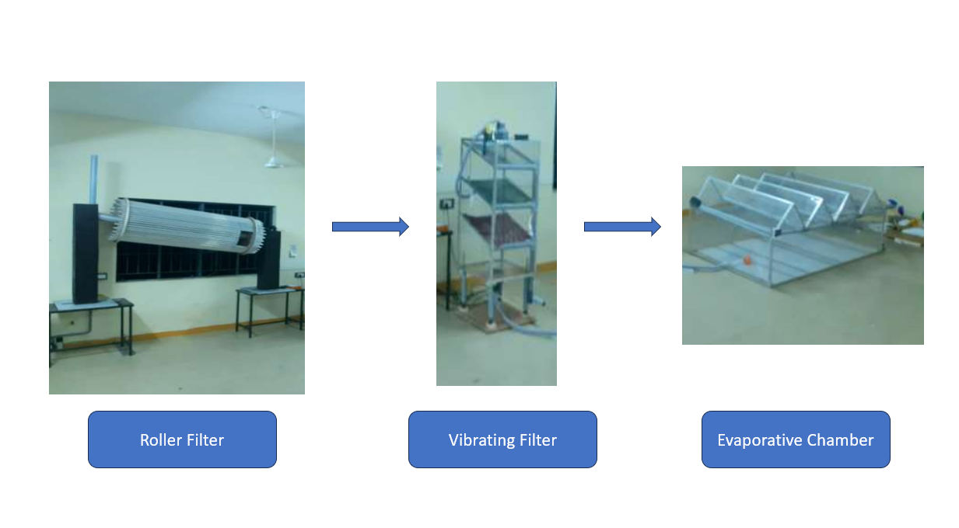

**Figure 1:** Filters involved

1. **RESULTS AND DISCUSSION**

The goal of this system is to use solar energy to efficiently evaporate sewage water, leaving behind impurities and contaminants, and then collect and condense the evaporated water into fresh, potable water. Single Chamber consists of many lenses and collecting strip. In evaporative chamber, sewage water is filled of 5000 ml. Calculate the pure water, based on the atmosphere temperature of solar energy in the time morning to evening.

**Table 1.** Reading of Pure Water Consumed

|  |  |  |
| --- | --- | --- |
| **TIME** | **ATMOSPHERE**  **TEMPERATURE (in %) (°C)** | **PURE WATER**  **CONSUME (ml)** |
| 9.15 AM | 27°C | 4900 ml |
| 9.30 AM | 28°C | 4800 ml |
| 9.45 AM | 29°C | 4700 ml |
| 10.00 AM | 30°C | 4600 ml |
| 10.15 AM | 31°C | 4500 ml |
| 10.30 AM | 32°C | 4400 ml |
| 10.45 AM | 33°C | 4300 ml |
| 11.00 AM | 34°C | 4200 ml |
| 11.15 AM | 35°C | 4100 ml |
| 11.30 AM | 36°C | 4000 ml |
| 11.45 AM | 37°C | 3900 ml |
| 12.00 PM | 38°C | 3800 ml |
| 12.15 PM | 39°C | 3700 ml |
| 12.30 PM | 40°C | 3600 ml |
| 12.45 PM | 41°C | 3500 ml |
| 01.00 PM | 41°C | 3400 ml |
| 01.15 PM | 42°C | 3300 ml |
| 01.30 PM | 42°C | 3200 ml |
| 01.45 PM | 42°C | 3100 ml |
| 02.00 PM | 41°C | 3000 ml |
| 02.15 PM | 40°C | 2900 ml |
| 02.30 PM | 39°C | 2800 ml |
| 02.45 PM | 38°C | 2700 ml |
| 03.00 PM | 37°C | 2600 ml |
| 03.15 PM | 36°C | 2500 ml |
| 03.30 PM | 35°C | 2400 ml |
| 03.45 PM | 34°C | 2300 ml |
| 04.00 PM | 33°C | 2200 ml |

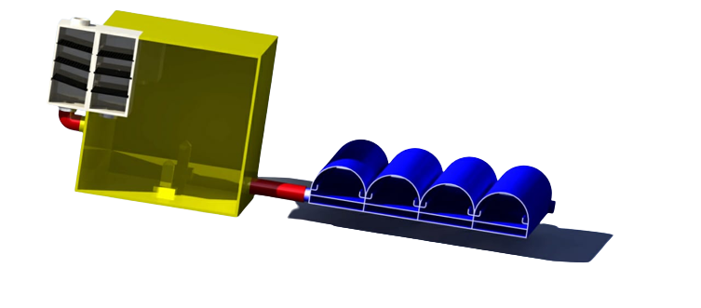

**Figure 2:** Evaporative Chamber

Lens coated floating Evaporative chamber is used to convert the wastewater for the reusable water. Sun rays are entered through lens which converged on the sea water surface so water will get evaporated quickly. In evaporative chamber, sewage water is filled of 5000 ml. We Calculate the pure water, based on the atmosphere temperature of solar energy in the time morning to evening. The result was pure water consumed in solar collector is 2200 ml and pure water pH value was 6.8.

**CONCLUSION**

Through extensive research, innovative design, and meticulous fabrication, we have successfully developed advanced filtration and solar-based evaporation technologies to address the critical challenges of wastewater treatment. Our roller and vibrating filters efficiently remove solid particles, from large debris to micro-pollutants, without relying on chemical additives, ensuring enhanced wastewater treatment with minimal environmental impact. Complementing this, the integration of a lens-coated solar evaporative chamber with a focal length maintaining system harnesses solar energy to purify contaminated water, providing a decentralized and eco-friendly solution for wastewater treatment. This dual approach not only optimizes resource utilization and promotes environmental sustainability but also reduces the burden on centralized sewage systems and mitigates the adverse effects of untreated effluents. By transforming wastewater into clean, usable water, our project contributes to water resource sustainability, particularly in regions facing scarcity. As environmental challenges evolve, continuous refinement and adaptation of these technologies will be crucial in ensuring efficient, sustainable, and responsible wastewater management for the benefit of both communities and the planet.

1. **REFERENCES**

[1] Chen, W., & Wang, H. (2017). "Mesh Filtration Technologies for Sustainable Sewage Treatment." Water and Environment Research,Vol.29, No.6, pp.881- 894.

[ 2] Chen, X., & Liu, Y. (2019). "Enhanced Wastewater Filtration using Rotating Cylinder Filters." Water Quality Research, Vol.45, No.2, pp.134-147.

[3] Gomez, A., & Rodriguez, M. (2017). "Application of Rotating Filters in Solid-Waste Segregation for Industrial Wastewater." Environmental Science and Technology, Vol.22, No.1, pp.74-86.

[4] Jiang, L., & Li, Q. (2019). "Enhancing Solid Waste Separation in Wastewater using Rotational Filters: A Review." Environmental Engineering and Management Journal, Vol.45, No.3, pp.421-434.

[5] Kim, S., & Lee, H. (2018). "Inclined Slit Gap Separation for Solid-Waste Removal in Sewage Treatment." Journal of Environmental Engineering, Vol.36, No.3, pp.312-325.

[6] Li, H., & Xu, Q. (2017). "Micro-Particle Filtration in Wastewater: A Comprehensive Review of Vibrational Filter Technologies." Separation and Purification Technology, Vol.62, No.3, pp.821-835.