**Author(s):**

**Seun Emmanuel Faluyi  
Affiliated Institution:**

**UNICAF University**

**Glory Eromosele**

**Affiliated Institution:**

**Goes here**

**Praise Eromosele**

**Affiliated Institution:**

**Vanderbilt University**

**Title**:

Africa's Emerging Role in the Global AI Ecosystem: Innovation, Adaptation, and Inclusive Growth

**Abstract:**

The global artificial intelligence (AI) boom has been predominantly characterised by the narrative that "America invents, China scales, and Europe regulates." However, this framework overlooks the increasingly significant role of Africa, a continent uniquely positioned to shape the future of AI through innovation, adaptation, and inclusive growth. This paper explores Africa's emerging contributions to the global AI ecosystem, focusing on its potential to address local and global challenges, foster technological leapfrogging, and create equitable AI-driven solutions. A confluence of factors marks Africa's AI landscape: a youthful and rapidly growing population, increasing digital connectivity, and a burgeoning tech startup ecosystem. These elements provide fertile ground for AI innovation tailored to the continent's unique socio-economic context. From healthcare and agriculture to finance and education, African innovators are leveraging AI to solve pressing challenges, such as improving access to medical diagnostics, optimising crop yields, and enhancing financial inclusion. These localised solutions address African needs and offer scalable models for other developing regions. Moreover, Africa's role in the global AI boom extends beyond localised innovation. The continent is becoming a testing ground for AI technologies, prioritising inclusivity and ethical considerations. Unlike the regulatory frameworks in Europe or the scaling strategies in China, Africa's approach to AI is often community-driven and focused on addressing systemic inequalities. This paper examines case studies of AI applications in Africa, highlighting how these initiatives shape global conversations around ethical AI, data sovereignty, and digital rights. The paper also investigates Africa's challenges in fully realising its AI potential. These include infrastructural deficits, limited access to funding, and a shortage of skilled AI talent. However, the continent's resilience and adaptability demonstrate its ability to overcome these barriers through collaborative efforts—such as public-private partnerships, international collaborations, and homegrown talent development programs. Finally, this research argues that Africa's role in the global AI boom is not merely supplementary but transformative. By contributing unique perspectives, innovative solutions, and a commitment to inclusivity, Africa is poised to redefine the global AI narrative. This paper calls for increased investment in African AI ecosystems, greater recognition of the continent's contributions, and a more inclusive global AI framework that integrates diverse voices and experiences. Through qualitative and quantitative analysis, this study provides a comprehensive overview of Africa's current and potential impact on the global AI landscape. It concludes that Africa's participation in the AI boom is essential for the continent's development and creating a more equitable and sustainable global AI ecosystem.

Keywords: Artificial Intelligence, AI, AI in Africa, Artificial intelligence for Africa,

**Introduction**

Artificial intelligence (AI) has become a component of the Fourth Industrial Revolution, driving innovation across various sectors such as healthcare, finance, transportation, and defence. The global AI market is projected to grow from 62.35 billion in 2020 to 997.77 billion by 2028, reflecting a compound annual growth rate of 40.2% (Grand View Research, 2021).

The United States, China, Australia and Europe have become the main centres of AI development in this quickly changing environment, each utilising unique advantages and tactics.

Due to its thriving technological businesses, academic institutions, and venture capital investment ecosystem, the United States has long been at the forefront of AI advancement. Silicon Valley has significantly influenced AI research and development (R&D), which is home to tech behemoths like Google, Apple, and Facebook (now Meta). Nearly 60% of all private AI funding worldwide came from U.S. private investment, which totalled $23.8 billion in 2021 (Stanford AI Index, 2022).

The U.S. government has also played a significant role in fostering AI growth. The National AI Initiative Act of 2020 established a coordinated federal strategy to accelerate AI R&D, emphasising the importance of maintaining global leadership in AI (Bal & Gill, 2020). Additionally, the Department of Defense has invested heavily in AI for military applications, further solidifying the U.S.'s competitive edge (Brundage et al., 2018).

China has emerged as a strong competitor in the global AI race, leveraging its vast population, data resources, and government support to achieve rapid progress. The Chinese government's "Next Generation Artificial Intelligence Development Plan," launched in 2017, aims to make China the world leader in AI by 2030 (State Council of China, 2017). This plan has spurred significant investments in AI infrastructure, talent development, and industrial applications.

Chinese tech companies such as Baidu, Alibaba, and Tencent have become major players in AI, particularly in areas like facial recognition, natural language processing, and autonomous vehicles. In 2021, China accounted for 20% of global AI journal citations and 26.5% of AI conference papers, reflecting its growing influence in AI research (Stanford AI Index, 2022).

Access to enormous datasets, a vital resource for AI algorithm training, is another factor driving China's AI rise. However, given China's social credit system and usage of AI for state control, this has sparked worries about data privacy and surveillance (Zeng, 2020). Notwithstanding these disputes, China has established itself as a major force in the global AI scene thanks to its strategic concentration on AI. Guo et al. (2025) also suggest that the AI and machine learning algorithm of China is a major competitor to the Open AI's algorithm and argue that the performance of both AI inventions are very comparable.

Europe has distinguished itself in the global AI boom by prioritising the development of ethical AI and strong regulatory frameworks. With programs like the General Data Protection Regulation (GDPR) and the proposed Artificial Intelligence Act, which seeks to create a thorough legal framework for AI, the European Union (EU) has established itself as a pioneer in AI governance (European Commission, 2021).

European countries have also made significant investments in AI research and innovation. The EU's Horizon 2020 program has allocated 5 billion euros to AI-related projects, fostering collaboration between academia, industry, and government (European Commission, 2020). Organisations like the United Kingdom, Germany, and France have launched national AI strategies to enhance their competitiveness in the global AI market.

Europe's emphasis on ethical AI and human-centric design has established a global standard for responsible AI development, even though it is behind the United States and China regarding private investment and market domination. This strategy could impact global AI governance and guarantee that AI systems align with social norms (Feijóo et al., 2020).

China, Europe, and the United States all bring unique advantages and approaches to the global AI revolution. Europe places a high priority on moral governance and regulation, China makes use of governmental assistance and data resources, while the United States leads the world in innovation and private-sector investment. One of the questions that comes to mind is: What role is Africa playing in the era of global AI innovation and adoption?

Faluyi (2025) suggests that a solid understanding of the impact of AI in the job market can positively improve job placement and development globally.

Africa's distinct socioeconomic and cultural background has influenced its AI path. Economic inequality, poor infrastructure, and restricted educational opportunities are issues facing the continent that have traditionally impeded technological growth (Asongu & Nwachukwu, 2018). But these difficulties have also sparked creativity, as African researchers and businesspeople create technological solutions suited to regional requirements, including AI innovations. For instance, natural language processing (NLP) technologies are being utilised to overcome language barriers, increase agricultural output, and expand access to healthcare through AI-powered platforms (Marivate, 2020).

Africa's youthful population, with a median age of 19.7 years, presents a significant opportunity for AI development. This demographic dividend, coupled with increasing mobile phone penetration and internet access, has created a fertile ground for AI innovation (GSMA, 2022). Moreover, the continent's rich linguistic and cultural diversity offers unique datasets that can enrich global AI research and development.

**Research Problem:**

* Limited recognition of Africa's role in the global AI ecosystem.
* Gaps in understanding how Africa's unique context shapes AI innovation and adoption.
* Analyse the lack of funding and innovation for African Startups
* If America introduced ChatGPT, China introduced DeepSeek and Europe introduced Mistral AI, what large language model could Africa bring to the party.

**Objectives of Research:**

* To explore Africa's emerging role in AI innovation, adaptation, and inclusive growth.
* To identify challenges and opportunities for Africa in the global AI landscape.
* To Suggest the role Africa plays in the building of AI technologies.
* To suggest how Africa can be a frontline to other emerging technologies like quantum computing and the rest.

**Research Questions:**

* How is Africa contributing to AI innovation and adaptation on the global stage?
* What are the barriers to Africa's full participation in the global AI ecosystem?
* How can Africa's AI initiatives promote inclusive growth and ethical AI development?

**Significance of the Study:**

* Contribution to the academic literature on global AI dynamics.
* Policy implications for fostering AI development in Africa and beyond.

**Methodology**

Mixed-methods approach combining qualitative and quantitative analysis.

Data Collection:

* Case studies of African AI initiatives.
* Interviews with AI experts, policymakers, and entrepreneurs in Africa.
* Analysis of secondary data (reports, academic papers, and industry publications).

**Limitations**:

Data availability and regional disparities within Africa.

**Literature Review**

Artificial Intelligence (AI) is transforming the global economy, driving productivity, innovation, and economic growth across industries. By automating routine tasks, optimising processes, and enabling data-driven decision-making, AI creates new opportunities for businesses and governments while presenting challenges that require careful management. This section explores the economic impact of AI, focusing on its contributions to productivity, job creation, and global competitiveness (Holmström, 2022).

A subset of artificial intelligence called machine learning (ML) has advanced significantly in recent years. Natural language processing (NLP), computer vision, and reinforcement learning have all advanced thanks in large part to deep learning (LeCun, Bengio, & Hinton, 2015). NLP tasks have been transformed by the emergence of transformer-based models like GPT-4 and BERT, which allow for more precise and contextually aware language processing (Vaswani, 2017). Furthermore, self-supervised learning methods are decreasing the need for labelled datasets, increasing the scalability and effectiveness of AI systems (Jaiswal et al., 2020).

Ethical concerns have emerged as AI systems are increasingly deployed in critical domains. Issues such as algorithmic bias, data privacy, and accountability have prompted calls for responsible AI development (Floridi et al., 2018). For instance, biased training data can lead to discriminatory outcomes, exacerbating social inequalities (Mehrabi et al., 2021). Researchers are developing frameworks for fairness, transparency, and explainability in AI systems (Doshi-Velez & Kim, 2017). Regulatory bodies are also stepping in, with initiatives like the European Union's AI Act aiming to establish guidelines for ethical AI deployment (European Commission, 2021).

The integration of AI with edge computing is another emerging trend, enabling real-time data processing and decision-making at the source of data generation. This approach reduces latency and bandwidth usage, making it ideal for applications such as autonomous vehicles and IoT devices (Shi et al., 2016). Edge AI also enhances privacy by minimising the need to transmit sensitive data to centralised servers (Satyanarayanan, 2017). However, challenges remain, including the limited computational resources of edge devices and the need for efficient model compression techniques (Han et al., 2016).

AI is increasingly being integrated with other technologies, such as blockchain, quantum computing, and biotechnology to solve complex problems and create business opportunities. For example, AI-driven drug discovery is accelerating the development of new treatments by analysing vast datasets of molecular structures (Topol, 2019). Similarly, combining AI and blockchain enhances data security and transparency in supply chain management (Tapscott & Tapscott, 2017). These interdisciplinary collaborations are expanding the scope of AI applications, creating new opportunities for innovation.

In their research, Faluyi & Mboga, (2025) stressed the importance of leadership in African organisations to have a clear vision of adopting AI and other emerging technologies into their operational strategies, this would help foster innovation and better business results for the continent.

Notwithstanding the encouraging developments, several issues need to be resolved to guarantee AI's long-term advancement and application. These include the risk of employment displacement owing to automation, the necessity for strong cybersecurity measures, and the environmental impact of training massive AI models (Brundage et al., 2018). To solve these problems, future research should create algorithms that use less energy, improve AI governance, and encourage stakeholder cooperation.

**AI in Africa:**

Africa has achieved significant advancements in AI innovation despite its low resources. Nations like South Africa, Kenya, Rwanda, and Nigeria are emerging as AI research and entrepreneurship centres.

Africa is home to many AI-driven innovations that address local challenges and contribute to global AI development. For instance, AI is being used to improve healthcare delivery, enhance agricultural productivity, and optimise energy usage. In Kenya, the startup Ushahidi has developed AI-powered tools for crisis mapping and disaster response, demonstrating the potential of AI to address pressing social issues (Marsden & Oduor Lungati, 2023). Similarly, Zenvus uses AI in Nigeria to analyse soil data and provide farmers with actionable insights, boosting agricultural yields and sustainability (Obasi et al., 2024). Nigeria's "AI Saturdays" project has fostered an active network of AI aficionados, " which has trained thousands of people in AI and machine learning (AI Saturdays Lagos, 2023).

An essential factor in promoting AI innovation is Africa's thriving startup scene. Tech hubs like Silicon Cape in Cape Town, Lagos's CcHub, and Nairobi's iHub give entrepreneurs the tools, networking opportunities, and mentorship they need to create AI solutions (GSMA, 2022). Global tech behemoths like Google and Microsoft are also investing in these hubs, setting up AI research labs and innovation centres in Africa (Adu, 2024). Google's AI lab in Ghana, for instance, is dedicated to creating AI solutions for African languages and enhancing information access for marginalised groups (Gupta et al., 2020).

**Challenges Africa faces regarding the innovation and adoption of AI**

Artificial intelligence is transforming industries and economies around the world, offering opportunities for innovation and development. In Africa, the innovation around Artificial intelligence has the potential to address critical challenges in healthcare, agriculture, education, governance, manual labour, etc. However, the continent faces unique obstacles that limit its ability to fully harness the benefits of AI.

One of the most significant challenges to AI innovation and adoption in Africa is the lack of adequate infrastructure. Reliable electricity, internet connectivity, and computing resources are essential for developing and deploying AI systems. However, many African countries struggle with frequent power outages, limited broadband access, and high data costs (Alupo et al., 2022). For instance, only 22% of the African population has access to the internet, compared to the global average of 66% (ITU, 2021). This digital divide negatively impacts the ability of African researchers and entrepreneurs to access the tools and platforms needed for the development of AI technologies.

Another significant obstacle to AI innovation in Africa is the lack of qualified AI specialists and talents. Many bright people from the continent are leaving for richer nations in quest of greater chances, causing a brain drain (Ndung'u & Signé, 2020). Furthermore, the development of Indigenous talent is negatively impacted by the absence of training initiatives and educational programs centred on AI. Although organisations such as the African Institute for Mathematical Sciences (AIMS) are making attempts to close this gap, more extensive efforts are necessary due to the challenge's magnitude (AIMS, 2021). Also, organisations like Data Science Nigeria are also trying to bridge the educational gap of artificial intelligence in the continent by offering regular training boot camps (Data Science Nigeria, 2023). Africa would find it difficult to compete in the global AI market without a strong pipeline of AI specialists.

Large, high-quality datasets are essential for the training and validation of AI systems. However, the lack of data, its fragmentation, and its poor quality present serious problems for Africa. The governance structures and infrastructure required for efficient data collection, storage, and sharing are lacking in many African nations (Neumark & Prince, 2021). Concerns regarding data sovereignty and the fair distribution of AI advantages are also raised by the dominance of multinational tech businesses in data collection (Zuboff, 2019). Investments in data infrastructure and the creation of regulations that encourage data sharing and interoperability are necessary to address these problems.

The ethical implications of AI adoption in Africa cannot be overlooked. Issues such as algorithmic bias, privacy violations, and the misuse of AI for surveillance pose significant risks to individuals and communities (Floridi et al., 2018). For example, biased AI systems could exacerbate existing inequalities by discriminating against marginalised groups (Mehrabi et al., 2021). Moreover, the lack of comprehensive regulatory frameworks for AI in many African countries creates uncertainty for innovators and investors.

It goes without saying that significant financial resources are needed for AI innovation, yet these are frequently scarce in Africa. African researchers and companies are unable to create and grow AI solutions due to limited access to grants, venture capital, and other funding sources (GSMA, 2022). Governments, businesspeople, and development partners must work together to close the financial gap.

**Insights from Interviews with AI Experts regarding the state of AI in Africa**

For this study, we interviewed 10 experts on the current state and future of AI adoption in Africa. Fifty percent of these experts believe AI can help address some pressing challenges facing Africa, such as poverty, inequality, and climate change. They also believe that Africa can leverage AI to develop the financial sector, prevent electoral fraud, and automate various industrial tasks, thereby improving these sectors. Although the other fifty percent are undecided, it is worth noting that no one concluded that AI cannot help address the challenges facing Africa.

All interviewees agree on the need for more education and awareness programs about AI within the African Continent. Sixty percent believe that Africa is not making significant contributions to the building of current AI technologies, with only ten percent believing the opposite and thirty percent being uncertain [Fig 1]. Furthermore, only twenty percent are aware of some AI initiatives happening in Africa [Fig 2]. Regarding ethical concerns, fifty percent of the interviewees believe that there are significant ethical concerns surrounding the development or use of AI in Africa [Fig 3]. Moreover, eighty percent feel that they may have a role to play in the development or adoption in Africa [Fig 4].

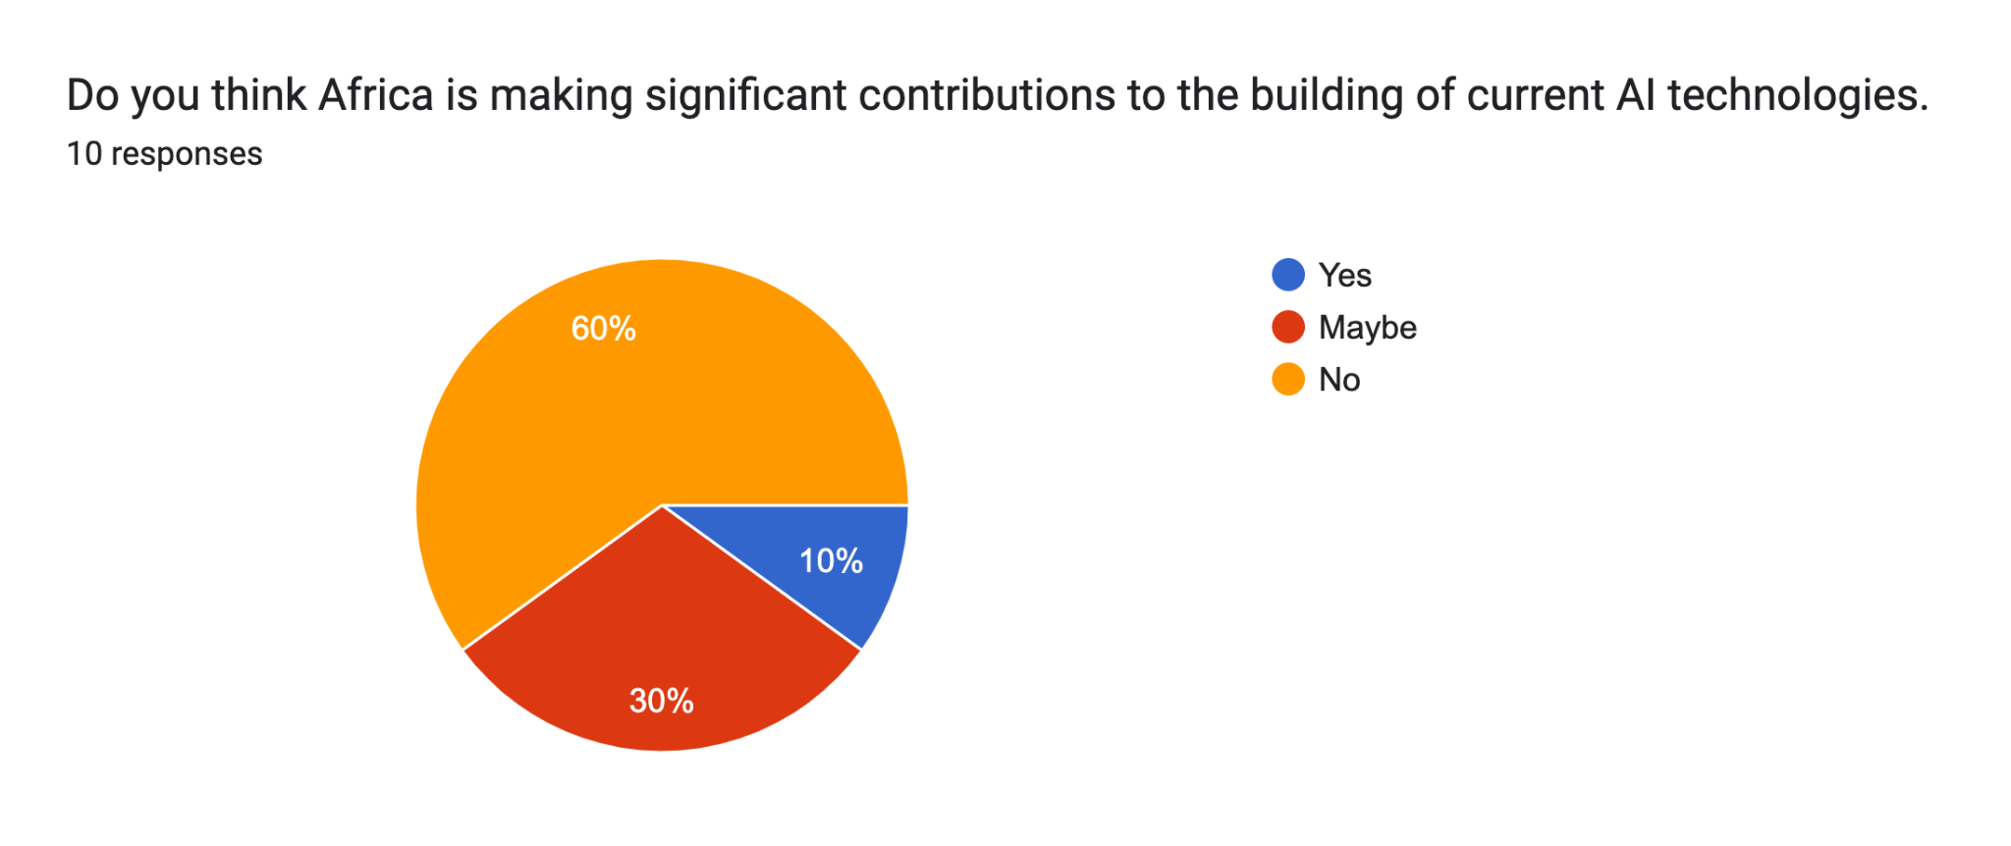

Fig 1. Expert responses to the question, “Do you think Africa is making significant contributions to the building of current AI technologies?”

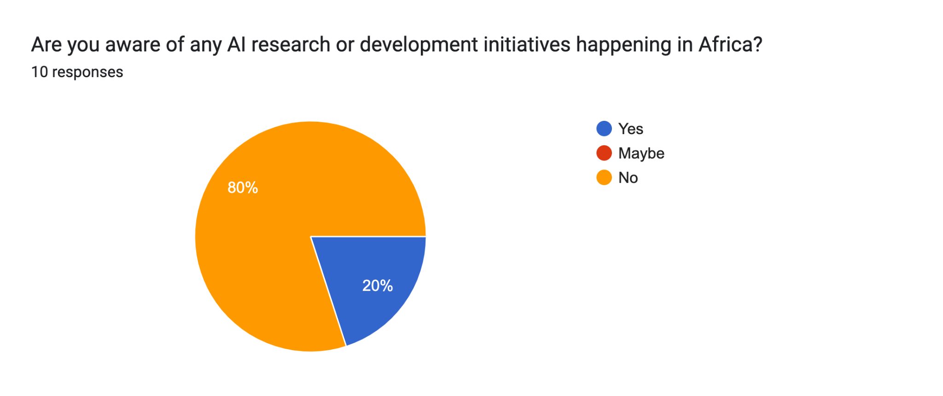

Fig 2. Expert responses to the question, “Are you aware of any AI research or development initiatives happening in Africa?”

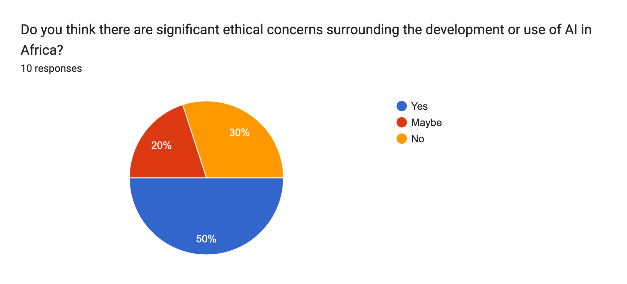

Fig 3. Expert responses to the question, “Do you think there are significant ethical concerns surrounding the development or use of AI in Africa?”

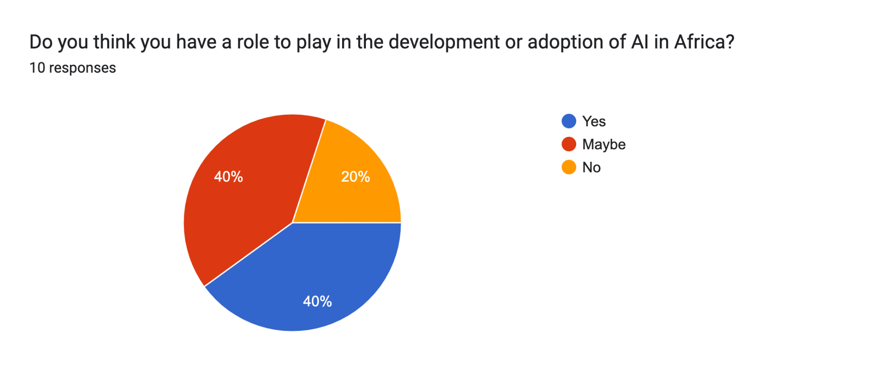

Fig 4. Expert responses to the question, “Do you think you have a role to play in the development or adoption of AI in Africa?”

Overall, the long-term ethical implications of AI in Africa were a key concern for many respondents. There was uncertainty about whether Africa's legacy of corruption would influence human capital investment in AI. There was also concern about the use of AI by students in schools, with some thinking that it might be used as a shortcut and replace genuine learning. Hence, respondents stressed the importance of AI literacy for students and teachers so that AI can be used as a learning aid without replacing instructors or leading to a decline in student critical thinking. They called for a balanced approach to maintain human involvement in education while also harnessing the power of AI to improve learning outcomes. Data was another key issue. Respondents highlighted that high-quality data collection and analysis would be prerequisites for AI development.

**Policy Implications and Recommendations**

Africa is on the verge of a technological revolution and has the potential to make a substantial contribution to the field of artificial intelligence (AI) worldwide. Africa can become a major participant in AI innovation by utilising its distinct assets, including a youthful population, cultural diversity, and unexplored market potential, if it receives sufficient funding and strategic assistance. Africa's potential remains largely untapped due to systemic challenges, including limited infrastructure, funding, and technical expertise (Nwokolo et al., 2023).

**For African Governments**

African governments can play a vital role in driving an AI revolution by prioritising investments in digital infrastructure and innovation. Enhancing the digital landscape through the provision of reliable high-speed internet connectivity is essential for creating an AI-friendly environment (Mienye et al., 2024). At the same time, integrating AI-focused curricula in schools will help develop a future workforce skilled in leveraging emerging technologies (Cardona et al., 2023). This training should extend to the existing workforce to ensure broad-based technological adaptation. Singapore has demonstrated a proactive approach in this regard, incorporating a fund in its 2024 budget to upskill and reskill its workforce, focusing on individuals aged 40 and above (Blockchain Council, 2024). Similarly, African governments can invest in lifelong learning initiatives to enhance domestic innovation and productivity, positioning their economies more competitively on the global stage (Cardona et al., 2023).

Beyond infrastructure and education, governments must actively cultivate an enabling environment for AI startups and broader innovation. Providing targeted incentives such as grants, incubation support, and mentorship programs can lower the barriers to entry for AI entrepreneurs (Brookings, 2025). Additionally, streamlining regulatory processes and reducing setup costs or tax burdens for emerging AI companies can further encourage investment and growth, thereby cultivating a thriving AI ecosystem (Deloitte, 2024).

**For International Stakeholders**

Investing in Africa’s AI ecosystem offers international stakeholders access to a rapidly expanding market with significant long-term potential. Given the relatively nascent stage of the industry and workforce, early investors stand to gain a first-mover advantage as the sector matures (World Bank, 2023). Additionally, Africa presents a unique set of challenges that demand innovative AI-driven solutions, which could, in turn, influence how existing technologies are adapted and applied in other regions.

Foreign direct investment in AI startups, research institutions, and innovation hubs can accelerate the continent’s technological development, transforming promising ideas into tangible solutions. Such investments will not only drive innovation but also allow stakeholders to harness the creativity and ingenuity of young African minds (Brookings, 2025).

In addition, knowledge transfer through collaborations with international partners is essential for capacity building. This can be achieved through specialised training, mentorship programs, and AI-focused exchange initiatives. Scholarships and fellowships designed to cultivate emerging talent will further ensure that the next generation of African professionals is fully equipped to contribute to and shape global AI advancement (Deloitte 2024).

**For Global AI Governance**

Global AI governance bodies must adopt a more inclusive approach that ensures African perspectives are actively integrated into global AI ethics and policy discussions. Leaders in Africa’s AI industry must have greater representation in forums where the future of AI governance is shaped, as policies crafted without consideration for Africa’s unique socio-economic and cultural realities risk being ineffective or even detrimental (UNDP, 2024). Meaningful participation will not only safeguard Africa’s interests but also facilitate the adoption of African-developed AI technologies in other regions where they may offer valuable solutions. Moreover, incorporating African voices into global AI discussions will help drive the democratisation of AI research and foster cross-border collaborations. This, in turn, will promote a more equitable distribution of AI resources and create a more balanced global AI ecosystem, ensuring that technological advancements benefit all regions rather than being concentrated in a few dominant markets (Seger at al., 2023).

Additionally, recognising the idiosyncrasies of Africa’s AI landscape is essential for developing policies that encourage innovation while maintaining ethical integrity. A one-size-fits-all regulatory framework risks exacerbating existing disparities in technological capabilities, as it may impose constraints that do not align with Africa’s infrastructure, market conditions, or developmental needs (Mienye et al., 2024). Instead, AI governance should adopt a flexible, context-driven approach that empowers African AI initiatives while upholding globally recognised ethical standards.

**Conclusion**

This paper has explored and highlighted Africa’s growing role in the global AI ecosystem, negating the conventional narrative that overlooks the continent’s potential. Through localised innovation and international collaboration, Africa is uniquely positioned to redefine the future AI landscape. The continent’s young workforce is an advantage for developing innovative solutions to critical socio-economic challenges, such as in the healthcare, agricultural, financial, and educational sectors.

Obstacles to Africa’s rise as an AI powerhouse include infrastructural deficits, limited access to connectivity and funding, and a shortage of skilled talent, amongst others. Experts have highlighted the need for improved education and increased awareness about AI, as well as ethical concerns that may arise with the proliferation of AI. However, these hurdles may be overcome by strategic investments by African governments and collaboration with international partners. African governments must prioritise the rapid investment in digital infrastructure, education, and cultivating an enabling environment for local AI startups. International stakeholders can also play a role by facilitating knowledge transfer and providing foreign direct investment to budding African companies.

Africa has the potential to create solutions that are not just at the cutting edge of technology but maintain cultural and social relevance, thus providing a unique perspective on solving global problems using AI. Future research could explore the specific ways in which these initiatives can be implemented, as well as their short and long-term impact on existing issues in Africa and the world.

**References**

Adu, J. A. (2024). The Diffusion and Reinvention of Information and Communication Technology in Africa: An Exploratory Study of Artificial Intelligence in Ghana and Kenya (Doctoral dissertation).

Alupo, C. D., Omeiza, D., & Vernon, D. (2022). Realizing the potential of ai in africa: It all turns on trust. In Towards Trustworthy Artificial Intelligent Systems (pp. 179-192). Cham: Springer International Publishing.

AI Saturdays Lagos. (2023). About AI Saturdays Lagos. Retrieved from <https://www.aisaturdayslagos.com>

AIMS. (2021). Artificial Intelligence for Development in Africa. African Institute for Mathematical Sciences. Retrieved from <https://aims.ac.za>

Asongu, S. A., & Nwachukwu, J. C. (2016). The role of governance in mobile phones for inclusive human development in Sub-Saharan Africa. Technovation, 55, 1-13.

Bal, R., & Gill, I. S. (2020). Policy approaches to artificial intelligence based technologies in China, European Union and the United States.

Blockchain Council (2024). Singapore to Train Employees Over 40 Years with AI Education. Retrieved from<https://www.blockchain-council.org/news/singapore-to-train-employees-over-40-years-with-ai-education/>

Brookings. (2025). Leveraging AI and emerging technologies to unlock Africa’s potential. Retrieved from<https://www.brookings.edu/articles/leveraging-ai-and-emerging-technologies-to-unlock-africas-potential/>

Brundage, M., Avin, S., Clark, J., Toner, H., Eckersley, P., Garfinkel, B., ... & Amodei, D. (2018). The malicious use of artificial intelligence: Forecasting, prevention, and mitigation. arXiv preprint arXiv:1802.07228.

Cardona, M. A., Rodríguez, R. J., & Ishmael, K. (2023). Artificial Intelligence and the Future of Teaching and Learning. Retrieved from <https://www.ed.gov/sites/ed/files/documents/ai-report/ai-report.pdf>

Data Science Nigeria. (2023). DSN BootCamp 2023 Covered By TechEconomy. Retrieved from <https://datasciencenigeria.org/dsn-bootcamp-2023-covered-by-techeconomy/>

Deloitte. (2024). AI for Inclusive Development in Africa – Part II: Data and Digital Infrastructure. Retrieved from <https://www2.deloitte.com/content/dam/Deloitte/us/Documents/public-sector/ai-adoption-in-africa-part-ii-data-and-infrastructure-2024-dec.pdf>

Doshi-Velez, F., & Kim, B. (2017). Towards a rigorous science of interpretable machine learning. arXiv preprint arXiv:1702.08608.

European Commission. (2020). Horizon 2020: The EU framework programme for research and innovation. Retrieved from <https://ec.europa.eu/programmes/horizon2020/>

European Commission. (2021). Proposal for a regulation laying down harmonized rules on artificial intelligence (Artificial Intelligence Act). Retrieved from <https://eur-lex.europa.eu/legal-content/EN/TXT/?uri=CELEX:52021PC0206>

Faluyi, S. E. (2025). AI and job market: Analysing the potential impact of AI on employment, skills, and job displacement.

Faluyi, S., & Mboga, J. (2025). Effective leadership in the 21st century: leveraging exemplary leadership models to achieve goals. International Journal of Complexity in Leadership and Management, 4(1), 65-82.

Feijóo, C., Kwon, Y., Bauer, J. M., Bohlin, E., Howell, B., Jain, R., ... & Xia, J. (2020). Harnessing artificial intelligence (AI) to increase wellbeing for all: The case for a new technology diplomacy. Telecommunications Policy, 44(6), 101988.

Floridi, L., Cowls, J., Beltrametti, M., Chatila, R., Chazerand, P., Dignum, V., ... & Vayena, E. (2018). AI4People—An ethical framework for a good AI society: Opportunities, risks, principles, and recommendations. Minds and Machines, 28(4), 689-707.

Grand View Research. (2021). Artificial intelligence market size, share & trends analysis report. Retrieved from <https://www.grandviewresearch.com/industry-analysis/artificial-intelligence-ai-market>

GSMA. (2022). The mobile economy: Sub-Saharan Africa 2022. Retrieved from <https://www.gsma.com/mobileeconomy/>

Guo, D., Yang, D., Zhang, H., Song, J., Zhang, R., Xu, R., ... & He, Y. (2025). Deepseek-r1: Incentivizing reasoning capability in llms via reinforcement learning. arXiv preprint arXiv:2501.12948.

Gupta, A., Thomas, B., Alsoubaie, F., Gadiraju, H., Patil, P., Daim, T. U., & Meissner, D. (2020). Internationalizing Google AI Research Google AI. Innovation Management in the Intelligent World: Cases and Tools, 55-66.

Han, S., Mao, H., & Dally, W. J. (2016). Deep compression: Compressing deep neural networks with pruning, trained quantization and Huffman coding. arXiv preprint arXiv:1510.00149.

Holmström, J. (2022). From AI to digital transformation: The AI readiness framework. Business Horizons, 65(3), 329-339.

ITU. (2021). Measuring digital development: Facts and figures 2021. International Telecommunication Union. Retrieved from <https://www.itu.int>

Jaiswal, A., Babu, A. R., Zadeh, M. Z., Banerjee, D., & Makedon, F. (2020). A survey on contrastive self-supervised learning. Technologies, 9(1), 2.

LeCun, Y., Bengio, Y., & Hinton, G. (2015). Deep learning. nature, 521(7553), 436-444.

Marsden, J., & Oduor Lungati, A. (2023). Ushahidi. In Evaluating Participatory Mapping Software (pp. 219-233). Cham: Springer International Publishing.

Marivate, V. (2020). Why African natural language processing now? A view from South Africa# AfricaNLP. Leap 4.0: African Perspectives on the Fourth Industrial Revolution, 126.

Mehrabi, N., Morstatter, F., Saxena, N., Lerman, K., & Galstyan, A. (2021). A survey on bias and fairness in machine learning. ACM computing surveys (CSUR), 54(6), 1-35.

Mienye, I. D., Sun, Y., & Ileberi, E. (2024). Artificial intelligence and sustainable development in Africa: A comprehensive review. Machine Learning with Applications, 18, 100591.

Ndung'u, N., & Signé, L. (2020). The Fourth Industrial Revolution and digitization will transform Africa into a global powerhouse.

Neumark, T., & Prince, R. J. (2021). Digital health in East Africa: innovation, experimentation and the market. Global Policy, 12, 65-74.

Nwokolo, S. C., Eyime, E. E., Obiwulu, A. U., & Ogbulezie, J. C. (2023). Africa's path to sustainability: harnessing technology, policy, and collaboration. Trends in Renewable Energy, 10(1), 98-131.

Obasi, S. N., Aa, T. V., Obasi, C. C., Jokthan, G. E., Adjei, E. A., & Keyagha, E. R. (2024). Harnessing Artificial Intelligence For Sustainable Agriculture: A Comprehensive Review Of African Applications In Spatial Analysis And Precision Agriculture.".

Seger, E., Ovadya, A., Siddarth, D., Garfinkel, B., & Dafoe, A. (2023). Democratising AI: Multiple Meanings, Goals, and Methods. Proceedings of the 2023 AAAI/ACM Conference on AI, Ethics, and Society, 715–722.

Satyanarayanan, M. (2017). The emergence of edge computing. Computer, 50(1), 30-39.

Shi, W., Cao, J., Zhang, Q., Li, Y., & Xu, L. (2016). Edge computing: Vision and challenges. IEEE Internet of Things Journal, 3(5), 637-646.

Stanford AI Index. (2022). Artificial intelligence index report 2022. Retrieved from <https://aiindex.stanford.edu/>

State Council of China. (2017). Next generation artificial intelligence development plan. Retrieved from <http://www.gov.cn/zhengce/content/2017-07/20/content_5211996.htm>

Tapscott, D., & Tapscott, A. (2017). Blockchain revolution: How the technology behind bitcoin is changing money, business, and the world. Penguin.

Topol, E. J. (2019). High-performance medicine: the convergence of human and artificial intelligence. Nature medicine, 25(1), 44-56.

UNDP. (2024). Equitable AI for Africa. Retrieved from<https://www.undp.org/blog/equitable-ai-africa>

Vaswani, A. (2017). Attention is all you need. Advances in Neural Information Processing Systems, 30, 5998-6008.

World Bank. (2023). Investing in Youth, Transforming Africa. Retrieved from<https://www.worldbank.org/en/news/feature/2023/06/27/investing-in-youth-transforming-afe-africa>

Zeng, J. (2020). Artificial intelligence and China's authoritarian governance. International Affairs, 96(6), 1441-1459.

Zuboff, S. (2019). The Age of Surveillance Capitalism: The Fight for a Human Future at the New Frontier of Power, edn. PublicAffairs, New York.

**Appendices**

Enter text here…