“Traffic Monitoring System Using Bolled Rolled Hydraulic Barriers”

Prof. Jagtap P.N*1, Prof. Dane M.A*2, Khaire Prajakta S*3, Pagar Ravina B*4, Magar Vishal S*5, Kolhe Mahesh G*6, Chaudhari Pravin R*7

1,2Associate Professor Department of Civil Engineering, Santosh N. Darade Polytechnic, Yeola (Maharashtra, India.

3, 4, 5 ,6 , 7 Students, Department Of Civil Engineering, Santosh N. Darade Polytechnic, Yeola (Maharashtra , India.

# ABSTRACT

Traffic congestion and unauthorized vehicle movement are significant challenges in urban areas and high security zones. To address these issues, this project presents a Traffic Monitoring System with a Bolled Rolled Hydraulic Barrier, designed to enhance traffic regulation and security management. The system integrates real-time traffic monitoring using sensors and cameras, ensuring efficient vehicle tracking and data collection. The bolled rolled hydraulic barrier serves as a dynamic access control mechanism, allowing or restricting vehicle entry based on predefined conditions such as traffic density, security clearance, or automated signals. The hydraulic mechanism ensures smooth and robust operation, making it suitable for high-traffic and high-security applications. Additionally, the system can be linked with automated control units, including RFID-based access, number plate recognition, or remote control operation. The combination of traffic monitoring and an intelligent barrier system improves safety, prevents unauthorized access, and optimizes traffic flow. This project aims to provide a cost- effective, durable, and scalable solution for modern traffic management, ensuring enhanced security and efficient urban mobility

**Keywords: - Traffic Monitoring System, Bolled Rolled Hydraulic Barrier, traffic management.**

# INTRODUCTION

With increasing urbanization and vehicular movement, efficient traffic management and security enforcement have become critical challenges. Traditional traffic control systems often struggle with congestion, unauthorized vehicle entry, and inefficient access control. To address these issues, this project introduces a Traffic Monitoring System with a Bolled Rolled Hydraulic Barrier, which combines real-time traffic monitoring with an automated hydraulic barrier to regulate vehicle flow and enhance security.The traffic monitoring system utilizes sensors and cameras to analyze vehicle movement, detect congestion, and manage traffic patterns. Simultaneously, the bolled rolled hydraulic barrier acts as a controlled entry mechanism, which can be raised or lowered based on predefined security or traffic conditions. The use of a hydraulic mechanism ensures durability, smooth operation, and high resistance against forceful vehicle entry, making it ideal for high-security zones, toll plazas, parking lots, and restricted areas.This system can be integrated with advanced technologies such as RFID, license plate recognition, or remote control operations, making it adaptable for various applications. By automating traffic control and improving access regulation, this project aims to enhance traffic efficiency, security, and safety in both urban and restricted environments.

# PROBLEM IDENTIFICATION

1. Rising accident rates.
2. Fuel wastage and pollution.
3. Increased stress for passengers and traffic police.
4. Negative psychological impact of traffic congestion.
5. Work delays due to traffic.
6. Violation of traffic rules leading to accidents.

# CURRENT SCENARIO OF TRAGGIC IN INDIA

1. Most people do not obey traffic rules because they have no fear of consequences.
2. Due to poor enforcement at traffic signals, people cross the roads without following the rules.
3. On highways, during crimes, criminals do not follow traffic rules. This contributes to the alarming statistic of one road accident-related death per minute in our country.
4. There are 53 road accidents every hour.

# RESEARCH GAP

After reviewing previous research papers, we analyzed that some studies have used image processing techniques to determine traffic density. In another study, cable barriers were employed to control traffic; however, their maintenance is costly due to soil upkeep, foundation damage, and repair expenses. One research paper proposed a flexible median divider made from a suitable polymer material to reduce accident risks at median dividers. However, it was found to be costly and overly flexible. Based on our study and analysis, we propose the use of an Automatic Traffic Barrier with Hydraulic Mechanism**.** This system will be integrated with traffic signals and a webcam. For emergency situations, such as allowing ambulances to pass, a manual switch will be included. When the traffic signal turns red, the barrier will automatically lift upward, and when the signal turns green, it will return to its original position. This system will help regulate traffic, reduce the number of accidents, and provide safety for pedestrians crossing during red signals.

# METHODOLOGY

1. **Traffic Volume and Flow Data** – Collection of input data related to traffic density, vehicle types, and movement patterns.
2. **Traffic Signal Cycle System** – Design and operation of signal timing, including green, yellow, and red light phases.
3. **Computerized Traffic Signal Design** – Software-based algorithms for optimizing traffic signal timing and coordination.
4. **Integration of Automatic Hydraulic Barrier with Algorithm** – Connectivity of automated barriers with intelligent control systems.
5. **Operation and Installation of Automatic Hydraulic Barriers** – Explanation of how hydraulic barriers work and their installation process.
   1. **Methods Used for Traffic Volume Count**
      1. Manual Method - This involves field personnel manually recording traffic data on prepared sheets based on the specific requirements of an intersection.
      2. Combination of Manual and Mechanical Method **-** This method integrates both manual and mechanical techniques. An example is the use of multiple pen recorders.
      3. Video Photography - Video recording provides a permanent record of traffic volume. The recorded footage can be analyzed later in an office setting by replaying the cassette or digital file on a monitor.
      4. Photographic Method - Time-lapse photography is used to determine vehicle speeds and traffic movement patterns in crowded areas.
   2. **Components Used**
      1. **Hydraulic actuator barriers** - Operate using pressurized hydraulic flui**d** to control barrier movement. When activated, hydraulic pressure moves a piston inside the actuator, raising or lowering the barrier. Single-acting **actuators** use hydraulic force for movement in one direction, with a spring or external force for return. Double- acting actuators apply hydraulic pressure in both directions for controlled motion.

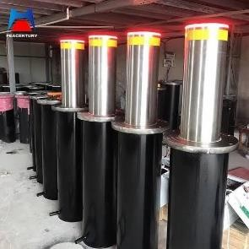

* + 1. **ATmega328P** - is an 8-bit microcontroller from the AVR family by Microchip (formerly Atmel). It is widely used in embedded systems and is the core of the Arduino Uno.

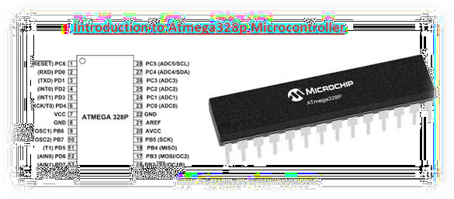

* + 1. **12 RPM Gear Mortor** - A 12RPM gear motor is a combination of an electric motor and a gear reduction system that reduces the motor's speed while increasing its torque. Electric Motor Operation: The motor converts electrical energy into mechanical rotation. It typically runs at a high speed (e.g., 1000-3000 RPM). Gear Reduction: The motor's output shaft is connected to a gearbox, which reduces the speed to 12 RPM while proportionally increasing the torque.

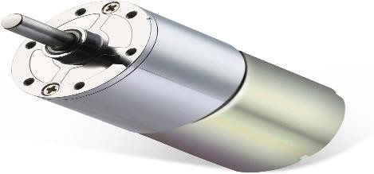

* + 1. **7-segment display** - **A** 7-segment display is an electronic display used to show decimal numbers and some letters. It consists of seven LED segments (labeled a to g) arranged in the shape of an "8" and sometimes includes a decimal point (DP)**.** By turning specific segments on or off, different numbers and characters can be displayed.

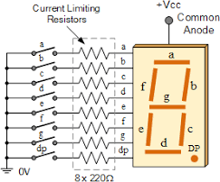

* + 1. **5. Atmega 328p -** The ATmega328P is an 8-bit AVR microcontroller widely used in embedded systems and Arduino boards. It operates at up to 20 MHz with 32 KB Flash, 2 KB SRAM, and 1 KB EEPROM. Powered by 5V (or 3.3V), it features 23 GPIO pins, 8 analog inputs (10-bit ADC), 6 PWM channels, and supports UART, SPI, and I2C communication. It works by executing instructions from Flash memory, using SRAM for temporary data, and EEPROM for non-volatile storage. It processes digital and analog inputs, controls outputs, manages tasks via timers and interrupts, and communicates with peripherals. Applications include robotics, IoT, motor control, and sensor interfacing.

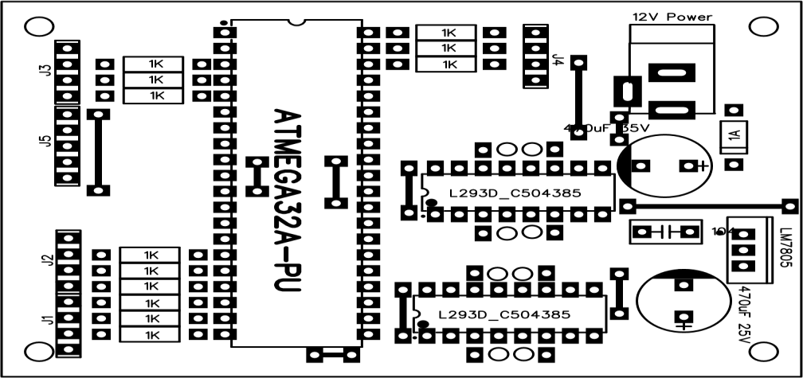

* 1. **Computerized Traffic Signal Design**

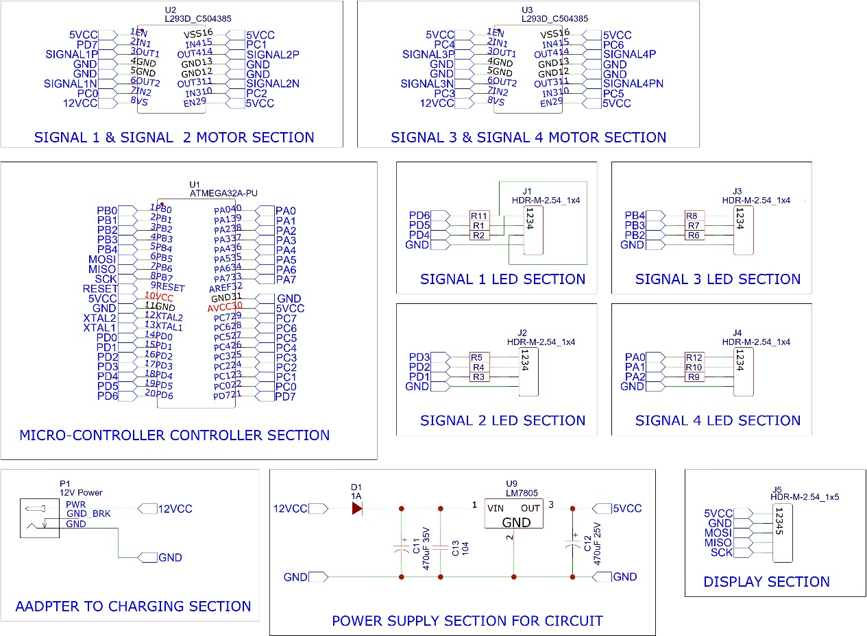

* 1. 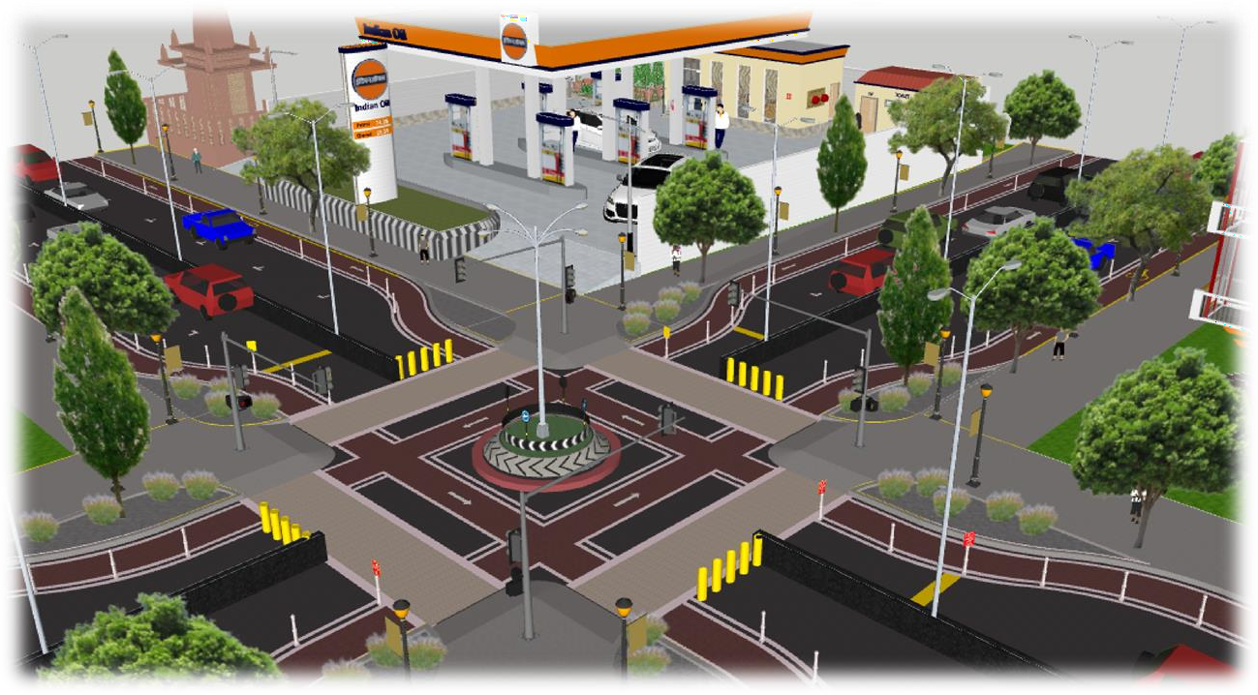**Model Diagram Of Traffic Signal With Hydraulic Actuator**

# CONCLUSION

The deployment of an automated movable road barrier presents an efficient approach that leverages computer vision to monitor roadways and regulate traffic. By utilizing a camera or an appropriate IoT sensor, the system detects the vehicle count in each lane and determines the positioning and operational state of the barrier accordingly. This mechanism helps mitigate traffic congestion caused by uneven vehicle distribution or excessive traffic flow during peak hours. The current study focuses on analyzing car densities exclusively; however, future improvements can expand its capability to detect various types of vehicles and optimize traffic management. A custom algorithm is developed to control automatic hydraulic barriers based on predefined signal timing configurations. Additionally, a prototype model has been constructed to simulate real-world traffic flow scenarios across multiple lanes.Hydraulic barriers play a crucial role in reinforcing traffic regulations, ensuring controlled movement, and improving road safety. Hence, the proposed system is particularly beneficial at high-risk intersections, where accidents frequently occur, by providing enhanced traffic regulation and safety measures.

# ACKNOWLEDGMENT

This research has been made possible through the generous support and assistance of numerous individuals, and we would like to extend our heartfelt appreciation to all of them.Above all, we dedicate this achievement to God Almighty, whose wisdom, strength, serenity, and good health enabled us to successfully complete this study. We sincerely thank our families for their unwavering encouragement, which played a crucial role in the successful completion of this research. We are profoundly grateful to Snatosh N Darade polytechnic Babhulgaon (423401) , the Department of Civil Engineering, and the Head of the Department, along with the esteemed faculty members, for their continuous guidance, insightful supervision, and for equipping us with essential knowledge and resources throughout this study. Their invaluable support has been instrumental in bringing this endeavor to fruition. Our deepest gratitude extends to our mentor, Prof.Jagtap P.N, for generously sharing his expertise, wisdom, and mentorship, which greatly enriched our work. We also wish to acknowledge and express our appreciation to our colleagues Prof. Kolhe Swati.N, Prof. Dane Mayuri.A, along with everyone who has willingly contributed their skills and assistance towards this research. This project would not have been possible without the collective efforts and contributions of all those mentioned.

# REFERENCES

1. J. P. Quittner, “Transferable roadway lane divider,” Nov. 25 1986, uS Patent 4,624,601.
2. R. E. Wasley, “Movable traffic line,” Apr. 12 1966, uS Patent 3,245,327.
3. V. Ferrari, “Apparatus and method for moving roadway lane dividers,” May 25 1976, uS Patent 3,958,890.
4. M. Bigni, “Road barrier with pivotable span joints,” Jun. 3 1969, uS Patent 3,447,786.
5. F. D. Mahoney, “Movable traffic barrier,” Jul. 9 1968, uS Patent 3,391,620.
6. G. W. Peppel, “Low maintenance crash barrier for a road divider,” Jun. 8 1993, uS Patent 5,217,318.
7. Z. Jan, B. Verma, J. Affum, S. Atabak, and L. Moir, “A convolutional neural network based deep learning technique for identifying road attributes,” in 2018 International Conference on Image and Vision

**AUTHORS PROFILES**

* 1.** 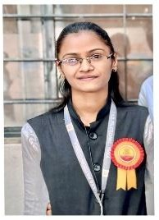) Prof. Jagtap Pradnya.N** Associate Professor in Department of Civil Engineering. Pursuing research in the field of Heat and Mass transfer. Having more than 6 years of teaching experience in Civil Engineering. Published more than 4 papers in International Conference and Journals. Contact: [jagtappradnya71@gmail.com](mailto:jagtappradnya71@gmail.com)
  2.** 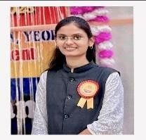) Prof. Dane Mayuri.A** Associate Professor in Department of Civil Engineering. Pursuing research in the field of Heat and Mass transfer. Having more than 5 years of teaching experience in Civil Engineering. Published more than 2 papers in International Conference and Journals. Contact: [Mayuridane2000@gmail.com](mailto:Mayuridane2000@gmail.com)
  3. **) Mr. Magar Vishal.S ,** currently pursuing Final year of Civil Engineering at Santosh N Darade Polytechnic, Babhulgaon ,Yeola India. Has presented papers at many National level symposium and seminars. Research interest includes designing system of traffic monitoring system using bolled rolled hydraulic steel barriers etc.

Contact: [vishalmagar2005@gmail.com](mailto:vishalmagar2005@gmail.com)

* 1.** 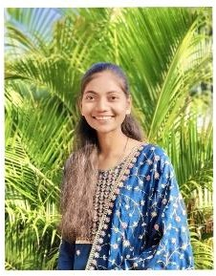) Miss. Pagar Ravina.B ,** currently pursuing Final year of Civil Engineering at Santosh N Darade Polytechnic, Babhulgaon ,Yeola India. Has presented papers at many National level symposium and seminars. Research interest includes designing system of traffic monitoring system using bolled rolled hydraulic steel barriers etc.

Contact: [ravinapagar244@gmail.com](mailto:ravinapagar244@gmail.com)

* 1. **) Miss. Khaire Prajakta.S ,** currently pursuing Final year of Civil Engineering at Santosh N Darade Polytechnic, Babhulgaon ,Yeola India. Has presented papers at many National level symposium and seminars. Research interest includes designing system of traffic monitoring system using bolled rolled hydraulic steel barriers etc.

Contact: [prajaktakhaire1113@gmail.com](mailto:prajaktakhaire1113@gmail.com)

* 1. **) Mr. Chaudhari Pravin.R ,** currently pursuing Final year of Civil Engineering at Santosh N Darade Polytechnic, Babhulgaon ,Yeola India. Has presented papers at many National level symposium and seminars.

Contact: [chaudhari pravin546@ gmail .com](mailto:chaudharipravin546@gmail.com)

* 1. **) Mr. Kolhe Mahesh.G ,** currently pursuing Final year of Civil Engineering at Santosh N Darade Polytechnic, Babhulgaon ,Yeola India. Has presented papers at many National level symposium and seminars.

Contact: [Maheshkolhe402@gmail.com](mailto:Maheshkolhe402@gmail.com)