**BOREWELL RESCUING SYSTEM USING ARDUINO**

# Ajay Kumar Bhupathi*1, Kagitha Naga Jyothsna*2, Golla Tharuna Sree*3, Gorji Eswar Avinash*4, Kanukollu Jyostna Rama Lakshmi*5

*1,2,3,4,5Seshadri Rao Gudlavalleru Engineering College, India.

# ABSTRACT

Borewell accidents, where children fall into open or abandoned borewells, pose significant rescue challenges. Traditional rescue methods, such as manual digging, are time-consuming, labor-intensive, and often inefficient, leading to delayed and sometimes unsuccessful rescue operations. The risk of injury or fatality increases with prolonged entrapment due to factors like restricted oxygen levels, exposure to harmful gases, and unstable borewell walls. This project introduces a smart borewell rescue system incorporating real-time video streaming, environmental monitoring, and robotic gripping mechanisms to enhance rescue efficiency and ensure safety.

The system employs an ESP32 camera to provide live video streaming, allowing rescuers to assess the trapped child's condition remotely. Various sensors, including a PIR motionsensor, gas sensor (MQ Series), and DHT11 sensor, continuously monitor movement, hazardous gas levels, temperature, and humidity inside the borewell. A robotic gripper controlled by a DCmotor and pulley mechanism is used to secure and lift the child safely. The entire system is remotely operated via switches, reducing human intervention and minimizing associated risks. Additionally, ThingSpeak cloud integration enables real-time data transmission, allowing authorities to monitor rescue parameters and make informed decisions.

This innovative approach ensures faster, safer, and more precise borewell rescues compared to traditional methods. The automation reduces response time, while IoT-based monitoring enhances situational awareness. The proposed system's adaptability makes it suitable for various confined-space rescues, disaster response operations, and hazardous environment monitoring. Future enhancements may include AI-driven gripping optimization, thermal imaging for low-light conditions, and extended battery backup for prolonged rescue efforts. This project highlights the transformative potential of IoT and robotics in life-saving operations, making borewell rescues more efficient, reliable, and scalable.

**Keywords:** Borewell Rescue, IoT, ESP32, Robotic Gripper, ThingSpeak, Environmental Monitoring.

# INTRODUCTION

Borewells are narrow and deep holes drilled into the ground for water extraction. Over time, many borewells are abandoned without proper sealing, creating hazardous open pits that pose serious risks, especially to children. Due to their small size, children can accidentally fall into these borewells, leading to life-threatening situations. The increasing number of borewell accidents has raised serious concerns about the safety of rural and semi-urban areas where borewells are commonly used. In most cases, children who fall into these wells become trapped due to the narrow space, making rescue operations extremely challenging. The confined environment of the borewell restricts movement, ventilation, and visibility, making traditional rescue attempts difficult and time-consuming. Existing borewell rescue methods rely primarily on manual labor, where a parallel pit is dug to reach the trapped child. This method is highly inefficient, as it requires significant manpower, heavy machinery, and prolonged excavation, increasing the risk to both the child and rescue personnel. Furthermore, structural collapses during digging operations can worsen the situation and make the rescue even more dangerous.

One of the biggest challenges in borewell rescues is the **lack of real-time monitoring** inside the well. Rescuers often struggle to assess the exact condition of the child and the surrounding environment, leading to delayed decision-making and ineffective strategies. The absence of real-time data on oxygen levels, temperature, and gas concentrations further complicates rescue efforts, increasing the chances of fatal outcomes. The development of **technologically advanced borewell rescue systems** is essential to overcome these challenges. Innovations in **robotics, IoT (Internet of Things), and automation** have enabled the creation of smart rescue systems that can provide **real-time monitoring, precise control, and remote operation**. By integrating robotic mechanisms and advanced sensor networks, modern borewell rescue systems can significantly improve efficiency and success rates. The **Internet of Things (IoT)** plays a crucial role in improving borewell rescue operations by enabling remote monitoring and automated decision-making. With IoT-enabled sensors, critical parameters such as temperature, humidity, gas levels, and child movement can be monitored in real time, allowing for better coordination and faster response. Robotics is another key component in modern borewell rescue systems. The use of **robotic arms with precision gripping mechanisms** ensures safe retrieval without causing additional harm to the child. These robotic systems can be operated remotely, eliminating the need for manual intervention in dangerous conditions. Additionally, **AI-driven automation** can enhance the decision-making process by analyzing environmental data and optimizing rescue strategies. The integration of **live video streaming technology**, such as the **ESP32 camera module**, provides rescuers with a clear real-time view of the child’s condition. This helps in making informed decisions, improving communication between rescue teams, and reducing uncertainties during operations. Additionally, **infrared or night vision cameras** can be implemented to enhance visibility in dark environments. Incorporating **cloud-based data transmission** using platforms like **ThingSpeak** allows rescue teams to access real-time data from remote locations. This data-driven approach ensures that multiple experts can collaborate and provide guidance without being physically present at the site, enhancing decision-making efficiency and response times. Safety measures, such as **automated gas detection and ventilation control**, can be integrated into borewell rescue systems to prevent suffocation risks. **Gas sensors (MQ Series)** help detect the presence of toxic gases, allowing rescuers to introduce fresh air or deploy oxygen masks to ensure the safety of the trapped child. The application of **AI and machine learning** in borewell rescue operations can further optimize response strategies. By analysing past rescue attempts and environmental conditions, AI algorithms can predict potential hazards, recommend the best rescue approaches, and automate critical decision-making processes. In conclusion, the **advancement of IoT, robotics, and AI-driven automation** presents a revolutionary approach to borewell rescues. By leveraging these technologies, we can overcome the limitations of traditional rescue methods, ensuring faster, safer, and more efficient operations. This paper explores the design, implementation, and impact of a **smart borewell rescue system**, highlighting its potential to save lives and prevent future accidents.

# EXISTING SYSTEM & DRAWBACKS

Rescuing children from borewells is traditionally performed through manual operations, which involve digging parallel pits and tunnels to reach the trapped victim. This process is time-consuming, labor-intensive, and often leads to delayed rescue efforts, reducing the chances of survival. The existing system has several major drawbacks:

* **Time Consumption:** The manual digging process can take several hours or even days, significantly delaying rescue operations. Prolonged exposure in the borewell can be fatal for the trapped child, especially in extreme weather conditions.
* **Limited Monitoring:** Traditional methods lack real-time monitoring tools, making it difficult to assess the child’s condition. Rescuers rely on guesswork and rudimentary tools, reducing the efficiency and precision of the operation.
* **High Risk to Rescuers:** Manual operations expose rescue personnel to dangers such as tunnel collapses and toxic gases. The instability of the borewell walls poses an additional threat, increasing the likelihood of accidents during the rescue process.
* **Inefficient Rescue Mechanisms:** Conventional gripping tools used in manual rescues may not securely hold the trapped child, increasing the risk of injury during extraction. The inability to adjust gripping force dynamically further complicates the process.
* **Lack of Automation:** The absence of automated tools and robotic intervention leads to dependency on human rescuers, slowing down the response time and reducing accuracy. Manually controlled rescue systems lack precision in critical situations.
* **Inaccurate Positioning:** Traditional borewell rescue attempts struggle with precisely locating and positioning the rescue equipment. The inability to control descent and retrieval mechanisms accurately often results in failed operations or delays.
* **Limited Communication:** In most cases, there is no way to communicate with the trapped child, increasing fear and anxiety. The absence of a two-way communication system prevents rescuers from assessing the child’s mental and physical condition in real time.

These limitations highlight the urgent need for a **smart, automated rescue system** that integrates real-time video streaming, IoT-based monitoring, and robotic assistance to enhance efficiency and safety. By incorporating advanced sensors, automated gripping mechanisms, and remote-controlled operations, the proposed system aims to **overcome these drawbacks** and significantly improve the effectiveness of borewell rescues.

# PROPOSED SYSTEM

The proposed system integrates IoT and robotic mechanisms to facilitate efficient rescue operations. It consists of:

* **ESP32 Camera:** Provides real-time video streaming for monitoring, allowing rescuers to assess the situation inside the borewell accurately. Future versions could include night vision or infrared cameras for low-light conditions.
* **PIR Motion Sensor:** Detects movement inside the borewell, confirming the trapped child's status and movements. This ensures real-time tracking of the child’s well-being.
* **Gas Sensor (MQ Series):** Monitors hazardous gas levels to ensure a safe rescue operation. It detects gases such as carbon dioxide, methane, and oxygen levels, which are critical for maintaining a safe environment during the rescue.
* **DHT11 Sensor:** Measures temperature and humidity, providing essential environmental data to aid in the decision-making process. High temperatures or humidity changes can indicate unstable conditions that require immediate attention.
* **Robotic Gripper & Pulley Mechanism:** A robotic arm equipped with a gripper mechanism is used to secure and lift the trapped child safely. The gripper is designed with soft, adjustable grips to prevent injury and provide a firm hold during retrieval.
* **Switch-Controlled Operation:** The system is operated via switches, enabling remote control of the gripper mechanism and pulley movement to precisely position the gripper inside the borewell. This reduces manual errors and ensures safety.
* **ThingSpeak Cloud Integration:** The entire sensor data set is transmitted to the ThingSpeak cloud platform, allowing real-time monitoring and remote access to rescue parameters. This enables coordinated rescue efforts and real-time analysis.
* **Microcontroller-Based Automation:** The system is powered by a microcontroller programmed to process sensor inputs and control the robotic mechanism efficiently. This automation reduces human intervention and improves accuracy.
* **Real-Time Alerts & Data Logging:** The system logs critical parameters such as gas levels, temperature, and child movement, ensuring data-driven decision-making for the rescue team. The stored data can also help improve future rescue strategies.
* **Battery Backup System:** A rechargeable battery pack is integrated into the system to ensure continuous operation even in remote areas with limited power supply. This feature is crucial for rescue operations in locations where electricity is unreliable.
* **Two-Way Communication System:** A microphone and speaker module can be included to enable communication between the trapped child and rescuers. This allows the child to receive instructions and reassurance while aiding in situation assessment.

This IoT-based robotic system provides a reliable, efficient, and technologically advanced approach to borewell rescue operations, significantly improving the success rate and ensuring the safety of both the trapped individual and the rescue team.

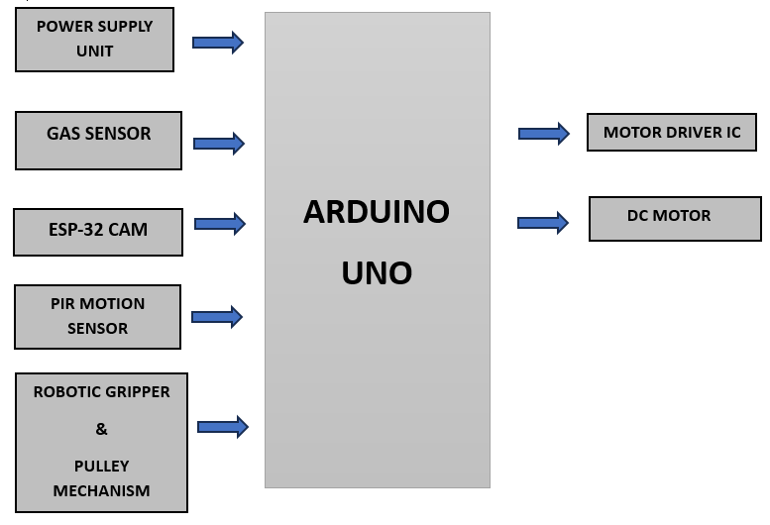

**Figure 1:** Block Diagram of Proposed System

The system follows a structured process to ensure an effective and systematic approach to borewell rescue operations:

1. **System Initialization:** The ESP32 camera is activated, initiating live video streaming while sensors such as PIR, gas, and DHT11 begin collecting environmental data. This ensures immediate situational awareness before proceeding with the rescue.
2. **Environmental Monitoring:** The system continuously tracks motion using the PIR sensor, detects hazardous gases like methane and carbon dioxide, and measures temperature and humidity levels inside the borewell. This data is analyzed in real-time to assist rescuers in making informed decisions.
3. **Rescue Operation:** The robotic gripper, mounted on a motorized pulley mechanism, is carefully lowered into the borewell. The live video feed enables precise positioning of the gripper, ensuring the trapped child or object is safely secured without causing harm.
4. **Secure Lifting:** Once the robotic gripper successfully grips the child or object, it gently lifts them towards the surface. The system’s automated control ensures minimal physical strain and reduces the chances of sudden movement that could endanger the rescue effort.
5. **Data Transmission:** The entire process is monitored remotely, with sensor data and live video streaming uploaded to the ThingSpeak cloud platform. This enables real-time monitoring by rescue teams and authorities for better coordination and decision-making.
6. **Rescue Completion:** After safely retrieving the child, the system powers down, logging the final rescue data for analysis and future improvements. The collected data can be used for refining rescue techniques, enhancing safety protocols, and improving response efficiency in similar scenarios.

# This structured and automated approach significantly reduces human dependency while increasing the efficiency, accuracy, and success rates of borewell rescue operations. The use of IoT and robotics ensures timely response, reduces physical risks to rescuers, and enhances monitoring capabilities, making it a more reliable alternative to traditional manual rescue methods.

# HARDWARE/SOFTWARE DETAILS

Hardware

1. ESP32 camera module.
2. PIR motion sensor.
3. Gas sensor (MQ series).
4. DHT11 temperature and humidity sensor.
5. DC motor with pulley mechanism.
6. Robotic gripper.
7. Switches for control.
8. Power supply.

Software

1. Arduino IDE for programming.
2. ThingSpeak platform for IoT monitoring.
3. Mobile app for live video feed and sensor data.

# RESULTS & DISCUSSIONS

The borewell rescue system was tested in a simulated environment, where it successfully demonstrated efficient monitoring, precise gripping, and controlled lifting. The integration of IoT and robotics significantly reduced response time and increased accuracy in identifying and extracting the trapped child.

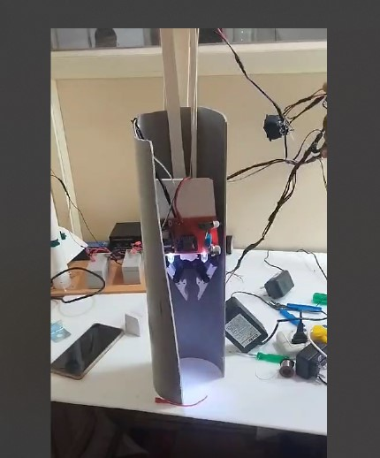

**Figure 2A**: Robotic System with Gripper Mechanism

* **Real-time monitoring:** Itwas achieved through the ESP32 camera, which provided a clear video feed, allowing precise positioning of the robotic gripper. To improve visibility in low-light conditions, future implementations could integrate night vision or infrared cameras for enhanced image clarity.
* **Sensor performance:** It was a critical aspect of the system, as gas sensors successfully detected harmful gases such as carbon dioxide, methane, and oxygen levels. These sensors provided real-time feedback on environmental conditions inside the borewell. Additionally, temperature and humidity sensors played a crucial role in assessing heat and moisture levels, helping rescuers make informed decisions regarding the trapped individual's safety.
* **Rescue efficiency:** It was significantly improved due to the robotic gripping mechanism, which securely held and lifted objects of varying sizes, simulating the safe retrieval of a child from a borewell. The automated descent and retrieval process minimized response time compared to traditional manual digging methods. This aspect of the system was particularly beneficial in reducing physical strain on rescue personnel while ensuring a more precise and controlled rescue operation.
* **Reliable power supply**: for remote areas was ensured through the integration of a battery backup system, allowing uninterrupted operation even in rural locations with limited electricity access. The system-maintained functionality for several hours, ensuring extended rescue efforts when needed. This feature is crucial in emergencies where access to stable power sources may be unavailable.

Future considerations for enhancing the system include additional testing in real-life scenarios to further validate system robustness. The incorporation of thermal imaging cameras would enhance the ability to detect body heat, providing rescuers with a clearer view of the trapped individual’s condition. Moreover, AI-driven gripping optimization could improve precision and adaptability, allowing the robotic arm to adjust its grip based on real-time object recognition and force analysis. These advancements will contribute to making the

system even more efficient, accurate, and reliable in complex rescue missions.

The real-time data collected from the borewell rescue monitoring system is visualized through ThingSpeak. The recorded parameters include temperature, humidity, motion detection (PIR sensor), and gas concentration levels. Below are the graphical representations of these parameters:

**1. Temperature and Humidity:**

The temperature readings fluctuated between 26.0°C and 30.0°C, while humidity varied between 43% and 52%. These values indicate environmental conditions within the borewell, crucial for assessing the safety of a trapped individual.

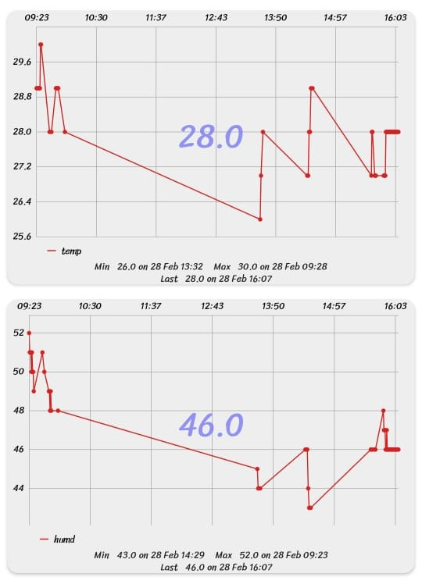

**Figure 2B:** Temperature Variation and Humidity Levels Over Time

**2. PIR Motion Detection and Gas Concentration:**

The PIR sensor primarily remained at a value of 1.0, indicating motion detection. Meanwhile, gas concentration fluctuated between 69 and 172 units, which suggests varying air quality inside the borewell. High gas levels could pose a threat and require immediate intervention.

These graphs provide a clear analysis of environmental conditions, aiding in decision-making for rescue operations. Future enhancements could include integrating alarm systems to alert rescue teams when critical thresholds are exceeded.

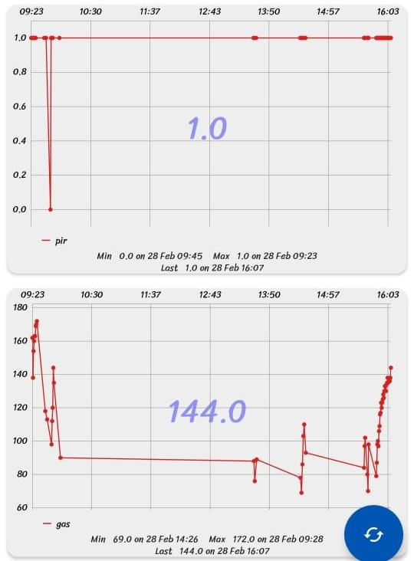

**Figure 2C:** PIR Motion Detection Data and Gas Concentration Levels Over Time

1. **SCOPE**

The scope of the borewell rescue system extends beyond child rescue operations and encompasses various domains. In disaster management, it can be employed in earthquake-affected areas, collapsed buildings, and mining accidents to assist in locating and retrieving trapped individuals. The system’s ability to detect hazardous gases, monitor environmental conditions, and provide real-time video feeds makes it an essential tool for emergency response teams. Additionally, this system has significant applications in industrial safety. Many workers operate in confined spaces such as underground tunnels, pipelines, and chemical plants where toxic gas leaks and accidents pose serious threats. Deploying an IoT-enabled robotic rescue system in such environments ensures worker safety by monitoring critical conditions and providing timely alerts to prevent fatalities. Military applications also present a vital area where this technology can be utilized. In war zones or remote locations with difficult terrains, conventional human-led rescue operations are often too dangerous. The integration of AI-driven autonomous rescue bots equipped with infrared and night vision cameras can aid in locating and rescuing soldiers trapped in battle zones or harsh environments, improving survival rates in combat situations. In agriculture, borewell safety remains a pressing concern in rural areas. Open and abandoned borewells frequently cause fatal accidents, especially for children and livestock. This system can be adapted to monitor borewells and detect movements in real time, allowing authorities to take preventive measures before accidents occur. Additionally, it can be integrated with automated borewell sealing mechanisms to enhance rural safety initiatives. Looking towards the future, advancements in artificial intelligence and machine learning can make this system more autonomous and intelligent. Features such as self-learning navigation, obstacle detection, and predictive analytics can improve rescue efficiency. Furthermore, adapting this system for underwater and space exploration missions could lead to breakthroughs in retrieving objects or individuals in extreme environments. This project lays the foundation for broader applications in diverse fields, ensuring enhanced safety, efficiency, and reliability in rescue operations.

1. **CONCLUSION**

The smart borewell rescue system presents a significant advancement over traditional rescue methods by integrating IoT, robotics, and real-time monitoring. The implementation of real-time video streaming, environmental sensors, and a robotic gripper significantly improves the efficiency and safety of borewell rescues. The system minimizes manual intervention, reduces response time, and enhances situational awareness for rescuers. One of the key strengths of this system is its scalability and adaptability, making it suitable for deployment in various terrains and borewell structures. The battery backup system enhances its reliability, ensuring continuous operation even in remote and power-scarce regions where rescue efforts are often delayed due to infrastructural challenges. Additionally, its semi-automated design reduces the need for extensive human intervention, allowing authorities to deploy it with minimal training and setup time. By leveraging IoT and cloud-based monitoring, the system enables real-time data transmission, allowing for informed decision-making during rescue operations. Additionally, the integration of a robotic gripping mechanism ensures a secure and controlled retrieval process, minimizing potential injuries to the trapped individual. The battery backup system further enhances its reliability, making it suitable for remote and rural applications where power sources are limited.

Future developments may include AI-driven automation to improve precision in gripping and lifting, enhanced environmental sensors for better hazard detection, and machine learning models to predict risks and optimize rescue strategies. The addition of thermal imaging cameras could further improve visibility in challenging conditions. Moreover, refining the system’s mechanical components for increased flexibility and adaptability will further enhance its effectiveness. This project serves as a crucial step towards making borewell rescues more efficient, safer, and technologically advanced, ultimately reducing casualties and improving rescue success rates. With further refinements and real-world testing, this system has the potential to become a standard solution for borewell rescue operations worldwide.

1. **REFERENCES**
2. Manjunatha, R., Patel, J.A., Reddy, I.H.S., Reddy, P.S.P. and Afrin, U., 2023. Design and implementation of child rescue system in open borewell using IOT. International Research Journal of Modernization in Engineering Technology and Science, 5(7), pp.928- 933.
3. Veena, S., Gali Jaswanth Reddy, K. G. Shruthi, and M. Snayani. "Child rescue system from open borewells using flap folding mechanism." International Journal of Advanced Research in Computer and Communication Engineering 12, no. 5 (2023).
4. R. T. Charulatha, S. Priyadharshini, V. Sujatha, R. Sabitha and M. Dinesh, "A Novel Implementation of an IoT Powered Open Borewell Child Rescue System using ESP8266 and Logical Sensors Association," 2024 International Conference on Advances in Computing, Communication and Applied Informatics (ACCAI), Chennai, India, 2024, pp.1-6,doi:10.1109/ACCAI61061.2024.10601878.keywords: {Gases;Microcontrollers;Zigbee;Robotsensingsystems;Controlsystems;Transceivers;Sensors;Internet of Things;IoT;Open Borewell;Child Rescue;NodeMCU;ESP8266;Logical Sensors;IoTBCR;ZigBee;ZBCR},
5. "Smart Borewell Rescue and Monitoring System Using Arduino" by [2023 4th International Conference on Smart Electronics and Communication (ICOSEC)](https://ieeexplore.ieee.org/xpl/conhome/10275782/proceeding).
6. "Child Rescue System from Open Borewell using Robot" by [2022 4th International Conference on Inventive Research in Computing Applications (ICIRCA)](https://ieeexplore.ieee.org/xpl/conhome/9985450/proceeding).
7. "IoT-based Child Rescue System from Borewell" by [2022 6th International Conference on Electronics, Communication and Aerospace Technology](https://ieeexplore.ieee.org/xpl/conhome/10009019/proceeding).