Secured And Decentralized E-Voting System Using Blockchain

J. Bhargavi

*Assistant Professor*

*CSE-AI&ML Dept*

ACE Engineering College Hyderabad, India

D. Ganesh, Student

*CSE-AI&ML*

ACE Engineering College Hyderabad, India

R. Naveena, Student

*CSE-AI&ML*

ACE Engineering College Hyderabad, India

G.Gowtham Raju, Student

*CSE-AI&ML*

ACE Engineering College Hyderabad, India

## **ABSTRACT**:

Recently, the need for a secure and effective voting framework has become progressively basic. Conventional voting strategies, whether paper-based or electronic, confront various challenges, including voter extortion, and information control. This paper proposes a Computerized Voting Framework leveraging Blockchain Innovation to address these issues. Blockchain, as a decentralized and tamper-proof record, guarantees that votes are recorded safely without manipulation. Each vote is treated as an exchange and is confirmed through an agreement instrument, dispensing with the chance of false exercises. This framework also upgrades voter namelessness while keeping up the judgment of the race handle. The utilization of smart contracts computerizes vote checking and result arrangement, diminishing human mediation and mistakes. By actualizing blockchain in voting, the framework gives real-time reviewing capabilities, boosting open belief within the discretionary handle. This innovation not only guarantees the security of voter information but also encourages inaccessible voting, expanding openness for voters. The proposed framework has the potential to revolutionize the way decisions are conducted, making them more secure, productive, and cost-effective.

## .

**Keywords**: Blockchain, Digital Voting, Security, Smart Contracts, Decentralization.

1. **INTRODUCTION**

Elections are an essential portion of democratic societies, but traditional voting systems frequently confront issues like the need for transparency, voter extortion, and inefficiencies. Blockchain innovation, particularly through stages like Ethereum, offers an arrangement by giving a secure, decentralized, and transparent voting framework.

Ethereum empowers the utilization of smart contracts to computerize key forms such as voter enlistment, vote casting, and result counting. Each vote is recorded as an immutable transaction, guaranteeing security, voter secrecy, and real-time inspecting. This framework makes strides in availability, allowing remote voting, and has the potential to revolutionize elections by making them more secure, proficient, and reliable.

Elections serve as a fundamental pillar of vote vote-based system, empowering citizens to specify their choices reasonably and transparently. Be that as it may, traditional voting methods, counting paper votes, and electronic voting machines (EVMs), confront various security and operational challenges. Issues such as vote altering, extortion, the need for transparency, and wasteful vote tallying have raised concerns about the reliability of existing frameworks. Indeed online voting stages, despite advertising convenience, are defenseless to cyber threats, centralization risks, and potential manipulation.

Blockchain innovation offers a progressive approach to advanced voting by giving a tamper-proof, decentralized, and transparent framework. Unlike centralized systems, blockchain guarantees that each vote is safely recorded, scrambled, and permanent, decreasing the dangers of unauthorized modifications. By utilizing smart contracts, cryptographic confirmation, and agreement mechanisms, blockchain-based voting dispenses with the requirement for third-party intermediaries while enhancing voter belief and election security. This paper introduces a Digital Voting System Using Blockchain Innovation, planned to handle basic concerns such as voter verification, transparency, vote integrity, and security. The proposed framework incorporates the following key features:

Secure voter authentication utilizing cryptographic verification strategies. Immutable vote recording on a decentralized blockchain record. Real-time vote examining and confirmation to enhance decision transparency. Anonymity-preserving mechanisms to protect voter privacy. Decentralized decision-making to eliminate dependence on a central specialist. The framework is executed utilizing savvy contracts composed in Strength, a React. js-based frontend, a Node. js-powered backend, and Web3.js for the blockchain network. Also, the proposed demonstration addresses adaptability concerns, protection security, and defense against cyber dangers, ensuring a dependable and tamper-resistant voting framework. With increasing global demand for secure, transparent, and efficient constituent processes, blockchain-based voting has the potential to rethink the future of democratic elections, mitigating extortion and reinforcing public confidence in election results.

**BLOCKCHAIN:**

Blockchain could be a conveyed record innovation that safely records, verifies, and stores information in a chain of pieces, kept up over a decentralized organization of computers, guaranteeing transparency, immutability, and resistance.

## **LITERATURE SURVEY**

#### Early Works

**[1] Secure Electronic Voting System:** The paper "SecEVS: Secure Electronic Voting System Using Blockchain Technology" by Ashish Singh and Kakali Chatterjee examines how blockchain can improve e-voting by progressing security, transparency, and reliability. It presents a university-specific demonstration that uses SHA-256 encryption, advanced marks, and decentralized blockchains to ensure security, guarantee precision, and avoid extortion. The framework handles weaknesses in both traditional and electronic voting, illustrating solid assurance against common assaults.

## **[2] Blockchain-based E-voting system:** Albin Benny, Aparna Ashok Kumar, Abdul Basit, Betina Cherian, and Amol Kharat, 2024, "Blockchain-based E-voting System," explores using blockchain, particularly Ethereum and smart contracts, to enhance the security, transparency, and privacy of electronic voting. The paper addresses common issues in traditional voting like fraud and hacking, proposing a system design that combines front-end technologies (HTML/CSS, Bootstrap) with a blockchain back-end for voter registration and voting.

## **[3] A Proposal of Blockchain-based Electronic Voting System:** Cosmas Krisna Adiputra, Rikard Hjort, and Hiroyuki Sato, 2024, "A Proposal of Blockchain-Based Electronic Voting System," presents a blockchain voting system to fix problems like security and transparency in current systems. It uses encryption to secure votes and decentralization for better transparency. While it's more secure, the system faces challenges like being hard for non-technical users, relying on officials for key management, and privacy issues. The authors aim to make it easier to use and more efficient for fair elections.

## **[4] Blockchain-based Voting system in Local Network**: Vairam T, Sarathambekai S, and Balaji R, 2024, "Blockchain-based Voting System in Local Network," presents a blockchain-based solution to improve local voting by making it secure, transparent, and decentralized. Using Ethereum, Ganache, and Metamask, the system allows secure remote voting, ensuring privacy, real-time vote counting, and tamper-proof records. This approach can increase voter participation and speed up election results​.

## **PROPOSED SYSTEM**

# The proposed computerized voting system leverages blockchain innovation to ensure transparency, security, and immutability all through the election process. At first, voters and admins verify themselves utilizing unique credentials. Upon successful confirmation, voters are redirected to the voting page, whereas admins are coordinated to the admin page. The admin setup includes arranging the decision, counting including candidates, and defining voting dates, which are managed utilizing smart contracts deployed on the Ethereum blockchain. Once the setup is total, voters can get to the framework, cast their votes, and confirm the accommodation on the blockchain, ensuring both transparency and immutability.

# Smart contracts are significant in administering the voting handle, as they ensure that votes cannot be altered with which as it were eligible users can participate. The framework gives real-time vote upgrades, permitting immediate access to voting insights and ensuring transparency. Once the voting period closes, the framework naturally stops accepting votes, and the final vote count is displayed, concluding the election in a consistent and secure manner

**Advantages of the Proposed System:**

* **Upgraded Security:** The framework leverages blockchain innovation, guaranteeing that votes are safely recorded and ensured from altering or **Transparency vote** is recorded on an immutable blockchain record, making it publicly verifiable and transparent. Voters can independently confirm their votes without compromising protection, expanding belief within the discretionary handle.
* **Immutable and Tamper-proof Records:** Once a vote is cast, it cannot be modified, erased, or controlled due to the blockchain's immutability. This guarantees the integrity of the election process, preventing false exercises such as vote fixing.
* **Elimination of Voter Fraud:** The framework guarantees that as it was verified qualified voters can take part, avoiding copy or fake votes. Biometric authentication or cryptographic keys can be utilized to assist in reinforcing voter personality confirmation.
* **Decentralization and Diminished Dependency on Authorities** Unlike traditional voting frameworks that depend on central specialists, blockchain-based voting eliminates the requirement for intermediaries. The decentralized nature of blockchain guarantees that no single entity can control or control the election results.
* **Real-time Vote Checking and results:** Votes are prepared and checked in genuine time, disposing of delays in result declarations. Election results can be instantly viewed once voting closes, ensuring fast and transparent decision-making.

1. **ARCHITECTURE**

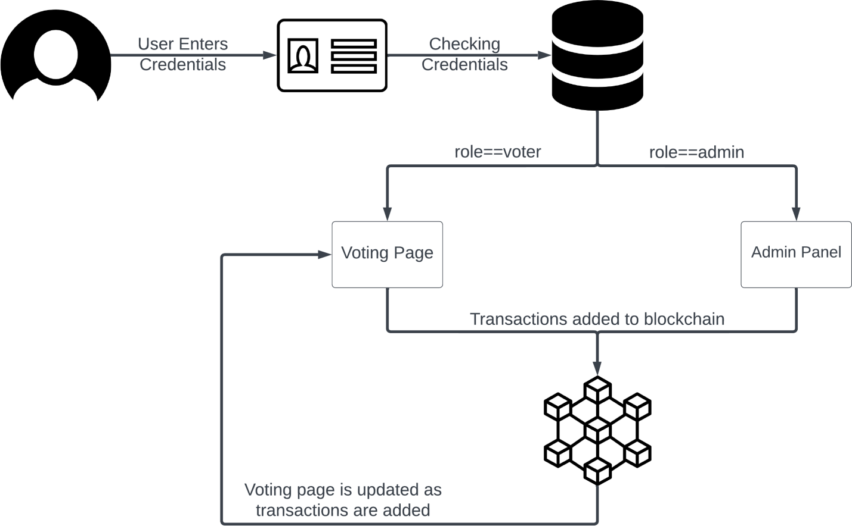

**1. User Verification:**

* **Authentication Process:** Voters and admins log in utilizing unique credentials (ID and password) to ensure as it were authorized people can access the framework.
* **Redirect to Respective Pages**: Upon successful authentication, voters are redirected to the voting page where they can cast their votes, whereas admins are diverted to the admin page for election administration.

**2. Admin Setup:**

* Election Arrangement: Admins are responsible for arranging the election, counting including candidates, and setting voting dates.
* Smart Contracts for Automation: All authoritative activities are managed and secured utilizing smart contracts conveyed on the Ethereum blockchain. This guarantees that the decision setup is computerized and free from altering.
* Ensuring Transparency and Security: Smart contracts facilitate transparency by ensuring that all activities taken by admins are safely recorded on the blockchain, ensuring integrity.

**3. Voting Process:** Casting Votes: Once verified, voters can get to the framework and cast their votes on the assigned page.

* **Immutable Recording of Votes:** After a vote is cast, it is safely recorded and verified on the blockchain, ensuring its immutability and anticipating any alteration.
* **Ensuring Transparency:** The use of blockchain ensures that the votes stay transparent and tamper-proof, giving voters affirmation that their votes are recorded precisely.

**4. Smart Contracts and Blockchain:**

* **Role of Smart Contracts:** Smart contracts administer the election process, ensuring that as it were qualified users can vote and the votes are appropriately checked.
* **Unchanging nature of Blockchain:** Blockchain serves as a permanent record, forever recording all votes. This guarantees that once a vote is cast, it cannot be adjusted or eradicated, securing the judgment of the election.
* **Tamper-proof Environment:** The combination of smart contracts and blockchain innovation makes a secure, tamper-proof environment for the whole voting handle, dispensing with the hazard of extortion or control.

**5. Real-time Results:**

* **Real-time Vote Updates:** The framework gives real-time updates on the current vote count and other significant data, offering quick insight into the progressing race handle.
* **Transparency for All Stakeholders:** This highlight gives straightforwardness by permitting both voters and the common open to tracking the advance of the race in real-time.
* **Building Believe in the System:** Real-time comes about helps cultivate trust by demonstrating that the voting process is continuously advancing and votes are being precisely numbered.

## **CONCLUSION**

A decentralized voting system uses blockchain to make elections more secure and transparent. Votes are safely recorded in a way that can't be changed, and everyone can check the results. Voters are verified through encryption to ensure their identity, but their votes stay private. Smart contracts handle vote counting automatically, making the process quicker and more efficient. While there are challenges like making the system accessible to everyone, it offers a safer, cheaper, and more reliable way to run elections and build trust in the results.

1. **REFERENCES**

[1] Ashish Singh, Kakali Chatterjee, SecEVS: Secure Electronic Voting System Using Blockchain Technology.

[2] Fririk p.Hjalmarsson, Gunnlaugur k. Hreiarsson, Mohammad Hamdaqa, Gisli Hjalmtysson, Blockchain-Based E-voting System.

[3] Cosmas Krisna Adiputra, Rikard Hjort, and Hiroyuki Sato; A Proposal of Blockchain-based Electronic Voting System.

[4] Vairam T1, Sarathambekai S2, Balaji R3; Blockchain based Voting system in Local Network.

[5] Albin Benny, Aparna Ashok Kumar, Abdul Basit, Betina Cherian, and Amol Kharat(2024), Blockchain-based E-voting System.