**Implementation of a Real-Time Water Quality Monitoring System Based on Internet of Things (IoT)**

**Aryan Kumar1, Aman Jaiswal2, Aman Gour3, Kashish Goyal4**

Computer Science & Engineering at Oriental Institute of Science and Technology, Bhopal (462022)

**ABSTRACT:** Ensuring access to safe drinking water is challenging due to complex hydro-geological conditions, natural disasters, and cross-boundary water management issues. Industrial toxins further complicate efforts to achieve safe and affordable drinking water access. Ensuring proximity to safe drinking water is essential for maintaining public health.

To mitigate waterborne illnesses and prevent contamination, monitoring key water parameters such as pH, turbidity, temperature, dissolved oxygen, and salinity is crucial. This work proposes a low-cost, sustainable IoT-based water quality measurement system designed to effectively monitor these parameters. The system integrates multiple sensors connected to an Arduino device, which communicates with a NodeMCU to transmit real-time data to an online platform.

A QR code is attached to each water source, allowing users to quickly access water quality information by scanning it. This system can assist authorities in monitoring water conditions and taking appropriate actions. Additionally, it can be adapted for applications in agriculture and industrial sectors, promoting improved water management strategies.

**KEYWORDS** - IoT, Water Quality Monitoring, Real-time system, Turbidity, pH, Temperature, Dissolved Oxygen, Salinity, Arduino, NodeMCU.

1. **INTRODUCTION:**

With the rapid population growth, effective management of freshwater resources has become critically important to meet increasing demands across agricultural, industrial, and domestic sectors. The quality of freshwater is primarily defined by its physical, chemical, and biological properties, making regular monitoring essential to detect pollution, contamination, and harmful substances.

Traditional water quality monitoring relies heavily on manual processes, involving sample collection, laboratory testing, and expert interpretation. This method, though common, is time-consuming and expensive. It also requires skilled personnel, which limits its practicality in many areas.

* Water sampling
* Testing samples
* Investigative analysis.

With advancements in technology, real-time water quality monitoring systems have emerged. These systems offer faster and more reliable detection of contamination, reducing reliance on manual processes. Automation provides continuous data streams, enabling authorities to make timely decisions.

This study proposes an IoT-based water quality monitoring system that addresses the limitations of traditional monitoring by enabling real-time data collection, wireless transmission, and automated analysis. The system tracks key water quality parameters and uploads data to an online platform for real-time analysis.

The system also sends alerts to remote users when water quality exceeds safe limits, allowing faster responses. The aim is to develop a low-cost and simple model, suitable for areas with limited resources, and to calculate the Water Quality Index (WQI) to assess the water’s suitability for drinking, irrigation, or aquatic life.

The Water Quality Index (WQI) serves as a standardized composite indicator that combines various water quality measurements into a single numerical score on a scale of 0 to 100. This index provides an easy-to-understand representation of overall water quality, assisting both policymakers and local communities in making informed decisions about water use and management. By integrating real-time sensing, wireless communication, and automated WQI calculation, this system offers a comprehensive, scalable, and user-friendly solution for monitoring water quality in vulnerable regions.

1. **OBJECTIVE:**

The objective of this project is to develop and implement a low-cost, sustainable IoT-based water quality measurement system for real-time monitoring of drinking water in coastal areas of Bangladesh. By integrating multiple sensors with Arduino and NodeMCU, the system measures key water parameters such as pH, turbidity, temperature, dissolved oxygen, and salinity, transmitting the data to an online platform for easy access. A QR code system allows users to check water safety instantly, while authorities can utilize the collected data to address contamination issues and improve water management. This system can also be extended to agricultural and industrial applications, ensuring better water quality monitoring and public health protection.

1. **PROPOSED SYSTEM AND METHODOLOGY:**

The proposed IoT-based water quality monitoring system is a comprehensive and technologically advanced solution that integrates multiple hardware and software components to ensure efficient, real-time data collection, transmission, and analysis of water quality parameters. This system is designed to monitor key water quality indicators such as pH, turbidity, temperature, dissolved oxygen, and salinity, providing critical data to both users and government authorities for proactive decision-making regarding water safety. Below is a detailed description of all the components included in the system and their respective roles:

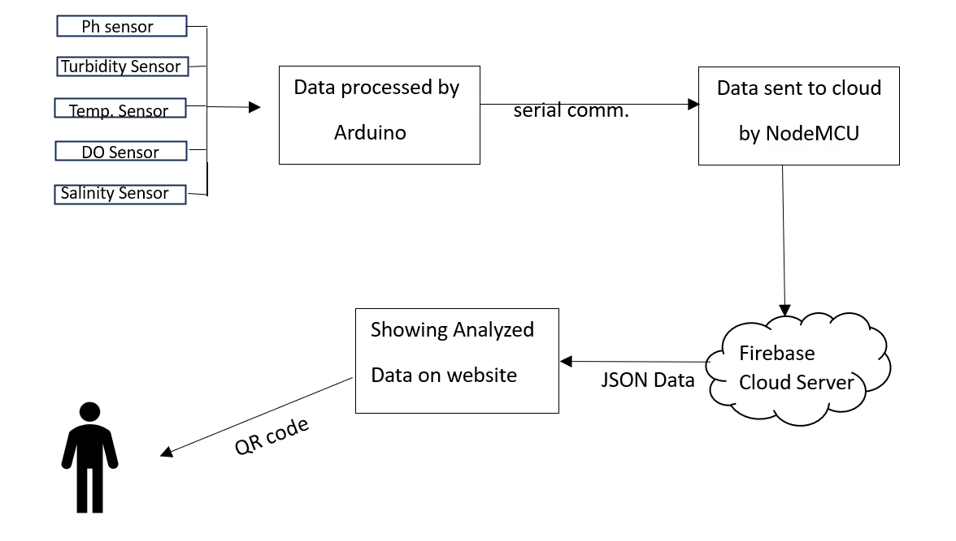

1. **Arduino Uno** (Microcontroller for Sensor Data Processing)

Arduino Uno is an open-source microcontroller that serves as the primary processing unit for sensor data collection. It receives analog inputs from various sensors, processes the data, and sends it to NodeMCU via serial communication. The Arduino board has both digital and analog input/output (I/O) pins, allowing seamless interfacing with multiple sensors and communication modules. It is programmed using C and C++ via the Arduino IDE.

2. **NodeMCU** (Wi-Fi-Enabled IoT Module for Data Transmission)

NodeMCU, based on the ESP8266 Wi-Fi SoC, is responsible for wireless communication. It receives processed data from Arduino through serial communication, transmits it to the Firebase real-time database, and facilitates remote monitoring through a web-based dashboard. The Lua scripting language is used for programming, and it operates at a baud rate of 115200 for high-speed data transmission.

3. **pH Sensor** (Water Acidity Measurement)

The pH sensor module consists of a pH probe and a signal conditioning board that outputs an analog voltage proportional to the pH value of water. This sensor helps determine whether water is acidic, neutral, or alkaline, with values ranging from 0 (extremely acidic) to 14 (extremely basic). The sensor data is converted into digital format and processed through Arduino.

4. **Turbidity Sensor** (Water Clarity Measurement)

The turbidity sensor measures the cloudiness or clarity of water in Nephelometric Turbidity Units (NTU). It works by detecting light transmission and scattering rates caused by suspended particles in water. Higher turbidity levels indicate a higher presence of pollutants. The sensor provides both analog and digital outputs, and its data is processed using a straight-line equation to convert voltage values into NTU readings.

5. **Dallas Temperature Sensor** (Water Temperature Measurement)

The Dallas DS18B20 temperature sensor is a 1-wire programmable sensor capable of measuring temperatures between -55°C and +125°C with an accuracy of ±0.5°C. It is used in rugged environments and is waterproof, making it ideal for underwater applications. The sensor transmits data digitally, reducing signal interference.

6. **Analog Dissolved Oxygen Sensor** (Oxygen Level Measurement)

The dissolved oxygen (DO) sensor measures the amount of oxygen present in water, which is crucial for aquatic life and overall water quality assessment. Low DO levels indicate poor water quality and can be harmful to aquatic organisms. The sensor provides analog voltage readings, which are converted into mg/L values through Arduino.

7. **Salinity Sensor** (Electrical Conductivity - EC)

The salinity sensor measures the concentration of dissolved salts in water by detecting its electrical conductivity (EC). Higher conductivity indicates a higher salt concentration, which can affect both drinking water quality and agricultural applications. This analog sensor outputs a voltage signal proportional to the salt content, which is then processed and converted into digital values.

8. **Logic Level Converter** (Voltage Adjustment for Safe Communication)

Since Arduino operates at 5V logic levels and NodeMCU operates at 3.3V, a logic level converter is used to facilitate safe bidirectional communication between the two microcontrollers. This component prevents potential damage caused by voltage mismatches and ensures stable data transmission.

9. **Serial Communication** (Data Transfer Between Arduino and NodeMCU)

To enable seamless data exchange between Arduino and NodeMCU, serial communication is implemented. This method transmits sensor data characters by character and ensures efficient real-time processing. The Software Serial library is used to establish communication at a baud rate of 9600 to match the operating speeds of both devices.

10. **Firebase Real-Time Database** (Cloud Storage for Water Quality Data)

Firebase is a cloud-based real-time database that stores processed water quality data sent by NodeMCU. The system uses JSON format to store and retrieve sensor data efficiently. The cloud storage enables authorities and users to access historical data, analyze trends, and make informed decisions regarding water safety.

11. **Web-Based Monitoring System** (User Interface for Data Visualization)

A dedicated web-based dashboard is developed to display real-time water quality parameters retrieved from Firebase. The dashboard allows:

Users check water quality from any device.

Authorities to monitor water sources and detect contamination trends.

Data visualization using graphs, tables, and alerts for abnormal values.

12. **QR Code System** (Instant Water Quality Access)

Each monitored water source is assigned a unique QR code. Users can scan the QR code with a smartphone to instantly access real-time water quality information, ensuring quick and convenient decision-making about whether the water is safe for consumption.

13. **Power Supply** (Energy Source for System Components)

The system can be powered using:

USB power from a computer or power adapter (for Arduino and NodeMCU).

Rechargeable batteries or solar panels for remote or off-grid applications.

14. **Signal Processing and Data Conversion Mechanism**

Analog sensor values (pH, turbidity, dissolved oxygen, salinity) are converted into digital values using calibration formulas.

Data normalization and error correction techniques ensure accuracy.

Processed data is formatted into JSON format before being uploaded to Firebase.

1. **RESULTS AND DISCUSSION:**

After implementing the IoT-based water quality monitoring system on different water sources, we collected and analyzed data to determine water suitability. Four water samples were tested: purified water, pond water, lemon-mixed water (acidic), and calcium hydroxide-mixed water (alkaline). The pH values indicated that purified water was neutral, pond water was slightly acidic, lemon-mixed water was highly acidic, and calcium hydroxide-mixed water was strongly alkaline, confirming the system's ability to differentiate water quality based on key parameters.

Measurement of Water Quality Index (WQI)

The Weighted Arithmetic Water Quality Index (WQI) method was used to assess overall water quality. The formula is:

WQIA​=∑wi​ /∑ wi​qi​​

WQI Interpretation

WQI < 50 → Excellent (Purified Water)

50 ≤ WQI < 100 → Good (Pond Water)

100 ≤ WQI < 200 → Poor (Lemon Water)

WQI > 200 → Unsuitable (Calcium Hydroxide Water)

We measured water quality for four sample waters

1) Normal purified water

2) Lemonade water

3) Lime water

4) Polluted water

|  |  |  |  |
| --- | --- | --- | --- |
| Sample | pH | Turbidity (NTU) | Temperature (°C) |
| Purified Water | 6.8 | 2.5 | 22 |
| Lemonade Water | 5.5 | 13.5 | 23 |
| Lime Water | 10.7 | 55 | 35 |
| Polluted Water | 5.9 | 91 | 24 |

The study demonstrates the effectiveness of real-time water quality monitoring using an IoT-based system. The results emphasize the importance of continuous assessment, especially in areas prone to water contamination. The cloud-based data storage and QR accessibility ensure instant decision-making for safe water consumption. The system is scalable and can be extended for industrial, agricultural, and environmental monitoring, with potential improvements such as heavy metal detection and AI-driven predictive analysis.

1. **CONCLUSION AND FUTURE SCOPE:**

**Conclusion**

Water quality monitoring has become an essential component of environmental protection and public health management, particularly in regions where water contamination poses a serious threat to human life. Traditional water testing methods are time-consuming, require manual intervention, and are often not feasible for real-time or large-scale monitoring. The development of an IoT-based water quality monitoring system offers a highly efficient, automated, and scalable solution to address these challenges. By integrating multiple sensors, Arduino, NodeMCU, cloud computing, and a web-based monitoring system, this technology enables real-time tracking of key water quality parameters such as pH, turbidity, temperature, dissolved oxygen, and salinity. The automatic nature of the system eliminates the need for continuous human intervention, making it cost-effective and energy efficient. Additionally, the use of Wi-Fi connectivity and cloud-based storage allows for seamless data access from any location, empowering both individuals and authorities with critical information about water safety. The inclusion of a QR code system enhances accessibility by enabling users to instantly check water quality using their smartphones. Moreover, this system provides a proactive approach to detecting and addressing water contamination issues, helping to mitigate the risk of waterborne diseases and ensuring safer drinking water supplies. The flexibility and modularity of the system also make it suitable for diverse applications, including industrial wastewater management, agricultural irrigation, and aquaculture monitoring. As a sustainable and innovative solution, this IoT-based system has the potential to significantly improve environmental conservation efforts, water resource management, and overall public health.

**Future Scope**

As technology continues to evolve, the potential for enhancing and expanding this IoT-based water quality monitoring system is vast. One of the key areas of future development lies in incorporating advanced electrochemical and biosensors to detect a wider range of contaminants, including heavy metals (such as arsenic, lead, and mercury), harmful chemicals (such as trihalomethanes and nitrates), and microbial pathogens. These additions would enhance the system’s ability to provide comprehensive water quality assessments for drinking, industrial, and agricultural purposes. Furthermore, advancements in sensor miniaturization and energy-efficient designs can enable large-scale deployment of these sensors throughout water distribution networks, providing high-resolution, real-time monitoring of municipal water supplies.

Additionally, the integration of Artificial Intelligence (AI) and Machine Learning (ML) can significantly improve the analytical capabilities of the system. By utilizing AI-driven data analytics, the system could predict water contamination trends, identify potential sources of pollution, and even generate automated alerts and recommendations for preventive measures. This predictive modeling could assist authorities in taking proactive actions to prevent water crises before they occur.

Another promising development is the use of blockchain technology for data security and transparency. By implementing blockchain-based ledgers, water quality data can be stored in a tamper-proof and decentralized manner, ensuring that the information remains accurate, reliable, and accessible to all stakeholders, including government agencies, environmental organizations, and the general public.

1. **REFERENCE:**

* Kedia, N. (2015). Water Quality Monitoring for Rural Areas - A Sensor Cloud-Based Economical Project. NGCT.
* Bhatt, J., & Patoliya, J. (2016). IoT Based Water Quality Monitoring System. IRFIC.
* Kartakis, S., et al. (2012). Adaptive Edge Analytics for Water Systems. SECON.
* Sun, Z., et al. (2012). QOI-Aware Energy Management in IoT. SECON.
* Phadatare, S., & Gawande, S. (2016). Development of Water Quality Index. IJETR.