**Vibration Based Fault Diagnosis in Industrial Machinery Using Digital Signal Processing**

**Tanmay Wani1, Tanvi Wani2, Harshika Mhapsekar3, Prathamesh Mane4**

1Student, Electrical Engineering, Sardar Patel College of Engineering, Mumbai, Maharashtra, India

2,4Student, Electronics and Telecommunication Engineering, Sardar Patel Institute of Technology, Mumbai, Maharashtra, India

3Student, Mechanical Engineering, Sardar Patel College of Engineering, Mumbai, Maharashtra, India

**ABSTRACT**

Monitoring vibrations in industrial machinery is crucial for early fault detection and system reliability. This study introduces a computational framework for diagnosing and analyzing vibration-related faults in rotary machinery. A composite vibration signal is synthesized, incorporating multiple fault sources to ensure a comprehensive fault representation. Fault detection relies on identifying characteristic frequency spikes at harmonics of the rotor frequency. Frequency filtering is performed using a bandpass Butterworth filter to isolate relevant spectral components, enhancing fault identification. A Hamming window is applied to improve spectral resolution by minimizing spectral leakage. The methodology employs the Welch transform for power spectral density estimation, improving accuracy by reducing noise through segment averaging. The analysis is conducted on the Interroll Drum Motor DM 0138, operating at 30 Hz, demonstrating practical applicability to industrial environments. The proposed approach exhibits high precision in distinguishing fault signatures, underscoring the effectiveness of digital signal processing techniques for predictive maintenance in industrial applications.

**Keywords:** Vibration Analysis, Fault Detection, Power Spectral Density, Butterworth Filter.

1. **INTRODUCTION**

Industrial machinery, particularly rotating equipment such as motors, pumps, and bearings, is prone to faults caused by operational stresses. If undetected, these faults can lead to severe failures, prolonged downtime, and costly repairs. Among rotating machinery, asynchronous three-phase motors are widely used in industrial automation and production systems, necessitating robust fault detection techniques to ensure reliability.

This paper investigates vibration-based fault diagnosis using signal processing techniques. A MATLAB-based computational framework is developed for diagnosing faults in the Interroll Drum Motor DM 0138, an asynchronous three-phase motor operating at 30 Hz. Commonly found in conveyor belt systems, the motor generates electrical noise due to inherent faults. Vibration analysis [1] is a reliable technique for early fault detection, enabling predictive maintenance strategies.

Various faults produce distinct vibration signatures [2], making it possible to diagnose issues based on frequency analysis [3]. For instance, imbalance faults [4] typically generate vibrations at 0.8 to 1.2 times the rotor frequency, while misalignment faults [5] result in vibrations ranging from 2 to 6 times the rotor frequency. Bearing faults [6] manifest through frequencies linked to the ball pass frequency and ball spin frequency, while gear mesh faults [7] occur at the gear mesh frequency (GMF) [8] of the rotating system. Looseness faults [9] are characterized by vibrations occurring between 0.5 to 3 times the rotor frequency.

By analyzing these frequency components, specific faults can be accurately identified. Traditional methods like the Fast Fourier Transform (FFT) [10] are commonly employed to transform time-domain vibration data into the frequency domain, allowing detailed spectral analysis.

Previous research [11] introduces a DSP-based FFT analyzer for real-time fault diagnosis of rotating machines using vibration analysis. The system is designed to acquire and process vibration signals in real-time, effectively monitoring machine conditions and isolating faults with high reliability. The paper details the development of fault and non-fault models, alongside the implementation of both hardware and software solutions for fault detection. Through extensive testing on small three-phase asynchronous motors, the system proves its capability in promptly detecting faults, minimizing false alarms, and delivering robust diagnostic performance. The proposed DSP-based approach significantly enhances real-time monitoring, making it a valuable tool for industrial maintenance​.

In [12], the study explores the detection of misalignment faults in induction motors using rotor vibration and stator current signature analysis. The paper emphasizes that misalignment is one of the most prevalent mechanical faults in rotating machinery, significantly impacting motor efficiency and longevity. Through experimental analysis using fast Fourier transform (FFT) and orbit plots, the authors differentiate between various misalignment conditions such as parallel, angular, and combined misalignment. The research highlights that misalignment leads to distinct vibration characteristics, particularly affecting harmonics of rotor vibration and current response. The findings offer a diagnostic approach that integrates both vibration and current analysis to enhance fault detection accuracy.

In [13], the study presents a comprehensive analysis of unbalance and looseness faults in ventilation turbines through vibration signature analysis. The research utilizes numerical simulations and experimental validation to model and detect these common faults in rotating machines. Using SolidWorks for dynamic simulations, the study replicates unbalance conditions, where mass imbalance generates centrifugal forces leading to vibrations. Similarly, mechanical looseness, often caused by poor fitting or structural weaknesses, is analyzed through harmonic excitation. The findings demonstrate that vibration analysis serves as an effective predictive maintenance tool, offering cost-efficient and reliable fault detection methods for industrial rotating machinery. This study builds on these approaches, employing digital signal processing techniques to enhance fault detection in industrial motors.

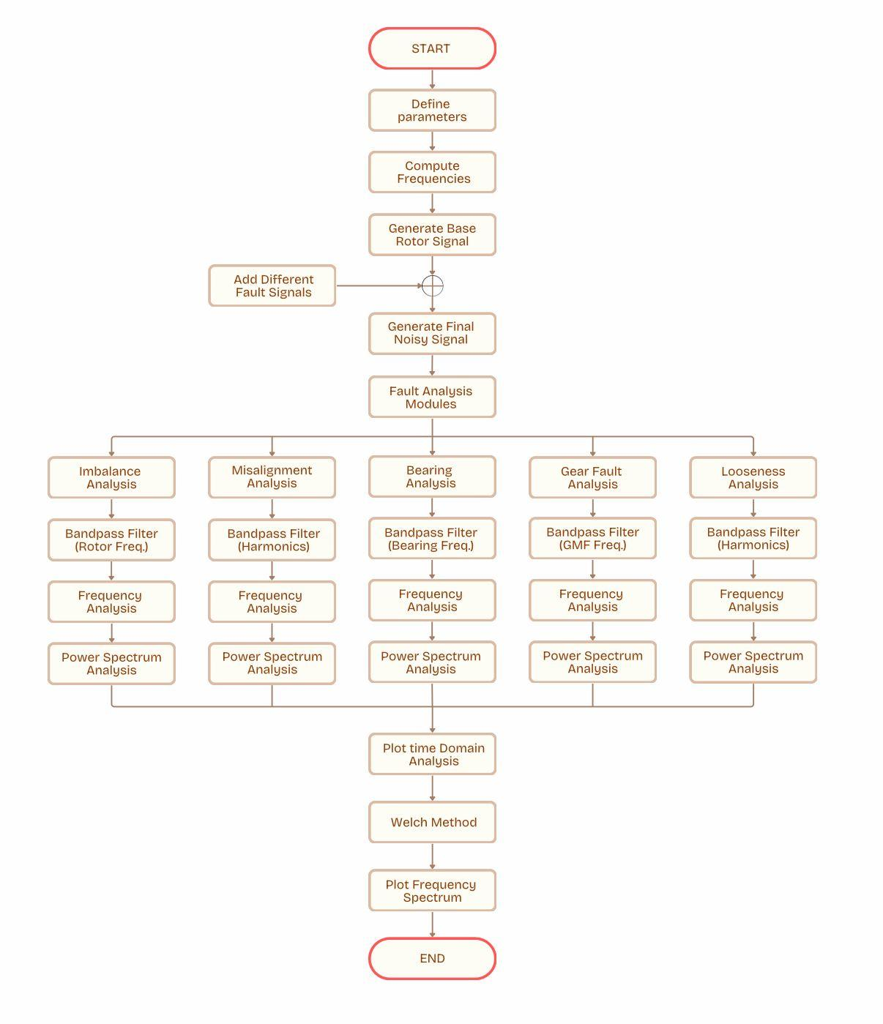

**Figure 1**: Frame Work of Fault Analysis

The methodology used is systematically represented in the form of a flowchart in Fig.1, outlining the key steps in fault diagnosis. The process begins with defining motor parameters and computing characteristic frequencies, followed by generating a baseline rotor signal. Fault signals corresponding to imbalance, misalignment, gear defects, bearing faults, and looseness are incorporated to simulate real-world conditions. Each fault undergoes targeted bandpass filtering and frequency analysis, with power spectrum analysis highlighting deviations from normal operation. The final stage includes time-domain visualization and spectral estimation using the Welch method [14], ensuring precise fault identification. This structured approach enhances the reliability of industrial machinery by facilitating early intervention and minimizing unplanned failures.

1. **PROBLEM STATEMENT**

Rotating industrial machinery, such as motors, is prone to faults like imbalance, misalignment, and bearing defects, leading to failures, increased downtime, and maintenance costs. Traditional fault detection methods often struggle with noise interference and overlapping frequency components, reducing accuracy. This study addresses these challenges by developing a MATLAB-based framework that integrates bandpass filtering, power spectral density estimation using the Welch method, and spectral analysis for precise fault diagnosis. By systematically analyzing vibration signals, this research enhances predictive maintenance strategies, improving the reliability and efficiency of industrial motors.

1. **METHODOLOGY**

The MATLAB implementation is structured into five key sections: Input parameters wherein the operator is expected to input the machine parameters thereby increasing the real-world fidelity and the variety of machines this can be applied for; Noise Generation, where noise is simulated with components of different faults such as imbalance, misalignment, gear mesh faults, bearing faults, and looseness; Filtering of signals, achieved using bandpass filters of suitable ranges; Welch Transform of Faults, where power spectral density estimation is performed; Fault Analysis, where filtered signals are examined to identify characteristic fault signatures. Additionally, a Hamming window is applied during spectral estimation to minimize spectral leakage and improve the resolution of fault-related frequency spikes. These preprocessing techniques ensure that the extracted fault features are precise and reliable, aiding in accurate diagnostics.

**3.1 Noise Generation**

The framework is initialized by acquiring user-defined input parameters that characterize the machine's operating conditions, including gear properties (number of teeth and rotational speed), bearing parameters (number of rolling elements), ball diameter, rotational speed, contact angle, and rotor speed. These parameters enable the calculation of key fault frequencies, such as the Gear Mesh Frequency (GMF) and characteristic bearing defect frequencies, which include ball pass frequencies for the inner and outer races, ball spin frequency, and fundamental train frequency. The highest fault frequency is determined to guide the selection of an appropriate sampling rate, set at 24,000 Hz to satisfy Nyquist criteria. A baseline sinusoidal signal representing an ideal rotor motion is synthesized, onto which multiple fault components are systematically superimposed to generate a composite noisy signal. Imbalance is introduced as a frequency spread around the rotor speed, misalignment is simulated through harmonic multiples of the rotor frequency, and bearing faults are incorporated using predefined defect frequencies derived from machine geometry. Additionally, GMF is embedded to represent gear-related anomalies, while looseness is modelled by adding randomized subharmonic and super harmonic components of the rotor frequency. The final composite signal, containing contributions from all fault modes, is analyzed in both the time and frequency domains, where Welch’s method is employed to compute the Power Spectral Density (PSD), effectively revealing fault signatures as distinct frequency-domain spikes.

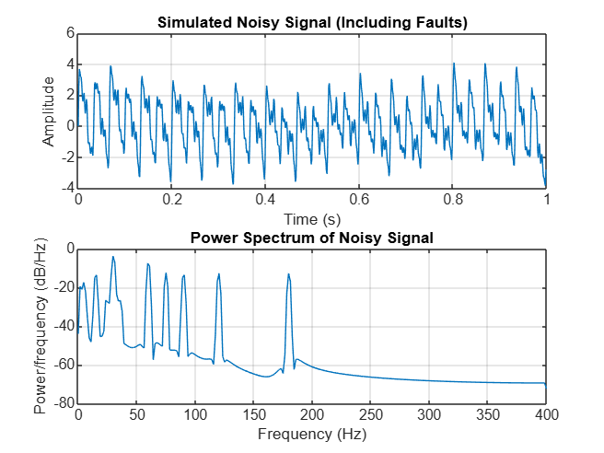

**Figure 2:** Simulated Noise signal followed by its Welch Transform

**3.2 Imbalance Fault**

An imbalance fault arises from non-uniform mass distribution around the rotational axis, inducing centrifugal forces that generate excessive vibrations. It is prevalent in rotating machinery such as turbines, compressors, and industrial motors, where precision balancing is critical. The fault manifests at 0.8 to 1.2 times the rotor frequency due to minor variations in mass displacement, assembly misalignment, and material inconsistencies, leading to sideband frequency components. To extract the imbalanced signature, a fourth-order Butterworth bandpass filter [15] is applied within this frequency range, ensuring suppression of non-relevant spectral components. The filter coefficients are computed, and the filtered signal is obtained. The time-domain representation of the extracted imbalance fault is plotted, followed by spectral analysis using Welch’s method, revealing spikes within the defined range of frequency.

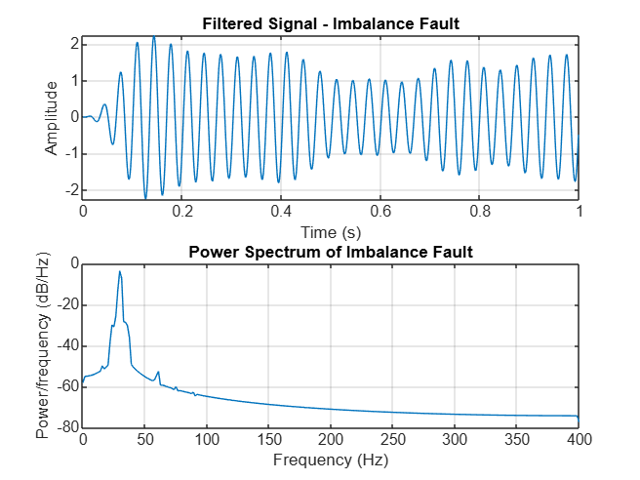

**Figure 3:** Bandpass filtered Imbalance Fault frequencies followed by their Welch Transform for fault detection

**3.3 Misalignment Fault**

Misalignment faults occur when coupled rotating components deviate from perfect collinearity, generating harmonics at 2 to 6 times the rotor frequency due to periodic torque fluctuations. These faults induce excessive vibrations and mechanical wear. To isolate misalignment, a fourth-order Butterworth bandpass filter is applied, with cutoff frequencies defined at 2 and 6 times the rotor frequency. The time-domain response is visualized by Welch's power spectral density estimation, highlighting distinct misalignment-induced harmonics, represented as spikes.

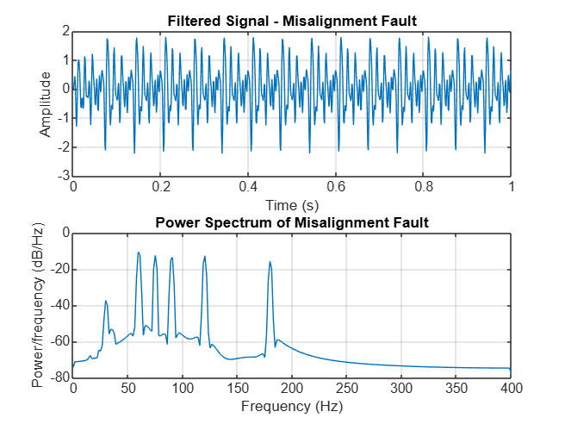

**Figure 4:** Bandpass filtered Misalignment Fault frequencies followed by their Welch Transform for fault detection

**3.4 Bearing Fault**

Bearing faults arise from localized defects in rolling elements, the inner race, outer race, or the bearing cage, leading to characteristic vibration signatures. Bearing faults exhibit multiple frequency components due to periodic impacts between defective surfaces. The framework models four primary fault types: outer race defects, where rolling elements strike a damaged outer ring at a frequency given by $f_{\text{bearing outer}}=\frac{n_{\text{b}}}{120}N_{\text{bearing}}\left(1-\frac{d}{D}\cos{β}\right)$ and inner race defects, occurring when elements pass over an inner-ring defect at $f_{\text{bearing inner}}=\frac{n_{\text{b}}}{2}N_{\text{bearing}}\left(1+\frac{d}{D}\cos{β}\right)$. Additionally, ball spin frequency is determined by the interaction of rolling elements with localized imperfections, computed as $f_{\text{bearing spin}}=\frac{D⋅N_{\text{bearing}}}{d⋅60}\left(1-{\left(\frac{d}{D}\right)}^{2}\cos{β}\right)$ while fundamental train frequency, associated with bearing cage instability, occurs at $f_{\text{bearing train}}=\frac{N_{\text{bearing}}}{2.60}\left(1-\frac{D}{d}\cos{β}\right)$. A fourth-order Butterworth bandpass filter is applied over the range between the inner race defect frequency and ball spin frequency. The filtered signal is extracted, preserving only the bearing-related fault frequencies. The time-domain representation is plotted. Welch’s spectral analysis highlights the distinct frequency components, enabling precise fault identification.

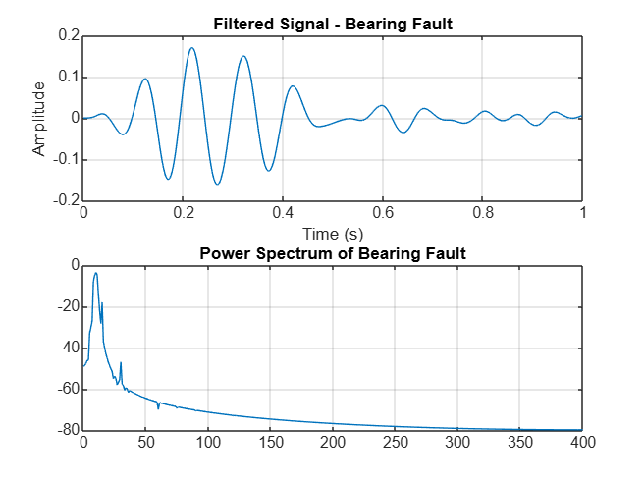

**Figure 5:** Bandpass filtered bearing fault frequencies followed by their Welch Transform for fault detection.

**3.5 Gear Mesh Fault**

Gear mesh faults arise due to irregularities in the meshing of gear teeth, leading to periodic excitation at the Gear Mesh Frequency (GMF). These faults are prevalent in gear-driven systems such as turbines, automotive transmissions, and industrial gearboxes. The GMF is determined based on the number of gear teeth and its rotational speed, calculated as $\text{GMF}=Z_{g}⋅ω_{g}$ ​, where Zg represents the number of teeth, and ωg​ is the gear running speed. To isolate the gear mesh fault, a fourth-order Butterworth bandpass filter is applied, allowing only the GMF to pass while attenuating other frequency components, ensuring that the vibration response associated with meshing irregularities is retained. The time-domain representation of the extracted signal is plotted, while Welch’s spectral analysis highlights the dominant spectral component at GMF, facilitating fault detection and characterization.

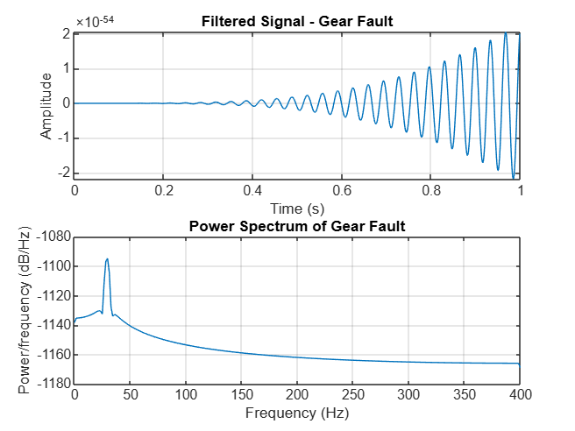

**Figure 6:** Bandpass filtered gear fault frequencies followed by their Welch Transform for fault detection

**3.6 Looseness Fault**

Looseness faults occur due to excessive clearance or insufficient structural support in rotating machinery, leading to nonlinear contact forces and erratic vibrations. These faults are commonly observed in motor housings, bearings, and mechanical couplings, where loose fittings or worn-out components result in unwanted movement. Looseness-induced vibrations manifest over a broad frequency range, typically between 0.5 to 3 times the rotor frequency, producing subharmonic and super harmonic frequency components. A fourth-order Butterworth bandpass filter is applied, retaining only the relevant frequency range while suppressing unrelated spectral components. The extracted signal is analyzed in the time domain to observe irregular motion patterns, while Welch’s power spectral density estimation reveals distinct peaks within the expected frequency range, aiding in fault detection and characterization. 

**Figure 6:** Bandpass filtered looseness fault frequencies followed by their Welch Transform for fault detection

1. **RESULTS**

The results of this study demonstrate the effectiveness of the MATLAB-based framework in diagnosing various faults in rotating machinery by analyzing their vibration signatures. Each fault type—imbalance, misalignment, bearing defects, gear mesh irregularities, and looseness—was successfully isolated and identified using a combination of Butterworth bandpass filtering and Welch's power spectral density estimation. The analysis provided distinct frequency-domain spikes, which serve as critical indicators of fault presence and severity, corresponding to the characteristic fault frequencies. These spikes represent an increase in spectral energy at specific frequencies associated with different mechanical issues, making them essential for fault diagnosis.

The presence and amplitude of these spikes not only confirm the existence of faults but also provide insights into their severity, as higher amplitude spikes often indicate worsening fault conditions. Each fault signature was clearly distinguishable, with minimal overlap between fault components, demonstrating the framework's precision in fault isolation and quantification. A summary of the detected fault frequencies and their respective spectral components is presented in Table 1.

**Table 1.** Summary of Fault Analysis

|  |  |  |  |
| --- | --- | --- | --- |
| SN. | Fault Name | Fault Frequencies | Calculated Values |
| 1 | Imbalance Fault | 0.8 to 1.2 times the rotor frequency | 24 to 36 hertz |
| 2 | Misalignment Fault | 2 to 6 times the rotor frequency | 60 to 180 hertz |
| 3 | Bearing Fault | Anywhere between bearing inner race frequency to bearing spin frequency | 114.188 to 332.701 hertz |
| 4 | Gear Mesh Fault | At gear mesh frequency | 29.1 hertz |
| 5 | Looseness Fault | 0.5 to 3 times the rotor frequency | 15 to 90 hertz |

1. **CONCLUSION**

This study presents a computational framework for fault detection in rotating machinery using vibration signal analysis, integrating bandpass filtering, Hamming windowing, and Welch’s power spectral density estimation to effectively identify fault signatures associated with imbalance, misalignment, bearing defects, gear mesh irregularities, and looseness. While the approach demonstrates high accuracy, its effectiveness depends on the quality of acquired vibration signals, making it susceptible to noise and distortions. Additionally, it relies on predefined fault frequencies, which may not fully capture complex or evolving faults, and is currently implemented in an offline MATLAB environment, limiting real-time applicability. Future work should focus on developing embedded systems or FPGA-based solutions for continuous monitoring, integrating adaptive filtering to enhance noise resilience, and exploring machine learning techniques for automated fault classification beyond predefined spectral patterns. Extending the framework to analyze turbines and compressors would further validate its scalability and industrial relevance. Addressing these limitations will enhance predictive maintenance strategies, improving the reliability and efficiency of rotating machinery in industrial applications.

1. **REFERENCES**
2. S. Botha and N. Gule, "Vibrational Analysis of an Unbalanced Brushless Doubly Fed Induction Machine," 2023 IEEE International Electric Machines & Drives Conference (IEMDC), San Francisco, CA, USA, 2023, pp. 1-6, doi: 10.1109/IEMDC55163.2023.10239081.
3. S. Nadarajan, R. Wang, A. Kumar Gupta and S. Kumar Panda, "Vibration signature analysis of stator winding fault diagnosis in brushless synchronous generators," 2015 IEEE International Transportation Electrification Conference (ITEC), Chennai, India, 2015, pp. 1-6, doi: 10.1109/ITEC-India.2015.7386919.
4. T. Wang, G. Lu and P. Yan, "A Novel Statistical Time-Frequency Analysis for Rotating Machine Condition Monitoring," in *IEEE Transactions on Industrial Electronics*, vol. 67, no. 1, pp. 531-541, Jan. 2020, doi: 10.1109/TIE.2019.2896109.
5. Küçüker, Ahmet & Bayrak, Mehmet. (2013). Detection of Mechanical Imbalances of Induction Motors with Instantaneous Power Signature Analysis. Journal of Electrical Engineering and Technology. 8. 10.5370/JEET.2013.8.5.1116.
6. Verma, Alok & Sarangi, Somnath & Kolekar, Maheshkumar. (2015). Misalignment Fault Prediction of Motor-Shaft Using Multiscale Entropy and Support Vector Machine. 10.1007/978-3-319-11218-3.
7. Nabhan, Ahmed & Ghazaly, Nouby & Samy, Abdelhalim & M.O, Mousa. (2015). Bearing Fault Detection Techniques - A Review. Turkish Journal of Engineering, Sciences and Technology. 3.
8. Vikas Sharma, Anand Parey, A Review of Gear Fault Diagnosis Using Various Condition Indicators, Procedia Engineering, Volume 144, 2016, Pages 253-263, ISSN 1877-7058, <https://doi.org/10.1016/j.proeng.2016.05.131>.
9. E. Ebrahimi, "Fault diagnosis of Spur gear using vibration analysis," *Journal of American Science*, vol. 8, no. 1, pp. 133-138, 2012.
10. Jung, Junyeong & Lee, Sang & Lim, Chaewoong & Cho, Changhee & Kim, Kwon-Hee. (2016). Electrical Monitoring of Mechanical Looseness for Induction Motors With Sleeve Bearings. IEEE Transactions on Energy Conversion. 31. 1-1. 10.1109/TEC.2016.2583473.
11. T. Li, Z. Gao, Y. Li and Q. Dong, "A Comprehensive Study of Fast Fourier Transform for Bearing Fault Diagnosis with Long Short-Term Memory Networks," 2023 3rd International Conference on Electrical Engineering and Mechatronics Technology (ICEEMT), Nanjing, China, 2023, pp. 876-879, doi: 10.1109/ICEEMT59522.2023.10263172.
12. G. Betta, C. Liguori, A. Paolillo and A. Pietrosanto, "A DSP-based FFT-analyzer for the fault diagnosis of rotating machine based on vibration analysis," in IEEE Transactions on Instrumentation and Measurement, vol. 51, no. 6, pp. 1316-1322, Dec. 2002, doi: 10.1109/TIM.2002.807987.
13. Verma, Alok & Sarangi, Somnath & Kolekar, Maheshkumar. (2013). Misalignment fault detection in induction motor using rotor shaft vibration and stator current signature analysis. Int. J. of Mechatronics and Manufacturing Systems. 6. 422 - 436. 10.1504/IJMMS.2013.058519.
14. Djemana, Mohamed & Benyoucef, Rania & Hrairi, Meftah. (2022). Detection of unbalance and looseness faults in a ventilation turbine using vibration signature analysis. IOP Conference Series: Materials Science and Engineering. 1244. 012022. 10.1088/1757-899X/1244/1/012022.
15. J. Yang, N. Chen and S. Ni, "Research on submarine signal detection method based on Welch algorithm," 2018 IEEE 4th Information Technology and Mechatronics Engineering Conference (ITOEC), Chongqing, China, 2018, pp. 1394-1397, doi: 10.1109/ITOEC.2018.8740766.
16. V. Kumar, M. Arya, A. Kumar and D. K. Jhariya, "Design and Comparison Between IIR Butterworth and Chebyshev Digital Filters using MATLAB," 2024 Fourth International Conference on Advances in Electrical, Computing, Communication and Sustainable Technologies (ICAECT), Bhilai, India, 2024, pp. 1-7, doi: 10.1109/ICAECT60202.2024.10469026.