**‘’The Role of the Gut Microbiome in Infectious Diseases: Mechanisms, Implications, and Therapeutic Potential’’**

**Janmejay Soni 1, Dr. Adarsh Kumar soni 2, Dr. Ankur Yadav 3**

1. Tutor (Department of Microbiology) Mahayogi Gorakhnath University, Gorakhpur (janmejaysonicktd@gmail.com) (9305785518)

2. Intern at SSPG Divisional District hospital Varanasi ([adarshkrsoni99@gmail.com](mailto:adarshkrsoni99@gmail.com)) (9621999900).

3. Intern at SSPG Divisional District hospital Varanasi ([ankuryadav11111@gmail.com](mailto:ankuryadav11111@gmail.com)) (6387771222).

**Abstract:**

The gut microbiome, a complex and dynamic ecosystem residing within the gastrointestinal tract, has emerged as a critical player in shaping host health and susceptibility to disease. Beyond its well-recognized roles in nutrient metabolism and immune system development, accumulating evidence highlights the profound influence of the gut microbiome in infectious diseases. This review explores the multifaceted mechanisms by which the gut microbiome interacts with pathogens, influencing infection susceptibility, severity, and outcomes. We delve into the implications of microbiome dysbiosis in various infectious disease contexts, ranging from bacterial and viral to fungal and parasitic infections. Furthermore, we discuss the therapeutic potential of targeting the gut microbiome through strategies such as fecal microbiota transplantation, probiotics, prebiotics, and phage therapy to prevent and treat infectious diseases. Understanding the intricate interplay between the gut microbiome and infectious agents is crucial for developing novel and effective approaches to combat infectious diseases and improve global health.

**Keywords:** Gut Microbiome, Infectious Diseases, Dysbiosis, Immune Modulation, Therapeutic Strategies, Colonization Resistance.

**1. Introduction:**

The human gut harbors a vast and diverse community of microorganisms, collectively known as the gut microbiome, encompassing bacteria, archaea, fungi, viruses, and protozoa. This intricate ecosystem, estimated to contain trillions of microbial cells, plays a pivotal role in numerous physiological functions essential for host health [1]. These functions include dietary nutrient processing, vitamin synthesis, xenobiotic metabolism, and, importantly, the education and modulation of the host immune system [2]. The gut microbiome acts as a crucial interface between the host and the external environment, forming a dynamic barrier against pathogens and shaping the host’s response to infection.

Dysbiosis, an imbalance in the gut microbial community characterized by reduced diversity, altered composition, and functional impairment, has been increasingly linked to a wide range of diseases, including inflammatory bowel diseases, metabolic disorders, autoimmune conditions, and cancer [3]. Emerging evidence robustly positions gut microbiome dysbiosis as a significant factor in altering susceptibility to and outcomes of infectious diseases [4]. This review aims to elucidate the key mechanisms by which the gut microbiome influences infectious diseases, explore the implications of these interactions across diverse infections, and critically examine the therapeutic potential of manipulating the gut microbiome to combat infections.

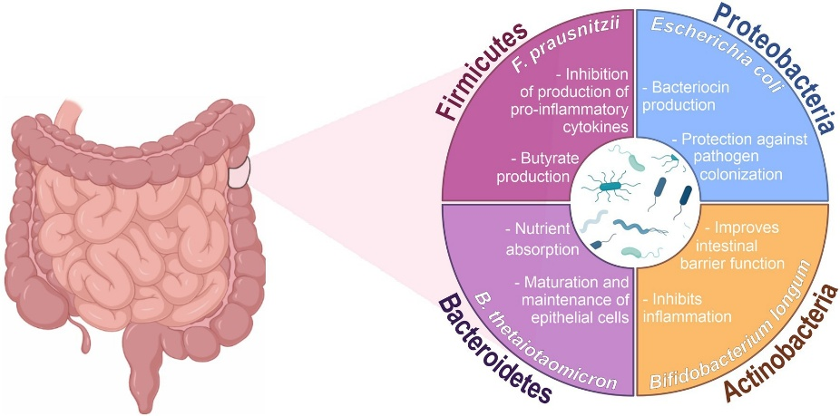

Figure Role of gut microbiota in infectious and inflammatory diseases.

Source: Adapted from Frontiers in Microbiology, Guilherme Cerutti MullerGuilherme Cerutti Muller et al., 2023.

**2. Mechanisms of Gut Microbiome Influence on Infectious Diseases:**

The gut microbiome exerts its influence on infectious diseases through a variety of interconnected mechanisms, broadly categorized into:

**2.1. Barrier Function and Colonization Resistance:**

A healthy and diverse gut microbiome strengthens the intestinal barrier, acting as a physical and functional shield against invading pathogens.

* **Physical Barrier Reinforcement:** Beneficial commensal bacteria contribute to the integrity of the intestinal epithelial barrier by promoting tight junction protein expression, reducing intestinal permeability, and stimulating mucus production. This robust barrier inhibits pathogen translocation from the gut lumen to the systemic circulation.
* **Nutrient Competition:** Commensal microbes compete with pathogens for available nutrients and adhesion sites within the gut, limiting pathogen colonization and proliferation [7]. This "competitive exclusion" is a cornerstone of colonization resistance.
* **Antimicrobial Substance Production:** Gut bacteria produce a range of antimicrobial substances, including bacteriocins, short-chain fatty acids (SCFAs) like butyrate, acetate, and propionate, and other metabolites that directly inhibit pathogen growth or modulate the gut environment to be less hospitable for pathogens. For example, butyrate can enhance epithelial barrier function and reduce inflammation.

**2.2. Immune System Modulation:**

The gut microbiome is instrumental in shaping both innate and adaptive immune responses, influencing the host’s ability to effectively respond to infections.

* **Innate Immune Training:** Microbial-associated molecular patterns (MAMPs) from commensal bacteria, such as lipopolysaccharide (LPS) and peptidoglycans, interact with pattern recognition receptors (PRRs) like Toll-like receptors (TLRs) on immune cells in the gut-associated lymphoid tissue (GALT). This interaction "primes" and "trains" the innate immune system, leading to enhanced responsiveness upon subsequent pathogen exposure.
* **Adaptive Immunity Development and Function:** The gut microbiome is crucial for the development and maturation of the adaptive immune system, including T and B cells. It influences the balance between pro-inflammatory (Th1, Th17) and regulatory (Treg) T cell subsets, shaping the overall immune tone and dictating the nature of immune responses to infections. Specific bacterial species can promote the differentiation of Treg cells, contributing to immune homeostasis and preventing excessive inflammation during infection.
* **Cytokine Modulation:** The gut microbiome can modulate the production of cytokines, signalling molecules that orchestrate immune responses. Beneficial bacteria can promote anti-inflammatory cytokine production (e.g., IL-10) while suppressing pro-inflammatory cytokines (e.g., TNF-α, IL-6), contributing to balanced immune responses during infection and preventing immunopathology.

**2.3. Impact on Pathogen Virulence and Host Susceptibility:**

The gut microbiome can directly influence pathogen virulence and indirectly alter host susceptibility to infection.

* **Quorum Sensing Interference:** Some commensal bacteria can interfere with bacterial quorum sensing, a cell-to-cell communication system used by many pathogens to coordinate virulence factor production. This interference can attenuate pathogen virulence and reduce infection severity.
* **Metabolic Cross-talk:** Microbial metabolites, particularly SCFAs, can have profound effects on host physiology and immune function, thereby influencing susceptibility to infection. For instance, butyrate can improve intestinal epithelial barrier function and enhance neutrophil antimicrobial activity.
* **Modulation of Host Gene Expression:** Gut bacteria can influence host gene expression, including genes involved in immunity and metabolism, leading to changes in host susceptibility to infection.

**Table 1. Mechanisms of Gut Microbiome Influence on Infectious Diseases**

|  |  |
| --- | --- |
| Mechanism | Details |
| Barrier Function | Strengthens intestinal barrier via tight junctions, mucus production, and reduced permeability. |
| Colonization Resistance | Competes with pathogens for nutrients and adhesion sites; produces antimicrobial substances (e.g., SCFAs, bacteriocins). |
| Immune Modulation | Trains innate immunity (via PRRs, MAMPs); regulates adaptive immunity (Tregs, IgA); modulates cytokines (e.g., IL-10, TNF-α). |
| Pathogen Virulence | Interferes with quorum sensing; alters host gene expression; produces metabolites (e.g., SCFAs) that influence pathogen behaviour. |

**3. Implications in Specific Infectious Diseases:**

The influence of the gut microbiome extends across diverse infectious diseases. We highlight some key examples across bacterial, viral, fungal, and parasitic infections.

**3.1. Bacterial Infections:**

* ***Clostridium difficile* Infection (CDI):** CDI, a major healthcare-associated infection, often arises from antibiotic-induced gut microbiome dysbiosis, which disrupts colonization resistance and allows *C. difficile* to proliferate and produce toxins. Fecal microbiota transplantation (FMT), restoring a healthy microbiome, is highly effective in treating recurrent CDI.
* **Enteric Pathogens (e.g., *Salmonella*, *Escherichia coli*):** A dysbiotic microbiome increases susceptibility to enteric pathogens. Commensal bacteria can compete with *Salmonella* for nutrients, limit its invasion, and enhance gut barrier function, reducing infection severity. Conversely, dysbiosis can impair these protective mechanisms, leading to more severe infections.

**3.2. Viral Infections:**

* **Influenza:** The gut microbiome can modulate the host immune response to influenza virus infection. A diverse and balanced microbiome has been associated with milder disease outcomes and enhanced vaccine efficacy. Specific gut bacteria can promote antiviral immunity and reduce lung inflammation.
* **HIV:** Gut dysbiosis is commonly observed in HIV-infected individuals and is implicated in disease progression and chronic inflammation. The microbiome can influence systemic immune activation and viral reservoir establishment. Modulating the microbiome might offer therapeutic strategies in HIV management.
* **COVID-19:** Emerging evidence suggests that the gut microbiome plays a role in COVID-19 susceptibility and severity. Dysbiosis has been linked to more severe disease and prolonged viral shedding. Specific bacterial taxa have been associated with either protective or detrimental outcomes in COVID-19.

**3.3. Fungal Infections:**

* ***Candida* Infections:** The gut microbiome can influence susceptibility to *Candida* overgrowth and invasive infections. Commensal bacteria can compete with *Candida* for resources, produce antifungal metabolites, and modulate mucosal immunity to control *Candida* colonization. Dysbiosis can predispose to *Candida* infections, particularly in immunocompromised individuals.

**3.4. Parasitic Infections:**

* **Helminth Infections:** The gut microbiome can impact the establishment and clearance of helminth infections. Microbiome composition can influence the gut environment, affecting parasite survival and host immune responses to parasites [26]. Some studies suggest that specific gut bacteria can promote anti-helminth immunity and parasite clearance.

**Table 2. Implications in Specific Infectious Diseases**

|  |  |
| --- | --- |
| Infection Type | Examples |
| Bacterial | *Clostridium difficile* (CDI): Dysbiosis increases susceptibility; FMT is effective. Enteric pathogens (e.g., *Salmonella*): Commensals compete for nutrients and enhance barrier function. |
| Viral | Influenza: Balanced microbiome associated with milder disease. HIV: Dysbiosis linked to chronic inflammation. COVID-19: Dysbiosis linked to severity and prolonged viral shedding. |
| Fungal | *Candida*: Commensals compete for resources and produce antifungal metabolites. |
| Parasitic | Helminths: Microbiome influences parasite survival and host immune responses. |

**4. Therapeutic Potential: Microbiome-Targeted Interventions:**

The profound influence of the gut microbiome on infectious diseases has spurred interest in microbiome-targeted therapies.

**4.1. Fecal Microbiota Transplantation (FMT):**

FMT involves transferring fecal material from a healthy donor to a recipient with a dysbiotic microbiome. It has demonstrated remarkable efficacy in treating recurrent CDI and is being explored for other conditions, including other infectious diseases and immune-mediated disorders.

**4.2. Probiotics and Prebiotics:**

* **Probiotics:** Live microorganisms, when administered in adequate amounts, confer a health benefit on the host. Specific probiotic strains have shown promise in preventing or mitigating certain infections, such as respiratory infections, urinary tract infections, and *C. difficile* associated diarrhea. However, strain-specific effects and indication-specific efficacy remain important considerations.
* **Prebiotics:** Non-digestible food ingredients that selectively stimulate the growth and/or activity of beneficial bacteria in the colon. Prebiotics, often dietary fibers, can modulate microbiome composition and function, potentially enhancing colonization resistance and immune function, thus contributing to infection prevention.

**4.3. Symbiotic:**

Symbiotic are combinations of probiotics and prebiotics designed to enhance the survival and activity of probiotic bacteria in the gut. Synbiotic approaches may offer synergistic benefits in modulating the microbiome and influencing infectious disease outcomes.

**4.4. Postbiotics:**

Postbiotics refer to bioactive compounds produced by bacteria or released when bacteria are lysed. These include SCFAs, bacteriocins, enzymes, and cell wall fragments. Postbiotics can directly exert beneficial effects on the host, such as modulating inflammation and enhancing barrier function, without the need for live bacteria, offering a potentially safer and more stable therapeutic approach [30].

**4.5. Phage Therapy:**

Bacteriophages are viruses that specifically infect bacteria. Phage therapy, using bacteriophages to target and eliminate specific pathogenic bacteria, is gaining renewed interest as a potential alternative to antibiotics, particularly in the context of antibiotic resistance [31]. Phage therapy could be used to selectively target and reduce pathogenic bacteria in the gut while preserving beneficial commensals.

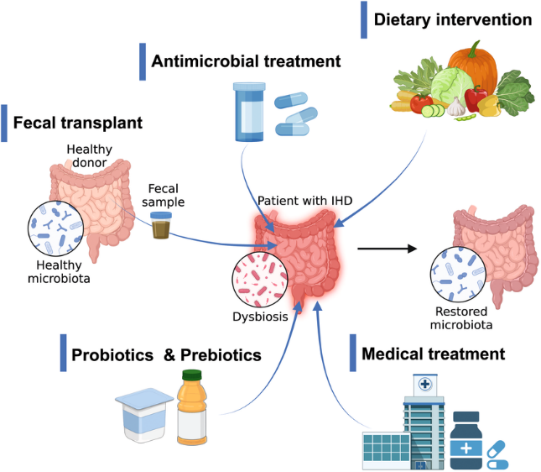

Figure : Gut microbiome‐targeted interventions in humans with ischemic heart disease (IHD). For general restoration of microbial composition and functions, there are interests in testing the microbiome‐targeted interventions on the disrupted microbiome of IHD patients.

(Source: Adapted from [Fan Y.et al., 2023], ResearchGate, [Year], URL: <https://www.researchgate.net/>... )

**5. Challenges and Future Directions:**

While the field of gut microbiome and infectious diseases is rapidly advancing, several challenges and future directions warrant consideration.

* **Causality vs. Association:** Establishing causal relationships between specific microbiome alterations and infectious disease outcomes remains a significant challenge. While observational studies have demonstrated strong associations, interventional studies (e.g., FMT, probiotics) providing more direct evidence of causation are needed for many infections beyond CDI.
* **Microbiome Complexity and Individual Variation:** The gut microbiome is incredibly complex, and its composition varies significantly between individuals due to genetics, diet, environment, and other factors. Personalized microbiome-based therapies, taking into account individual microbiome profiles and disease contexts, are a future goal.
* **Mechanism Elucidation:** While we have identified several key mechanisms by which the microbiome influences infections, a deeper understanding of the precise molecular interactions and signaling pathways is crucial for developing targeted therapeutic strategies.
* **Long-term Effects and Safety:** Long-term effects and safety considerations for microbiome-based therapies, particularly FMT and probiotics, need further investigation, especially in vulnerable populations.
* **Standardization and Regulation:** Standardization of microbiome-based therapies, particularly FMT and probiotic products, and regulatory frameworks for their clinical use are needed to ensure safety and efficacy.

**Table 4. Challenges and Future Directions**

|  |  |
| --- | --- |
| Challenge | Details |
| Causality vs. Association | Need for interventional studies to establish causal relationships. |
| Individual Variation | Personalized therapies based on individual microbiome profiles. |
| Mechanism Elucidation | Deeper understanding of molecular interactions and signaling pathways. |
| Long-term Effects/Safety | Further investigation needed for vulnerable populations. |
| Standardization/Regulation | Ensure safety and efficacy of microbiome-based therapies. |

**6. Conclusion:**

The gut microbiome plays a critical and multifaceted role in infectious diseases, influencing host susceptibility, infection severity, and treatment outcomes. The mechanisms involve complex interactions, including barrier function reinforcement, immune system modulation, and direct effects on pathogen virulence. Dysbiosis can disrupt these protective mechanisms, increasing vulnerability to a wide range of infections. Microbiome-targeted therapies, such as FMT, probiotics, prebiotics, synbiotics, postbiotics, and phage therapy, hold considerable promise for preventing and treating infectious diseases. Future research should focus on elucidating precise mechanisms, addressing challenges related to causality and individual variation, and developing standardized and safe microbiome-based interventions to translate the exciting potential of microbiome science into improved patient care and public health.

**References:**

Sender, R., Fuchs, S., & Milo, R. (2016). Revised Estimates for the Number of Human and Bacteria Cells in the Body. PLoS Biology, 14(8), e1002533.

Hooper, L. V., & Macpherson, A. J. (2010). Immune adaptations to the gut microbiota. Nature Reviews Immunology, 10(3), 159–174.

Carding, S., Verbeke, K., Vermeire, S., Walter, J., Valdés, A. M., & Sanz, Y. (2015). Dysbiosis of the gut microbiota in disease. Nature Reviews Gastroenterology & Hepatology, 12(4), 177–192.

Belkaid, Y., & Hand, T. W. (2014). Role of the microbiota in immunity and human disease. Cell, 157(1), 121–141.

Buffie, C. G., & Pamer, E. G. (2013). Microbiota-mediated colonization resistance against intestinal pathogens. Nature Reviews Immunology, 13(11), 790–801.

Groschwitz, K. R., & Hogan, S. P. (2009). Intestinal barrier function: molecular regulation and disease pathogenesis. Journal of Allergy and Clinical Immunology, 124(1), 3–20; quiz 21-22.

Kamada, N., Seo, S. U., Chen, G. Y., & Núñez, G. (2013). Role of the gut microbiota in immunity and inflammatory diseases. Nature Reviews Immunology, 13(5), 321–335.

Corr, S. C., Hill, C., & Gahan, C. G. M. (2009). Gut bacteria and bacteriocins. FEMS Microbiology Letters, 297(1), 1–9.

Macfarlane, G. T., & Macfarlane, S. (2003). Physiology of short-chain fatty acid production in the human large intestine. Advances in Microbial Physiology, 44, 165–225.

Round, J. L., & Mazmanian, S. K. (2009). The gut microbiota shapes intestinal immune responses and area-restricted disease. Nature Reviews Immunology, 9(5), 313–323.

Netea, M. G., Joosten, L. A. B., Latz, E., Mills, K. H. G., Natoli, G., Stunnenberg, H. G., … & O’Neill, L. A. J. (2016). Trained immunity: A program of innate immune memory in health and disease. Science, 352(6284), aaf1098.

Gensollen, T., Iyer, S. S., Kasper, D. L., & Blumberg, R. S. (2016). How colonization by microbiota in early life shapes the immune system. Science, 352(6282), 1100–1104.

Ivanov, I. I., & Littman, D. R. (2010). Segmented filamentous bacteria take the stage. Mucosal Immunology, 3(1), 21-28.