**DEVELOPMENT AND PERFORMANCE EVALUATION OF BIO-DIGESTER FOR METHANE PRODUCTION USING COW DUNG**

Rilwanu O. Agede1; Joy O. Nwokolo-ojo1; Onyilo, R. Ivogbe1; Akwonya, C. Adadu1

1 Department of Industrial Technology, Faculty of Technology and Industrial Studies, Benue State University Makurdi, Benue State, Nigeria

**ABSTRACT**

A cost-effective bio-digester was explored to convert biological waste into useful clean households’ energy. The aim of the study was to develop Biofuel System using 60 litres digester from Methane for biogas production. The bio-digester was designed and developed. The cow dung being the raw material for the production of biogas was obtained from Lafia Abattoir, Lafia Local Government Area of Nasarawa State and transported to Mechanical and Chemistry laboratory of Benue State University, Makurdi, for processing and biogas production. The collected fresh cow dungs were loaded with water into the digester and was properly air-tight. The mixtures were allowed in the biodigester for 1 month. The biogas digester produced an average of 0.50 m3 of biogas per day, with a methane content of 60–65%. The developed biogas digester was simple, cost effective, and easy to operate. The interlocking drum provided stability and safety, while the readily available materials made the digester accessible for the production of the gas and the produced gas is stored in the tube. In conclusion, a 60 litres bio-digester was successfully designed and constructed for the production of biogas for economic and waste management using locally available cow dung material in Nigeria. It is recommended that increased development or procurement of bio-digester be considered in order to ease households cooking by using the produced gas.

**Keywords: Biofuel System, Methane production, Cow dung, Performance, Digester**

**INTRODUCTION**

The world energy consumption is considerably increasing in recent times. This may be as a result of population growth and the industrial development yet the use of fossil fuels is still the main energy sources (Kumar et al., 2024). However, normal fuels are not renewable energies, further, they are highly polluting and their production tends to decrease during the next few decades (Moses and Oludolapo, 2022). In spite of that, the increased energy consumption based on normal fuels affects our environment through the greater amounts of gas emissions, the environmental pollution of water, air and soil, and the climate changes, which dramatically influence the quality of life and the health of people (Nuhu et al., 2024).

The fast population growth, industrialization, and change in human living styles are the fundamental reasons behind the increasing demand and the present energy crisis. These problems have led researchers to seek alternative energy sources to our existing carbon-based energy sources (Sarkodie, 2022). These alternatives incorporate hydropower, solar energy, wind energy geothermal energy, nuclear energy, and bioenergy (biofuels) resources. KeChrist et al. (2020) reported that biofuels are the best alternatives, especially for Africa, due to the continent’s enormous biomass potential of all the enumerated alternative energy resources (Shanab et al., 2022). Biofuels are usually liquid and gaseous fuels, which can be derived from agricultural yields, animal wastes and municipal (domestic and industrial) wastes (both solid and wastewater). Similarly, human geography studies show that robust economic distributional influences can happen due to biofuel utilization (Verstraete et al., 2021). Thus, the enthusiasm for biofuel development has been growing and has established remarkable attention in present-day as the best alternative replacement of fossil fuels, especially in transportation and power generation sectors (Okafor et al., 2022). Correspondingly, due to their environmental recognition, and scope of seen benefits, biodiesel and methane are considered as viable alternatives to conventional diesel and petrol fuels (Jekayinfa et al., 2020). Due to the above mentioned and other several supposed advantages, many countries are promoting their sustainable use. Similarly, Nigeria, as a net oil importer country and having an enormous agricultural base, has started developing biofuels with an aspiring goal.

However, Internationally, the biofuel sector is greatly influenced by national policies whose major objectives are to support the farmer, minimize green-house gas emission, and enhance energy independence (Organization for Economic Co-operation and Development and Food and Agriculture Organization of the United Nations, 2021). According to FAO (2019), Nigeria National Petroleum Corporation was issued a directive on an Automotive Biomass Programme for Nigeria by the Federal Government of Nigeria to provide enabling environment for the establishment of fuel methane industry in-country in order to minimize the dependence on the importation of gasoline and environmental pollution, improve the quality of automotive fossil-based fuels, and create jobs. This was envisaged to integrate the agricultural sector of the economy with the downstream petroleum sector. In addition, the programme was anticipated to provide revenue to the country, provide enabling environment to attract foreign investors, increased yield and production of agricultural products, and reduction in greenhouse gas (GHG) emission (Nwozor et al., 2021). The first phase of the programme involves importation of fuel methane and blending of about 10 % with gasoline leading to the production of E-10 (The process of mixing ethanol with gasoline to create fuel that is 10% ethanol and 90% gasoline). The second phase is the production of biofuel in-country and it was expected to run concurrently with the first phase. With a blending ratio of 10 %, up to 1.3 billion litres was required for the country and the quantity was anticipated to increase to approximately 2 billion litres in 2020 (Nuhu et al., 2024). The blending ratio of biodiesel was 20 % with a corresponding quantity of 480 million litres which was anticipated to increase to about 900 million litres by 2020. This second phase was expected to achieve 100 % domestication of biofuel production in Nigeria by 2020 (Nwozor et al., 2021).

In an attempt to implement the policy, the Nigerian National Petroleum Corporation (NNPC) secured 70,000 Euros from the Renewable Energy, Energy Efficiency Partnership (REEEP) from Germany as a grant to conduct feasibility studies for the establishment of biofuel plants at target locations (Oyedepo 2015). The Corporation carried out the studies on bio-methane production with cassava and sugarcane as feed stocks, and on biodiesel production using palm oil as feedstock. In addition, it also attracted investors and the construction of about twenty bio-methane factories commenced some years back with fourteen others in view (Olanrewaju et al., 2019). Unfortunately, information regarding the progress and operation of the biofuel factories is lean in the public domain, and are contained mostly in the newspaper. There has not been any report in the annual reports of Nigeria’s Bureau of Statistics, Central Bank of Nigeria and was not contained in the Nigeria Economic Recovery and Growth Plan 2017-2020 (Okafor et al., 2022).

However, NNPC according to Ohimain, (2013), have made some progress by installing biofuel handling facilities in some of the depots of the Corporation and selected outlets, staff training and developing quality assurance guidelines for biofuel production and importation through the help of the Standard Organization of Nigeria (SON), and public enlightenment (Ohimain, 2013). Despite these achievements, it is speculated that the government has not shown substantial commitments towards the actualization of a biofuel economy through the biofuel policy after fifteen years of adopting the policy. This is evidenced in its inability to establish the Biofuels Energy Commission and the Biofuels Research Agency which are reposed with the responsibilities of implementing the policy (Nwozor et al., 2021).

A study was carried out by Modestus et al. (2020) on the design and development of a biodigester for production of biogas from dual waste. The researchers used semi-structured interview protocol to generate data from 15 participants who live and engage in small businesses requiring electricity supply. Data obtained from the participants was transcribed, coded, and categorised to yield results of the study. The results of the preliminary enquiry revealed that various sources of alternative energy were being sought after by residents and owners of small scale enterprises due to exorbitant cost of the erratic supply of electricity provided by the National Grid. For example, petrol and gas generators, solar panels and batteries, among others. In essence, excessive hardship is being experienced by people living in respective communities of the State due to unreliable supply of electricity from the National Grid. After the product need assessment, it was established that there is need for the design and production of the Biofuel System (60 litres Digester for Methane Gas production) which the present study intends to develop. This conception rhythm with the work of researchers like Jekayinfa *et al*. (2020) who conducted a study titled Experimental Study of Biogas Production from Cow Dung as an Alternative for Fossil Fuels.

**MATERIALS AND METHODS**

**Research Design**

The design of this study is quantitative because it will be experimental in nature. Experimental design is the process of carrying out research in an objective and controlled fashion so that precision is maximized and specific conclusions can be drawn regarding a hypothesis statement. (Peter et al., 2017).

**Sample Collection:** The fresh cow dung being the raw material for the production of biogas was obtained from Lafia Abattoir, Lafia Local Government Area of Nasarawa State and transported to Mechanical and Chemistry laboratory of Benue State University, Makurdi, Benue State for processing and biogas production.

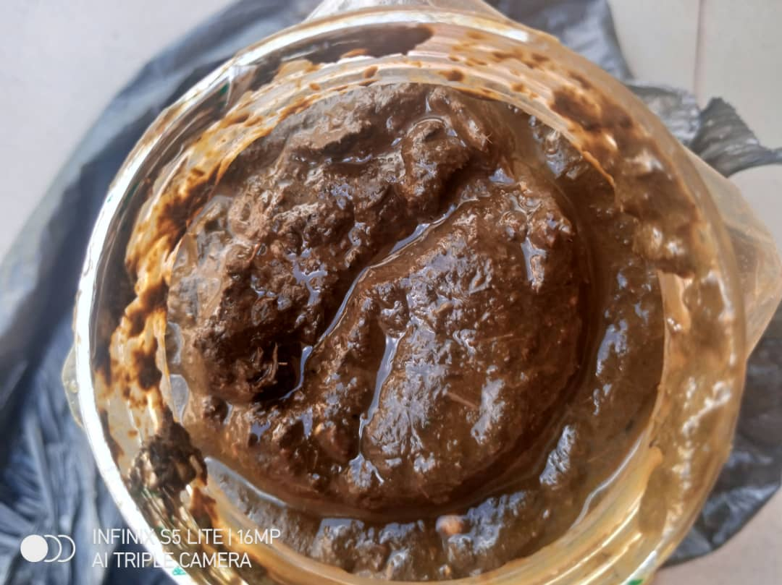

**Plate 1: The cow dung being the raw material for the production of biogas**

**Design Considerations**

Primarily, the following parameters were put into considerations:

1. **Material selection:** The materials needed for the construction of the bio-digester and the production of the gas must be assembled and compatible for the purpose of the study.
2. **Type of design:** This must be put into consideration because there are several models and type of bio-digester with several purposes. This particular design must be able to fit in to the purpose of the study.
3. **Quality Slurry:** This is the residue of inputs that comes out from the outlet after the substrate is acted upon by the methanogenic bacteria in an anaerobic condition inside the digester.
4. **Size and weight of the bio-digester:** The main function of this structure is to provide anaerobic condition within it. As a chamber, it should be air and water tight. It can be made of various construction materials and in different shape and size. The easy movement of the bio-digester is an important factor, so that anywhere the machine will be needed, it can be easily conveyed to the place.
5. **Ease of operation:** The bio-digester was designed in a way that it will be easy for assemble, disassemble and loading of the selected materials.
6. **Efficiency:** The design will be effective and productive for domestic, industrial, and agricultural purposes.
7. **Low cost:** The bio-digester construction and the production of the gas will provide an alternative cheaper fuel or gas that will be use for domestic purpose etc

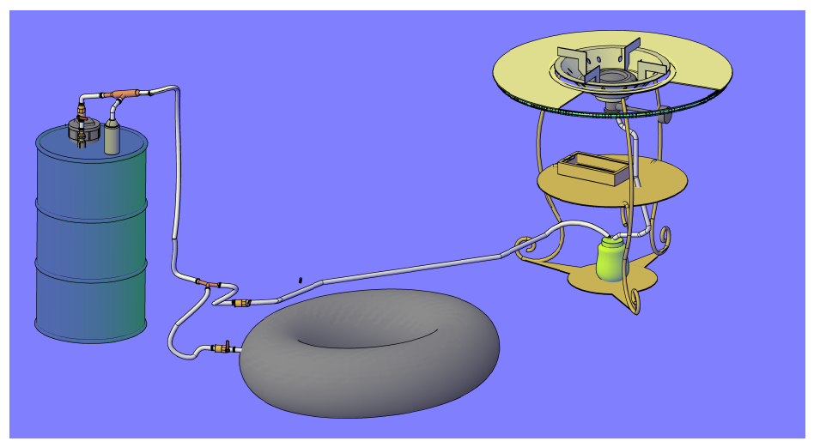

**Plate 2. Developed Bio-Digester coupled with Gas Chamber, hose and control valve**

**Introduction of Cow Dung as Feedstock for Slurry**

Cow Dung feedstock contains – 50 - 75 % of methane Gas, CH4, 25 – 50% of carbon dioxide, CO2, Water vapour, H2O, Hydrogen sulfide, H2S, Oxygen, O2 and Nitrogen etc. In comparison to other organic feedstocks like donkey dung, pig dung, human faeces, urine, vegetable/fruit matter and poultry dung, cow dung feedstock has a Carbon to Nitrogen ration of 30:1 making it the best feedstock that is reliable, durable and sustainable for any household or industrial complex application. The elaboration of the slurry is done in a ratio of 1:1 between organic feedstock and ordinary water from a well, river or stream. The temperature for fermentation of the slurry in a chosen air tight container is between 35 – 370 centigrade. The gestation period for slurry or bacteria fermentation for cow dung feedstock is 14 – 30 days. For other feedstock is 7 days.

**Production of the Methane**

The collected fresh cow dungs were loaded with water into the digester, foreign materials were carefully removed. The substrate was formed in two treatments. The first mixture contained 5 kg cow dung and 10 kg of water were mixed thoroughly in order to homogenize the substrates (ratio 1:1 of the substrate and water). The mixture was introduced into the digester. In other to catalyze the anaerobic digestion of the slurry. The mixture was also introduced into the digester that was properly to ensure air-tightness. After loading, the substrate was not stirred since the digester was sealed. This was because opening the digester would give way for air to enter the system, thus truncating the gas formation process for the period of 1 month.

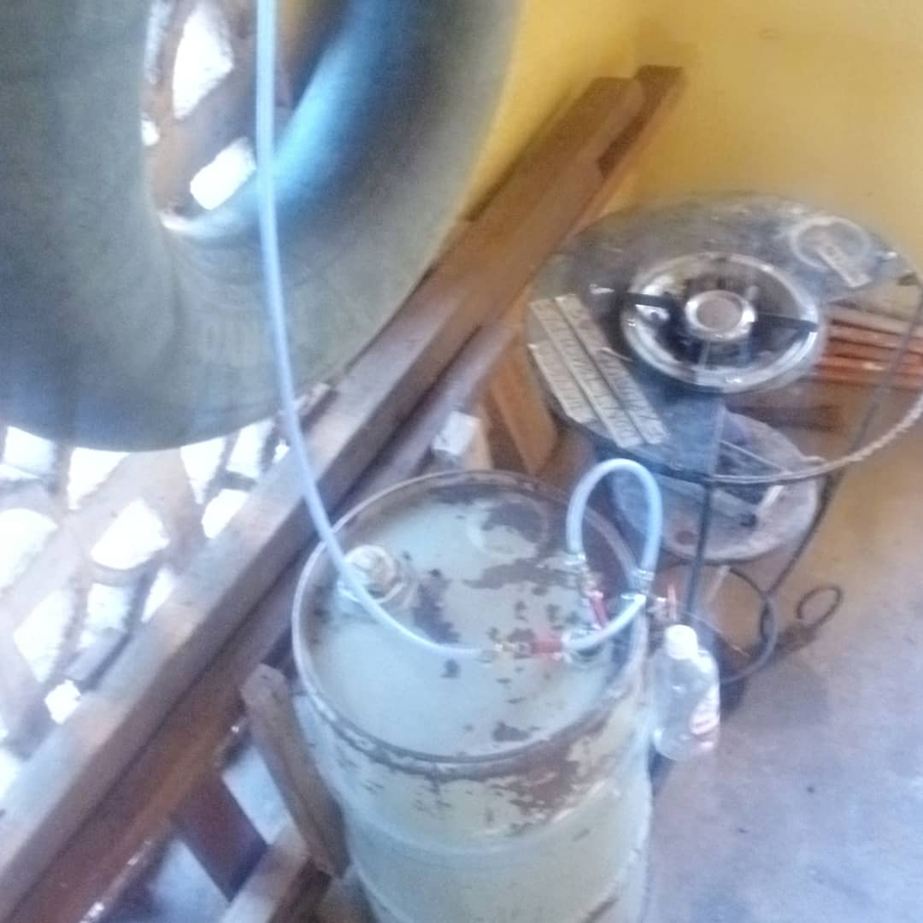

**Plate 3. Biogas Sample Being Collected in a Tube**

**RESULTS AND DISCUSSION**

**Gas and methane production Using a Biodigester**

The developed biogas digester was simple, cost effective, and easy to operate. The interlocking drum provided stability and safety, while the readily available materials (cow dung) made the digester accessible for the production of the gas and the produced gas is stored in the tube. The biogas digester produced an average of 0.50 m3 of biogas per day, with a methane content of 60–65%. The gas complied with standard cooking gas specifications in terms of chemical composition, sulfur content, hydrogen sulfide content, and calorific value. The biogas production rate was influenced by the feedstock composition and ambient temperature. Higher organic waste content and warmer temperatures led to increased gas production (Nuhu et al., 2024).

**Testing of the Biogas Using the Biodigester**

Done by boiling 600 liters of cold water in a 1200 liters pot for 4 tea cups of 150 liters each for 4 people each or 2 tea cups of 300 liters for 2 people respectively.

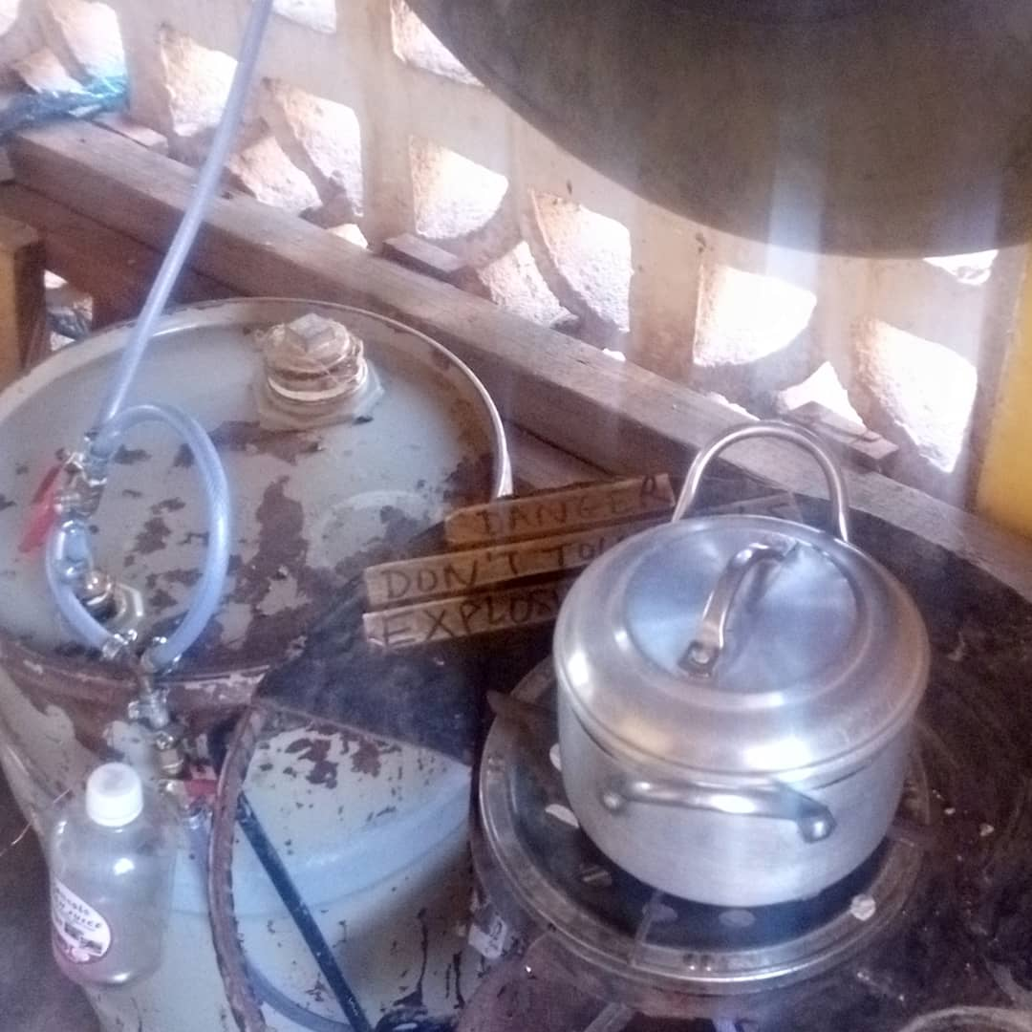

**Plate 4: Testing of the Biogas Using the Biodigester**

These results indicate that the digester can effectively generate clean biogas suitable for domestic cooking. This is in line with the work of Okafor *et al*. (2022). It was observed that the bio-gas was able to produce a very suitable heat that can cook very well and faster. It is also observed from the results obtained that biogas production for all the treatments went on smoothly with limited disruption, perhaps due to the fact that the experiment was conducted in a relatively constant condition where no significant temperature changes were noticed throughout process thereby permitting an approximate stability of micro-organisms activities within the system. The ability to maintain relatively constant temperature and pressure also helped in stabilizing the biogas production in all the treatments (Nwozor et al., 2021). This was done by keeping the digester in an enclosure where temperature can be controlled and maintained as much as possible as the ambient to minimize temperature migration as suggested by Nimame and Iyama (2021). Similarly, the substrates contained adequate amount of carbon and nitrogen and a number of trace elements that leads to high biogas production. This could be as a result of the available nutrient in the digestrates (Moses and Oludolapo, 2022). There was also has higher volatile solids content that aids higher biogas formation (Modestus et al., 2020). It was observed in the present study that the digester temperature fluctuated between 28 and 36.7°C while the pH of the medium changed progressively from acidic to slightly alkaline fluctuating optimally between 6.5 and 7.8. The high biogas production could also be attributed to the high content of carbon, oxygen, hydrogen, nitrogen, sulphur, phosphorous, potassium, calcium, magnesium and a number of trace elements in the Cow dung (Kumar et al., 2024). Also, the result shows that cow dung derived content could have attributed to multiplication of microbial organism within the methanogenesis stage. The biogas produced is a function of bacterial growth. The higher and faster biogas generation could be attributed to the faster rate of decomposition of cow dung derived content which have already undergone a form of digestion in the digestive system of the cows (KeChrist et al., 2020). Also, this may be due to higher nitrogen content in poultry droppings as compared to other feedstocks. The higher biogas production from poultry droppings could also be attributed to the available nutrient in the droppings (Adaramola and Oyewola, 2020). Providing adequate mixing facilities can reduce the scum formation during anaerobic digestion. Biogas production from poultry manure of large farms is an ecologically and economically effective technology. Greater percentage of carbon oxygen demand (COD) reduction can take place with larger biogas volume produced for every proportion of degraded organic matter. This is in collaboration with the work of Ajieh *et al.* (2020).

**Conclusion**

A 60 litres bio-digester was successfully designed and constructed for the production of biogas for economic and waste management using locally available cow dung material in Nigeria. Cow dung was used as feed stocks in varying ratios of 1:1. Proximate analyses of the feed stocks was done to ascertain their suitability for gas production. Maximum gas production was obtained from 1:2 slurry ratio suggesting the importance of moisture in facilitating fermentation. It produced clean biogas suitable for cooking, offering a sustainable alternative to fossil fuels and contributing to reduced deforestation and greenhouse gas emissions. The abundant availability of animal manure in Nigeria, particularly from cow dung, makes it an attractive and cheap source of raw material for biogas production which could be commercialized and made available to both rural and urban dwellers.

**Recommendations**

1. Optimize digester design for increased biogas production: This could involve exploring alternative feedstocks, temperature and moisture control mechanisms, and improved gas collection and storage systems.
2. More attention should be given to animal dung as feedstock for anaerobic digestion plants.
3. Production of biogas from dung is not a dream anymore but a reality, other researchers should focus on using the gas for generation of electricity.
4. If the biogas produced is going to be used to run engines, it has to be cleaned because it contains impurities that can damage engines.
5. Collaborate with stakeholders: Partnering with government agencies, NGOs, and private companies can facilitate funding, distribution, and technical support for successful implementation.
6. Promote policy incentives: Advocating for government policies that incentivize renewable energy solutions can further encourage the adoption and scale-up of mini-biogas digesters.

**Contribution To Knowledge**

This study has established the use of cow dung as suitable feedstocks for biogas production, waste management and cost-saving enterprise.

**Conflicts of Interest:** The authors declare no conflict of interest

**REFERENCES**

Adaramola, M. S., and Oyewola, O. M. (2020). Wind Speed Distribution and Characteristics in Nigeria. *ARPN Journal of Engineering and Applied Sciences,* 6(2), 82-86. Retrieved March 5, 2013 from [www.Arpnjournals.Com/Jeas/Research_Papers/Rp.../Jeas_0211_45 8.Pdf](http://www.Arpnjournals.Com/Jeas/Research_Papers/Rp.../Jeas_0211_45%20%098.Pdf).

Ajieh, M. U., Ogbomida, T. E., Onochie, U. P., Akingba, O., Kubeyinje, B. F., Orerome, O. R., and Ogbonmwan, S. M. (2020). Design and construction of fixed dome digester for biogas production using cow dung and water hyacinth. *African Journal of Environmental Science and Technology*, 14(1), 15-25

Anjum M, Qadeer S, Khalid A (2018). Anaerobic Co-digestion of Catering and Agro-Industrial Waste: A Step Forward Toward Waste Biorefinery. *Frontiers in Energy Research,* 6, 116. doi: 10.3389/fenrg.2018.00116

FAO (2019). Ranking of Countries that produce the most cassava. FAOSTAT. Org.

Jagadish HP, Malourdu AR, Muralidhara PL, Desai SM, Mahadeva Raju GK (2012). Kinetics of Anaerobic Digestion of Water Hyacinth Using Poultry Litter as Inoculum. *International Journal of Environmental Science and Development,* 3(5), 94-98.

Jekayinfa, S. O., Orisaleye, J. I., and Pecenka, R. (2020). An assessment of potential resources for biomass energy in Nigeria. *Resources,* 9(8), 92.

KeChrist, O., Sampson, M., Edson, L. M., Golden, M., and Nwabunwanne, N. (2020). Design and Fabrication of a Plastic Biogas Digester for the Production of Biogas from Cow Dung. *Hindawi Journal of Engineering,* Volume 2020, Article ID 1848714, 11 pages <https://doi.org/10.1155/2020/1848714>

Kumar V, Singh J, Nadeem M, Kumar P, Pathak VV (2018). Experimental and kinetics studies for biogas production using water hyacinth (Eichhornia crassipes [Mart.] Solms) and sugar mill effluent. *Waste and Biomass Valorization*, <https://doi.org/10.1007/s12649-> 018- 0412-9, (ISSN: Online: 1877-265X; Print: 1877-2641).

Kumar, J. P., Ranjeet, K. M., Sampath, C., Prakash, B., and Naveen, D. (2024). A comprehensive study on anaerobic digestion of organic solid waste: A review on configurations, operating parameters, techno-economic analysis and current trends. *Biotechnology Notes*, 5, 35-49

Kumar, S., Smith, S. R., Fowler, G., Velis, C., Kumar, S. J., Arya, S. R., Kumar, R., and Cheeseman, C. (2017). Challenges and opportunities associated with waste management in India. *Royal Society Open Science,* 4(3),1-11

Ministry of Budget and National Planning (2017). Nigeria economic recovery and growth plan. 2017- 2020.

Modestus, O. O., Olusegun, D. S., Omonigho, B. O., Promise, P. B., Ogugu, J. T., and Ebenezer, O. (2020). Design and development of a bio-digester for production of biogas from dual waste. *World Journal of Engineering,* 17(2), 247–260

Mohamed, M. A., Nourou, D., Boudy, B., and Mamoudou, N. (2018). Theoretical models for prediction of methane production from anaerobic digestion: A critical review. *International Journal of Physical Sciences*, 13(13), 206-216

Moses, J. B. K. and Oludolapo, A. O. (2022). Biogas Production and Applications in the Sustainable Energy Transition. *Hindawi Journal of Energy*, Volume 2022, Article ID 8750221, 43 pages <https://doi.org/10.1155/2022/8750221>

Nigeria National Petroleum Corporation (2007). Official Gazette of the Nigerian bio-fuel policy and incentives, NNPC.

Nigerian National Petroleum Corporation Bio-Methane Project (NNPC) (2005). Nigeria to Earn US $150m from Biofuels Intiatives. Accessed http://www.nnpcgroup.com/ news/biofuels.html.

Nimame, P. K. and Iyama, W. A. (2021). Evaluation Of Biogas Production Using Cow Dungs. *Journal of Multidisciplinary Engineering Science and Technology (JMEST),* 8(4), 13796- 13803

Njogu P, Kinyua R, Muthoni P, Nemoto Y (2015). Biogas Production Using Water Hyacinth (*Eicchornia crassipes*) for Electricity Generation in Kenya. *Energy and Power Engineering,* 7(5), 209

Nuhu, A., Abubakar, A. S., Ahmad, S. A., and Sani, A. A. (2024). Fabrication of Mini Bio-Gas Digester using Locally Available Material for Cooking Purposes. *FUOYE Journal of Engineering and Technology*, 9(2), 151-154

Nwozor, A., Owoeye, G., Olowojolu, O., Ake, M., Adedire, S., and Ogundele, O. (2021). Nigeria’s quest for alternative clean energy through biofuels: an assessment. In IOP Conference Series: *Earth and Environmental Science*, 655 (1), 12-54. IOP Publishers.

Nwozor, A., Owoeye, G., Olowojolu, O., Ake, M., Adedire, S., and Ogundele, O. (2021). Nigeria’s quest for alternative clean energy through biofuels: an assessment. In IOP Conference Series: *Earth and Environmental Science*, 655 (1), 12-54. IOP Publishers.

OECD, and Food and Agriculture Organization of the United Nations. (2021). OECD-FAO Agricultural Outlook. 2021–2030.

OECD, and Food and Agriculture Organization of the United Nations. (2021). OECD-FAO Agricultural Outlook. 2021–2030.

Ohimain, E. I. (2013). Can the Nigerian biofuel policy and incentives (2007) transform Nigeria into a biofuel economy? Energy Policy, 54(20), 352-359.

Okafor, C. C., Nzekwe, C. A., Ajaero, C. C., Ibekwe, J. C., and Otunomo, F. A. (2022). Biomass utilization for energy production in Nigeria: A review. Cleaner Energy Systems, 100043.

Oyedepo, S. O. (2015). On energy for sustainable development in Nigeria. Renewable and sustainable energy reviews, 16(5), 2583-2598.

Saleh, A., and Sillah I. U. (2022). Development and Performance Evaluation of Bio-Digester Using Cow Dung and Elephant Grass (*Pennisetum purpureum Schumach*). *Nigerian Journal of Engineering Science Research (NIJESR)*, 5(1): 55-64

Sarkodie, S. A. (2022). Winners and Losers of Energy Sustainability-Global Assessment of the Sustainable Development Goals. Science of the Total Environment. 831. 154945.Bibcode:2022ScTEn.831o4945S.doi:10.101 6/j.scitotenv.2022.154945. ISSN 0048-9697. PMID 35367559. S2CID 247881708

Shanab SM, Hanafy EA, Shalaby EA (2022). Water hyacinth as non-edible source for biofuel production. *Waste and Biomass Valorization,* https://doi.org/10.1007/s1264 9-016-9816- 6.

Shubham, S., and Shubh, K. Y. (2022). Study and Analysis of Biogas Production from Sewage Treatment Plant and Design Anaerobic Digester*. International Research Journal of Engineering and Technology (IRJET), 0*9(03), 237- 245

Surendra KC, Takara D, Hashimoto AG, Khanal SK (2020). Biogas as a sustainable energy source for developing countries: Opportunities and challenges. *Renewable and Sustainable Energy Reviews,* 3(6), 846- 859.

Verstraete W, Morgan-Sagastume F, Aiyuk S, Waweru M, Rabaey K, Lissens G (2021). Anaerobic digestion as a core technology in sustainable management of organic matter. *Water Science and Technology,* 52(1-2), 59-66.

**APPENDIX**

**Table A1:** **The tools and materials that will be used are:**

|  |  |  |  |  |
| --- | --- | --- | --- | --- |
| **S/N** | **Materials** | **Quantity** | **Specifications** | **Selection criteria** |
| 1 | Metal drum Bio-digester | 1 | 60 Litres | Cost effective |
| 2 | Metal drum rigid cover | 1 | 3 inch | Workability |
| 3 | Brass gas intake valve | 1 | ½ inch | Cost effective |
| 4 | Metal barrel slurry excess gauge | 1 | ½ inch | Cost effective |
| 5 | Maintenance/slurry outlet | 1 | ½ inch | Cost effective |
| 6 | Slurry intake funnel | 1 | 1 ft | Cost effective |
| 7 | Metal barrel tube (non-compressed) | 1 | R-20 | Cost effective |
| 8 | Metal T-Junction | 1 | ½ inch | Cost effective |
| 9 | Iron clips | 1 |  | Cost effective |
| 10 | Flexible Metal barrel Pipe | 1 | ¼ inch | Cost effective |
| 11 | Brass Male Socket (reduction type) | 1 | ¼ inch | Cost effective |
| 12 | Galvanized Iron Disc | 1 | 45.5 cm | Cost effective |
| 13 | Topped Universal Cooker | 1 | 45.5 cm | Corrosion resistance, Cost effective |
| 14 | Chromated colour burner | 1 | 21.3 cm | Cost effective |
| 15 | Burner on/off valve | 1 | ½ inch | Cost effective |
| 16 | Gas pipe adopter for burner | 1 | ½ inch | Cost effective |
| 17 | Adjustment/Safety valves | 1 | ½ inch | Cost effective |
| 18 | Stand for burner | 1 | 10 mm | Cost effective |
| 19 | Glass filter | 1 | 12 by 6 cm | Cost effective |
| 20 | Flexible pipe | 2 | ¼ inch | Cost effective |
| 21 | Weigh Balance | 1 | Camry 20kg capacity and 0.001g sensitivity |  |
| 22 | Thermometer | 1 |  |  |
| 23 | pH Meter | 1 | HI9610 |  |
| 24 | Mortar and Pestle | 1 |  | Used for size reduction for better digestion of the slurry |

**Source: Compiled by the Researcher**

**Table A2:** **Cost of Production**

|  |  |  |  |  |
| --- | --- | --- | --- | --- |
| **S/N** | **Materials** | **Quantity** | **Rate** | **Cost** |
| 1 | Plastic tank Digester | 1 | 50,000 | 50,000 |
| 2 | Brass rigid cover | 1 | 5,000 | 5,000 |
| 3 | Brass gas intake valve | 2 | 1,500 | 3,000 |
| 4 | Metal barrel slurry excess gauge | 1 | 1,000 | 1,000 |
| 5 | Maintenance/slurry outlet | 1 | 1,000 | 1,000 |
| 6 | Slurry intake funnel | 1 | 2,000 | 2,000 |
| 7 | Tyre tube (non-compressed) | 1 | 10,000 | 10,000 |
| 8 | Metal barrel T-Joint (Female socket) | 1 | 400 | 400 |
| 9 | Iron clips | 1 | 300 | 300 |
| 10 | Flexible PVC Pipe | 1 | 1,500 | 1,500 |
| 11 | Brass Male Socket (reduction type) | 1 | 1,000 | 1,000 |
| 12 | Galvanized Iron Disc Topped Universal Cooker | 1 | 2,000 | 2,000 |
| 13 | Chromated colour burner | 1 | 5,000 | 5,000 |
| 14 | Burner on/off valve | 1 | 1,500 | 1,500 |
| 15 | Gas pipe adopter for burner | 1 | 500 | 500 |
| 16 | Adjustment/Safety valves | 1 | 1,500 | 1,500 |
| 17 | Stove steel Stand for burner | 1 | 5,000 | 5,000 |
| 18 | Glass filter | 1 | 2,000 | 2,000 |
| 19 | Flexible pipe | 2 | 2,000 | 2,000 |
| 20 | Paint | ½ gallon | 7,000 | 7,000 |
| 21 | Fuel | 4 litre | 5,000 | 5,000 |
| 22 | Transportation and contingency |  | 100,000 | 100,000 |
|  | **TOTAL** |  |  | **206,600** |

**Source: Compiled by the Researcher**