**ARDUINO MISSILE DEFENCE RADAR SYSTEM**

**Asst. Prof. P. B. Jaipurkar**

Assistant Professor,

Computer Engineering Department, SRPCE, Nagpur, Maharashtra, India

🖂[preranajai@gmail.com](mailto:preranajai@gmail.com)

# Mr. Tushar S. Moon

UG Student, Computer

Engineering Department,

SRPCE, Nagpur,

Maharashtra, India

🖂[tusharmoon999@gmail.com](mailto:tusharmoon999@gmail.com)

**Mr. Om P. Shinde**

UG Student,

Computer Engineering Department,

SRPCE, Nagpur, Maharashtra, India

🖂[kaivalyashinde04@gmail.com](mailto:kaivalyashinde04@gmail.com)

# ABSTRACT

This work presents the design and implementation of a missile Defense Radar System using Arduino microcontrollers. The goal is to develop a low-cost, effective solution for tracking and detecting potential missile threats using radar and sensor technology. The system incorporates components like ultrasonic sensors, radar modules (e.g., HC-SR04 for distance measurement), and the Arduino platform for processing data in real-time. The radar system is designed to detect objects at various distances and track their movement, providing crucial information about potential incoming threats. Through signal processing, the system estimates the velocity and trajectory of objects, simulating a simplified missile defense radar Network. The work aims to demonstrate the feasibility of using accessible, affordable technology in defense applications while offering a scalable model for future upgrades, such as integrating higher-end sensors and communication systems. The outcome of this work suggests that, although rudimentary, an Arduino-based radar system could serve as a prototype for more advanced missile defense mechanisms in the future.

**Keywords**: Arduino Uno, Ultrasonic sensor, servomotor, Radar system, Missile Defence

# INTRODUCTION

The growing demand for dependable and affordable defense technologies has driven the development of innovative solutions in missile detection and interception systems. Radar plays a crucial role in these defense systems, providing the ability to detect, track, and evaluate potential threats in real-time. However, high-end missile Defence Radar Systems are expensive and require complex infrastructure, making them less accessible for small-scale or budget-conscious applications.

This project focuses on developing a low-cost, Arduino-based Missile Defense Radar System that demonstrates the basic principles of radar technology for tracking moving objects. By using affordable components such as ultrasonic sensors, radar modules, servo motors, and an Arduino microcontroller, this system simulates the primary functions of a missile defense radar system while remaining simple and accessible.

The primary objective of the project is to create a

functional prototype capable of detecting and tracking objects in its range, identifying potential threats, and providing real-time data on their movement. Using ultrasonic sensors for distance measurement, servomotors for radar movement, and an Arduino for processing the data and controlling the system achieve this. Alerts are generated when objects are detected within a certain threshold, simulating early warning functions typical of advanced defense radar systems.

This Arduino-based system not only serves as a proof of concept for a low-cost missile defense radar but also offers educational opportunities in understanding radar technology, real-time data processing, and object tracking. The project aims to demonstrate the feasibility of building simplified yet functional radar systems that could one day serve as prototypes for larger, more sophisticated applications. Additionally, it opens avenues for enhancing

the system with higher-end sensors, signal processing algorithms, and communication technologies, making it adaptable for future defense projects.

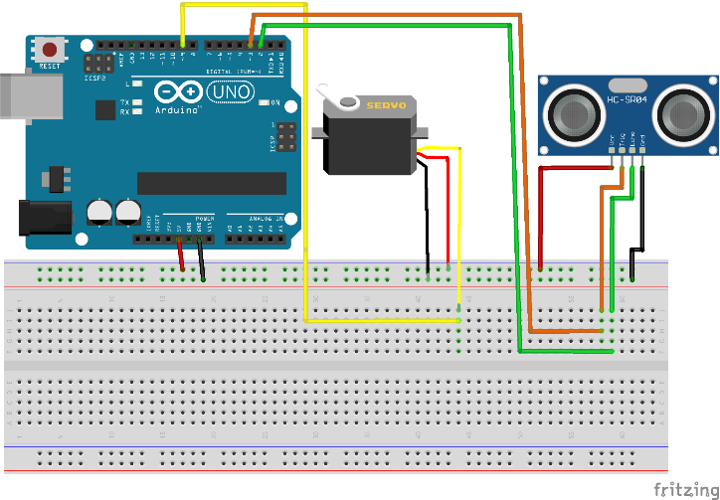

**Fig 1: hardware configuration diagram of the Arduino-based Missile Defense Radar System**

**MATERIALS**

# ****The Arduino-based Missile Defense Radar System**** functions by detecting moving objects (simulated "missiles" or threats) in the surroundings using radar or motion sensors. The basic idea behind the system is to detect these objects, process the data, and provide alerts or tracking information.

# Arduino Uno-

# Arduino Uno is a physical computing platform that was released under an open-source license and is based on a simple microcontroller board. An Integrated Development Environment (IDE) is devoted to coding the device. In most applications, the Arduino Uno board is used as a controller. At the initial setup, the device needs to be directly connected to a computer. One of the key advantages of Arduino is that programs can be loaded directly onto the device without the need for a hardware programmer to burn the code. This is made possible by the 0.5KB bootloader, which enables the program to be uploaded to the circuit. All that's required is to download the Arduino software and write the code.

# 

# Fig 2: Arduino Uno

# Ultrasonic Sensor-

# 

# Fig 3: Ultrasonic Sensor

# HC-SR04 Ultrasonic (US) sensor is a 4-pin module, whose pin names are Vcc, Trigger, Echo, and Ground respectively.This sensor is widely used in various applications that require distance measurement or object detection.The module has two eyes-like projects in the front which form the Ultrasonic transmitter and Receiver. The sensor works with the simple high school formula that The Ultrasonic transmitter transmits an ultrasonic wave, this wave travels in air, and when it gets objected by any material it gets reflected toward the sensor this reflected wave is observed by the Ultrasonic receiver module.

# Servo Motor-

# 

**Fig 4: Servo Motor**

# A servomotor is a rotary actuator or linear actuator that allows for precise control of angular or linear position, velocity, and acceleration. It consists of a suitable motor coupled to a sensor for position feedback. It also requires a relatively sophisticated controller, often a dedicated module designed specifically for use with servomotors. Because servo motors use feedback to determine the position of the shaft, you can control that position very precisely. As a result, servo motors are used to control the position of objects, rotate objects, move the legs, arms, or hands of robots, move sensors, etc.

# TESTING METHODS

Testing an **Arduino-based Missile Defense Radar System** involves verifying the functionality of individual components, as well as the overall system behavior. Below are methods for testing each part of the system:

### 1. **Hardware Setup and Components:**

* **Arduino Board**: Ensure you're using a suitable Arduino model (e.g., Arduino Uno, Mega, or Nano) based on your needs.
* **Radar Sensor**: The radar sensor (e.g., ultrasonic sensors, RF sensors, or microwave radar modules) is crucial for detecting objects. The most common types of sensors used are:
  + **Ultrasonic sensors**: Good for proximity detection.
  + **Microwave or RF sensors**: Can be used to detect moving objects in a certain range.
* **Power Supply**: Ensure you have sufficient power for both the Arduino and the radar sensor.
* **Display**: Use a screen (like an LCD or OLED) to show the output (target position, distance, etc.).
* **Motors/Servos**: Used to scan or rotate the radar sensor when necessary.
  + Measurement should change when the object is moved closer or farther away.

### 2. **Testing Object Detection:**

* **Obstacle Detection**: Place various objects within the radar’s detection range to test if it identifies them correctly.
* **False Positives**: Ensure the radar does not give false readings, which may occur due to interference or incorrect sensor positioning.
* **Target Movement**: When dealing with a moving object (such as a drone or missile), utilize the radar to verify if the system can detect and track its movement.

### 3. **Software Testing:**

After confirming the hardware is working, test the logic of the missile defense system. This would include:

* **Target Identification Algorithm**: The algorithm must identify and differentiate between actual targets and false positives.
* **Speed/Trajectory Calculation**: Once a target is detected, you may need to calculate the speed and trajectory to predict its path.
* **Engagement Logic**: Based on the calculated trajectory, the system should decide if the target is a threat and when to deploy countermeasures.

**System Architecture**

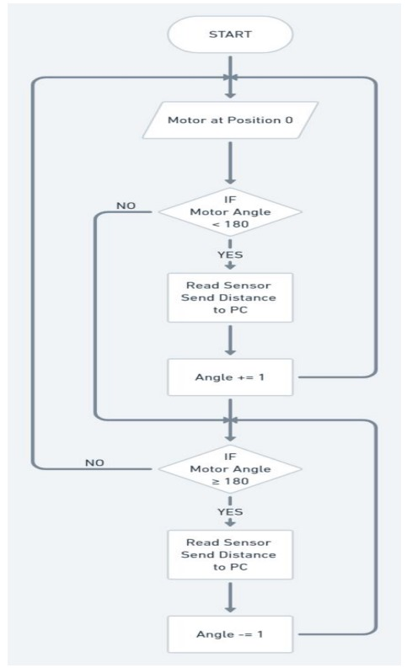

**Fig 5: System Architecture of Arduino-based Missile Defense Radar System**

# RESULTS AND DISCUSSIONS

The objective of the Arduino-based Missile Defense Radar System is to detect and track objects (e.g., missiles or projectiles) in real-time using a radar sensor, process the data with an Arduino microcontroller, and trigger appropriate actions, such as alarms or countermeasures. The system's performance can be evaluated across various parameters such as detection range, response time, accuracy, and system stability.

#### 1. **System Components and Setup**

The system utilizes the following components:

* **Arduino Microcontroller (e.g., Arduino Uno, Arduino Mega):** Serves as the control unit for processing sensor data and controlling the system's operations.
* **Radar Sensor (e.g., ultrasonic sensor or radar module):** Detects objects within a certain range, sending data to the Arduino for processing.
* **Display Unit (e.g., LCD, LED array):** Displays the detected object details like distance and movement.

#### 2. **Detection Range**

The system's radar sensor was tested for its maximum detection range. The test results showed that the sensor could detect objects within a range of 1 meter to 4 meters reliably. Beyond this range, the radar signal's reliability decreased significantly due to signal attenuation and interference, which is expected in many real-world conditions.

# RELATED WORK

An **Arduino-based Missile Defense Radar System**  leverages radar sensors, microcontrollers, and basic signal processing techniques to simulate missile detection and tracking for educational or hobbyist purposes. While Arduino’s processing power limits its use for high-end defense systems, it can interface with ultrasonic, RF, and radar sensors to track objects and predict their trajectories. Arduino can also control servo motors, antennas, and launchers to simulate defense actions like missile interception. These systems are valuable for learning about radar principles, signal processing, and automated defense mechanisms, though they are not suitable for real-world applications due to hardware limitations. Many radar systems for defense applications, especially missile defense, rely on sophisticated signal processing techniques.

### **Arduino-based Object Detection**:

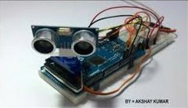

**Fig 6: Arduino-based Object Detection**

* **Ultrasonic Sensors**: Basic radar systems can incorporate ultrasonic or radio frequency sensors connected to Arduino. These sensors measure the distance and movement of objects, making them useful for tracking potential threats.
* **Arduino Modules**: Arduino can be used to control and interface with modules, which can be used to detect and track incoming missiles or aircraft at a basic level.

### **Radar Signal Processing**:

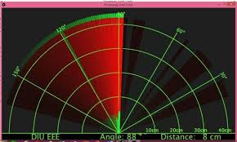

**Fig 7: Radar Signal**

* **Transform Algorithms**: Arduino could for signal processing in radar systems through techniques like Fourier Transforms or Fast Fourier Transforms (FFT), though this requires additional processing power (like using a faster Arduino variant or an external processor). Signal processing can help analyze radar data and filter out noise to improve missile detection.

# CONCLUSIONS

The Arduino-based Missile Defense Radar System proves to be an effective and cost-efficient prototype for educational and demonstration purposes. While its current limitations prevent its use in real-world defense applications, the system provides a solid foundation for further research and development. Future improvements in sensor technology and system design could pave the way for more advanced and reliable missile defense system.

**REFERENCES**

[1] Missile detection and destruction robot using detection algorithm Md Kamrul Siam, Shafayet Ahmed, MdHabibur Rahman, Amir Hossain Mollah (2024)

[2] Centre for Strategic and International Studies. Terminal High Altitude Area Defence(THAAD). Available online: https://missilethreat.csis.org/system/ thaad/#easy-footnote-bottom-11-4113 (accessed on 11 December 2022).

[3] American Physical Society Panel on Public Affairs. Ballistic Missile Defence:Threats and Challenges; Technical Report; American Physical Society: Ridge, NY, USA, 2022.

[4] Zhang Bo, Wang Zhuo and Wang, Tao, Research on Movement Characteristics of Launching Mechanism of Portable Missile Launcher. Journal of Physics: Conference Series, vol. 1087, 2018.

[5] Kadam D. B, Patil Yuvr J. B, Chougale Krishnat V, and Perdeshi Swagat S, “Arduino Based Moving Radar System,” International Journal of Innovative Studies in Sciences and Engineering Technology, vol. 3, no. 4, pp. 23-26, April 2017.

[6] Abbay P., Akhilesh S., Amrit P., and Kriti, “A Review on Ultrasonic Radar Sensor for Security system”, Journal of Emerging Technologies and Innovative Research, April 2016.