**Dracunculiasis: Eradication Efforts, Symptoms, and Prevention of Guinea Worm Disease**

# **Himanshu Patil*1, Turusbekova Akshoola Kozmanbetovna*2, Parpieva Takhmina Makhamatkalylovna*3, Mahima Shahare*4.**

# **Group: 20**

*1,4Final year MBBS student, International Medical Faculty, Osh state University, Osh, Kyrgyzstan

*2Associate professor and Head of the Department of Public Health, International Medical Faculty, Osh state University, Osh, Kyrgyzstan

*3Practical teacher of the Department of Public Health, International Medical Faculty, Osh state University, Osh, Kyrgyzstan

**ABSTRACT**

This report summarizes the status of the global Dracunculiasis Eradication Program as of the end of 2017. Dracunculiasis (guinea worm disease) has been eliminated from 19 of 21 countries where it was endemic in 1986, when an estimated 3.5 million cases occurred worldwide. Only Chad and Ethiopia reported cases in humans, 15 each, in 2017. Infections of animals, mostly domestic dogs, with Dracunculus medinensis were reported in those two countries and also in Mali. Insecurity and infections in animals are the two main obstacles remaining to interrupting dracunculiasis transmission completely.

**METHODOLOGY**

Method and analysis which is performed in your research work should be written in this section. A simple strategy to follow is to use keywords from your title in first few sentences.

**Subheading**

Font size – 14pt, font type- Times New Roman.

**Subheading**

Subheading should be 14pt Times New Roman.

I. **INTRODUCTION**

The Global Dracunculiasis Eradication Program (DEP) has made significant progress in stopping the transmission of Guinea worm disease since the last review five years ago. Dracunculiasis is caused by Dracunculus medinensis and spreads through contaminated drinking water containing infected copepods. Recent evidence suggests that consuming undercooked aquatic animals may also transmit the parasite. The disease is painful, disabling, and economically harmful, though not fatal. There is no vaccine or treatment, but prevention includes public education, water filtration, larvicide application, and providing clean drinking water.

The eradication campaign began at the CDC in 1980 and has been led by The Carter Center since 1986, in partnership with WHO, UNICEF, and national health ministries. Cases have dropped from 3.5 million to a few dozen annually. Although the initial goal to stop transmission by 2009 was not met due to conflicts and outbreaks in some countries, efforts continue to eliminate the disease completely.

In addition to detailing the parasite’s life cycle, the disease, and its epidemiology, our goal here is to outline the key events that built momentum for the eradication campaign, examine the strategies employed, and review the progress made, particularly in the final phase of eliminating this ancient affliction.

**What is Dracunculiasis?**

Dracunculiasis is parasitic. It's a worm that infects the body through pollutedwater. This parasite is aggravating, with so much pain and suffering. Guinea worm disease can be avoided, and this is a fact.

**How is Guinea Worm Contracted?**

Individuals contract Guinea worm disease through the consumption of water. The water harbors small fleas that have Guinea worm larvae. Afterentering your body, the larvae develop. They develop into long, slender worms. It is a painful and slowprocess, but understanding how it occurs makes us prevent it.

II. **LIFE CYCLE OF DRACUNCULIAIS**

**SPECIES**

Humans become infected by drinking unfiltered water containing copepods (small crustaceans) which are infected with larvae of D. medinensis. Following ingestion, the copepods die and release the larvae, which penetrate the host stomach and intestinal wall and enter the abdominal cavity and retroperitoneal space. After maturation into adults and copulation, the male worms die and the females (length: 70 to 120 cm) migrate in the subcutaneous tissues towards the skin surface. Approximately one year after infection, the female worm induces a blister on the skin, generally on the distal lower extremity, which ruptures. When this lesion comes into contact with water, a contact that the patient seeks to relieve the local discomfort, the female worm emerges and releases larvae. The larvae are ingested by a copepod and after two weeks (and two molts) have developed into infective larvae. Ingestion of the copepods closes the cycle. The Guinea worm life cycle is verydistinctive. Humans drink contaminated water. The larvae are expelled. They develop in the body for about a year. The female worm creates a sore blister. She emerges from the skin. When the blister 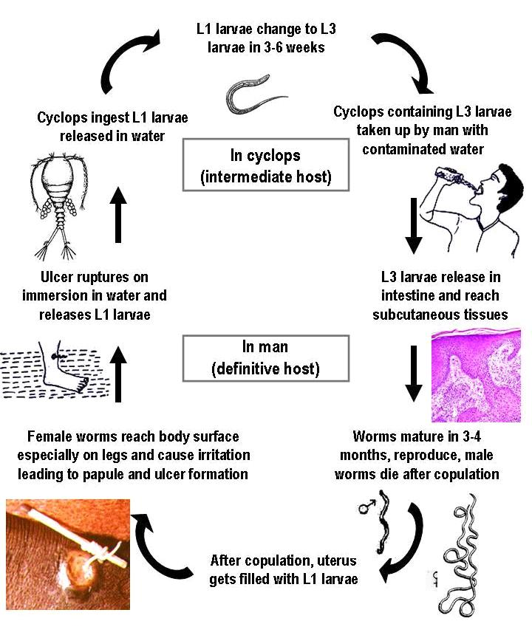getswet,

she sheds more larvae and starts the cycle all over again.

III. **EPIDEMIOLOGY AND GLOBAL DISTRIBUTION**

The disease is endemic to the rural and more deprived areas of the world and is most common in African countries like **Chad**, **South Sudan**, **Ethiopia**, and **Mali**. Guinea worm affects rural area population groups whose livelihood depends on subsistence agriculture. The disease can occur in any age group but frequently presents in young adults between 15 to 45 years. Men and women are equally affected. Transmission of the disease depends on seasonal variation and usually occurs during the rainy season or dry season.

Estimates are that around 48 million people were affected by this disease in Africa, the Middle **East, and India** in the 1940s. Approximately 3.5 million cases were reported annually in the mid-1980s. Since the start of the Guinea Worm Eradication Program in the 1980s, the number of dracunculiasis cases have significantly decreased and is now on the verge of being eradicated. Recent World Health Organization (WHO) reports from October 2018 state that only a few cases have been reports in **Chad**, **South Sudan, and Angol**

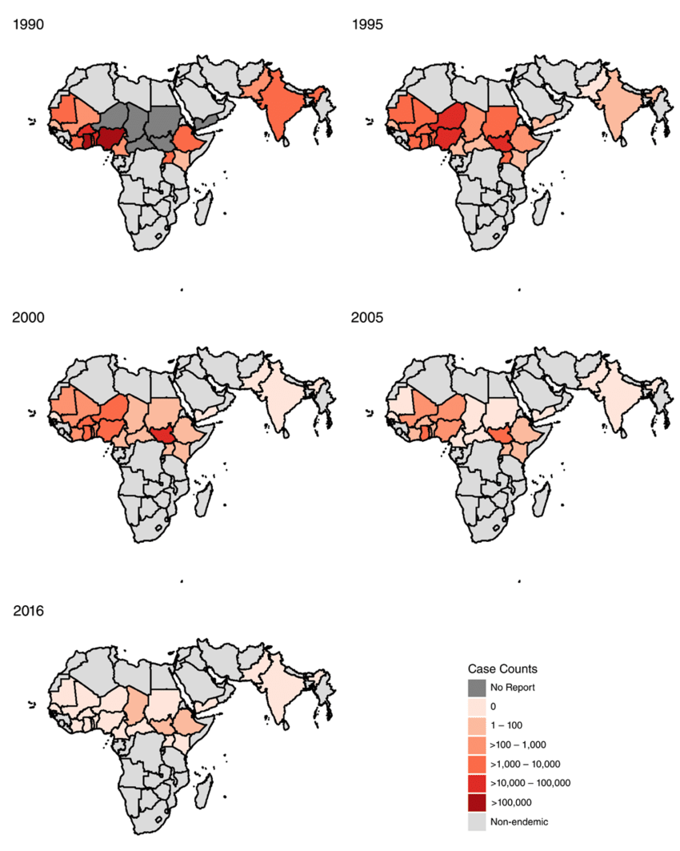

**CITIES AND THE DISRTIBUTION**

**CHAD.**

Cases of dracunculiasis were rediscovered in Chad in 2010 after the country had reported no cases during the previous decade. Chad has reported a total of 97 cases (representing 31 ethnicities in 78 villages) in 2010–2017, ranging from 9 to 16 cases per year (15 cases in 14 villages in 2017), and was declared endemic again in 2012, after three consecutive years of indigenous cases. The specific source locations of infection of the cases in Chad are unknown. The number of infected domestic dogs reported increased steadily from 27 in 2012 to 1,011 in 2016 before being reduced by 19% to 817 infected dogs in 271 villages in 2017, when the number of guinea worms removed from dogs fell by 31%, from 2,019 in 2016 to 1,386 . These were the first reductions in infected dogs and emerging guinea worms in Chad since infections in dogs were reported in 2012. Chad also reported a total of 33 infected cats in 2013–2017, including one wild cat in 2014. In 2014, Chad established a new category to denote its affected villages of concern for operational purposes: “1+ case village,” a village with one or more indigenous and/or imported guinea worm infection in a human, dog and/or cat in the current and/or previous calendar year. Most cases in humans peak during the rainy season in June–September, with no marked preponderance in adults versus children or males versus females. Dog infections peak in April–August. Since 2014, Chad’s GWEP, The Carter Center, and WHO have pursued a robust research agenda to help understand the unusual epidemiology of dracunculiasis in the country.[7](https://pmc.ncbi.nlm.nih.gov/articles/PMC6090361/#b7) Results so far appear to support the hypothesis that transmission involves a paratenic or transport host, that frogs may be more susceptible hosts than fish; that guinea worms recovered from infected dogs and from humans in Chad are indistinguishable from each other but slightly different by analysis of microsatellite and mitochondrial DNA (Liz Thiele, unpublished data) and analysis of full genome DNA (James Cotton, unpublished data) from guinea worms in other endemic countries; and that GPS collars and examination of stable isotopes in dog whiskers are feasible ways to study dog movements and dietary habits in Chad. One D. medinensis larva has been recovered from a wild-caught frog in Chad.

**ETHIOPIA.**

Ethiopia had seemed to be on the verge of success when it reported only one case in 2006 and zero cases in 2007. Ethiopia reported a total of 20 cases of dracunculiasis in humans during the 5-year period 2012–2016 before having an outbreak of 15 cases that began in September 2017. The latter outbreak occurred among migrant farm laborers from Oromia region who drank contaminated water while working at a commercial farm in adjacent Gambella Region. The program located and interviewed most laborers who worked at the commercial farm in 2016 and 2017. Although 12 of the cases in 2017 were not contained, the Ethiopia DEP (EDEP) applied Abate in areas around the farm associated with the cases. Surface sources of water in their home areas in Oromia region were all flowing streams or rivers, which is unsuitable habitat for copepods. The program began enhanced health education activities similar to those in Gambella in affected areas of Oromia in October in response to the outbreak.

The EDEP also reported a total of 34 infected domestic dogs and five infected baboons in the 5 years before 2017; in 2017, it reported 11 infected dogs (six contained) and four infected baboons. Most of the baboons were killed by dogs that were protecting crops or accompanying hunters; the guinea worms were noticed after the baboons were killed. In 2014–2016, almost all infected animals and humans with dracunculiasis as well as the infected animals in 2017 occurred in Gambella Region’s Gog district, which reported no cases in humans in 2017 for the first time in 7 years. The cases in Gog district in 2014–2016 were mostly ethnic Agnuak males older than 10 years who were hunters, gathered honey, or had other activities in or at the edge of the forest. Centers for Disease Control and Prevention confirmed worm specimens from humans, dogs, and baboons as D. medinensis. In 2017, a veterinarian from the GWEP at Carter Center headquarters began working with the EDEP and Ethiopian veterinary, public health and wildlife officials in preparation for a baboon–dog epidemiology and ecology project to begin in Gog district early in 2018. This will be the first time that baboons in Gambella will be the subject of such a study.

Since 2015, the EDEP has increased the numbers of surface water sources where it has applied Abate in forest areas associated with human and animal infections in Gog district 10-fold, treating 44 surface water bodies in the core endemic subdistrict of Atheti in July 2015, 131 in July 2016, and 484 in July 2017, for example, in addition to providing the villagers health education, cloth filters and pipe filters. Unlike in Chad, most of the surface water bodies of concern here are small enough to be treated with Abate but are numerous and transient. All of the five villages at high risk in Gog district have at least one safe source of drinking water. Insecurity limited activities in some affected areas of Gambella Region in December 2015–January 2016.

**SOUTH SUDAN.**

South Sudan, which reported 521 cases of dracunculiasis in 2012, reported 70 cases in 2014 and six cases in 2016. At the end of December 2017, it reached the major milestone of 13 consecutive months with zero reported cases despite submitting 27 worm specimens to CDC during 2017, none of which was confirmed as D. medinensis. South Sudan’s latest case, a 13-year-old Lou girl from Jur River County in Western Bahr el Ghazal State, had her worm emerge on November 20, 2016. The South Sudan GWEP (SSGWEP) monitored all six cases from 2016 throughout 2017. It has only once detected an infected dog, and this occurred in the household of a patient with dracunculiasis in Jur River County in 2015. South Sudan experienced significant sporadic insecurity in some areas during the period under review, to a degree that required evacuation of 33 expatriate Carter Center–supported staff during the off-peak season in December 2013–February 2014, and again in July 2016. Only about five expatriate senior staff returned after the second evacuation, but local volunteers and indigenous supervisors continued to function at a high level under the effective leadership of the national program coordinator and continued exceptionally strong political support of the South Sudanese government. The SSGWEP’s indigenous workers included 78 administrative and transport staff, 208 supervisors, and 3,137 village volunteers in 2016, and numbered 2,306 supervisors and 18,169 village volunteers at their peak in 2007. The minister of health visited endemic villages in 2014 and 2016 and launched the nationwide communication campaign mentioned previously in 2017. In 2015, the SSGWEP’s annual review meeting in Juba was opened by the vice president of South Sudan in the presence of the governor of the highest endemic state, three national ministers, six state ministers of health, and four county commissioners.

**MALI.**

Mali reported only four cases of dracunculiasis in 2012 when it also suffered a coup d’etat in March followed by virtual partition of the country that made much of the northern half of the nation inaccessible to the program for over a year, and very insecure after that. Security improved by 2014 when the national program coordinator visited Kidal region in April. Mali reported 11 cases in 2013, then had an outbreak of 40 cases in three villages in August–November 2014: 29 cases (28 contained) at Tanzikratene in Gao region, 10 cases (seven contained) at Nanguaye in Timbuktu region, and one uncontained case at Fion in Segou region. All but one of the latter cases were ethnic black Tuaregs. Neither Tanzikratene nor Nanguaye had a functioning source of safe drinking water. However, for the first time since the Malian program began, in October 2015 it found one dog with an emerging guinea worm in Tominian district of Segou region. The new minister of public health visited Tominian district in 2016, when Mali reported 11 infected dogs (nine contained) in that district. The program began offering a reward equivalent to US$20 for reporting and tethering any infected dog in March 2016 (78% of persons queried in 2017 were aware of that reward). It intensified health education of villagers in Tominian and a few adjacent districts where the infected dogs originated and applied Abate in surface water sources associated with the infected dogs. This area of Mali is part of the inland delta of the Niger River, with ecology somewhat similar to that along the Chari River in Chad. Mali reported nine infected dogs (eight contained) and one infected cat (contained) in 2017.

**IV. Symptoms and Diagnosis**

Knowledge of symptoms of Guinea worm disease is crucial. Knowledge facilitates early diagnosis. Early diagnosis prevents further spread.

**Early Symptoms**

You might not notice much prior tothe worm coming out. Some people experience mild symptoms. These can be a low-grade fever, rash, or nausea. These initial signs are inconspicuous. But knowing is helpful.

Dracunculiasis (Guinea worm disease) symptoms appear about a year after infection and include:

1. **Painful Blister**– A blister forms, usually on the lower limbs, as the adult worm prepares to emerge.
2. **Worm Emergence**– A white, thread-like worm (up to 1 meter long) slowly emerges from the skin over several weeks.
3. **Burning Sensation** – Intense pain and burning occur at the blister site, often relieved by immersing the area in water.
4. **Swelling and Redness** – Inflammation around the blister.
5. **Secondary Infections** – Bacterial infections can lead to abscesses, cellulitis, or sepsis.
6. **Fever and Nausea**– Some patients experience mild fever, nausea, and dizziness before the blister appears.
7. **Temporary Disability** – The pain and infections can cause difficulty walking or using affected limbs, incapacitating individuals for weeks to months.

While not fatal, the disease severely impacts daily life, especially in agricultural communities.

**Worm Emergence and Complications**

The most obvious sign is the time at which the worm occurs. It is usually on the lower extremities. It starts as a blister sore. After the blister has burst, the worm begins oozing out. It takesweeks and is very painful. Secondary bacterial infections are usually common, complicating the case.

**Clinical impact**

Dracunculiasis has been recognized as a human parasitic disease for thousands of years, with evidence suggesting its presence as far back as ancient Egypt (Muller, 1971; Hopkins and Hopkins, 1992). The infection progresses slowly, with acute systemic symptoms typically emerging 10 to 14 months after the initial exposure. These symptoms are closely associated with the development of a painful blister, as illustrated in Figure 4, which eventually ruptures, creating an open skin lesion through which the Guinea worm emerges and becomes exposed to the external environment. The formation of this blister is usually accompanied by localized redness and induration, signaling inflammation in the affected area. Prior to the blister’s appearance, individuals often experience a range of systemic allergic symptoms, including fever, rash, and general discomfort, which further contribute to the distressing nature of the disease. The long incubation period and the painful emergence of the worm make dracunculiasis a particularly debilitating condition, significantly impacting the health and daily lives of those infected.

**V.** **DIAGNOSTIC MODALITIES**

**Clinical diagnosis**

The clinical presentation of dracunculiasis is so typical that it doesn't usually require laboratory confirmation.

The disease occurs in areas where laboratory confirmation is unlikely to be available.

The fluid discharged by the worm can show rhabditiform larvae.

**Laboratory diagnosis**

Conventional PCR applied to a DNA preparation from emergent worm fragments

Quantitative PCR for the detection of the mitochondrial cytochrome b (cytb) gene of Guinea worm

LAMP tests for Dracunculus medinensis

**Radiological diagnosis**

X-rays may be taken to locate calcified worms.

**Other methods**

Examining the worm and its larvae under a microscope to ensure it is a D. medinensis worm  Testing samples of copepods taken from ponds using lamp test.

Diagnosis of Dracunculiasis is usually simple. Doctors can diagnose the illness by looking at the blister. They will look at the worm emerging. There are no complex tests to be done. But it's better to go see a doctor. This rules out other problems.

VI. **TREATMENT AND CONTROL STRATEGIES**

There is no specific drug treatment for guinea worm disease. Rather, the infection typically is managed through the careful removal of the worm in its entirety. Soaking the site of the blister in a container of water encourages the worm to emerge. Once it has broken through the skin, gentle traction  is applied to the worm, speeding its emergence, which may take several days or weeks. The worm usually is wrapped around a piece of gauze or a stick to maintain tension and prevent the worm from retracting into the body. Topical often are applied to the site of the wound to prevent infection with another organism during the extraction period. Aspirin  and Ibuprofen may be administered to relieve pain and reduce inflammation.

**Traditional Worm Extraction**

The traditional method remains the main mode of worm extraction. That isgradually uncoiling the worm from the blister. It is done little by little. It can take weeks. Patience and a stronghand are required.

**Wound Care and Prevention ofInfection**

Wound cleaning is important. Wash with soap and water daily. Useantibiotic ointment to prevent secondary infection. Dress the wound with a sterile dressing. Wound care can prevent complications and accelerate healing.

**Pain Management**

The removal of the worm is painful. Pain relievers like ibuprofen may be employed. Applying cool compresses on the area also helps in alleviating pain. Some individuals use local anesthetics to numb the area. This is for alleviating pain during removal.

**Prevention and Eradication Efforts**

Prevention of guinea worm disease is all about clean water and education. Global efforts have progressed a long way.

**VII. Global Eradication Programs**

Organizations like The Carter Center and WHO are leading the way. They work with communities. They provide education and support. They have reduced the number of casesdramatically. They are closer than ever to eradicating the disease.

**Water Filtration and Sanitation**

Providing access to clean water is essential. Guinea worm larvae carriedby fleas can be wiped out using water filters. Boiling water is another effective means. Keeping the sources of water from being contaminated is also important. Clean water means no Guinea worm.

Health Education and Community Involvement

Educating people on Guinea worm disease is vital. Community members need to understand how it spreads. They should know how to prevent it. Local health workers play animportant role here. They educate their friends and neighbors. Successcan only come about through community involvement.

If you travel to endemic regions, becautious. Drink only filtered or boiled water. Be aware of the local health situation. Educate yourself. Take care of yourself and others.

**VIII. Current Status and Future Challenges**

We've come this far, but the war is notyet won. There are still challenges to be faced.

Current Prevalence and Endemic Regions

Incidence of Dracunculiasis is at an all-time low. Most of the cases are now in some countries in Africa. These include South Sudan, Chad, and Angola. Continuous surveillance is essential.

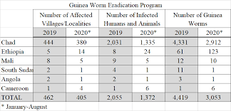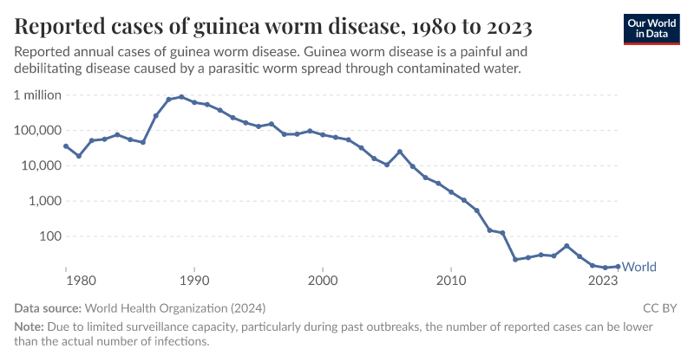

**Challenges to Eradication**

War can disrupt eradication efforts. It can also limit access to clean water. Access to remote populations isdifficult. Detection of all the cases and interruption of transmission is essential.

**The Future of Dracunculiasis Eradication**

In spite of the challenges, there is hope. With collaboration, Guinea worm disease can be eliminated. Nolonger will the world suffer from this painful disease. Commitment, resources, and coordination are needed. The goal is possible.

IX. **CONCLUSIONS**

Guinea worm disease, or dracunculiasis, is a terrible illness. It's caused by contaminated water. Due to international efforts, we are almost atthe point of eradicating it. Clean water, health education, and mobilization of the community are essential. Support those groups that are working towards the eradication of Guinea worm disease. Your help can make a difference. The world is now closer than ever to eradicating dracunculiasis, with cases in humans reported in only Chad and Ethiopia in 2017. No cases were reported worldwide for the first time in January 2015 and in five other months in 2015–2017. In theory, the last person to suffer from this disease could occur at any time, but we will not know when we will have reached that milestone until no cases are detected for a year or more after it happens.

At Mali and South Sudan, the two countries with the most insecurity then and now, would become the first two of the final four to interrupt transmission to humans. Surveillance is imperfect in both countries because of sporadic insecurity in some areas but daily acts of courage by dedicated nationals and some expatriates have produced substantial relevant documentation nonetheless. The program of South Sudan enjoyed exceptional political support from the country’s leaders and the technical ability of its national coordinator, which helped it overcome challenges of complex epidemiology and weak infrastructure as well as ongoing insecurity. Mali has had no known cases in humans in 2016 or 2017, despite detecting 20 infected dogs and a cat in a small partly insecure area of the country in those 2 years after transmission to humans was interrupted.

Apart from insecurity and the challenges of maintaining sensitive surveillance in the areas of concern, the biggest challenge to completing eradication now is the large number of infected dogs in Chad, where it appears that the numerous infections in dogs are driving the sporadic infections with the same D. medinensis in humans. Throughout the global campaign previously, and in a few other observed reports in the former Soviet Union and elsewhere earlier, transmission among humans appeared to be the fundamental driving force of guinea worm infections, with incidental infection of dogs. The reverse appears to be true in Chad, where dog infections appear to be the main driving force of infection, with incidental infection of humans. We assume that the few guinea worm infections in dogs that have been reported in some formerly endemic South Asian countries after 1950 and that were called D. medinensis but not analyzed genetically, were probably due to an unknown zoonotic Dracunculus species, because they were not associated with any known human infections. With few infected dogs, Mali and Ethiopia will soon show whether past experience that predicts the disappearance of D. medinensisinfections in dogs after human cases cease will be realized there. An additional unknown being researched in Chad is the potential role of paratenic transmission via an amphibian host. In Ethiopia the few known infections in baboons are also being researched but current indications are that infected baboons are handicapped and hence more likely to be killed by dogs and that the small numbers of dogs, baboons, and residual endemic human cases are associated with forest activities in a very small area where assiduous application of Abate should stop transmission to all.

As noted previously, it now appears that transmission of infections with guinea worms continued in Chad during the decade when no cases were reported in humans and before infections were discovered in domestic dogs there. Why the outbreak among dogs appeared in Chad when it did and the reason for the paradoxical and unique occurrence in Chad of D. medinensis so commonly in dogs but so infrequently in humans may never be answered. Ecological changes associated with over-fishing and drought may have played a role, but elders and leaders of the earlier campaign confirm that infections in dogs were not seen before the current outbreak and that seasonal mass fishing has been practiced along the river for generations. There is no evidence that the slight genetic difference in guinea worms in Chad has a significant role in the epidemiological peculiarity of the current outbreak there. The first reductions in dog infections in 2017, the continued intensification of available interventions, and the robust research agenda in Chad are reasons to expect that this final challenge also will be overcome soon.

 in cutting the global footprint of fascioliasis.

**X. REFERENCES**

L.D. Egungbola

Babana parasitic disease project II.

R. Muller   
Advances in Parasitology (1971)

2. S.J. Watts   
Social Science Medicine (1989)

3. O.A. AdeyebaSecondary infections in dracunculiasis: bacteria and morbidity  
International Journal of Zoonoses(1985)

4. O.A. Adeyeba et al.Epidemiology of dracunculiasis and its socio-economic impact in a village in south-west Nigeria  
West African Journal of Medicine (1991)

5. D.W. Belcher et al.Guinea worm in southern Ghana: its epidemiology and impact on agricultural productivity  
American Journal of Tropical Medicine and Hygiene (1975)

6. S. Cairncross et al.Dracunculiasis (Guinea worm disease) and the eradication initiative Clinical Microbiology Reviews (2002)

7. Implementation of health initiatives during a cease-fire – Sudan, 1995 Morbidity and Mortality Weekly Report (1995)

8. Progress towards global eradication of dracunculiasis, 2002–2003 Morbidity and Mortality Weekly Report (2004)

9. J.P. Chippaux et al.Social and economic impact of dracunculiasis: a longitudinal study carried out in two villages in Benin  
Bulletin of the World Health Organization (1992)

10. C. GreenawayDracunculiasis (guinea worm disease) Canadian Medical Association Journal (2004)

11. Hopkins, D.R. (1990). Report on IDWSSD Impact on Dracunculiasis. Report prepared for the Steering Committee for...

12. D.R. Hopkins et al.Guinea worm disease  
Science (1981)