Title : Campus Hire

NAME | EMAIL | PHONE NO.
Preeti Santosh Solase | preetisolase21@gmail.com | 9561642127
Shravani Avdhut Kumthekar | kumthekarshravani309@gmail.com | 7499569544
Shravani Dipak Mahajan | shravanimahajan30@gmail.com | 8767786739
Saloni Anil Bedkyale | salonibedkyale@gmail.com | 7030724275
Guide Name : Ms. Trupti Bharat Vadagave
Email : truptivadagave07@gmail.com phone no:8625906423
Institute Name : Sharad Institute of Technology Polytechnic, Yadrav
Department : Computer Engineering

ABSTRACT
The Placement Cell App for Android is designed to streamline and enhance the recruitment process for both students and recruiters. It acts as a platform where students can access the latest job openings, internships, and placement opportunities offered by various companies. Through a user-friendly interface, the app ensures that students stay updated with upcoming placement drives, deadlines, and necessary documents required for interviews. The app also allows students to manage their profiles, upload resumes, and track the status of their applications in real time.For recruiters, the app serves as an efficient tool to access a pool of talented students from various disciplines. They can post job vacancies, internships, and requirements with ease. Additionally, recruiters have the ability to filter candidates based on their qualifications, skills, and preferences, making the recruitment process more targeted and effective. The Placement Cell administrators can also use the app to monitor student participation and placement statistics, ensuring smooth coordination between the institution and the recruiters. The app's key features include real-time notifications for placement events, application deadlines, and interview schedules.

INTRODUCTION
The Placement Cell App for Android is a mobile solution designed to simplify and optimize the campus recruitment process for both students and placement officers. It serves as a centralized platform where students can connect with potential employers, stay informed about placement events, and manage their job applications directly from their smartphones.
This app aims to bridge the gap between educational institutions and the corporate world, making the entire placement process more transparent, organized, and efficient. Students can access a variety of job opportunities, apply for positions, and receive updates on interview schedules and selection results. Placement officers benefit from streamlined communication with recruiters and students, enabling them to track progress, manage events, and facilitate a smooth placement experience for all stakeholders.By bringing together all aspects of campus recruitment into one easy-to-use application, the Placement Cell App ensures that both students and recruiters can make the most of their time, while also enhancing the overall efficiency and effectiveness of the placement process.
The Placement Cell App is a powerful mobile application designed to revolutionize the college placement process for students, companies, and placement officers. This Android app aims to create a seamless and efficient platform for all stakeholders, making the entire recruitment process more streamlined and accessible. The Placement Cell app aims to simplify this journey by connecting users with a wealth of resources and potential employers, all at their fingertips .The app fosters an environment where aspiring professionals can explore tailored job listings that align with their unique skills and aspirations.
By delving into detailed company profiles, users can gain insights into organizational cultures, helping them make informed decisions about their future. The intuitive resume builder and interview preparation tools are designed to empower users, ensuring they present their best selves to potential employers. Moreover, The Placement Cell app emphasizes the importance of networking, providing opportunities to connect with alumni and industry professionals who can offer guidance and support. Whether you're just beginning your career journey or are ready to take the next big step, [App Name] is here to support you every step of the way. Download now to unlock your potential and embark on the path to your dream career.

METHODOLOGY

The development of a Placement Cell App in Android involves several phases, including planning, design, development, testing, and deployment.

In the planning phase, the requirements of the app are gathered and analysed . This involves identifying the stakeholders, including students, placement officers, and employers, and collecting their requirements. The project scope, timeline, and budget are also defined in this phase.
The design phase involves creating the visual design of the app, including the layout, graphics, and typography. The user interface (UI) design is also created in this phase, including the layout of the screens, the navigation, and the controls. The database design is also created in this phase, including the definition of the tables, fields, and relationships.

In the development phase, the app is built using the Android Studio IDE. The app's features are implemented, including user registration, job posting, and application management. The database is also integrated with the app, including implementing data storage and retrieval. Security measures, including authentication, authorization, and encryption, are also implemented in this phase.

The testing phase involves verifying that the app meets the requirements and works as expected. This involves conducting unit testing, integration testing, and system testing. The app's performance and security are also tested in this phase.
Finally, in the deployment phase, the app is prepared for release, including creating a release build and configuring the app's settings. The app is then published on the Google Play Store and made available for download.

MODELING AND ANALYSIS

Requirements Analysis
The app serves multiple user roles, including students, recruiters, and administrators. Students need to create profiles, upload resumes, search for job opportunities, and track applications. Recruiters must be able to post job openings, view student applications, and shortlist candidates.
System Modeling
To understand the system structure, various models like Use Case Diagrams, Class Diagrams, and Entity-Relationship Diagrams (ERD) are used.The Use Case Diagram outlines interactions between users and system functionalities, such as login, job searching, application submission, and recruiter actions.
Architecture Design
A robust architectural approach is necessary to ensure maintainability and scalability. The MVVM (Model-View-ViewModel) architecture is suitable for clean code structuring, improving data handling and UI responsiveness. The backend can be managed using Firebase for real-time data synchronization.
UI/UX Design
The app’s design is crucial for user engagement. Wireframes and prototypes define the navigation and interface layout. The home screen should display job listings and notifications, while dedicated sections allow users to manage their profiles, view application status, and interact with recruiters.
Performance and Security Considerations
To enhance performance, the app should include optimized database queries, caching mechanisms, and background sync for seamless data retrieval. Security is a major concern, requiring data encryption, role-based access control (RBAC), and secure authentication protocols to protect user information.

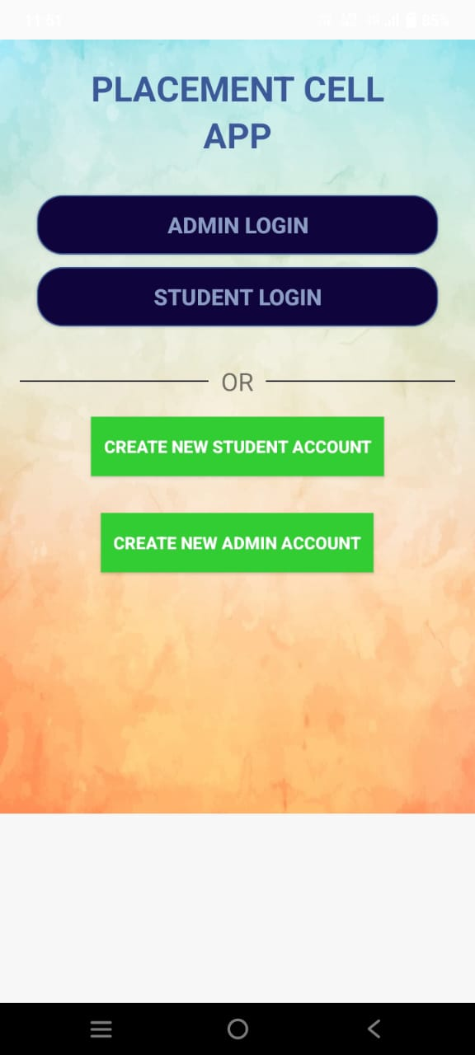
RESULT

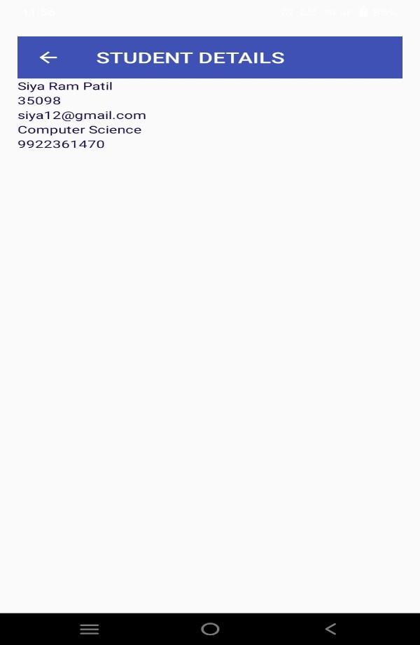
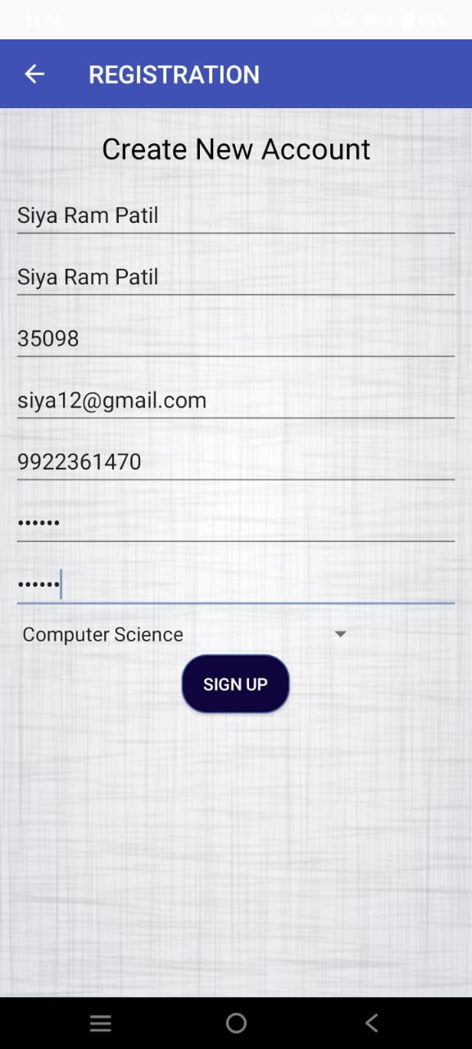

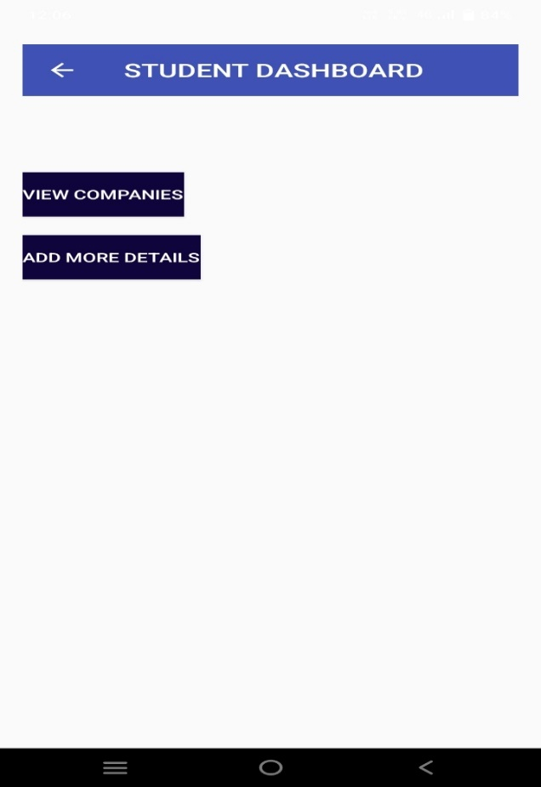
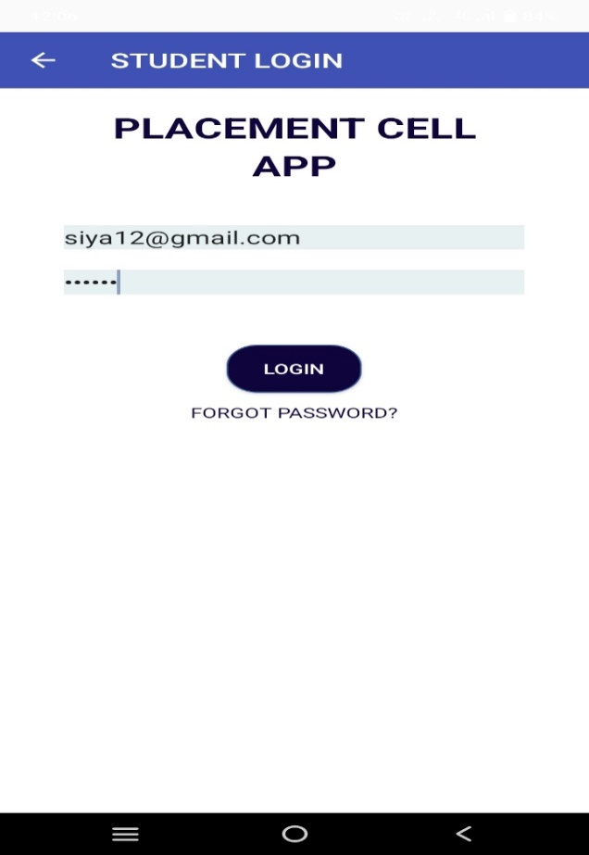

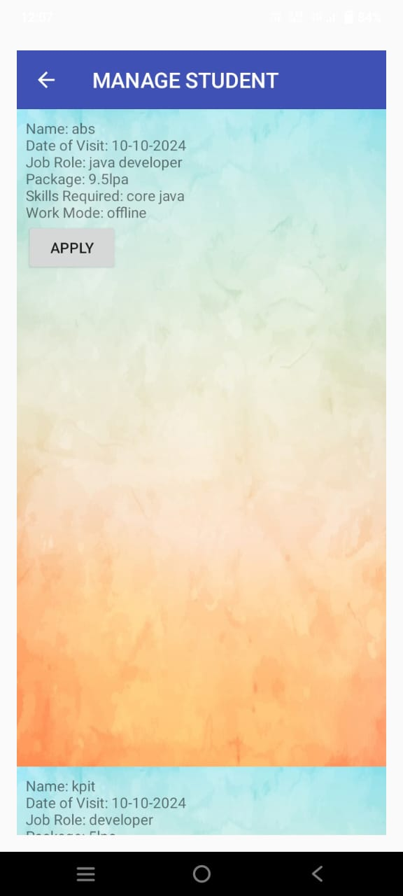
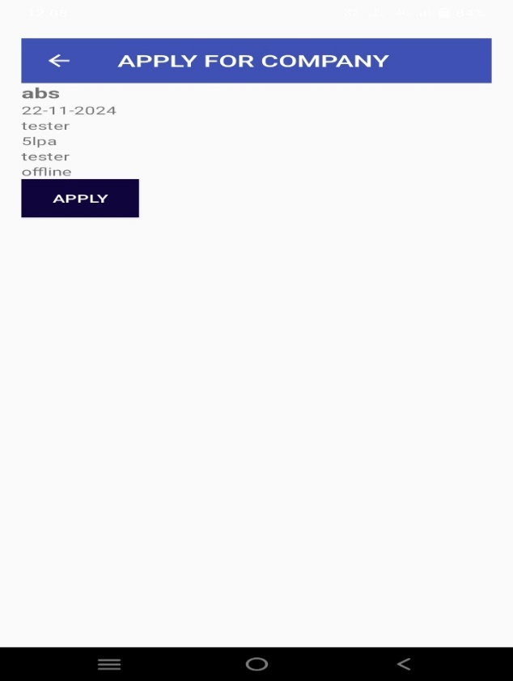

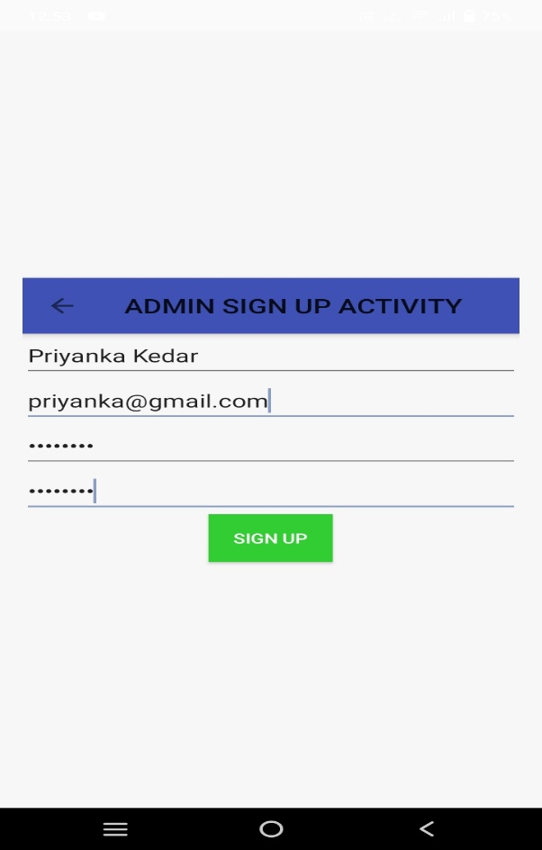
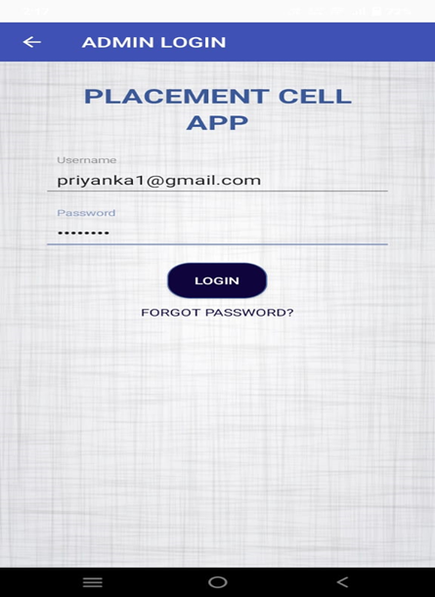

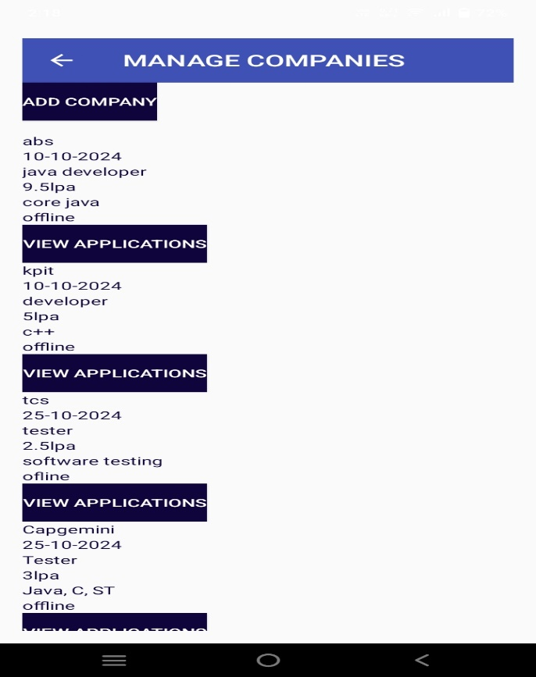
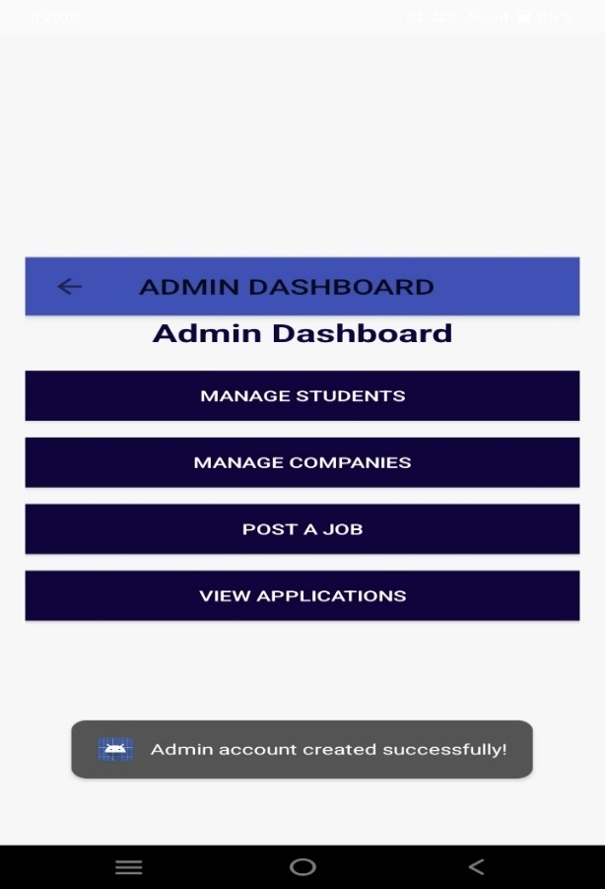

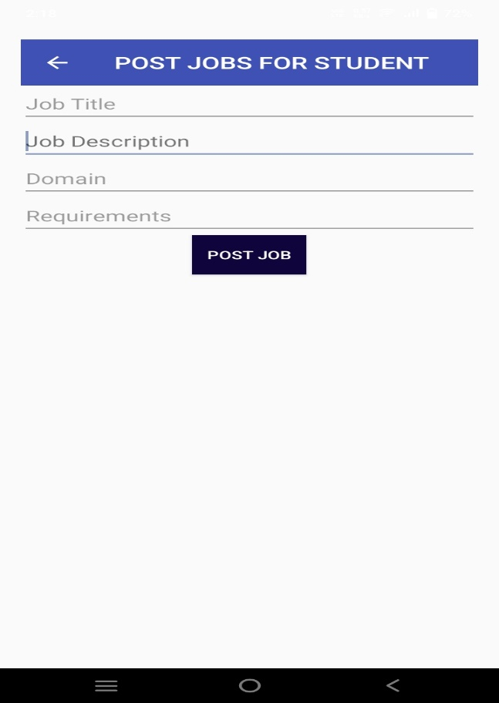
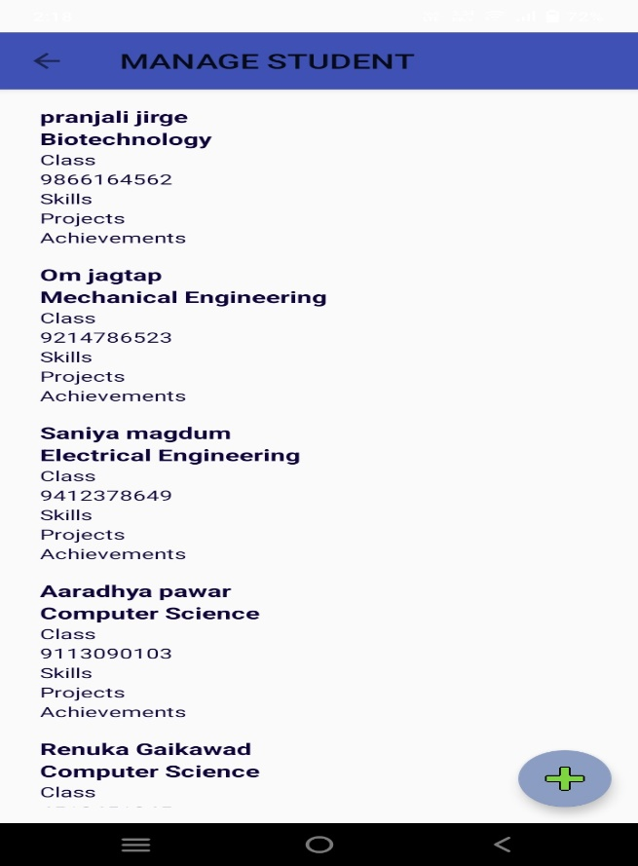
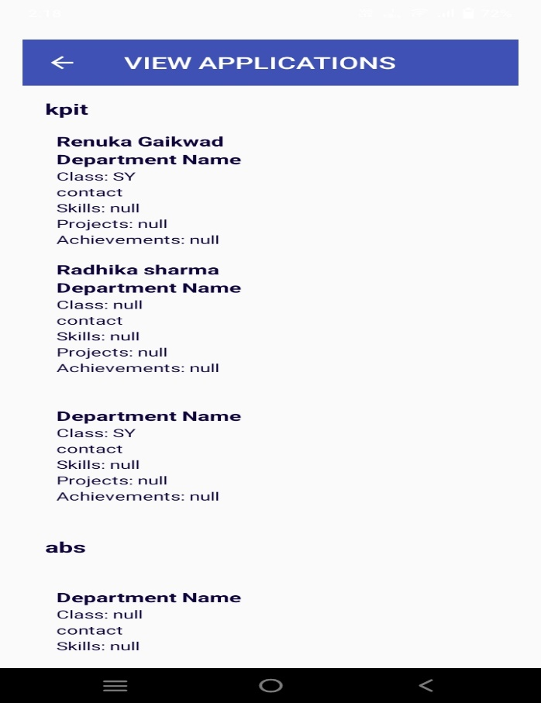

CONCLUSION

A well-designed Placement Cell app on Android offers a seamless platform for students, recruiters, and faculty to manage and streamline the placement process. For students, it serves as a central hub for job opportunities, application tracking, and career resources. For recruiters, the app provides a direct channel to access student profiles and streamline their recruitment efforts. Ultimately, a Placement Cell app bridges the gap between students and potential employers, fostering a more effective, organized, and transparent placement process. The use of modern technologies, user-friendly interfaces, and timely notifications ensures that both students and recruiters have a positive and productive experience, making the entire placement process more accessible and efficient .The development of a Placement Cell app for Android offers significant benefits for educational institutions, students, and recruiters alike. By providing an efficient digital platform, the app streamlines the entire placement process, which is traditionally managed manually and can be time-consuming .For students, the app acts as a personalized career hub, offering features such as job notifications. From an institutional perspective, the Placement Cell app centralizes all placement-related activities, reducing administrative overheads. Faculty and placement officers can monitor the progress of students, track the placement statistics, and collaborate with recruiters seamlessly through the app.

ACKNOWLEDGEMENTS
We would like to express our sincere gratitude to everyone who has contributed to the development of the Placement Cell App in Android.
First and foremost, we would like to thank our project guide, Ms.T.B.Vadagave, for their invaluable guidance, support, and encouragement throughout the project. Their expertise and knowledge in the field of Android app development have been instrumental in shaping our project. We are also grateful to our institution, Sharad Institute of Technology Polytechnic, Yadrav for providing us with the necessary infrastructure, resources, and support to complete the project.

REFERENCE

  - https://ijariie.com/AdminUploadPdf/Android_app_for_Training_and_Placement_Cell_ijariie1323_volume_1_14_page_341_345.pdf?srsltid=AfmBOopz3L7fWELTRw5g7cPyLR53Isef6caA6R8-0byD77j9eqGIaJ7S
  - https://chatgpt.com/
  - https://www.scribd.com/document/434762689/Synopsis
  - https://github.com/Ayush-Kanduri/Placement-Cell-Application
  - https://www.ijies.net/finial-docs/finial-pdf/050322723.pdf

