# **Microprocessor Based FingerLock Vehicle Security System**

¹Sneha Mandal, ²Runjan Ramteke, ³Vaibhav Parshuramkar, ⁴Prerna Kadwe, ⁵Vasudeo Dabhade  
¹,²,³,⁴Student’s PCE Nagpur  
⁵ Assistant Professor PCE Nagpur  
¹ snehamandalsm23@gmail.com  
² runjanramteke2415@gmail.com  
³ vaibhavparshuramkar1211@gmail.com  
⁴ prernakadwe26@gmail.com  
⁵ vasudeo.dabhade@gmail.com

## **Abstract**

The rising incidence of vehicle theft, particularly among two-wheelers, necessitates the development of advanced and reliable security solutions. Traditional key-based ignition systems are increasingly vulnerable to unauthorized access and theft. To address these challenges, this research proposes a **Fingerprint-Based Vehicle Security System** that leverages biometric authentication to ensure that only authorized users can start the vehicle. The system is built using an **ESP32 microcontroller**, an **R307S fingerprint sensor**, a **16x2 LCD display**, **push buttons**, **LED indicators**, **MPU6050 gyroscope** for movement detection, and a **SIM808 GSM module** for theft alerts. A **relay module** is used for actual vehicle ignition control. This paper provides a detailed discussion of the system's design, implementation, and testing, highlighting its effectiveness as a secure and intelligent vehicle ignition solution.

## **I. Introduction**

Vehicle security has emerged as a critical concern due to the increasing prevalence of unauthorized access and theft. Two-wheelers, such as motorcycles and scooters, are particularly susceptible to theft due to their compact design and ease of operation. Traditional lock-and-key mechanisms, which have been the standard for decades, are now considered outdated and easily bypassed by thieves. This has created a pressing need for innovative security solutions that ensure only the rightful owner can access and operate the vehicle.

Biometric authentication, particularly fingerprint recognition, offers a highly personalized and secure method of identification. With advancements in embedded systems and the Internet of Things (IoT), fingerprint-based vehicle security systems have become both practical and cost-effective. This project, titled **Fingerlock Vehicle Security System**, integrates fingerprint authentication into the vehicle ignition process, enhancing security while maintaining user convenience.

## **II. Related Work**

Several studies have contributed to the development of biometric vehicle security systems. **Kumar and Sharma (2017)** introduced a basic fingerprint-based ignition system, laying the groundwork for biometric authentication in vehicles. **Patel and Singh (2019)** expanded on this by incorporating IoT features for remote vehicle monitoring. **Lee and Kim (2020)** explored the integration of biometric authentication with IoT-enabled vehicles, highlighting the potential for real-time monitoring and control. **Zhang et al. (2020)** addressed the challenges of fingerprint recognition in noisy environments, proposing algorithms to improve accuracy under adverse conditions.

More recent studies by **Gupta and Kumar (2021)** and **Verma and Singh (2022)** have focused on overcoming obstacles in biometric vehicle security systems, such as power consumption and sensor reliability. **Sharma and Yadav (2021)** emphasized the importance of energy-efficient sensor usage, which is crucial for the long-term viability of such systems. These studies collectively provide a strong foundation for the Fingerlock Vehicle Security System, which combines real-time fingerprint authentication with features like accident detection and GSM-based theft alerts.

## **III. System Design and Architecture**

### **A. Hardware Components**

The Fingerlock Vehicle Security System is built around the following key hardware components:

1. **ESP32 Microcontroller**: Serves as the brain of the system, controlling all operations and communications between components.
2. **R307S Fingerprint Sensor**: Captures and verifies fingerprints, ensuring that only authorized users can access the vehicle.
3. **16x2 LCD Display**: Provides real-time feedback to the user, showing system status, instructions, and authentication results.
4. **Push Buttons**: Allow users to navigate the system's menu, enabling functions such as fingerprint registration, deletion, and system reset.
5. **LED Indicator**: Indicates system status alongside the relay module controlling the vehicle's ignition.
6. **MPU6050 Gyroscope**: Detects unusual vehicle movements, such as those caused by theft attempts or accidents.
7. **SIM808 GSM Module**: Sends real-time alerts to the vehicle owner in case of suspected theft or unauthorized access.
8. **Relay Module**: Activates the vehicle's ignition system upon successful fingerprint authentication.
9. **Power Supply**: Ensures reliable operation of all components.

### **B. Pin Configuration Overview**

The following table outlines the pin configuration for the ESP32 microcontroller and its connection to other components:

| **Component** | **ESP32 Pin No.** |
| --- | --- |
| Fingerprint Sensor (TX/RX) | 16 / 17 |
| LCD Display | 22, 21, 5, 18, 23, 19 |
| LED Output | 2 |
| Select Button | 34 |
| Reset Button | 35 |
| Up Button | 26 |
| Down Button | 27 |
| Relay Control | 4 |
| MPU6050 (SCL/SDA) | 22 / 21 |
| SIM808 (TX/RX) | 14 / 12 |

### **C. Circuit Operation**

The system operates as follows:

1. **Fingerprint Authentication**: The fingerprint sensor communicates with the ESP32 microcontroller via UART protocol, capturing and verifying fingerprints.
2. **LCD Feedback**: Displays real-time system messages such as "Place Finger", "Matched!", and menu options for fingerprint management.
3. **Push Button Navigation**: Enables the user to register new fingerprints, delete existing ones, or reset the system.
4. **Ignition Control**: Upon successful fingerprint authentication, the relay activates the vehicle's ignition system.
5. **Motion Detection**: The MPU6050 gyroscope continuously monitors vehicle movements and detects unusual activity.
6. **Theft Alerts**: If abnormal movements are detected, the SIM808 GSM module sends an immediate SMS or call alert to the registered owner.

### **D. Circuit Diagram**

The complete circuit diagram of the Fingerlock Vehicle Security System is illustrated in **below diagram.** The diagram shows the interconnection of all components with the ESP32 microcontroller, ensuring synchronized operation for secure vehicle ignition and theft alert functionality.

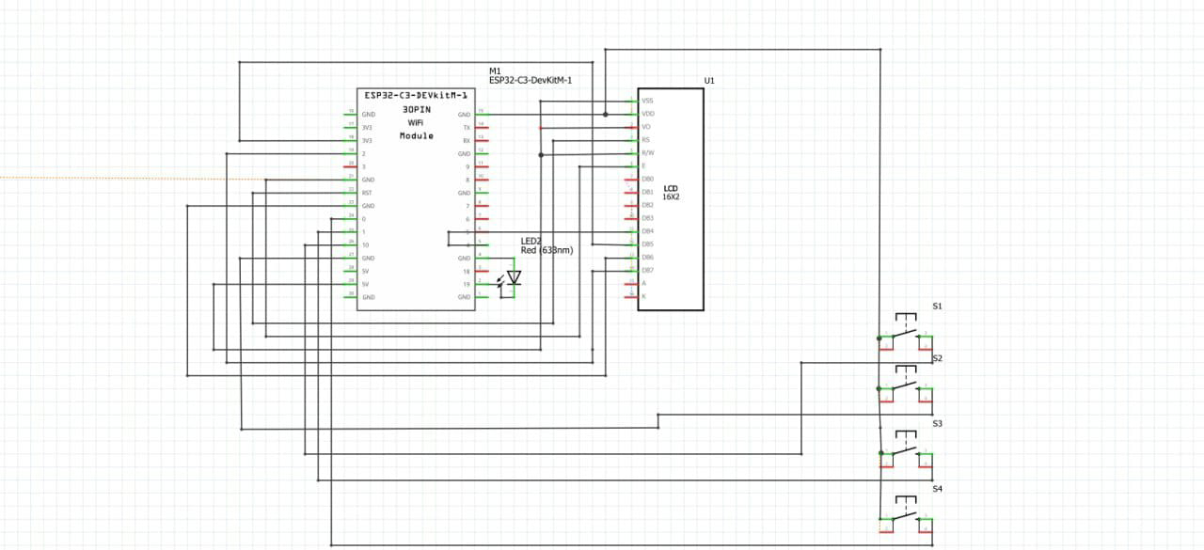

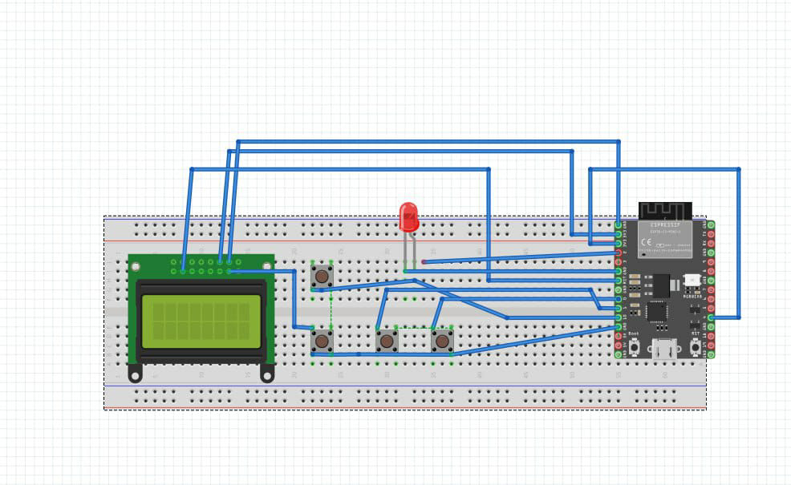

## **IV. System Workflow**

The Fingerlock Vehicle Security System follows a structured workflow to ensure secure and efficient operation:

1. **Startup**: The system initializes the fingerprint module, LCD display, gyroscope, and GSM module upon power-up.
2. **Authentication**: The user places their finger on the fingerprint sensor. If the fingerprint matches the stored data, the relay activates the ignition.
3. **Menu Operations**: Users manage fingerprints via the push button menu:
   * **Register New Fingerprints**
   * **Delete Existing Fingerprints**
   * **Reset Menu**
4. **Security Alerts**: The gyroscope detects abnormal movements, triggering the GSM module to send alerts.
5. **Ignition Control**: The relay controls the vehicle's ignition, allowing operation only after successful authentication.

## **V. Results and Discussion**

The fully implemented Fingerlock Vehicle Security System was tested under various scenarios:

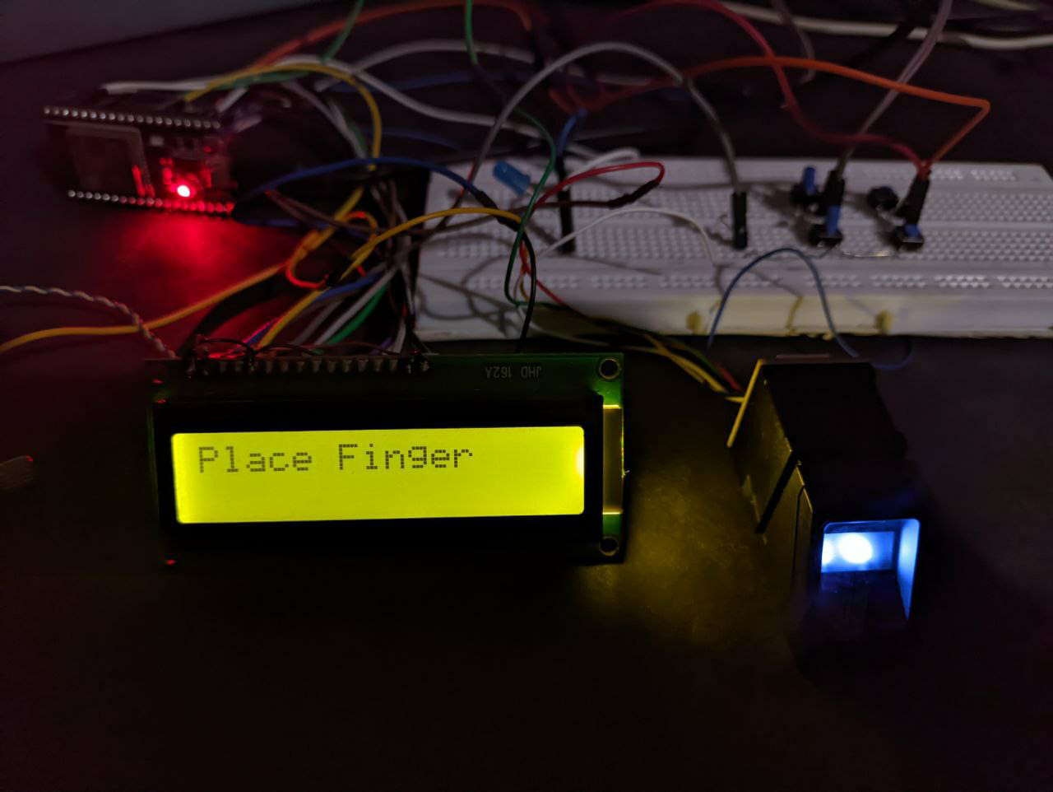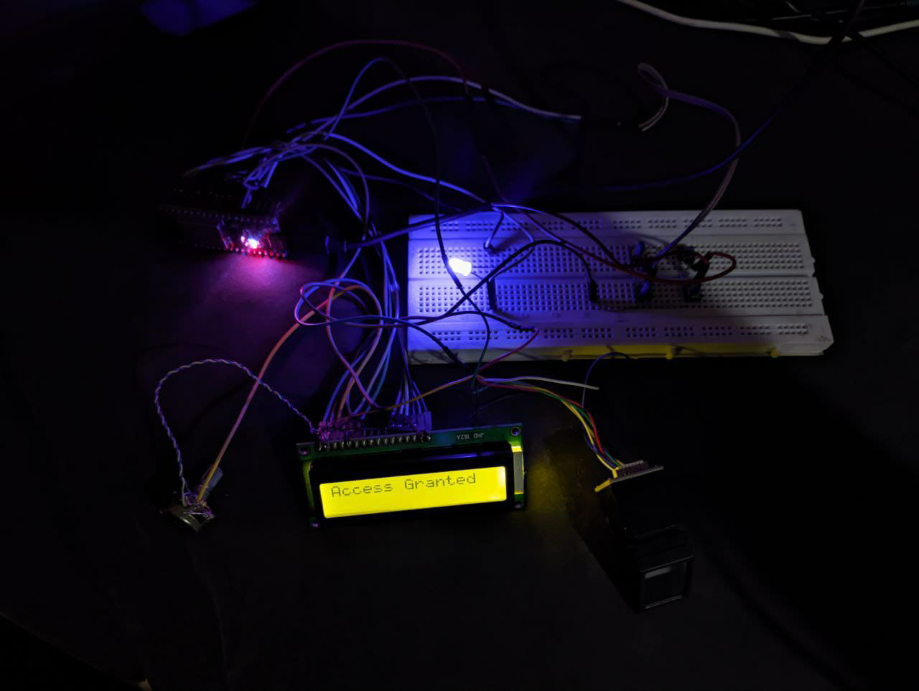

1. **Correct Fingerprint**: Successfully activated the ignition with a registered fingerprint.
2. **Incorrect Fingerprint**: Denied access with an unregistered fingerprint.
3. **Multiple Fingerprints**: Effectively managed registration and deletion of multiple fingerprints.
4. **Environmental Conditions**: Maintained accuracy under varied lighting and minor dust conditions.
5. **Motion Detection**: The gyroscope reliably detected suspicious movements.
6. **Theft Alerts**: The GSM module successfully sent real-time notifications to the owner.

The system demonstrated a high success rate, proving to be a reliable, low-cost, and scalable solution for vehicle security.

## **VI. Conclusion**

The **Fingerlock Vehicle Security System** represents a significant advancement in vehicle security, particularly for two-wheelers. By replacing traditional key-based ignition systems with biometric fingerprint authentication, the system reduces the risk of theft and ensures that only authorized users can access the vehicle. With integrated features like accident detection and GSM-based owner alerts, the Fingerlock system delivers a comprehensive and modern solution to vehicle security challenges.

## **References**

1. Kumar, A., & Sharma, R. (2017). *Fingerprint-Based Vehicle Ignition System*. Journal of Embedded Systems.
2. Patel, S., & Singh, M. (2019). *IoT-Enabled Vehicle Monitoring System*. International Journal of Advanced Research in Computer Science.
3. Lee, J., & Kim, H. (2020). *Biometric Authentication in IoT-Enabled Vehicles*. IEEE Transactions on Vehicular Technology.
4. Zhang, Y., et al. (2020). *Fingerprint Recognition in Noisy Environments*. Pattern Recognition Letters.
5. Gupta, R., & Kumar, S. (2021). *Challenges in Biometric Vehicle Security Systems*. Journal of Cybersecurity and Privacy.
6. Verma, P., & Singh, A. (2022). *Improvements in Biometric Vehicle Security*. International Journal of Automotive Engineering.
7. Sharma, K., & Yadav, R. (2021). *Energy-Efficient Sensor Usage in Vehicle Security Systems*. Renewable and Sustainable Energy Reviews.