**Tetanus: Understanding the Disease and Preventative Measures**

**Tanmay Shinde*¹, Turusbekova Akshoola Kozmanbetovna*² , Parpieva Takhmina Makhamatkalylovna*³ , Suraj Bhoknal *⁴ , Kshama Desbhratar*⁵**

**\*¹'⁴'⁵ Final Year MBBS Student, International Medical Faculty, Osh State University, Osh, Kyrgyzstan.**

**\*² "Associate Professor and Head of the Department of Public Health, International Medical Faculty, Osh State University, Osh, Kyrgyzstan.**

**\*³ Practical Teacher of the Department of Public Health, International Medical Faculty, Osh State University, Osh, Kyrgyzstan.**al Medical Faculty, Osh State

eh, International Medical Faculty, Osh State University, Osh, Kyrgyzstan.rsity, Osh, Kyrg

Abstract

Tetanus is a bacterial infection caused by *Clostridium tetani*, which produces toxins that affect the nervous system. The infection typically occurs when the bacteria enter the body through a wound or cut. Common sources include puncture wounds, burns, or injuries involving dirt or feces.Tetanus is a medical emergency and requires prompt treatment, typically involving antibiotics and a tetanus antitoxin. Vaccination is highly effective in preventing tetanus and is usually administered as part of routine childhood immunizations (the DTaP vaccine), with booster shots recommended every 10 years.

**Introduction**

Tetanus is a life-threatening bacterial infection t8hat affects the nervous system, leading to severe muscle spasms and potentially fatal complications. It is caused by the bacterium *Clostridium tetani*, which produces a toxin that can interfere with the normal functioning of the nervous system. Tetanus is often associated with contaminated wounds but can occur in any situation where the bacteria enter the body through a break in the skin. Though preventable, tetanus remains a global health concern, particularly in areas with limited access to medical care and immunization.

II. METHODOLOGY

Method and analysis which is performed in your research work should be written in this section. A simple strategy to follow is to use keywords from your title in first few sentences.

Subheading

Subheading should be Font Size- 10pt, Font Type- Cambria, justified.

Subheading

Subheading should be 10pt Times new Roman,

III. MODELING AND ANALYSIS

Model and Material which are used is presented in this section. Table and model should be in prescribed format

**Causes and Transmission**

*Tetanus* is caused by the bacterium *Clostridium tetani*, which is commonly found in soil, dust, and animal feces. The bacteria are typically harmless in the environment, but when they enter the body through a puncture wound, deep cut, burn, or any injury that creates a pathway for the bacteria, they produce a potent toxin known as tetanospasmin. This toxin affects the nerves and causes the muscles to contract uncontrollably, leading to symptoms like spasms and stiffness. The infection is not contagious and cannot be transmitted from person to person.

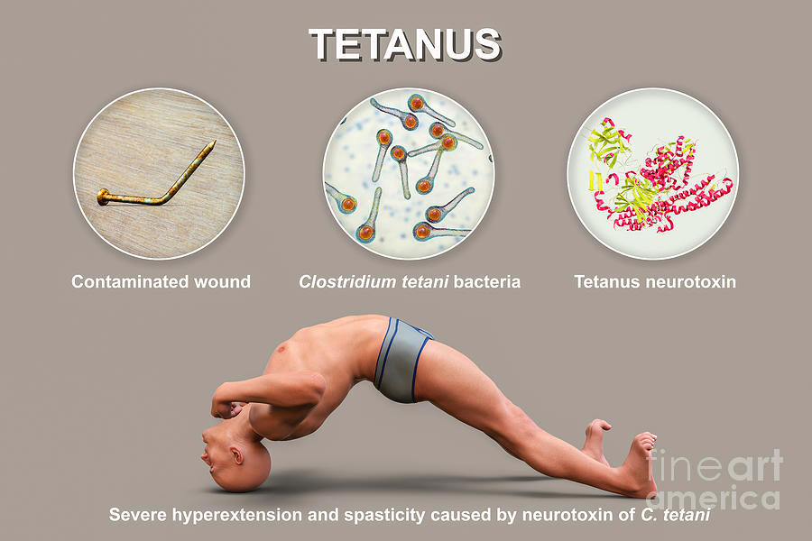

**Pathogenesis**

The pathogenesis of tetanus is caused by infection with *Clostridium tetani*, a gram-positive, spore-forming, anaerobic bacterium. Here's how the process unfolds:

1. **Entry of Spores**: *Clostridium tetani* spores typically enter the body through a wound or injury, especially if it is deep, contaminated with dirt, or punctured by an object. The spores are resistant to environmental conditions and can remain dormant until they find an anaerobic (low-oxygen) environment, such as deep tissue.
2. **Germination and Bacterial Growth**: In the anaerobic conditions of the wound, the spores germinate, and the bacteria begin to grow and multiply.
3. **Production of Tetanus Toxin**: The bacteria produce tetanospasmin, a potent neurotoxin, which is the primary cause of tetanus symptoms. Tetanospasmin is synthesized and released into the local tissues.
4. **Transport of Toxin**: Tetanospasmin enters the bloodstream and is transported to the nervous system. It binds to peripheral nerve endings, particularly in the motor neurons, and is transported retrogradely along the axons to the spinal cord and brainstem.
5. **Action of Tetanospasmin**: Once in the nervous system, tetanospasmin inhibits the release of neurotransmitters, particularly gamma-aminobutyric acid (GABA) and glycine, which are essential for inhibitory synaptic transmission. This inhibition prevents normal relaxation of muscles after contraction.
6. **Uncontrolled Muscle Contractions**: The lack of inhibition results in the continuous stimulation of muscles, leading to sustained and often painful muscle contractions, which are characteristic of tetanus. This muscle rigidity often starts with the jaw (lockjaw) and can spread to other muscles, including those controlling breathing, which can be fatal if the respiratory muscles are affected.
7. **Symptoms and Complications**: As the disease progresses, symptoms like muscle stiffness, spasms, and difficulty swallowing (dysphagia) become severe. In extreme cases, respiratory failure and autonomic dysfunction (such as fluctuating heart rate and blood pressure) can occur, which may be life-threatening.

Tetanus is not transmitted person-to-person but is instead caused by the introduction of *C. tetani* spores into a wound. Vaccination with tetanus toxoid is the most effective way to prevent the disease.

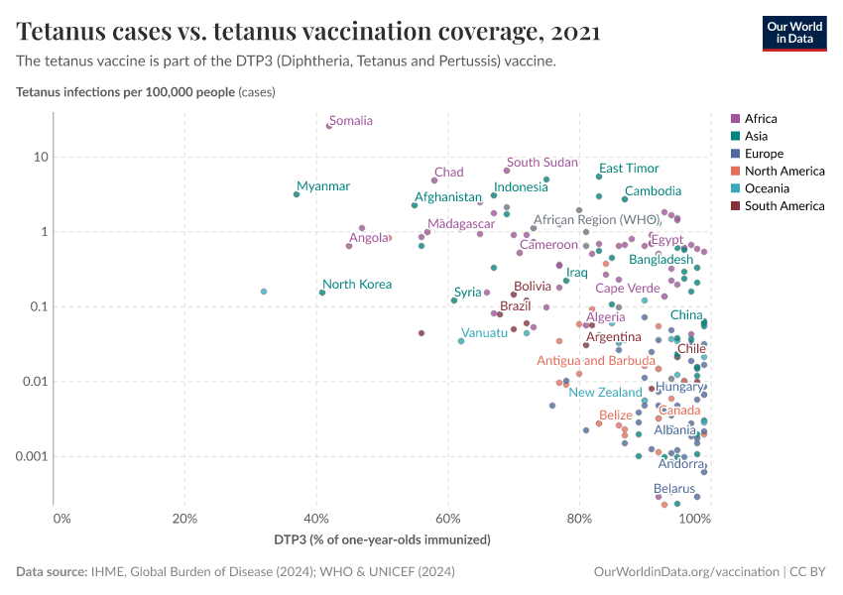

**Symptoms of Tetanus**

The symptoms of tetanus usually develop within 3 to 21 days after exposure to the bacteria, with an average incubation period of about 7 days. Early signs may include:

1. **Muscle stiffness and spasms**: These often begin in the jaw (referred to as "lockjaw") and may progress to other parts of the body.
2. **Difficulty swallowing**: As muscle stiffness affects the throat.
3. **Muscle rigidity**: The stiffness typically spreads to the neck, abdomen, and limbs.
4. **Abnormal postures**: Such as arched back and rigid limbs.
5. **Difficulty breathing**: Due to spasms of respiratory muscles, which can be life-threatening.
6. **Fever and sweating**: Resulting from the infection and the body’s response to the toxin.

In severe cases, untreated tetanus can lead to respiratory failure and death. The spasms can be so intense that they cause fractures or dislocations. The disease progresses rapidly, and without timely medical intervention, it can be fatal.

**Diagnosis and Treatment**

Diagnosing tetanus is typically based on clinical symptoms, as the condition is not identified through standard laboratory tests. The history of injury or wound exposure is an essential part of the diagnosis. If tetanus is suspected, immediate treatment is necessary.

The primary treatment for tetanus involves:

1. **Administration of tetanus immune globulin (TIG)**: This helps neutralize the toxin in the body and prevent further damage to the nervous system.
2. **Antibiotics**: To eliminate *Clostridium tetani* from the body and prevent further bacterial growth.
3. **Muscle relaxants and sedatives**: To control muscle spasms and alleviate pain.
4. **Supportive care**: This includes mechanical ventilation if breathing difficulties arise, as well as intravenous fluids and nutritional support.
5. **Wound care**: To clean and debride the wound to remove any remaining bacteria.

Tetanus is a medical emergency, and prompt intervention can save lives. The mortality rate for untreated tetanus can be as high as 50%, but with proper treatment, this figure significantly decreases.

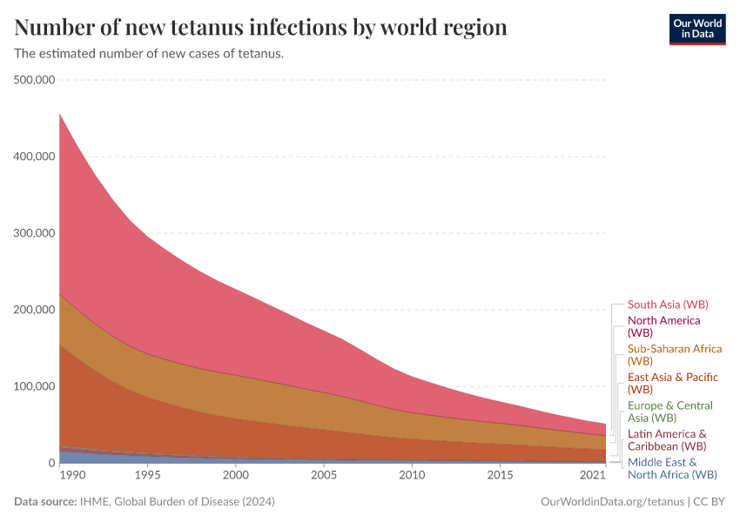

**Prevention**

The most effective way to prevent tetanus is through vaccination. The tetanus vaccine, typically combined with diphtheria and pertussis (DTaP or Td), is highly effective in preventing infection. Routine immunization begins in infancy, with booster shots given every 10 years. People who sustain severe wounds or injuries and have not received a tetanus booster within the last 5 years may be given a tetanus vaccine or tetanus immune globulin to reduce the risk of infection.

Other key prevention strategies include:

1. **Proper wound care**: Cleaning and disinfecting wounds immediately to reduce the risk of bacterial infection.
2. **Proper vaccination**: Ensuring individuals, especially those in high-risk areas, are up to date with tetanus vaccinations.
3. **Safe practices in healthcare and agriculture**: Ensuring proper hygiene, sterilization of medical instruments, and safe handling of animals and tools in farming environments.

**Global Impact**

Despite the availability of vaccines, tetanus continues to be a significant health issue in parts of the world, particularly in developing countries with limited access to healthcare. Neonatal tetanus, which occurs in newborns whose umbilical cords are cut with unsterilized instruments, remains a major concern in areas with poor sanitation. The World Health Organization (WHO) has set a goal to eliminate neonatal tetanus worldwide, and significant progress has been made in reducing cases through vaccination and better healthcare practices.

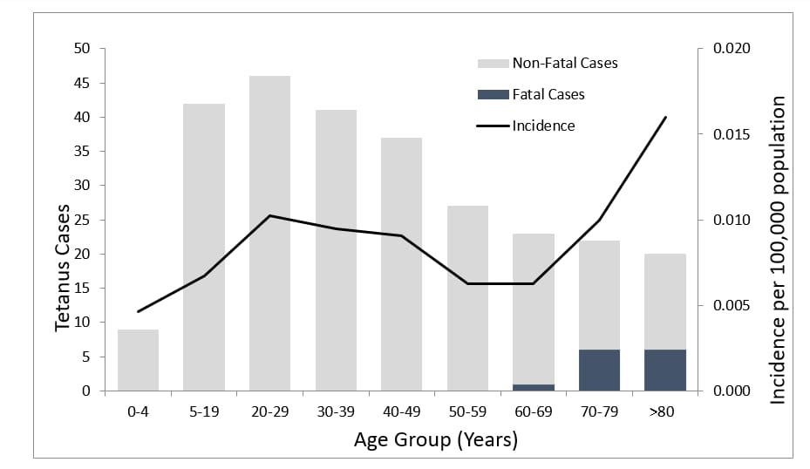

**Conclusion**

Tetanus remains a dangerous and potentially fatal disease, but with proper prevention, diagnosis, and treatment, its impact can be minimized. Vaccination is the most effective tool in the fight against tetanus, and ensuring that people receive timely immunizations can prevent unnecessary suffering and death. In addition to vaccination, good wound care practices and public health measures play crucial roles in reducing the incidence of this deadly disease. Awareness of the symptoms and seeking prompt medical attention can also make the difference between life and death in cases of tetanus. The continued global effort to eliminate neonatal tetanus and ensure vaccine access for all will help bring this preventable disease under control.

References

1.World Health Organization (WHO)

World Health Organization. (2021). Tetanus fact

2.Centers for Disease Control and Prevention (CDC)

Centers for Disease Control and Prevention. (2022)

3. National Institutesof Health (NIH)

National Institutes of Health. (2020)

4.Mayo Clinic

Mayo Clinic. (2020).

5.PubMed Central

Article: Liu, Y., et al. (2019). Tetanus: Pathogenesis, clinical features, and treatment.

Journal of Clinical Medicine

6.Infectious Diseases Society of America (IDSA)

Infectious Diseases Society of America. (2019). Tetanus: Prevention and management.