HIV INFECTION: PATHOGENESIS, DIAGNOSIS, AND ADVANCE IN MANAGEMENT.

**Swapnil Takate*1,Turusbekova Akshoola Kozmanbetovna*2,Parpieva Takhmina Makhamatkałylovna*3,Rushikesh Kuklare*4,Vikke Kumar*5**.

*1,4,5 Final Year MBBS Student, International Medical Faculty, Osh State University, Osh, Kyrgyzstan.

*2 Associate Professor and Head of the Department of Public Health, International Medical Faculty, Osh State University, Osh, Kyrgyzstan.

*3 Practical Teacher of the Department of Public Health, International Medical Faculty, Osh State University, Osh, Kyrgyzstan

**Abstract**

Human Immunodeficiency Virus (HIV) infection remains a significant global health challenge,affecting millions worldwide. This article provides a comprehensive review of the pathogenesis,transmission, clinical manifestations, diagnosis, and advancements in HIV management,including antiretroviral therapy (ART) and emerging therapeutic strategies. Despite significantprogress in reducing morbidity and mortality, challenges such as drug resistance, adherence,and socio-economic barriers persist. This review highlights current research directions andfuture prospects in HIV treatment and prevention.

**Introduction**

HIV is a retrovirus that targets the immune system, primarily CD4+ T cells, leading toprogressive immunosuppression and increased susceptibility to opportunistic infections.Acquired Immunodeficiency Syndrome (AIDS) represents the most advanced stage of HIVinfection. Since its discovery in the early 1980s, HIV has evolved from a fatal disease to amanageable chronic condition due to advancements in ART. However, eradication remains elusive, necessitating continued research into novel therapies, vaccines, and cure strategies.

**II. METHODOLOGY**

Method and analysis which is performed in your research work should be written in this section. A simple strategy to follow is to use keywords from your title in first few sentences.

Subheading

Subheading should be Font Size- 10pt, Font Type- Cambria, justified.

Subheading

Subheading should be 10pt Times new Roman,

**III. MODELING AND ANALYSIS**

Model and Material which are used is presented in this section. Table and model should be in prescribed format

**Epidemiology**

HIV remains a major public health concern, particularly in sub-Saharan Africa, which accountsfor more than two-thirds of global infections. According to the World Health Organization (WHO),approximately 38 million people were living with HIV in 2023, with 1.5 million new infections and650,000 AIDS-related deaths annually. Key populations at risk include men who have sex withmen (MSM), intravenous drug users, commercial sex workers, and individuals in low-resource settings.

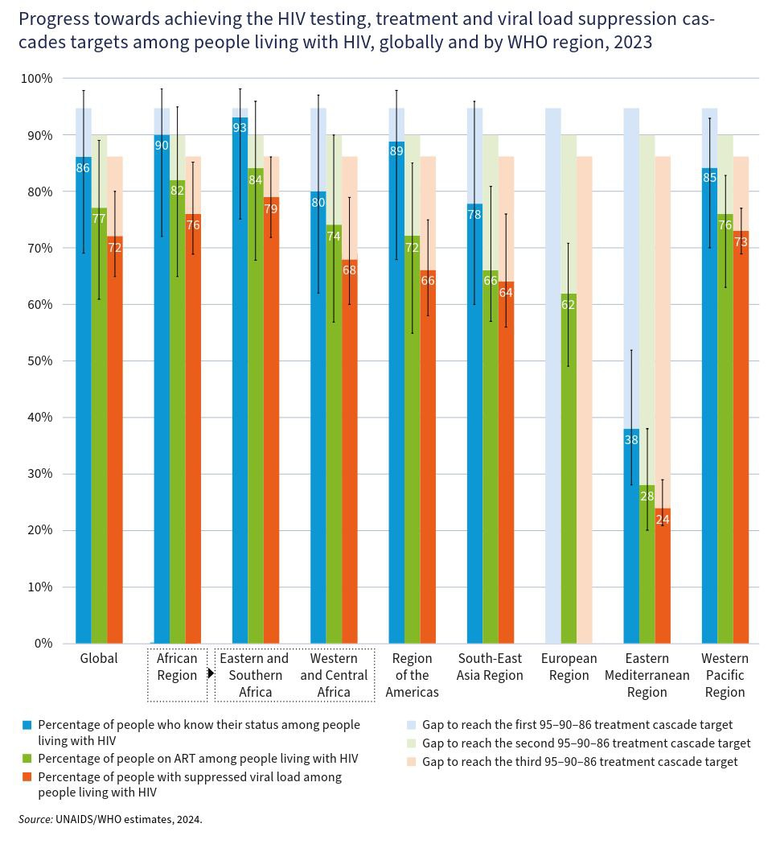

**Pathogenesis and Transmission**

HIV is transmitted through unprotected sexual contact, blood transfusion, needle-sharing, and from mother to child during childbirth or breastfeeding. The virus primarily infects CD4+ T cells,leading to progressive immune depletion. The course of infection is divided into:

1. Acute HIV Infection*(2-4 weeks post-exposure): Characterized by flu-like symptoms, high viral load, and rapid CD4+ decline.

2. Chronic HIV Infection(Clinical Latency): Virus persists at low levels; asymptomatic but ongoing immune activation occurs.

3. AIDS Stage: Defined by CD4+ count <200 cells/μL or the presence of opportunistic infections (e.g., Pneumocystis jirovecii pneumonia, tuberculosis, Kaposi's sarcoma). 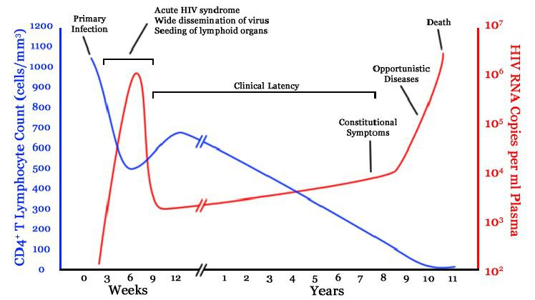

**Clinical Manifestations**

HIV infection presents in three phases:

- Acute Retroviral Syndrome (ARS):Fever, lymphadenopathy, sore throat, rash, and myalgia.

- Chronic Phase:Persistent generalized lymphadenopathy, weight loss, diarrhea, oral candidiasis.

- AIDS: Opportunistic infections (cryptococcal meningitis, cytomegalovirus retinitis),malignancies (Kaposi’s sarcoma, non-Hodgkin lymphoma), and neurological complications.

**Diagnosis**

Early and accurate diagnosis is essential for treatment and prevention of transmission.

Diagnostic modalities include:

1.Serological Tests:

- ELISA (Enzyme-linked immunosorbent assay):Detects HIV antibodies.

- Rapid Tests: Point-of-care detection for screening.

2. Confirmatory Tests:

- Western Blot:Confirms HIV infection.

- PCR (Polymerase Chain Reaction):** Detects HIV RNA, useful for early infant diagnosis.

3. CD4 Count & Viral Load Monitoring:

- CD4 count assesses immune function.

- Viral load guides treatment efficacy.

**Management and Treatment Advances.**

The introduction of ART has revolutionized HIV care, reducing morbidity and mortality.

Antiretroviral Therapy (ART)

ART consists of a combination of drugs that suppress viral replication and restore immune

function. Classes include:

1. Nucleoside Reverse Transcriptase Inhibitors (NRTIs): Zidovudine, Tenofovir.

2. Non-Nucleoside Reverse Transcriptase Inhibitors (NNRTIs):Efavirenz, Nevirapine.

3. Protease Inhibitors (PIs):Lopinavir, Darunavir.

4. Integrase Strand Transfer Inhibitors (INSTIs):Dolutegravir, Raltegravir.

5. Entry Inhibitors:Maraviroc (CCR5 antagonist), Enfuvirtide (fusion inhibitor).

Emerging Therapies and Cure Strategies

1. Long-Acting Injectable ART: Cabotegravir-Rilpivirine simplifies adherence.

2. Broadly Neutralizing Antibodies (bNAbs):Target multiple HIV strains.

3. Gene Therapy & CRISPR: Aim for viral eradication.

4. HIV Vaccines:mRNA-based candidates are in development.

Challenges in HIV Management

- Drug Resistance: Mutations in HIV genome reduce ART efficacy.

- Adherence Issues:Socioeconomic factors affect ART compliance.

- Stigma & Discrimination:Limit access to care in marginalized populations.

- HIV Co-Infections:Tuberculosis, Hepatitis B & C complicate management.

**Conclusion**

Despite remarkable advances in HIV treatment, challenges remain in achieving a functional cure.Ongoing research into novel therapies, vaccines, and gene-editing strategies offers hope for an HIV-free future. Efforts to improve ART adherence, reduce stigma, and enhance global healthcare access are critical for ending the HIV epidemic.

**References**

1. UNAIDS Global HIV Report 2023.

2. WHO Guidelines on HIV Treatment and Prevention.

3. Fauci AS, Lane HC. *Harrison's Principles of Internal Medicine*, 21st Edition, 2022.

4. Here are five notable Indian doctors who have made significant contributions to HIV/AIDS research and treatment:

1. Dr. Sunil Suhas Solomon - Affiliation: Associate Professor of Medicine, Division of Infectious Diseases, Johns Hopkins University School of Medicine; Chairman, YR Gaitonde Centre for AIDS Research and Education (YRGCARE) - Department: Medicine

- Institution: Johns Hopkins University School of Medicine; YRGCARE

- City: Baltimore, USA; Chennai, India

2. Dr. Rajeev Sadanandan - Affiliation: Former Additional Chief Secretary, Government of Kerala

- Department: Health and Family Welfare

- Institution: Government of Kerala

- City: Thiruvananthapuram, India

3. Dr. Sheela Godbole - Affiliation: Director, National Institute of Translational Virology and AIDS Research (formerly National AIDS Research Institute - NARI)

- Department: Virology and AIDS Research

- Institution: National Institute of Translational Virology and AIDS Research

- City: Pune, India

4. Dr. N. Kumarasamy - Affiliation: Chief Medical Officer, YRGCARE

- Department: Infectious Diseases

- Institution: YR Gaitonde Centre for AIDS Research and Education (YRGCARE)

- City: Chennai, India

5. Dr. Suniti Solomon (Posthumous) - Affiliation: Founder, YRGCARE - Department: Microbiology

- Institution: YR Gaitonde Centre for AIDS Research and Education (YRGCARE)

- City: Chennai, India