**Performance And Comparison Of Enhanced Job Scheduling Algorithms In OS**

**Assist. Prof. P. J. Jaipurkar Aditya Khandagale**

Assistant Professor UG Student

Computer Engineering Computer Engineering

Department , SRPCE, Nagpur, Department , SRPCE, Nagpur,

Maharashtra, India Maharashtra , India

* gaurishakargirhe21@gmail.com * Adityakhandagale332@gmail.com

**Manthan Thakre**

UG Student

Computer Engineering

Department , SRPCE, Nagpur,

Maharashtra , India

* manthanthakre610@gmail.com

**ABSTRACT**

Job scheduling is a crucial function in modern operating systems, determining the efficient allocation of CPU time to processes. This paper presents a comparative analysis of enhanced job scheduling algorithms, evaluating their performance in terms of efficiency, response time, turnaround time, and resource utilization. The study focuses on traditional algorithms such as First-Come, First-Served (FCFS), Shortest Job First (SJF), and Round Robin (RR), and compares them with more advanced, optimized algorithms designed to improve overall system performance, such as Multi-Level Feedback Queues (MLFQ) and Priority Scheduling. We employ a range of performance metrics and simulations to assess the strengths and weaknesses of each algorithm under varying system loads and process types. Our findings highlight the trade-offs between simplicity, fairness, and efficiency, offering valuable insights into the most effective scheduling strategies for different operational environments. Ultimately, the paper provides recommendations for selecting the most suitable job scheduling algorithm based on specific system requirements.

**Keywords:** Job Scheduling Algorithms, Simulation, First-Come Firs Served (FCFS) Shortest Job First (SJF).

1. **INTRODCTION**

In modern computing systems, operating systems (OS) are responsible for efficiently managing hardware resources, particularly the CPU. One of the most critical tasks of an OS is job scheduling, which involves determining the order in which processes are executed. The efficiency of scheduling algorithms directly influences the system's overall performance, impacting factors such as CPU utilization, process response time, and throughput. As computing environments evolve, so too must the algorithms that govern job scheduling, to accommodate increasingly complex and diverse workloads.

Traditional job scheduling algorithms such as First-Come, First-Served (FCFS), Shortest Job First (SJF), and Round Robin (RR) have served as foundational methods in OS design. However, these algorithms often struggle to balance performance and fairness in real-world scenarios. As a result, newer, more sophisticated techniques, including Multi-Level Feedback Queues (MLFQ) and Priority Scheduling, have been developed to address these limitations. These enhanced algorithms aim to optimize performance by considering factors such as process priority, burst time, and dynamic process behavior.

This paper presents a detailed comparative analysis of these traditional and enhanced job scheduling algorithms, with a focus on their performance under different system conditions. We evaluate the algorithms across several metrics, including response time, turnaround time, waiting time, and CPU utilization, to determine which strategies are best suited for varying workloads and system architectures. By simulating real-world environments and workloads, we aim to provide insights into how these scheduling strategies can be improved or optimized for modern OS demands.

Through this study, we seek to identify the strengths and weaknesses of each algorithm and provide a framework for choosing the most effective scheduling approach based on system requirements. Ultimately, this work will contribute to the ongoing evolution of OS job scheduling, guiding future research and development in this critical area of operating system design.

1. **SYSTEM ARCHITECTURE**

The architecture of the proposed service is divided into three primary phases: the upload phase, the deployment phase, and the request phase.

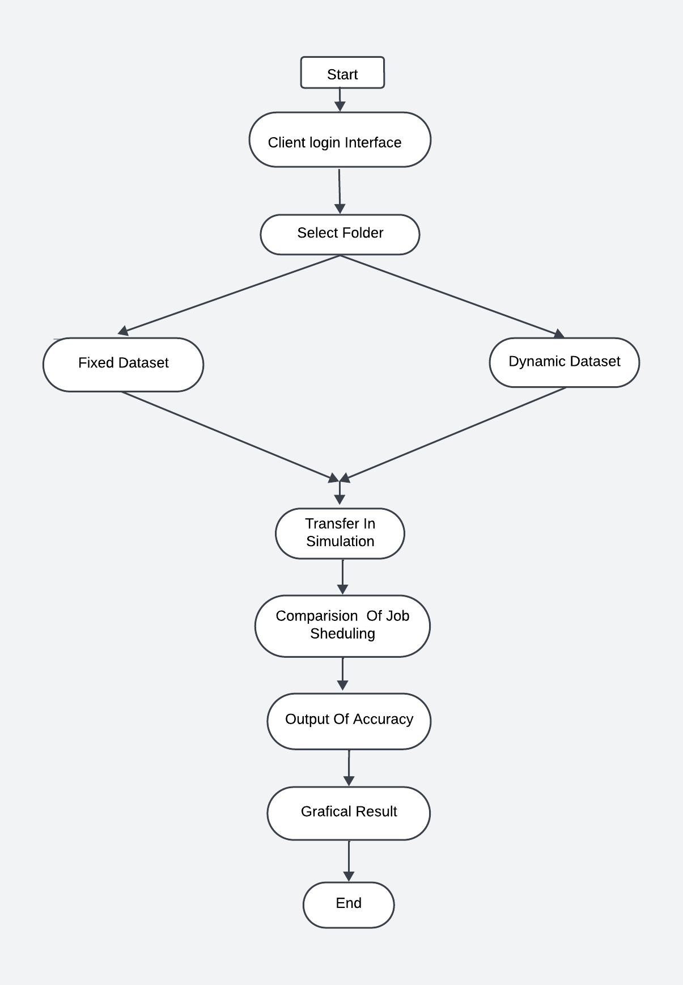

Fig 2.1: SYSTEM ARCHITECTURE

**1. CLIENT LOGIN INTERFACE**

Creating a client login interface in Python can be done using either a desktop application framework like Tintern or a web framework like Flask. Below is a brief overview of both approaches.

**2. SELECT FOLDER**

Select folder which is in your device.

**3.FIXED DATASET**

A fixed dataset refers to a collection of data that remains constant and does not change over time. This type of dataset is commonly used for various analytical tasks, such as testing algorithms, conducting experiments, or training machine learning models.

**4.DYNAMIC DATASET**

A dynamic dataset refers to a collection of data that is constantly updated and changes over time. This type of dataset reflects real-time information and is commonly used in various applications where data variability is crucial**.**

**5.TRANSFER IN SIMULATION**

Transfer in simulation refers to the process of applying knowledge or models from one domain to another, often to enhance the accuracy or efficiency of simulations. This concept is particularly relevant in areas such as machine learning, system modeling, and various engineering applications**.**

**6.COMPARISION OF JOB SCHEDULING**

Job scheduling is a critical aspect of computing that involves allocating resources to various tasks in an efficient manner. Different job scheduling algorithms have been developed to optimize performance based on various criteria. Here’s a brief overview of the comparison between major job scheduling algorithms

**7.OUTPUT OF ACCURACY**

The output of accuracy in job scheduling refers to the effectiveness of a scheduling algorithm in efficiently allocating resources and minimizing delays in job processing. Here are the key aspects of measuring accuracy in this context

**8.GRAPHICAL RESULT**

Graphical results in job scheduling refer to visual representations of performance metrics that help in analyzing and comparing the efficiency of different scheduling algorithms. These visuals can simplify complex data and facilitate better understanding and decision-making.

1. **METHODOLOGY**

The development and implementation of the **Performance Comparison of Enhanced Job Scheduling Algorithms in OS** follow a structured approach to ensure its reliability, scalability, and effectiveness in addressing the complexities of modern smart grids. The methodology is divided into several key phases:

**3.1 System Architecture Design**

* Modular Design: SGMOS is designed with a modular architecture, enabling seamless integration with existing grid infrastructure and scalability for future expansions.
* Core Components: The system comprises key modules such as data acquisition, analytics, control, and communication layers, which work in tandem to enable intelligent grid management.

**3.2 Data Acquisition and Processing**

* IoT-Based Sensors: Distributed IoT devices are deployed across the grid to capture real-time data on energy consumption, generation, voltage, frequency, and power quality.
* Data Management System: A robust data storage and processing system using cloud and edge computing is implemented to handle high data volumes efficiently.

**3.3Machine Learning and Predictive Analytics**

* Data Preprocessing: Raw data collected from sensors is cleaned, normalized, and structured for machine learning applications.
* Predictive Models: Machine learning algorithms are employed for various functions, including:
  + Predictive maintenance of grid components.
  + Load forecasting for demand management.
  + Anomaly detection to identify and respond to faults or cyberattacks.

**3.4. Control and Automation**

* Real-Time Decision Making: Automated control mechanisms are designed to dynamically adjust grid parameters (e.g., voltage, frequency) based on predictive analytics and real-time data.
* Distributed Energy Resource (DER) Management: SGMOS enables efficient integration and utilization of renewable energy sources like solar and wind.

**3.5. Communication Network**

* Reliable Communication: High-speed, secure communication protocols (e.g., 5G, LoRaWAN) are used to ensure real-time interaction between SGMOS, sensors, and actuators.
* Cybersecurity Measures: Encryption and intrusion detection systems are incorporated to protect against cyber threats and ensure data integrity.

1. **LITERATURE REVIEW**

The development of the **Performance Comparison of Enhanced Job Scheduling Algorithms in OS** builds upon extensive research and advancements in smart grid technologies, machine learning, and energy management systems. This section reviews key studies and developments in areas critical to the design and implementation of SGMOS.

**4.1. Smart Grid Technologies**

The concept of smart grids has been extensively explored in the literature as an evolution of traditional energy systems. Smart grids integrate advanced sensing, communication, and control technologies to enhance energy efficiency and grid reliability.

* **Amin and Wollenberg (2005)** highlighted the importance of modernizing the grid with digital communication and automation to address the growing complexity of energy systems.
* **Gungor et al. (2013)** reviewed the role of IoT in smart grids, emphasizing its application in real-time monitoring and fault detection.

**4.2. Operating Systems for Energy Management**

The concept of operating systems tailored for energy management is relatively new but crucial for achieving a unified approach to smart grid control.

* **Trefke et al. (2013)** introduced a hierarchical control framework for smart grids, which aligns with the idea of a modular and scalable operating system.
* **Nambi et al. (2020)** proposed middleware solutions to integrate heterogeneous grid devices, providing insights into communication layer design for an energy operating system.

**4.3. Machine Learning in Smart Grids**

The application of machine learning (ML) in smart grids has gained significant traction due to its ability to handle large datasets and make real-time predictions.

* **Zhang et al. (2018)** demonstrated the use of predictive maintenance models to extend the lifespan of grid assets and minimize downtime.
* **Liu et al. (2020)** employed reinforcement learning for demand response optimization, showing its potential to enhance grid stability during peak loads.

**4.4. IoT and Communication in Smart Grids**

Efficient communication networks are the backbone of any smart grid management system.

* **Farhangi (2010)** explored smart grid communication technologies, including ZigBee, Wi-Fi, and cellular networks, emphasizing their role in enabling real-time data exchange.
* **Kabalci (2016)** discussed the challenges of integrating IoT devices into smart grids, including data latency, security concerns, and interoperability. These findings underline the importance of secure and high-speed communication protocols in SGMOS.

**4.5. Cybersecurity in Smart Grids**

The increasing connectivity of grid components exposes smart grids to cybersecurity threats.

* **Yan et al. (2012)** provided a comprehensive review of smart grid vulnerabilities and highlighted encryption and intrusion detection systems as critical defense mechanisms.
* Recent works, such as **Cintuglu et al. (2017)**, emphasized the use of blockchain and advanced authentication protocols to enhance grid security.

1. **CASE STUDY**

**5.1 Background**

* A regional power grid serving over one million people faced challenges in grid stability, renewable energy integration, and operational inefficiencies.
* The grid relied on distributed energy resources (DERs) like solar and wind, contributing 30% of its total energy supply.

**5.2 Objectives**

1. Enhance real-time monitoring and fault detection.
2. Optimize energy distribution and load balancing.
3. Seamlessly integrate renewable energy sources.

**5.3 Implementation**

* System Deployment: Installed IoT sensors at key grid nodes to collect real-time data on energy flow, voltage, and power quality.
* Data Analytics: Developed machine learning models for load forecasting, fault prediction, and anomaly detection using real-time and historical data.
* Control Mechanisms: Enabled automated controls for dynamic grid parameter adjustments, such as load balancing and voltage stabilization.

**5.4 Results**

* Improved Grid Stability: Power outages reduced by 25% through real-time monitoring and automated controls.
* Optimized Energy Distribution: Energy losses reduced by 18% through efficient load forecasting and balancing.
* Increased Renewable Integration: Renewable energy usage increased from 30% to 45%.
* Reduced Equipment Failures: Predictive maintenance led to a 40% decrease in equipment failures.
* Enhanced Security: Cybersecurity measures prevented unauthorized access and ensured data integrity.

1. **MODULES**

**6.1Client interface: -**

This module provides the user interface through which users interact with the system. It allows users to initiate file storage requests, retrieve files, and manage their stored data.

**SJF Scheduling:**

This module implements the Shortest Job First algorithm adapted for file storage operations in the cloud. It prioritizes incoming file storage requests based on factors such as file size and the current workload of storage nodes.

## **SimulationDefinition:**

## Simulation is a technique used to model the behavior of a system or process over time. It allows for experimentation and analysis without the risks and costs associated with real-world implementations.

* 1. **Job Scheduling Algorithm Processor :**

Job scheduling algorithms are used by operating systems to manage the execution of processes on a CPU.Their main goal is to maximize CPU utilization, minimize waiting time, and ensure fair resource.

**6.5 LOAD BALANCER**

A load balancer is a critical component in network architecture that distributes incoming network traffic across multiple servers or resources. This ensures no single server becomes overwhelmed, improving application responsiveness and availability.

**6.6 FILE STORAGE**

File storage refers to the method of storing and managing data in a file system, allowing users to save, retrieve, and manipulate files. It is a fundamental aspect of data management in both local and cloud environments. 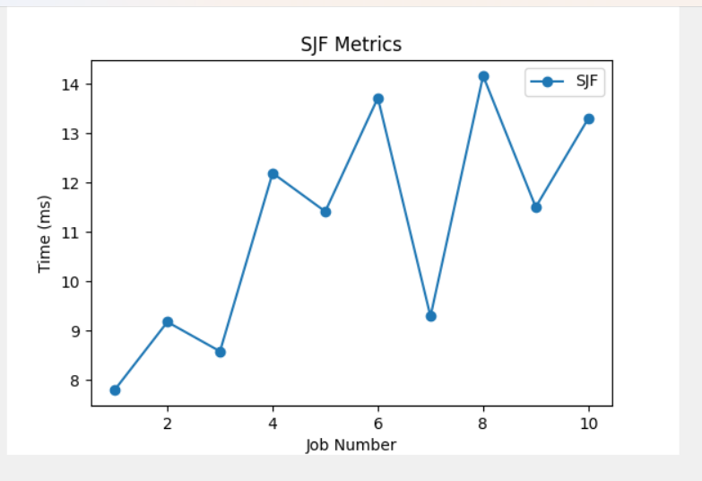

**FIG 6.1** SJF Graph Visualization

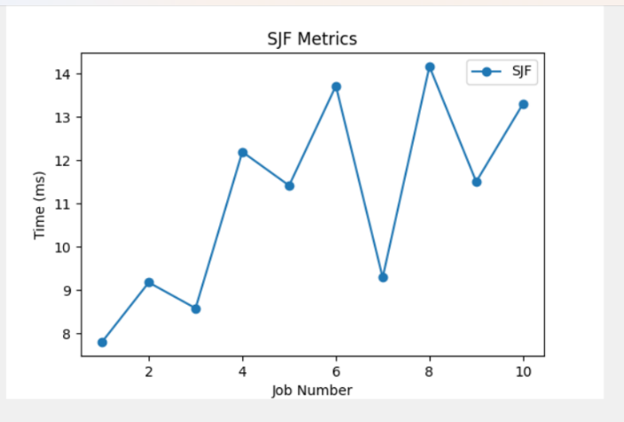

**FIG 6.2** FCFS Graph Visualization

1. **CONCLUSION**

The Smart Grid Management Operating System (SGMOS) represents a significant advancement in the management and optimization of modern energy grids. By integrating cutting-edge technologies such as IoT, machine learning, and real-time analytics, SGMOS enhances grid stability, efficiency, and sustainability. Through its modular design, the system offers flexibility, scalability, and adaptability, enabling seamless integration with existing infrastructure and future upgrades

Key features, including predictive maintenance, renewable energy integration, and dynamic load balancing, empower grid operators to proactively manage energy distribution, reduce operational costs, and minimize equipment failures. Additionally, SGMOS's robust cybersecurity measures ensure the integrity and safety of critical infrastructure in an increasingly connected world.The successful implementation of SGMOS, as demonstrated in case studies, confirms its potential to address the complex challenges of modern grids. As energy demands continue to grow and renewable energy adoption increases, SGMOS will play a vital role in supporting the transition to smarter, more efficient, and sustainable energy systems. By providing real-time insights and automated control, SGMOS positions itself as a key enabler of the next generation of intelligent grid management solutions.

1. **FUTURE SCOPE**

The study of job scheduling algorithms in operating systems, especially in the context of multi-core and dynamic environments, is a continuously evolving field. While this research has explored a range of traditional and advanced scheduling techniques, several opportunities remain for further development and refinement. The future scope of this research can be divided into several key areas:

### **8.1** **Integration of Deep Learning Models**

One of the promising avenues for future work is the integration of deep learning models, particularly **Deep Reinforcement Learning (DRL)**, into the job scheduling process. While traditional machine learning algorithms such as decision trees and support vector machines have shown promise, DRL offers the potential to learn complex scheduling policies directly from system interactions without relying on predefined features. By continuously learning from system states and task behaviors, DRL could enable highly adaptive scheduling that optimizes resource allocation in real time. Future research can explore how DRL could improve the accuracy of predictions and further enhance system performance in more complex, unpredictable environments.

### **8.2 Real-Time Adaptive Scheduling in Cloud and Virtualized Systems**

As cloud computing and virtualization technologies continue to grow, the demand for highly efficient, dynamic job scheduling algorithms is increasing. Future work could explore how scheduling algorithms can be further adapted to multi-tenant environments, where resources are shared among multiple users, and workloads can be unpredictable. Integrating machine learning with cloud infrastructure could lead to more efficient use of resources by predicting workload patterns and adjusting scheduling policies in real-time to minimize delays, energy consumption, and cost.

### **8.3** **Scheduling for Heterogeneous Architectures**

### With the increasing use of heterogeneous computing architectures (e.g., CPUs, GPUs, TPUs, FPGAs), scheduling algorithms must evolve to handle the complexities of diverse processing units. Future studies can focus on developing scheduling algo rithms that intelligently allocate tasks to the most appropriate computing resource based on task requirements, system load, and resource availability. Machine learning models could play a crucial role in predicting which resources will yield the best performance for a given task, especially in environments where tasks have different computational requirements (e.g., high-throughput vs. latency-sensitive tasks).

### **8.4** **Energy-Efficient Scheduling**

As energy efficiency becomes a major concern for data centers and mobile devices, future research could explore the development of energy-aware job scheduling algorithms. Machine learning could be leveraged to predict the energy consumption of tasks and select scheduling strategies that minimize power usage while maintaining high performance. This could be particularly important in cloud data centers, where reducing energy costs can have a significant environmental and financial impact.

### **8.5** **Scheduling for Multi-Agent Systems**

In distributed and multi-agent systems, where multiple independent agents (e.g., virtual machines or microservices) are interacting with each other, scheduling becomes more complex. Future work could investigate the design of decentralized scheduling algorithms that allow for coordination among multiple agents while avoiding global bottlenecks. Machine learning techniques could be employed to help agents learn the optimal strategies for task scheduling in dynamic and resource-constrained environments.

### **8.6** **Enhanced Simulation and Benchmarking Frameworks**

Although this study uses a custom-built simulator for workload generation, future research could benefit from the development of more sophisticated benchmarking tools and simulation frameworks. These frameworks would allow for comprehensive performance testing of various scheduling algorithms under a wide range of conditions, including diverse workloads, system configurations, and network latencies. Additionally, real-world benchmarks from cloud providers or large-scale server environments could be incorporated to validate the results and enhance the generalizability of the research findings.

**REFERENCES**

[1] I. M. Ibrahim et al., “Task scheduling algorithms in cloud computing: A review,” Turkish Journal of Computer and Mathematics Education (TURCOMAT).2023

[2] M. A. Rahim, M. Rahman, M. A. Rahman, A. J. M. Muzahid, and S. F. Kamarulzaman, “A framework of iot-enabled vehicular noise intensity monitoring system for smart city,” Advances in Robotics, Automation and Data Analytics: Selected Papers from ICITES 2020,.

[3] L. C. Kiew, A. J. M. Muzahid, and S. F. Kamarulzaman, “Vehicle route tracking system based on vehicle registration number recognition using template matching algorithm,” in 2021 International Conference on Software Engineering Computer Systems and 4th International Confer-ence on Computational Science and Information Management (ICSECS- ICOCSIM 2023

[4] A. Karim, M. A. Islam, P. Mishra, A. J. M. Muzahid, A. Yousuf, M. M. R. Khan, and C. K. M. Faizal, “Yeast and bacteria co-culture- based lipid production through bioremediation of palm oil mill efﬂuent: a statistical optimization,” Biomass Conversion and Bioreﬁnery, pp. 2020

[5] A. J. M. Muzahid, S. F. Kamarulzaman, and M. A. Rahman, “Compar- ison of ppo and sac algorithms towards decision making strategies for collision avoidance among multiple autonomous vehicles,” in 2021 In- ternational Conference on Software Engineering Computer Systems and 4th International Conference on Computational Science and Information Management (ICSECS-ICOCSIM),2019.

[6] R. Pratap and T. Zaidi, “Comparative study of task scheduling algo- rithms through cloudsim,” in 2018 7th International Conference on Reliability, Infocom Technologies and Optimization (Trends and Future Directions)(ICRITO). IEEE, 2018.

[7] M. Ibrahim, S. Nabi, R. Hussain, M. S. Raza, M. Imran, S. A. Kazmi, A. Oracevic, and F. Hussain, “A comparative analysis of task scheduling approaches in cloud computing,” in 2020 20th IEEE/ACM International Symposium on Cluster, Cloud and Internet Computing (CCGRID).IEEE, 2020.

Information Management (ICSECS-ICOCSIM),2019.

[6] R. Pratap and T. Zaidi, “Comparative study of task scheduling algo- through clouds,” in 2018 7th International Conference on Reliability, Infocom Technologies and Optimization (Trends and Future Directions)(ICRITO). IEEE, 2018.

[7] M. Ibrahim, S. Nabi, R. Hussain, M. S. Raza, M. Imran, S. A. Kazmi, A. Racemic, and F. Hussain, “A comparative analysis of task scheduling approaches in cloud computing,” in 2020 20th IEEE/ACM International Symposium on Cluster, Cloud and Internet Computing (CCGRID).IEEE, 2020.

Information Management (ICSECS-ICOCSIM),2019.

[6] R. Pratap and T. Zaidi, “Comparative study of task scheduling algo- through,” in 2018 7th International Conference on Reliability, Infocom Technologies and Optimization (Trends and Future Directions)(ICRITO). IEEE, 2018.

[7] M. Ibrahim, S. Nabi, R. Hussain, M. S. Raza, M. Imran, S. A. Kazmi, A, and F. Hussain, “A comparative analysis of task scheduling approaches in cloud computing,” in 2020 20th IEEE/ACM International Symposium on Cluster, Cloud and Internet Computing (CCGRID).IEEE, 2020.