1. **Title Page** 
   1. **Title of the Project :** METROLOGICAL TESTING.
   2. **Student Details:**

**Name**  **Roll No**

Gitanjali Prabhakar Koshti. 35087

Snehal Sachin Khamkar. 35083

Sejal Rajkumar Magadum. 35091

Sanika Suhas Magdum. 35093

* 1. **Institution Name:** Sharad Institute of Polytechnic, Technology, Yadrav.
  2. **Department :** Computer Engineering

**1.5 Supervisor’s Name :** Ms. Shraddha Suresh Nandai.

**Abstract:**

The Project aim is to save the information into the database and reduce the chances of error and data lost. The Civil department of our collage has done Compression testing for the firms and organization used for that the maintaining the record and calculation for their test they used Excel sheet. We identified this and decided to make the Software that can maintain the record into the database, do all the calculation related to the test. This will reduce the human error and maintain record into database. We will do the provision that to take the data backup regularly so the data loss in prevented.

1. **Introduction:**

Presently our collage Civil Engineering department done some testing on the construction jobs of some construction firms and organization in their laboratory. The test results storage and calculation purpose they used the Microsoft Excel sheet. Traditional way the results are stored in the sheets one after another and also do the calculations in it.

This is the time-consuming process and generation of results sheet manually So, there is chance of data lost when there is the issue with PC, some other causes, security of data and might result in error.

**2.2 Exiting System:**

* No software present at all.
* Time consuming.
* Manual creation of report.

**2.3. Objectives:**

The objective of the systems: -

* It reduced the Operational time.
* To reduce paperwork as generate Pdf report.
* Increase accuracy and reliability.
* Increase operational efficiency.
* Data security.

This software packages can be readily used by non – programming personal avoiding human handled chance of error.

**2.4 SCOPE OF PROJECT:**

This project has a large scope as it has the following features which help in making it easy to use, understand and modify it

* Ease of Procedure.
* No Need to do Paper Work as Pdf copy of report is generated.
* To save the environment by using paper free work.
* To increase the accuracy and efficiency of the placement procedure.
* Management of Data.

**Main Points are**: -

• Simplified Management of customer Profiles.

• Pdf of report with QR code.

• Selection Results.

• Real-time Information through system

**3. Methodology:**

**3.1 Approach**

Successful software projects are managed well. To manage a project efficiently, the manager or development team must choose the software development methodology that will work best for the project at hand. All methodologies have different strengths and weaknesses and exist for different reasons. Here’s an overview of the most commonly used software development methodologies and why different methodologies exist. They are

1. **Agile development methodology.**
2. **Waterfall development methodology.**
3. **Rapid application development.**
4. **DevOps development methodology.**

In our project we proposed the Agile methodology. The description for this is as follows:

* **Agile development methodology**

Teams use the agile development methodology to minimize risk (such as bugs, cost overruns, and changing requirements) when adding new functionality. In all agile methods, teams develop the software in iterations that contain mini-increments of the new functionality. There are many different forms of the agile development method, including scrum, crystal, extreme programming (XP), and feature-driven development (FDD).

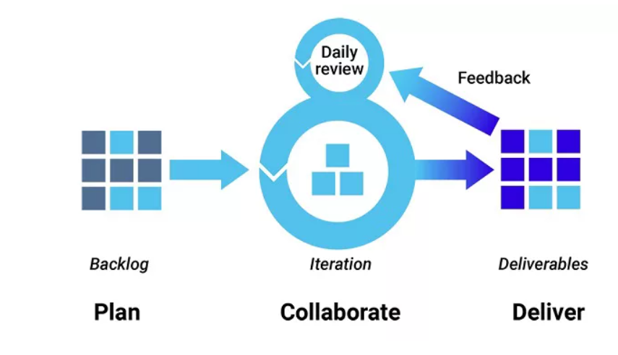

**Advantage:**

* The primary benefit of agile software development is that it allows software to be released in iterations.
* Iterative releases improve efficiency by allowing teams to find and fix defects and align expectation early on.
* They also allow users to realize software benefits earlier, with frequent incremental improvements.

**Disadvantages:**

* Agile development methods rely on real-time communication, so new users often lack the documentation they need to get up to speed.
* They require a huge time commitment from users and are labor intensive because developers must fully complete each feature within each iteration for user approval.

Agile development methods are similar to rapid application development and can be inefficient in large organizations. Programmers, managers, and organizations accustomed to the waterfall method (see below) may have difficulty adjusting to an [agile SDLC](https://www.synopsys.com/glossary/what-is-agile-sdlc.html)(Software Development Life Cycle). So a hybrid approach often works well for them.

**3.1.2 Technology:**

* **C# Language**

The Ecma standard lists these design goals for C#:

* The language is intended to be a simple, modern, general-purpose, [object-oriented](https://en.wikipedia.org/wiki/Object-oriented_programming) programming language.
* The language, and implementations thereof, should provide support for software engineering principles such as [strong type](https://en.wikipedia.org/wiki/Strong_and_weak_typing) checking, array [bounds checking](https://en.wikipedia.org/wiki/Bounds_checking), detection of attempts to use [uninitialized variables](https://en.wikipedia.org/wiki/Uninitialized_variable), and automatic [garbage collection](https://en.wikipedia.org/wiki/Garbage_collection_(computer_science)). Software robustness, durability, and programmer productivity are important.
* The language is intended for use in developing [software components](https://en.wikipedia.org/wiki/Software_components) suitable for [deployment](https://en.wikipedia.org/wiki/Deployment_environment) in distributed environments.
* [Portability](https://en.wikipedia.org/wiki/Software_portability) is very important for [source code](https://en.wikipedia.org/wiki/Source_code) and [programmers](https://en.wikipedia.org/wiki/Programmer), especially those already familiar with [C](https://en.wikipedia.org/wiki/C_(programming_language)) and [C++](https://en.wikipedia.org/wiki/C%2B%2B).
* Support for [internationalization](https://en.wikipedia.org/wiki/Internationalization_and_localization) is very important.
* C# is intended to be suitable for writing applications for both hosted and [embedded systems](https://en.wikipedia.org/wiki/Embedded_system), ranging from the very large that use sophisticated [operating systems](https://en.wikipedia.org/wiki/Operating_system), down to the very small having dedicated functions.
* Although C# applications are intended to be economical with regard to memory and [processing power](https://en.wikipedia.org/wiki/Processing_power) requirements, the language was not intended to compete directly on performance and size with C or assembly language.

**3.2 Design and Development**

Our proposed system has four menu option they are –

* New File
* Open File
* Settings
* Backup

**3.2.1** **New File: -**

In this menu we have all the data entry parameters which required for the report generation. There are 4 buttons are present in this section they are as follow

1. SAVE: - It is used to Save all the data.
2. RESET: - It is used to Reset the parameters.
3. DELETE: - It is used to Delete the data if we don’t want it.
4. PRINT: - It proposed for print the Reports.

**3.2.2** **Open File: -**

This menu option used when we want to edit some data of particular record. In this menu option all button as in New File are present.

**3.2.3** **Settings: -**

In this menu option we have some changeable parameters which are Notes, Terms and Conditions, Designation and their name etc.

**3.2.****4 Back-up: -**

This menu option is used for the Backup the Data.

**3.3 Tentative Architecture:**

***2.3.1 System Block Diagrams***: -

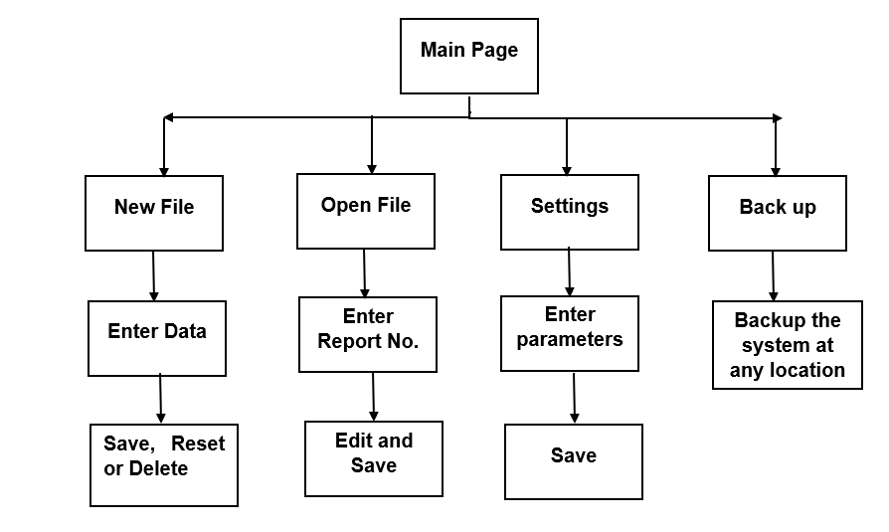

The flow chart for the Save the Data is as follows

User Inputs Data

Display Error Message

Validate Data?

No

Yes

Save Data to Database

Save Successfully?

No

Log Error

Display Error Message

Yes

Display Confirmation Message

The flow chart for the Print report is as follows

Stored Certificate no shows

Display Error Message

Select Certificate no. for report Print.

Not

selected

Yes

Display Report Pdf for Print

The flow chart for the Edit is as follows

Search Certificate no in search textbox

Get Details and Make Change

Press RESET Button

Yes No

Save The Changes

* Main Page

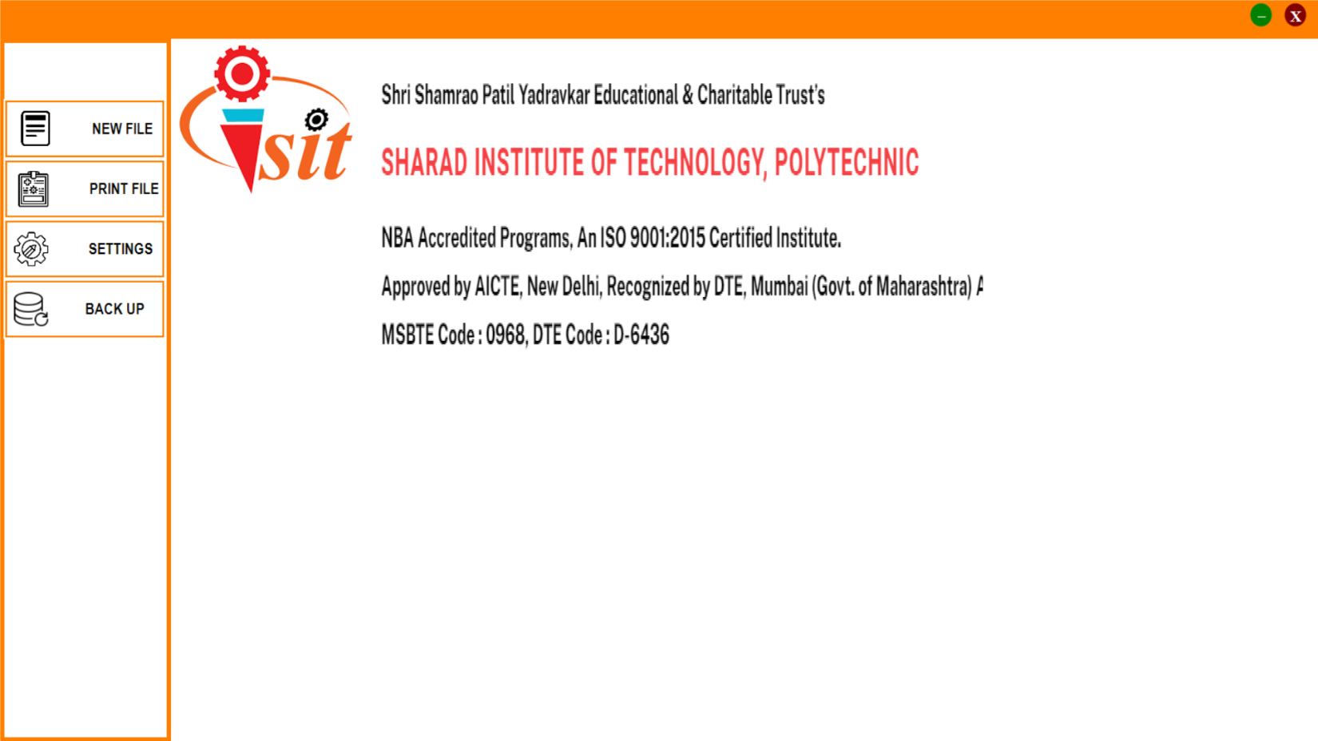

***Image 1 :- Main Page***

The above image shows the design and overview of the Main Page of software. This page contains the The Menu bar, in which we can navigate in to the software through it.

The Menu bar contains menu which described in section 2.2 , they are

* New File
* Open File
* Settings
* Backup
* Print File

From all above menu we have first concentrate on the main part of the which is the New File.

***NEW FILE :-***

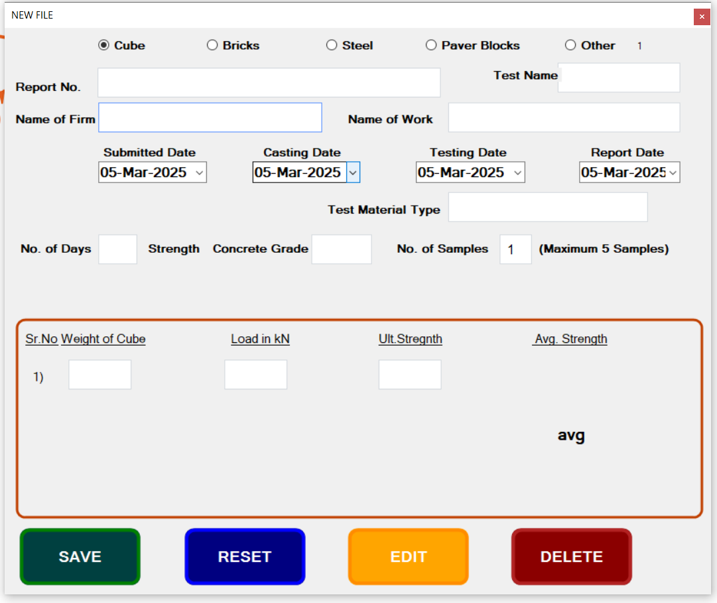

***Image 2:- NEW FILE***

In New File we have enter all Test Data.

* There is selection buttons according to test material type which are

1) Cube and Paver.

2) Bricks.

3) Steel.

4) Paver Blocks

5) Other

according to the type of material, we have to select one of the above type.

* + The data entry fields are
    1. Name of Firm – from which firm we have the work allotted.
    2. Name of Work – For which company the firm doing work.
    3. Report No. – The report number is allotted by the Lab.
    4. Date – There are four dates Casting date, Submitted date, Testing date, Report date.
    5. Testtype – According to test material type we have to enter which type of test material we have used like Cube, Bricks, Paver, Reinforcement Steel etc.
    6. Test Material Type - In this field we have to enter the use of test material like footing, Slab etc.
    7. No of day Strength – This information is given by the Firm.
    8. Concrete Grade – This field is for which Grade material used.
    9. No. of Samples - The number of sample submitted for testing. In this software we have limited to 5 samples for one report.
    10. Reading Table - According to the no of Sample the data entry text boxes are changed.
* In the above image we have take 5 sample so there are 5 data entry text boxes.
* The Calculation are done automatically accordingly the data entered.
  + 1. The three buttons are to Save, Reset, Delete are used to save, reset and delete the record.
    2. **Edit** - By Pressing this button we see the Search Text box with Search button,Enter the Certificate Number and press search button.All Data related to that certificate will appear in respective text boxes. Change the Data which we want to change and Save.

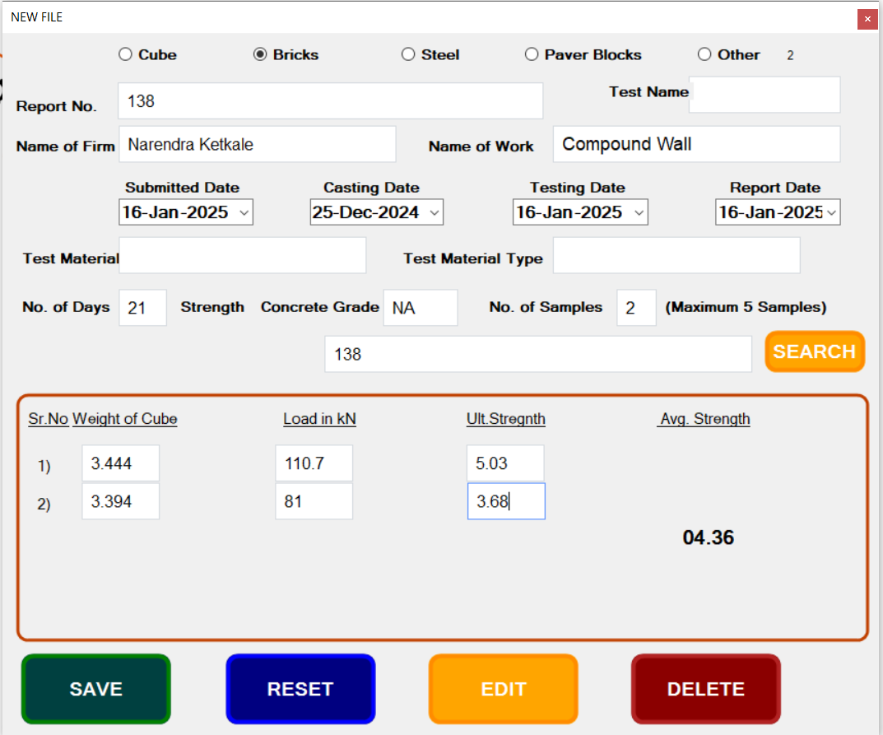

**Edit Text Box & Button**

***Image :- NEW FILE with Edit option***

* ***PRINT FILE :-***

The Print button will navigate us to the report print page

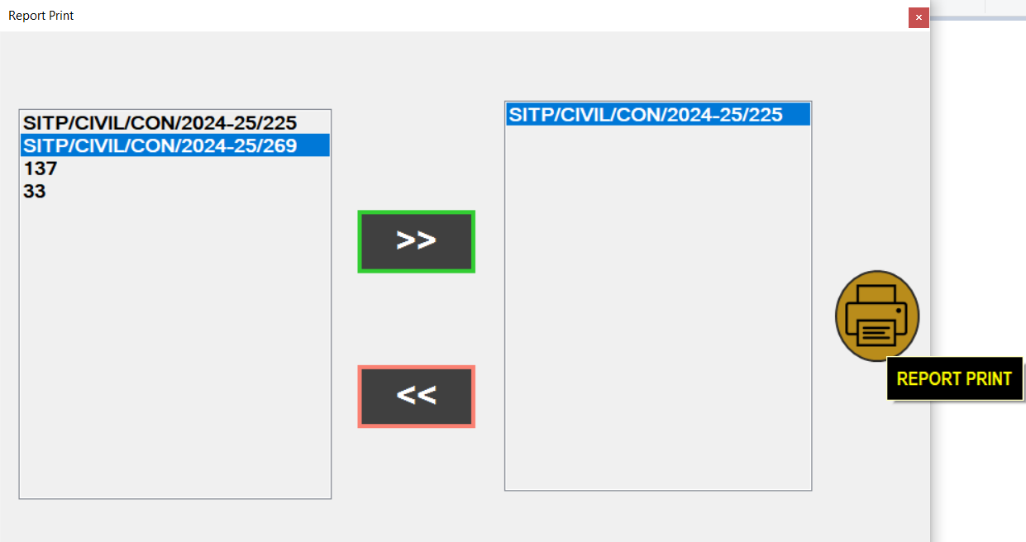

***Image 3 – PRINT FORM***

The above Image 4 Shows the Report Print Form, in which the the list of the saved report are shown.

There are two buttons which are ADD, REMOVE ,REPORT PRINT.

* ADD - It will add the report which we want to print into print report list
* REMOVE - It will remove the report which we selected to print into print report list
* REPORT PRINT – This button will shows the report in the pdf form, so we can save it or print it.

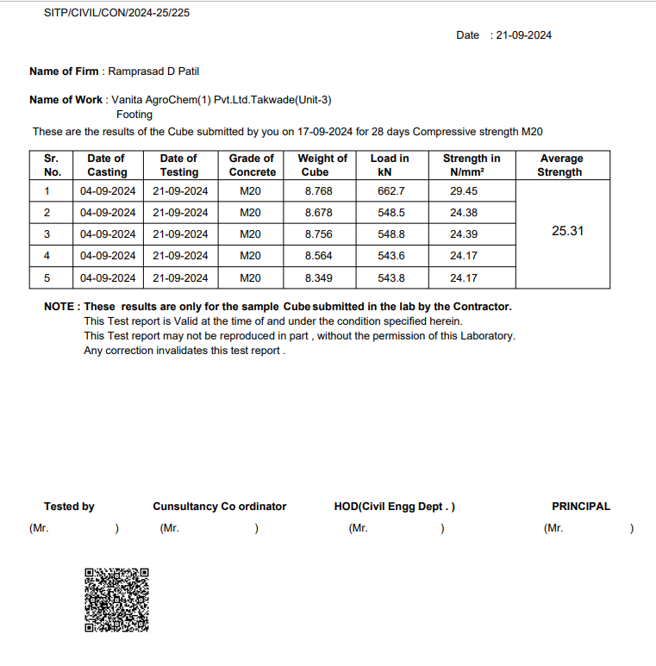

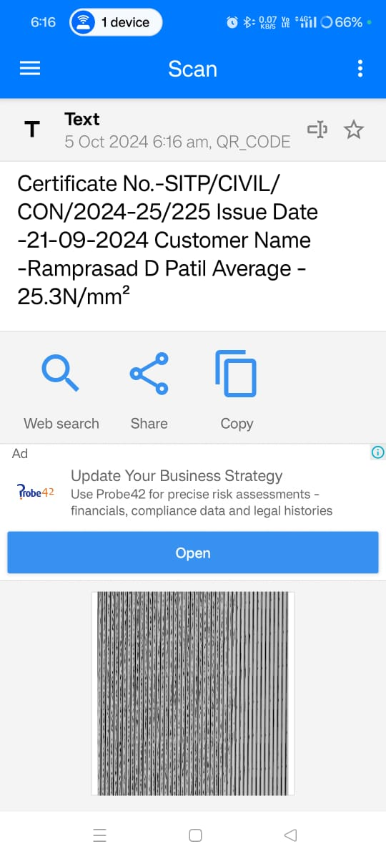

***Image 4 – REPORT PRINT***



***Image 5 – QR CODE SCAN***

The above Image 5 and 6 shows the Report and QR code scan data.

The extra feature of QR code is added in the report.

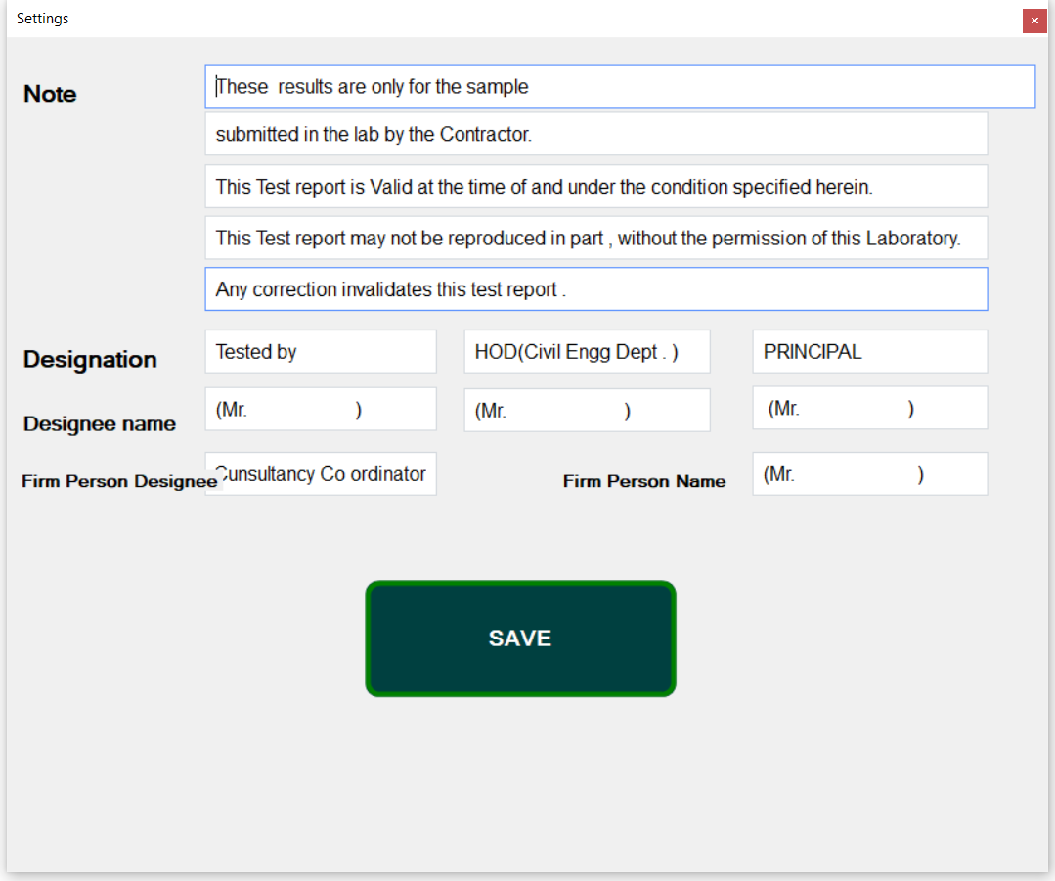

* ***SETTINGS :-***

***Image 7 – SETTINGS FORM***

The above Image 7 Shows the Settings Form, in which the the list of the saved report are shown.

In which we have saved some data which is editable as per the rule or condition of management changed.

* The fields are in setting page are,

1.Notes

2.Designation

3.Name of Designee

4. Firm Person Designee

5. Firm Person Name

1. **Notes**

* In the Notes we can mention the terms and condition for the report according to guideline of management.

1. **Designation and Name**

* In this we can add Designation of Authorized person and their Names respectively for the report.
* As in the above form we have the designations are
  + - 1. Tested By
      2. HOD(Civil Department)
      3. Principal

**4. Firm Person Designation and Name**

* In this field we can add the Authorized firm person Designation and Name if he/she presents during the test perform as for proof on the report.
* Or we can mention this on report for acknowledgment for our consideration as report has received by the Authorized person of firm for which testing has done.
* ***BACK UP :-***

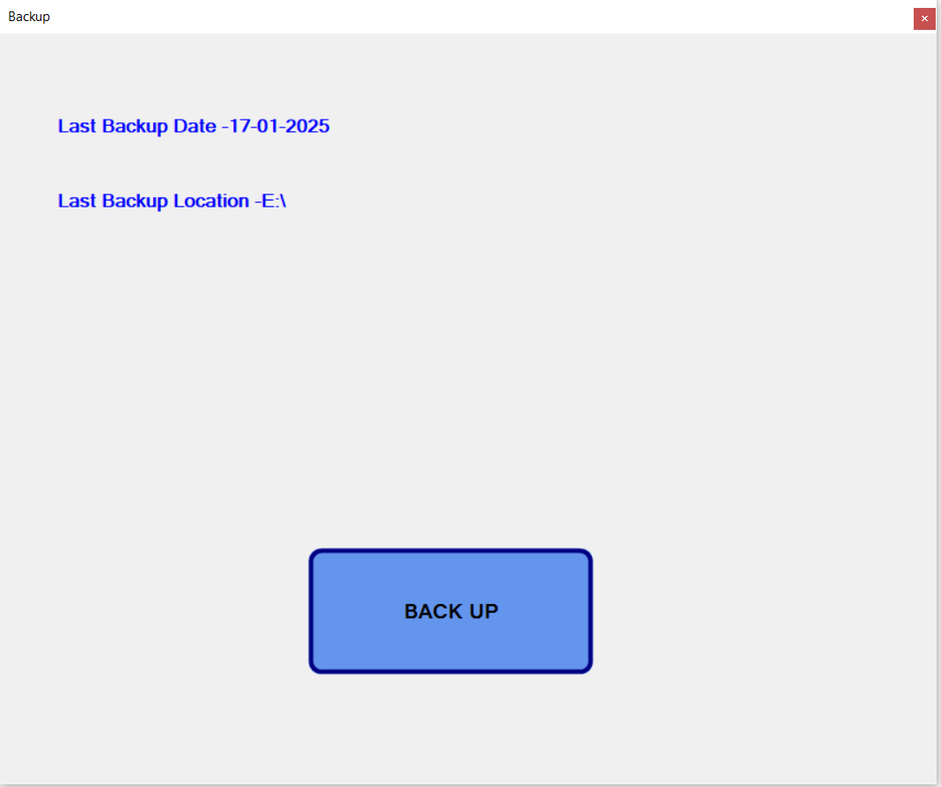

***Image 8 – BACKUP FORM***

The above Image 8 Shows the BACKUP Form, in which the the list of the saved report are shown.

The above Image shows Back up form.

* In this we can take the back up of all the data saved in Database by pressing the Back Up button.
* If the back up is taken earlier then the there is provision has made in the form that it shows

1.Last Back up Date.

2. Back up Location.

**1.Last Back up Date.**

The Date on which Back up was taken previously.

**2.Back up Location.**

The Location where the previous Back up Stored

As above image shows that the Last Back up Date which is

17-01-2025 and the Location was on E Drive.

**There are two buttons on Main page**

**1.Minimize**

on the Upper Right Corner the Green Circular button which is used to minimize the Application.

**2.Exit**

On the Menu bar the Last button is Close; by Pressing this button we can Exit the Application.

* ***Microsoft SQL Server: -***

Data base used in the software is Microsoft SQL Server, which is secure and reliable. We make three tables which are following with their description.

* *TestBasics* :- The data related to New File form is stored in the this table.

Column used in this table are as follows –

* testId(Primary key - int) – It unique Id for each test.
* testFirm(nvarchar(250)) – It used to store the Firm name for which work done.
* testWork(nvarchar(250)) – It is used to store the test on which work is done.
* testContractor(nvarchar(250)) – It used to store the Contractor name.
* testType(int) – It used to store test type.
* testMaterial(nvarchar(100)) – It used to store the test Material.
* testCertNo(nvarchar(250)) – It used to store the Certificate number.
* testMtype(nvarchar(100)) – It used to store the test Material type.
* testSubmitdt, testCastingdt, testTestingdt, testReportdt(smalldatetime)-It used to store the submitted, Testing , Casting and Report Date.
* testDays(int) - It used to store the number of days strength.
* testGrade(nvarchar(50)) – It used to store material grade.
* testNoSampl(int) – It used to store the number of sample submitted for test.
* Also there are columns for store test results according to there test Type.
* *TestSettings* :- The data related to Settings form is stored in the this table, which may change periodically.

Column used in this table are as follows –

* testNote1, testNote11, testNote2,testNote3,testNote4 (nvarchar (500))-

It is used to store the Note or Disclaimer.

* testDes1, testDes2, testDes3, testDesNam1, testDesNam2, testDesNam3(nvarchar(50)) – It used to store Designation and Designee Name.
* testConPerson, testConPersonName(nvarchar(50))- It used to store the Contractor Person Designation and Name.
* *DBBACKUP* :- This table save the back up data.
* bkpId(int) – It used to store the backup Id.
* bkpDate(smalldatetime)- It used to store backup Date.
* bkpPath(nvarchar(MAX)) – It used to store backup Path where back up is stored.

**5. Tools and Technologies:**

Following requirements for the installation of software, Tools used to develop the software.

**5.1 Hardware requirements:**

* 1GHz processor
* 1GB RAM

**5.2 Software requirements:**

* Microsoft SQL Server:

Microsoft SQL Server is a relational database management system developed by Microsoft. As a database, it is a software product whose primary function is to store and retrieve data as requested by other software applications, be it those on the same computer or those running on another computer across a network (including the Internet). There are at least a dozen different editions of Microsoft SQL Server aimed at different audiences and for different workloads (ranging from small applications that store and retrieve data on the same computer, to millions of users and computers that access huge amounts of data from the Internet at the same time

* Visual Studio 2019:

Microsoft Visual Studio is a powerful IDE that ensures quality code throughout the entire application lifecycle, from design to deployment. Whether you’re developing applications for SharePoint, the web, Windows, Windows Phone, and beyond, Visual Studio is your ultimate all-in-one solution.

**5.3 Tools:**

* Gun UI:

**1**.Guna Framework gives you access to unlimited updates. Optimized Performance.

**2**.Lightweight on Visual Studio & outputs optimized GUIs. **3**.Developer Friendly and Easy.

**4**. **UI** tools for WinForms C# and VB.NET app development

**5**. 50+ **UI** Controls.

**6**. Comprehensive components with extensive features to help to develop anything.

* Pdf Sharp:

1. PDF sharp is an open-source .NET library for processing PDF files.
2. It is written in C#.
3. The library can be used to create, render, print, split, merge, modify, and extract text and meta-data of [PDF](https://en.wikipedia.org/wiki/PDF) files.
4. Features include images with transparency (color mask, monochrome mask, alpha mask), font embedding and sub setting, and graphical implementation based either on GDI+ or WPF

**6. Advantages:**

* User friendly GUI.
* Reduce the time.
* Facility of Unit change.
* Pdf copy of report generated.
* Data security.

**7. Project Roadmap**

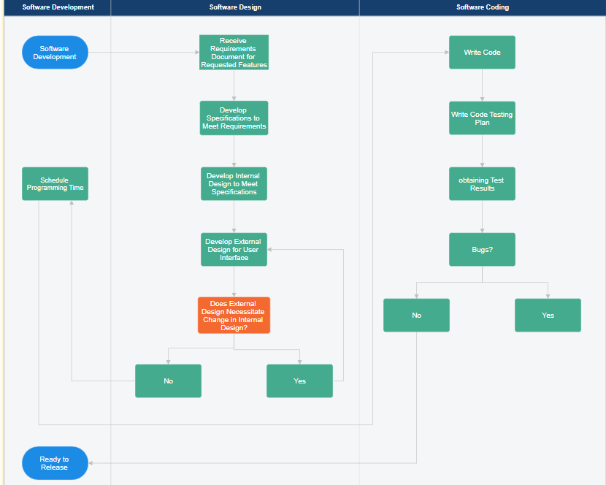

* **September 2024**

1. Designing the Main Page and New File Page.
2. Write down the required code for calculation, CRUD operation and Print report.

* **October 2024**

1. Designing and coding of Open File, Settings and Backup menu options.
2. Demo to Civil laboratory and take suggestions and also take information for other tests for including in software

* **January and February 2025**

1**.**Completion of other test coding and report generation.

2. Submitting project for Testing.

* **March 2025**

1.Completion of the suggestions and improvement in software.

2. Preparation Project report

**8.** **SIGNIFICANCE OF PROJECT:**

The significance of the project is to provide the following benefits:

• The significance of project is to ease of the process in the laboratory.

• There is no worry of checking time to time.

• Needed to updates as per requirement is easy.

• Create lists of all reports

**9.References:**

* www.w3schools.com
* [www.stackoverflow.com](http://www.stackoverflow.com)
* [www.pdfsharo.net](http://www.pdfsharo.net)
* https://gunaui.com