# LOWER HEAD WATER TURBINE ELECTRICITY GENERATOR

PROF. D. P. JADHAV, DIGAMBAR A. JAGDALE, DARSHAN R. VELIS, KRUSHNA N. PARDESHI, SOHAM R. GOVERDHANE

M.V.P’S RAJARSHI SHAHU MAHARAJ POLYTECHNIC, NASHIK, MAHARASHTRA,INDIA, DEPARTMENT OF MECHANICAL ENGINEERING

***Abstract:*** The alternative energy source of river water diversion or micro hydro power generation, are detail discussed in the present investigation. Reuse of Nasardi river water can be a stable, inflation proof, economical, reliable and renewable energy source of electricity. Both the historical and the present day civilization of many kind are closely interwoven with energy and there is no reason to doubt but that in the future our existence will be more dependent upon the energy. Electrical energy occupies the top position in the energy hierarchy. But conventional sources of electricity generation are limited in used. So there are many renewable energy resources are used for generation of fluid. Electricity such as: solar energy, Biomass energy and wind energy etc. But in the modern day one of the most useful resources are including for generation of Electricity is based on “River water based Hydro power plant”.

## *Index Terms* - vortex turbine, motor generation System modelling, diversion system.

1. Introduction

[1].Hakim study on a study on the effect of distances between oscillating parts in vortex- associated power generation approach [2]. Perman study effect of free surface on the oscillating part concerning to the performance lies vortex power. As a result; the deeper the location of the oscillating part, the greater amplitude average can be produced and vice versa when tested at a greater speed in the same depth then the resulting amplitude will be smaller. This is due to many reasons, one of which is the holder stability who may not have been perfect [3].With a continued global population growth, a 70% growth in electricity demand is expected by the year 2035 (WWAP, 2014). The growing need for energy for a such rapidly increasing population is one of the most important challenges in the near future, as energy is vital for all other developmental processes. The impact of energy availability influences the living conditions of communities to a large extent. Without electricity there can be no water purification, no health-care and no pharmaceuticals. Hence electricity is essential for life in the Twenty-first Century and an emphasis needs to be laid on power availability.

1. LITERATURE SURVEY

## Pilot Plant in Belgium

Turbulent installed its first pilot site in Kleerbeek, Belgium. At this location there is an old watermill with a sudden fall of 2 meters that’s being fed by a small river through a bypass. The river has a flow of 230 l/s and the total power output of the turbine is 2,2kW.

# SELECTION OF TURBINE:

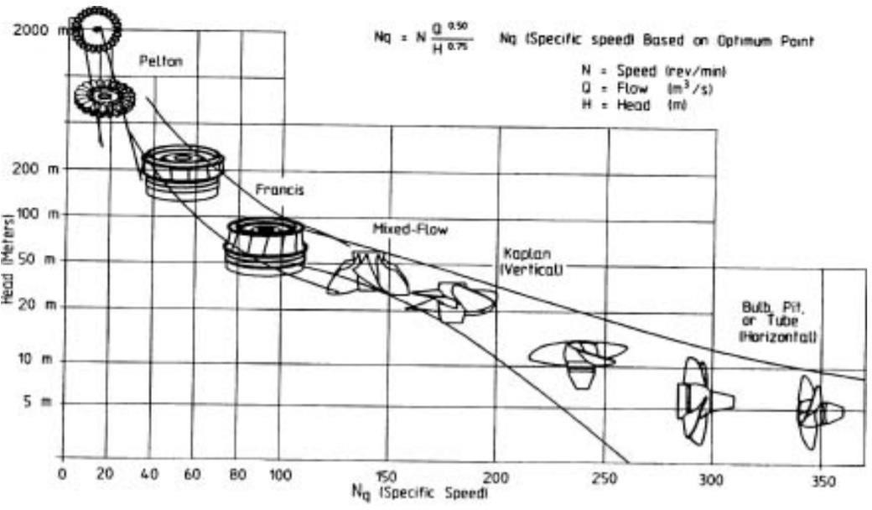

**CRITERIA OF GRAVITATION VORTEX TURBINE:**

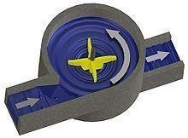

The gravitation water vortex power plant is a type of micro hydro power plant which is capable of producing energy using a low hydraulic head of 0.7–3 metres (2 ft 4 in–9 ft 10 in). The technology is based on a round basin with a central drain. Above the drain the water forms a stable line vortex which drives a water turbine. It was first implemented by Austrian engineer Franz Zotlöterer while attempting to find a way to accelerate water without an external power **source.**

**WHY WE USED TO VORTEX TURBINE:** Our turbine was developed to operate at high level of efficiency on rivers and canals with a low height difference thanks to a new technology based on the vortex principle. It generates electricity in the form of a single turbine or a network of multiple turbines.

It's Key features:

* Fish friendly
* Long operating life
* No flood risk
* Low maintenance

## Low head hydropower

Low-head hydropower generation with very low discharge using water wheels or other devices which do not require reservoirs or dams across rivers have the advantage that they cause slight or no impact on the environment. They are termed as free-flow turbines and, using small scale power generators, do not require costly high-voltage transmission lines. They are an uninterrupted source of energy. This characteristic is of significance as are renewable energy source and cannot be replaced by other renewables like wind or solar energy. Information on free-flow turbine technology in the public domain is almost nonexistent (Khan, Iqbal and Quaicoe, 2008). Conventional low head hydropower is relatively expensive as the turbines have to b designed and manufactured according to individual specifications. Very low head hydropower generation using machines like water wheels comes as an alternative. These units can be adapted to serve remote communities as off-grid solutions.

Most hydro-power plant developers focus on low rotating speed of their turbine. This means that they are working with high torques and this forces them to use large infrastructures, like a concrete base made to specific specs. While Turbulent goes for small and standard, lightness, ease of installation and maintenance Taking all this theoretical status, we considered; formation of vortex motion moves the flaps. Transmits the movement of the bearing shaft attached to it here. Sealing is important for bearings. Dynamo power structure was created to get the rotating shaft. Thus, by varying the magnetic field through the coil is able to generate electrical energy. To ensure this, the location is good way to measure the coil and magnets. Faraday and Lenz laws are basic reference in our study.

Image of actual site of Nasardi River:

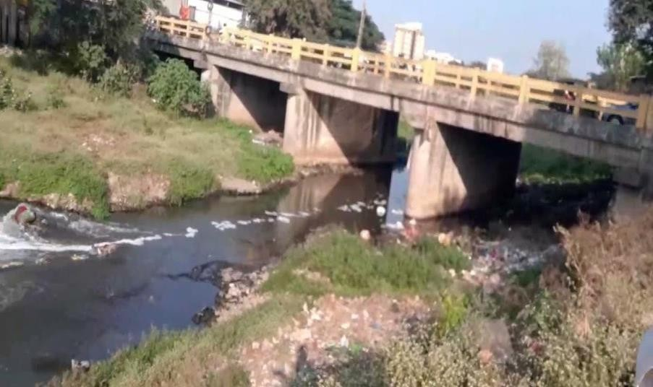

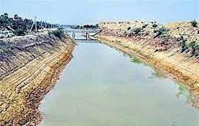

The operation of the turbine is quite simple. It has only one moving part, extending it's operating life, energy production and thus requiring very little maintenance A self- cleaning screen holds large debris out of the turbine

* + The flow is guided into a vortex through our optimized concrete basin.
  + The vortex powers a high technology impeller.

The water flows back into the stream Rivers with a small height difference of 3 meters over a distance of 100 meters are perfect for turbulent vortex turbine. These rivers are generally characterized by white water and turbulent flow.

For these sites we need you to tell us the flow and the height difference of the river over a distance of 100 meters.

How to measure the flow and the height difference?

in a river as we observe the waterfall sites and sudden height difference of minimum 1.5 meters, as we observe and then take action. These sites are incredibly easy to develop and need modifications to the river. These installations normally take about 15 day to finish, also civil works included.

1. Conclusion:

In this study, our aim is not to provide high values of electricity generation. Only, renewable electricity produces the design water flow. Meanwhile, this system will use in many areas such as dam, river and sanitary installations. Obtained in this study with a small vortex is provided at the level of about 1 volt of electricity generation on nasardi river. Many factors had caused power loss such as fraction and used materials. These effects can be reduced to systems prepared with a better budget. This system can be added as an innovation in the design of hydroelectric power plants.

Reference:

1. Furukawa, A., Watanabe, S., Matsushita, D. and Okuma, K., 2010, *Development of ducted Durries turbine for low head hydropower utilization*, Current Applied Physics, 10, pp. 128S132.
2. Harvey, 2006, *Micro Hydro Design Manual: A guide to small scale water power scheme*, IT Publications Ltd London.
3. Singal, S. K. and Saini, R. P., 2008, *Cost analysis of low head demote small hydropower plants based on number of generating units*, Energy for Sustainable Development 12, pp. 5560.
4. Wallace, A.R., 1996, *Embedded mini-hydro generation in the water supply industry*, IEE Conference Publication, 419, pp. 168171.
5. Williams, A., Smith A., N.P.A, Bird, C. and Howard, C., 1998, *Pumps as Turbines and Induction Motors as Generators for Energy Recovery in Water Supply Systems*

,chartered institution of water and environmental management 53 ,pp. 17517.

1. Reviews, 12(8), pp. 2177–2193. doi: 10.1016/j.rser.2007.04.016. Kleefsman, K. M.

T. and Veldman, A. E. P. (2004) ‘An improved volume-of-fluid mehtod for wave impact’, European Congress on Computational Methods in Applied Sciences and Engineering, ECCOMAS 2004, p. 19 pp.

1. Lakehal, D., Meier, M. and Fulgosi, M. (2002) ‘Interface tracking towards the direct simulation of heat and mass transfer in multiphase flows’, International Journal of Heat and Fluid Flows, (23), pp. 242-257.