**Topic: EMRGING TRENDS IN MECHANICAL ENGINEERING**

**Sub Topic: Electric Mobility and Automotive Innovations**

Authors: Mohd Zaid Israr khan1,

Ayyubkhan Aslam Jummal2,

Mr. Suhail Nasaruddin Kazi3

1Anjuman-I-Islam’s Abdul Razzak Kalsekar Polytechnic, Mechanical Engineering TY Student

2Anjuman-I-Islam’s Abdul Razzak Kalsekar Polytechnic, Mechanical Engineering TY Student

3Anjuman-I-Islam’s Abdul Razzak Kalsekar Polytechnic, Sr. Lecturer in Mechanical Engineering Department

**ABSTRACT**

The transportation sector is undergoing a significant transformation driven by the rise of electric mobility and advancements in automotive technology. This paper explores the recent innovations in electric vehicles (EVs), the technological advancements in automotive, and the implications for environmental sustainability, and economic factors, it aims to provide a comprehensive overview of current trends and future directions in the field.

**Introduction:**

The global automotive industry is at a pivotal juncture, influenced by increasing environmental concerns, advancements in technology, and evolving consumer preferences. Electric mobility, characterized by the use of electric vehicles (EVs), represents a critical component of this transformation. Innovations in automotive technology, including autonomous driving, smart connectivity, and advanced materials, are reshaping the industry. This paper examines these developments and their implications for the future of transportation

**Electric Vehicles (EVs)**

**# 1 WHAT IS AN ELECTRIC VEHICLE:** Electric vehicles (EVs) are vehicles that are powered by electric motors instead of internal combustion engines. They use electricity stored in batteries to drive the motor and are recharged via external power sources. There are different types of EVs, including Battery Electric Vehicles, which rely solely on electricity, and Plug-in Hybrid Electric Vehicles, which combine electric power with a conventional engine. EVs offer benefits such as reduced emissions, lower operational costs, and decreased dependence on fossil fuels, contributing to cleaner and more sustainable transportation solutions.

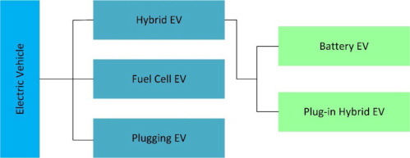

**2 Components of EVs**

Electric vehicles (EVs) consist of several key components that work together to provide efficient and sustainable transportation. Such as Electric motor, battery pack, Battery management system (BMS), Inverter, Charging port etc.

**2.1 Electric Motor:** The electric motor in an EV converts electrical energy from the battery into mechanical energy to drive the wheels. It provides high torque and smooth acceleration, operating quietly and efficiently. Key types include AC and DC motors, with AC motors being more common due to their superior performance and efficiency.

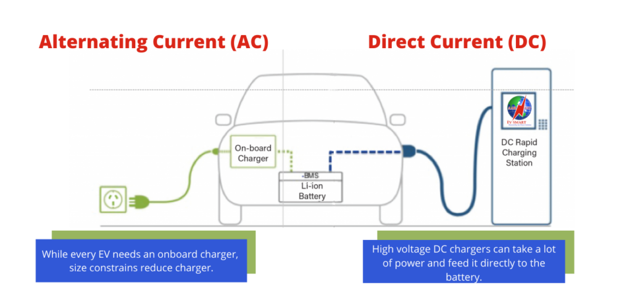

**2.2 Battery Pack:** The battery pack in an EV stores electrical energy to power the motor. Typically, lithium-ion, it comprises multiple cells arranged to provide the required voltage and capacity. The pack's size, measured in kilowatt-hours (kWh), determines the vehicle’s driving range and overall energy efficiency. 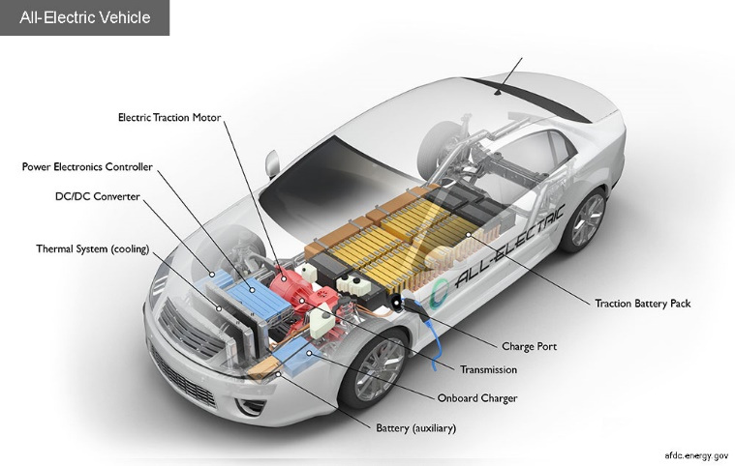

**2.3 Battery Management System (BMS):** The Battery Management System oversees the health and performance of an EV's battery. It monitors charge levels, temperature, and cell balance, ensuring safe operation by preventing overcharging and deep discharging. The BMS optimizes battery life, efficiency, and performance, enhancing overall vehicle reliability.

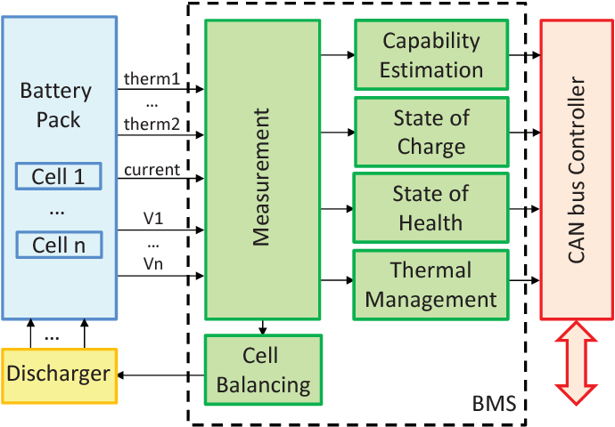

**2.4 Inverter:** The inverter in an EV converts direct current (DC) from the battery into alternating current (AC) for the motor. It also regulates motor speed and torque by adjusting the AC power's frequency and amplitude, ensuring efficient performance and responsiveness while driving.

**2.5 Charging Port:** Connects the EV to an external power source for recharging the battery. It supports various charging standards, including Level 1, Level 2, and DC fast charging. The port must be compatible with the vehicle’s charging system for efficient and safe recharging.

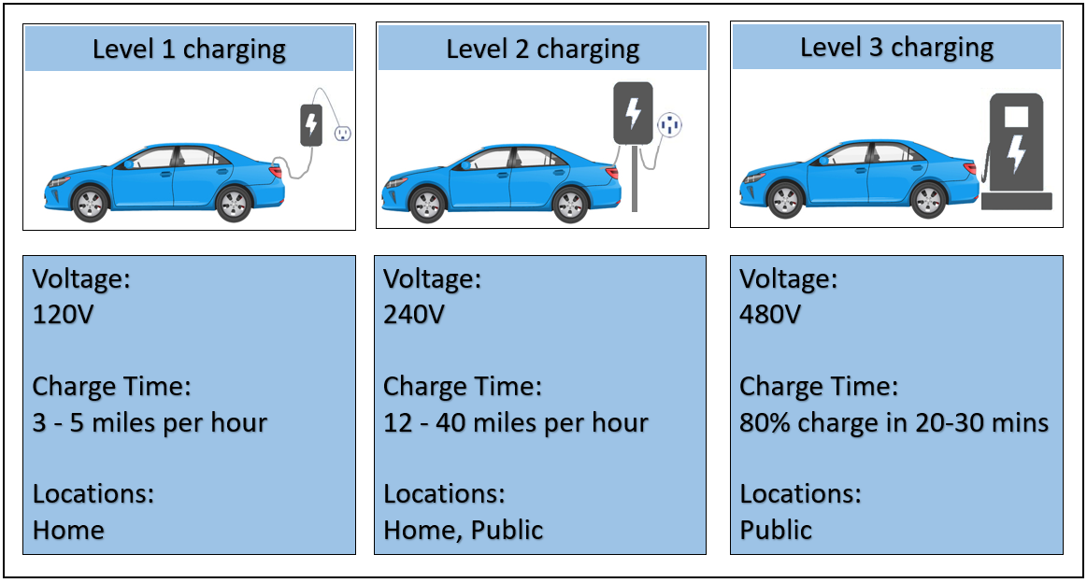

**2.6 Onboard Charger:** Converts AC electricity from the charging port into DC electricity to charge the battery. It manages the charging process, including power conversion and communication with the charging station, ensuring efficient and safe battery charging.

**2.7 Regenerative Braking System:** Recovers kinetic energy during braking and converts it into electrical energy to recharge the battery. This process enhances energy efficiency by extending the vehicle’s driving range and reduces overall energy consumption.

**2.8 Thermal Management System:** Regulates the operating temperatures of the battery and motor. It includes cooling and heating systems to prevent overheating, ensuring optimal performance and longevity of components. Proper thermal management is crucial for efficiency and safety.

**2.9 Control Units:**  Manages the overall performance of the EV, including power distribution and motor control. It processes inputs from the driver and other systems, optimizing performance and integrating advanced features like adaptive cruise control and autonomous driving capabilities.

**2.10Electric Drive Transmission:** Transfers power from the motor to the wheels. Unlike traditional transmissions, EVs often use a single-speed transmission due to the electric motor's broad torque range. This simplifies the drivetrain and provides a smooth, efficient driving experience.

**3 Innovations in electric vehicles**

**3.1 Advanced Battery Technologies:**

**Solid-State Batteries:** They promise to extend driving range and reduce weight. All-solid-state batteries (ASSBs) have emerged as a promising solution to address the limitations of traditional lithium-ion batteries (LIBs). These batteries offer the potential to revolutionize industries ranging from electric vehicles to renewable energy systems. By replacing the liquid electrolyte found in LIBs with solid materials, ASSBs aim to enhance safety, increase energy density, and extend the overall lifespan of energy storage systems. In this article, we’ll introduce all-solid-state batteries, similarities and differences to LIBs, ongoing research challenges, and instrumentation requirements.

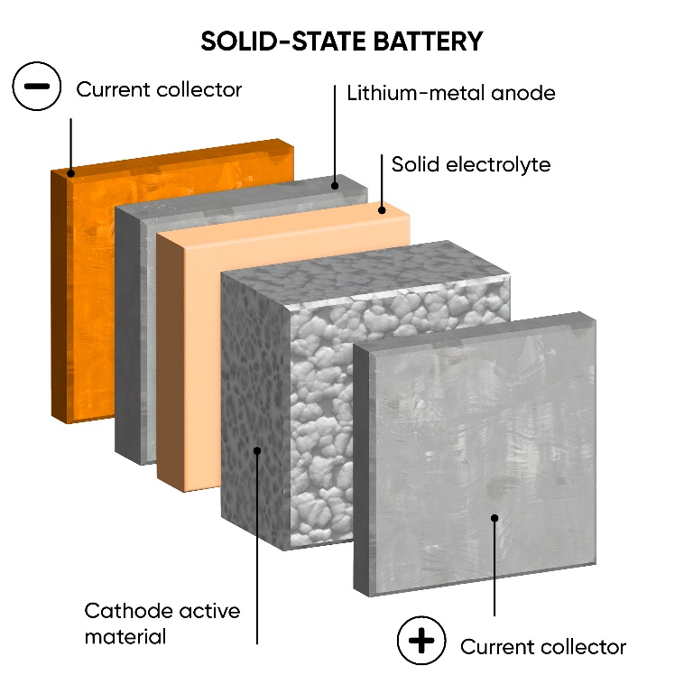

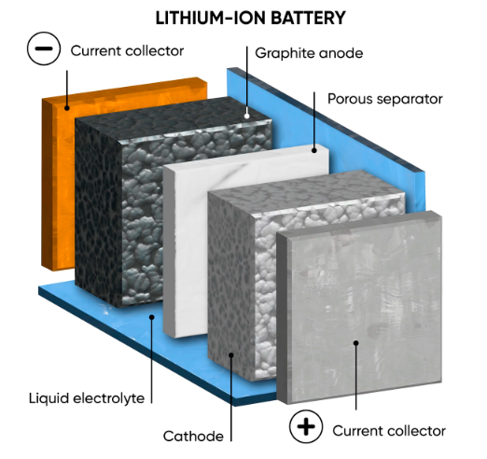

**Battery recycling:** It involves processing used batteries to recover valuable materials like lithium, cobalt, and nickel. This reduces environmental impact, minimizes waste, and lowers the need for new raw materials. Advanced recycling technologies enhance efficiency and sustainability, making the battery lifecycle eco-friendlier and supporting the growing demand for EVs. 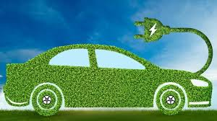

**3.2 Ultra-fast charging:**

**High-Power Charging Stations:** Rapid chargers offer the fastest possible charging speed with a rate of 50 kW. Rapid charging requires only about 30 to 60 minutes to charge an EV battery from 0 to 80 percent

For example, Tesla Supercharger Using 480-volt technology, Superchargers are pretty fast and if you find a V3 running at 250kW, you’ll be on your way again in a matter of minutes after a charging session begins. Basically, at maximum speed, a 10-80% charge on a Supercharger will take around 31 minutes for a [Model Y](https://www.vanarama.com/car-leasing/tesla/model-y), rising to 38 minutes for a Model S or X with the 100kWh battery pack. You’ll be looking at more like an hour for the same charge on an older V1 or V2 running at 150kW.

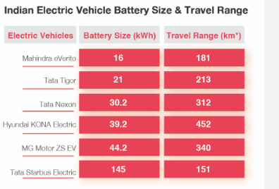

**Wireless Charging:** A two-coil system is used in this technology based on electromagnetic induction. When the installation is complete, the receiving coil is installed in the vehicle, while the charging coil is placed on the road surface. Recent advancements in WPT technology have attracted interest in EV applications because they make it possible to recharge the vehicle safely and conveniently. A standard connector is unnecessary for the charger (but standard coupling technology is required), and the charger can be operated while driving.

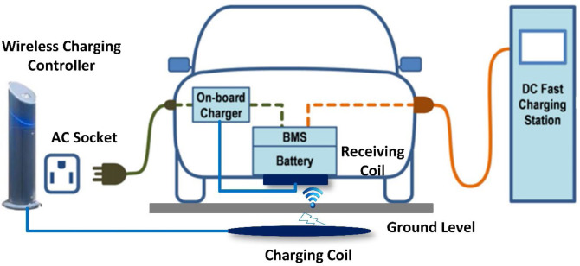

**3.3 Enhanced Range and Efficiency:**

**Range Improvements:** Advances in battery chemistry and vehicle design have extended driving ranges, with some EVs now exceeding 400 miles per charge.

**Energy Recovery Systems:** Enhanced regenerative braking systems and efficient components increase overall vehicle efficiency and range.

**3.4 Smart Charging Solutions: Home Charging Stations:** Smart home integration allows for optimized charging based on energy rates and usage patterns. Home charging calculator helps in calculating the charging time of the electric vehicle and how much it costs. Most of the electric car owners would rely on home charging, given that the private cars would be parked overnight, in order to ensure that their EV is available for use each morning. In most cases, charging overnight at homes will be the cheapest method to recharge.

**4 environmental sustainability:**

In India, electric vehicles (EVs) offer significant environmental sustainability benefits by reducing greenhouse gas emissions and decreasing reliance on fossil fuels, which can help combat air pollution and climate change. However, the sustainability of EVs hinges on several factors. Firstly, the production and disposal of EV batteries involve the extraction of raw materials like lithium, cobalt, and nickel, which can impact ecosystems if not managed properly. Effective recycling and disposal systems are essential to mitigate these effects. Secondly, the environmental benefits of EVs are maximized when the electricity used for charging comes from renewable sources. Integrating solar, wind, and other green energy into India’s power grid is crucial. Lastly, increasing public awareness and developing policies to support EV infrastructure and battery recycling will enhance the overall sustainability of the EV ecosystem, ensuring that India's shift towards electric mobility is environmentally beneficial.

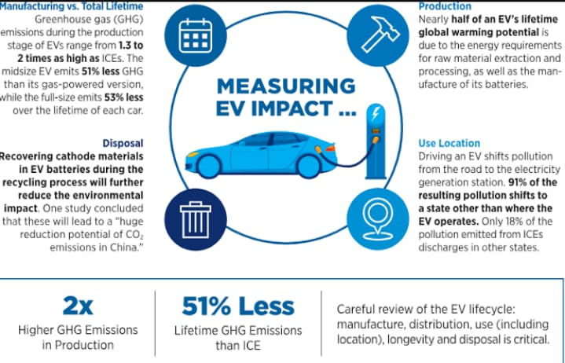 **5 Economic Factors:**

**\*Government Policies:** Incentives as tax credits, subsidies, and emissions regulations are promoting EV adoption. Such as Fame PM-E drive.

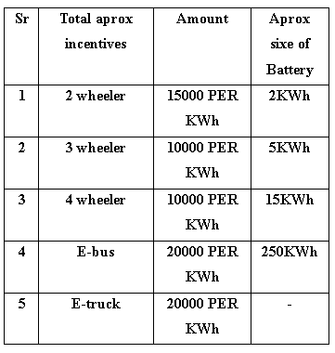

**\*Cost of Ownership:** While the initial cost of EVs can be higher, lower operating costs and reduced maintenance requirements can lead to cost savings over the vehicle's lifetime

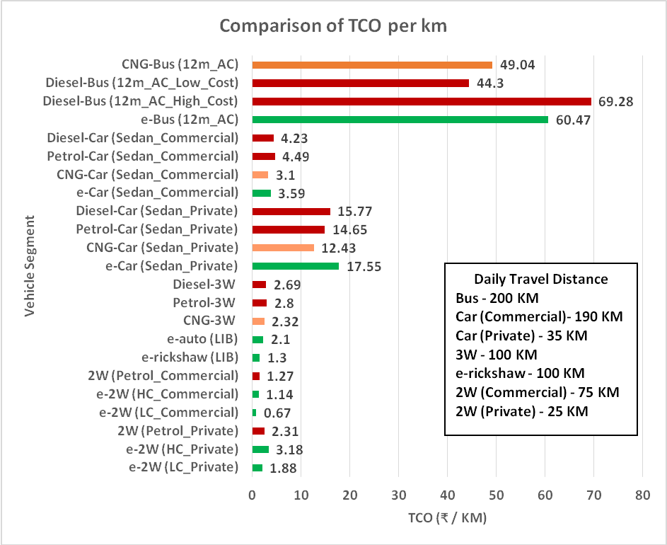

**5 Infrastructure Investments & Future Directions**

**Infrastructure Investments:** The development of charging infrastructure and smart grid enhancements require significant investment, which presents both challenges and opportunities for economic growth.

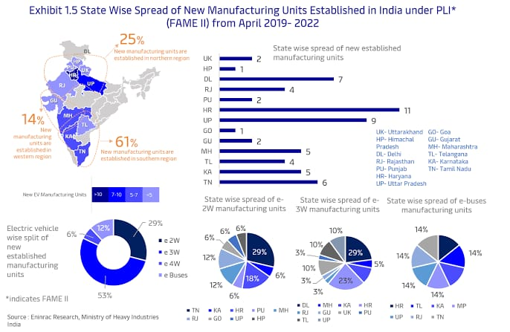

**Future Directions:** India has a huge scope for the electric vehicle. The government has taken so many policies to convert from petrol or diesel to electric vehicles by 2030. The government is

offering so many subsidies on the electric vehicle like deduction road tax etc. The electric vehicle has excellent scope in the future. In the future, these areas have huge scope to connect with the integrated grid. It can create a new scope for engineers and scientists. An uninterrupted power supply is needed for the vehicle to the grid. So, battery choice is one of the main objectives before processing it. In the future, a million miles of battery also, will enter the battery club.

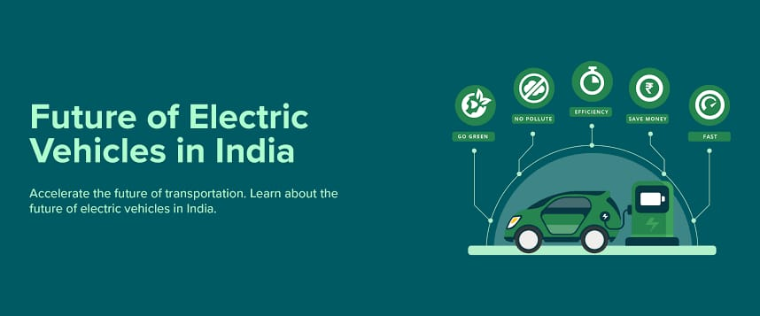

**Integration of Renewable Energy:** The synergy between EVs and renewable energy sources, such as solar and wind power, will play a crucial role in achieving sustainability goals**. 6. Conclusion**

Electric mobility and automotive innovations are driving a paradigm shift in the transportation sector. Advances in EV technology, autonomous driving, connectivity, and materials are reshaping the automotive landscape, with significant implications for environmental sustainability, economic growth, and consumer behavior. As the industry continues to evolve, ongoing research and collaboration will be essential in navigating the challenges and opportunities that lie ahead.

**References**

1. "Electric Vehicles: A Review of Network Modeling and Optimization"

Authors: W. Gao, F. Rachidi, S. Grzybowski

2. "Challenges and Opportunities for Electric Vehicle Adoption: A Global Perspective"

Authors: S. Peters, H. Wolf, M. Patel

3. "Battery Technologies for Electric Vehicles: A Comparative Study"

Authors: J. G. Karlsson, L. A. Hockaday

4. "Wireless Charging for Electric Vehicles: Challenges and Advances"

Authors: M. Budimir, P. C. Chiu, D. Kar

5. "Range Anxiety in Electric Vehicles: Psychological and Technical Approaches"

Authors: E. Schmidt, K. Thomas, L. L. Williams

6. "Energy Management in Hybrid Electric Vehicles"

Authors: C. Zhang, R. K. Agarwal, N. Shirakawa

7. "Electric Mobility in Urban Areas: Challenges and Solutions"

Authors: B. Alkalay, J. Greenfield, P. M. Silva

8. "Environmental Impacts of Electric Vehicles: A Lifecycle Perspective"

Authors: J. Clarkson, R. Jones, S. Humphries

9. "Next-Generation Power Electronics in Electric Vehicles"

Authors: D. P. Thakur, A. S. Bakshi, P. Wadhwa

10. "Infrastructure Challenges for Electric Mobility in Developing Countries"

Authors: T. Gupta, P. Kumar, R. Tan

11."Sustainable Materials for Electric Vehicle Manufacturing"

Authors: F. Dubois, K. K. Yoon, M. Reinhart

12. "Autonomous Driving and Electric Vehicles: A Synergistic Future"

Authors: M. Bradley, C. R. Liu, N. Levitt

13. "Advances in Battery Swapping Technology for Electric Vehicles"

Authors: Y. Zhang, H. Chan, F. Wang

14. "EV Charging Networks: A Critical Infrastructure for Future Mobility"

Authors: A. M. Saeed, S. N. Gaur, D. Kalpana

15. "Solid-State Batteries for Electric Vehicles: Progress and Challenges"

Authors: B. Lampert, G. V. Liu, H. M. Drake

16. "The Economics of Electric Vehicle Production and Adoption"

Authors: R. Thompson, A. Verma, C. Kim

17. "Innovations in Electric Vehicle Drivetrains"

Authors: C. Holmes, N. L. Xu, P. S. Rajan

18. “Schwarting-AR”

Author Daniela Rus