**PROJECT TITLE : A STUDY ON MAGAZINE BRANDING AND IDENTITY: STRATEGIES FOR MARKET LEADERSHIP**

**ABSTRACT**

In the rapidly evolving world of media and publishing, the role of magazine branding and identity has become increasingly significant. Branding is not merely about creating an attractive cover or a memorable logo; it is about crafting a comprehensive identity that resonates with readers, differentiates the publication in a crowded marketplace, and fosters long-term loyalty. As the publishing industry faces challenges from digital disruption and changing consumer preferences, effective branding strategies are more crucial than ever for sustaining a magazine's relevance and success.

This research paper explores the key strategies employed by successful publications to establish and maintain a distinct presence in the competitive magazine market. By examining case studies of leading magazines and analysing their branding approaches, we aim to identify best practices and innovative techniques that contribute to building strong magazine brands in the digital age.

Keywords: Magazine branding, Unique Selling Proposition, Digital transformation, Audience engagement, Content strategy

**INTRODUCTION**

Historical Context of Magazine Branding

Early Beginnings 1731The Gentleman's Magazine Simple, text-heavy covers Industrial Revolution1800sMass production Illustrations and engravings Early 20th Century1900sColor printing Iconic magazinesemergeMid-20th Century1950sGolden Age of Magazines Photography becomes central Late 20th Century1980sDigital graphics Brand consistency emphasis Digital Age 2000s Online presence Multi-platform branding Evolution of Magazine Branding

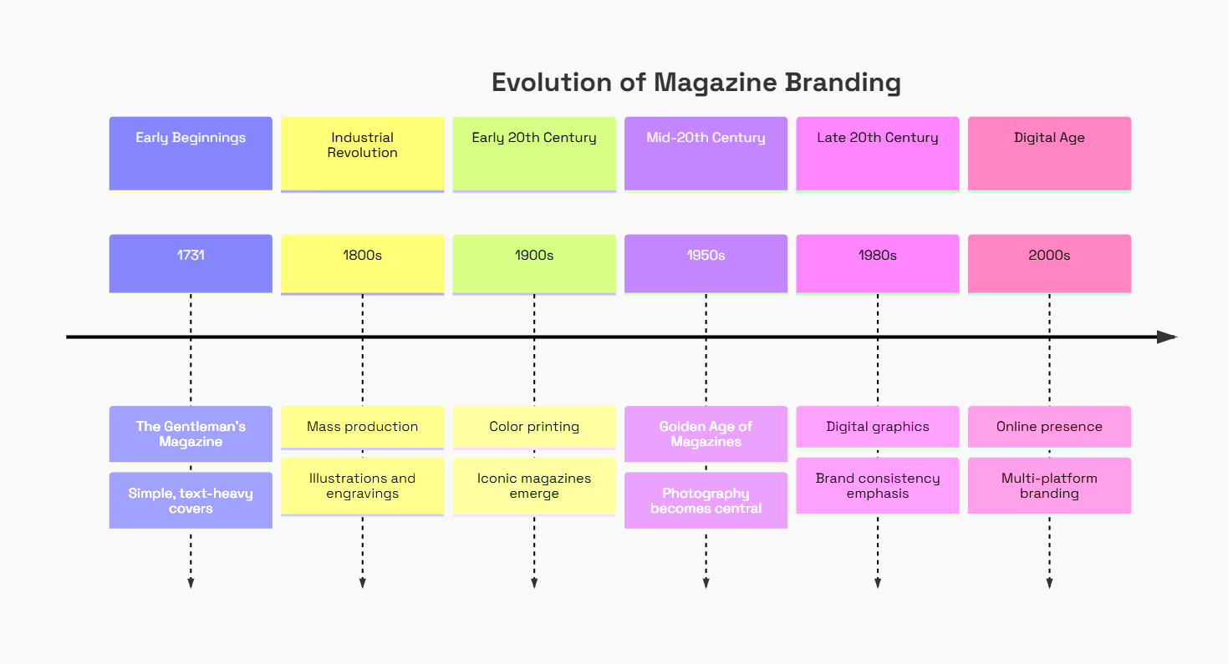

*Fig. 1: Timeline of major developments in magazine branding from the 18th century to the present*

Key Elements of Magazine Branding

* Visual Identity: Logos, color schemes, typography, and overall design aesthetic
* Editorial Voice: Tone, style, and perspective of the magazine's content
* Content Focus: Specific topics, themes, or niches the magazine covers
* Target Audience: The demographic and psychographic profile of the intended readership
* Brand Values: The core principles and beliefs that the magazine represents
* Consistency: Maintaining a cohesive brand image across all platforms and touchpoints
* Digital Presence: Website, social media, and other digital platforms that extend the brand
* Community Engagement: Strategies to foster a sense of community among readers

**RESEARCH METHODOLOGY**

A qualitative research approach was adopted, incorporating case studies of leading magazines. Data collection methods included:

Data Collection Methods

* Primary Data: Interviews with magazine branding professionals.
* Secondary Data: Analysis of industry reports, market research studies, and past branding campaigns.

Data was analyzed thematically to extract insights into branding consistency, audience engagement strategies, and digital adaptations and some brand related case studies which are explained below.

**Case Study: The New Yorker**

The New Yorker magazine exemplifies effective branding through its distinctive identity and consistent editorial voice. Known for its in-depth reporting, literary content, and sharp commentary, The New Yorker has established itself as a sophisticated publication that appeals to a discerning audience. The magazine's iconic covers, featuring original artwork and illustrations, have become a hallmark of its visual identity. The New Yorker's success in maintaining a consistent voice and high standards helps nurture reader loyalty and sets it apart in a crowded marketplace.

Key branding strategies of The New Yorker include:

* Distinctive cover art and the iconic 'Eustace Tilley' mascot
* Consistent typography and minimalist layout
* Focus on high-quality, long-form journalism and cultural commentary
* Engagement with readers through events like The New Yorker Festival
* Successful adaptation to digital platforms while maintaining brand integrity

The New Yorker's 'Right Question Changes Everything' campaign further reinforces its brand identity by emphasizing thought-provoking content and intellectual engagement with readers.

Visual Identity Comparison

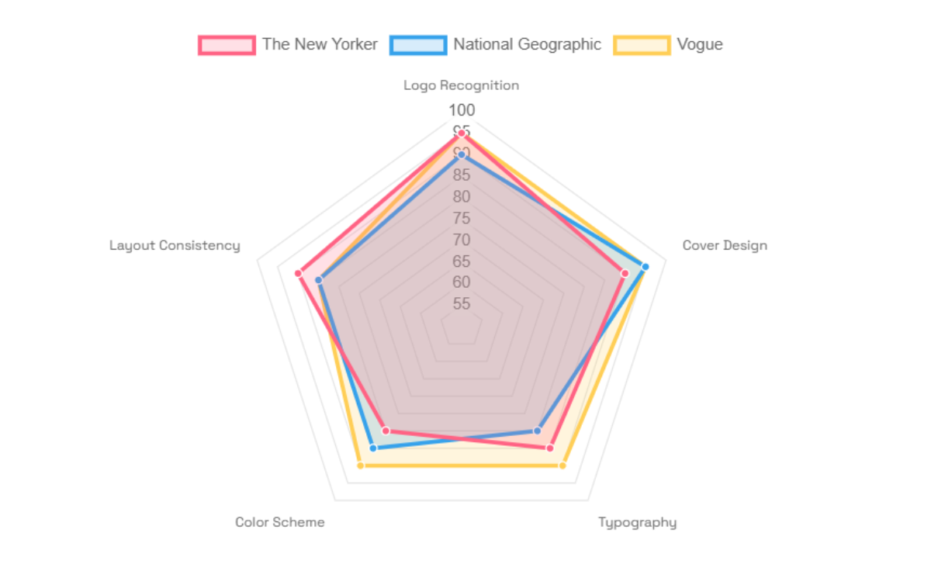

*Fig. 2: Comparison of visual identity elements across three major magazines*

**Case Study: National Geographic**

National Geographic has built its brand identity around science, exploration, and storytelling. The magazine is globally recognized for its stunning photography and compelling narratives about nature, culture, and human history. National Geographic's branding strategy emphasizes visual excellence and educational content, positioning itself as a leader in exploration and discovery.

Key aspects of National Geographic's branding include:

* Iconic yellow border on covers, instantly recognizable worldwide
* Focus on high-quality photography and visual storytelling
* Commitment to environmental conservation and cultural preservation
* Expansion into various media formats, including television and digital platforms
* Engagement with readers through interactive content and citizen science initiatives

The 'Wanderlust' campaign exemplifies National Geographic's branding strategy by encouraging user-generated content and fostering a community of exploration enthusiasts.

Digital Engagement Metrics

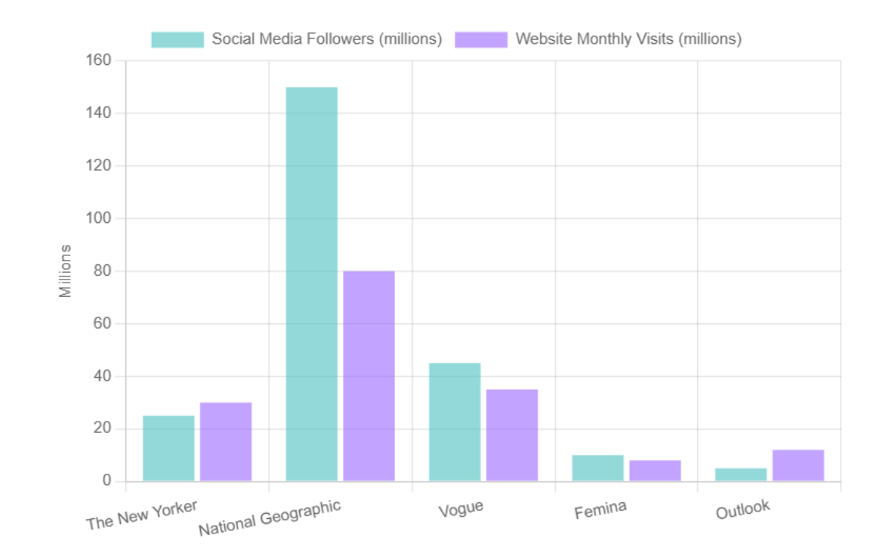

*Fig. 3: Comparison of digital engagement metrics across major magazine brands*

Case Study: Vogue

Vogue magazine has established itself as the pinnacle of fashion publishing, with a brand identity that embodies luxury, style, and cultural influence. Vogue's branding strategy focuses on maintaining its position as a trendsetter and authority in the fashion world while also addressing broader social issues.

Key elements of Vogue's branding strategy include:

* Iconic logo and sophisticated visual design
* Featuring high-profile celebrities and fashion icons on covers
* Comprehensive coverage of fashion trends and industry news
* Expansion into digital platforms and social media engagement
* Organizing influential events like the Met Gala
* Promoting diversity and inclusivity in content and representation

Vogue's '#VogueEmpower' campaign demonstrates how the magazine leverages its brand influence to address social issues and engage with a broader audience beyond fashion enthusiasts.

Brand Value Proposition

Magazine Brand

Content Quality

Visual Appeal

Reader Engagement

Digital Integration

Expert Contributors

In-depth Reporting

Distinctive Design

High-quality Imagery

Community Building

Interactive Features

Multi-platform Presence

Digital Exclusives

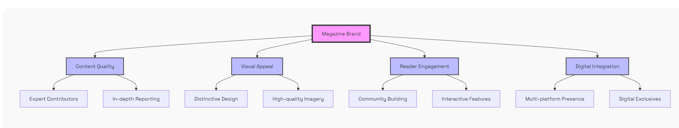

*Fig. 4: Key components of a magazine's brand value proposition*

Consistency in Branding

Maintaining consistency across all platforms is crucial for successful magazine branding. This involves using the same visual elements, tone, and messaging across print, digital, and social media channels. Consistency helps reinforce brand identity and creates a seamless experience for the audience.

Benefits of consistent branding include:

* Enhanced brand recognition and recall
* Increased trust and credibility among readers
* Improved customer loyalty and engagement
* Clearer differentiation from competitors
* More effective cross-platform marketing efforts

Successful magazines like Vogue and National Geographic demonstrate the importance of consistency in their branding efforts, maintaining a unified brand presence across various media formats and touchpoints.

Market Research and Audience Understanding

Leveraging market research for audience understanding is a fundamental aspect of effective magazine branding. By gaining insights into reader preferences, behaviors, and values, magazines can tailor their branding strategies to meet the needs and expectations of their target audience.

Key aspects of market research in magazine branding include:

* Demographic and psychographic analysis of the target audience
* Tracking reader engagement and feedback across platforms
* Monitoring industry trends and competitor strategies
* Conducting surveys and focus groups to gather direct reader input
* Analyzing social media interactions and online discussions

Magazines like Femina and Outlook have successfully used market research to refine their branding strategies, resulting in content and visual designs that resonate strongly with their respective audiences.

Reader Engagement Strategies

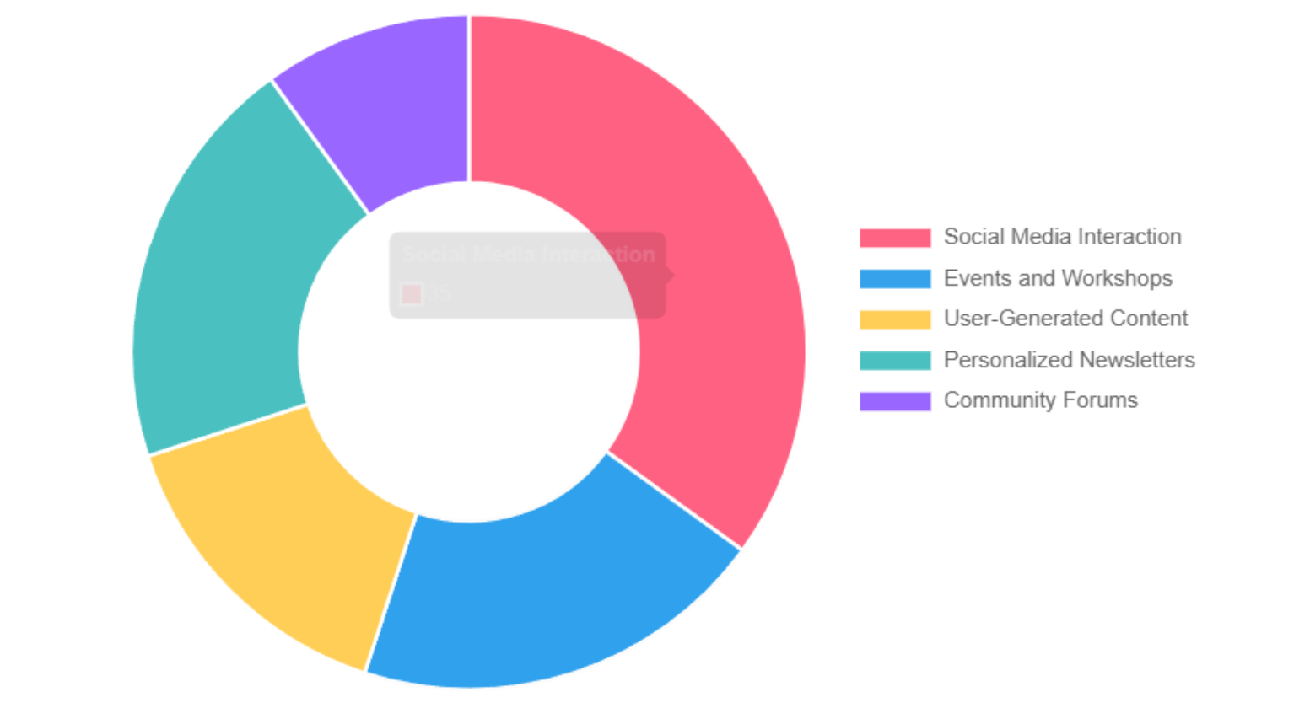

*Fig. 5: Breakdown of various strategies used by magazines to engage readers*

Digital Integration in Magazine Branding

The integration of digital elements has become essential in modern magazine branding strategies. Digital platforms offer new opportunities for engaging with the audience and extending the reach of the brand. Successful magazines have effectively incorporated digital elements into their branding efforts, creating a cohesive and engaging brand experience across both print and digital mediums.

Key aspects of digital integration in magazine branding include:

* Developing robust websites and mobile apps
* Utilizing social media for content distribution and audience interaction
* Creating digital-exclusive content to complement print editions
* Implementing interactive features like polls, quizzes, and multimedia content
* Leveraging data analytics for personalized content recommendations
* Exploring emerging technologies like augmented reality for enhanced reader experiences

Magazines like The New Yorker and Vogue have successfully integrated digital elements into their branding strategies, maintaining their brand identity while adapting to the digital landscape.

Print vs. Digital Revenue

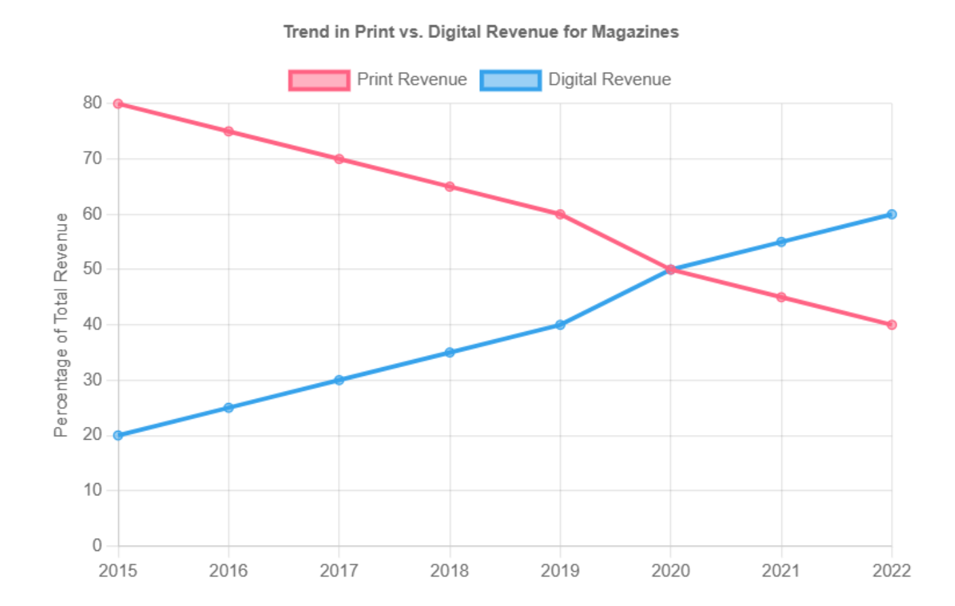

*Fig. 6: Shift in revenue sources for magazines from print to digital over time*

Challenges in Magazine Branding

* Digital Disruption: Adapting to the shift from print to digital while maintaining brand identity
* Audience Fragmentation: Catering to diverse reader preferences across multiple platforms
* Content Overload: Standing out in an oversaturated media landscape
* Revenue Model Shifts: Balancing traditional advertising with new monetization strategies
* Tech Integration: Incorporating new technologies without compromising brand essence
* Generational Differences: Appealing to both older loyal readers and younger digital natives
* Social Responsibility: Addressing social issues while maintaining editorial focus
* Data Privacy Concerns: Navigating data collection for personalization while respecting reader privacy

Future Trends in Magazine Branding

As the publishing industry continues to evolve, several trends are shaping the future of magazine branding:

1. Hyper-Personalization: Utilizing AI and machine learning to deliver highly personalized content experiences.
2. Multimedia Integration: Blending print, digital, audio, and video content for a comprehensive brand experience.
3. Sustainability Focus: Emphasizing eco-friendly practices in production and content to appeal to environmentally conscious readers.
4. Niche Specialization: Catering to specific interest groups with highly targeted content and branding.
5. Community-Driven Content: Increasing reader involvement in content creation and curation.
6. Augmented Reality (AR) Integration: Using AR to create interactive print experiences that bridge the physical and digital worlds.
7. Brand Collaborations: Partnering with complementary brands to expand reach and offer unique value propositions.
8. Data-Driven Decision Making: Leveraging big data analytics to inform branding and content strategies.

Magazines that can adapt to these trends while maintaining their core brand identity will be well-positioned for success in the future media landscape.

Branding Strategy Framework

Define Brand Identity

Understand Target Audience

Develop Visual Identity

Craft Editorial Voice

Create Consistent Brand Elements

Implement Across Platforms

Print Edition

Digital Platforms

Social Media

Monitor and Analyze

Refine and Adapt Strategy

**FINDINGS AND DISCUSSION**

1. Defining Magazine Identity and USP

* Strong USPs differentiate magazines within their niche.
* Visual identity elements (color schemes, typography, logo design) reinforce brand recognition.
* Case study: *Vogue* maintains luxury positioning through high-fashion aesthetics and exclusive content.

2. Consistency in Branding Across Platforms

* A uniform identity across print, digital, and social media fosters trust.
* Case study: *The New Yorker* ensures cohesive branding through distinct editorial voice and visual elements.

3. Leveraging Market Research for Audience Understanding

* Consumer insights shape branding decisions.
* Case study: *Harper’s Bazaar* uses audience segmentation to refine content strategy.

4. Integration of Digital Elements

* Social media, interactive content, and multimedia storytelling enhance reader engagement.
* Case study: *National Geographic’s* "Wanderlust" campaign successfully leveraged user-generated content.

5. Impact of Branding on Audience Engagement

* Campaign-driven branding efforts increase reader involvement.
* Case study: *Femina’s* "Believe" campaign empowered women through storytelling.

**Conclusion**

Magazine branding and identity play a crucial role in the success and longevity of publications in today's competitive media landscape. Through our analysis of successful magazine brands like The New Yorker, National Geographic, Vogue, Femina, and Outlook, we have identified several key strategies that contribute to effective branding:

* Developing a strong and consistent visual identity
* Crafting a unique editorial voice that resonates with the target audience
* Leveraging market research to understand and cater to reader preferences
* Seamlessly integrating digital elements while maintaining brand integrity
* Engaging readers through multiple platforms and interactive experiences
* Adapting to emerging trends while staying true to core brand values

As the publishing industry continues to evolve, magazines must balance tradition with innovation in their branding efforts. Those that can successfully navigate the challenges of digital disruption, audience fragmentation, and changing consumer behaviors will be well-positioned to thrive in the future of publishing.

The most successful magazine brands will be those that can create a cohesive and engaging experience across all touchpoints, fostering a deep connection with their audience while remaining adaptable to the ever-changing media landscape. By focusing on authenticity, quality content, and reader engagement, magazines can build strong, enduring brands that continue to captivate and inspire their audiences for years to come.

**References.**

1. Five steps to develop an effective magazine market research strategy, <https://spyglassintel.com/five-steps-to-develop-an-effective-magazine-market-research-strategy/>
2. The 8 Types of Market Research - Qualtrics, <https://www.qualtrics.com/experience-management/research/market-research-types/>
3. How to Do Market Research, Types, and Example - Investopedia, <https://www.investopedia.com/terms/m/market-research.asp>
4. Brands with print magazines – who's reaping the rewards? - Dialogue, <https://www.dialogue.agency/blog/brands-with-print-magazines-whos-reaping-the-rewards>
5. Improving Your Content Strategy Through Market Research - Zinklar, <https://zinklar.com/blog/getting-your-content-marketing-strategy-right/>
6. The Power of Audience Insights - Meltwater, <https://www.meltwater.com/en/blog/the-power-of-audience-insight>
7. The Complete Guide to Content Marketing Research, <https://marketinginsidergroup.com/content-marketing/the-complete-guide-to-content-marketing-research/>
8. Magazine Advertising: How to Be Effective - Black and Walkyr, <https://blackandwalkyr.com/blog/magazine-advertising-how-to-be-effective/>
9. How do Brands keep their audience engaged & how it helps them?, <https://www.linkedin.com/pulse/how-do-brands-keep-audience-engaged-helps-them-bhavesh-verma>
10. Building Brand Loyalty Through Consistent Magazine Advertising, <https://info.zimmercommunications.com/blog/building-brand-loyalty-through-consistent-magazine-advertising>