**MANDARIN**

**R.Srivishal,K.Rajeshwari**

Student,Master of Computer Application,Adhiyamaan College Of Engineering,Hosur,Tamil Nadu,India

professor,Master of Computer Application,Adhiyamaan College Of Engineering,Hosur,Tamil Nadu,India

**ABSTRACT**

The Mandarin is a mobile application designed to revolutionize Chinese language learning through an interactive and user-friendly platform with adaptive learning capabilities. Aiming to make learning Chinese more accessible, efficient, and enjoyable for learners worldwide, the app features vocabulary building, speech recognition to improve pronunciation, and contextual insights for better understanding. Additionally, it offers multimedia content, personalized lesson plans, real-time progress tracking, and peer interaction to create an engaging and comprehensive learning experience. By combining advanced technology with proven methodologies, The Mandarin ensures effective learning for users of all proficiency levels, making language acquisition more intuitive and rewarding

**Keywords:** Mobile Application, Chinese Language Learning, Vocabulary building, Speech Recognition, Improve Prounciation, Progress Tracking.

1. **INTRODUCTION**

The language learning has evolved significantly with the integration of technology, making it more accessible and engaging for learners worldwide. The Mandarin is a cutting-edge mobile application designed to revolutionize Chinese language learning through an interactive, user-friendly platform with adaptive learning capabilities. By combining advanced technology with proven educational methodologies, The Mandarinoffers a comprehensive learning experience tailored to users of all proficiency levels.

1. **METHODOLOGY**

This study focuses on **Chinese language learning through an interactive and user-friendly platform with adaptive learning capabilities.** The methodology involves a structured approach to designing and implementing **The Mandarin** application, ensuring an effective and engaging learning experience.

* 1. **Speaking and pronunciation module**

Integrates voice recognition technology to allow users to practice speaking and improve pronunciation. Provides instant feedback on accuracy and fluency.Enables users to engage in simulated real-life dialogues, helping them build confidence and improve their speaking skills in various everyday situations. Helps users master Mandarin's tonal pronunciation by providing real-time analysis and correction of tones, ensuring accurate speech patterns. Allows users to compare their pronunciation with native speakers, highlighting differences and providing targeted exercises for improvement.

* 1. **Level Assesment**

Provides quizzes or tests to assess the user's current proficiency and recommend a starting level (e.g., Beginner, Intermediate, Advanced). Adapts lesson plans based on assessment results, ensuring a personalized and effective learning experience tailored to the user's strengths and areas for improvement. Incorporates periodic reassessments to track progress and adjust learning paths accordingly. Utilizes analytics to provide targeted feedback and suggest supplementary resources for continuous improvement.

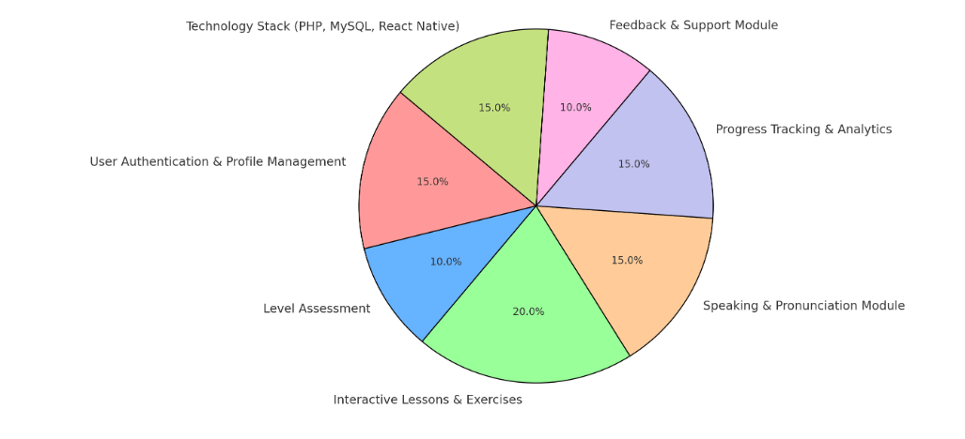

**Chart -1**: Pie Chart

1. **RESULT**

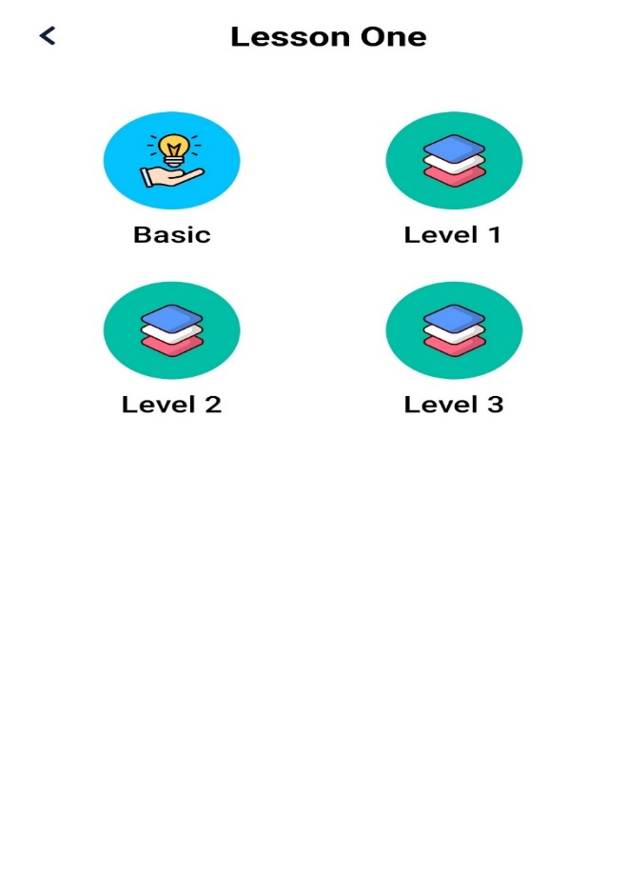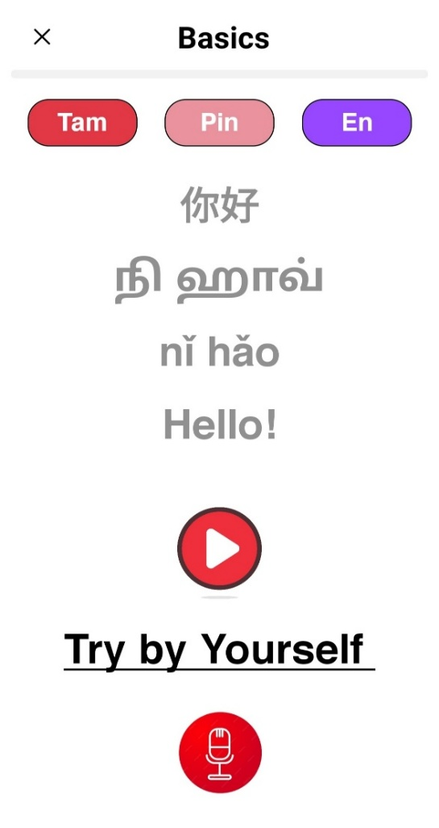

1. **CONCLUSION**

In conclusion, The Mandarin App is a comprehensive and innovative solution for learning the Chinese language. By integrating interactive lessons, voice recognition, adaptive learning, and real-time progress tracking, the app ensures an engaging, efficient, and personalized learning experience. Its user-friendly interface, multimedia content, and structured approach make Chinese language acquisition more accessible to learners of all levels. With a strong technological foundation in React Native, PHP, and MySQL, The Mandarin App leverages modern tools to enhance language learning. Ultimately, this project aims to bridge the gap in language education, making Chinese learning more immersive, enjoyable, and effective for users worldwide. As the app evolves, future updates will incorporate AI-driven enhancements and gamification elements to further motivate learners. By continuously refining its features based on user feedback, The Mandarin App strives to become a leading platform for mastering the Chinese language.

1. **ACKNOWLEDGEMENTS**

This journal paper was truly prepared by my itself I agree the terms and conditions.

1. **REFERENCES**

[1] **Brown, H. D. (2007).** *Principles of Language Learning and Teaching.* – Covers language acquisition methodologies.

[2] **Zhao, Y., & Liao, Q. (2018).** *Technology in Second Language Learning.* – Discusses digital tools in language education.

[3] **Nguyen, T., & Warschauer, M. (2020).** *The Role of Mobile Apps in Mandarin Learning.* – Analyzes mobile-assisted learning.

[4] **Chin, W., & Li, X. (2019).** *Speech Recognition in Language Learning Apps.* – Explores pronunciation improvement.

[5] **ISO/IEC 25010:2011.** *Software Quality Standards.* – Guides best practices for app development