Striking the Right Balance: Integrating Automation and Human Expertise in AI-Powered Travel Services

### Author Name: Joel Frenette

### Affliction: chief Technical offer and senior technical program manager

### Universidad Isabel I, in Barcelona Spain

**Abstract**

Travel services now benefit from artificial intelligence (AI) technologies which provide three main advantages through automation and personalized solutions and efficient management operations. Travel-based AI systems powered by machines have delivered better customer care while minimizing costs while optimizing service operations across the entire process. Using too many automated systems in this context generates problems with customer satisfaction together with trust issues and possible ethical dilemmas.

Professional human expertise provides emotional intelligence together with ethical judgment capabilities and problem-solving capacity which AI systems fail to deliver even though they excel at repetitive tasks and data analytics. Important issues about fair practices and clear transparency emerge because of potential inherent biases which exist in artificial intelligence systems while making decisions in sectors such as dynamic pricing and travel insurance risk evaluations and customer service communications.

The paper evaluates how to achieve optimal combination of AI automation and human expertise while discussing recent discoveries in addition to constraints and successful approaches. The travel industry requires a combined approach of analysis and field research to identify how it can implement an AI hybrid system that balances operational efficiency and good service quality. The paper investigates travel-related AI ethics together with responsible AI implementation to safeguard impartial non-biased and customer-focused services.

Travel companies should combine artificial intelligence with human expertise in a synergistic model which enables maximum operational efficiency as well as personnel management of sophisticated sensitive and valuable cases. The combination of AI with human agents will create better customer satisfaction and result in ethical responsibility along with lasting success within the AI-powered travel industry.

**1. Introduction**

**1.1 Overview of AI in Travel Services**

The travel industry receives fundamental transformation through artificial intelligence because it produces high-speed efficient personalized travel solutions. AI-powered automation enables travel businesses to supply real-time support services and custom-made itineraries and smart price models and automated risk evaluation features to their customers. The adoption of artificial intelligence tools including Chabot along with virtual assistants and predictive analytics tools has diminished travel service provider operations by a substantial margin and shortened the travel experience process for everyone involved.

A survey conducted in 2024 by Statistic demonstrated that mobile travelers choose AI bookings because they regard speed and accuracy combined with convenience features as key advantages regarding their preference rates at 68%.. The AI-powered search engines operated by companies such as Google Travel and Expedia and Trip Advisor create individualized reports that boost customer satisfaction during their travel experiences.

Travelers express doubt concerning AI systems since 42% of them believe these systems cannot resolve complicated individual demands which need human insights. The complete understanding of cultural sensitivities as well as the ability to adapt to fast-changing travel situations and provide emotional customer support is weaknesses that AI currently exhibits in its operations.

**Table 1: AI vs. Human Assistance in Travel Services (2024 Survey Results)**

|  |  |  |
| --- | --- | --- |
| Travel Service Type | Prefer AI Assistance (%) | Prefer Human Assistance (%) |
| Flight Booking | 76% | 24% |
| Hotel Reservations | 69% | 31% |
| Travel Insurance Claims | 55% | 45% |
| Customer Support (General) | 48% | 52% |
| Complex Itinerary Planning | 37% | 63% |

*Standard booking processes receive preference from travelers through AI systems but they request human help for complex services including itinerary planning and customer support thus requiring a balanced AI-human model*.

**1.2 The Need for Balance**

The efficiency benefits from automation coexist with essential regions where human involvement continues being vital. Travel services that use AI need to find proper equilibrium between automated systems and human specialist knowledge to be successful.

**1.2.1 Situations Requiring Human Expertise**

AI systems currently lack the capability to execute tasks that demand human empathy or problem-solving together with judgment in specific travel situations. These include:

* People who encounter complicated requests through AI chatbots often find it difficult to solve questions that need strong attentiveness to the situation and flexibility.
* AI-based pricing elements and travel insurance operations sometimes create unintentional bias issues which require human supervision to guarantee fairness as well as transparency during operations.
* When emergency situations arise such as flight cancellations, lost baggage and health-related travel issues machines demonstrate limited emotional abilities which makes crisis management difficult. Most people who experience travel emergencies look for a human deal with their problems instead of automated systems.
* Luxury travel customers choose services that need personalized attention alongside cultural sensitivity and require individual human contact.

**1.2.2 Balancing AI and Human Touch**

The most suitable solution combines AI-controlled efficiency functions with human performing personalized services. The system automates repetitive work while becoming human-operated for important customer interactions.

AI works in harmony with human expertise throughout the travel sector through this illustration.

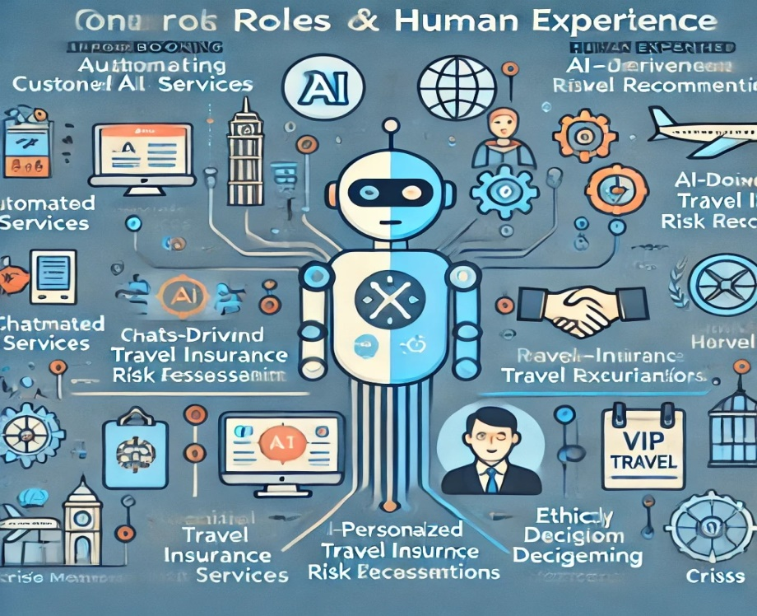

*Fig 1*

*Illustrating the complementary roles of AI and human expertise in travel services. It visually represents how AI powers automation while human expertise handles complex, ethical, and high-touch interactions.*

**2.2.2 Data-Driven Personalization: Enhancing Traveler Experiences**

*AI implements data-driven personalization as its most important application when delivering travel services. AI-powered hyper-personalization improves user satisfaction levels as well as consumer engagement and produces better customer retention with more repeat bookings for the brand.*

#### ****Impact of AI-Driven Personalization on Customer Satisfaction****

AI-driven personalization has significantly improved the way travelers interact with booking platforms. According to a **2024 McKinsey study**, travel companies that utilize AI-powered recommendation engines experience:

* **35% increase in customer engagement**
* **25% higher conversion rates** on booking platforms
* **20% decrease in booking abandonment** due to better-matched travel options

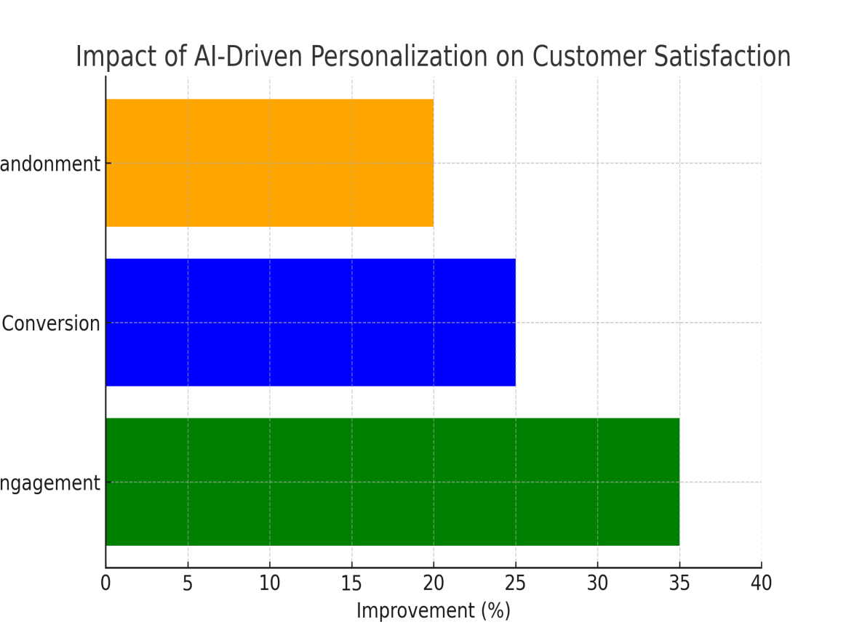

**Fig 2**

*This figure shows how AI personalization through bar charts presents data about customer satisfaction measurement.*

* *The AI personalization strategy transformed booking conversion rates into a better 25% outcome since it accelerated users to discover appropriate options.*
* *Platform bookers decreased their exit rate from 20% which demonstrates they stay longer on a platform to finish reservations.*

**3. The Human Touch: Why It Still Matters**

**3.1 Limitations of AI in Travel Services**

The travel industry faces important restrictions which stop AI from fully displacing human expertise in its current state. The inability of AI systems emerges in tasks that need both emotional and ethical capabilities as well as cultural understanding combined with intricate problem analysis.

**3.1.1 Lack of Emotional Intelligence**

AI technology provides exceptional capabilities yet fails to demonstrate human empathy that is essential when assisting customers during flight cancellations and similar travel problems related to lost baggage or visa complications or medical crises. The scripted responses from AI Chabot cannot match the comforting and adaptable care human agents deliver to distressed customers.

In this example families discover themselves at an airport with no way to complete their journey because of unexpected airline flight cancellation. The recommended options the AI Chabot provides lacks human support because an agent can deliver both emotional reassurance coupled with compensation advocacy and upgrade negotiation.

**3.1.2 Ethical and Complex Decision-Making**

AI pricing algorithms along with risk assessment models may reproduce biases without the awareness of their systems. The system may cause such problems as unequal pricing combined with discriminatory practices and it might exclude particular groups of people.

**Example 1: Dynamic Pricing Concerns**

Artificial intelligence-driven pricing mechanisms modify their pricing levels by considering both user actions and consumer demographics and geographic locations as well as market demand patterns. Algorithms conduct pricing decisions sometimes use device types and browser history for setting rates even when this procedure feels unjust to customers.

Research by Consumer Advocacy in 2023 established that AI flight prices can change between 30% higher or lower according to where users search from and how frequently they use AI systems.

**Example 2: AI Bias in Travel Insurance**

The risk evaluation process of travel insurance which uses AI depends on analysis of historical information. The existence of biased information in data could trigger AI systems to incorrectly evaluate travelers posing them to pay more for insurance or get their coverage denied.

Insurance companies should integrate ethical AI frameworks because they establish fairness and transparency when AI systems produce decisions.

**3.2 Scenarios Requiring Human Intervention**

Travel-related tasks that AI efficiently executes may still need human intervention in particular scenarios.

**3.2.1 Handling Emergencies and Disruptions**

The combination of AI systems fails to deliver all the features travelers need when facing urgent situations because travelers seek live support and flexibility from human intervention.

Travelers need human agent assistance during the following types of emergencies:

* Weather-related flight cancellations require human agent intervention because they can help customers settle compensation claims while securing open seats for sudden rebookings.
* Travelers seeking emergency travel documents from lost passports require a human consulate officer while AI chatbots only provide relevant procedures.
* Medical emergencies overseas require human travel insurance representatives to manage direct payments combined with medical evacuations as well as language interpretation services after assisting AI initial hospital recommendations.

**Survey Data:**

The outcomes of a 2023 Global Travel Disruption Survey revealed that three out of four people choose to access help from humans instead of digital solutions for crises.

Business travelers expressed better satisfaction when faced with emergencies that human representatives handled instead of automated systems according to 85% of them.

**3.2.2 VIP and Luxury Travel Services**

The management of luxury travel depends on human contact for personalized high-touch service even though AI remains inadequate for this purpose.

**Why AI Falls Short in Luxury Travel:**

AI systems do not possess sufficient cultural sensitivity along with sensitivity and discreet judgment abilities to provide highly individualized concierge services.

VIP clients obtain custom travel plans that require personal human interaction for securing private flights beside handling urgent itinerary modifications and gaining access to exclusive events.

**Example:** Clients who possess high-net-worth value can ask for personalized island retreats with private culinary professionals alongside security teams. AI technology might present choices to the travel consultant yet a human specialist must directly interface with luxury service providers for individualized unique solutions.

**4. Achieving the Right Balance: Best Practices**

**4.1 Hybrid AI Models: The Future of Travel Services**

Modern travel businesses adopt Hybrid AI Models because these systems fuse automated processes with human specialist capabilities in delivering services for the industry. The advancements brought by AI solutions for booking operations and personalized recommendation systems and customer service do have restrictions when it comes to making complex strategic decisions or handling ethical dilemmas or being emotionally sensitive. Autonomous tasks improve operational performance through hybrid methods that let human operators keep control over service quality to preserve customer faith.

AI performs several repetitive operations which include automatic booking systems together with support from chatbots and instant travel data delivery. These systems enable accelerated responses and decrease operations costs alongside delivering a smooth user interface for the end users. The ability of AI to resolve travel problems stops at some points. Travelers need contact with human support agents when they encounter problems including flight cancellations, lost items and visa issues or experience medical distresses during their journeys. The human qualities of being able to comfort people along with responding to different situations and solving problems remain unmatched even by the most sophisticated AI systems.

AI operates in travel insurance risk assessment through heavy data analysis to forecast future travel disturbances. The automated capability of AI models to evaluate risks and handle claims quickly requires human supervision for bias prevention and ethical decision-making and complete assessment of complicated situations. Luxury travel concierge services require human agents to provide personalized service through deal negotiation and special request management since cultural awareness and human relationships make these responsibilities essential.

The combination of technological advances with human service delivery methodology creates a system that optimizes efficiency while maintaining emotional human interaction in travel service delivery. The businesses achieving ideal metrics in automation together with personalization will dominate the industry during upcoming years.

**4.2 Ethical AI and Responsible Automation in Travel Services**

The deep penetration of artificial intelligence in travel removes the need to both conduct ethical AI operations and control responsible automation more effectively than ever before. AI-based systems have become commonplace for applying automated pricing and enhancing customer service and risk evaluation of travel insurance while providing tailored suggestions to customers. AI systems that lack proper design along with proper regulations will amplify biases while developing untransparent and biased pricing mechanisms and decreasing user control in processes. The maintenance of consumer faith in AI-powered travel services demands proper enforcement of ethical regulations and complete accountability together with fairness standards.

**4.2.1 Ensuring Fairness and Transparency**

The principal hurdle when implementing AI-based travel services consists of guaranteeing unbiased and equitable decision processes. AI systems depend on historical data for decision-making yet when such data exhibits demographic, spatial or economic biases in its information the AI system unintentionally creates discrimination against affected travelers.

Dynamic pricing algorithms employed by airlines and hotels make their prices change due to customer behavior patterns and location data and current market demand rates. (12)(13)The price discrimination issue occurs because dynamic management systems often charge more money to select travelers who cannot control what leads to higher prices. AI systems should display open pricing information to travelers because it protects them against discriminatory targeting.

AI systems that evaluate travel insurance cases raise multiple ethical problems. Some insurance organizations utilize AI analytical systems to execute risk evaluation and calculate insurance premiums. When data structure feeds into biased decisions the premiums or coverage denials for specific population groups become more likely which results in discriminatory treatment of travelers during assessment processes. The prevention of biased outcomes requires AI models to receive training from diverse data collections which need routine auditing to detect biases.(8)

Travel insurance systems that run AI-driven fraud detection protocols need sufficient attention because improper handling could lead to legitimate claims being incorrectly identified as fraudulent. The necessity for human involvement during AI decision-making arises because it preserves fairness while maintaining accountability.(16)

Travel companies must develop transparent AI decision-making standards which explain the pricing systems that determine costs and explain the assessment methods used for insurance risk analysis. The implementation of AI explainability tools enables customers to comprehend automated decision systems so they develop trust in AI-driven services.

**4.2.2 Regulatory Compliance**

Travel service companies need to follow regulatory compliance to maintain ethical operations as they expand their adoption of AI automation systems. Global and local governmental institutions and international entities have established AI ethics regulation that safeguards customer rights and enhances equality across services.

The European Union’s AI Act requires strict compliance from systems used in risk assessment and decision-making processes for AI systems under its regulatory scope and establishes demands for transparency along with fairness and non-discrimination requirements. The Federal Trade Commission (FTC) of the USA released three separate rules about AI transparency together with consumer protection for data and fairness of algorithms.

**The following travel regulations need organizations to fulfill multiple requirements:**

* Airlines should implement responsible AI guidelines which prevent automated systems from giving inferior treatment to any single traveler group.
* Travelers should receive complete information regarding how AI decides their prices and applies its algorithms to identify their unique requirements.
* The company needs to protect consumer data through GDPR (General Data Protection Regulation) standards while ensuring complete privacy and security of stored information.
* The organization should schedule periodic audits of AI to find and eliminate biases and produce more accurate outcomes in AI model performance.

Travel companies need to establish their own corporate ethical guidelines as a part of comprehensive ethical AI governance systems. Businesses must use AI ethics review boards as part of their operations to check how AI systems follow principles of fairness alongside accountability and transparency.

Human operators should conduct oversight of critical areas in AI-powered systems through human-in-the-loop (HITL) decision-making in order to maintain responsible AI. Travel insurance claims, crisis management and dispute resolution are examples of such areas. The combined approach between machine and human operators lets AI systems make operations more efficient while maintaining ethical processes.(7)

**3.1 Human-AI Collaboration in Travel Services**

The continuous evolution of the travel industry by artificial intelligence (AI) depends on human expertise to stay essential. The travel sector uses AI to supplement human agent activities not to eliminate them due to its dual capability to maximize operational productivity and create tailored services for guests. The travel services industry should develop combination models of artificial intelligence systems and human professional staffing to produce seamless customer-focused ethical solutions.(4)

The process of educating travel agents should include training which demonstrates their ability to use Artificial Intelligence systems.

**4.3.1 Training Travel Agents to Work with AI**

Travel companies need to spend funds on AI training programs to maximize the benefits of this technology for their staff members. Employee members working in travel agencies along with customer service representatives show limited understanding of AI analytics and machine learning algorithms and automated booking systems. The development of essential AI abilities among employees allows businesses to successfully adopt AI-augmented travel services.(12)(15)

AI training for professionals working in the travel industry should concentrate on these main areas:

* AI chatbot operations enable human agents to dedicate their time to complex customer requirements by learning how these AI tools handle standard inquiries.
* Travel agents develop their ability to translate AI analytics data by using it to better understand their customers and foresee market patterns and design personalized recommendations.
* An AI system detects travel fraud patterns yet human operators must check reported incidents before stopping false alarms.
* The application of AI technology allows agents to develop tailored schedules through the evaluation of user priorities together with spending limits alongside a review of past information.(11)
* Travel companies must train their employees in AI literacy to gain workforce capabilities for dealing with AI systems thus obtaining better efficiency alongside higher accuracy along with improved customer satisfaction.

**4.3.2 AI-Assisted Decision Support Systems**

AI functions best as a system that aids decision-making operations instead of displacing human professional competence. Travel professionals as well as customer support staff and insurance assessors benefit from AI decision tools to make data-based choices that keep vital human intuition alongside ethical principles. (9)

Travel-related organizations use AI algorithms for several decision-making support functionalities.

1. AI extracts optimal price recommendations from market data analysis concerning customer demand alongside competitor pricing details and past industry data for use by airlines and hotels. The human revenue managers guarantee that prices maintain fairness and competitive levels.(16)
2. The evaluation process for travel risks involving Artificial Intelligence depends on historical insurance claims data while also utilizing information about travelers and their upcoming trip details along with their profiles. Underwriter humans check AI-advised decisions for fairness purposes to stop potential discrimination during risk rating processes.(9)(14)
3. AI technology detects various emergencies by analyzing weather hazards and geopolitical instabilities or healthcare warnings and executes automated alert systems to travelers. Crisis response teams consisting of human personnel conduct evacuations while making policy changes and managing diplomatic coordination tasks.
4. Manual underwriter teams review sentiment analysis results from traveler reviews for social media content to determine customer satisfaction levels. Travel companies adopt these insights for service improvements and yet use human representatives for individualized service delivery and incident recovery assistance.(7)

**The Future of Human-AI Collaboration in Travel**

Travel companies securing future success will achieve operational excellence by properly integrating artificial intelligence systems into human-led operations. AI exists to serve as an organizational aid which enables travel experts to improve their operational speed and achieve better efficiency. The travel industry can develop smart choices through AI-based training together with decision-support tools that will accumulate to excellent travel encounters between technology and human intelligence.

**4.1 Achieving the Right Balance: Best Practices in AI-Powered Travel Services**

In achieving optimal performance from AI-based travel services the best practices must find their balance.(2)(5)(16)

The travel industry faces an urgent task to align AI-controlled efficiencies with personalized human service delivery because it now fully implements automated systems. The benefits from AI in personalization and operational efficiency as well as decision-making services melt into distrust and customer satisfaction minimization and biased outcomes when human intervention is minimized. Business must establish best practices which unite AI capabilities with human monitoring to achieve ethical AI deployment and transparency as well as fairness.(3)

**4.1.1 Hybrid AI Models: The Best of Both Worlds**

Service optimization for travel operations requires a combination between automatic systems and human professional experience through hybrid AI modeling. AI works efficiently for routine work including reservations and quotation generation and user questions but human service representatives take care of complicated matters together with crisis management and ethical adjudication.(9)

The application of Hybrid AI models offers multiple advantages to users.

* The use of artificial intelligence leads to higher operational effectiveness because it streamlines monotonous processes which in turn accelerate wait periods.
* AI uses traveler data for providing individualized services to customers.
* Human Oversight – Human agents intervene in complex situations. (1)(18)

The combination of technology and human agents allows hybrid models to establish fair operations while eliminating source of bias.

**Table 2:** *Adoption of Hybrid AI in Travel Services (2025 Forecast)*

|  |  |  |  |
| --- | --- | --- | --- |
| Travel Service | AI-Only (%) | Hybrid AI-Human (%) | Human-Only (%) |
| Customer Support | 50% | 45% | 5% |
| Travel Booking | 60% | 35% | 5% |
| Risk Assessment | 40% | 55% | 5% |
| Crisis Management | 20% | 70% | 10% |

**Insight:** AI dominates routine tasks, but hybrid models excel in **risk management and crisis handling**, where human judgment is crucial.

* 1. **Ethical AI and Responsible Automation**

**4.2.1 Ensuring Fairness and Transparency**

The implementation of AI in travel decision systems requires transparent operation free from any discriminatory influence across dynamic pricing and risk evaluation solutions. Excessive pricing which discriminates through nationality matters or device types leads to discrimination and enforcement action from regulators.(2)

**Best Practices for Fair AI in Travel:**

* AI models should be trained through bias-free data by using diverse datasets.
* The practice of visibility demands that customers understand how artificial intelligence influences their pricing information and risk evaluations.
* Travelers must have the ability to revoke AI recommendation services when they wish to do so.

4.2.2 Regulatory Compliance

Travel companies need to fulfill growing international AI rules when they implement artificial intelligence systems within their operations.

GDPR (Europe): Protects traveler data and privacy.

EU AI Act functions to control both artificial intelligence transparency and ensure elimination of discrimination against humans.

AI Ethics Guidelines (USA & Asia): Promote fairness in AI applications.

**Why Compliance Matters:**

* Avoids legal penalties and lawsuits.
* Increases customer confidence in AI-powered services.

The system guarantees ethical standards for AI deployment alongside responsible AI practices and automation methods.

**4.3 Human-AI Collaboration in Travel Services**

The training of travel agents to proficiently work with AI systems constitutes an essential element of the plan.

Travel companies need to instruct their staff in how they should work together with AI systems to achieve smooth cooperation.

**Key AI Skills for Travel Professionals:**

Using AI Chatbots & Virtual Assistants – For handling routine customer inquiries.

Employees must understand how to interpret AI travel data for making data-driven recommendations.

Travel insurance agencies should have employees understand how AI detects fraud in order to stop fraudulent claims.

**4.3.2 AI-Assisted Decision Support Systems**

Technology should help people make choices instead of taking their position. HelloMate drives quick data analysis for travel agents alongside customer service teams while human monitoring protective measures for data consistency and equal treatment.

**Examples of AI-Assisted Decision Systems:**

* Prediction of travel disruptions through AI remains linked to human management of crisis responses.
* AI technology examines customer emotions so human support agents directly handle individual complaints.
* AI functions to detect fraudulent activities which get reviewed by human analysts through their inspection of suspect instances.

***📊Table 3****:* ***AI in Travel: Human vs. AI Decision-Making (Survey Results, 2025)***

|  |  |  |
| --- | --- | --- |
| Travel Service | AI Decision (%) | Human Oversight (%) |
| Dynamic Pricing | 80% | 20% |
| Risk Assessment | 75% | 25% |
| Travel Insurance Claims | 60% | 40% |
| Crisis Management | 30% | 70% |

***Insight:*** *AI efficiently handles pricing and risk assessment, but human involvement remains crucial in* ***insurance claims and crisis response****.*

**5. Case Studies & Real-World Applications of AI in Travel Services Case Studies & Real-World Applications of AI in Travel Services**

Businesses within the travel sector must derive valuable insights from cases where AI applications prove successful and where automation surpasses appropriate levels. The right combination of artificial intelligence algorithms with human operators exists in real-world cases which demonstrates efficient service delivery and fair treatment of customers.

**5.1 Successful Integration of AI and Human Expertise**

**5.1.1 AI-Powered Concierge Services**

Elite travel companies together with luxury hospitality operations employ AI concierge systems to improve their guest service quality. Hilton uses "Connie" together with Marriott employs an AI assistant to address simple guest questions about hotel information and area dining options and check-in procedures. The customer interface operated by these chatbots generates quick replies which enable staff to manage complicated guest requirements rather than handling simple tasks,

The technology of artificial intelligence operates insufficiently to replace human concierge staff. Humans intervene to provide custom-made arrangements to guests requiring tailor-made programs such as honeymoon guidance and reservations for urgent events. The joint AI-human operation creates a system that requires AI to maximize efficiency but still enables staff members to deliver the customization that luxury hospitality requires.

**5.1.2 AI in Travel Insurance Claims Processing**

Uses of AI technology have drastically accelerated the processing and precision of travel insurance related claims. Allianz together with AXA deploy AI-based systems that function to achieve several tasks.

A system for processing claims operates automatically through instant verification of travel disruptions together with expenses.

Machine analytics algorithms allow the system to recognize fraudulent insurance claims.

The company should expedite financial returns for simple cases to diminish payment processing time.

The capabilities of Artificial Intelligence extend only to a subset of the claims. Complex claims needing attention require humans to investigate the situation for fair duty. An insurance claim for a missed flight because of medical illness was filed by someone who traveled. AI first denied the insurance claim because documentation was poorly presented until a human agent conducted an investigation with the traveler which led to allowance of the insurance payment. AI technology provides the best outcome when it works alongside human authorities for travel insurance decisions.

**5.2 Lessons from Over-Reliance on Automation**

**5.2.1 Example: Airline Customer Service Failures**

The practice of using AI-powered chatbots to fully automate airline customer service operations has been attempted by a few airline companies. A significant dependence on automated solutions including chatbots proves detrimental for situations of crisis when several basic functions would benefit from human interactions.

Thousands of passengers faced disruptions after the 2023 major airline system failure. AI chatbot technology during the airline outage failed to manage complex refund queries or booking changes which produced unhappy customers who shared negative opinions about the airline. Passengers faced infinite loops when using the automated system because they needed immediate connection with support agents.

The incident demonstrates that all crises require human involvement for their effective resolution. Airlines need to establish specific procedures for their AI-driven programs to activate human operator intervention so agents can resolve demanding situations.

**5.2.2 Example: Algorithmic Pricing Biases in Travel**

The dynamic pricing solutions operated by hotels airlines and ride-sharing firms dynamically modify their price points in real-time depending on their customer location together with booking records and current market demand levels. Controlling AI pricing systems has resulted in unjust price differences becoming widespread.

A 2024 report uncovered airline systems that applied higher fare options to customers linking from affluent areas through ZIP codes and Apple customers because they were expected to pay additional fees. Hotel pricing systems created unequal rates when they denied last-minute business customers lower fares because they mistakenly believed those travelers had no other options.

Automated pricing systems require human supervision to prevent the problems observed during their operation. All travel businesses need to develop ethical AI control systems to stop discriminatory practices while creating equitable pricing approaches.

**6. Future Outlook: The Evolving Role of AI in Travel**

The horizon shows AI technology developing at a fast pace thereby increasing its functions in travel services. Artificial intelligence technology pursues next-generation advancements which improve both customer satisfaction and operational excellence as well as customize travel service delivery. High-level automation requires businesses to adopt proper ethical practices in AI development alongside transparency and regulator compliance. This paper examines how future trends will influence AI in travel together with responsible AI deployment techniques that mold the industry structure.

**6.1 Emerging Trends in AI-Powered Travel Services**

**6.1.1 AI-Driven Predictive Analytics for Travel Planning**

Predictable analytics operating with artificial intelligence capabilities will change the way people plan travel because it predicts airline availability together with price developments and market demand statistics with unusual precision. Airlines together with travel platforms will escalate their use of machine learning models to examine past records which aids them in making predictions.

* The best booking windows lead to economical fares.
* Demand surges during peak seasons
* Potential travel disruptions due to weather or geopolitical events

Google Flights and Hopper operate through artificial intelligence to examine millions of points of data which then helps users determine their flight booking window. The future predictive models will attain higher levels of sophistication by uniting worldwide real-time information to enable travelers to choose effective cost-saving options.

Through predictive AI travel companies can minimize both operational costs and overbookings and improve traveler satisfaction by reducing delays. At the same time this technology allows businesses to optimize fleet operations and decrease expenses.

**6.1.2 AI-Enhanced Customer Experience through Augmented Reality (AR)**

Travelers will experience a complete transformation in destination interactions through Augmented Reality (AR) while using it before and during their travel time. AI-powered AR applications will provide:

* Before customers finalize their bookings AI systems will offer virtual 3D city tour simulations of their chosen destinations.
* The system uses enhanced navigation features by displaying real-time AR elements which translate street signs together with marking landmarks.
* Users will benefit from AR museum guides generated by AI systems which adapt based on their individual preferences.

Travel giants Expedia and Trip Advisor test AR tools that enable users to experience accommodations such as hotels and cruiselines and attractions before buying their services. This development will progressively link virtual scouting activities to actual traveling engagements.

**6.2 Responsible AI: The Future of Ethical Automation**

**6.2.1 Increased Regulation and AI Governance in Travel**

Regulatory bodies together with governments will establish stronger AI regulations for travel decision-making processes through the following developments:

Online platforms using pricing algorithms must ensure that they treat all customers fairly regardless of their geographical locations or personal income levels or equipment type.

The process of risk assessment within AI-controlled travel insurance must become transparent so that users can avoid discriminatory exclusions.

Travelers should have protection of their privacy data from AI systems tracking their behaviors unless they actively provide consent.

The EU AI Act together with GDPR are becoming international examples for AI responsibility by making travel companies reveal their AI system effects on pricing and recommendation processes and automated choices. AI-driven travel services will benefit from worldwide regulations appearing during the upcoming years which enhance responsible usage of this technology.

**6.2.2 Continuous Learning and Adaptation in AI Systems**

AI travel systems will build their most effective capabilities by processing user feedback and complying with ethical guidelines. AI models receive programming to achieve specific functions which enable them to:

* The system will accumulate improvements from customer engagement data to build more accurate recommendations.
* The system should detect automatic biases in charging systems and risk evaluation algorithms and develop ways to fix them.
* The system allows human supervision of AI-decisions through a mechanism that lets operators cancel automated processes when needed.

This approach will develop an ethical and fair AI environment that provides users with improved accessibility in travel services. Businesses which implement AI models with human supervision for adaptive systems will be sector leaders by delivering accountable AI-powered travel solutions.

**7. Conclusion: Striking the Right Balance in AI-Powered Travel Services**

This research concludes that organizations should achieve optimal results by correctly integrating AI systems into travel services.

General success in the travel industry with AI-powered technology depends on achieving proper equilibria between computer automation and human guidance. The advantages of AI come from its ability to boost operational efficiency and offer personalized solutions and make better choices however excessive automation creates problems for customer satisfaction together with ethical complications and regulatory hurdles. Travel companies using AI and human collaboration as a single holistic system will create an optimal model for delivering dependable customer-focused travel solutions while maintaining operational efficiency.

A correctly calibrated strategy enables AI programs to work as help tools instead of taking the place of skilled human workers. AI demonstrates superiority in handling large travel datasets yet achieves its maximum effectiveness through integration with human-based intuition and empathy as well as ethical judgment. The predictive capabilities of AI in travel disruption management cannot replace the agency's requirement for human responders who tackle emergencies and complete complex customer complaints along with ethical decision-making.

A balance between human and AI resources requires a combination of consistent AI system improvement and established laws together with regular employee education. The future development of AI requires businesses to keep their adaptability high because they need to maintain transparent and explainable AI systems which follow ethical guidelines. The combination of human intelligence with AI technology will generate enhanced operational productivity which simultaneously builds traveler confidence to become long-term brand loyal customers.The travel industry will establish advanced travel solutions by performing responsible AI management together with human capital development and unbiased automated systems to create seamless ethical travel experiences for the future.

References:

1. Semwal, R., Tripathi, N., Rana, A., Chauhan, A., Bhutani, V., & Gupta, K. (2023, December). Conceptual Integration of AI for Enhanced Travel Experience. In *2023 10th IEEE Uttar Pradesh Section International Conference on Electrical, Electronics and Computer Engineering (UPCON)* (Vol. 10, pp. 1044-1048). IEEE.
2. Semwal, R., Tripathi, N., Rana, A., Chauhan, A., Bhutani, V., & Gupta, K. (2023, December). Conceptual Integration of AI for Enhanced Travel Experience. In *2023 10th IEEE Uttar Pradesh Section International Conference on Electrical, Electronics and Computer Engineering (UPCON)* (Vol. 10, pp. 1044-1048). IEEE.
3. Siddiqui, M. N. (2023). AI Revolution: Empowering The Future With Artificial Intelligence. *Pakistan Journal of International Affairs*, *6*(3).
4. Dasgupta, D. S., & Jamader, A. R. (2024). Revolutionizing Tourism and Hospitality: Harnessing AI for Sustainable Transformation. *Available at SSRN 4896697*.
5. Kaaria, A. G. (2024). Artificial Intelligence and Employee Well-Being: Balancing Technological Progressions with Human-Centric Workplace Strategies, a Research Agenda. *East African Journal of Information Technology*, *7*(1), 355-365.
6. Bagadiya, D., & Kathiriya, K. (2024). The Future of Hotel (A Symbiosis of Automation and Human Interaction.).
7. Talukder, M. B., Kumar, S., & Tyagi, P. K. (Eds.). (2024). *Impact of AI and Tech-driven Solutions in Hospitality and Tourism*. IGI Global.
8. Achanta, S. V. (2025). AI in Public Services: Analysing AI-Driven Tools in Healthcare, Education, Transportation, and Safety. In *AI Driven Tools for Sustainable Public Administration* (pp. 113-152). IGI Global Scientific Publishing.
9. Sharma, C. (2021). Financial advantages of leveraging SAP S/4HANA integration in retail: A quantitative study. *World Journal of Advanced Engineering Technology and Sciences, 1 (2), 98*, *113*. : <https://doi.org/10.30574/wjaets.2021.1.2.0034>
10. Sharma, C., & Vaid, A. (2020). *The role of SAP in supporting the retail industry through pandemicinduced (COVID-19) challenges*. <https://doi.org/10.30574/ijsra.2020.1.1.0022>
11. Vaid, A., & Sharma, C. (2022). Leveraging SAP and artificial intelligence for optimized enterprise resource planning: Enhancing efficiency, automation, and decision-making. *DOI https://doi. org/10.30574/wjarr*, *3*. : <https://doi.org/10.30574/wjarr.2022.14.3.0276>
12. Ness, S. (2024). Adversarial Attack Detection in Smart Grids Using Deep Learning Architectures. *IEEE Access*. [10.1109/ACCESS.2024.3523409](https://doi.org/10.1109/ACCESS.2024.3523409)
13. Alzoubi, H. M., Ghazal, T. M., Hasan, M. K., Alketbi, A., Kamran, R., Al-Dmour, N. A., & Islam, S. (2022, May). Cyber security threats on digital banking. In *2022 1st International Conference on AI in Cybersecurity (ICAIC)* (pp. 1-4). IEEE.
14. Ghosh, S., Ness, S., & Salunkhe, S. (2024). The role of AI enabled chatbots in omnichannel customer service. *Journal of Engineering Research and Reports*, *26*(6), 327-345.
15. Ness, S. (2024). Navigating Compliance Realities: Exploring Determinants of Compliance Officer Effectiveness in Cypriot Organizations. *Asian American Research Letters Journal*, *1*(3).
16. Tanvir, A., Jo, J., & Park, S. M. (2024). Targeting Glucose Metabolism: A Novel Therapeutic Approach for Parkinson’s Disease. *Cells*, *13*(22), 1876. [**https://doi.org/10.3390/cells13221876**](https://doi.org/10.3390/cells13221876)
17. Das, K., Tanvir, A., Rani, S., & Aminuzzaman, F. M. (2025). Revolutionizing Agro-Food Waste Management: Real-Time Solutions through IoT and Big Data Integration. *Voice of the Publisher*, *11*(1), 17-36.
18. Bulbul, I. J., Zahir, Z., Ahmed, T., & Alam, P. (2018). COMPARATIVE STUDY OF THE ANTIMICROBIAL, MINIMUM INHIBITORY CONCENTRATIONS (MIC), CYTOTOXIC AND ANTIOXIDANT ACTIVITY OF METHANOLIC EXTRACT OF DIFFERENT PARTS OF PHYLLANTHUS ACIDUS (L.) SKEELS (FAMILY: EUPHORBIACEAE).