HAND GESTURE CANVAS-

A NEW DIGITAL DRAWING EXPERIENCE

*Mrs.K.Ashwini 1 , Samudrala Sindhuja 2, Amma Sravani 3, Lavudya Sandeep 4*

*Assistant Professor 1, Scholar2,3,4*

*Department of Computer Science and Engineering,*

*Nalla Narasimha Reddy Education Society's Group of Institutions, Hyderabad, India.*

***ABSTRACT : As technology continues to advance, virtual control through human gestures is becoming more prevalent across various sectors. In digital drawing applications, traditional tools like a mouse, stylus, or touchscreen can feel restrictive, making it difficult for users to freely express their creativity. Many users have a desire to create or draw just by moving their hand without relying on physical input devices. The Hand Gesture Canvas project addresses this need by developing a motion-to-text converter that uses real-time hand tracking to enable the hand to act as a pen. This allows users to draw shapes, write text, and clear the canvas using simple hand gestures. The system is built using the Open Computer Vision Library (OpenCV) and MediaPipe, which work together to capture and interpret hand movements through a camera. By integrating computer vision, machine learning algorithms, and augmented reality, the project is able to detect and translate physical gestures into digital drawings in real time. This innovative approach provides a powerful and accessible means of communication, especially for the deaf, by reducing the need for traditional input methods like mobile phones or laptops. Moreover, the Hand Gesture Canvas offers intuitive interaction and has promising applications in fields such as education, remote collaboration, and interactive installations. Future improvements will focus on enhancing the accuracy of gesture recognition and expanding system features, potentially transforming how users interact with digital content.***

***Keywords: Hand Gesture Recognition, Real- Time Hand Tracking, OpenCV, MediaPipe, Virtual Control.***

1. **INTRODUCTION**

Advancements in human-computer interaction (HCI) have led to the development of intuitive and natural ways to interact with digital systems, with gesture-based interaction emerging as a significant innovation. This approach allows users to control devices through hand gestures rather than traditional input methods like a mouse or keyboard. Gesture recognition is gaining popularity in fields such as virtual reality, gaming, sign language interpretation, and creative applications like digital drawing. In creative industries, artists typically use physical tools such as styluses and drawing tablets. However, integrating gesture recognition with computer vision offers a novel alternative, enabling users to draw on a virtual canvas in mid-air using simple hand movements. This approach enhances accessibility and creativity by eliminating the need for physical input devices. This project explores creating a gesture-based virtual drawing application using OpenCV and MediaPipe, allowing users to draw by moving their hand in front of a webcam. The application aims to improve user interaction by providing a touch- free, gesture-based interface. It offers freedom of movement and accessibility, particularly useful in situations where specialized equipment is unavailable. The system will detect hand movements in real-time, allowing users to draw, select colors, and clear the canvas using gestures. Additionally, users can save their drawings with a keypress. The project's goal is to develop a user- friendly prototype that tracks hand movements effectively and provides a smooth drawing experience, with potential applications in digital art, design, education, and virtual collaboration.

# RELATED RESEARCH

Existing systems like Leap motion and touchscreen-based applications such as Adobe Illustrator offer intuitive ways to interact with digital content, but each has limitations. Leap Motion enables precise 3D hand tracking using infrared sensors, ideal for tasks like gaming and virtual reality. However, it requires specialized hardware, making it less accessible and more expensive for casual users. Similarly, touchscreen-based tools like Adobe Illustrator provide high accuracy and detailed control through styluses and tablets, but they also rely on specific hardware. Users without such devices miss out on the precision offered by these tools, and their design limits natural, gesture-based movement.

Other gesture-based systems, such as Microsoft Kinect and Sony PlayStation Move, focus on whole-body motion tracking, but they are often tailored to specific contexts like gaming and do not provide the fine-tuned control needed for digital drawing. Additionally, like Leap Motion, they require dedicated hardware, which restricts their accessibility to a broader audience.

In contrast, our gesture-based virtual drawing system stands out by eliminating the need for specialized hardware. By leveraging a standard webcam and open-source libraries like **OpenCV** and **MediaPipe**, our system provides an accessible, cost-effective solution for users. Most users already have access to a webcam, making this system highly inclusive and easy to implement. The combination of OpenCV and MediaPipe ensures real-time hand tracking and gesture recognition, allowing users to draw, select colors, and clear the canvas with simple gestures.

Unlike many existing systems that focus on niche applications like 3D navigation or touch-based input, our system integrates gesture-based digital drawing with real-time interaction. This approach opens up new possibilities for creative and

educational applications, where intuitive and accessible interfaces are crucial. Our system democratizes gesture-based digital interaction, offering an innovative, hardware-free alternative that enables users to engage in virtual drawing without expensive or specialized tools. This makes it especially useful for digital art, design, and online learning, providing a versatile and user-friendly experience for a wide range of users.

# METHODOLOGY

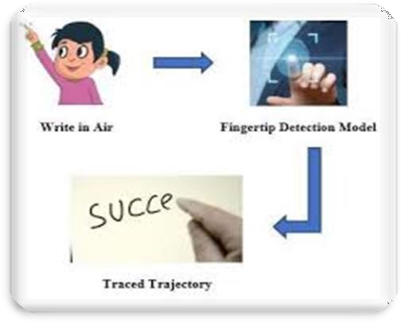

The methodologies used in the "Hand Gesture Canvas" project, as outlined in your document, involve various approaches, techniques, and tools aimed at creating a real-time, gesture-based virtual drawing system. Here's a detailed breakdown:

## Hand Detection and Landmark Identification

The system uses **Mediapipe**, a machine learning framework, to detect the user's hand in real time. This process identifies 21 key landmarks on the hand (e.g., fingertips, wrist), which are tracked throughout the interaction. The relative positions of these landmarks are then analyzed to understand specific gestures.

## Gesture Recognition

The system is designed to recognize hand gestures by analyzing the position of the hand landmarks.

For example, when the forefinger and thumb come close together, the system interprets this as a “click” action, while movements of the forefinger are understood as drawing commands on the virtual canvas.

## Real-Time Image Processing

**OpenCV** is used to capture and process video frames from the webcam in real-time. This enables the system to continuously track the hand’s movements and update the canvas based on those movements. Techniques such as frame flipping, color space conversion, and the drawing of shapes (e.g., lines, circles) are essential to managing real-time interaction.

## Drawing Logic

The drawing is facilitated by a **deque** data structure (double-ended queue) to store points of the user's forefinger movements. As the forefinger moves, new points are added, and lines are drawn between consecutive points on the virtual canvas. The system also enables color selection based on gestures, allowing users to draw in different colors such as blue, green, red, and yellow.

## Color Selection and Canvas Control

Gestures are not only used for drawing but also for interacting with the system. The user can select different colors and clear the canvas by making specific hand gestures over predefined areas on the screen. For example, moving the hand over certain sections of the screen triggers a color change or clears the entire canvas.

## Computer Vision Techniques

The project utilizes **computer vision** to analyze the webcam feed, detect hand movements, and identify relevant features such as hand landmarks. Image processing techniques, including converting frames from BGR to RGB and drawing visual elements (e.g., buttons and strokes), help manage the visual aspect of the application.

## Real-Time Hand Tracking

Mediapipe’s hand tracking model is essential for identifying and tracking hand landmarks in real time. This technique allows the system to continuously monitor the user’s hand movements, enabling dynamic and responsive interaction with the virtual canvas.

## Tools, Software, and Hardware Used

**Python**: The programming language used to build the system. Python's ecosystem of libraries supports tasks like real-time processing and computer vision.

**OpenCV**: Responsible for handling video input and image processing tasks.

**Mediapipe**: Detects and tracks hand landmarks to translate gestures into drawing commands.

**NumPy**: Supports handling array operations, such as creating and updating the virtual canvas.

**Hardware**: The system primarily uses a webcam to capture hand movements, making it a highly accessible solution that doesn't require specialized hardware like motion sensors.

## Testing and Results

Various testing methodologies were used, including unit testing, integration testing, and functional testing, to ensure the system operates as intended. These tests validated features such as color selection, hand tracking, and canvas clearing, ensuring that the system responds accurately to user gestures.

## Augmented Reality (AR)

Though not fully explored, AR features were integrated by overlaying the virtual canvas on top of the real-time video feed. This adds a layer of interactivity, blending the user’s physical environment with the virtual drawing space.

# ARCHITECTURE

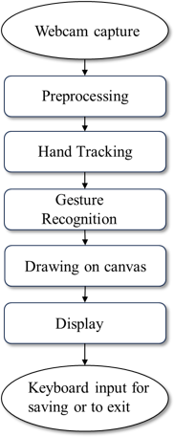

The architecture of the "Hand Gesture Canvas" project is designed to create a gesture-based virtual drawing application that leverages computer vision and machine learning technologies.

## Input Devices

**Webcam**: The primary input device capturing video frames of the user's hand movements. A standard webcam with a resolution of 640x480 or higher is sufficient for real-time tracking.

## Software Components

**OpenCV**: An open-source computer vision library used for capturing video from the webcam, processing images, detecting hand gestures, and displaying the output.

**Mediapipe**: A machine learning framework developed by Google that provides solutions for detecting and tracking hand landmarks in real-

time. It identifies key points on the hand to facilitate gesture recognition.

**Python**: The programming language used for developing the application due to its simplicity and extensive libraries for machine learning and image processing.

## Core Functionalities

**Hand Detection and Landmark Identification**: The system uses Mediapipe to detect 21 key landmarks on the user's hand, allowing it to track movements accurately.

**Gesture Recognition**: By analyzing the relative positions of these landmarks, the system recognizes specific gestures (e.g., moving the forefinger to draw, pinching for clicking).

**Real-Time Image Processing**: OpenCV processes video frames in real-time, ensuring smooth interaction between hand gestures and drawing commands.

**Drawing Logic**: The application uses a deque (double-ended queue) structure to store points where the user's forefinger moves. Lines are drawn between these points on the virtual canvas.

## User Interaction

**Color Selection**: Users can select different colors for drawing through simple hand gestures, such as moving their hand over designated areas on the screen.

**Canvas Control**: Users can clear the canvas or start a new drawing with specific gestures, enhancing user experience without physical buttons.

## Augmented Reality Integration

The system overlays virtual drawings onto the real-world environment captured by the webcam, providing immediate visual feedback and creating an immersive experience.

# RESULT

The results of the "Hand Gesture Canvas" project highlight the development of an innovative gesture-based virtual drawing system that utilizes real-time hand tracking and augmented reality technologies. This system allows users to create drawings in a virtual environment using simple hand gestures, eliminating the need for traditional input devices like styluses or mice. The project successfully integrates OpenCV for video processing, Mediapipe for hand landmark detection, and Python as the programming language, demonstrating how accessible tools can facilitate intuitive user interactions. Key findings include the system’s ability to accurately recognize hand gestures and translate them into drawing commands, enabling users to select different colors and clear the canvas through natural movements. The augmented reality feature enhances user experience by overlaying virtual drawings onto the real-world video feed captured by a webcam, making it suitable for creative applications such as digital art and virtual collaboration. The results indicate that this gesture-based interaction model is not only effective but also cost-efficient, as it relies on widely available hardware. User feedback suggests that the system is engaging and easy to use, with potential applications in education, remote collaboration, and interactive installations. Future enhancements could focus on advanced gesture recognition capabilities, multi-hand tracking for more complex interactions, cloud integration for seamless saving and sharing of drawings, and improved augmented reality features. **©**

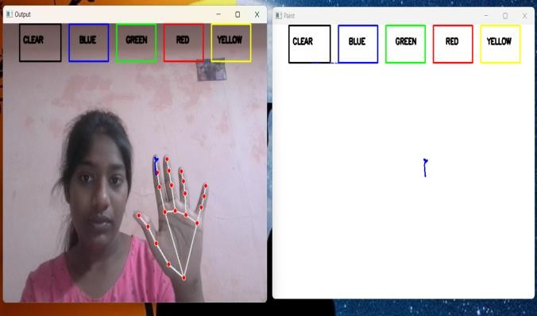

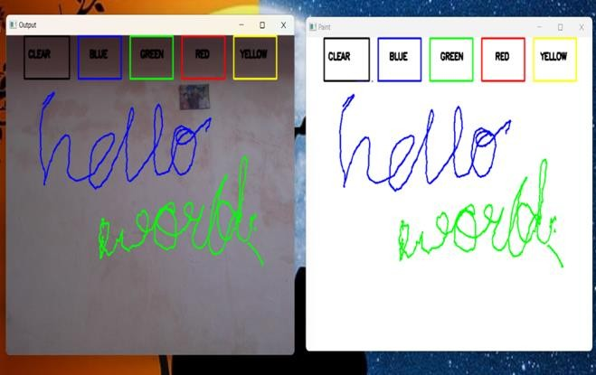

Output (RESULT)

# CONCLUSION

The Hand Gesture Canvas successfully develops a **gesture-based virtual drawing system** using real-time hand-tracking and augmented reality (AR) techniques. The system allows users to interact with a virtual canvas through natural hand gestures, without the need for physical input devices like a mouse or stylus. By utilizing a standard webcam, OpenCV for video processing, Mediapipe for hand tracking, and NumPy for canvas creation, the system demonstrates how accessible tools can create an intuitive and interactive experience.

The system’s ability to recognize hand gestures and map them to drawing actions provides a seamless user experience. Users can select different colors, clear the canvas, and create drawings simply by moving their hands in the air. Furthermore, the integration of AR features enhances the user experience by blending virtual drawings with the real-

world environment, making it suitable for creative applications such as digital art, virtual whiteboarding, and remote collaboration.

## Key Achievements:

* Real-time Hand Gesture Recognition:

The system accurately tracks the user’s hand movements and gestures in real-time, enabling drawing with natural motion.

* Augmented Reality Integration:

Virtual elements such as drawings and controls are superimposed on the real-world video feed, offering an immersive AR experience.

* Seamless User Interaction:

The system responds instantly to hand movements, ensuring a smooth and responsive interaction with the virtual canvas.

* Accessible and Low-Cost Solution:

The system uses widely available hardware (a webcam) and open-source software, making it cost-effective and accessible to a wide range of users.

# REFERENCES

1. Sonal Gupta, Dr. Satish Kumar, "Air- Writing Recognition Using Machine Learning Techniques," International Journal of Advanced Research in Computer Science and Software Engineering, Volume 8, Issue 4, April 2018.
2. T. Zhang, S. Y. Huang, "Gesture-Based Human-Computer Interaction Using Convolutional Neural Networks," International Conference on Machine Vision and Information Technology (MVIT), October 2019.

[3]. Y. Huang, X. Liu, X. Zhang, and L. Jin, "A Pointing Gesture Based Egocentric Interaction System: Dataset, Approach, and Application," 2016 IEEE Conference on Computer Vision and Pattern Recognition Workshops (CVPRW), Las Vegas, NV, pp. 370-377, 2016.

[4]. P. Ramasamy, G. Prabhu, and R. Srinivasan, "An economical air writing system is converting finger movements to text using a web camera," 2016 International Conference on Recent Trends in Information Technology (ICRTIT), Chennai, pp. 1-6, 2016.

[5]. Saira Beg, M. Fahad Khan and Faisal Baig, "Text Writing in Air," Journal of Information Display Volume 14, Issue 4, 2013

1. Alper Yilmaz, Omar Javed, Mubarak Shah, "Object Tracking: A Survey", ACM Computer Survey. Vol. 38, Issue. 4, Article 13, Pp. 1-45, 2006
2. T. Grossman, R. Balakrishnan, G. Kurtenbach, G. Fitzmaurice, A. Khan, and

B. Buxton, "Creating Principal 3D Curves with Digital Tape Drawing," Proc. Conf. Human Factors Computing Systems (CHI' 02), pp. 121- 128, 2002.

1. T. A. C. Bragatto, G. I. S. Ruas, M. V. Lamar, "Real-time Video-Based Finger Spelling Recognition System Using Low Computational Complexity Artificial Neural Networks", IEEE ITS, pp. 393-397, 2006
2. Yusuke Araga, Makoto Shirabayashi, Keishi Kaida, Hiroomi Hikawa, "Real Time Gesture Recognition System Using Posture Classifier and Jordan Recurrent Neural Network", IEEE World Congress on Computational Intelligence, Brisbane, Australia, 2012.