**Study on the Enhancement of Concrete properties using eco-friendly materials**

**Md Faizan**1, Mithun Kumar Rana2, Pushpendra Kumar Kushwaha3

1M. Tech. Research Scholar, Civil Department, RKDF College of Engineering, Bhopal (M. P.),402026 India

2Assistant Professor, Civil Department, RKDF College of Engineering, Bhopal (M. P.), 402026 India

3Assistant Professor, Civil Department, RKDF College of Engineering, Bhopal (M. P.), 402026 India

**ABTRACT**

The cost of cement production is increasing progressively over time. The process of cement production results in significant CO2 emissions, contributing to increased environmental hazards. Utilization of alternative materials, including fly ash and micro silica, which are classified as industrial by-products, presents a viable solution for addressing this issue in concrete applications. The availability of natural sand resources is diminishing gradually. Therefore, the necessity for an alternative to river sand has become urgent. Quarry dust, generated as a by-product from stone crushing operations, serves as a substitute for river sand. The incorporation of quarry dust in concrete negatively impacts the workability of the mixture, attributed to its increased water absorption capacity. Superplasticizers are incorporated to compensate for the water loss in concrete. The incorporation of fibers contributes to the preservation of the structural integrity of concrete. Sisal, recognized as a natural fibre, offers a cost-effective solution for incorporation into concrete production. The incorporation of Sisal fibres into concrete results in improved strength and durability of the material.

In this research work, Supplementary Cementitious Materials such as fly ash (0% to 40% by weight) and micro silica (0% to 15% by weight) were used in concrete as a partial replacement to cement in preparing iv concrete. Quarry dust was replaced equally with river sand and Conplast SP430 superplasticizers were added at a dosage of 1.5% by the weight of cementitious materials to compromise workability. Sisal fibres at an optimum rate of 1.5% by weight of the concrete were added after analysing with different combinations.

Keyword- Sisal fibres, durability, Coarse aggregates, resistance, hardness, toughness

**1. 1 Introduction**

Concrete is a prime material in the construction sector. Concrete constitutes cement, fine aggregates, coarse aggregates and water. Cement is an essential binder that combines the other materials in concrete, thus forming a dense structure. However, cement has become exhorbidant in cost and usage of certain cost-effective substances such as Portland pozzolona may prove to be a better solution. But, such addition may not be viable for strength consideration. Hence, while keeping in mind the cost, increasing the volume of concrete content would prove to be sound if inert minerals such as fly ash and micro silica are added and hence become this thesis. Fine aggregates have a special role in filling concrete voids and act as a workability agent. Coarse aggregates influence various significant roles of concrete, such as hardness, toughness, abrasion resistance, elastic modulus, etc., that manipulate the strength and durability of concrete. In this project, efforts have been made to study the variations in properties of concrete by incorporating eco-friendly materials such as fly ash, micro silica, quarry dust and sisal fibres in suitable proportions. Initially, river sand was replaced partially with quarry dust at various proportions and an optimum mix was attained. Keeping this mix constant, sisal fibres were added with varying sisar fibre contents and aspect ratios and an optimum mix was derived. Considering this as the reference mix, cement was replaced partially with fly ash and micro silica at varying ranges and the properties of the concrete are determined.

Concrete is the most important element of infrastructure development across the globe and a well-designed concrete can be a durable construction material. However, there is a growing concern about the environmental aspect of Portland cement, as the cement manufacturing industry is responsible for about 2.5% of total worldwide emission from industrial sources). Particularly, carbon dioxide emission has been a serious problem in the world due to the greenhouse effect. Concrete is the most used construction material in the world. Cement is the main binding material in concrete. Over the past 3 decades, the production of cement has grown rapidly all over the world. The cement production in India is projected to increase three-fold by the year 2050, as illustrated in Figure 1.1. Cement production presents significant environmental challenges that are a global concern.The production of one tonne of clinker results in the emission of approximately one tonne of CO2 into the atmosphere, accounting for nearly 5-7% of global anthropogenic carbon dioxide emissions. The manufacturing process of cement primarily generates gas emissions from the combustion of fuels and the thermal decomposition of calcium carbonate (CaCO3) into calcium oxide (CaO) and carbon dioxide (CO2). Supplementary cementitious materials serve to partially substitute clinker, thereby leading to a reduction in harmful emissions.

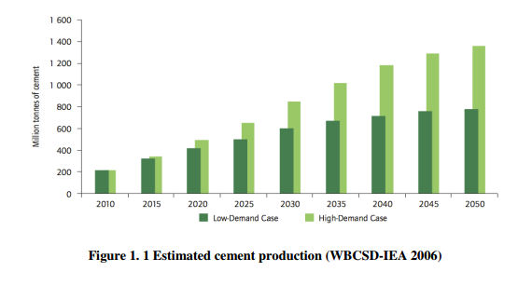

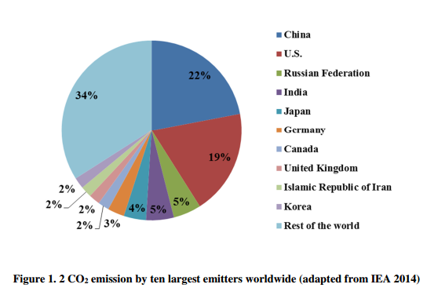

India is the second largest cement producer in the world after China. India produced 280 million tonnes of cement in the year 2014, with an expected annual growth of approximately 8% to 10% annually in the coming years.

1. **2 Literature survey & background**

Er. Kimmi Garg et al (2016) “Cement, fine aggregate, coarse aggregate, and water” are the ingredients of concrete. Concrete is used in enormous quantities because it is essential to the construction of infrastructure

P.Chandru et al (2016) Research on the partial replacement of the traditional ingredients of concrete by two chosen waste materials is the result of the building industry's growing look for sustainable and ecologically aware based resources.

Uzbas et al. (2019) conducted an analysis of fly ash concrete utilizing Scanning Electron Microscopy and X-Ray Diffraction techniques. Fly ash was substituted for cement at weight percentages of 5%, 10%, 15%, and 20%. X-ray diffraction (XRD) and Scanning Electron Microscopy (SEM) analyses were conducted to assess the microstructural properties. Fly ash concretes exhibited inadequate strength at 7 days; however, the strength of the fly ash concrete increased significantly by the 28th and 90th days. The XRD analysis indicated that both the age of the concrete and the quantity of fly ash affected the ratio of Calcium Hydroxide (CH) generated through hydration.

Jenaa and Panda (2018) conducted an investigation into the mechanical and durability properties of marine concrete incorporating fly ash and silpozz. Silpozz, an agro-waste derived from agricultural processes, along with fly ash, was utilized. Partial replacement was made with cement at various percentages.

Adithya Saran and Magudeswaran (2017) performed a SEM analysis focused on sustainable high-performance concrete. Fly ash was partially replaced with cement at 30% and 35%, while silica fume was incorporated at 7.5% and 10%. Additionally, fine aggregates were entirely substituted with manufactured sand. Coarse aggregates were partially replaced with recycled aggregates at proportions of 30%, 40%, and 50%. The specimens underwent compressive strength testing, revealing that the optimal strength was achieved in the concrete mix comprising 30% fly ash, 7.5% silica fume, and 40% recycled coarse aggregates.

* 1. **objective**

The objective of the research work is to study the behaviour of concrete containing mineral admixtures, quarry dust and sisal fibres. An extensive study was undertaken with the following objectives:

* The use of economical materials in construction.
* The utilization of industrial wastes in concrete.
* To determine the optimum content of mineral admixtures, quarry dust and sisal fibres in concrete.
* To study the workability, strength and durability of the concrete after adding respective minerals and admixtures.
  1. **Result**

**Compressive Strength Test**

The Compressive Strength Test is a common test used to measure the ability of a material, usually concrete, to withstand axial loads (compression). The test is used to determine the material's capacity to resist crushing or breaking under pressure, and it is a fundamental property for designing structures.

**Table 1 Average7,21 28-day compressive strength tests for various mixes**

|  |  |  |  |  |
| --- | --- | --- | --- | --- |
| **SN** | **MIX ID** | Compressive Strength for 28 days (MPa) | | |
|  |  | 7day | 21 days | 28 days |
| 1 | NC | 23.21 | 32.12 | 38.21 |
| 2 | MIX -1 | 24.12 | 33 | 39.1 |
| 3 | MIX -2 | 24.9 | 32 | 38.31 |
| 4 | MIX -3 | 25 | 33 | 39.1 |
| 5 | MIX -4 | 23.21 | 31 | 36.91 |
| 6 | MIX -5 | 22.23 | 29 | 34.85 |
| 7 | MIX -6 | 26 | 33.12 | 40.58 |
| 8 | MIX -7 | 28.9 | 38.12 | 44.84 |
| 9 | MIX -8 | 23.12 | 30.5 | 36.21 |

**Figure 1 Average 7-day compressive strength values for various mixes**

**Figure 2 Average 21-day compressive strength values for various mixes**

**Figure 5.3 Average 28-day compressive strength values for various mixes**

**Figure 3 Average 7,21, 28-day compressive strength values for various mixes**

Table 5.2 and Figure 5.1,5.2 .5.3 represents the average values of compressive strength on 7 ,21 28 days of curing. It can be noted that the Mix -4 and mix -5 specimens did not attain the target strength at 28 days. Mix 3 and mix 7 specimens were higher in compressive strength than the conventional concrete specimens at a rate of 6.12% and 13.39%, respectively. Similarly, mix 3 and mix 7 specimens were higher in compressive strength than the mix 1 specimen at 1.35% and 8.28%, respectively.

# **1.3 Conclusion**

1. Compressive, split tensile and flexural test results shows better performance in Mix 3 (20% Fly Ash, 50% Quarry Dust, 1.5% sisal fibres), and mix 7 (20% Fly Ash, 10% Micro silica, 50% Quarry Dust, 1.5% sisal fibres) specimens than the conventional concrete specimen and mix 1 specimen (50% quarry dust and 1.5 % sisal fibres).
2. Ultrasonic Pulse Velocity were found to be excellent in the Mix 7 specimen in relation to the rest of the specimens.
3. Durability tests such as water absorption, Tests conducted on the specimens reveal the extraordinary performance of the mix 7 specimen over all the other specimens due to its lesser permeability.

# REFERENCES

[1]Aggarwal Y, Siddique R (2014),Microstructure and properties of concrete using bottom ash and waste foundry sand as partial replacement of fine aggregates," Construction and Building Materials, volume 54, pages 210–223

[2] Mohd Syahrul Hisyam bin Mohd Sani, Fadhluhartini bt Muftah, and Zulkifli Muda (2010), ‘The Properties of Special Concrete Using Washed Bottom Ash (WBA) as Partial Sand Replacement’ International Journal of Sustainable Construction Engineering & Technology, Vol. 1, No. 2, December 2010, pp. 65–76.

[3] Remya Raju, Mathews Paul K., and Aboobacker K.A. (2014),'strength performance of concrete using bottom ash as fine aggregate’, International Journal of Research in Engineering & Technology, Vol. 2, Issue 9, September 2014, pp. 111–122.

[4] Soman K., Divya Sasi, Abubaker K.A. (2014), ‘Strength properties of concrete with partial replacement of sand by bottom ash’ International Journal of Innovative Research in Advanced Engineering, Volume 1, Issue 7 (August 2014), pp. 223-227.

[5] M.S. Shetty, S.Chand (2010), ‘Concrete technology, theory, and practice’ Tata McGrah Hill Company Ltd., New Delhi

[6] Vikas R. Nadig, Sanjith J., Ranjith A., and Kiran B. M. '(2015),'Bottom Ash as Partial Sand Replacement in Concrete: A Review’, IOSR Journal of Mechanical and Civil Engineering, Volume 12, Issue2, Ver. 6 Mar-Apr. 2015), p. 148–151.

[7] Edem Baite , Adamah Messan , Kinda Hannawi, François Tsobnang , William Prince(2016) Physical and transfer properties of mortar containing coal bottom ash aggregates from Tefereyre’ Construction and Building Materials 125 , pp. 919–926

[8] Aggarwal, Y. & Siddique, R. Microstructure and properties of concrete using bottom ash and waste foundry sand as partial replacement of fne aggregates. Constr. Build. Mater. 54, 210–223 (2014).

[9] Shaikh, N. A. & Tapkire, P. P. A partial replacement of fne aggregate by copper slag in concrete. Int. J. Eng. Comput. Sci. 12, 19809–19812 (2016).

[10] Ansari, T., Mishra, A. & Vanshaj, K. Partial replacement of fne aggregate by glass powder in concrete. Int. J. Res. Appl. Sci. Eng. Technol. 10(7), 4898–4904 (2020).