### AIADV: AI AUTONOMOUS DELIVERY VEHICLE

#### A Thesis

##### Submitted by

### Aashika Shravani KB (RCAS2022BAM005)

##### in partial fulfillment for the award of the degree of

### BACHELOR OF SCIENCE SPECIALIZATION IN

### ARTIFICIAL INTELLIGENCE AND MACHINE LEARNING



**DEPARTMENT OF COMPUTER SCIENCE**

### RATHINAM COLLEGE OF ARTS AND SCIENCE

**(AUTONOMOUS)**

COIMBATORE - 641021

**May - 2025**

**RATHINAM COLLEGE OF ARTS AND SCIENCE**

**(AUTONOMOUS)**

COIMBATORE - 641021



**BONAFIDE CERTIFICATE**

This is to certify that the thesis report entitled **AIADV: AI Autonomous Delivery Vehicle** submitted by **Aashika Shravani KB** RCAS2022BAM005 for the award of the Degree of **Bachelor of Science specialization in Artificial Intelligence and Machine Learning** is a bonafide record of the work carried out by her under my guidance and supervision at Rathinam College of Arts and Science, Coimbatore.

###### Dr.D.K. Arun Kumar, Ph.D., Dr.D.VimalKumar, Ph.D.,

Supervisor Head Of the Department

Submitted for the University Examination held on

###### INTERNAL EXAMINER EXTERNAL EXAMINER

**RATHINAM COLLEGE OF ARTS AND SCIENCE**

**(AUTONOMOUS)**

COIMBATORE - 641021

### DECLARATION

We, **Aashika Shravani KB**, hereby declare that this thesis entitled **“AIADV: AI Autonomous Delivery Vehicle”** is the record of the original work done by us un- der the guidance of **Dr.D.K. Arun Kumar, Ph.D.,** Dean, Department of Computer Science, Rathinam College of Arts and Science, Coimbatore. To the best of my knowl- edge, this work has not formed the basis for the award of any degree/diploma/fellowship/or a similar award to any candidate in any University.

###### Aashika Shravani KB

###### Place: Coimbatore Date:

#### COUNTER SIGNED

### Dr.D.K. Arun Kumar, Ph.D.,

Supervisor

**Contents**

|  |  |
| --- | --- |
| **Acknowledgement** | **iii** |
| **List of Figures** | **iv** |
| **List of Tables** | **v** |
| **List of Abbreviations** | **v** |
| **1 Introduction** | **1** |
| 1.1 Scope of the Project . . . . . . . . . . . . . . . . . . . . . . . . . . . . | 4 |
| 1.2 Contributions . . . . . . . . . . . . . . . . . . . . . . . . . . . . . . . . | 4 |
| 1.3 Module Description . . . . . . . . . . . . . . . . . . . . . . . . . . . . . | 5 |
| 1.4 Existing System . . . . . . . . . . . . . . . . . . . . . . . . . . . . . . | 6 |
| **2 Literature Survey** | **9** |
| **3 Methodology** | **13** |
| 3.1 Overview of project . . . . . . . . . . . . . . . . . . . . . . . . . . . . . | 13 |
| 3.2 Hardware Modules . . . . . . . . . . . . . . . . . . . . . . . . . . . . . | 15 |
| 3.3 Software IDE . . . . . . . . . . . . . . . . . . . . . . . . . . . . . . . . | 19 |
| 3.4 Advantages . . . . . . . . . . . . . . . . . . . . . . . . . . . . . . . . . | 21 |
| **4 Experimental Setup** | **23** |

* 1. Proposed System 23
  2. Short description 25
  3. Suggestion for experiments 28

1. Results and Discussions 31
   1. Digital Output 31
   2. Analog Output 34
2. Deployment Process 36
   1. Overview of the process 36
   2. User Interface 38
   3. Execute Structure 40
3. Conclusion 43
   1. Conclusion 43
   2. Future Works 45

References 48

**Acknowledgement**

The satisfaction and euphoria that accompanies the successful completion of any task would be incomplete without the mention of the people who made it possible. Primarily, we thank **“THE ALMIGHTY”** for the strength and encouragement have given to us throughout all the challenging moments of this work. Profound gratitude and unwavering respect to the following captioned persons for the help and support extended to making this project possible.

**Dr. Madan. A. Sendhil, M.S, Ph.D.,** Chairman, Rathinam Group of Insti- tutions, Coimbatore and **Dr. R. Manickam, MCA., M.Phil., Ph.D.,**, Rathinam Group of Institutions for giving us the opportunity to study in this college. We are extremely grateful to **Dr. S. Balasubramanian, M.Sc., Ph.D (Swiss), pdf (Swiss USA),** Principal and **Dr.D.Vimalkumar, Ph.D.,** HOD- Rathinam College of Arts and Science (Autonomous). We thank **Ms.A. Vanitha, B.E, M.E.,** Co-ordinator Rathinam Campus, **Dr.A Revathi, MCA, M.Phil, Ph.d.,** Project Coordinator and all faculty members of the Department of Computer Science, Rathinam Campus for their constructive suggestions. We convey special thanks to our supervisor **Dr.D.K. Arun Kumar, M.E, MBA, Ph.D.,** for his inestimable support, guidance, and mo- tivation.

We dedicate sincere respect to our parents for their moral motivation in completing the project.

**List of Figures**

* 1. Overview of project 14
  2. Arduino Mega 2560 15
  3. HC-06 Bluetooth module 16
  4. NEO-6M GPS Module 17
  5. HMC5883L magnetometer 18
  6. Motor Control Shield (Arduino Mega) 19
  7. Circuit Diagram 23
  8. AIADV Robot 36
  9. App UI 40
  10. Libraries 40

**List of Abbreviations**

AIADV Artificial Intelligence - Autonomous Delivery Vehicle ADR Autonomous delivery robots

DRL Daytime Running Light LiDAR Light Detection and Ranging GPS Global Positioning System

GLONASS Globalnaya Navigazionnaya Sputnikovaya Sistema GNN Graph Neural Network

IMU Inertial Measurement Unit

LED Light-Emitting Diode

PWM Pulse width Modulation

QR Quick Response Code

RFID Radio Frequency Identification RSU Road Side Units

SPP Serial Port Profile

UART Universal Asynchronous Receiver Transmitter

**Abstract**

AI automation revolutionized logistics with the creation of the AI Autonomous Delivery Vehicle for streamlined, self-navigated deliveries. Based on machine learning, computer vision, LiDAR, and GPS, it safely navigates, identifies hazards, and main- tains real-time monitoring with minimal human intervention. Conventional delivery mechanisms are plagued with inefficiencies, delays, excessive costs, and environmental issues. The demand for quicker, timely, and mechanized solutions generates the de- mand for autonomous vehicles, which improve efficiency and sustainability. I helped in the creation of the autonomous system, incorporating LiDAR for live mapping, and en- ergy efficiency optimization with an electric power system. I also implemented smooth communication between the car, delivery hubs, and consumers. Consumers are able to pick up their packages from specified hubs using authentication, with a fixed weight limit for ensuring proper handling of packages. Future enhancements involve improving AI for more informed decision-making, responding to varied terrain and weather condi- tions, and learning from real-world data. These improvements will render autonomous deliveries smarter, greener, and more dependable.

**Chapter 1 Introduction**

AI automation has revolutionized the transportation and logistics industry, bringing efficiency, speed, and sustainability to a sector that has long relied on tradi- tional methods. Among the many challenges in this field, last-mile delivery remains one of the most difficult to optimize. Here the final stage of the delivery process getting a package from a distribution center to its final destination is often the slowest, most expensive, and environmentally damaging part of the supply chain.

Factors such as traffic congestion, fuel consumption, inefficient routing, and labor- intensive processes contribute to delays and high costs. Additionally, with the growing demand for same-day and next-day deliveries, businesses are struggling to meet cus- tomer expectations using outdated systems. Traditional last-mile delivery methods rely heavily on human resources, including delivery personnel and drivers, leading to high operational costs and potential inefficiencies due to human error, fatigue, and unpredictable traffic conditions. As consumer demand rises and cities become more congested, these manual approaches are proving to be unsustainable and ineffective. Moreover, the environmental impact of fuel-powered delivery vehicles is a growing con-

cern, prompting companies to seek greener alternatives that reduce carbon emissions and fuel dependency.

To address these issues, businesses are turning to AI-powered autonomous delivery solutions that utilize automation, data analytics, and real-time decision-making to op- timize logistics. Technologies such as Machine Learning (ML), Computer Vision (CV), sensor fusion, and advanced GPS routing enable vehicles to navigate efficiently, avoid obstacles, and find the shortest routes with minimal human intervention. AI-driven systems help in predicting traffic patterns, reducing delivery times, and lowering costs, ultimately enhancing both business efficiency and customer satisfaction.

By embracing AI automation, the logistics industry is undergoing a major trans- formation, shifting away from labor-intensive, high-emission delivery models toward more cost-effective, fast, and environmentally friendly solutions. The integration of AI-powered delivery vehicles, drones, and robotics in last-mile delivery is not just a technological advancement it is a necessary evolution that will shape the future of global supply chains, ensuring smoother, faster, and more sustainable transportation systems. -emission

AIADV robot is an innovative solution designed to revolutionize automated delivery by integrating real-time ML, CV, and sensor fusion for navigation and decision-making. It is supposed to continue self-determining the fastest and safest route for itself from traffic, roadblocks, or weather conditions, updating its path at each point in time. It would depend on LiDAR-based mapping, GPS routing, cameras, and radar sensors to detect obstacles, recognize traffic signals, and ensure smooth movement in both urban

and suburban environments. The AIADV would use sensor fusion to combine data from various sources, including LiDAR for 3D mapping, GPS for precise location tracking, and vision-based AI for object detection. The vehicle would autonomously adjust to unexpected obstacles, rerouting as needed without human intervention. Designed for efficiency and safety, this AI-powered system aims to optimize logistics, reduce human dependency, and enhance delivery speed and accuracy, making it a game-changer in modern transportation and supply chain management.

AIADV robot is also designed with sustainability in mind. It runs on an electric power system and is supported by solar energy, which helps reduce pollution and supports green logistics. Its communication systems also make it easy to coordinate between delivery centers, customers, and fleet managers, making operations more efficient and improving customer satisfaction.

The primary objective of our project is to make last-mile delivery better, cut costs, im- prove efficiency, and reduce harm to the environment. Because it could adapt to varying delivery needs, the AI Autonomous Delivery Vehicle would most probably change the face of logistics work in the future. This project explains the technology behind the vehicle, how it works, its features, and the kind of impact that it could create in the logistics industry.

* 1. **Scope of the Project**

Our project aims to make delivery at the last mile better in cost, efficiency, and re- duction of harm to the environment. The AI Autonomous Delivery Vehicle can change the way logistics work in the future due to its ability to work under different kinds of delivery needs. This project explains the technology that stands behind the vehicle, how it works, the key features, and how it might affect the logistics industry.

1. **Improving Last-Mile Delivery:** This project aims to make last-mile delivery faster, more efficient, and cost-effective.
2. **Reducing Environmental Impact:** AIADV is powered by electricity and solar energy to ensure ecologically friendly logistics.
3. **Increasing Automation in Logistics:** AIADV reduces human involvement with AI of navigation, decisions, and obstacle detection.
4. **Increasing Safety and Reliability:** AIADV is equipped with LiDAR, GPS, and sensors to ensure a risk-free and safe delivery operation.
5. System supports scalability and adaptability, which allow the vehicle to serve different delivery scenarios, ranging from suburban areas to urban sites.
   1. **Contributions**

Big changes in artificial intelligence (AI) and automation technologies have come into several industries, most notably in the transportation and logistics industries. However, last-mile delivery has emerged as one of the major challenges for this industry, it refers

to the final mile of bringing a package to a destination. Last-mile delivery tends to be slow, costly, and bad for the environment. Since businesses today demand faster, more efficient, and environmentally friendly solutions, the old modes of delivery with a high reliance on human labor are becoming obsolete. To solve these problems, the AIADV robot has been invented as the new solution.

The AIADV robot takes advantage of smart technologies like ML, CV, and sensor fusion to run smoothly and make decisions in real-time. It also automatically finds the best routes with the help of key technologies such as LiDAR-based mapping, GPS routing, and obstacle detection. These features allow the robot to move safely in urban and suburban areas with minimal human assistance.

This robot is designed to be sustainable. It runs on an electric power system and is powered by solar energy, thus reducing pollution and supporting green logistics. Its communication systems also allow easy coordination between delivery centers, cus- tomers, and fleet managers, which can make it easier to conduct operations, enhancing customer satisfaction.

* 1. **Module Description**

**Navigation Module:** The module enables the vehicle to move safely by using LiDAR, GPS, and sensors to detect roads, obstacles, and traffic conditions.

**Object Detection Module:** This part of the system identifies and recognizes objects like pedestrians, vehicles, and delivery drop-off points to avoid accidents.

**Route Optimization Module:** The module finds the best possible path for delivery, reducing travel time and improving efficiency.

**Energy Management Module:** The module controls the usage of power. It ensures that the electric battery and solar panels work efficiently to maximize energy savings.

**Communication Module:** The module connects the vehicle with delivery hubs, cus- tomers, and fleet managers to provide real-time updates and tracking information.

* 1. **Existing System**

###### Autonomous Delivery Vehicles: A Quantitative Study from the Perspec- tive of Innovativeness

Autonomous delivery through vehicles is increasingly becoming popular in the trans- portation of goods, thanks to the advancements in machine learning and AI. This paper investigates the use of AI and various algorithms to ensure autonomous delivery be- comes more efficient. It highlights the contribution of AI in decision-making, route planning, and personalization to enhance the delivery process. The use of intelligent algorithms guarantees quicker, safer, and more dependable deliveries.

AUTHOR: Bu¨lent Yıldız Year: 2024

###### AUTONOMOUS VEHICLE DELIVERY WITH PERSONALIZATION

Autonomous delivery is gaining popularity as a result of advancements in machine learn- ing and AI. This paper explains how smart algorithms and AI contribute to enhancing

autonomous deliveries, with an emphasis on personalization. The future of autonomous delivery is bright, with numerous new innovations set to be created and applied.

AUTHOR: Rathnakumar Udayakumar Year: 2023

###### Artificial intelligence-empowered vision-based self-driver assistance sys- tem for internet of autonomous vehicles

Artificial intelligence (AI) and edge computing have enhanced automobile networks so that real-time traffic can be easily analyzed. Based on the information provided by passing autonomous cars and roadside units (RSUs), traffic situations can be estimated with more accuracy and speed. Both technologies contribute towards enhanced route planning, smoother traffic flow, and enhanced road safety. AI-driven systems are able to forecast traffic behavior, recognize obstacles, and aid autonomous car decision-making. **AUTHOR:** Shashank Gupta, Oshin Rawlley

**Year:** 2022

###### Performance Comparison of Three Rival AI-Powered Intelligent Trajec- tory Tracking Controllers for an Autonomous Delivery Van

With the rise of e-commerce, traffic from delivery vehicles has risen by 71 Percent in the past 20 years. Therefore, automating delivery vans has become necessary to enhance road safety and make deliveries more efficient. Autonomous delivery vans can reduce traffic congestion, decrease fuel usage, and eliminate human errors, resulting in safer and quicker deliveries.

**AUTHOR:** Mohammad Ghazali, Ishaan Gupta, Mohamed Ben Abdallah, Joshua

Clarke, Vairavsundaram Indragandhi, Ahu Ece Hartavi

**Year:** 2023

###### AI-based competition of autonomous vehicle fleets with application to fleet modularity

This paper discusses how an autonomous vehicle fleet in the future can conduct a complex military operation. The military fleet has to work in hostile environments where damage is likely to occur. It also has to react to enemy movements in real time. AI and sensors enable these vehicles to identify threats, make quick decisions, and adjust to shifting battlefield conditions, enhancing mission success and soldier safety. **Authors:** Xingyu Li, Bogdan I. Epureanu

**Year:** 2020.

###### Artificial Intelligence in Service Delivery Systems: A Systematic Litera- ture Review

Autonomous delivery robots (ADRs) are a recent advent in delivery services. While studies on the technical aspects of ADRs are growing rapidly from technical perspec- tives, studies of ADRs from the business perspective are scarce. ADRs are undoubtedly going to be a hot topic in the technology, innovation, and entrepreneurship literature. However, no literature review has yet sought to understand the current state-of-the-art for ADRs from the business perspective.

**AUTHOR:** Mokter Hossain

**Year:** 2023.

**Chapter 2 Literature Survey**

The rapid pace of development of the autonomous delivery system from 2021 to 2024 reflects the major developments in AL, Robotics, and sustainability. Substan- tial improvements have been done in various studies and engineering to enhance these systems’ efficiency and reliability. This literature review focuses on some of the key studies, new technologies, and real-world applications developed in this period. One of the major areas for research is that of improving AI in delivery vehicles. ML and CV have advanced greatly, allowing delivery vehicles to look out for potential obstacles, to recognize traffic lights, and other smart decisions entirely without human support. Several research studies have actually shown how it can improve navigation, eradicate errors, and speed up the delivery process.

The development of robotics and automation is also another important aspect. There are experiments of delivery robots and drones in busy cities and remote ru- ral areas. Scientists have worked to make these robots more adaptive to different types of roads, weather conditions, and delivery tasks. Studies have also been conducted to see how several autonomous vehicles can work together for efficiency and shorter

delivery times. Sustainability has been a major focus of innovation in recent years. Many studies highlight the use of electric and solar-powered delivery systems to reduce pollution and energy consumption. Companies and researchers have explored new bat- tery technologies, lightweight vehicle designs, and smart energy management systems to extend the operating time of autonomous delivery vehicles.

**Challenges in Self-Driving Delivery Trucks :** There are quite some challenges that self-driving delivery trucks have to deal with before wider adoption takes place. The first area of concern is the technical part of AI and sensor technology, which remains a significant hindrance. AI-based navigation and decision-making systems must become efficient enough to handle unpredictable environments and extreme weather conditions.

**Future of AI Transportation Systems:** The emergence of AI-driven delivery sys- tems holds a lot of promise for the future. Emerging technologies such as 5G and the Internet of Things (IoT) are likely to enhance delivery services globally. These tech- nologies will enable real-time communication among delivery vehicles, traffic control, and command centers, making transport more efficient. With these developments, de- liveries will get quicker, more secure, and more dependable, enhancing overall supply chain and client satisfaction.

**Safety Measures in AI-Based Logistics:** Ensuring safety is the top priority in AI- based logistics. It will develop AI-powered risk assessment systems that can predict and prevent accidents by analyzing real-time data from sensors and cameras. It would also include mechanisms for emergency stop and remote control so that human operators

could intervene when needed.

**AI Influence on Jobs in Logistics:** AIADV is altering the landscape of jobs in logis- tics. While automation reduces the need for manual labor in traditional delivery roles, it also opens up new job opportunities in AI management, vehicle maintenance, and software development. Companies will need to invest in workforce upskilling programs to train employees in AI-based operations and system management.

**Independent Navigation Systems:** In 2021, DRL gained much coverage due to its performances applied in independent navigation. Wang et al. (2021) demonstrated the possibility of vehicles navigating the dynamic urban environment to optimize decision- making processes online. In 2022, research such as that by Zhang et al. has extended multi-modal sensor fusion techniques, integrating LiDAR and radar along with vision, which increases the accuracy for object detection or avoidance of obstacles in poor vision conditions.

**Route Optimization and AI Algorithms:** One of the main highlights of 2021 was the application of GNNs to route optimization. The article presented by Kumar et al. demonstrated the usage of GNNs for solving the problem of real-time traffic routing. In 2022, predictive analytics powered by AI triggered the shift in vehicle routes in advance based on weather and traffic predictions (Liu et al.).

**Sustainability and Energy Efficiency:** In 2021, Chen et al. studied technologies that used swapping of batteries for self-driving electric vehicles to address inadequacies of charging infrastructures. In 2022, solar-assisted self-driving cars trended, and Zhao

et al. showed the rate at which solar panels can reduce energy consumption by as much as 30 Percent. Patel et al. researched the regenerative braking-solar hybrid systems of energy systems in the year 2023 where great benefits are gained in terms of energy saving.

**Communication Protocols and Customer Integration:** By 2021, 5G technology started to improve communication for autonomous systems by enabling faster data transmission between vehicles and logistics hubs (Smith et al.). This advancement helped delivery vehicles share real-time information, improving efficiency, safety, and overall coordination in transportation networks.

**Practice Implementation and Field Test:** Autonomous delivery robots, such as Starship Technologies, will be tested in urban settings for the first time in 2021, proof that AI-based delivery technologies could be an option for delivery services. Amazon began full-scale testing of its Scout Delivery robots in 2022 for suburbs and rural areas. Walmart and DroneUp tested aerial delivery platforms in 2023, demonstrating how autonomous vehicles and drones can be integrated to make delivery times more efficient.

**Chapter 3 Methodology**

* 1. **Overview of project**

Our project is on the design, development, and deployment of an AIADV robot that will enhance last-mile delivery operations. It brings together some of the latest developments in the fields of artificial intelligence, robotics, and sustainable engineering to introduce a fully self-operating delivery vehicle. The goal is to address the increased volume being channeled into the e-commerce sector with faster, safer, and more efficient deliveries.

From here, parcels will be picked up from a central hub and delivered to different locations. For the right parcel to reach the right person, the system will work on a secure QR code verification technique. Here, once the parcel reaches its delivery location, the recipient has to scan the QR code to unlock and collect his parcel from there. This provides additional security so that no unauthorized person gains access to the parcel.

Additionally, the robot will have a specific weight limit for the parcels it can carry. This ensures that the system operates efficiently and safely without overloading the robot. By using AI for route optimization, obstacle detection, and real-time navigation, the robot will be able to move smoothly in different environments, including urban and suburban areas. Our project aims to make last-mile delivery more reliable, cost- effective, and eco-friendly by reducing human intervention and using electric or solar- powered energy sources.

The AI system will constantly analyze traffic conditions, road obstacles, and weather conditions to determine the safest and fastest route for delivery. It will also have an emergency stop feature and remote monitoring capabilities, allowing human operators to take control if needed. The AIADV robot will be equipped with sensors, cameras, and LiDAR technology to detect obstacles, avoid collisions, and ensure smooth navigation. To ensure sustainability, the robot will be an electric battery-powered vehicle with additional solar panels that can extend its range, as it should not necessarily depend on the charging stations.

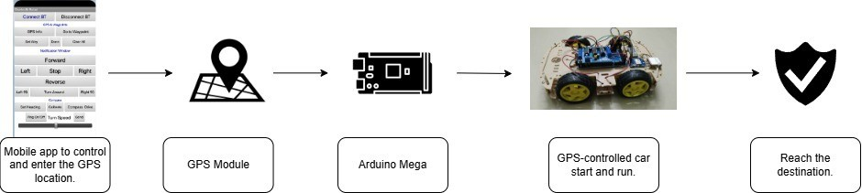

Figure 3.1: Overview of project

* 1. **Hardware Modules**

###### Arduino Mega 2560:

Arduino Mega 2560 is a powerful microcontroller board based on ATmega2560. It is beneficial for projects that require numerous inputs and outputs. It has 54 digital I/Os in which 15 pins have a PWM facility, 16 analog inputs, and 4 hardware serial ports or UARTs. So, it is mainly used in complex applications like robotics, automation, and IoT. The working voltage of the board is 5V with a 7-12V input voltage. It has 256 KB of flash memory, 8 KB of SRAM, and 4 KB of EEPRO for sufficient storage of large programs. The Arduino Mega 2560 communicates via USB, I2C, SPI, and UART and is used for easy integration with various sensors and modules.

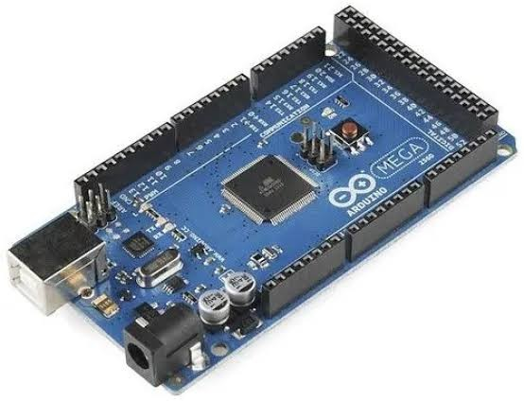

Figure 3.2: Arduino Mega 2560

###### Bluetooth Module:

The HC-06 is a simple, low-cost wireless communication device applied for serial data transmission. It usually operates using Bluetooth 2.0 and supports the Serial

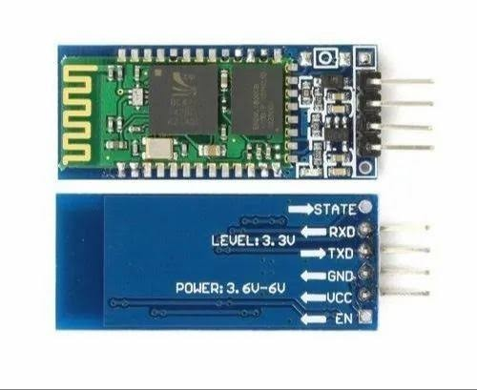Port Profile (SPP), so it’s very ideal for short-range communication between the mi- crocontroller and other Bluetooth-enabled devices like smartphones or laptops. The module operates on a voltage of 3.3V for logic levels. It is easy to set up using AT com- mands, allowing users to configure settings like baud rate and device name. With its compact design and reliable connectivity, the HC-06 is widely used in wireless control applications, home automation, and IoT projects.

Figure 3.3: HC-06 Bluetooth module

###### GPS Module:

The NEO-6M GPS module is a compact and highly reliable GPS receiver based on the 6 chipset, designed to provide accurate geolocation data. It is capable of receiving signals from the GPS (Global Positioning System) constellation and offers excellent performance with fast positioning and low power consumption. The module is capable of determining location with an accuracy of up to 2.5 meters, making it ideal for a wide range of applications, from robotics and drones to vehicle tracking systems. It can also support GLONASS (the Russian global navigation system) when properly configured. The NEO-6M operates at a voltage range of 3.3V to 5V

and communicates with other devices via UART or I2C interfaces, making it easy to integrate into various embedded projects.

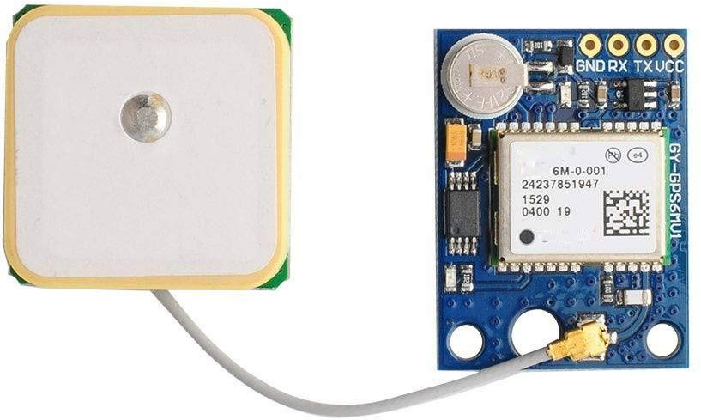

Figure 3.4: NEO-6M GPS Module

###### HMC5883L magnetometer:

The HMC5883L is a 3-axis digital magnetometer, which measures the strength of a magnetic field and detects the direction. It is mainly employed in electronic compass applications, navigation systems, and orientation detection in robotics and drone appli- cations. Communication with the microcontrollers is based on the I2C protocol, so the module is easy to integrate into devices like Arduino. The operating voltage is between

* 1. V to 5V. It has high accuracy measurements in the magnetic fields along the three axes X, Y, and Z. Thus, analyzing the readings above determines the direction relative to the heading of Earth’s magnetic field for the HMC5883L. A low consumption of power, the module is applicable for projects working with batteries. The module has a high-resolution measurement to detect the direction correctly even in locations that have very weak magnetic fields.

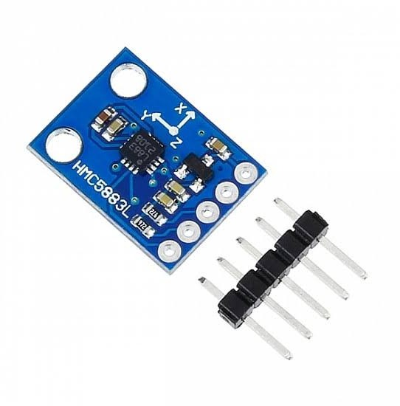

Figure 3.5: HMC5883L magnetometer

###### Motor Control Shield (Arduino Mega):

This Arduino Mega shield is an extension board to provide easy control for DC motors, stepper motors, and servos. H-bridge motor drivers, which usually are the L298P or L293D, allow this board to send PWM (pulse width modulation) signals that actually control motor speed and direction. The Arduino Mega shield was also designed to snap onto the Mega board so connections and wiring do not need too much trouble with. It usually supports two to four DC motors or one to two stepper motors, depending on the design. It also comes with a built-in protection circuit to prevent overheating and overcurrent damage which makes it safe and reliable to use for motor control.

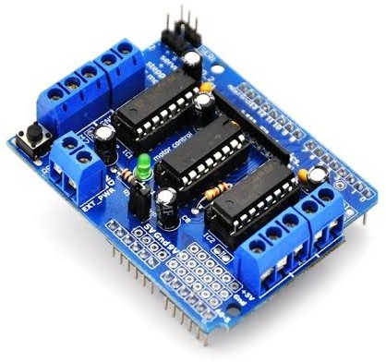

Figure 3.6: Motor Control Shield (Arduino Mega)

* 1. **Software IDE**

###### Arduino IDE

Arduino IDE, an acronym for Integrated Development Environment, is a software tool freely available as open-source. Its primary function is to enable the creation and testing of code for various hardware components. It serves as a virtual workshop for electronics enthusiasts and professionals alike, offering a platform to prototype elec- tronic projects efficiently.

One of the key features of Arduino IDE is its ability to simulate electronic devices, allowing users to understand how different components interact within a project. This simulation capability is invaluable for prototyping and testing ideas before moving on to physical implementation.

The software provides a user-friendly interface where users can write and debug code for their projects. Once the code is ready, Arduino IDE offers seamless integration with hardware, enabling users to upload their code to devices effortlessly. This streamlined process optimizes resource utilization and simplifies project management.

Moreover, Arduino IDE facilitates real-time data monitoring and preprocessing.

Users can easily monitor various parameters and sensor readings, allowing for rapid iteration and refinement of their projects. This feature enhances the development pro- cess by providing valuable insights into the performance of electronic components and systems.

###### Embedded C

Embedded C is a variant of the C programming language that is designed specifically for embedded systems, like microcontrollers found on Arduino boards. Unlike general- purpose programming, Embedded C is optimized to work within the constraints of limited memory, processing power, and real-time constraints in an embedded device. It contains hardware-specific libraries and direct memory access capabilities to efficiently control peripheral devices such as sensors, motors, and displays.

Arduino is an open-source electronics platform that combines hardware and software to simplify the development of embedded systems. Embedded C is used to program the microcontroller, and users can create interactive projects by writing code in the Arduino Integrated Development Environment (IDE). The IDE offers a user-friendly interface, built-in libraries, and debugging tools, making it accessible for beginners and experienced developers alike. Arduino has been tremendously influential in home automation, robotics, wearable technology, and Internet of Things (IoT) applications; it enables the easy construction of smart and automated systems.

* 1. **Advantages**

1. **Simplified Development:** Our project, the design of electronic projects is made more accessible. You don’t have to be an expert to start. It’s like a virtual workshop where you can try anything without the risk of breaking something. Our platform offers guided steps, live simulations, and pre-built libraries to simplify development. You can experiment with circuits, sensors, and code in a safe and interactive environment. From beginners to professional developers, you can bring your ideas to life with ease.
2. **Cost Savings:** Save money using our project. You don’t have to spend a fortune buying equipment just to experiment with electronics. Everything can be simulated on your computer, saving you from investing in physical components until you’re ready. With our virtual environment, test circuits, debug code, or modify designs- you risk nothing here, nothing goes wrong. Your learning and prototyping become affordable, efficient, and hassle-free. Once you fix your design to your liking, you can with con- fidence transition into real-world implementation, thereby significantly reducing the trial-and-error cost.
3. **Faster Prototyping:** Want to see how our project will work before building it?

This project lets you do just that. You can simulate the entire project on your com- puter, tweaking and testing until you’re satisfied with the results. It saves time and reduces the risk of errors.

1. **Efficient Resource Management:** When you’re ready to go from simulation to the real thing, our project helps you optimize your resources. It ensures that your

code runs smoothly on the hardware, making the most of what you have without wast- ing space or processing power. Thus, with efficiency insight and resource management tools, we will guide you to optimize both memory use and processing. It means designs would run more speedily on fewer powers that consume less for deployment on phys- ical hardware. That way, once again, transitions from virtual prototyping to its real prototype while maintaining functionality on one hand, but also at optimal levels for a project that could be feasible to deploy.

1. **Real-Time Monitoring:** With our project, you can keep an eye on our project as it runs. You can see how different components are performing and make adjustments on the fly. It’s like having a window into the inner workings of your electronics, giving you greater control and insight.

**Chapter 4 Experimental Setup**

## Proposed System

* + - Delivering Robot.
    - Self-Driving.

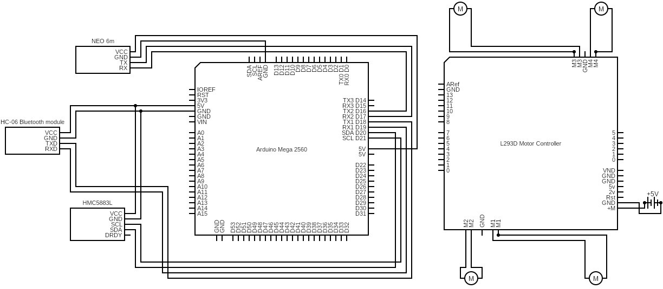

Figure 4.1: Circuit Diagram

A circuit diagram is a graphical representation of an electrical circuit. It shows the components of the circuit and how they are connected. Circuit diagrams are used to design, build, and troubleshoot electrical circuits.

In order to connect the Neo 6M GPS module, HC-06 Bluetooth module, and HMC5883L magnetometer with the Arduino Mega, one will need to perform the fol- lowing connections. Start with connecting VCC of Neo 6M with the 5V pin of the Arduino Mega, GND to a GND pin, RX to Pin 16 (TX2), and TX to Pin 17 (RX2). Next, for the HC-06 Bluetooth module connect its VCC (red wire) to 5V near Pin 22 on the Arduino Mega, GND (green wire) to the GND pin near Pin 53, TXD (blue wire) to Pin 19 (RX), and RXD (yellow wire) to Pin 18 (TX).

Lastly, for the HMC5883L magnetometer, connect its VCC to the 5V pin, GND to a GND pin, SCL to Pin 21 (SCL), and SDA to Pin 20 (SDA) on the Arduino Mega. These will allow proper communication between the modules and the Arduino Mega. To build this circuit, you will need the following components:

* Neo 6M GPS module
* HC-06 Bluetooth module
* HMC5883L magnetometer
* Arduino Mega 2560
* Jumper wires
* Car Chassis
* Motor Control Shield (Arduino Mega)

## Short description

###### Neo 6M GPS module

The NEO-6M GPS module is a compact and highly reliable GPS receiver based on the 6 chipset, designed to provide accurate geolocation data. It is capable of receiving signals from the GPS (Global Positioning System) constellation and offers excellent performance with fast positioning and low power consumption. The module is capable of determining location with an accuracy of up to 2.5 meters, making it ideal for a wide range of applications, from robotics and drones to vehicle tracking systems. It can also support GLONASS (the Russian global navigation system) when properly configured. The NEO-6M operates at a voltage range of 3.3V to 5V and communicates with other devices via UART or I2C interfaces, making it easy to integrate into various embedded projects.

###### HC-06 Bluetooth module

The HC-06 Bluetooth module is a simple, low-cost wireless communication device that can be used for serial data transmission. It operates using Bluetooth 2.0 and sup- ports the Serial Port Profile (SPP), which makes it very ideal for short-range communi- cation between microcontrollers and other Bluetooth-enabled devices like smartphones or laptops. The module operates on a voltage of 3.3V for logic levels.

###### HMC5883L magnetometer

The HMC5883L is a 3-axis digital magnetometer used in the measurement of mag- netic field strength and the detection of direction. It is primarily used in electronic compass applications, navigation systems, and orientation detection in robotics and drones. Communication with the microcontrollers is based on the I2C protocol, so the module is simple to integrate into devices such as Arduino. It operates at a volt- age of 3.3V to 5V and provides accurate readings of magnetic fields along the X, Y, and Z axes. By analyzing these readings, the HMC5883L helps determine the heading direction relative to Earth’s magnetic field.

###### Arduino Mega 2560

Arduino Mega 2560 is a powerful microcontroller board based on ATmega2560. It is beneficial for projects that require numerous inputs and outputs. It has 54 digital I/Os in which 15 pins have a PWM facility, 16 analog inputs, and 4 hardware serial ports or UARTs. So, it is mainly used in complex applications like robotics, automation, and IoT. The working voltage of the board is 5V with a 7-12V input voltage. It has 256 KB of flash memory, 8 KB of SRAM, and 4 KB of EEPROM for sufficient storage of large programs. The Arduino Mega 2560 communicates via USB, I2C, SPI, and UART and is used for easy integration with various sensors and modules. It is used in advanced electronics projects that require high processing power and multiple peripherals.

###### Jumper Wires

Flexible electrical wires having connectors on both ends are called jumpers, and they are used to temporarily connect parts of an electronic circuit or a breadboard. Usually, they are constructed using insulated stranded copper wire to guard against short cir- cuits. Male-to-male, male-to-female, and female-to-female connector types are among the different lengths, colors, and connector types available for jumper wires. Since they make it simple to connect, rearrange, and remove components without soldering, they are indispensable tools for prototyping. In order to make temporary electrical connec- tions and test circuit designs, jumper wires are frequently utilized in hobbyist projects, educational activities, and professional growth.

###### Car Chassis

A car chassis is the structural framework of a vehicle, supporting all its components, including the engine, wheels, suspension, and electronic systems. It provides stability, strength, and durability in withstanding various driving conditions. A robot car chassis is typically a metallic or acrylic base, designed with the mounting points for the motors, wheels, sensors, and a microcontroller like Arduino or Raspberry Pi in robotics and DIY projects. It is designed to house essential components such as batteries, motor drivers, and sensors, which will enable autonomous or remote-controlled vehicle operations. Car chassis come in different designs, such as four-wheel drive (4WD) or two-wheel drive (2WD) configurations, depending on the project requirements.

###### Motor Control Shield (Arduino Mega)

This shield for Arduino Mega is an extension board to provide easy control for DC motors, stepper motors, and servos. H-bridge motor drivers, which usually are the L298P or L293D, allow this board to send PWM (pulse width modulation) signals that actually control motor speed and direction. The Arduino Mega shield was also designed to snap onto the Mega board so connections and wiring do not need too much trouble with. It usually supports two to four DC motors or one to two stepper motors, depending on the design. The shield operates at a 5V logic level and can handle external power sources (typically 6V to 12V) to drive motors with higher current requirements. It is widely used in robotics, automation, and remote-controlled vehicle projects where precise motor control is needed.

## Suggestion for experiments

AIADV robot will be an autonomous solution designed to transform last-mile delivery services, integrating cutting-edge technologies such as artificial intelligence, the Internet of Things, and autonomous navigation. As demand grows for fast, efficient, and con- tactless delivery solutions, the robot aims to address key logistics industry challenges in reducing dependency on human drivers, minimizing operational costs, and overall reliability of the delivery service.

###### Advanced Navigation and Route Optimization

Equipped with high-precision GPS, LiDAR, ultrasonic sensors, and CV, the robot will autonomously navigate through any terrain: urban or suburban, and with perfectly

efficient detection and averting obstacles for safe passage. Algorithms powered by AI analyze real-time traffic data, road conditions, and environmental factors to optimize dynamically for delivery routes. The system can further adapt over time to new or unpredictable road scenarios using machine learning models.

###### Safe and Intelligent Parcel Packaging

Its advanced parcel handling includes smart locks that ensure safe deliveries, bio- metric authentication, as well as a secure encrypted connection for wireless communica- tions. Access to packages could be through one-time passcodes, RFID authentication, or facial recognition features, thereby assuring safety as well as stopping theft. Sensing is achieved through tamper-proof sensors along with real-time tracking that further allows users through a mobile or web interface.

###### Wireless Communication and IoT Integration

AIADV robot seamlessly integrates with e-commerce platforms, logistics manage- ment systems, and cloud-based databases through IoT connectivity. It communicates in real-time through Wi-Fi, 4G/5G, or Bluetooth, allowing fleet operators to monitor vehicle performance, battery status, and package deliveries remotely. The IoT-enabled architecture allows for predictive maintenance, reducing downtime and enhancing sys- tem reliability.

**Energy Efficiency and Sustainability** AIADV robot is designed with an energy- efficient battery system and is powered by renewable energy sources, like solar-assisted charging. Being an eco-friendly substitute for conventional fuel-based delivery vehicles, this will help cut carbon emissions. Higher efficiency of the light and strong material

used will ensure longer operating hours. It will also help reduce fuel costs and climate change impacts as it eliminates fuel. This technology supports the global shift toward sustainable urban mobility.

**Versatile Applications Across Industries:** AIADV robot can be used across multi- ple industries in retail, health services, food services, and logistics. These robots allow seamless automated deliveries of groceries, medical supplies, restaurant orders, and essential goods to deliver excellent customer experiences with reduced time and cost delivery. In health services, for example, a robot can ensure the safe transportation of medicines and lab samples by providing timely contactless delivery to hospitals and clinics.

###### Scalability, Reliability, and Future Prospects

AIADV robot is designed modularly and scalable, for use in both small and large package deliveries, as well as for commercial shipping. Its 24/7 operational ability al- lows businesses to fulfill deliveries at any time of the day, improving the convenience of service and improving efficiency. With AI-fleet management integrated, multiple robots can work in tandem while optimizing deliveries citywide.

AIADV robot is a modern advancement in logistics, smart city applications, and sustainable transportation through the use of advanced technologies.

**Chapter 5**

**Results and Discussions**

## Digital Output

One of the primary uses of digital outputs in AIADV is for motor control. AIADV robot requires precise movement to navigate urban environments and perform deliver- ies. Digital output pins from the Arduino Mega are connected to motor drivers (such as L298N or L293D) that control the DC motors responsible for moving the vehicle. These output pins send high (1) or low (0) signals to the motor driver circuits, which decide whether the motors should move forward, backward, or remain stationary. AIADV robot can change direction or speed by alternating between these signals. For instance, a digital output pin can set the robot to move forward by providing a high signal to the motor that is connected to the forward direction and a low signal to the motor that controls the reverse direction.

Digital outputs control several LED indicators that communicate the operational status of the robot. These LEDs may have several different applications, like inform- ing the person if the robot is ready for work when it is idle, or even in case of some malfunction. For example, green might signify normal operation by lighting up; on the other hand, a red LED can signify an error or a low battery. A state of the play is also brought about by its status LEDs critical for users and operators to note the current situation of the robot, especially in automated or controlled settings.

The buzzer system or alarm function is another integral digital output of the robot. They provide auditory responses to the users. The buzzer can be activated during important events, such as a successful delivery, an error in the system, or even as an emergency alert when the robot encounters a critical failure.

Using a digital output pin, the Arduino can trigger the buzzer to emit sounds at specific intervals, providing the user with alerts or notifications. For instance, in case the delivery is successful, a short beep can confirm the action, while a continuous alarm may sound in case the robot has sensed an obstacle or cannot complete the task.

To handle parcels safely, the robot can come with servo motors that are designed to work with mechanisms for locking and unlocking delivery compartments. Digital outputs can power these servos, and the robot can open and close compartments based on commands from the system or interaction with the recipient. For instance, when the robot reaches the destination, a digital signal can unlock the robot’s compartment using a servo motor, allowing the recipient to access their package. In some systems,

the servo can be controlled to move the lock mechanism to ensure that packages are securely stored during transport.

The AIADV robot also relies on wireless communication for remote monitoring, de- livery tracking, and real-time status updates. The Arduino’s digital output pins can switch on or switch off communication modules such as HC-06 Bluetooth or Wi-Fi modules, for instance, letting the robot talk to the cloud, send its data to the central server, or talk to the app. For instance, a digital output may be employed to make a Bluetooth connection between the robot and a user’s mobile app, allowing a user to monitor the delivery or updates about the status of the robot.

In safety, the robot has emergency stop protocols that are activated by pins of digital outputs. For example, the robot could turn off the motor through a digital output of the Arduino if the system finds any problem such as a failure of parts, or even a hazard such as a blocking that can cause damage to it. The digital output of the robot may trigger the braking system, or cut power to the motors, ensuring the robot stops when accidents or breakage of commodities are likely.

## Analog Output

AIADV robot, analog outputs are relevant for controlling systems that need a variable output, not just high or low. Their uses are mostly in governing motors and fine-tuning sensors. The PWM signals generated by Arduino’s digital pins control analog outputs by simulating an analog output by varying the amount of time for the given signal between pulsing it on and off.

Analog outputs in the robot are widely used to control the speed of motors. Digital outputs, as previously stated, determine whether the motor moves forward or back- ward. However, the analog output, specifically PWM, is what determines the speed. The Arduino generates a PWM signal on specific pins connected to the motor driver, adjusting the duty cycle of the signal to change the voltage supplied to the motors. A higher duty cycle results in a higher motor speed, while a lower duty cycle slows down the motor. This allows the robot to adjust its speed according to the environment, optimizing delivery time and energy consumption.

For instance, in densely populated areas, the motor’s speed should slow down to pre- vent collisions, whereas in open spaces, it will increase to traverse places more rapidly. Thus, PWM modulation for the motor to move more effectively and safely helps the robot achieve its objectives.

The other usage of analog output is for varying the brightness of LEDs. Where an LED can be turned on and off with a digital output, an analog output can vary the brightness of the LED using pulse-width modulation. One possible application for this is as status indicators or visual cues to the robot. For example, an LED may blink at various intensities as the robot goes through its various states. A dim light is a sign to indicate that a robot is possibly on standby while a bright one indicates that it is actively taking a package in. With this ability, the robot gives users or operators more fluid feedback and easy visual indications of how the robot operates at a mo- ment. This capability also enables the robot to blend well in different environments as the brightness of the lights can adjust itself when moving through dull or bright areas.

In the AIADV robot, analog outputs are indispensable for controlling systems that require adjustable outputs. These outputs enable the regulation of motor speeds, ad- justment of LED brightness, control of actuator motion, and management of power consumption. Using PWM signals and variable control, the robot can increase its capability of performing more tasks in an autonomous manner while reacting to the environment, ensuring that each package is dropped in place accurately. This flexibility is of utmost importance for attaining optimum performance, extending battery life, and providing a smooth, reliable delivery experience.

**Chapter 6 Deployment Process**

## Overview of the process

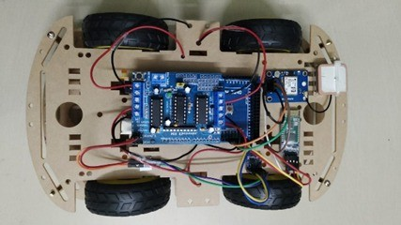

Figure 6.1: AIADV Robot

The AIADV robot is a revolutionary innovation in the robotics and IoT realms, carefully designed to meet the diverse needs of robotics enthusiasts, engineers, and re- searchers. It is an all-in-one platform that offers a wide range of features that have been

meticulously crafted to empower users across various fields of robotics and automated systems exploration.

At its core, the system is a testament to ingenuity, combining state-of-the-art hard- ware, including the Arduino Mega, GPS module, Bluetooth module, and a 4-wheel car chassis kit, with advanced software functionalities. Its intuitive interface and ergonomic design make it a seamless tool for users, regardless of their expertise level, promoting hands-on exploration and innovation in the world of autonomous robotics.

The AIADV robot exemplifies creativity in robotic exploration and shows users the opportunity to explore the possibility of traveling and navigating completely au- tonomous vehicles based on GPS coordinates. The very precise mechanisms allow users to have the control to dive into intricate autonomous navigation and mapping. There- fore, the current level of involvement with robotic systems is unmatched. Whether indoors or outdoors, users can use the GPS to navigate the robot and discover the endless potential of location-based robotics.

The advanced Bluetooth module makes it possible for remote control and commu- nication. Bluetooth integration allows the user to remotely manage and monitor the movements of the robot. This creates a dynamic user experience that opens new possi- bilities in remote operation and testing. This GPS and Bluetooth combination makes it perfect for a variety of robotics applications, from academic research to real-world automated tasks.

Furthermore, the system provides insight into the world of IoT-enabled robotics. The Arduino Mega integration allows users to modify and adapt the robot’s behaviors

and sensors to allow for the customization of navigation protocols, task automation, and environmental interactions. Users can experiment with adding new features or enhancing existing ones, ensuring that the system remains flexible and adaptive to a variety of research and development projects.

The robot is also an excellent tool to be used to learn the complexity of autonomous vehicle control systems. Using advanced coding and sensor integration, users will fine- tune their understanding of automated decision-making and system design under real conditions. The flexibility of the system is what makes it an irreplaceable tool for learning how to develop, deploy, and improve autonomous vehicles.

In conclusion, the AIADV Robot is an adaptive platform that enables exploration beyond traditional limitations to evaluate and improve robotic systems in unprece- dented depth and precision. Thus, it symbolizes innovation in the industry of IoT- enabled robotics, empowering hobbyists and professionals to reach and discover new horizons of creativity and technical advancement. This revolutionary device is a rev- olutionary piece of work in the context of autonomous vehicles and IoT, holding out much promise for people interested in revolutionizing modern robotics.

## User Interface

In the development of mobile applications, an Android device offers reliable and scalable resources to meet user needs. It is powered by Android OS and provides users with easy access to robust mobile-based features and connectivity.

Download and install the mobile app for Android. The user will start to use it by

launching it, and connecting their Android device via Bluetooth or Wi-Fi to the car’s system. The car’s navigation system can be used, and then users can start to control their car’s movement and get data on location from GPS.

This app acts as a strong interface to transmit real-time GPS coordinates to the car and receive feedback about its current location. By inputting the destination in the app, one can send the coordinates to the car’s system, which would drive autonomously toward the specified destination.

The app’s interface has an intuitive layout, with simple controls that let the user easily input his destination. Users can also view the car’s current location on the map, which helps in navigation. The app also includes options for adjusting settings, such as destination preferences, real-time tracking, and route optimization. Furthermore, the app includes a user-friendly system for controlling the car’s speed and route. Users can monitor the car’s progress in real-time and make any necessary adjustments during the journey. The app’s built-in GPS and mapping services ensure the car reaches its destination efficiently, whether navigating through city streets or rural areas.

In conclusion, with the use of Android mobile technology, GPS, and an intuitive app interface, the whole process is so smooth that a user can simply control the car, input the destination, and track progress through the Android device. With mobile technology, it brings the travel experience to one’s hand to make it efficient and enjoyable while enjoying the use of autonomous car navigation.

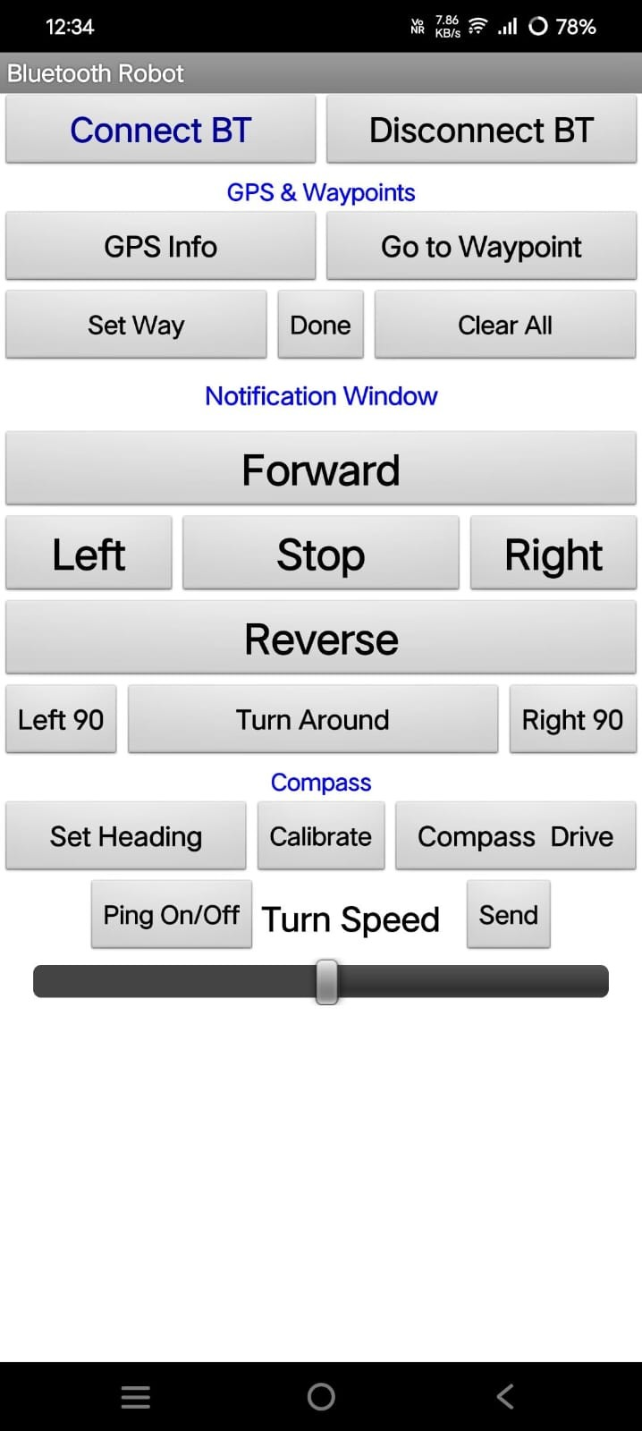

Figure 6.2: App UI

## Execute Structure

###### Libraries

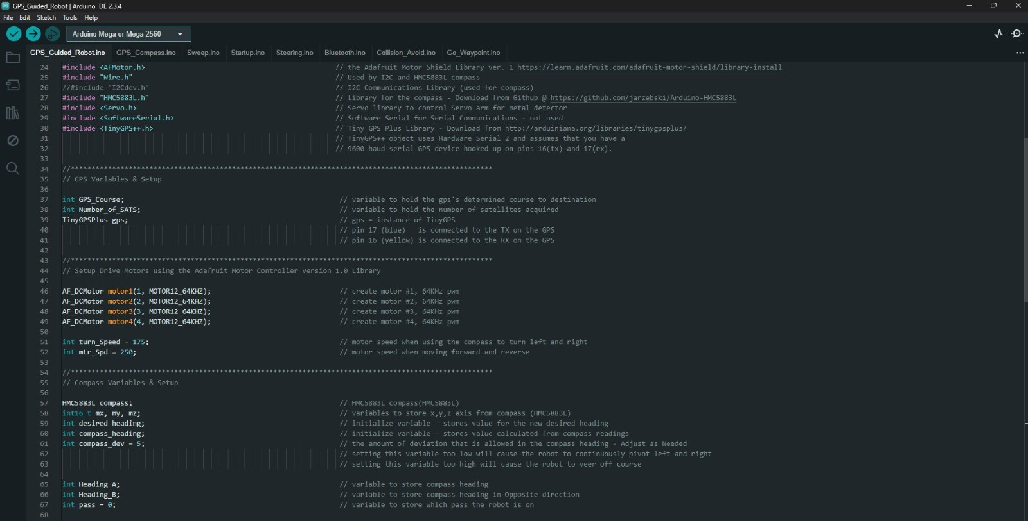

Figure 6.3: Libraries

* + 1. **Servo.h:** The Servo.h library is applied in working with servo motors in an Arduino project. A servo motor is a small motor that can rotate to a definite angle, typically between 0 and 180°. It is very helpful for controlling small mechanical parts,

robotic arms, and sensors. Using the Servo.h library, we can do the following things:

* + - * Control the angle position easily of the servo motor.
      * Use simple commands like .attach() to connect the servo and .write() for the angle.
      * Operate multiple servo motors at once.
      * This library is commonly used in applications where proper movement is required, like robotics and door movement of an automatic door and camera positioning.
    1. **TinyGPS++:** TinyGPS++ library is used for working with GPS modules in Arduino projects. A GPS module helps in finding out the exact location of a device using signals from the satellite. We can:
       - Obtain latitude and longitude where the device’s location is.
       - Find altitude, speed, and direction of movement.
       - Convert raw GPS data to human-readable information.
       - This library is used in projects such as vehicle tracking, outdoor navigation, and smart delivery systems.
    2. **Wire.h:** Wire.h is for I2C communication, a method by which multiple sensors and devices can be made to speak to each other using only two wires: SDA and SCL. With the Wire.h library, we can accomplish the following:
       - Connect multiple sensors such as temperature sensors, accelerometers, and even displays.
       - Communicate with I2C devices like OLED screens, EEPROM, motor drivers, and more.
       - Sends and receives data efficiently between the Arduino and the sensor.
       - This library is used in projects relating to sensors, smart gadgets, and data col- lection systems.

**Chapter 7 Conclusion**

## Conclusion

The AIADV robot is an unprecedented advancement in modern logistics and an edge technology that provides complete autonomy for last-mile deliveries. Developed for growing demands on speed, safety, and efficiency of delivery systems, the robot includes advanced technologies like AI, the IoT, and autonomous navigation. This ensures the independent functionality of AIADV and the capability to make decisions in real-time that further boost the delivery’s speed, accuracy, and safety.

At the core of the AIADV’s capabilities is its intelligent control system, which utilizes digital and analog outputs to ensure precise and adaptable performance. Digital outputs are used to manage motor control, status indicators, safety alerts, and wireless communication, ensuring that the robot operates efficiently and stays connected to cloud-based monitoring systems. Analog outputs play a critical role in fine-tuning motor speeds, adjusting the brightness of LEDs for visibility, and controlling the movement of actuators to facilitate smooth interaction with packages and obstacles. This level of fine

control ensures smooth navigation, optimized energy usage, and safe transportation of goods in urban and suburban environments.

Beyond its core functionalities, the AIADV robot is highly adaptive and scalable, making it suitable for any delivery environment. It can traverse busy city streets, residential neighborhoods, and all other terrains, adjusting its route, speed, and mech- anisms of obstacle avoidance dynamically. Its wireless communication systems allow for real-time updates on package status, route modifications, and potential hazards, ensuring accurate and reliable deliveries even in unpredictable conditions.

With AI-driven machine learning algorithms, AIADV learns from previous deliver- ies, traffic, and environmental factors to continue its improvement over time. The ability to self-learn enhances its route planning, speed optimization, and energy consumption, which will make it a more economically feasible and environmentally conscious alter- native to the traditional delivery system.

In essence, the AIADV robot is more than an autonomous vehicle; it is a technolog- ical revolution in last-mile logistics. Reducing human dependency, lowering operational costs, and enhancing delivery precision will pave the way for a future where AI-powered logistics redefine the efficiency and sustainability of the transportation industry.

With the ability to navigate intricate urban landscapes, detect obstacles, optimize routes in real-time, and handle parcels carefully, the AIADV robot guarantees a de- pendable and contactless delivery experience. It is an eco-friendly alternative in terms of using energy-efficient battery systems as the technology is designed to limit harm to

the environment.

In addition, the integration with e-commerce and logistics platforms allows for seam- less, automated deliveries, making the process more efficient while supporting scalabil- ity, 24/7 availability, and continuous service expansion. As retail, healthcare, and food services continue to evolve, the AIADV robot offers a technology-driven solution that enhances operational efficiency while reducing dependency on human labor.

In a nutshell, the AIADV robot represents the transformation to a smarter, greener, and more efficient delivery solution. It exemplifies how autonomous systems can rev- olutionize industries, leading to more growth opportunities and fulfilling the demands that last-mile deliveries need to provide in modern society.

## Future Works

The future generations of AIADV robot are supposed to be fitted with advanced ML models for improved object detection, facial recognition, and autonomous decision- making. Such improvements will ensure that the AIADV robot is capable of real-time analysis and response in its environment, thereby improving its adaptability to various delivery environments.

This enhanced object detection allows the AIADV to precisely identify and cate- gorize pedestrians, cyclists, automobiles, and other static objects, such as parked cars and road barriers. With this, safer and more efficient navigation will be achieved while preventing accidents and minimizing delivery routes. The robot will also be capable of providing safe and contactless package deliveries, as it uses facial recognition to verify

the recipient’s identity before finalizing the drop-off.

Improved decision-making capacity will further facilitate the AIADV to decipher and understand the meanings of traffic lights, road signs, and crosswalks as it operates even in highly complex urban areas with less interaction from humans. The prediction about human movement as sensing when a pedestrian will step in the street to cross will further ensure frictionless interactions of autonomous delivery robots with daily urban life.

The future versions of the AIADV will continue to learn from real-world experiences and evolve into highly intelligent, fully autonomous delivery solutions that make last- mile logistics faster, safer, and more efficient while reducing reliance on human labor and enhancing urban mobility.

**AI-Powered Object Recognition Decision-Making:** Future generations of the AIADV robot may add machine learning models for advanced object detection, facial recognition, and decision-making capabilities. This will enable the robot to detect pedestrians, traffic signals, and road signs and navigate complex urban environments with minimal human intervention.

**Enhanced Obstacle Avoidance System:** The installation of LiDAR sensors be- side ultrasonic and infrared sensors will significantly enhance the detection capabilities of the robot and its ability to avoid obstacles. More accurate and safe route planning may be allowed by using 3D mapping and environmental analysis in real time.

**Autonomous Charging and Power Management:** Integration of wireless charging stations or solar panels is key in future enhancement so that batteries can be kept going for extended periods, which may help prevent extended downtime. This robot should be able to self-navigate when its batteries run low toward specified charging stations, thus prolonging the system uptime.

**Weather Adaptability and Terrain Handling:** The robot could be equipped with all-terrain wheels, weather-resistant enclosures, and climate-adaptive sensors to expand its usability in various environments. The system would therefore allow for a smooth operation across different conditions such as rain, snow, or extreme temperatures.

**Integration with Smart City Infrastructure:** Developing and implementing in- teroperability standards can make it easier for different systems to communicate and exchange data, improving the overall efficiency of the Healthcare Monitoring System in IoT Cloud.

# References

* + 1. ”Artificial intelligence in the military: An overview of the capabilities, applica- tions, and challenges” Authors: Rashid, Adib Bin and Kausik, Ashfakul Karim and Al Hassan Sunny, Ahamed and Bappy, Mehedy Hassan Source: International Journal of Intelligent Systems.
    2. ”Research on the application of “last-mile” autonomous delivery vehicles in the context of epidemic prevention and control” Authors: Du, Dan. Source: IEEE.
    3. ”Autonomous vehicles and intelligent automation: Applications, challenges, and opportunities” Authors:Bathla, Gourav and Bhadane, Kishor and Singh, Rahul Kumar and Kumar, Rajneesh and Aluvalu, Rajanikanth and Krishnamurthi, Ra- jalakshmi and Kumar, Adarsh and Thakur, RN and Basheer, Shakila Source: Mobile Information Systems.
    4. ”AI-based competition of autonomous vehicle fleets with application to fleet mod- ularity” Authors: Li, Xingyu and Epureanu, Bogdan I Source: European journal of operational research
    5. ”Artificial intelligence-empowered vision-based self-driver assistance system for

Internet of autonomous vehicles” Authors: Rawlley, Oshin and Gupta, Shashank Source: Transactions on Emerging Telecommunications Technologies

* + 1. ”Performance Comparison of Three Rival AI-Powered Intelligent Trajectory Track- ing Controllers for an Autonomous Delivery Van ” Authors: Ghazali, Mohammad and Gupta, Ishaan and Abdallah, Mohamed Ben and Clarke, Joshua and Indra- gandhi, Vairavsundaram and Hartavi, Ahu Ece Source: Transportation Research Procedia
    2. ” Autonomous delivery robots: A literature review” Authors: Hossain, Mokter Source: IEEE Engineering Management Review.
    3. ”Artificial intelligence in service delivery systems: A systematic literature review” Authors: Reis, Joa˜o and Amorim, Marlene and Cohen, Yuval and Rodrigues, Ma´rio. Source: Trends and Innovations in Information Systems and Technologies: Volume 1 8.
    4. ”Dynamic pickup and delivery problem for autonomous delivery robots in an air- port terminal” Authors: Jeong, Joonhwa and Moon, Ilkyeong Source: Computers & Industrial Engineering
    5. ”The Future of Driving: A Review on the Combination of Artificial Intelligence and Autonomous Vehicles” Authors: Zade, Nikita and Gawande, Mayur and Verma, Prateek and Gundewar, Swapnil Source: IEEE
    6. ”Autonomous delivery robot” Authors:Zavin, Sarin Rahman and Rahaman, Kazi

Habibur and Nayeem, Safat Ahmed and Bin Mujahid, SK and Sarkar, Swapnil. Source: Brac University

* + 1. ”Study of sidewalk autonomous delivery robots and their potential impacts on freight efficiency and travel” Authors: Jennings, Dylan and Figliozzi, Miguel Source: Transportation Research Record.
    2. ”Customer perception and acceptance of autonomous delivery vehicles in the State of Kuwait during COVID-19” Authors: AlKheder, Sharaf and Bash, Amina and Al Baghli, Zahra and Al Hubaini, Rahaf and Al Kader, Abedallah. Source: Tech- nological Forecasting and Social Change.
    3. ”Understanding customer preferences for autonomous delivery vehicles in instant delivery: Exploring the impact of delivery and personal attributes” Authors: Huang, Chengyuan and Lu, Miaojia and Wang, Ran and Zhang, Rong Source: International Journal of Transportation Science and Technology
    4. ”Two-echelon vehicle-routing problem: Optimization of autonomous delivery vehicle- assisted E-grocery distribution” Authors: Liu, Dan and Deng, Zhenghong and Mao, Xinhua and Yang, Yang and Kaisar, Evangelos I. Source: IEEE Access
    5. ”Autonomous vehicles delivery systems classification: introducing a TSP with a moving depot” Authors: Madani, B and Ndiaye, M Source: IEEE
    6. ” Artificial intelligence in autonomous vehicles: Current innovations and future trends” Authors: Noviati, Nuraini Diah and Putra, Fengki Eka and Sadan, Sadan

and Ahsanitaqwim, Ridhuan and Septiani, Nanda and Santoso, Nuke Puji Lestari Source: International Journal of Cyber and IT Service Management

* + 1. ”Application of blockchain and smart contracts in autonomous vehicle supply chains: An experimental design” Authors: Arunmozhi, Manimuthu and Venkatesh, VG and Arisian, Sobhan and Shi, Yangyan and Sreedharan, V Raja. Source: Transportation Research Part E: Logistics and Transportation Review
    2. ”Autonomous Delivery Robot Operating System for 24-hour Delivery Service” Authors: Kim, Seu-jan and Um, Tai-Won Source: The Journal of Contents Com- puting.
    3. ”Model for crowdsourced parcel delivery embedded into mobility as a service based on autonomous electric vehicles” Authors: He, Yinying and Csisza´r, Csaba. Source: Energies.