**In Vitro Antimicrobial Activity Analysis of Green Synthesized Copper Nanoparticles with *Amaranthus dubius* Leaf Extract Against *Bacillus subtilis* & *Salmonella typhi***

**Vemuri Sritejas1 Shreosee Ghosh2 Dr. Rupak Roy2**

1Birla Open Minds International School, Kollur, Hyderabad, India

2SHRM Biotechnologies Pvt. Ltd., Madhyamgram, Kolkata, West Bengal, India

*Corresponding Author’s Email Id: rupak@shrmbio.com

**Abstract**

The present study explores a green and eco-friendly approach for the synthesis of copper nanoparticles (CuNPs) using *Amaranthus dubius* leaf extract and evaluates their antimicrobial efficacy against *Bacillus subtilis* and *Salmonella typhi*. The extracellular biogenic synthesis of CuNPs using *A. dubius* is a novel approach, as this plant has not been previously employed for nanoparticle synthesis. Phytochemicals in the leaf extract facilitated the reduction of Cu²⁺ ions, leading to the formation of well-defined CuNPs. The synthesized CuNPs were tested for their antimicrobial activity using the agar well diffusion method. The results demonstrated that *S. typhi* exhibited higher susceptibility to CuNPs, showing a prominent zone of inhibition across all tested concentrations, whereas *B. subtilis* displayed resistance at lower concentrations but showed significant inhibition at higher CuNP concentrations. This study confirms the potential of green-synthesized CuNPs as effective antimicrobial agents, highlighting their promising applications in pharmaceuticals, biomedical research, and nanotechnology-based therapeutics.

**Keywords**

Green synthesis, copper nanoparticles, Amaranthus dubius, Bacillus subtilis, Salmonella typhi, antimicrobial activity, biogenic synthesis, nanotechnology.

**Introduction**

Nanotechnology is emerging as a dynamic field of research in modern agriculture and related disciplines. Nanoparticles exhibit unique or enhanced properties due to their specific characteristics, including morphology, size, and distribution. Among nanomaterials, metallic nanoparticles are gaining prominence for their distinct physicochemical and biological properties compared to their macro-scale counterparts. Nanotechnology research is currently one of the most active areas in materials science. However, traditional physical and chemical synthesis methods for nanomaterials have significant drawbacks, such as high-pressure and high-temperature requirements, the use of expensive and hazardous chemicals, long reaction times, and the presence of toxic by-products on nanoparticle surfaces.

The properties of nanoparticles are influenced by their size, shape, composition, and structure. In recent years, there has been a growing interest in green synthesis techniques for nanomaterials, making them one of the most popular approaches in modern material sciences. Nanotechnology involves studying particles at a scale ranging from 10⁻⁷ to 10⁻⁹ meters and has broad applications in pharmaceuticals, electronics, environmental sciences, biotechnology, applied microbiology, medicine, drug and gene delivery systems, quantum dots, surface-enhanced Raman scattering (SERS), chemistry, space exploration, the chemical industry, energy science, mechanics, optics, and optoelectronic devices. Nanoparticles, which range in size from 1 to 100 nm in at least one dimension, are increasingly being used in biotechnology due to their compatibility with biomolecules and their tunable properties based on the biosynthesis method used.

Copper nanoparticles (CuNPs) are among the most widely used nanoparticles in medicine. These can be synthesized through both physical and chemical methods. However, physical methods often yield low nanoparticle production and require significant energy to maintain high temperatures and pressures. Chemical methods, on the other hand, rely on toxic precursor chemicals, produce hazardous by-products, and use harmful solvents.

Various chemical synthesis techniques, such as chemical reduction (Prakash et al., 2009), electrochemical reduction (Zhang, 2008), chemical vapor deposition (Rao et al., 2006), thermal decomposition (Kim et al., 2006), and solvothermal reduction (Tang et al., 2006), have successfully produced metallic nanoparticles. However, these methods are energy-intensive, generate toxic by-products, and involve hazardous chemicals. Consequently, there is a growing demand for cost-effective, environmentally friendly, and sustainable nanoparticle synthesis methods. This has led researchers to explore biological alternatives for nanoparticle production. Scientists have increasingly utilized biological organisms, including plants, algae, fungi, bacteria, and viruses, as eco-friendly and efficient alternatives for synthesizing non-toxic metallic nanoparticles. Several plant species, such as Azadirachta indica (Neem) (Shankar et al., 2004), Emblica officinalis (Amla) (Ankamwar et al., 2005), Mangosteen leaf (Veerasamy et al., 2011), and Chenopodium album (Dwivedi and Gopal, 2010), have been used in nanoparticle synthesis. Studies suggest that biomolecules like proteins, phenols, and flavonoids play a crucial role in reducing ions to the nanoscale and stabilizing nanoparticles (Arya, 2010).

Biological synthesis of copper nanoparticles is considered a bottom-up approach, utilizing bacteria, algae, fungi, plants, and plant-based products, where oxidation or reduction reactions drive nanoparticle formation. Phytochemical-based synthesis of nanoparticles is particularly promising as it is both environmentally and biologically safe. Biosynthesized inorganic nanoparticles present a potential solution to the rise of multidrug-resistant microbes. They can serve as substitutes for conventional organic antimicrobial agents, which have limitations due to their high decomposition rates and low heat resistance. CuNPs, in particular, stand out due to their unique chemical and physical properties, cost-effective preparation, high surface-area-to-volume ratio, and low toxicity. These attributes make CuNPs highly effective as gas sensors, photocatalysts, dye absorbents, antioxidants, and antimicrobial, antimalarial, and antitumor agents, surpassing gold, zinc, iron, and silver nanoparticles in various applications.

Green synthesis has become the preferred method for overcoming the challenges associated with physical and chemical nanoparticle synthesis, such as extreme temperature and pressure requirements, expensive and hazardous chemicals, long reaction times, and toxic by-products. This method offers an eco-friendly and cost-effective alternative by utilizing biological entities ranging from simple prokaryotic bacteria to complex eukaryotic plants. Unlike chemical and physical methods, green synthesis does not involve toxic chemicals and supports large-scale production without requiring additional energy input. Furthermore, chemical and physical methods may result in toxic chemicals adhering to nanoparticle surfaces, which can cause adverse reactions in medical applications. Green synthesis enables the production of stable and well-characterized nanoparticles by carefully selecting organisms, optimizing reaction conditions, and employing advanced characterization techniques. The choice of the best plant species for green synthesis depends on its ability to detoxify heavy metals and accumulate them efficiently, along with optimized reaction conditions such as pH and temperature. Metal-tolerant bacteria play a crucial role in nanoparticle synthesis as they not only accumulate but also detoxify heavy metals through mechanisms involving reductase enzymes and extracellular polymeric substances (EPS).

Copper has been used as an antimicrobial agent for over two centuries, with reports indicating that it can reduce microbial concentrations by 99.9% (Krithiga et al., 2013; Subhankari and Nayak, 2013). Numerous studies have demonstrated that copper nanoparticles exhibit broad-spectrum antimicrobial activity against bacteria, fungi, viruses, and algae. Compared to conventional organic antimicrobials, nanoscale copper has a longer shelf life and is more effective against antibiotic-resistant pathogens. According to Makhluf et al. (2005), while the crystalline structure and particle shape of nanomaterials have minimal impact on their antibacterial efficacy, smaller nanoparticles with higher surface areas exhibit stronger antimicrobial properties.

Plants are rich sources of flavonoids, which provide numerous health benefits, including coronary heart disease prevention, free radical scavenging, anticancer properties, and anti-HIV activity. They also serve as chemotaxonomic markers and antimicrobial agents. Additionally, plants play a vital role in maintaining the water cycle, balancing ecosystems, producing oxygen, and supplying chemicals for drug discovery. Increasingly, plants are being explored for their potential in nanotechnology, particularly for their phytochemical content, which aids in nanoparticle synthesis. Several plant species, such as Aloe vera, Asparagus adscendens, Allium sativum, Dodonaea viscosa, Citrus medica, Punica granatum, and Eclipta prostrata, have been successfully used for CuNP synthesis. Copper nanoparticles are gaining preference over gold and silver nanoparticles due to their high oxidation resistance, superior electrical conductivity, low electrochemical migration, small size, high surface-area-to-volume ratio, and cost-effective production.

This study focuses on bio-nanotechnology, specifically the green synthesis of copper nanoparticles using Amaranthus dubius leaf extract. Amaranthus dubius, commonly known as edible amaranth, is a member of the Amaranthaceae family. This plant is widely cultivated for its ornamental and culinary value and is used as a leafy vegetable in various regions, including Africa, China, Japan, India, Korea, and the Caribbean. Besides its culinary uses, A. dubius has medicinal properties, with traditional applications in treating hemorrhage, improving vision, strengthening the liver, and serving as an astringent and diuretic. Prior studies have reported its antimicrobial, hypolipidemic, insecticidal, and anthelmintic activities.

Although various pharmacological properties and toxicity studies of A. dubius extracts have been documented, there is no existing research on the synthesis of CuNPs from this plant and their antimicrobial potential. This study, therefore, investigates, for the first time, the synthesis of CuNPs using Amaranthus dubius leaf extract and evaluates their antimicrobial efficacy against Escherichia coli and Staphylococcus aureus.

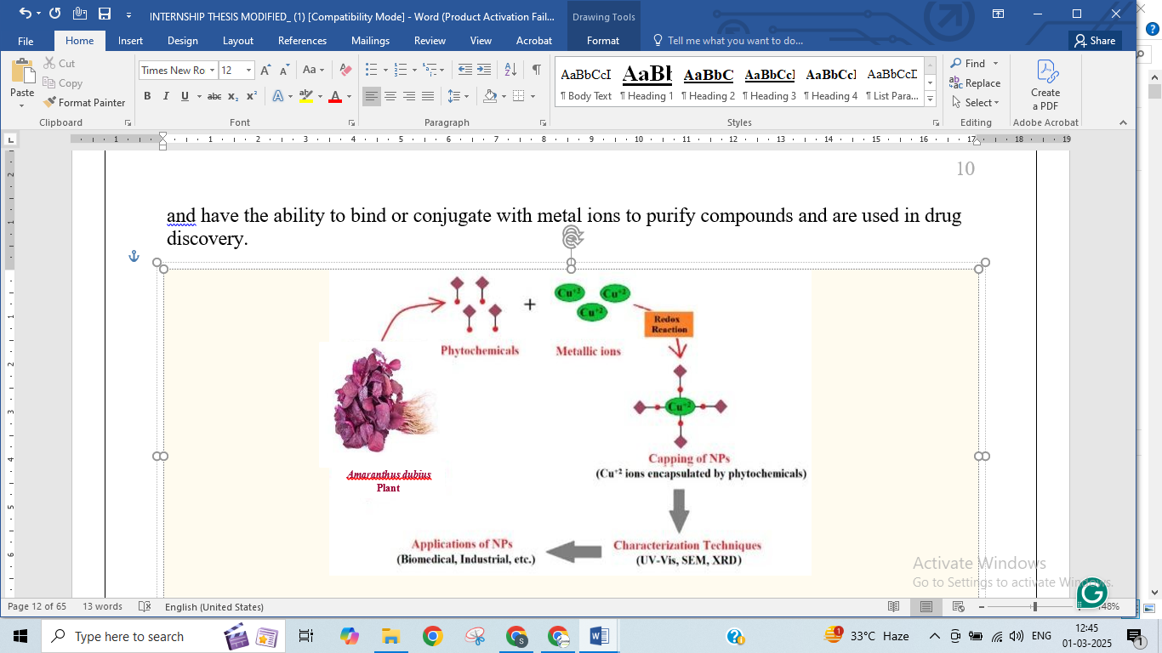

**Figure 1:** Diagrammatic representation of green synthesis mechanism and utilization of copper nanoparticles.

The in vitro synthesis of nanoparticles from plant extracts involves three primary phases: (1) Nucleation, where proton activation reduces metallic ions and leads to the formation of reactive oxygen species (ROS); (2) Ostwald Ripening, or Aggregation, where nanoparticles grow by forming different shapes such as nanoprisms, nanotubes, and nanorods; and (3) Bio-reduction, which stabilizes nanoparticles through interactions with plant biomolecules. Factors such as light, temperature, pH, metal concentration, and enzymatic activity influence nanoparticle morphology and size. Green-synthesized nanoparticles can be characterized using techniques such as X-ray diffraction (XRD), Fourier transform infrared (FT-IR) spectroscopy, UV-visible spectroscopy, scanning electron microscopy (SEM), transmission electron microscopy (TEM), and atomic force microscopy (AFM).

**Materials and Methods**

**Green synthesis of copper nanoparticles**

**Preparation of leaf extract:**

Fifty grams of *Amaranthus dubius* leaves were thoroughly washed with tap water and air-dried. The dried leaves were finely chopped using a sterile knife and transferred to a large beaker containing 500 ml of distilled water. The mixture was heated in a water bath at 80°C for one hour. After cooling, the extract was filtered to obtain phytochemicals. The filtered extract was stored in a clean beaker, sealed with aluminium foil, labelled, and refrigerated.

**Preparation of chemical solutions:**

To prepare a 1-liter solution of 0.1M CuSO₄ · 5H₂O, 24.9685 g of Copper (II) Sulfate Pentahydrate (100% purity) was dissolved in 1000 ml of distilled water. The solution was transferred to a clean, dry conical flask, covered with aluminum foil, and labeled. For the preparation of 100 ml of 5M NaOH solution, 20 g of Sodium Hydroxide pellets was dissolved in 100 ml of distilled water. The prepared solution was stored in a clean, dry conical flask, covered with aluminum foil, and labeled.

**Extraction of copper nanoparticles:**

Leaf extract volumes of 10 ml, 15 ml, 20 ml, 25 ml, and 30 ml were measured into five separate conical flasks. Each flask received 200 ml of 0.1M CuSO₄ · 5H₂O solution and was subjected to magnetic stirring at 80°C for 1.5 hours. At 15-minute intervals, 3 ml of 5M NaOH solution was added until a blackish-brown precipitate was formed.

**Washing step:**

The supernatant was removed by pipetting from all five flasks, and the precipitate was transferred into Falcon tubes containing 20 ml of 70% ethanol. The suspension was centrifuged at 2000 rpm for 10 minutes using a benchtop centrifuge. The washing step was repeated three times to eliminate impurities, replacing the supernatant with fresh 70% ethanol each time.

**Drying step:**

The final pellet was collected in five separate Petri plates and completely dried in a hot air oven to obtain powdered copper nanoparticles. The weight of the nanoparticles from each extract was determined using a physical balance and stored in zip-lock pouches.

**Anti-microbial assay**

Five stock solutions of 10 mg/ml were prepared by dissolving 10 mg of each CuNP powder in 1 ml of crude ethanol. Seven working solutions of different concentrations were prepared from the stock solutions, maintaining a total volume of 1 ml.

**Table 1: Quantity of Solvents Used in Working Solution Preparation**

|  |  |  |
| --- | --- | --- |
| **Working Solution Concentration (mg/ml)** | **Stock Volume Used (μl)** | **Volume of Crude Ethanol (μl)** |
| 0.01 | 1 | 999 |
| 0.05 | 5 | 995 |
| 0.1 | 10 | 990 |
| 0.2 | 20 | 980 |
| 0.4 | 40 | 960 |
| 0.6 | 60 | 940 |
| 0.8 | 80 | 920 |

Twenty millilitres of nutrient broth were prepared and divided into two test tubes, one for *Bacillus subtilis* and one for *Salmonella typhi*. The broth was autoclaved and allowed to cool. Each tube was inoculated with bacterial culture and incubated at 37°C for 24 hours. Cultures were stored in a refrigerator for further use. A total of 500 ml of nutrient agar was prepared in a large conical flask. The flask and 20 Petri plates were autoclaved. The molten agar was poured into sterile Petri plates and left undisturbed until solidified.

Using a sterile cotton swab, *B. subtilis* and *S. typhi* cultures were spread onto 10 nutrient agar plates each and incubated for 10 minutes. Each plate was divided into four quadrants, and uniform wells of 8 mm diameter were created using a gel puncture. Each well was marked with the respective sample concentration and a negative control. For CuNPs synthesized from 10 ml of leaf extract, two plates were used for *B. subtilis* and two for *S. typhi*, with eight wells per bacterium: seven for different CuNP concentrations and one for control. The prepared working solutions were loaded into each well using a micropipette, while crude ethanol was added to control wells. After 24 hours of incubation, antimicrobial activity was assessed by measuring the diameter of the inhibition zones, including controls.

**Determination of optical density:**

A total of 10 μl of CuNP sample was taken from each of the five stock solutions. To each sample, 990 μl of crude ethanol was added, resulting in a 100-fold dilution, and the solution was vortexed. Ethanol was used as a blank in a spectrophotometer, and the instrument was set to zero absorbance at 560 nm. Each sample was analyzed individually, and absorbance at 560 nm was recorded. Three absorbance readings were taken per sample, and the average was calculated.

**Results and Discussion**

The antibacterial efficacy of copper nanoparticles (CuNPs) synthesized using Amaranthus dubius leaf extract was evaluated against Bacillus subtilis and Salmonella typhi through the agar well diffusion method. The results demonstrated a differential inhibition pattern based on the volume of leaf extract used in the nanoparticle synthesis.

For CuNPs synthesized with **10 mL** of A. dubius leaf extract, **no zone of inhibition** was observed against Bacillus subtilis in any of the working solutions. However, a **clear inhibition zone** was evident for Salmonella typhi at stock volumes of **10 μL and above**.

In the case of CuNPs synthesized using **15 mL** of A. dubius leaf extract, Bacillus subtilis exhibited **no inhibition zones** at any stock volume. Conversely, Salmonella typhi showed a **clear inhibition zone** at stock volumes of **5 μL and above**.

For CuNPs prepared with **45 mL** of A. dubius leaf extract, no inhibitory effect was observed against Bacillus subtilis across all working solutions. However, a **clear inhibition zone** was recorded for Salmonella typhi at **5 μL and higher stock volumes**.

CuNPs synthesized with **25 mL** of A. dubius leaf extract displayed a **clear inhibition zone** against Bacillus subtilis at stock volumes of **40 μL and above**, while Salmonella typhi exhibited a **prominent inhibition zone** across all tested working solutions.

For CuNPs derived from **30 mL** of A. dubius leaf extract, Bacillus subtilis demonstrated **clear inhibition zones** at **1 μL and 20 μL onwards**, whereas no inhibition was observed at **5 μL and 10 μL** stock volumes. In contrast, Salmonella typhi exhibited a **prominent inhibition zone** for all tested working solutions.

These findings suggest that the antibacterial activity of CuNPs is influenced by the volume of A. dubius leaf extract used in the synthesis process, with Salmonella typhi displaying higher susceptibility compared to Bacillus subtilis.

1. **B.**

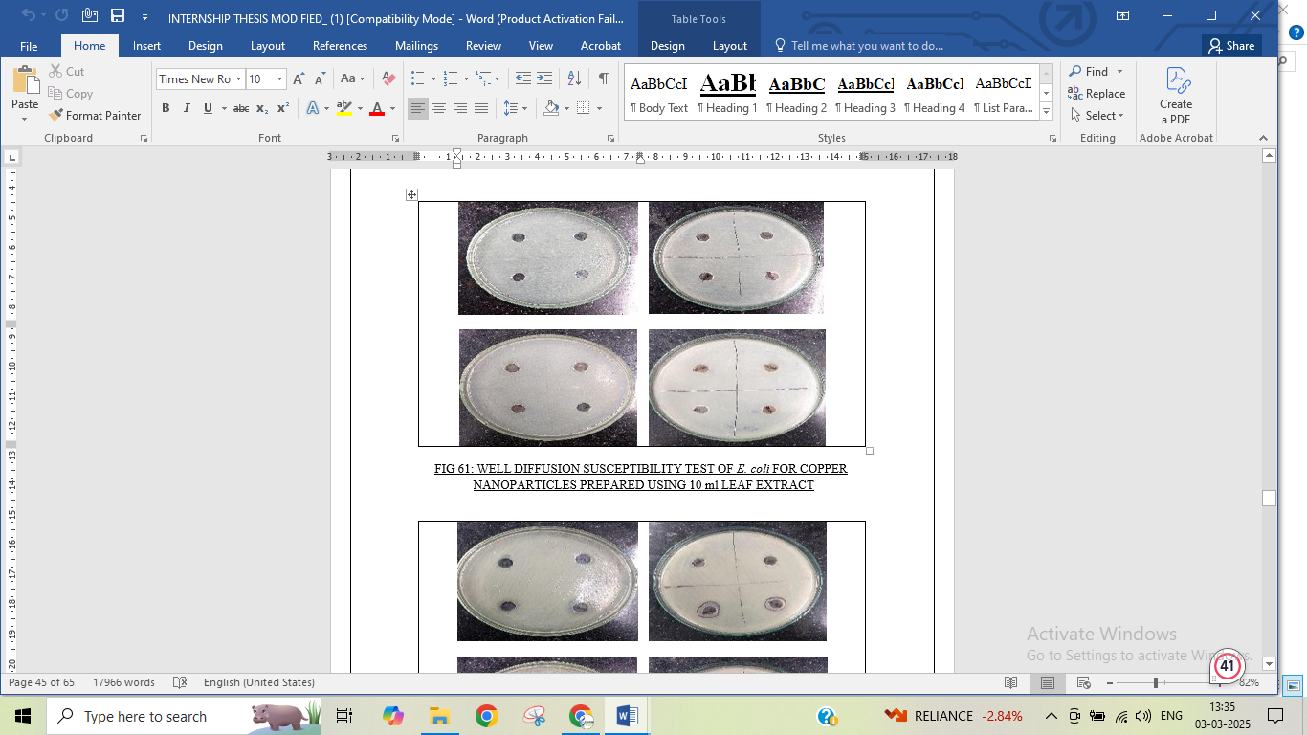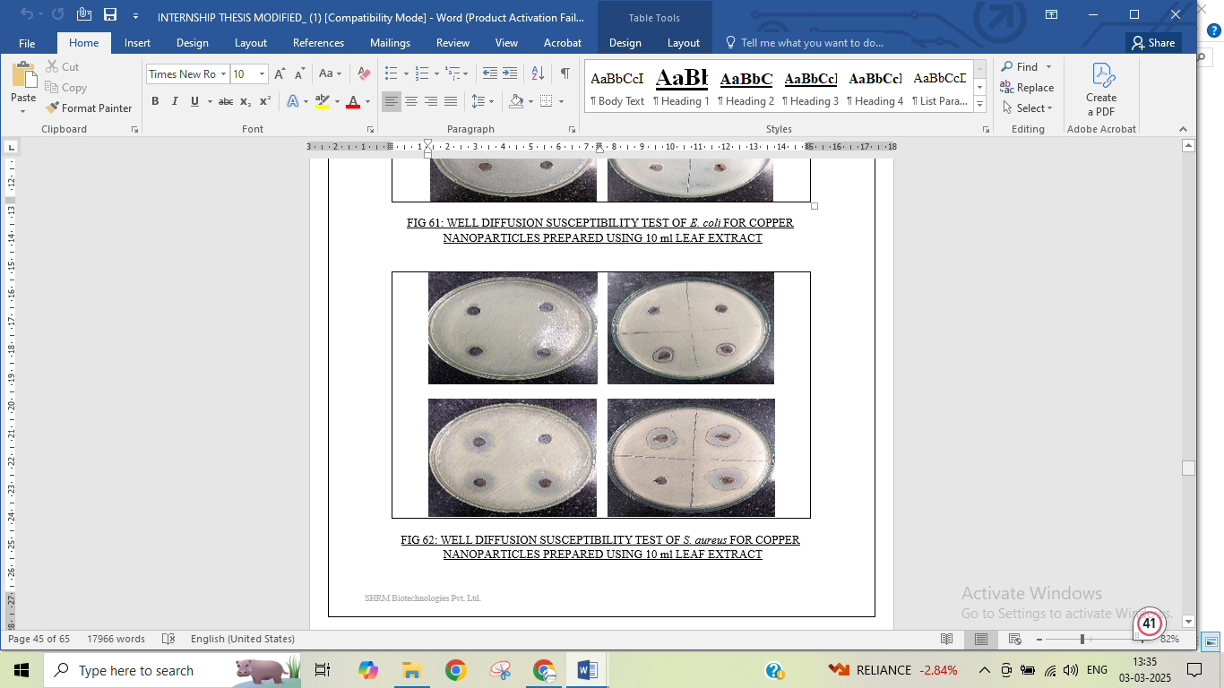

**C. D.**

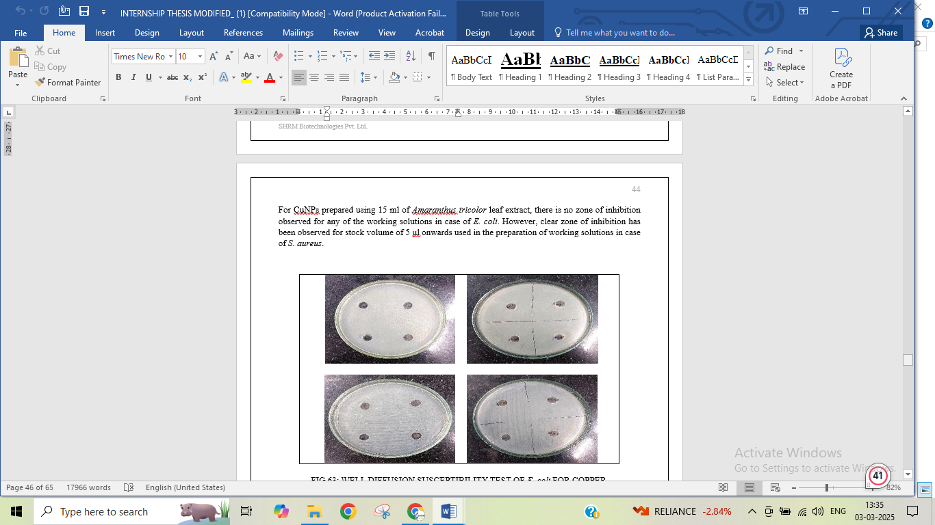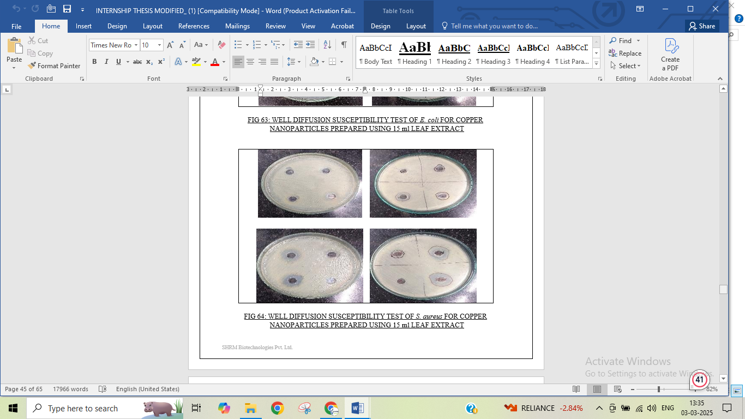

**E. F.**

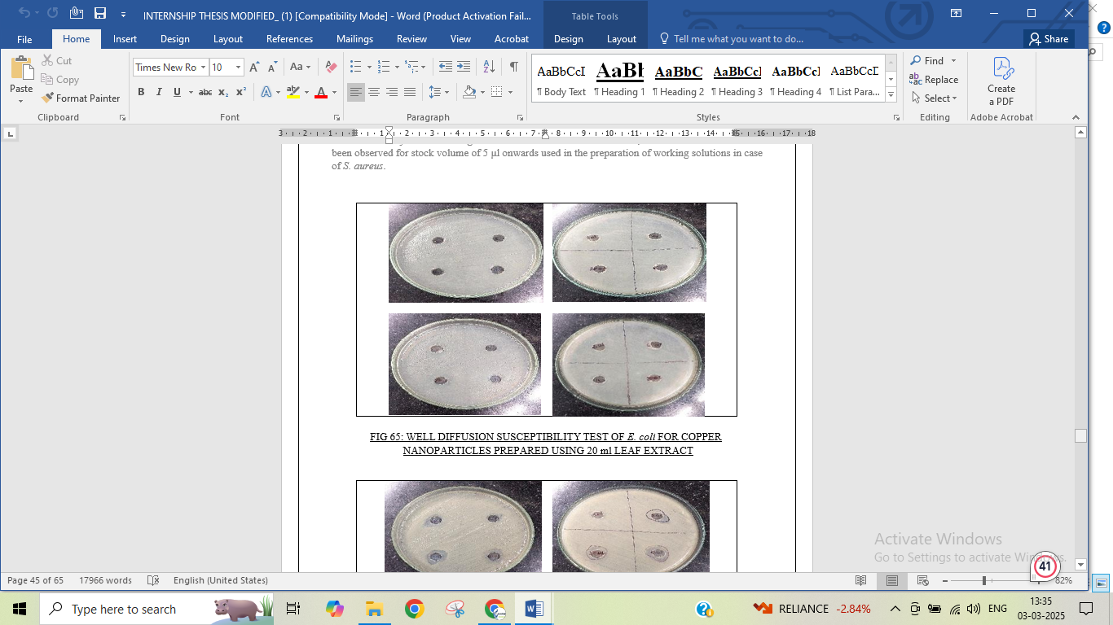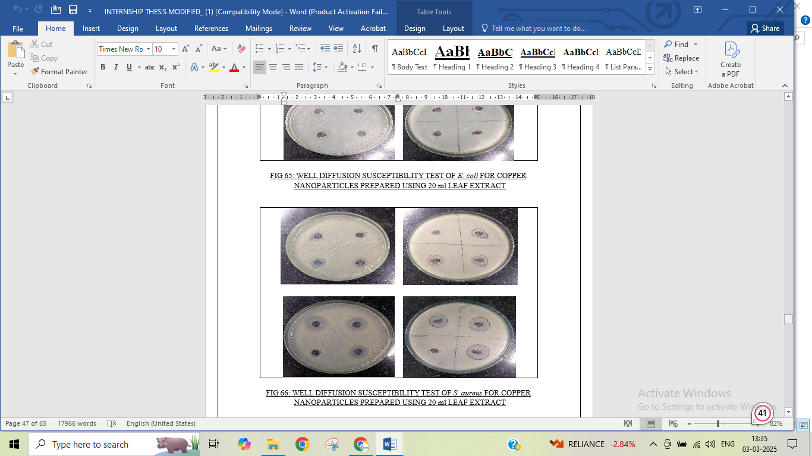

**G. H.**

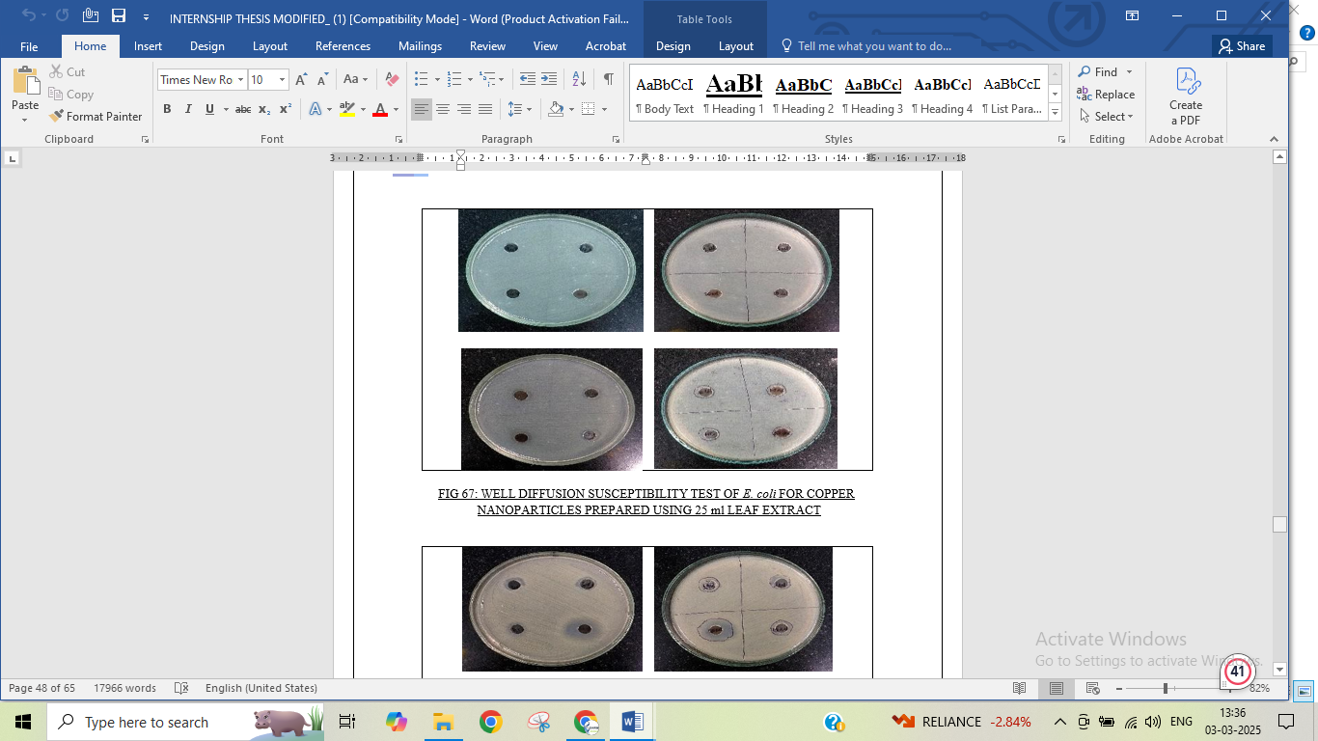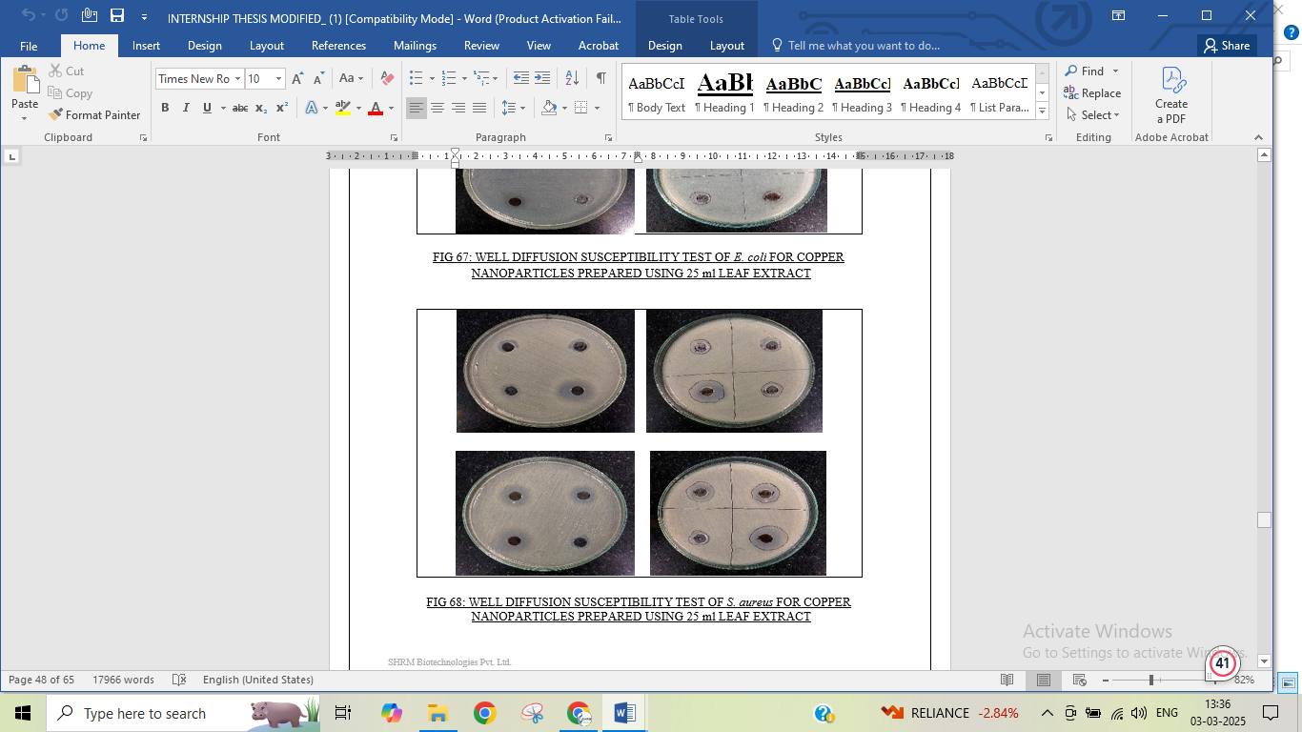

**I. J.**

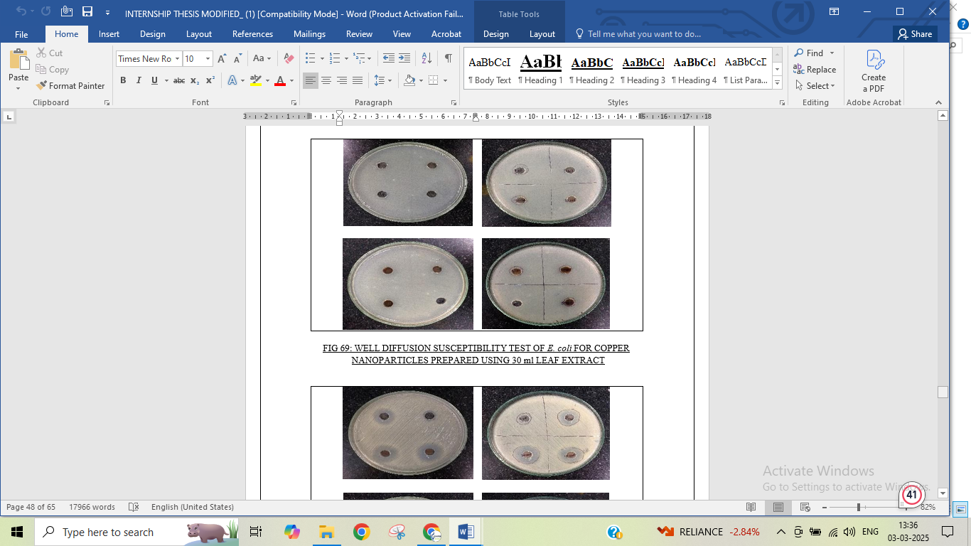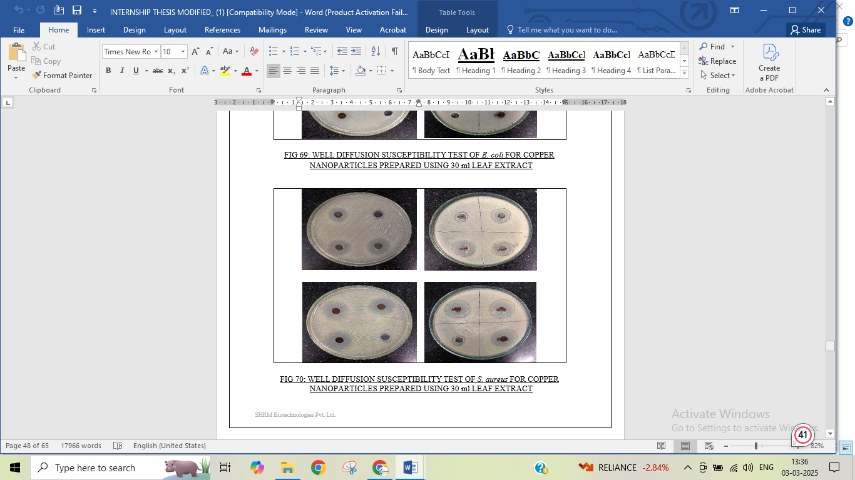

**Figure 2: A.** Well diffusion susceptibility test of Bacillus subtilis for copper nanoparticles prepared using 10 ml leaf extract **B.** Well diffusion susceptibility test of Salmonella typhi for copper nanoparticles prepared using 10 ml leaf extract **C.** Well diffusion susceptibility test of Bacillus subtilis for copper nanoparticles prepared using 15 ml leaf extract **D.** Well diffusion susceptibility test of Salmonella typhi for copper nanoparticles prepared using 15 ml leaf extract **E.** Well diffusion susceptibility test of Bacillus subtilis for copper nanoparticles prepared using 20 ml leaf extract **F.** Well diffusion susceptibility test of Salmonella typhi for copper nanoparticles prepared using 20 ml leaf extract **G.** Well diffusion susceptibility test of Bacillus subtilis for copper nanoparticles prepared using 25 ml leaf extract **H.** Well diffusion susceptibility test of Salmonella typhi for copper nanoparticles prepared using 25 ml leaf extract **I.** Well diffusion susceptibility test of Bacillus subtilis for copper nanoparticles prepared using 30 ml leaf extract **J.** Well diffusion susceptibility test of Salmonella typhi for copper nanoparticles prepared using 30 ml leaf extract

**Conclusion**

This study successfully demonstrated a simple, eco-friendly, and efficient green synthesis approach for copper nanoparticles (CuNPs) using Amaranthus dubius (Laal Shak) leaf extract. The extracellular biogenic synthesis of CuNPs from this plant is a novel aspect, as it has not been previously explored for nanoparticle synthesis. Phytochemicals present in the leaf extract facilitated the reduction of metal ions, leading to the formation of well-defined CuNPs.

The antimicrobial efficacy of the synthesized CuNPs was evaluated at different concentrations against Bacillus subtilis and Salmonella typhi. The results revealed that CuNPs exhibited significant inhibitory effects on S. typhi, while B. subtilis showed resistance at lower concentrations. At concentrations exceeding 0.1 mg/mL, CuNPs effectively inhibited B. subtilis, demonstrating dose-dependent antimicrobial activity. Furthermore, all CuNP samples displayed superior antibacterial performance compared to crude ethanol, which served as the positive control.

This green synthesis approach offers a sustainable, non-toxic, rapid, and cost-effective alternative to conventional nanoparticle synthesis methods, eliminating the need for hazardous chemical reducing agents. Given their strong antimicrobial properties, CuNPs synthesized using A. dubius hold great potential for applications in pharmaceuticals, drug delivery systems, and biomedical research. The findings of this study provide a promising foundation for further exploration of CuNPs in various biomedical and industrial applications, which will be elaborated in future studies.

**References**

* Amjad R., Mubeen B., Ali S.S., Imam S.S., Alshehri S., Ghoneim M.M., Alzarea S.I., Rasool R., Ullah I., Nadeem M.S. Green Synthesis and Characterization of Copper Nanoparticles Using *Fortunella margarita* Leaves. *Polymers*. 2021; 13(24):4364. [https://doi.org/10.3390/polym13244364.](https://doi.org/10.3390/polym13244364) [Open access]
* Iliger K.S., Sofi T.A., Bhat N.A., Ahanger F.A., Sekhar J.C., Elhendi A.Z., Al-Huqail A.A., Khan F. Copper nanoparticles: Green synthesis and managing fruit rot disease of chilli caused by *Colletotrichum capsica*. *Saudi Journal of Biological Sciences*. DOI:[10.1016/j.sjbs.2020.12.003](http://dx.doi.org/10.1016/j.sjbs.2020.12.003). [ResearchGate]
* Bernard O.S., Jackson K.C., Achisa C.M. Optimization, Characterization, and Antibacterial Activity of Copper Nanoparticles Synthesized Using *Senna didymobotrya* Root Extract. *Journal of Nanotechnology*, 2021, 5611434,15 pages, <https://doi.org/10.1155/2021/5611434>. [Open access] [ResearchGate]
* Mali S.C., Dhaka A., Githala C.K., Trivedi R. Green synthesis of copper nanoparticles using *Celastrus paniculatus* Willd. leaf extract and their photocatalytic and antifungal properties. *Biotechnol Rep (Amst)*. 2020 Aug 11; 27:e00518. doi: 10.1016/j.btre.2020.e00518. PMID: 32923378; PMCID: PMC7475076. [[PubMed](https://pubmed.ncbi.nlm.nih.gov/16323269)] [ResearchGate]
* [Ghosh](https://pubs.rsc.org/en/results?searchtext=Author%3AMithun%20Kumar%20Ghosh) M.K., [Sahu](https://pubs.rsc.org/en/results?searchtext=Author%3ASanjay%20Sahu) S., [Gupta](https://pubs.rsc.org/en/results?searchtext=Author%3AIndersh%20Gupta) I., [Ghorai](https://pubs.rsc.org/en/results?searchtext=Author%3ATanmay%20Kumar%20Ghorai) T.K. Green synthesis of copper nanoparticles from an extract of *Jatropha curcas* leaves: characterization, optical properties, CT-DNA binding and photocatalytic activity *RSC Adv.*, 2020,10, 22027-22035. [Open access]
* Alshammari S.O., Mahmoud S.Y., Farrag E.S. Synthesis of Green Copper Nanoparticles Using Medicinal Plant *Krameria* sp. Root Extract and Its Applications. *Molecules* 2023, *28*, 4629. [https://doi.org/10.3390/molecules28124629.](https://doi.org/10.3390/molecules28124629) [ResearchGate]
* Amaliyah S., Pangesti D.P., Masruri M., Sabarudin A., Sumitro S.B. Green synthesis and characterization of copper nanoparticles using *Piper retrofractum Vahl* extract as bioreductor and capping agent. *Heliyon*. 2020 Aug 7; 6(8):e04636. doi: 10.1016/j.heliyon.2020.e04636. PMID: 32793839; PMCID: PMC7415843. [[PubMed](https://pubmed.ncbi.nlm.nih.gov/16323269)]
* Alvarez M.P., Pliego G.C., Camacho O.P., Padilla V.E.C., Alvarado C.J.C., Salazar E.S. Green Synthesis of Copper Nanoparticles Using Cotton. *Polymers*. 2021; 13(12):1906. [https://doi.org/10.3390/polym13121906.](https://doi.org/10.3390/polym13121906) [Open access]
* Kausar H., Mehmood A., Khan R.T., Ahmad K.S., Hussain S., Nawaz F., Iqbal M.S.,

Nasir M., Ullah T.S. Green synthesis and characterization of copper nanoparticles for investigating their effect on germination and growth of wheat. *PLoS One*. 2022 Jun 21;17(6):e0269987. doi: 10.1371/journal.pone.0269987. PMID: 35727761; PMCID: PMC9212164. [[PubMed](https://pubmed.ncbi.nlm.nih.gov/16323269)]

* Nguyen P.A., Nguyen A.V.P., Dang-Bao T. Green synthesis of copper nanoparticles using Cocoa pod extract and its catalytic activity in deep oxidation of aromatic hydrocarbons. *SN Applied Sciences*. 2020;2(11). doi:10.1007/s42452-020-03539-8. [ResearchGate]
* [Fernando](https://www.researchgate.net/scientific-contributions/Jessica-Fernando-2154062657?_tp=eyJjb250ZXh0Ijp7ImZpcnN0UGFnZSI6InB1YmxpY2F0aW9uIiwicGFnZSI6InB1YmxpY2F0aW9uIn19) J., [Gurulakshmi](https://www.researchgate.net/scientific-contributions/P-Gurulakshmi-2154056936) P. Green Synthesis and Characterization of Copper Nanoparticles and Their Applications. *Journal of Nanoscience and Technology*, Volume 2, Issue 5,2016 Pages 234-236. DOI:[10.13140/RG.2.2.18292.19842.](http://dx.doi.org/10.13140/RG.2.2.18292.19842) [ResearchGate]
* Muhammad A., Umar A., Birnin-Yauri A.U., Sanni H.A., Elinge C.M., Ige A.R., Ambursa

M.M. Green synthesis of copper nanoparticles using *Musa acuminata* aqueous extract and their antibacterial activity, 2023. *Asian Journal of Tropical Biotechnology*. DOI: [10.13057/biotek/c200102](http://dx.doi.org/10.13057/biotek/c200102). [ResearchGate]

* [Sreeja](https://www.researchgate.net/scientific-contributions/C-Sreeja-2181467202) C., [Philip](https://www.researchgate.net/scientific-contributions/K-Annieta-Philip-2181428238?_tp=eyJjb250ZXh0Ijp7ImZpcnN0UGFnZSI6InB1YmxpY2F0aW9uIiwicGFnZSI6InB1YmxpY2F0aW9uIn19) K.A., [Shamil](https://www.researchgate.net/scientific-contributions/K-Shamil-2181419743?_tp=eyJjb250ZXh0Ijp7ImZpcnN0UGFnZSI6InB1YmxpY2F0aW9uIiwicGFnZSI6InB1YmxpY2F0aW9uIn19) K., [Asraj](https://www.researchgate.net/scientific-contributions/O-P-Asraj-2181423607) O.P.[, Sreeja](https://www.researchgate.net/scientific-contributions/S-Sreeja-2285080970) S. Biomediated Green Synthesis of Copper Nanoparticles using *Piper nigrum* Leaf Extract. *Journal of Nanoscience and Technology*, Volume 6, Issue 3, 2020, Pages 908-910. DOI:[10.30799/jnst.305.20060303](http://dx.doi.org/10.30799/jnst.305.20060303). [ResearchGate]
* Yao L.H., Jiang Y.M., Shi J., Tomas-Barberan F.A., Datta N., Singanusong R., Chen S.S. Flavonoids in food and their health benefits. *Plant Food Hum. Nutr.* 2004; 59:113–122. doi: 10.1007/s11130-004-0049-7. [[PubMed](https://pubmed.ncbi.nlm.nih.gov/15678717)] [[CrossRef](https://doi.org/10.1007%2Fs11130-004-0049-7)] [[Google Scholar](https://scholar.google.com/scholar_lookup?journal=Plant%2BFood%2BHum.%2BNutr.&title=Flavonoids%2Bin%2Bfood%2Band%2Btheir%2Bhealth%2Bbenefits&author=L.H.%2BYao&author=Y.M.%2BJiang&author=J.%2BShi&author=F.A.%2BTomas-Barberan&author=N.%2BDatta&volume=59&publication_year=2004&pages=113-122&pmid=15678717&doi=10.1007/s11130-004-0049-7)]
* Cushnie T.T., Lamb A.J. Antimicrobial activity of flavonoids. *Int. J. Antimicrob. Agents.* 2005; 26:343–356. doi: 10.1016/j.ijantimicag.2005.09.002. [[PMC free](https://www.ncbi.nlm.nih.gov/pmc/articles/PMC7127073/) [article](https://www.ncbi.nlm.nih.gov/pmc/articles/PMC7127073/)] [[PubMed](https://pubmed.ncbi.nlm.nih.gov/16323269)] [[CrossRef](https://doi.org/10.1016%2Fj.ijantimicag.2005.09.002)] [[Google Scholar](https://scholar.google.com/scholar_lookup?journal=Int.%2BJ.%2BAntimicrob.%2BAgents.&title=Antimicrobial%2Bactivity%2Bof%2Bflavonoids&author=T.T.%2BCushnie&author=A.J.%2BLamb&volume=26&publication_year=2005&pages=343-356&pmid=16323269&doi=10.1016/j.ijantimicag.2005.09.002)]
* Robards K., Antolovich M. Methods for assessing the authenticity of orange juice. A Review. *Analyst.* 1995; 120:1–28. doi: 10.1039/an9952000001. [[CrossRef](https://doi.org/10.1039%2Fan9952000001)] [[Google Scholar](https://scholar.google.com/scholar_lookup?journal=Analyst&title=Methods%2Bfor%2Bassessing%2Bthe%2Bauthenticity%2Bof%2Borange%2Bjuice.%2BA%2BReview&author=K.%2BRobards&author=M.%2BAntolovich&volume=120&publication_year=1995&pages=1-28&doi=10.1039/an9952000001)]
* Seth M.K. Trees and their economic importance. *Bot. Rev.* 2003; 69:321–376. doi: 10.1663/0006-8101(2004)069[0321:TATEI]2.0.CO;2. [[CrossRef](https://doi.org/10.1663%2F0006-8101(2004)069%5B0321%3ATATEI%5D2.0.CO%3B2)] [[Google Scholar](https://scholar.google.com/scholar_lookup?journal=Bot.%2BRev.&title=Trees%2Band%2Btheir%2Beconomic%2Bimportance&author=M.K.%2BSeth&volume=69&publication_year=2003&pages=321-376&doi=10.1663/0006-8101(2004)069%5b0321%3ATATEI%5d2.0.CO%3B2)]
* Martin C.R. Welcome to nanomedicine. *Nanomedicine.* 2006; 1:5. doi:10.2217/17435889.1.1.5. [[CrossRef](https://doi.org/10.2217%2F17435889.1.1.5)] [[Google Scholar](https://scholar.google.com/scholar_lookup?journal=Nanomedicine&title=Welcome%2Bto%2Bnanomedicine&author=C.R.%2BMartin&volume=1&publication_year=2006&pages=5&doi=10.2217/17435889.1.1.5)]
* Nalwa H.S. Academic Press; Cambridge, MA, USA: 2002. Handbook of Thin Film Materials. [[Google Scholar](https://scholar.google.com/scholar?q=Nalwa%2BH.S.%2BHandbook%2Bof%2BThin%2BFilm%2BMaterials%2BAcademic%2BPress%2BCambridge%2C%2BMA%2C%2BUSA%2B2002%2B)]
* Sharma V.K., Yngard R.A., Lin Y. Silver nanoparticles: Green synthesis and their antimicrobial activities. *Adv. Colloid Interface Sci.* 2009; 145:83–96. doi: 10.1016/j.cis.2008.09.002. [[PubMed](https://pubmed.ncbi.nlm.nih.gov/18945421)] [[CrossRef](https://doi.org/10.1016%2Fj.cis.2008.09.002)] [[Google Scholar](https://scholar.google.com/scholar_lookup?journal=Adv.%2BColloid%2BInterface%2BSci.&title=Silver%2Bnanoparticles%3A%2BGreen%2Bsynthesis%2Band%2Btheir%2Bantimicrobial%2Bactivities&author=V.K.%2BSharma&author=R.A.%2BYngard&author=Y.%2BLin&volume=145&publication_year=2009&pages=83-96&pmid=18945421&doi=10.1016/j.cis.2008.09.002)]
* Jahn W. Chemical aspects of the use of gold clusters in structural biology. *J. Struct. Biol.* 1999; 127:106–112. doi: 10.1006/jsbi.1999.4123. [[PubMed](https://pubmed.ncbi.nlm.nih.gov/10527899)] [[CrossRef](https://doi.org/10.1006%2Fjsbi.1999.4123)] [[Google Scholar](https://scholar.google.com/scholar_lookup?journal=J.%2BStruct.%2BBiol.&title=Chemical%2Baspects%2Bof%2Bthe%2Buse%2Bof%2Bgold%2Bclusters%2Bin%2Bstructural%2Bbiology&author=W.%2BJahn&volume=127&publication_year=1999&pages=106-112&pmid=10527899&doi=10.1006/jsbi.1999.4123)]
* Murphy C. Sustainability as an emerging design criterion in nanoparticle synthesis and applications. *J. Mater. Chem.* 2008; 18:2173–2176. doi: 10.1039/b717456j. [[CrossRef](https://doi.org/10.1039%2Fb717456j)] [[Google Scholar](https://scholar.google.com/scholar_lookup?journal=J.%2BMater.%2BChem.&title=Sustainability%2Bas%2Ban%2Bemerging%2Bdesign%2Bcriterion%2Bin%2Bnanoparticle%2Bsynthesis%2Band%2Bapplications&author=C.%2BMurphy&volume=18&publication_year=2008&pages=2173-2176&doi=10.1039/b717456j)]
* Iravani S. Green synthesis of metal nanoparticles using plants. *Green Chem.* 2011; 13:2638– 2650. doi: 10.1039/c1gc15386b. [[CrossRef](https://doi.org/10.1039%2Fc1gc15386b)] [[Google Scholar](https://scholar.google.com/scholar_lookup?journal=Green%2BChem.&title=Green%2Bsynthesis%2Bof%2Bmetal%2Bnanoparticles%2Busing%2Bplants&author=S.%2BIravani&volume=13&publication_year=2011&pages=2638-2650&doi=10.1039/c1gc15386b)]
* Senapati S. *Ph.D. Thesis.* University of Pune; Pune, India: 2005. Biosynthesis and Immobilization of Nanoparticles and Their Applications. [[Google Scholar](https://scholar.google.com/scholar_lookup?title=Ph.D.%2BThesis&author=S.%2BSenapati&publication_year=2005)]
* Klefenz H. Nanobiotechnology: From molecules to systems. *Eng. Life Sci.* 2004; 4:211–218. doi: 10.1002/elsc.200402090. [[CrossRef](https://doi.org/10.1002%2Felsc.200402090)] [[Google Scholar](https://scholar.google.com/scholar_lookup?journal=Eng.%2BLife%2BSci.&title=Nanobiotechnology%3A%2BFrom%2Bmolecules%2Bto%2Bsystems&author=H.%2BKlefenz&volume=4&publication_year=2004&pages=211-218&doi=10.1002/elsc.200402090)]
* Goodsell D.S. John Wiley & Sons; Hoboken, NJ, USA: 2004. Bionanotechnology: Lessons from Nature. [[Google Scholar](https://scholar.google.com/scholar?q=Goodsell%2BD.S.%2BBionanotechnology%3A%2BLessons%2Bfrom%2BNature%2BJohn%2BWiley%2B&%2BSons%2BHoboken%2C%2BNJ%2C%2BUSA%2B2004%2B)]
* Tian Z.Q., Ren B. Adsorption and reaction at electrochemical interfaces as probed by surface- enhanced Raman spectroscopy. *Annu. Rev. Phys. Chem.* 2004; 55:197–229. doi: 10.1146/annurev.physchem.54.011002.103833. [[PubMed](https://pubmed.ncbi.nlm.nih.gov/15117252)] [[CrossRef](https://doi.org/10.1146%2Fannurev.physchem.54.011002.103833)] [[Google Scholar](https://scholar.google.com/scholar_lookup?journal=Annu.%2BRev.%2BPhys.%2BChem.&title=Adsorption%2Band%2Breaction%2Bat%2Belectrochemical%2Binterfaces%2Bas%2Bprobed%2Bby%2Bsurface-enhanced%2BRaman%2Bspectroscopy&author=Z.Q.%2BTian&author=B.%2BRen&volume=55&publication_year=2004&pages=197-229&pmid=15117252&doi=10.1146/annurev.physchem.54.011002.103833)]
* Song J.Y., Kim B.S. Rapid biological synthesis of silver nanoparticles using plant leaf extracts. *Bioprocess. Biosyst. Eng.* 2009; 32:79–84. doi: 10.1007/s00449-008-0224-6. [[PubMed](https://pubmed.ncbi.nlm.nih.gov/18438688)] [[CrossRef](https://doi.org/10.1007%2Fs00449-008-0224-6)] [[Google Scholar](https://scholar.google.com/scholar_lookup?journal=Bioprocess.%2BBiosyst.%2BEng.&title=Rapid%2Bbiological%2Bsynthesis%2Bof%2Bsilver%2Bnanoparticles%2Busing%2Bplant%2Bleaf%2Bextracts&author=J.Y.%2BSong&author=B.S.%2BKim&volume=32&publication_year=2009&pages=79-84&pmid=18438688&doi=10.1007/s00449-008-0224-6)]
* Shankar S.S., Rai A., Ankamwar B., Singh A., Ahmad A., Sastry M. Biological synthesis of triangular gold nanoprisms. *Nat. Mater.* 2004; 3:482–488. doi: 10.1038/nmat1152. [[PubMed](https://pubmed.ncbi.nlm.nih.gov/15208703)] [[CrossRef](https://doi.org/10.1038%2Fnmat1152)] [[Google Scholar](https://scholar.google.com/scholar_lookup?journal=Nat.%2BMater.&title=Biological%2Bsynthesis%2Bof%2Btriangular%2Bgold%2Bnanoprisms&author=S.S.%2BShankar&author=A.%2BRai&author=B.%2BAnkamwar&author=A.%2BSingh&author=A.%2BAhmad&volume=3&publication_year=2004&pages=482-488&pmid=15208703&doi=10.1038/nmat1152)]
* Ankamwar B., Damle C., Ahmad A., Sastry M. Biosynthesis of gold and silver nanoparticles using *Emblica officinalis* fruit extract, their phase transfer and transmetallation in an organic solution. *J. Nanosci. Nanotechnol.* 2005; 5:1665–1671. doi: 10.1166/jnn.2005.184. [[PubMed](https://pubmed.ncbi.nlm.nih.gov/16245525)] [[CrossRef](https://doi.org/10.1166%2Fjnn.2005.184)] [[Google Scholar](https://scholar.google.com/scholar_lookup?journal=J.%2BNanosci.%2BNanotechnol.&title=Biosynthesis%2Bof%2Bgold%2Band%2Bsilver%2Bnanoparticles%2Busing%2BEmblica%2Bofficinalis%2Bfruit%2Bextract%2C%2Btheir%2Bphase%2Btransfer%2Band%2Btransmetallation%2Bin%2Ban%2Borganic%2Bsolution&author=B.%2BAnkamwar&author=C.%2BDamle&author=A.%2BAhmad&author=M.%2BSastry&volume=5&publication_year=2005&pages=1665-1671&pmid=16245525&doi=10.1166/jnn.2005.184)]
* Huang J., Li Q., Sun D., Lu Y., Su Y., Yang X., Wang H., Wang Y., Shao W., Ning H., et al. Biosynthesis of silver and gold nanoparticles by novel sundried *Cinnamomum camphora* leaf. *Nanotechnology.* 2007;18:105104.doi: 10.1088/09574484/18/10/105104. [[CrossRef](https://doi.org/10.1088%2F0957-4484%2F18%2F10%2F105104)] [[Google Scholar](https://scholar.google.com/scholar_lookup?journal=Nanotechnology&title=Biosynthesis%2Bof%2Bsilver%2Band%2Bgold%2Bnanoparticles%2Bby%2Bnovel%2Bsundried%2BCinnamomum%2Bcamphora%2Bleaf&author=J.%2BHuang&author=Q.%2BLi&author=D.%2BSun&author=Y.%2BLu&author=Y.%2BSu&volume=18&publication_year=2007&pages=105104&doi=10.1088/0957-4484/18/10/105104)]
* Korbekandi H., Iravani S., Abbasi S. Production of nanoparticles using organisms. *Crit. Rev. Biotechnol.* 2009;29:279–306.doi: 10.3109/07388550903062462. [[PubMed](https://pubmed.ncbi.nlm.nih.gov/19929319)][[CrossRef](https://doi.org/10.3109%2F07388550903062462)] [[Google Scholar](https://scholar.google.com/scholar_lookup?journal=Crit.%2BRev.%2BBiotechnol.&title=Production%2Bof%2Bnanoparticles%2Busing%2Borganisms&author=H.%2BKorbekandi&author=S.%2BIravani&author=S.%2BAbbasi&volume=29&publication_year=2009&pages=279-306&pmid=19929319&doi=10.3109/07388550903062462)]
* Karimi J., Mohsenzadeh S. Copper Nanoparticles Using Flower Extract of *Aloe Vera*. *Synth. React. Inorg. Met. Org. Nano Met. Chem.* 2015; 45:895–898. doi: 10.1080/15533174.2013.862644. [[CrossRef](https://doi.org/10.1080%2F15533174.2013.862644)] [[Google Scholar](https://scholar.google.com/scholar_lookup?journal=Synth.%2BReact.%2BInorg.%2BMet.%2BOrg.%2BNano%2BMet.%2BChem.&title=Copper%2BNanoparticles%2BUsing%2BFlower%2BExtract%2Bof%2BAloe%2BVera&author=J.%2BKarimi&author=S.%2BMohsenzadeh&volume=45&publication_year=2015&pages=895-898&doi=10.1080/15533174.2013.862644)]
* Thakur S., Sharma S., Thakur S., Rai R. Green synthesis of copper nano-particles using *Asparagus adscendens roxb*. Root and leaf extract and their antimicrobial activities. *Int.*

*J. Curr. Microbiol. Appl. Sci.* 2018; 7:683–694. doi: 10.20546/ijcmas.2018.704.077. [[CrossRef](https://doi.org/10.20546%2Fijcmas.2018.704.077)] [[Google Scholar](https://scholar.google.com/scholar_lookup?journal=Int.%2BJ.%2BCurr.%2BMicrobiol.%2BAppl.%2BSci.&title=Green%2Bsynthesis%2Bof%2Bcopper%2Bnano-particles%2Busing%2BAsparagus%2Badscendens%2Broxb.%2BRoot%2Band%2Bleaf%2Bextract%2Band%2Btheir%2Bantimicrobial%2Bactivities&author=S.%2BThakur&author=S.%2BSharma&author=S.%2BThakur&author=R.%2BRai&volume=7&publication_year=2018&pages=683-694&doi=10.20546/ijcmas.2018.704.077)]

* Joseph A.T., Prakash P., Narvi S.S. Phytofabrication And Characterization of Copper Nanoparticles Using *Allium sativum* And Its Antibacterial Activity. *Int. J. Sci. Eng. Techn.* 2016; 4:463–472. [[Google Scholar](https://scholar.google.com/scholar_lookup?journal=Int.%2BJ.%2BSci.%2BEng.%2BTechn.&title=Phytofabrication%2BAnd%2BCharacterization%2Bof%2BCopper%2BNanoparticles%2BUsing%2BAllium%2Bsativum%2BAnd%2BIts%2BAntibacterial%2BActivity&author=A.T.%2BJoseph&author=P.%2BPrakash&author=S.S.%2BNarvi&volume=4&publication_year=2016&pages=463-472)]
* Daniel S.K., Vinothini G., Subramanian N., Nehru K., Sivakumar M. Biosynthesis of Cu, ZVI, and Ag nanoparticles using *Dodonaea viscosa* extract for antibacterial activity against human pathogens. *J. Nanopart. Res.* 2013; 15:1319. doi: 10.1007/s11051-012-1319-1.

[[CrossRef](https://doi.org/10.1007%2Fs11051-012-1319-1)] [[Google Scholar](https://scholar.google.com/scholar_lookup?journal=J.%2BNanopart.%2BRes.&title=Biosynthesis%2Bof%2BCu%2C%2BZVI%2C%2Band%2BAg%2Bnanoparticles%2Busing%2BDodonaea%2Bviscosa%2Bextract%2Bfor%2Bantibacterial%2Bactivity%2Bagainst%2Bhuman%2Bpathogens&author=S.K.%2BDaniel&author=G.%2BVinothini&author=N.%2BSubramanian&author=K.%2BNehru&author=M.%2BSivakumar&volume=15&publication_year=2013&pages=1319.&doi=10.1007/s11051-012-1319-1)]

* Shende S., Ingle A.P., Gade A., Rai M. Green synthesis of copper nanoparticles by *Citrus medica* Linn. (Idilimbu) juice and its antimicrobial activity. *World, J. Microbiol. Biotechnol.* 2015; 31:865–873. doi: 10.1007/s11274-015-1840-3.

[[PubMed](https://pubmed.ncbi.nlm.nih.gov/25761857)] [[CrossRef](https://doi.org/10.1007%2Fs11274-015-1840-3)] [[Google Scholar](https://scholar.google.com/scholar_lookup?journal=World%2C%2BJ.%2BMicrobiol.%2BBiotechnol.&title=Green%2Bsynthesis%2Bof%2Bcopper%2Bnanoparticles%2Bby%2BCitrus%2Bmedica%2BLinn.%2B(Idilimbu)%2Bjuice%2Band%2Bits%2Bantimicrobial%2Bactivity&author=S.%2BShende&author=A.P.%2BIngle&author=A.%2BGade&author=M.%2BRai&volume=31&publication_year=2015&pages=865-873&pmid=25761857&doi=10.1007/s11274-015-1840-3)]

* Nazar N., Bibi I., Kamal S., Iqbal M., Nouren S., Jilani K., Umair M., Ata S. Cu nanoparticles synthesis using biological molecule of *P. granatum* seeds extract as reducing and capping agent: Growth mechanism and photo-catalytic activity. *Int. J. Biol. Macromol.* 2018; 106:1203–1210. doi: 10.1016/j.ijbiomac.2017.08.126. [[PubMed](https://pubmed.ncbi.nlm.nih.gov/28851642)][[CrossRef](https://doi.org/10.1016%2Fj.ijbiomac.2017.08.126)][[Google Scholar](https://scholar.google.com/scholar_lookup?journal=Int.%2BJ.%2BBiol.%2BMacromol.&title=Cu%2Bnanoparticles%2Bsynthesis%2Busing%2Bbiological%2Bmolecule%2Bof%2BP.%2Bgranatum%2Bseeds%2Bextract%2Bas%2Breducing%2Band%2Bcapping%2Bagent%3A%2BGrowth%2Bmechanism%2Band%2Bphoto-catalytic%2Bactivity&author=N.%2BNazar&author=I.%2BBibi&author=S.%2BKamal&author=M.%2BIqbal&author=S.%2BNouren&volume=106&publication_year=2018&pages=1203-1210&pmid=28851642&doi=10.1016/j.ijbiomac.2017.08.126)]
* Chung I.M., Abdul Rahuman A., Marimuthu S., Vishnu Kirthi A., Anbarasan K., Padmini P., Rajakumar G. Green synthesis of copper nanoparticles using *Eclipta prostrata* leaves extract and their antioxidant and cytotoxic activities. *Exp. Ther. Med.* 2017; 14:18–24. doi: 10.3892/etm.2017.4466. [[PMC free article](https://www.ncbi.nlm.nih.gov/pmc/articles/PMC5488509/)] [[PubMed](https://pubmed.ncbi.nlm.nih.gov/28672888)] [[CrossRef](https://doi.org/10.3892%2Fetm.2017.4466)] [[Google Scholar](https://scholar.google.com/scholar_lookup?journal=Exp.%2BTher.%2BMed.&title=Green%2Bsynthesis%2Bof%2Bcopper%2Bnanoparticles%2Busing%2BEclipta%2Bprostrata%2Bleaves%2Bextract%2Band%2Btheir%2Bantioxidant%2Band%2Bcytotoxic%2Bactivities&author=I.M.%2BChung&author=A.%2BAbdul%2BRahuman&author=S.%2BMarimuthu&author=A.%2BVishnu%2BKirthi&author=K.%2BAnbarasan&volume=14&publication_year=2017&pages=18-24&pmid=28672888&doi=10.3892/etm.2017.4466)]
* Manceau A., Nagy K.L., Marcus M.A., Lanson M., Geoffroy N., Jacquet T., Kirpichtchikova

T. Formation of metallic copper nanoparticles at the soil− root interface. *Environ. Sci. Technol.* 2008; 42:1766–1772. doi: 10.1021/es072017o. [[PubMed](https://pubmed.ncbi.nlm.nih.gov/18441833)] [[CrossRef](https://doi.org/10.1021%2Fes072017o)] [Google Scholar]

* Ghosh S., More P., Nitnavare R., Jagtap S., Chippalkatti R., Derle A., Kitture R., Asok A., Kale S., Singh S., et al. Antidiabetic and antioxidant properties of copper nanoparticles synthesized by medicinal plant *Dioscorea bulbifera*. *J. Nanomed. Nanotechnol.* 2015; S6:1. doi: 10.4172/2157-7439.S6-007. [[CrossRef](https://doi.org/10.4172%2F2157-7439.S6-007)] [[Google Scholar](https://scholar.google.com/scholar_lookup?journal=J.%2BNanomed.%2BNanotechnol.&title=Antidiabetic%2Band%2Bantioxidant%2Bproperties%2Bof%2Bcopper%2Bnanoparticles%2Bsynthesized%2Bby%2Bmedicinal%2Bplant%2BDioscorea%2Bbulbifera&author=S.%2BGhosh&author=P.%2BMore&author=R.%2BNitnavare&author=S.%2BJagtap&author=R.%2BChippalkatti&volume=S6&publication_year=2015&pages=1&doi=10.4172/2157-7439.S6-007)]