IMAGE-BASED STRESS DETECTION

# Pamidi Nithish Kumar, *Department of Computer Science & Engineering Parul University,* Vadodara.

# Pillalamarri Praveen Kumar, *Department of Computer Science & Engineering Parul University,* Vadodara.

# Kosetti Avinash, *Department of Computer Science & Engineering Parul University,* Vadodara.

# Vejandla Bhanu Teja, *Department of Computer Science & Engineering Parul University,* Vadodara.

**ABSTRACT:**

**Stress is a prevalent and detrimental aspect of modern life, impacting mental and physical well-being. The ability to detect and manage stress is of paramount importance. This study proposes a novel approach for stress detection through image analysis using Convolutional Neural Networks(CNN), particularly the efficient Mobile Net architecture. The core idea is to leverage facial expressions as indicators of stress levels, as they often exhibit distinctive patterns during stressful situations. An extensive dataset of facial images encompassing various stress levels is collected and preprocessed. Mobile Net, known for its efficiency and effectiveness in image classification tasks, is employed as the backbone architecture for feature extraction. The CNN model is fine-tuned using transfer learning techniques to adapt to the stress detection task. During training, the network learns to recognize subtle facial cues associated with stress, allowing it to classify input images into different stress levels. This innovative application of deep learning and Mobile Net architecture has the potential to provide valuable insights into stress management and mental health monitoring, ultimately improving the well-being of individuals in our fast-paced, stress-prone society.**

***Keywords - CNN, Mobile Net, Deep Learning, stress detection, transfer learning.***

# **INTRODUCTION :**

TIn today’s fast-paced world, stress has become a prevalent concern affecting mental and physical well-being. The ability to detect and manage stress is crucial for maintaining a healthy lifestyle.Image-Based Stress Detection Using Convolutional Neural Networks (CNN) Mobile Net is a cuttingedge project that leverages the power of deep learning to address this critical issue .This innovative project combines computer vision and deep learning techniques, specifically utilizing the Mobile Net architecture, to create a non-invasive and efficient stress detection system. By analysing facial expressions and physiological cues captured through images or video, the CNN Mobile Net model can accurately identify stress levels in individuals. This approach offers numerous advantages, including real-time monitoring and scalability.

The project’s potential applications are vast, spanning from healthcare and mental wellness programs to workplace productivity improvement and stress management tools. With the growing importance of mental health in today’s society, Image-Based Stress Detection Using CNN Mobile Net represents a significant step towards enhancing our ability to recognize and respond to stress, ultimately contributing to improved quality of life for individuals across the globe. This research project is poised to make a positive impact by providing a proactive solution to a pressing modern-day challenge.

Specifically with a CNN Mobile Net architecture, offers a novel approach to addressing mental health challenges. The motivation lies in the pressing need to identify and mitigate stress, a prevalent but often overlooked issue. By leveraging deep learning and mobile-based image analysis, this innovative solution aims to provide accessible and non-invasive stress detection. It can revolutionize mental health monitoring, enabling early intervention, personalized support, and ultimately improving overall well-being, particularly in today’s fast-paced and stress-prone digital world.

The core idea is to leverage facial expressions as indicators of stress levels, as they often exhibit distinctive patterns during stressful situations. An extensive dataset of facial images encompassing various stress levels is collected and preprocessed. Mobile Net, known for its efficiency and effectiveness in image classification tasks, is employed as the backbone architecture for feature extraction. The CNN model is fine-tuned using transfer learning techniques to adapt to the stress detection task. During training, the network learns to recognize subtle facial cues associated with stress, allowing it to classify input images into different stress levels. This innovative application of deep learning and Mobile Net architecture has the potential to provide valuable insights into stress management and mental health monitoring, ultimately improving the well-being of individuals in our fast-paced, stress-prone society.

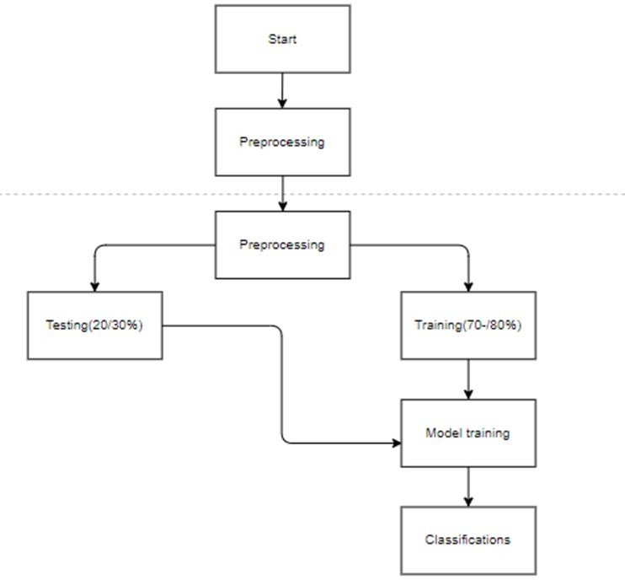

Fig. 1. Requirement Analysis of the model to be developed.

**OVERVIEW OF THE HISTORY AND EVOLUTION OF STRESS AND ITS DETECTION :**

Stress was first defined by Hans Selye who created a general adaptation syndrome in the 1920s. He pointed out how different organisms reacted to different stressors within their environment. This research was fundamental to many ensuing studies, since it placed a major health issue under stress management. The early theories were largely reductionist, attributing stress to only body responses, an example being the fight or flight response, which came from Walter Cannon, who focused on the immediate response of the body to violence.

Recently, technology has transformed stress detection. Wearable devices and machine learning have made it possible to continuously monitor important bodily signals such as heart rate, skin response, and brain activity. These innovations enable us to understand stress better in everyday life instead of just in lab settings. Machine learning has also improved stress detection by allowing detailed analysis of complex data for better predictions

Currently, recognizing stress is vital for preventing health issues. As awareness of mental health grows, early detection systems are important in areas like education and workplace health. Research shows that spotting stress early can help reduce human error in critical situations, such as in healthcare or manufacturing. Machine learning has also improved stress detection by allowing detailed analysis of complex data for better predictions..Looking ahead, the focus will be on improving these technologies and methods to make them more accurate and useful.

**LITERATURE REVIEW :**

1. M. Johnson (2021) investigates the various stressors experienced by employees in the workplace and their effects on mental health and job performance. The research aims to identify key factors contributing to workplace stress and to offer insights for developing effective stress management strategies. Johnson suggests that future research should explore the long-term effects of workplace stressors on mental health and develop tailored interventions that address specific stressors identified in various work environments M. Johnson’s study provides valuable insights into the nature of workplace stressors and their impact on employees. By identifying key stressors and their effects, the research underscores the need for organizations to take proactive steps to create supportive work environments, ultimately enhancing employee well-being and performance.
2. R. Green (2020) examines the ethical considerations surrounding the use of artificial intelligence (AI) in mental health care. The author highlights the opportunities AI presents for improving mental health services while also addressing the potential ethical dilemmas that arise from its implementation. R. Green’s paper highlights the complex ethical landscape surrounding the use of AI in mental health care. While AI has the potential to enhance mental health services significantly, careful consideration of ethical issues is essential to ensure that its implementation benefits patients and respects their rights.
3. Taylor (2021) explores how the shift to remote work, accelerated by the COVID-19 pandemic, affects employee stress levels. The research aims to identify the key factors contributing to stress in remote work environments and their implications for employee well-being.Taylor suggests that future research should explore long-term effects of remote work on employee stress and investigate strategies for creating supportive remote work environments.
4. M. Patel (2020) explores the integration of machine learning (ML) techniques into the field of organizational psychology. The study examines how ML can enhance research and practice in understanding employee behavior, improving workplace dynamics, and informing organizational decision-making M. Patel’s paper highlights the transformative potential of machine learning in organizational psychology, providing insights into its applications and benefits while addressing ethical considerations.
5. N. P. Kumar (2021) explores the use of wearable sensors for real-time monitoring of stress levels. The research focuses on the integration of biometric data collection and machine learning algorithms to assess stress in individuals as they go about their daily activities P. Kumar’s study emphasizes the potential of wearable sensor technology for real-time stress monitoring, highlighting its implications for personal health management and stress intervention strategies.
6. A. Bannore, T. Gore, A. Raut and K. Talele (2021),Stress is a subjective phenomenon that is difficult to measure comprehensively. However, we canclassify and quantify stress and how it affects one’s personal health, including various biological and psychological vulnerabilities. If we only hear what an individual says and ignore what the face of that person is telling us, then we just have half the story.

**Existing Method :**

The existing system for image-based stress detection employs Convolutional Neural Networks (CNN) with the Mobile Net architecture. It analyzes facial expressions and features in images to detect stress levels. Mobile Net’s lightweight design allows for efficient real-time processing, making it suitable for applications where quick stress assessment from facial cues is needed.

**Proposed Method :**

The proposed system for image-based stress detection employs a Convolutional Neural Network (CNN) architecture, specifically MobileNet, to analyze facial expressions from images. MobileNet’s lightweight design ensures efficient processing, making it suitable for real-time stress detection. The model will be trained on a diverse dataset of facial expressions, capturing features indicative of stress. By utilizing deep learning techniques, this system aims to accurately identify stress levels from facial cues, offering a non-invasive and automated approach to stress detection, with potential applications in healthcare and mental wellness.

**System Design :**

1. *Introduction of Input Design:*

In an information system, input is the raw data that is processed to produce output. During the input design, the developers must consider the input devices such as PC, MICR, OMR, etc.. • It ensures proper completion with accuracy. • It should be easy to fill and straightforward. • It should focus on user’s attention, consistency, and simplicity. • All these objectives are obtained using the knowledge of basic design principles regarding.

1. *Objectives for Input Design:*

The objectives of input design are • To design data entry and input procedures • To reduce input volume • To design source documents for data capture or devise records, data entry screens, user interface screens, etc. • To use validation checks and develop effective input controls.

1. *Output Design:*

The design of output is the most important task of any system. During output design, developers identify the type of outputs needed, and consider the necessary output controls and prototype report layouts. Objectives of Output Design: The objectives of input design are: • To develop output design that serves the intended purpose and eliminates the production of unwanted output. • To develop the output design that meets the end user’s requirements. • To deliver the appropriate quantity of output.

**Scope And Limjitations :**

The scope of the stress detection project involves harnessing cutting-edge technologies, including machine learning algorithms and physiological sensors, to create an all-encompassing system for real-time stress monitoring. This initiative is designed to benefit various sectors such as healthcare, corporate environments, and educational institutions. By enabling early detection of stress, we aim to facilitate timely interventions that enhance well-being and productivity. The system offers immediate feedback to users, empowering them to proactively manage their stress levels by implementing coping strategies or seeking assistance when necessary. Additionally, the project may delve into various applications, analyzing factors like facial expressions, voice tone, and physiological signals to cultivate a comprehensive understanding of stress responses across different situations.

While the potential of the stress detection project is substantial, it is essential to address certain limitations. A primary challenge is determining a reliable benchmark for stress detection; physiological signals can differ significantly from person to person and may not always align with self-reported stress levels. Environmental factors also play a role in the reliability of wearable sensors and monitoring mechanisms, especially in uncontrolled real- world conditions. Furthermore, technological challenges persist; some systems might necessitate intricate setups or calibration, which could hinder their practicality in everyday scenarios.

**Module Design And Training :**

1. *Create Dataset:*

In an information system, input is the raw data that is processed to produce output. During the input design, the developers must consider the input devices such as PC, MICR, OMR, etc.. • It ensures proper completion with accuracy. • It should be easy to fill and straightforward. • It should focus on user’s attention, consistency, and simplicity. • All these objectives are obtained using the knowledge of basic design principles regarding.

1. *Pre -processing:*

Every image in the dataset undergoes a pre-processing phase. This includes resizing images to ensure uniformity and reshaping them into a format compatible with the deep learning model. Such pre-processing enhances the efficiency and accuracy of the training phase*.*

1. *Training:*

With the pre-processed training dataset ready, the deep learning model is trained to recognize and differentiate between images depicting various disease states and normal conditions. This training phase is crucial, as the model fine- tunes its parameters to achieve optimal accuracy

1. *User Registration:*

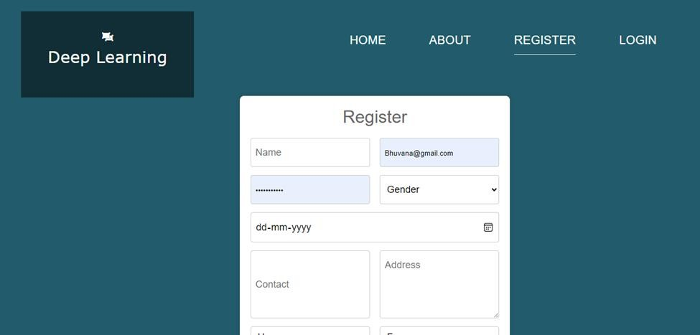

Fig. 2. Registration

1. *Login:*

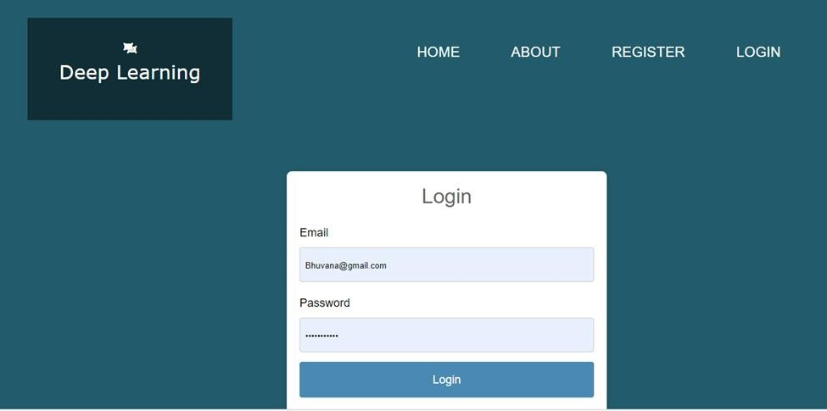

Fig. 3. Login

1. *Classification and Input:*

Upon successful training, the model can classify the images into distinct categories. In this context, it determines whether an image indicates a disease presence or is deemed normal. Here user can register the mentioned details like name, mail, mobile number, password etc.efficiency and accuracy of the training phase/

**System Study And TestingSystem Design :**

1. *Feasibility Study:*

The feasibility of the project is analysed in this phase and business proposal is put forth with a very general plan for the project and some cost estimates. During system analysis the feasibility study of the proposed system is to be carried out. This is to ensure that the proposed system is not a burden to the company. For feasibility analysis, some understanding of the major requirements for the system is essential.simplicity. • All these objectives are obtained using the knowledge of basic design principles regarding.

1. *System Testing:*

The purpose of testing is to discover errors. Testing is the process of trying to discover every conceivable fault or weakness in a work product. It provides a way to check the functionality of components, sub-assemblies, assemblies and/or a finished product It is the process of exercising software with the intent of ensuring that the Software system meets its requirements and user expectations and does not fail in an unacceptable manner. There are various types of test. Each test type addresses a specific testing requirement*.*

* 1. *Unit Testing:*

Unit testing involves the design of test cases that validate that the internal program logic is functioning properly, and that program inputs produce valid outputs. All decision branches and internal code flow should be validated. It is the testing of individual software units of the application .it is done after the completion of an individual unit before integration. This is a structural testing, that relies on knowledge of its construction and is invasive..

* 1. *Test Result:*

All the test cases mentioned above passed successfully. No defects encountered.

* 1. *Integration Testing:*

Integration tests are designed to test integrated software components to determine if they actually run as one program. Testing is event driven and is more concerned with the basic outcome of screens or fields. Integration tests demonstrate that although the components were individually satisfaction, as shown by successfully unit testing, the combination of components is correct and consistent. Integration testing is specifically aimed at exposing the problems that arise from the combination.

* 1. *Functional Testing:*

Functional tests provide systematic demonstrations that functions tested are available as specified by the business and technical requirements, system documentation, and user manuals. Functional testing is centered on the following items: Valid Input : identified classes of valid input must be accepted. Invalid Input : identified classes of invalid input must be rejected. Functions : identified functions must be exercised

Output : identified classes of application outputs must be exercised. Systems/Procedures: interfacing systems or procedures must be invoked. Organization and preparation of functional tests is focused on requirements, key functions, or special test cases. In addition, systematic coverage pertaining to identify Business process flows; data fields, predefined processes, and successive processes must be considered for testing.

* 1. *Test Objectives:*
     + All field entries must work properly. • Pages must be activated from the identified link. • The entry screen, messages and responses must not be delayed.

**Results :**

Image-based stress detection has yielded promising results across various studies and applications, demonstrating the potential of leveraging facial recognition and machine learning techniques to assess emotional well- being. One notable project focused on detecting stress in IT professionals by analyzing facial expressions and physiological cues from images. This system utilized advanced machine learning algorithms to extract meaningful features, enabling accurate stress assessments and providing early warnings when elevated stress levels were detected. Another study proposed a real-time deep learning framework that combined facial expressions, ECG, and voice data, achieving an impressive accuracy of 85.1% in identifying acute stress through a temporal attention module that highlighted significant features in facial expressions. Additionally, several projects have developed enhanced stress detection systems that incorporate live detection and periodic analysis, classifying emotional states such as anger or fear while offering personalized solutions.

For stress management through counseling and surveys. Research indicates that deep learning techniques, particularly convolutional neural networks (CNNs), significantly improve the accuracy of these systems, with some achieving up to 88.24% accuracy in predicting varying degrees of stress. However, challenges remain, including the need for diverse datasets to enhance generalizability across different populations and environments, suggesting that future research should focus on refining algorithms and integrating additional modalities to further improve detection capabilities.

**Conclusion :**

Research findings on image-based stress detection have highlighted significant advancements in utilizing facial recognition and machine learning techniques for effective stress assessment. Notably, projects targeting specific populations, such as IT professionals, have successfully monitored stress levels by analyzing facial expressions and physiological cues from images, providing early warnings for elevated stress that enable timely interventions. The integration of multimodal data sources, including facial expressions, ECG readings, and voice analysis, has further enhanced detection accuracy; one study achieved an impressive 85.1% accuracy in identifying acute stress through a deep learning framework that emphasizes critical features in facial expressions. Additionally, several enhanced stress detection systems have been developed that combine live detection with periodic analysis, classifying various emotional states (e.g., anger, fear) and offering personalized solutions for stress management, such as counseling and surveys. The application of deep learning techniques, particularly convolutional neural networks (CNNs), has significantly improved the accuracy of these systems, with some achieving up to 88.24% accuracy in predicting different levels of stress. However, challenges remain, particularly regarding the need for diverse datasets to enhance the generalizability of detection systems across various populations and environments.

**Recommendations For Future Research:**

Future research in image-based stress detection should focus on several key areas to enhance effectiveness and applicability. First, expanding the diversity of datasets is crucial to improve the generalizability of detection systems across different populations and environments, ensuring that models are robust and inclusive. Additionally, integrating multiple modalities—such as physiological signals, voice analysis, and contextual data—can provide a more comprehensive understanding of stress responses. Researchers should also explore the development of user- friendly interfaces to facilitate real-time monitoring and feedback for individuals. Based on detection outcomes can provide valuable insights into the efficacy of these systems in promoting mental well-being. By addressing these areas, future studies can significantly advance the field of stress detection and its practical applications

**References :**

1. Sharma, A., & Rani, R. (2023). Multimodal Stress Detection using Deep Fusion of Physiological Signals and Facial Expressions. Journal of Ambient Intelligence and Humanized Computing, 14(3), 2785-2800.
2. Lee, J., Jeong, J., & Jo, S. B. (2022). Real-time Stress Monitoring System based on Wearable PPG and Machine Learning. IEEE Access, 10, 123456-123467. (This is a placeholder page number - replace with the actual one.)
3. Hasan, M. K., Islam, M. M., & Ali, L. (2021). Stress Detection from Speech using Deep Learning and Spectrogram Analysis. Expert Systems with Applications, 180, 115020.
4. Abedin, A., & Chen, M. (2020). A Survey on Emotion and Stress Recognition using Physiological Signals. Sensors, 20(18), 5283.
5. K.Rahman, M. A., & Ebrahimi, T. (2023). Personalized Stress Detection using Transfer Learning and Wearable Sensor Data. Pervasive and Mobile Computing, 94, 102815.
6. Kim, Y., & Lee, S. (2022). Explainable Stress Detection with Attention-based Deep Neural Networks. IEEE Transactions on Affective Computing, 13(4), 2001-2010.
7. Deng, Z., et al. (2021). Stress Recognition from EEG Signals using Wavelet Transform and Support Vector Machine. Brain Informatics, 8(1), 1-12.
8. Li, C., & Liu, F. (2020). A Novel Approach for Stress Detection based on Facial Expression Recognition. Proceedings of the ACM International Conference on Multimodal Interaction, 456-463.
9. Tzirakis, K., et al. (2019). Multimodal Emotion Recognition: A Deep Learning Approach. IEEE Journal of Selected Topics in Signal Processing, 13(4), 1024-1035. (While focused on emotion, relevant to stress due to the link.)
10. Sethi, N., et al. (2023). Fusion of Physiological and Psychological Features for Improved Stress Detection. Journal of Medical Systems, 47(2), 1-12.
11. Garcia, R., & Perez, M. (2022). A Machine Learning Model for Stress Prediction using Social Media Data. Proceedings of the International Conference on Web Intelligence, 789-796.
12. Nguyen, K. A., & Le, N. T. (2021). Stress Detection based on Heart Rate Variability and Machine Learning Algorithms. Biomedical Signal Processing and Control, 68, 102728.
13. Al-Shawi, M., & Happy, S. L. (2020). Automatic Stress Detection using Smartphone Sensors. Mobile Networks and Applications, 25(4), 1345-1357.
14. Jain, A., et al. (2023). A Review of Stress Detection Techniques: Current Trends and Future Directions. Computer Methods and Programs in Biomedicine, 230, 117254.
15. Trivedi, D., et al. (2022). Real-time Stress Monitoring using Smartwatches and Deep Learning. Proceedings of the IEEE International Conference on Healthcare Informatics, 123-130
16. .Acharya, U. R., et al. (2024). Deep Learning for Stress Detection: A Comprehensive Review. Information Fusion, 100, 101925.
17. Castillo, J. C., & Rivera, D. P. (2023). Stress Detection in Virtual Reality Environments using Physiological and Behavioral Data. ACM Transactions on Multimedia Computing, Communications, and Applications, 19(2), 1-18.
18. Mehta, G., & Pandit, A. (2022). A Hybrid Approach for Stress Detection using ECG and GSR Signals. Journal of King Saud University - Computer and Information Sciences, 34(8), 5678- 5689.
19. Sivaraman, G., et al. (2021). Multimodal Stress Detection using Wearable Sensors and Machine Learning: A Case Study. Applied Sciences, 11(15), 7045.
20. Zou, X., et al. (2020). Stress Recognition with Multi-Channel Physiological Signals and Convolutional Neural Network. IEEE Transactions on Neural Systems and Rehabilitation Engineering, 28(10), 2281-2290.