The Study on Customer Satisfaction on Metal Sheet Manufacturing Industries

Mithran G, II-MBA, Kumaraguru School of Business, Coimbatore, Tamil Nadu, India, mithranpy@gmail.com

Mr.T.K. Ashvin, Assistant Professor, Kumaraguru School of Business, Coimbatore Tamil Nadu, India, ashvin.tk@ksbedu.in

# Abstract

This research paper explores the factors influencing customer satisfaction at Metal Sheet Manufacturing Industries, a prominent player in the metal pressing industry. Key factors such as product quality, delivery reliability, customer service, and communication are analyzed to understand their impact on customer satisfaction. Utilizing a structured survey and statistical analysis, insights are gathered from a sample of Metal Sheet Manufacturing Industries clientele. Findings indicate that while all factors contribute to satisfaction, customer service holds the strongest influence, followed by product quality. The study concludes with actionable recommendations to enhance customer experience, foster loyalty, and maintain a competitive edge.

# **Keywords**

Customer satisfaction, product quality, logistics, customer service, communication,

metal pressing industry

# **INTRODUCTION**

The study on customer satisfaction at "Metal Sheet Manufacturing Industries" aims to identify the key factors that help the company maintain its competitive edge in the metal pressing industry. Customer satisfaction is critical, as it directly influences repeat business, referrals, and long-term profitability. Since Metal Sheet Manufacturing Industries specializes in customized metal pressing solutions for sectors like automotive, construction, and manufacturing, it’s essential for the company to consistently meet or exceed customer expectations. The research focuses on several core areas, beginning with product quality, assessing how well products meet technical specifications, precision standards, and performance requirements to ensure durability. Timeliness and delivery reliability are also analyzed, given their importance to customers whose operations depend on timely deliveries. Another focal point is customer service efficiency, looking at how effectively Metal Sheet Manufacturing Industries handles inquiries, complaints, and defective product issues—key for building strong customer relationships. Additionally, the study evaluates communication and responsiveness, particularly how well the company keeps customers informed about order status, delivery schedules, and issues, and how these align with customers' preferred methods of communication. By identifying trends and areas for improvement, the study will enable Metal Sheet Manufacturing Industries to make data-driven improvements that enhance customer satisfaction, foster client loyalty, and strengthen its position in the market.

**Review of Literature**

Customer Satisfaction and Loyalty- Research in customer satisfaction highlights a direct correlation between satisfaction and customer loyalty, essential for sustainable business growth. A study of the mobile services sector demonstrates that customer loyalty is built on a foundation of high satisfaction, which in turn drives corporate sustainability. The findings suggest that customer satisfaction can positively influence brand reputation and retention rates, ultimately promoting long-term business success.

Service Quality and Customer Satisfaction in Retail Banking- A study conducted in Malta within the retail banking sector examined how service quality influences customer satisfaction. The SERVQUAL model revealed that prompt and efficient responses to customer inquiries significantly enhance customer loyalty. In this study, customer satisfaction served as a mediator between service quality and loyalty, showing that improving service quality is essential for fostering loyalty in highly competitive industries.

Impact of Product Quality on Satisfaction in Manufacturing- The relationship between product quality and customer satisfaction has been widely explored in manufacturing research. Studies indicate that superior product quality reduces customer complaints and returns, leading to higher satisfaction, quality assurance plays a pivotal role in maintaining customer trust and satisfaction, as customers expect precision and durability from metal products used in demanding applications.

Logistics Service Quality in Customer Satisfaction- Timeliness and reliability in logistics are critical to customer satisfaction. Studies in logistics service quality reveal that delayed deliveries or unreliable logistics can cause dissatisfaction, leading to additional costs for the customer. Companies that invest in efficient logistics systems are better positioned to meet customer expectations and maintain a positive reputation within their industries.

**OBJECTIVE OF THE STUDY**

**Primary objective**

* To study customer satisfaction of Metal Sheet Manufacturing Industries

# **Secondary objective**

* Analyses the impact of logistics on satisfaction: Understand how timely deliveries, line stoppages, and delivery delays affect customer satisfaction levels.
* Evaluate product quality perceptions: Assess how customers perceive the quality of products delivered, including specifications, defect resolution, and overall packaging.

# **Scope of Study**

The scope of this study focuses on enhancing customer service, understanding customer loyalty, and measuring customer satisfaction at Metal Sheet Manufacturing Industries. In terms of improving customer service, the study will examine current practices, analyze customer expectations, and identify any inefficiencies or gaps in service delivery. By pinpointing areas for improvement, the research aims to streamline customer service processes, boost responsiveness, and ultimately elevate the overall customer experience. When it comes to customer loyalty and retention, the study seeks to understand what influences customers to remain with the company over time. Retention is crucial, as it reduces the likelihood of customers switching to competitors. This aspect of the study will analyze factors that contribute to loyalty, such as personalized service, loyalty programs, or strengthened communication, to propose strategies for maintaining a loyal customer base. Lastly, measuring customer satisfaction will provide insights into how well the company meets or exceeds customer expectations. Through surveys, feedback forms, or interviews, the study will gather valuable data on satisfaction levels, identifying areas that need improvement and allowing Metal Sheet Manufacturing Industries to better understand and respond to customer needs and preferences.

# **Limitation**

The study on customer satisfaction for Metal Sheet Manufacturing Industries faced several limitations. A limited sample size may affect the representativeness of findings, as a smaller pool of respondents could overlook diverse customer experiences. Additionally, the geographic focus restricts generalizability to other regions with differing expectations. Response bias may further skew results, with personal opinions affecting the accuracy of feedback. The study's

scope is also limited, covering only certain variables like logistics and customer service, while overlooking others like pricing and technology. Finally, time constraints and reliance on self-reported data may impact the study’s accuracy, as responses may be influenced by seasonal or personal factors.

# **Conceptual Model**

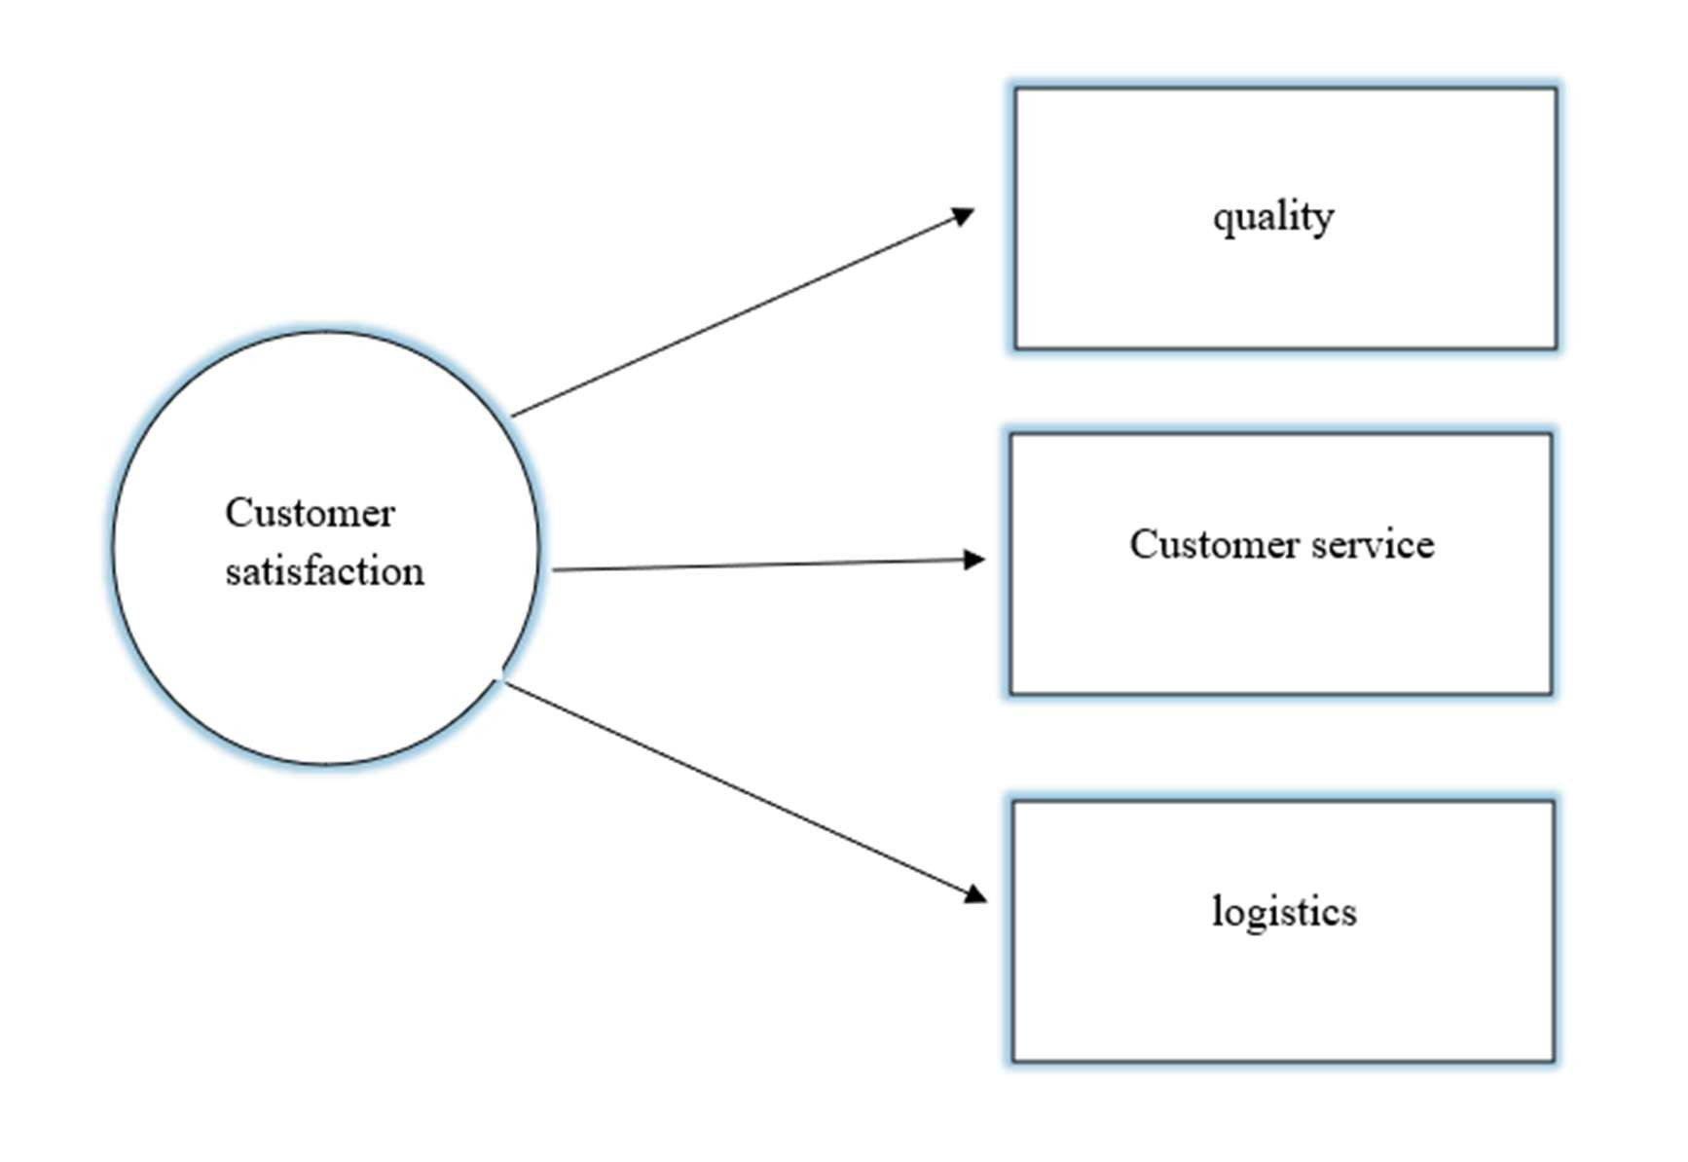

# **DATA ANALSIS**

Table No.03

|  |  |  |  |  |
| --- | --- | --- | --- | --- |
|  | | AGE |  | |
| Age | | Frequency | Percent | |
| Above 18 | | 38 | 38.0 | |
| 20-40 | | 52 | 52.0 | |
| Above 50 | | 10 | 10.0 | |
| Total | | 100 | 100.0 | |
| GENDER | | | |  |
| Gender | | Frequency |  | Percent |
| Male | | 55 |  | 55.0 |
| Female | | 45 |  | 45.0 |
| Total | | 100 |  | 100.0 |
| EXPERIENCE | | | |  |
| Experience | | Frequency |  | Percent |
| Below 10 years | | 40 |  | 40.0 |
| Above 10 years | | 50 |  | 50.0 |
| Above 25 years | | 10 |  | 10.0 |
| Total | | 100 |  | 100.0 |
| MODE OF COMMUNICATION | | | |  |
| Mode of Communication | Frequency | |  | Percent |
| Mail | 48 | |  | 48.0 |
| WhatsApp | 22 | |  | 22.0 |
| Phone Call | 30 | |  | 30.0 |
| Total | 100 | |  | 100.0 |

**Interpretation of the Data**

# Age Distribution

* The majority of respondents (52%) fall within the 20-40 age group, indicating that a significant portion of the sample is within their prime working age.
* 38% of respondents are above 18, which likely includes young professionals or recent graduates.
* Only 10% are above 50, suggesting a lower representation of older individuals in the study.

# Gender Distribution

* The male population (55%) is slightly higher than the female population (45%), indicating a relatively balanced gender representation.
* While the difference is not significant, it reflects a close-to-equal participation from both genders.

# Work Experience

* 50% of respondents have more than 10 years of experience, highlighting that a large segment consists of experienced professionals.
* 40% have below 10 years of experience, suggesting a good mix of early-career individuals.
* 10% have above 25 years of experience, representing a smaller group of highly experienced professionals.

# Preferred Mode of Communication

* The most preferred mode of communication is mail (48%), indicating a formal and structured communication preference.
* Phone calls (30%) are the second most preferred mode, showing a mix of direct and instant communication needs.
* WhatsApp (22%) is the least used, possibly due to organizational policies or professional preferences for more formal communication methods.

Table No.02

Mean Value for the Statement

|  |  |  |
| --- | --- | --- |
| SI.  No | Factors | Mean |
|  | QUALITY |  |
| 1 | Quality of the product delivered against drawing/specification | 1.49 |
| 2 | Packing quality and identification labelling method | 1.62 |
| 3 | Whether the product which are defect it was rectified properly and on time | 2.03 |
| 4 | Have you faced any field returns due to quality problem in our products | 2.85 |
|  | LOGISTICS |  |
| 5 | On time delivery performance | 2.86 |
| 6 | Have you faced any line stoppage due to our delivery | 2.86 |
| 7 | Have you faced any premium freight due to delay in our delivery | 2.88 |
| 8 | The premium freight is convenient | 2.61 |
|  | CUSTOMER SERVICE |  |
| 9 | Lead time &amp; effectiveness of handling customer complaints  &amp; customer returns | 2.35 |
| 10 | Lead time for new product development &amp; sample submission | 2.59 |
| 11 | How satisfied are you with the overall communication experience with our company? | 2.02 |

# **Findings**

The study population is primarily young to middle-aged, with 90% of respondents aged 40 or younger, reflecting a workforce rich in potential long-term involvement. Gender distribution shows a slight predominance of males, making up 55% compared to 45% females. A majority, approximately 90%, have over a decade of experience in sheet metal production, indicating high industry knowledge and stability, with 50% having specialized expertise as quality managers. A focus on quality assurance and management is evident, suggesting that these roles are pivotal in their organizations. The analysis revealed a moderate positive relationship between quality, logistics, customer service, and overall communication satisfaction. Although customer service significantly boosts communication satisfaction, quality and logistics alone do not show a meaningful impact. Customer service remains the strongest predictor of communication satisfaction, aligning with its critical role in customer interactions.

Additionally, experience levels in the field do not significantly influence perceptions of quality, indicating consistency across groups. With a statistically significant model, the findings suggest minimal differences among groups, largely attributed to random variance rather than systemic differences.

# **CONCLUSION**

To maintain and grow its customer base, Metal Sheet Manufacturing Industries (P) Lt must focus on improving product quality, delivery efficiency, and customer service. Strengthening quality control at every production stage, from raw materials to final inspection, will reduce defects and ensure products meet customer specifications. Proper testing, continuous improvement initiatives, and enhanced packaging will further improve quality.

Timely delivery is crucial, and Metal Sheet Manufacturing Industries should optimize its supply chain, improve logistics, and use real-time data to avoid delays. Predictive delivery systems and contingency plans can help mitigate disruptions.

Improving customer service requires establishing a dedicated support team and adopting customer-centric communication methods. A CRM system will streamline interactions, while proactive communication will build trust and loyalty. Addressing these areas will enhance customer satisfaction and foster long-term growth.

# **REFERENCE**

1. Customer Satisfaction, Loyalty, Knowledge, and Competitiveness in the Food Industry. (n.d.). This study looked at 1,530 customers in the Czech Republic to explore how customer satisfaction, loyalty, and product knowledge affect competitiveness in the food industry.
2. Customer Satisfaction and Loyalty in Mobile Communications. (n.d.). This research focused on Telekom customers, using 151 respondents to understand how satisfaction and loyalty contribute to corporate sustainability in mobile services.
3. Service Quality and Customer Satisfaction in Retail Banking. (n.d.). Conducted in Malta, this study used surveys to examine how service quality affects customer satisfaction and loyalty among banking customers.
4. Customer Satisfaction and Loyalty in Online Shopping. (n.d.). This analytical study gathered data from 120 customers to see how different satisfaction factors impact loyalty to online shopping sites in the Arabic market.
5. Customer Satisfaction with Crompton Greaves Agro Pumps. (n.d.). This survey aimed to understand customer preferences and satisfaction levels regarding agro pumps in Ahmednagar district.
6. Factors Affecting Customer Satisfaction. (n.d.). This research involved 150 respondents, exploring how pricing and customer service influence satisfaction and loyalty among Ufone network users.
7. Customer Satisfaction with Online Marketing in Chennai. (n.d.). This study collected feedback from a diverse group of respondents to assess their satisfaction with online marketing efforts in Chennai.
8. Product Quality's Impact on Customer Satisfaction and Loyalty. (n.d.). This study focused on El-Rayhan Food Industries, examining how product quality affects customer satisfaction and loyalty with 291 respondents.

**Website:**

* https://scholar.google.com/
* https://www.researchgate.net/