**ALFA – “Advanced Learning and Friendly Assistant”**

**Asst. Prof. P. B. Jaipurkar1, Shraddha M. Rangari2, Kshitija C. Wanjare3**

1Assistant Professor, Computer Engineering Department, SRPCE, Nagpure, Maharashtra, India

2UG Student, Computer Engineering Department, SRPCE, Nagpure, Maharashtra, India

3UG Student, Computer Engineering Department, SRPCE, Nagpure, Maharashtra, India

**ABSTRACT**

Robots are becoming smarter and more useful in different fields, from factories to healthcare. This paper introduces ALFA, an advanced learning robot designed to efficiently perform tasks by continuously learning and adapting to its surroundings. Using artificial intelligence and real-time feedback, ALFA can improve its performance over time, making it more precise and reliable. Its flexible design allows it to be used in various applications, such as industrial automation and service robotics. Tests show that ALFA outperforms traditional robots by learning tasks faster and executing them with greater accuracy. This research explores how AI-powered robots like ALFA can revolutionize automation and improve efficiency in the real world.

**Keywords:** Artificial Intelligence, Realtime Feedback, Task Execution, Automation, Robot Adaptation

1. **INTRODUCTION (Font-Times New Roman, Bold, Font Size -12)**

Robots are becoming an essential part of our daily lives, helping in industries, healthcare, and even household tasks. However, most traditional robots follow pre-programmed instructions and struggle to adapt to new or unexpected situations. This is where **ALFA (Advanced Learning and Friendly Assistant)** comes in. ALFA is designed to **learn and improve over time**, making it more efficient and adaptable compared to regular robots. Using artificial intelligence and real-time feedback, it can analyze its surroundings, make smart decisions, and perform tasks with increasing accuracy. Whether it’s assembling products in a factory, assisting in medical can procedures, or helping with everyday chores, ALFA can adjust to different environments and improve its performance without constant human intervention. This paper explores how ALFA works, its unique features, and how it outperforms traditional robots. By combining advanced learning techniques with task execution, ALFA represents the future of intelligent automation, making robots smarter, faster, and more useful in real-world applications. ALFA is an advanced virtual assistant robot designed to go beyond traditional assistant robot designed to go beyond traditional assistants by using **Artificial Intelligence (AI)** and **Machine Learning (ML)**. Unlike simple assistants that only follow commands, ALFA is capable of understanding context, learning from its interactions, and adapting its responses to offer smarter, more personalized work. In recent years human-robot interaction studies captured the attention of researchers because the large variety of domains in which these studies could be applied. Latest results encourage the development of agents capable of learning, interact and working as a real, effective, partners with humans. Different results from several research groups demonstrates many applications that can be conducted by robotic partners, Furthermore, many studies demonstrate that the robot capability to express emotions encourages a natural and believable interaction with humans, increasing the acceptance of the robot itself. Moreover, other researches also showed that robots with a believable personality will be more accepted by humans, that become more disposed to interact closely. This paper will represent an easily scalable robot ALFA that can be used in offices, receptions, or on any desktop. Recent studies show that empathy makes the robot more accepted by the people, so the capability of arousing it in humans is important on the designing of robots that should collaborate with humans. By introducing this project, the acknowledgement and significance of precision and versatility in modern robotics. Traditional robotic systems often rely on pre-programmed instructions, limiting their adaptability to dynamic environments. In contrast, this project leverages real-time processing to endow the ALFA.

1. **METHODOLOGY**

Project involving Arduino Uno, Raspberry Pi, a microphone, speaker, and display sounds exciting and can be implemented in various ways, depending on its purpose. If the robot is designed for voice interaction, the Raspberry Pi can handle speech recognition and AI processing, while the Arduino can control motors and sensors for movement. The microphone will allow the robot to listen to commands, and the speaker can be used for responses, making it an interactive system. The display can serve as a user interface, showing information such as voice command responses, sensor data, or even an animated face for a more engaging experience. In terms of communication, the Raspberry Pi and Arduino can be connected via **Serial (UART) or I2C**, where the Pi processes high-level tasks while the Arduino handles low-level motor control. The system can be programmed in **Python (for the Pi) and C++ (for the Arduino)**, integrating libraries like **OpenCV** for vision, **Google Speech-to-Text** for voice recognition, and **Text-to-Speech (TTS) engines** for responses. If the robot requires mobility, motors can be controlled using **motor drivers like L298N** connected to the Arduino. For power management, a **rechargeable battery** with proper voltage regulation will ensure smooth operation.

**SYSTEM ARCHITECTURE:**

The system architecture of ALFA consists of various elements and they are as following

Microprocessor Connected (Raspberry Pi/ Arduino)

3D Printed Body

LCD Display

Stereo Audio Amplifier Module

Speech Recognition

(Calculation, News etc.)

Voice Input Using Mic

Mini Robot

ALFA

(Advance Learning and Friendly Assistant)

Voice Recognition

(Switch Window Command Prompt etc.)

Arm/ Hand Movement

Displaying Output through LCD Display

Fig. 2.1 System Architecture

1. **MODELING AND ANALYSIS**

To ensure that an **advanced learning and task-executing robot** functions optimally, rigorous testing methods must be implemented. These tests cover hardware reliability, software efficiency, learning capabilities, and task execution accuracy. The following methods can be used:

**1. Hardware Testing:**

* This ensures that all components, including the Arduino Uno, Raspberry Pi, microphone, speaker, and display, are functioning correctly.
* Power Supply Testing: Checking voltage **levels** and power consumption.
* Sensor & Actuator Testing: Verifying motor movements, sensor readings, and response times.
* Communication Testing: Ensuring seamless data transfer between Arduino and Raspberry Pi via UART/I2C).

**2. Software Testing:**

* This evaluates the efficiency and correctness of the robot’s programming.
* Unit Testing: Testing individual code modules (Python on Raspberry Pi, C++ on Arduino).
* Integration Testing: Checking if different components (voice recognition, motor control, display) work together.
* Latency Testing: Measuring response time between command input and execution.

**3. Learning Capability Testing:**

* If the robot has machine learning (ML) capabilities, these need to be tested for accuracy.
* AI Model Training Validation: Evaluating datasets used for training.
* Speech Recognition Accuracy: Testing how well the robot understands various voices and accents.
* Task Adaptability: Checking if the robot improves performance based on past experiences.

**4. Task Execution Testing:**

* Verifying that the robot performs assigned tasks correction.
* Success Rate Analysis: Measuring how often the robot completes tasks without errors.
* Multi-Task Handling: Testing how well the robot manages multiple tasks simultaneously.
* Error Recovery Testing: Ensuring the robot can detect and correct errors automatically.

**5. User Interaction Testing:**

* Since the robot may interact with humans, usability testing is essential.
* Voice Command Recognition: Testing response accuracy in different environments.
* Display & UI Testing: Ensuring proper visibility and user-friendly navigation.

**6. Real-World Testing:**

* Deploying the robot in a real-world environment to observe performance.

1. **RELATED WORK**

**“Dexterous Manipulation Based on Prior Dexterous Grasp Pose Knowledge “(2024):** This paper presents a novel approach to dexterous manipulation by leveraging prior knowledge of dexterous grasp poses and aims to explore further enhancements in the integration of visualand tactile feedback to enable more human-like dexterity in robotic manipulation [1].

**"A.L.T.E.R. [Advanced Learning and Task Execution Robot]" (2024):** This study discusses the creation of a small robot designed for education and research. Equipped with sensors and actuators, the robot can perform basic autonomous tasks like avoiding obstacles and following lines [2].

**“N.I.V.A [NEXT-LEVEL INTELLIGENCE VIRTUAL ASSISTANT**]**” (2024):** These compact, AI-powered devices are designed to seamlessly integrate into your workspace, offering a range of functionalities from scheduling and reminders to entertainment and interactive engagement. Equipped with advanced sensors and machine learning capabilities, desktop robots can adapt to user preferences, providing a highly personalized experience [3].

**"Enhancing Robot Task Planning and Execution through Multi-Layer Large Language Models" (2024):** Researchers propose using layered language models to improve a robot's ability to handle complex tasks [4].

**"Learning Multi-Step Manipulation Tasks from A Single Human Demonstration" (2023):** Researchers propose a system that processes video demonstrations to translate human actions into robot commands, identifying key object positions relevant to the task [5].

1. **RESULTS AND DISCUSSION**

* **Voice Recognition Module:** Voice Recognition module enables a computer or device to identify, capture, and interpret spoken words and convert them into text or commands that the system can understand. It takes the commanded speech and converts it into text as well can they interpret those spoken commands and execute certain actions. There are many sub-modules like switching window, search in Wikipedia, take screenshot etc., For example:
* When we command **“switch the window”** the output generated will be as shown below:

# 

# Fig. 1.2: Switch the Window

* When we command **“take screenshot”** the output generated will be as shown below:

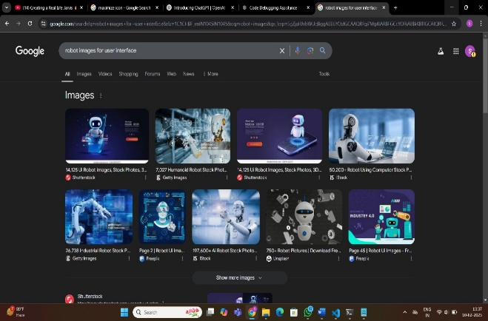

Fig. 1.3 Take Screenshot

* When we command **“take photo”** the below output is generated:

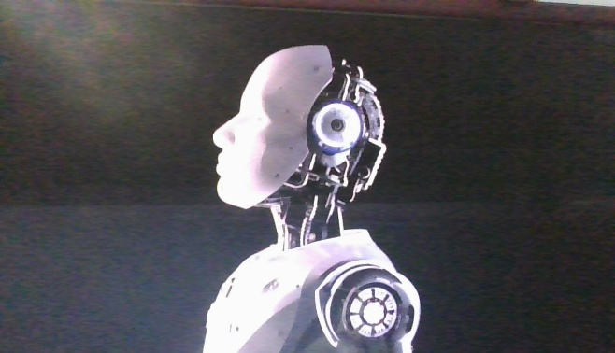

Fig. 1.4 Take Photo

* **Speech Recognition Module:** Speech recognition is the technology that allows a computer or device to recognize spoken language and convert it into text. Essentially, its "listens" to spoke words, analyzes the sound waves, and then processes these sounds to understand and transcribe the spoken words accurately. In this module there are many sub-modules like play music, who are you, etc., For example:
* When you say **"play music,"** the software recognizes this as a command to play music and it can do many tasks.

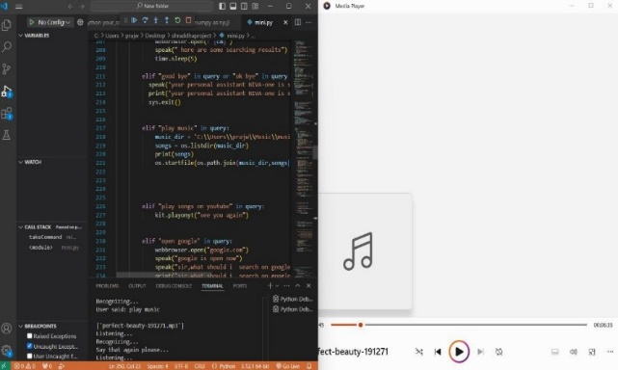

Fig. 1.5: Play Music

Fig: Play Music

Fig: Play Music

* When you say **“open command prompt”** the software recognizes this as a command and shows the below output:

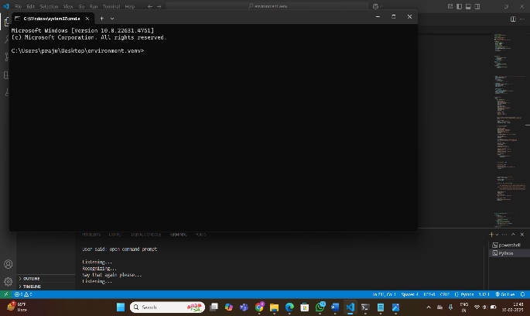

Fig. 1.6 Open Command Prompt

* When you say **“open google”** the software recognizes this as a command and shows the below output:

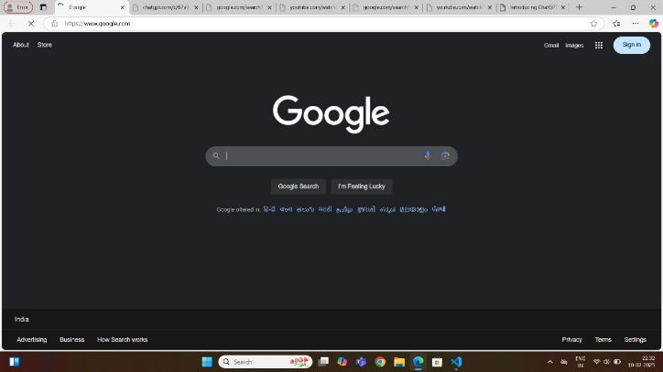

Fig. 1.7 Open Google

* **Display Module**: 2.4 Inch Touch Screen TFT Display Shield adds a touch up to your Arduino project with a beautiful large touchscreen display shield with built-in microSD card connection. This TFT display is big (2.4″ diagonal) bright and colorful! 240×320 pixels with individual pixel control. It has way more resolution than a black and white 128×64disply.

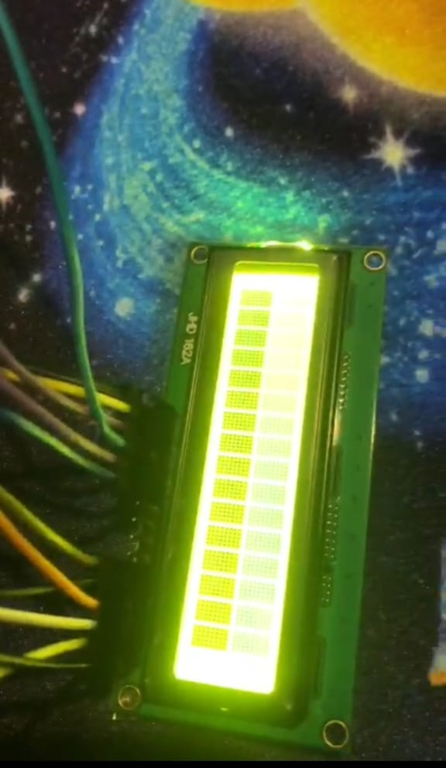

Fig. 1.8: Display Device

* **Microphone:** A microphone is a device that translates sound vibrations in the air into electronic signals and scribes the voices. Microphones enable many types of audio recording devices for purposes including communications of many kinds, as well as music vocals, speech and sound recording.

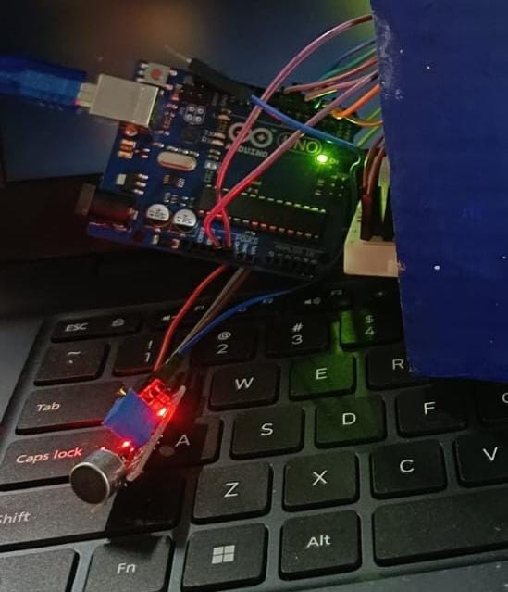

Fig. 1.9: Microphone

1. **CONCLUSION**

The paper explored the development and enhancement of an Advanced Learning and Friendly Assistant. Through improved learning algorithms and task execution strategies, the robot demonstrated increased efficiency, adaptability, and accuracy in performing complex tasks. The presented paper finds and highlight the potential of such systems in real-world applications from automation to human-robot collaboration.

Future search can focus on refining the robot's decision-making capabilities, real-time adaptability and interaction with humans to enhance its effectiveness further. By integrating more advanced AI techniques and expanding its dataset, we can push the boundaries of what such robots can achieve in various domains.

1. **REFERENCES**

**[1**] Hengxu Yan, Haoshu Fang, Cewu Lu **“Dexterous Manipulation Based on Prior Dexterous Grasp Pose Knowledge “-** 12/2024.<https://www.researchgate.net>

[**2]** Asst. Prof. P.B.Jaipurkar, Shraddha M. Rangari , Kshitija C. Wanjare **"ALFA[Advanced Learning and Task Execution Robot]"** International Research Journal of Engineering and Technology - 09 Sept 2024.[www. rjmets.com](https://www.irjmets.com/uploadedfiles/paper/issue_9_september_2024/61839/final/fin_irjmets1727546576.pdf?utm_source=chatgpt.com)

**[3]** Asst. Prof. P. B. Jaipurkar, Himanshu P. Maski, Shreyash P. Suryawanshi “N.I.V.A**[NEXT-LEVEL INTELLIGENCE VIRTUAL ASSISTANT]**” International Research Journal of Engineering and Technology - 09 Sept 2024.<https://www.irjmets.com>

**[4]** Zhirong Luan, Yujun Lai, Rundong Huang Shuanghao Bai, Yuedi Zhang, Haoran Zhang, Qian Wang **"Enhancing Robot Task Planning and Execution through Multi-Layer Large Language Models"** Multidisciplinary Digital Publishing Institute -06 March 2024.[mdpi.com](https://www.mdpi.com/1424-8220/24/5/1687?utm_source=chatgpt.com)

**[5]** Dingkun Guo **"Learning Multi-Step Manipulation Tasks from A Single Human Demonstration" -**04 Jan 2024.[arxiv.org](https://arxiv.org/html/2312.15346v2?utm_source=chatgpt.com)

**[6]** Chao Zeng, Jing GUO, Qiang Li, Chenguang Yang **"Advanced Learning Control in Physical Interaction Tasks"** – 24 Feb 2023[frontiersin.org](https://www.frontiersin.org/journals/robotics-and-ai/articles/10.3389/frobt.2023.1166759/pdf?utm_source=chatgpt.com)

**[7]** Kazuhiro Sasabuchi, Daichi Saito, Atsushi Kanehira, Naoki Wake, Jun Takamatsu, Katsushi Ikeuchi **"Task-sequencing Simulator: Integrated Machine Learning to Execution Simulation for Robot Manipulation"**- 03 Jan 2023 [arxiv.org](https://arxiv.org/abs/2301.01382?utm_source=chatgpt.com)

**[8]** Oliver Kroemer, Scott Niekum, George Konidaris **"A Review of Robot Learning for Manipulation: Challenges, Representations, and Algorithms"** – 01/2021[jmlr.org](https://www.jmlr.org/papers/volume22/19-804/19-804.pdf?utm_source=chatgpt.com)

**[9]** Guanwen Ding, Yubin Liu, Xizhe Zang, Xuehe Zhang, Gangfeng Liu, Jie Zhao **"A Task-Learning Strategy for Robotic Assembly Tasks from Human Demonstrations"** National Library of Medicine - 25 Sept 2020.[pmc.ncbi.nlm.nih.gov](https://pmc.ncbi.nlm.nih.gov/articles/PMC7583967/?utm_source=chatgpt.com)

**[10]** Staffan Ekvall and Danica Kragic **"Robot Learning from Demonstration: A Task-level Planning Approach** – 2019. [journals.sagepub.com](https://journals.sagepub.com/doi/10.5772/5611?icid=int.sj-full-text.similar-articles.6&utm_source=chatgpt.com)