**Smart Window Controller Using IOT**

**Omkar Rahul Desai1, Raviprasad Balasaheb Kumbhar2, Ajinkya Subhash Pawar3,**

**Prathamesh Satyajit Kumbhar4, Mrs. V.V.Patil 5**

1, 2, 3, 4 Department of Diploma in Computer Engineering, Third Year, Sharad Institute of Technology,

Polytechnic Yadrav, Ichalkaranji, Kolhapur, Maharashtra, India

5 Lecturer, Department of Diploma in Computer Engineering, Sharad Institute of Technology,

Polytechnic Yadrav, Ichalkaranji, Kolhapur, Maharashtra, India

**ABSTRACT**

The project is a smart window-closing system designed using Internet of Things technology with Wi-Fi connectivity and web-based interface. It allows the home automation to be treated as enhanced, making the in-house comfort, which can be controlled from anywhere in the house. It involves operation of windows via an easy-to-use web application with actuators and sensors at every window on the central network. When a person accesses the web application and clicks on the button to close a window, the command will then cross the internet to the appropriate actuator, making the action occur for closing a window.

The system ensures convenience by allowing remote access. That means the user could control their windows from anywhere. There is good connectivity between the web interface and the actuators through Wi-Fi, which has a positive implication of smooth communication hence fast and reliable operation. This technology is very advantageous for people wanting to control their windows from a central location or when they are away.

Aside from the aspect of convenience, the system also improves safety and efficiency in energy use due to better control over the home environment.

**Keywords:** Smart window-closing system, IoT technology, Wi-Fi connectivity

1. **INTRODUCTION**

The Wi-Fi Smart Window Controller is a very advanced solution that will give unprecedented convenience and ways of handling the window. The modern intelligent device uses the most advanced IoT technology to connect seamlessly with your home WiFi network, enabling you to manage remotely your windows via a dedicated website. Be it at home or away, just click a few links and have your windows opened or closed-new meaning of accessibility and easiness.

This system boasts an intuitive web-based interface that allows you to shut your windows instantly with one single click of a big button from the website. Great is the ability to control your home instantly in cases of weather fluctuations or whenever you cannot be home for opening and closing your windows according to comfort. Status updates in real time through the website will always keep you informed about whether your windows are opened or closed.

The smart window controller is developed with the convenience of the user in mind. The web platform is clean and simple, user-friendly, and accessible from all devices connected to the internet through smartphones, tablets, and PCs. This, in turn, means operating your windows should be hassle-free and efficient without necessarily taking physical control of the window hardware itself.

Besides adding convenience, the Wi-Fi-Enabled Smart Window Controller enhances home security by letting you check and change the status of your windows remotely. Extra security it provides-assuring that even when you are away, your window will be securely closed. Further, the system contributes to energy efficiency because it provides easiness to maintain optimal settings of windows, which again helps indoor climate and reduces energy consumption.

# **Essential Needs**

There is a great increase in the demand for automation in modern homes and offices. Behind this comes the tremendous growth in demands that show much concern over the control of various aspects of the environment, especially windows. The need to be manually left open or closed tends to be very inconvenient when users do not stay close to the windows or are away from home.

The above convenience is taken care of by your project to such an extent that users can open and close windows using an easy-to-use web interface, thus giving users convenience and ease to access. Particularly useful when one remote manages the ventilation or security during operations such as airflow or closing windows due to sudden unexpected conditions. Unlike any of the conventional window systems, your answer provides a cost-effective and user-friendly option without the burden of complicated sensor-based automation, thus opening up a larger market share.

# **Block Diagram**

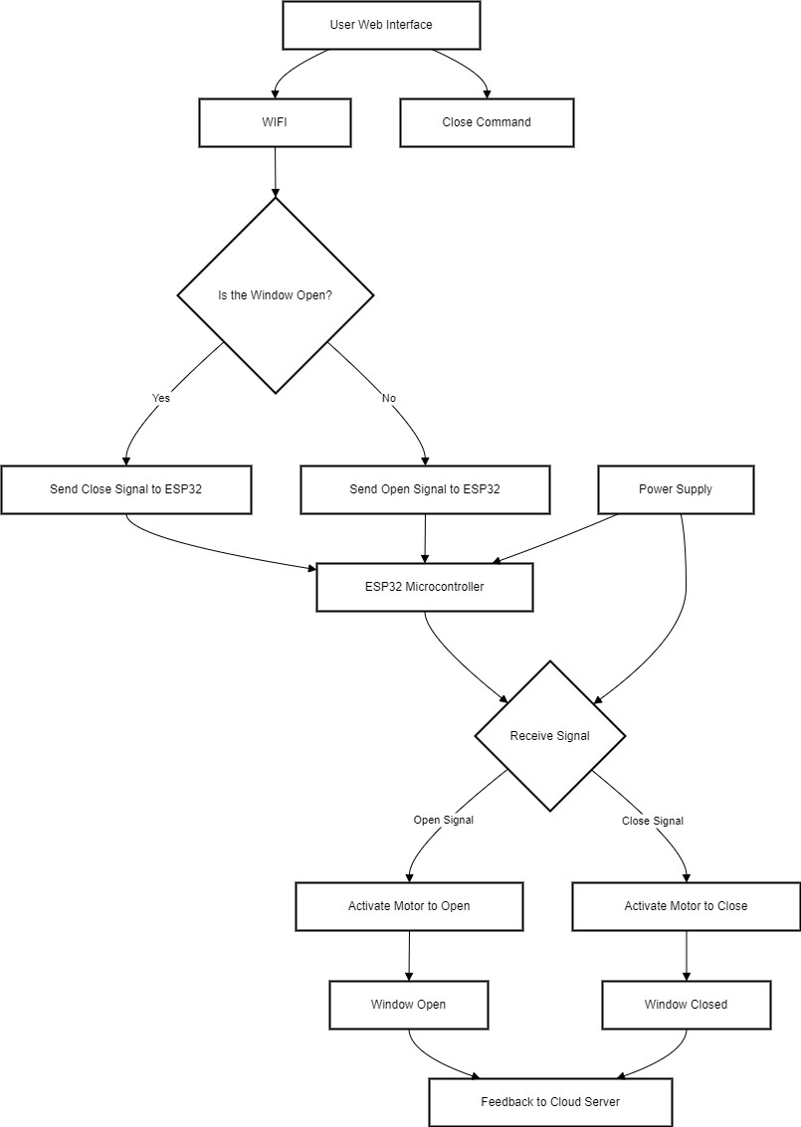

# **Methodology**

Project Planning and Requirements

* Task: Project scoping and system architecture.
* To-do's:
  + - Project objectives and components development
    - ESP32, MG996 servo motor, ultrasonic sensors, knowledge on Firebase integration. o Develop high-level system architecture and project timeline
* Project proposal with system architecture document

Hardware Procurement and Initial Setup

* Objective: Hardware procurement and setup.
* Activities o Order ESP32, MG996 servo motor, ultrasonic sensors, breadboard o Setting up basic hardware assembly on the breadboard.

o Test for minimum connectivity and functionality (power up, motor control).

* Delivered: Proof of concept for simple hardware build.

ESP32 Firmware Development

* Objective: Decide what ESP32 code should be written to be built so that it can control the motors to also read sensor data.
* Activities: o Write code to control servo motor and to read sensor data from ultrasonic sensors

o Safety Checks: Obstacle detection, full closure detection o Test and iterate firmware on breadboard.

* Deliverable : Firmware that successfully powers the motor and sensor .

Development of the Web App with collaboration Firebase Setup

* Target: Onsite, setting up Firebase accurately, developed User Interface for web app
* Activities o Setup remote and live Firebase database for control and monitoring o Develop simple UI web application on window opening/closing sensor data display

o Integrated web app with Firebase

* Deliverables: Functional web application with connectivity to Firebase.

System Integration and Testing

* Objective: integrate all hardware, firmware, and the web application.
* Activities:
  + - interconnectivity between the ESP32 and Firebase such that data is exchanged real time between them and the web application
    - Testing on the functionality of the whole system including: web application control of the motors acquisition of sensor data control of the motors
    - Debugging and solving arising problems due to the integration process.
* Deliverable: Fully integrated system at control on/from the web application.

Safety Countermeasures and Error Handling

* Objective: Implementing and testing the safety feature.
* Activities o Implement Safety checks in the Obstacle Detection and Window Closure Status.

o Implement fault-tolerant handling of sensor failures, disconnection of a Wi-Fi connection etc. Test all safety and finalize as required.

* Deliverable: The system with full functioning of safety mechanisms.

Final Testing, Optimization, Documentation

* Objective: Project completion with documentation • Activity:
  + - Final testing with proper running. o Optimization for reliability-code, sensor adjustment, and motor control.
    - Project documentation to be written: user manual, system flow, final report.
* Deliverables: Project submission with documentations.

Final Testing, Optimization, Documentation

* 1. Objective: Project completion with documentation
  2. Activity:
     + - Perform final tests with appropriate running. o Optimize for reliability - code, sensor setup, and motor control.
       - Project documentation to be written, including user manual, system flow, final report.
  3. Deliverable: Project submission with documentations

# **Hardware component**

1. ESP32 (Microcontroller):

This is a cheap microcontroller developed by Express if Systems specifically for IoT applications and implemented within various variants, popularly used, and integrates Wi-Fi, Bluetooth, a dual-core 32-bit processor operating at a frequency of up to 240 MHz, and has 520 KB of RAM memory, and 16 MB of external Flash. There is also flexibility in inter facing sensors, actuators, and so on, since ESP32 offers 34 GPIO pins. Besides that, it also supports a number of different communication protocols in the form of I2C, SPI, UART, PWM, in addition to 12-bit ADC and DAC for analog inputs and outputs. It designs on the efficiency of power with low-power modes, fitting the requirement of devices being battery-powered, with deep sleep current being as low as 10 µA.

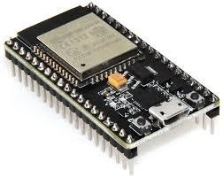

1. MG996 Servo Motor

This is a metal-geared servo that is good for robotics and automation or simply in hobby projects. The MG996 is strongly and ruggedly built with the ability to reach up to 9.4 kg-cm at 6 volts, thus ideal for heavy loads or mechanisms such as arms of a robot, wheels, or model airplane. It operates from between 4.8 V and 7.2 V and with an accurate amount of angular rotation; most have a range of 0° to 180°, although some systems can permit wider ranges. Feedback inside the motor will continue along that path for the precise position it is intended to hold in a system that demands true position control. This is because of the metal gear that extends its durability and lifetime compared to the plastic-geared competitor; hence, this model is more trusted when it comes to heavy usage or higher stresses. At 6V, the stall current is about 2.5A. A high power supply is, therefore very essential to ensure smooth working of the servo motor. They can be applied in projects of this type: robotic arms, RC vehicles, gimbals, and other motion control where great strength and precision are necessary.

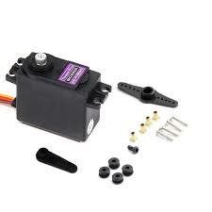

1. Ultrasonic Sensors HCSR04

HC-SR04 is the ultrasonic sensor widely available for distance measurement in different applications such as robotics, obstacle detection, and automation systems. It gives signals through ultrasonic frequencies of 40 kHz from the transmitter side and measures the time taken by the echo to reach the receiver side. This time difference helps to compute how far away an object is. The sensor can measure distances up to 400 cm and even 2 cm with accuracy around 3 mm. The HC-SR04 module is supplied with a 5V supply voltage and is typically connected to microcontrollers such as Arduino or ESP32 with four pins: VCC, GND, TRIG, and ECHO. The ultrasonic pulse is sent out by the sensor when a trigger signal is applied on its TRIG pin. The reflected signal is then received by ECHO pin, and a high pulse whose width is equal to the distance measured is produced. The HC-SR04 is popular due to its simple working principle, low cost, and reliable performance for projects like autonomous robots, security systems, and parking assistance systems.

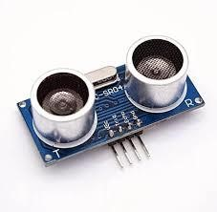

1. IR Sensor

An IR sensor is the device used for finding objects and providing distance-measuring applications by emitting and sensing infrared rays. It does this by carrying out the following actions: it emits infrared light from a channel in an IR LED; it senses it from a reflected through a photodiode or phototransistor; and back into the sensor reflecting IR light returns itself once an object within its detection range approaches it. IR sensors can be either active or passive. Active IR sensors produce their own infrared radiation, whereas the latter detect ambient infrared radiation produced by objects.

IR sensors typically operate at a voltage of 5V. In some cases therefore, applications in which such sensors are used include line-following robots and obstacle detectors, touchless switches and remote control. Its range depends on a design, though it is usually reliable within a few centimeters to a few meters range. The detection mechanism is very reliable under both daylight and low-light environments, making IR sensors applicable in a variety of automation, security, and robotic applications. Their simplicity, low cost, and versatility make them widely applied in DIY electronics and industrial systems.

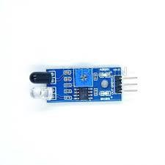

# **Software component**

It will allow a window to the real-time sensor data and control interface. Built on latest modern web technologies such as HTML5, CSS3, JavaScript, and Firebase.

Features of Web App

1. Control Buttons :-

• Operate Window buttons with state indicators of the present status, such as "Opening, Closing, Fully Closed."

1. Real-Time Sensor Data Display
   * both the ultrasonic sensors detect distance for hand detection and full-closure both
   * It will trigger an alert if there is an obstacle or the window cannot close
2. Firebase Backend:
   * a firebase real time database will continuously monitor the status of the window and value sensed by sensors at every instance of time.
3. Firebase Integration:

Data Flow:

* + A command seeking whether to open/close would be sent to Firebase and this would remind the ESP32
  + ESP32 would report periodically to Firebase regarding the latest sensor readings and window position
  + The web application would pull data from Firebase and alert the user.

# **Result and Discussion**

A report on the outcome and discussion of the project will be achieved by relating the performance of key components used in the system like ESP32, MG996 Servo Motor, HC-SR04 Ultrasonic Sensor, and IR Sensor. The results obtained in the testing phase will give an indication of whether the system is efficient by making use of ESP32 connectivity and responsiveness in controlling the devices, torque, and accuracy of the MG996 Servo Motor, along with accuracy regarding distances measured from the HCSR04 and capability of detection of the IR Sensor. Therefore, distances covered and servo angles will be very clear as there will be graphed and tabulated data.

The results will be explained in regard to theoretical predictions. Therefore, for instance, the MG996's performance under load would be compared to the spec, and its accuracy sensors will be checked if it achieves its expected performance. Any inconsistency in data, that is sensor inaccuracies when reading due to environmental causes, will be explained. Also, any limitations of the project in relation to power supply to the servo motor or a limitation to the detection range of the IR sensor will also be noted. Finally, future work will be discussed with suggestions on improvements that can be done regarding sensor placement or energy-saving elements towards enhancing overall performance and reliability of the system. Therefore, it will bring out the impacts that the contribution has and its applicability in real-life applications, involving robotics and automation fields.

# **System diagram**

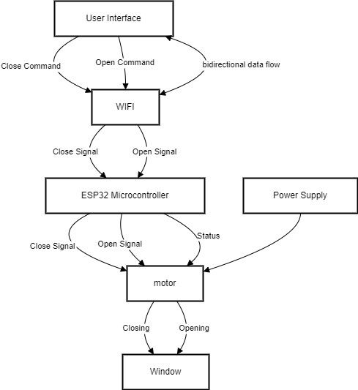

# **Conclusion**

Overall, the Smart Window Controller stands out as a proof that shows how IoT can actually be practically applied to enhance life day to day: window controlling via a web interface from a distance. Use of ESP32 also encourages efficient communication and control for energy efficiency while promoting home convenience. The immediate needs of the users are addressed by this project with other avenues for further development of home automation technologies opened. Future improvements can be done through integration with other smart home devices for a much better, automated living environment. This project is one example of the large impact the IoT solution has on modern-day life. It makes houses smarter and more responsive to users' preferences.

**References:**

1. IoT based monitoring and control system for home automation D Pavithra, Ranjith

Balakrishnan 2015 global conference on communication technologies (GCCT), 169173, 2015

1. Kar, M., & Ghosh, R. (2020). IoT based smart home automation: A survey. 2020 International Conference on Electronics and Sustainable Communication Systems (ICESC), 923–928. https://doi.org/10.1109/ICESC48915.2020.9087152
2. Kaluri, R., & Basu, K. (2020). Design of a smart home automation system using IoT. 2020 International Conference on Emerging Trends in Information Technology and Engineering (ic-ETITE)