GUIDEBOT

**Guided by Prof Nishanth Augustine1**

**Abhirami I2 , Lekshmi Mohan3 , Saigayathri J S4 ,Varsha V Raj5** 1Assistant Professor , Dept. of Electronics and Communication Engineering 2,3,4,5 Dept. of Electronics and Communication Engineering

# Abstract

Robotic guides combine artificial intelligence and advanced robotics to interact seamlessly with users and navigate complex environments. Using natural language processing (NLP), they interpret speech patterns, context, and intent to provide accurate, tailored answers. Equipped with sensors, cameras, and, they autonomously map surroundings, avoid obstacles, and adapt to changes. These guides are used in spaces like airports, malls, museums, healthcare, and education to assist with navigation and interactive learning. Despite challenges like data privacy and diverse user needs, future advancements aim to enhance adaptability, contextual understanding, and intuitive interfaces, transforming navigation and interaction in complex spaces.

**Keywords**: Campus Navigation, Real-Time Guidance, Natural Language Processing (NLP), Artificial Intelligence (AI), Visitor Assistance, Interactive Maps, Digital Campus Support.

# Introduction

The Guide Bot is an advanced navigation and communication system designed for college campuses. It provides real-time route guidance through interactive maps displayed on a monitor and offers verbal assistance for route-related queries. By leveraging Machine Learning and other technologies, the Guide Bot ensures a seamless and efficient navigation experience for both new and returning visitors, helping them explore the campus with ease and confidence.

# Proposed Work

The Guidebot system is an intelligent, AI-powered digital assistant designed to improve campus navigation, information accessibility, and visitor interaction in educational institutions. Large and complex college campuses often pose significant challenges for students, visitors, and staff in locating departments, facilities, or administrative offices. Traditional methods such as static maps, printed signage, and manual assistance are often inefficient, time-consuming, and unable to provide real-time information. The proposed Guidebot system aims to address these issues by offering interactive navigation assistance, real- time query resolution through the integration of Artificial Intelligence (AI), Natural Language Processing (NLP), and Machine Learning (ML) technologies.

# Scope and Relevance

The Guidebot is designed to improve navigation and communication for the LBS College community, catering to students, parents, faculty, staff, and visitors. It offers real-time route guidance, course details, and information on admissions, academic programs, and student services. Parents can access key academic dates, student well-being resources, and campus policies, while faculty and staff benefit from tools for managing schedules, announcements, and departmental information. Visitors can easily find directions, event details, and campus amenities.

Using advanced AI and machine learning, the Guidebot provides accurate responses through natural language processing (NLP) and seamless navigation via interactive campus maps. It will integrate with existing college databases to

offer up-to-date information on programs, events, and facilities. Future enhancements may include voice-based interaction, expanded query handling, and personalized responses to cater to a broader range of user needs efficiently.

# Objective

## Specific Objectives

The specific objective of the Guide Bot is to enhance campus navigation by providing real-time, turn-by-turn directions and interactive mapping. It ensures accessibility by offering optimized routes for users with disabilities and delivers contextual assistance for complex location queries. Additionally, the bot serves as an information hub, providing details on academic programs, admissions, faculty, and campus services. It improves the visitor experience by sharing event updates and real-time information while enabling seamless interactions through Natural Language Processing (NLP).

The system boosts efficiency with 24/7 availability, instant responses, and simplified interfaces. Leveraging advanced AI and machine learning, the Guidebot continuously learns from interactions, improving accuracy and adaptability. By integrating with college databases, it fetches real-time academic schedules, events, and resources. A feedback mechanism allows users to provide ratings and suggestions, ensuring iterative updates and feature refinement. Ultimately, the Guidebot streamlines information access, enhances navigation, and improves overall user experience on campus.

## Broad Objective

The primary objective of the Guidebot is to enhance the overall campus experience by providing efficient, accessible, and user-friendly assistance for navigation and information retrieval. By leveraging advanced technologies such as Artificial Intelligence, Machine Learning, and Natural Language Processing, the Guidebot aims to streamline campus navigation, offer real-time updates, and serve as a comprehensive virtual assistant for students, staff, visitors, and prospective applicants. It seeks to ensure inclusivity, improve operational efficiency, and foster better engagement by delivering accurate, real-time responses to a wide range of queries related to academic programs, events, campus facilities, and admission processes.

# Methodology

**User Interaction (Rasa):** The robot uses Rasa to handle user interactions. When a user asks for directions or route information, Rasa processes the request, identifying the user's intent and any specific details needed (like starting and ending locations).

**Route Calculation (Mapping API):** After identifying the user's request, the robot integrates with a mapping API (such as Google Maps API or OpenStreetMap) to calculate the route. The API returns the route information, including a visual map and step-by-step instructions.

**Display on LCD Screen:** The robot receives the route data and map image from the mapping API. It then sends this information to the 7-inch LCD screen, which displays the route map and instructions, allowing the user to easily follow along.

This system enables the robot to effectively provide navigation assistance through visual aids on the LCD screen.

**Speech-to-Text (Google Speech-to-Text):** The user speaks into a microphone, and the robot captures this audio. Google Speech-to-Text (STT) processes the audio input and converts it into text, which the robot uses as input to understand the user's command.

**Natural Language Processing and Response (Rasa):** The text is sent to Rasa, where it identifies the user’s intent and extracts any important details. Based on this, Rasa generates an appropriate text-based response. This response determines the robot's next action or reply.

**Text-to-Speech (pyttsx3) and Output:** The response text from Rasa is passed to pyttsx3, which converts it into speech. The robot then outputs this speech through its speaker, effectively communicating the response back to the user.

**Face Detection (Haar Cascade):** The robot uses the Haar Cascade algorithm to detect faces in real-time from a video feed, identifying facial features like eyes and edges to locate the face.

**Response Generation (Rasa):** Once a teacher is detected, Rasa generates a personalized response, such as greeting the teacher by name or offering relevant information, based on who has been identified.

**Gesture Triggering (Rasa):** When a user is detected, Rasa processes the interaction and triggers the greeting gesture, such as a hand wave, based on user input or recognized faces.

# Software Requirements

* + Jupyter Notebook is an open-source, web-based interactive environment used for creating and sharing documents that contain live code, equations, visualizations, and narrative text. It is widely used in data science, research, machine learning, and education for interactive computing and documentation. In a Jupyter Notebook, you can write and execute code in "cells," which can contain code (typically in Python, but also other languages like R, Julia, and more). The output of the code, such as graphs, tables, or text, is displayed immediately below the cell, making it highly interactive and ideal for data exploration and visualization.
  + The **Anaconda Prompt** is a command-line interface that allows users to manage environments and install packages within the Anaconda ecosystem. It simplifies the process of creating and switching between virtual environments, installing libraries, and running Python scripts. **Jupyter Notebook** is an interactive, web-based environment that allows you to write and execute Python code in an organized, cell-based format. It’s widely used for data analysis, machine learning, and research, allowing users to combine executable code, text explanations, visualizations, and even equations in a single document.
  + Python is the primary language for developing this project’s backend. It provides an extensive ecosystem of libraries necessary for machine learning, data manipulation, and web development.
  + The **Arduino IDE** (Integrated Development Environment) is a software application that allows users to write, compile, and upload code to Arduino microcontrollers. Arduino is an open-source platform used for building

electronics projects, and the IDE provides the interface for programming the Arduino boards.

# Result

The Guidebot for College successfully integrates multiple advanced technologies to create a comprehensive solution for campus navigation and information retrieval. The Google Speech Recognition API makes the bot easy to use through voice commands. RASA ensures the bot can understand and respond to a wide range of queries in natural language, and Pyttsx3 provides text-to-speech functionality for accessibility. Through the use of QR codes, users can quickly access relevant campus information, making it easier to navigate the campus and stay informed about events and schedules. The guidebot improves the overall user experience by offering an interactive, intuitive, and accessible platform for both new and returning users.

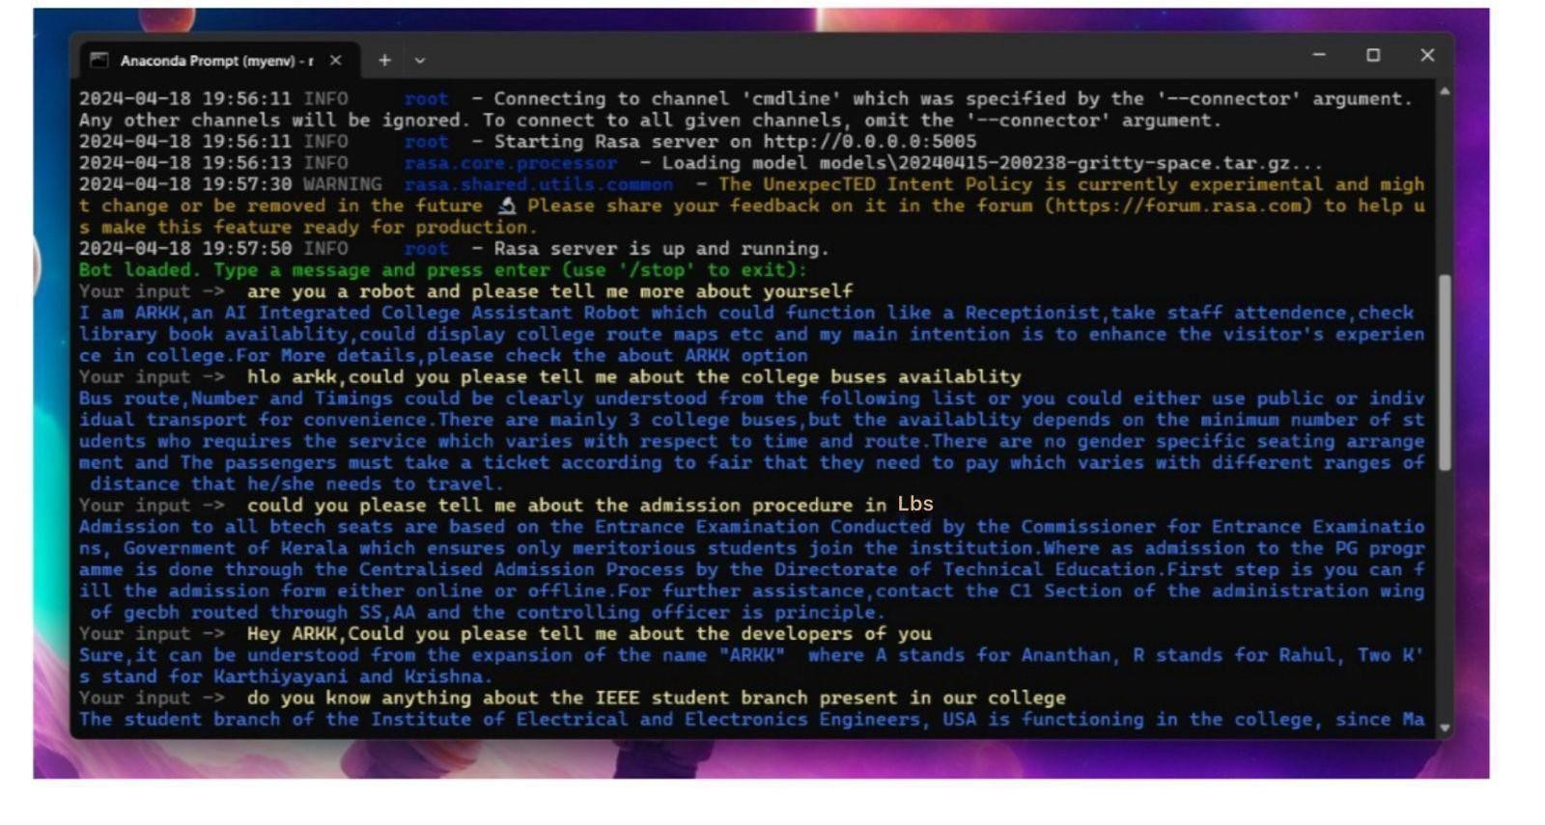

***Fig: Chatbot using RASA Framework***

***Fig:Infrastructure of the GUIDEBOT***

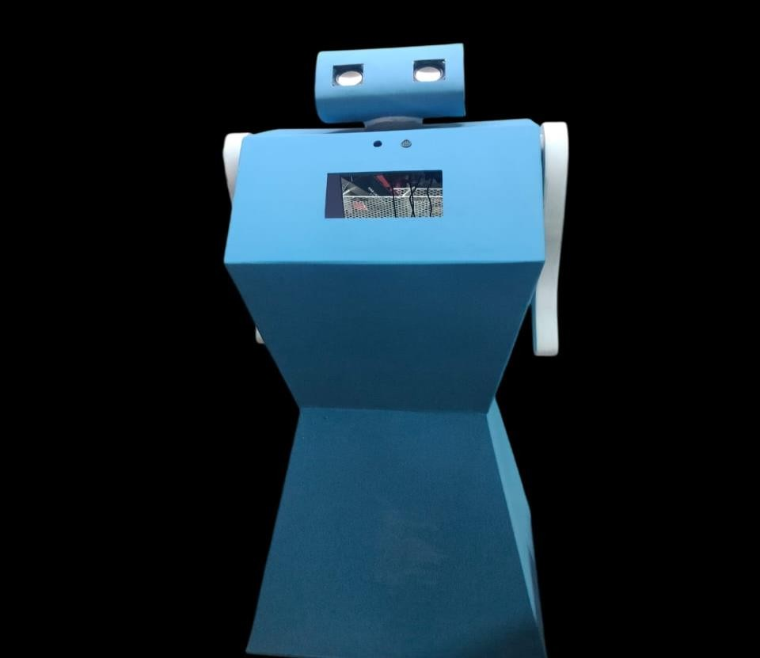***Fig: Structure of the GUIDEBOT***

# Conclusion

The College Guide Bot integrates advanced technologies to enhance campus navigation and user experience. Using the Haar Cascade Algorithm and LBPH, it enables facial detection for assistance. Google Speech Recognition API allows hands-free interaction, while the RASA framework ensures context-aware responses through NLP. Pyttsx3 enhances accessibility with text-to-speech capabilities. Additionally, QR codes provide quick access to location-specific information. Together, these features create an intuitive, interactive, and efficient solution for seamless campus navigation.

# Reference

1. Stock-Homburg, R. “Survey of Emotions in Human–Robot Interactions: Perspectives from Robotic Psychology on 20 Years of Research”. Int J of Soc Robotics 14, 389–411 (2022).
2. Biel Piero E. Alvarado VÃ¡squez, Fernando MatÃa, “A tour-guide robot: Moving towards interaction with humans”, Engineering Applications of Artificial Intelligence,Volume 88, 2020.
3. López J, Pérez D, Santos M, Cacho M. GuideBot. “A Tour Guide System Based on Mobile Robots”. International Journal of Advanced Robotic Systems. 2013.
4. V. Brydinskyi, D. Sabodashko, Y. Khoma, M. Podpora, A. Konovalov and V. Khoma, "Enhancing Automatic Speech Recognition With Personalized Models: Improving Accuracy Through Individualized Fine-Tuning," in IEEE Access, vol. 12, pp. 116649-116656, 2024
5. M. S. E and N. V, "Performance Analysis of Human Emotion via Speech Recognition using Convolution Neural Network Algorithm compared with Hidden Markov Model Classifier for Improved Accuracy," 2023 9th International Conference on Smart Structures and Systems (ICSSS),CHENNAI, India, 2023
6. S. K. Barnwal and P. Gupta, "Evaluation of AI System’s Voice Recognition Performance in Social Conversation,"5th International Conference on Contemporary Computing and Informatics (IC3I), Uttar Pradesh, India 2022.
7. G. K. Berdibaeva, O. N. Bodin, V. V. Kozlov, D. I. Nefed'ev, K. A. Ozhikenov and Y. A. Pizhonkov, "Pre-processing voice signals for voice recognition systems," 2017 18th International Conference of Young Specialists on Micro/Nanotechnologies and Electron Devices (EDM), Erlagol, Russia, 2017.
8. S. S. Chittibomma, R. Kishan Surapaneni and A. Maruboina, "Facial Recognition System for Law Enforcement: An Integrated Approach Using Haar Cascade Classifier and LBPH Algorithm," 2024 International Conference on Advancements in Power, Communication and Intelligent Systems (APCI), KANNUR, India, 2024.
9. A. M. Irfan, S. A. Deshmukh, H. D. Goel, G. M. Vernekar, S. S. Thomas and

R. A. Patil, "Comparative Analysis of Face Recognition Algorithms: Evaluating LBPH and FaceNet with Haar Cascade," 2023 14th International Conference on Computing Communication and Networking Technologies (ICCCNT), Delhi, India, 2023.

1. A Kumar and D. Singh, "Comprehensive approach of real time web-based face recognition system using Haar Cascade and LBPH algorithm," 2023 International Conference on Device Intelligence, Computing and Communication Technologies, (DICCT), Dehradun, India, 2023.
2. S. Patil and K. H. S, "Implementation of LBPH Algorithm for Covid Patient Isolation Violation Detection," 2022 IEEE 7th International Conference on Recent Advances and Innovations in Engineering (ICRAIE), MANGALORE, India, 2022, pp. 20-24.
3. S. Meshram, N. Naik, M. VR, T. More and S. Kharche, "College Enquiry Chatbot using RasaFramework," 2021 Asian Conference on Innovation in Technology (ASIANCON), PUNE, India,2021.
4. Y. Mellah, T. Bouchentouf, N. Rahmoun and M. Rahmoun, "Bilingual Chatbot For Covid-19 Detection Based on Symptoms Using Rasa NLU," 2022 2nd International Conference on Innovative Research in Applied Science, Engineering and Technology (IRASET), Meknes, Morocco, 2022.
5. L. Fauzia, R. B. Hadiprakoso and Girinoto, "Implementation of Chatbot on University Website Using RASA Framework," 2021 4th International Seminar on

Research of Information Technology and Intelligent Systems (ISRITI), Yogyakarta, Indonesia, 2021.

1. V. M. Reddy, T. Vaishnavi and K. P. Kumar, "Speech-to-Text and Text-to- Speech Recognition Using Deep Learning," 2023 2nd International Conference on Edge Computing and Applications (ICECAA), Namakkal, India, 2023.