**Enhancing the Dynamic Response Servo Positioning System Using Internal Model Control Based Compensator: A Case Study of HDD**

**Muoghalu, C. N. and Achebe, P. N.**

Department of Electrical and Electronic Engineering, Chukwuemeka Odumegwu Ojukwu University, Uli, Nigeria

**ABSTRACT**

This paper presents improving the head position servo control system of hard disk drive (HDD) using adaptive mechanism. The dynamic model of HDD servomechanism was presented as a transfer function to describe the behaviour of the R/W head position servo of the hard drive in a computer system. An internal model control tuned compensator was designed. Simulation analysis was conducted for conventional control state of the R/W head positioning of the HDD. The performance of the system was largely impacted by cycling which resulted in instability and therefore maintaining accurate track for efficient read and write operation was not guaranteed. Notwithstanding fast response in terms of very much reduced rise time of 0.0373 s, the step response performance of the uncompensated system indicated high overshoot of 95.4% and extended settling time of 9.13 s. Besides, the system in this situation was not able to track the desired position, which in this case, is represented by a step input and thereby yielding a final value of 0.0113 that caused steady state error of 0.9887. With the introduction of the designed IMC based compensator, the performance of the system was largely improved such that the rise time, settling time, overshoot, and steady state error were: 0.283 s, 0.492 s, and 0 overshoot and steady- state error. Comparison with MRAC-PID and PID revealed the superiority of the IMC over the two previously implemented controllers.

**Keywords:** Hard Disk Drive, Positioning System, Internal Model Control, PID.

1. **INTRODUCTION**

Most servo systems in their classical state of design are usually not capable to meet certain desired performance criteria that will make them practically attractive for practical application for commercial purposes. For this reason, subsystem called controller or compensator are usually integrated within most industrial plants or processes. The same holds for majority of engineering systems. For instance, in electrical discharge machining controller is implemented to ensure accurate and proper positioning and speed control of the metal removal process [1]. In microsatellite attitude control system, adaptive proportional and derivative (APD) controller is implemented as subsystem to meet performance criteria [2], while satellite antenna positioning control systems have used controllers such as, Proportional plus integral plus derivative (PID) and linear quadratic regulator (LQR) controllers respectively [3,4]. The stabilization of human heart based on mathematical model has been achieved by PID [5]. In this study, the focus is on using a feedback compensator to enhance a servo system, which in this case is a hard disk drive (HDD).

The prevalent trend in hard disk design is towards smaller hard disks with increasingly larger capacities. This implies that the track width to be smaller, which leads to lower error tolerance in the positioning of the head. In order to meet with increasingly demand in hard disk drives, the most important change in hard disk drive technology has been carried out with an increase in data storage density. The HDD applications are expected to be seen in digital camera, car navigation and audio systems, and even mobile phones in the near future due to the ever increasing effort of HDDs areal density. The servo system must achieve precise positioning of read-write head (R/W) on a desired track (track following) and fast transition from one track to another targeted track (track seeking) within shortest track seeking time for faster data transmission rates.

Most of the servo systems in hard HDD use a voice-coil motor (VCM) actuator to actuate the read/write (R/W) recording arm assembly which consists of a pivot with a ball bearing, a metal arm, and a rigid suspension that holds the R/W head and slider. In order to come up with devices that are smaller, cheaper and able to store more data and retrieve them with faster speed, the presence of friction in the rotary actuator pivot bearing becomes a more noticeable problem in the HDD industries. The pivot friction hysteresis nonlinearity introduced by the bearing of the actuator pivot results in large residual errors and high-frequency oscillations, which may produce larger positioning error signal to hold back the further decreasing of the track width and to deteriorate the performance of servo systems. Thus, it is highly desirable to design a position control algorithm to address the resulting positioning error. Thus, this work is designed to improve the position of HDD using internal model control (IMC) tuning mechanism.

The primary objective of HDD is to ensure effective dynamic response for R/W head operation by means of accurate positioning control. This type of control is essentially desirable in such area as antenna positioning system where different control strategies such as digital cascade compensator, proportional integral and derivative (PID) controller, model predictive control (MPC), back propagation neural network tuned PID have been implemented [6-9] and in robot grinding system where linear quadratic regulator [10]. For HDD, dynamic response of R/W head tracking system has been improved by a good number of methods. Instances include the use of model reference adaptive control (MRAC) to improve R/W head servo positioning system [11] and [12]. A state feedback-based optimal control scheme for two typical kinds of head-positioning systems with nonlinearities of hard disk drives that combine the improved event-triggering reset condition and an optimal reset law design problem was developed in [13]. Three actuation systems with different combinations of proportional plus integral (PI), proportional plus derivative (PD), and PID controller, lag-lead controller, lag filter, and inverse lead plus a PI controller were designed and analyzed through simulation to achieve high-precision positioning in HDD [14]. A tracking controller for dual stage-actuator HDDs based on a frequency domain data-driven feedback control design technique was presented in [15]. Head positioning control for HDDs with dual-stage actuator using stroke controller was achieved by [16]. Multi-input multi-output (MIMO) data driven feedback control system to achieve improved robust and performing tracking following in R/W head positioning for dual stage HDDs was presented in [17].

1. **SYSTEM DESIGN**

In this paper, the main tools employed are the MATLAB codes and the Simulink embedded blocks, which were used for the computer modelling and simulations. In order to determine the stability of the system, a transfer function representing the dynamics of the HDD head position was developed and a root locus plot was performed using the MATLAB codes, and also included is the open loop step response analysis of the system. The generated transfer function was subsequently implemented using MATLAB/Simulink.

**2.1 Dynamic Modelling**

The VCM is a direct current (DC) motor, thus Figure 1 shows the circuit arrangement of a DC motor in order to define the mathematical relationship between the rotary actuator torque and the coil current.

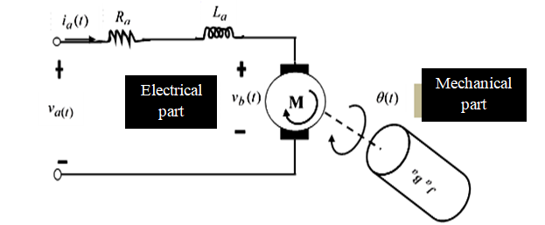

Figure 1 Circuit diagram of DC motor

It can be seen from Figure 1 that the DC motor circuit diagram is of two parts comprising the electrical and mechanical components. Thus the equation that connects the rotary actuator torque and the coil current (which is the armature current of the DC motor) is given by:

 (1)

whereis the torque constant, and  is the VCM coil current (or armature current).

The motion of the rotary actuator torque is defined by:

 (2)

whereis the moment of inertia of the head assembly,  is the viscous damping coefficient of the bearing, is the return spring constant, and  is the angular displacement or position.

Equating (1) and (2) gives the mathematical model of HDD servo system given by the following differential equation:

 (3)

Taking the Laplace transform of Equation (3) assuming zero initial conditions, gives:

 (4)

Rearranging Equation (4) as a transfer function expression of HDD head position servo system gives:

 (5)

Substituting the values of the model parameters of HDD read/write head positioning servo system taken from [18] as presented in Table 1 gives:

 (6)

**Table 1.** System parameters [18]

|  |  |  |
| --- | --- | --- |
| Definition | Symbol | Value |
| Rotary actuator (motor)torque |  | - |
| Coil current |  | - |
| Motor torque constant |  | 9.0 Nmrad-1 |
| Moment of inertia of the head assembly |  | 1.0 kgm2 |
| Viscous damping coefficient |  | 0.85 Nmrad-1s-1 |
| Spring constant |  | 788 Nmrad-1 |
| Angular displacement |  | - |

**2.2 Internal Model Control Tuned Compensator**

In control system, a compensator is used when the response is very unstable and requires to be stabilized so as to ensure particular performance is realized. The HDD servo-positioning system considered is prone to high level of oscillation without a compensator. There is need to cancel this effect by introducing Internal Model Control (IMC) tuned compensator. The design of the compensator was carried using the MATLAB control and estimation tool manager (CETM) and subsequently introduced to HDD servo-positioning control loop to enhance the dynamic response of the system. The use of CETM in compensator design has been performed in [19-21]. The structure of the IMC compensator control HDD R/W head system in MATLAB/Simulink is shown in Figure 2. The approach to the designed compensator via dominant closed-loop time constant adjustment and desired controller order is shown by the graphical user interface (GUI) in Figure 3.

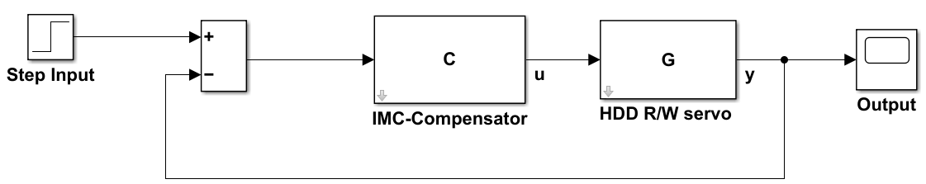

Figure 2: Designed IMC-compensator based HDD system

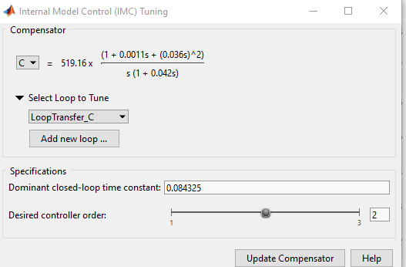

Figure 3 Graphical user interface (GUI) of the designed IMC-compensator

The mathematical expression of the designed compensator, C(s) and the closed-loop transfer function of the designed system are given by:

$C\left(s\right)=519.16\frac{\left(1+0.0011s+{(0.036s)}^{2}\right)}{s(1+0.042s)}$ (7)

$L(s)=\frac{140.63(s^{2}+0.85s+788}{{\left(s+11.86\right)}^{2}(s^{2}+0.85s+788)}$ (8)

With the system designed, performance comparison was performed with previously implemented MRAC-PID and PID control systems presented in [12]. The Simulink Model for the computer based simulation comparison analysis is shown in Figure 4.

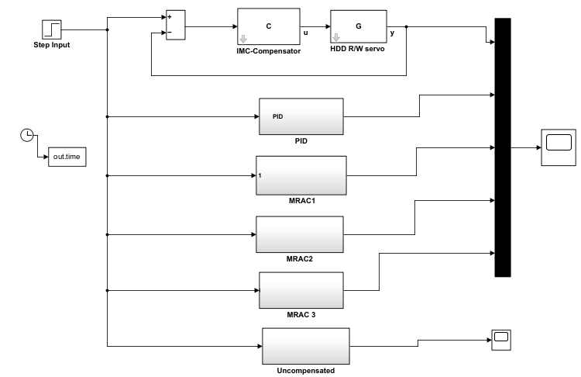

Figure 4: Simulink model of different control systems for HDD servo-positioning system

1. **RESULTS AND DISCUSSION**

This section presents the results of the simulations conducted in MATLAB/Simulink for the performance analysis of the read/write head position of HDD system. Simulations were basically performed for open loop and closed loop scenarios. In the open simulation analysis the HDD system was assumed to be operating without a feedback network and it was regard as uncompensated system (Sys1). The simulation curve and numerical analysis for the uncompensated system are shown in Figure 5 and Table 2. In the closed loop model (regarded as compensated), the designed IMC tuned compensator and other control methods were separately integrated with the HDD and the resulting dynamic response curves are shown in Figure 6. The numerical analysis of the performance of each of the control algorithm is listed in Table 3.

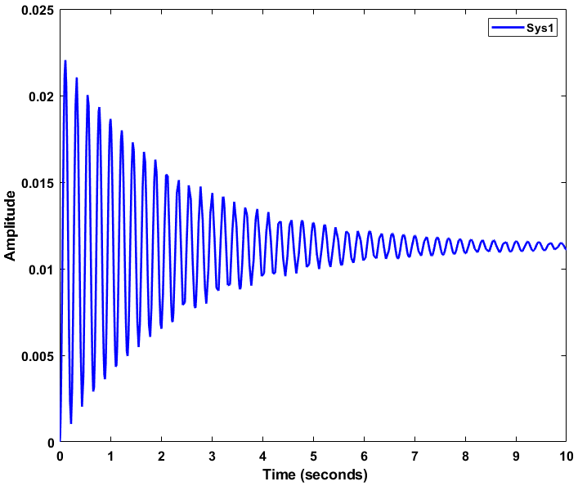

Figure 5: Step response of HDD system (uncompensated)

**Table 2**. Dynamic response parameters for HDD system in uncompensated state

|  |  |
| --- | --- |
| Parameter | Value |
| Rise time | 0.0373 s |
| Overshoot | 95.4% |
| Settling time | 9.13 s |
| Final value | 0.0113 |
| Steady state error | 0.9887 |

The performance evaluation of the response of the HDD servo positioning system dynamic response in Figure 5 is listed in Table 2. It can be seen that the system in this state is marred significant cycling or oscillation of the R/W head of the HDD operation as can be seen is very much high and overshooting the desired tracking value by 95.4%. This oscillation results in system instability and can cause undesirable positioning of the R/W head of the HDD on appropriate track. The HDD positioning performance efficiency will be largely affected by this effect.

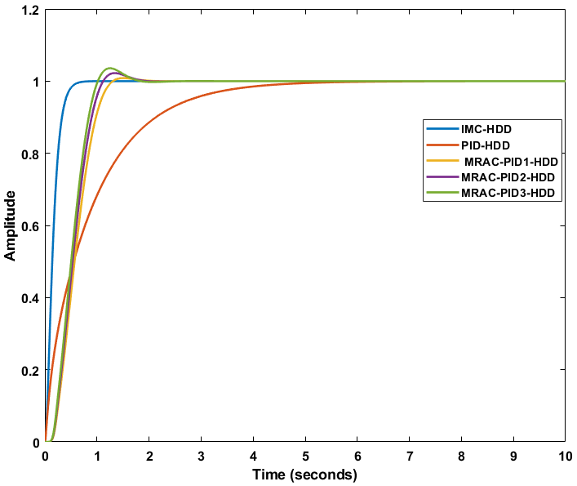

Figure 6 Responses of different HDD servo-positioning control systems

Table 3 Numerical performance comparison of IMC, PID, and MRAC control methods

|  |  |  |  |  |  |
| --- | --- | --- | --- | --- | --- |
| Parameter | PID | IMC | MRAC-PID1 | MRAC-PID2 | MRAC-PID 3 |
| Rise time (s) | 0.3169 | 0.283 | 0.0894 | 0.0415 | 0.0066 |
| Overshoot (%) | 0 | 0 | 0.85 | 1.1 | 1.15 |
| Settling time (s) | 2.51 | 0.492 | 1.45 | 1.45 | 1.45 |
| Final value | 1.0000 | 1.00 | 1.0000 | 1.0000 | 1.0000 |
| Steady state error | 0 | 0 | 0 | 0 | 0 |

Figure 6 is the step response performances of the designed IMC tuned compensator, PID controller, and MRAC-PID based controllers. Looking at the simulation curves in Figure 6 and numerical analysis of the curves in Table 3, it can be seen that the IMC compensator outperforms the PID in terms of all the time domain parameters except the percentage overshoot wherein both produced the same effect. Also, the IMC based compensator offered better performance than the MRAC-PID based controllers in terms for dynamic response parameters except rise time. Thus, the comparison showed that the IMC compensator provides most effective performance for the R/W head function.

The observations from the simulation test conducted are that: considering the step response curve of the transient characteristics of the HDD system without controller as shown Figure 5, the R/W operation of HDD will not be effective. Thus, for effective tracking in HDD, a servomotor based positioning system to improve the dynamic characteristics of the system is required. The performance of IMC compensator proves the robustness and the ability of the designed scheme to provide improved dynamic response to R/W head positioning of HDD. The simulation analysis of the designed controller with PID and MRAC-PID controller has shown that the IMC-compensator provides better robust control process effect in the for HDD system.

1. **CONCLUSION**

In this paper, the read/write (R/W) head position servo control system of hard disk drive using has been managed using IMC compensator. The mathematical equation of hard disk drive servomechanism was respected as a transfer function to describe the dynamic behaviour of the R/W head position servo of hard drive in a computer system. An IMC system was designed. The IMC was introduced to improve R/W operation of HDD. The system was modelled using control and estimation tool manager in MATLAB/Simulink environment for the purpose of analyzing its effectiveness. The evaluation of the performance of the HDD system was basically performed under two conditions that include open loop (or uncompensated system) and closed loop control. The designed compensator was implemented and it was observed that the IMC can used to effectively improve the performance of the R/W head positioning of HDD. The proposed control scheme was further compared with the popular PID control technique and MRAC-PID based controllers, where it proved to be superior.

**REFERENCES**

1. Achebe, P. N. (2019). Simulation of Electrical Discharge Machine (EDM) Process Pulse Generator Profile. International *Journal of Science and Management Studies*, *2*(1), 43-47.
2. Achebe, P. N. and Muoghalu, C. N. (2025). Design of Adaptive PD Controller for Microsatellite Yaw Axis Attitude Control System. *International Journal of Engineering Research and Development, 21*(2), 225-232.
3. Muoghalu, C. N. and Achebe, P. N. (2021). Two-Phase Hybrid Stepping Motor Based Antenna Positioning Control System Using Proportional Integral and Derivative Controller. *Iconic Research and Engineering Journals 4*(1), 152-157.
4. Anyanwu, K. U., Muoghalu, C. N., Ozumba, E. C., and Onuoha, M. K. (2024). Design of Discrete-time LQR for Optimal Positioning Control of Deep Space Satellite Antenna. *International Journal of Academic Engineering Research, 8*(8), 56-61.
5. Muoghalu, C. N., Achebe, P. N., and Okafor, C. S. (2024). Human Heart Stabilization using Mathematical Based Model with Proportional Integral and Derivative Controller. *International Journal of Latest Technology in Engineering, Management & Applied Science, 13*(3), 1-9. I: <https://doi.org/10.51583/IJLTEMAS.2024.130301>
6. Achebe, P. N. (2018). Design of Digital Cascade Compensator for Ground Station Satellite Antenna Servo Control System. *International Journal of Latest Engineering Science (IJLES), 1*(3), 26-31.
7. Muoghalu, C. N., and Achebe, P. N. (2021). Two-phase hybrid stepping motor based antenna positioning control system using proportional integral and derivative controller . *IRE Journals, 4*(10), 152-157
8. Onyeka, E. B., Chidiebere, M., & Achebe, P. N. (2018). Performance improvement of antenna positioning control system using model predictive controller. *European* *Journal of Advances in Engineering and Technology, 5*(9), 722-729.
9. Eze, P. C., Obichere, J. K., Mbonu, E. S., and Onojo, O. J. (2024). Positioning Control of Satellite Antenna for High Speed Response Performance. *IPTEK, The Journal of Engineering, 10*(2), 119-136. <http://dx.doi.org/10.12962/j23378557.v10i2.a20670>
10. Achebe, P. N. and Muoghalu, C. N. (2024). State-space modelling and control of two-phase hybid stepping motor for robot grinding using LQR controller. *International Journal of Academic Information Systems Research,8*(4), 132-136.
11. Eze, P. C., Ugoh, C. A., Ezeabasili, C. P., Ekengwu, B. O., & Aghoghovbia, L. E. (2017). Servo Position Control in Hard Disk Drive of a Computer Using MRAC Integrating PID Algorithm. *American Journal of Science, Engineering and Technology*, *2*(4), 2017, 97-105.
12. Onyekwelu, C. I., Nwabueze, C. A., Muoghalu, C. N., & Ekenwu, B. O. (2023). Model reference adaptive control based PID controller for hard disk drive read/write head servo positioning system. International Journal of Academic Multidisciplinary Research, 7(8), 135-144.
13. Wang, H., Zhu, F., & Tian, Y. (2018). Event-triggered optimal reset control of hard disk drive head-positioning servo systems *Journal of Systems and Control Engineering, 233*(5), 582–590.
14. Hossain, A. & Rahman, Md. A. (2019). Comparative Analysis among Single-Stage, Dual-Stage, and Triple-Stage Actuator Systems Applied to a Hard Disk Drive Servo System. *Actuators, 8*(65), 1-17.
15. Prakash, N. P. S., Seo, J., Rose, A., & Horowitz, R. (2023). Data-driven track following control for dual stage-actuator hard disk drives. arXiv:2304.00720v1 [eess.SY] 3 Apr 2023
16. Yabui, S., Atsumi, T., & Inoue, T. (2019). Stroke oriented controller design for dual-stage actuator of head positioning control system in hard disk drives. *International Federation of Automatic Control (IFAC), 52*(15), 573–578. <https://doi.org/10.1016/j.ifacol.2019.11.737>
17. Shah, P., Chen, Z., & Horowitz, R. (2020). Application of MIMO data driven feedback control design to dual stage hard disk drives. *ASME 2020 Dynamic systems and Control Conference, 1*, 10-18. <https://doi.org/10.1115/DSCC2020-3260>
18. Christian C. M., Afred E. O, and Chimezirim O. A. (2015). Compensator for Optimum Hard Disk Read/write Head Positioning and Control*. International Journal of Scientific and Engineering Research,* *6*(4), 697-692.
19. Achebe, P. N. (2019). Performance Improvement of Automatic Voltage Regulator using Two Loop Configuration. *International Journal of Latest Engineering Science, 2*(1), 12-17.
20. Muoghalu, C.N., Uju, I.U. and Mbachu, C.B. (2020). Performance Response Improvement of Automatic Voltage Regulator Using Linear Quadratic Gaussian Tuned Controller. *International Journal of Latest Technology in Engineering, Management & Applied Science, 9*(11), 6-12.
21. Onyeka, E. B., Chidiebere, M., and Nkiruka, A. P. (2018). Improved Response Performance of Two-Phase Hybrid Stepping Motor Control Using PID Tuned Outer and Inner Loop Compensators. *Journal of Engineering Sciences, 6*(1), D 1–D 6. DOI: 10.21272/jes.2019.6(1).d1