Addis Ababa Science and Technology University

College ff Architecture and Civil Engineering

Department Of Water Supply and Sanitary Engineering

**Jatani Bonaya Godana1, Getahun Tadesse Gobezu2, Tilahun Woldslassie Wondafrash3, Sisay Demeku (PhD)4**

**Correspondence author:**

Dilla University, Ethiopia

Faculty of Engineering and Technology

Department of Hydraulic and Water Resources Engineering

[jatanibonaya797@gmail.com](mailto:jatanibonaya797@gmail.com) or [jatanib@du.edu.et](mailto:jatanib@du.edu.et) ORCID: 0000-0002-5310-7042

**Title: Rooftop Rain Water Potential Assessment for Non-Domestic Use: A Case of Addis Ababa Science and Technology University**

# Abstract

*This study investigates the potential of rooftop rainwater harvesting (RWH) at Addis Ababa Science and Technology University (AASTU) as a sustainable and scalable solution to address pressing water and energy conservation challenges. By leveraging harvested rainwater for non-domestic applications, particularly landscaping, the research aims to mitigate water scarcity and reduce reliance on conventional water sources. Utilizing ground-based measurements and ArcGIS spatial analysis, the total rooftop area at AASTU was quantified at 68,195.74 m². Analysis of rainfall data from the Ethiopian Meteorology Agency (Akaki station) revealed an estimated annual rainwater harvesting potential of 662,273.4 m³, which substantially exceeds the university’s annual irrigation demand for landscaping (184,830.33 m³). These results highlight the viability of RWH as a robust strategy to supplement water supplies, enhance resource efficiency, and promote sustainable water management practices. The study emphasizes the critical role of RWH in addressing water scarcity, optimizing resource utilization, and advancing environmental sustainability at institutional scales. AASTU’s implementation of RWH serves as a replicable model for integrating innovative water conservation technologies into broader sustainability initiatives, offering valuable insights for similar institutions in water-stressed regions.*

**Keywords**: Rooftop rainwater harvesting, non-domestic water use, Water scarcity solutions, GIS analysis, Sustainable water management

# **1. INTRODUCTION**

## 1.1 Background

Water is an essential resource for sustaining life and is critical to social, economic, and environmental well-being. Despite covering a third of the planet, only 0.3% of Earth's water is fresh and accessible, making it a limited and precious resource. As global population pressures increase, access to potable water remains a challenge for many communities, often resulting in health risks and environmental degradation. To address these challenges, sustainable solutions like rooftop rainwater harvesting have gained significance.

Rooftop rainwater harvesting involves capturing and storing rainwater from roof surfaces for domestic, non-domestic, and irrigation purposes. (water, 2020). This method reduces reliance on groundwater, minimizes runoff-related issues, and offers an efficient, cost-effective, and environmentally friendly alternative for water management (Sharma, 1988). In areas like Addis Ababa Science and Technology University (AASTU), where centralized water systems are limited, rainwater harvesting provides a practical means of addressing water scarcity while contributing to environmental conservation.

## 1.2 Statement of the Problem

Ethiopia, often referred to as the water tower of Africa, faces significant water resource challenges, with much of its potential remaining untapped. Nationally, water scarcity is severe, compounded by the fact that only 3% of the world’s water is fresh, and merely 0.7% is usable due to climatic and geographic limitations. At AASTU, the situation is critical. Treated water, legally designated for domestic purposes under Ethiopian Water Resources Management Proclamation No. 197/2000, is being diverted for non-domestic uses, such as plant irrigation and car washing (Gazeta., 2000) This misuse results in a staggering weekly loss of approximately 352,730 liters (352.73 m³) of treated water further straining the already insufficient supply. Such practices highlight the urgent need for sustainable alternatives like rooftop rainwater harvesting to alleviate water scarcity, reduce dependency on treated water, and ensure compliance with national water use regulations.

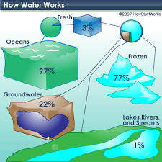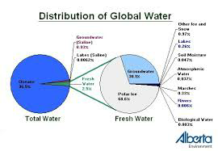

Figure Distribution of global water

Globally, water resources are abundant in quantity but limited in quality, making freshwater scarce. Of the 3% that is freshwater, 77% is trapped in polar ice, 22% is costly groundwater, and only 1% is readily available for living organisms and transportation. (Data, 2023). To address this scarcity, rooftop rainwater harvesting offers a practical solution. This research aims to explore this solution and answer the following questions:

1. To what extent can the problem of water supply services at AASTU be minimized through rooftop rainwater harvesting?
2. Which method is more accurate and effective for determining the roof catchment area?
3. How can an alternative water supply be provided for non-domestic uses to reduce the pressure on treated or potable water at the AASTU campus?
4. By what percentage can rooftop rainwater harvesting decrease the water demand load on potable water?

**Objective of the Study**

**General Objective**

* To estimate the contribution of rooftop rainwater harvesting in addressing water demand at Addis Ababa Science and Technology University (AASTU).

**Specific Objectives**

1. To estimate the rooftop catchment area using Google Earth procedures and ground measurements.
2. To calculate the potential amount of rainwater harvested from rooftop areas.
3. To assess the water demand for campus greenery and car washing.
4. To provide design parameters for rooftop rainwater harvesting to support future water resource management initiatives.

**Significance and Scope of the Study**

This research addresses water scarcity at Addis Ababa Science and Technology University (AASTU) by exploring rooftop rainwater harvesting as a sustainable solution to reduce reliance on treated water. It focuses on non-domestic uses such as irrigation, gardening, and car washing while promoting water conservation awareness. The study is limited to evaluating rooftop rainwater harvesting within AASTU's premises to support improved water resource management.

# **METHODOLOGY**

## 3.1 Description of the Research Area

### 3.1.1 Location

Addis Ababa Science and Technology University (AASTU), established in 2011, is one of Ethiopia's two Science and Technology universities. Located in the Kilintho area of the Akaki-Kality sub-city, southeast of Addis Ababa, it is 3.6 km from Tirunesh Beijing General Hospital. AASTU is positioned at 8°53'06" N latitude and 38°48'35.63" E longitude, with an elevation of 2,148 meters.

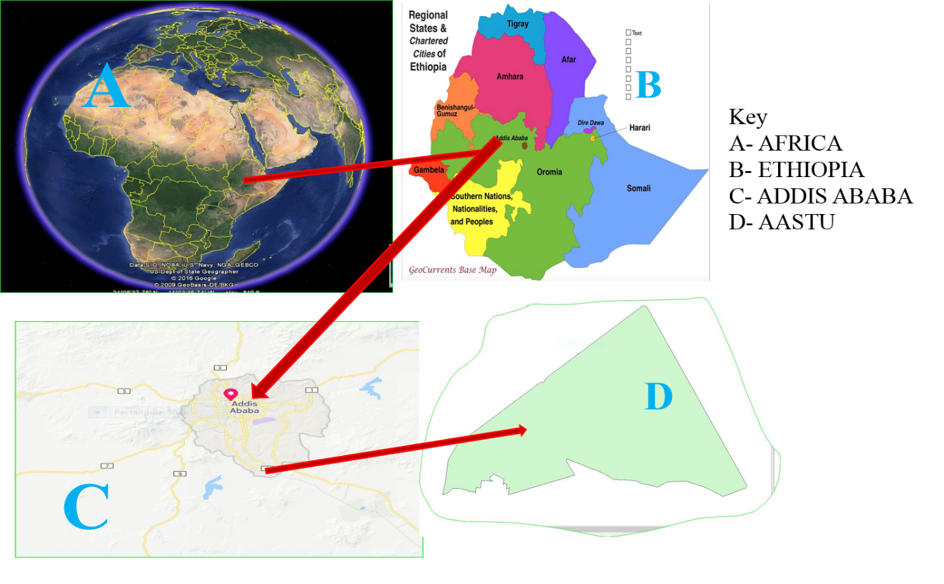

Figure Addis Ababa Science Technology University location map

Source (Google Earth)

### 3.1.2 Climate

Addis Ababa has a temperate climate due to its high-altitude subtropical location. Rainfall peaks during the boreal summer (July-August) and is minimal in winter (December-February). The average annual temperature is 15.9°C (60.7°F), with April being the hottest month at 20°C and December the coldest. Monthly temperatures range from 10°C to 20°C, with a maximum range of 23.4°C to 29.3°C. ((n.d.)., 2024).

## 3.2 Data Collection

Primary data includes water shortage at AASTU, wilting plants, campus building numbers and areas, plant types and quantities. Rooftop area was measured using ground and ArcGIS methods. The distance between plants was measured to determine water requirements using the canopy method. $$Area =\frac{Length*width}{2}$$

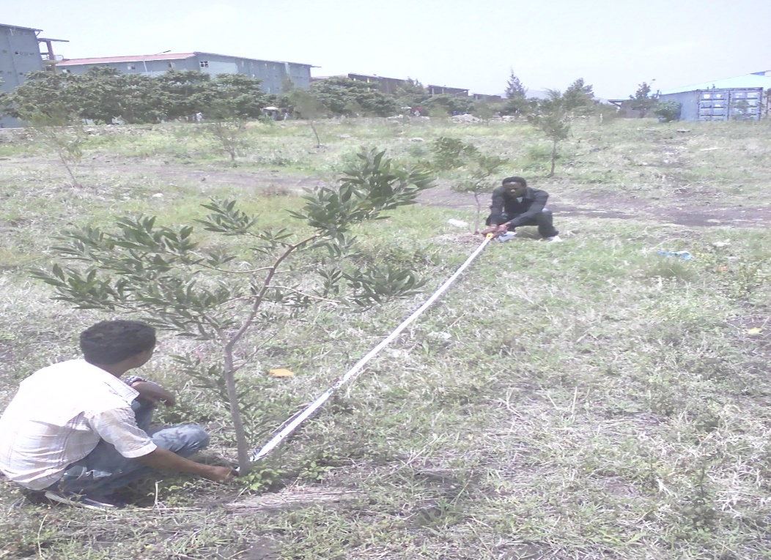

Figure Measurement of distance between plants.

Secondary data includes rainfall, precipitation, and temperature from national meteorology agencies, as well as campus-specific data such as the number and types of cars, plant types, water requirements per plant, and water usage for car washes.

## 3.3 Data Analysis

This research uses a non-experimental approach focused on calculating the rooftop catchment areas at AASTU for rainwater harvesting. The procedures include measuring rooftop areas (via ground measurement, Google Earth, and ArcGIS), estimating annual rainfall, calculating harvested water, comparing it with plant water usage, and determining crop water requirements and evapotranspiration.

### Catchment Area

This paper evaluates two methods for determining the catchment area: the Ground Area Calculation Method and Google Services (ArcGIS using Google Earth). Currently, AASTU has 91 buildings, categorized into 14 subtypes, as outlined in Table 10 (see Appendix 2).

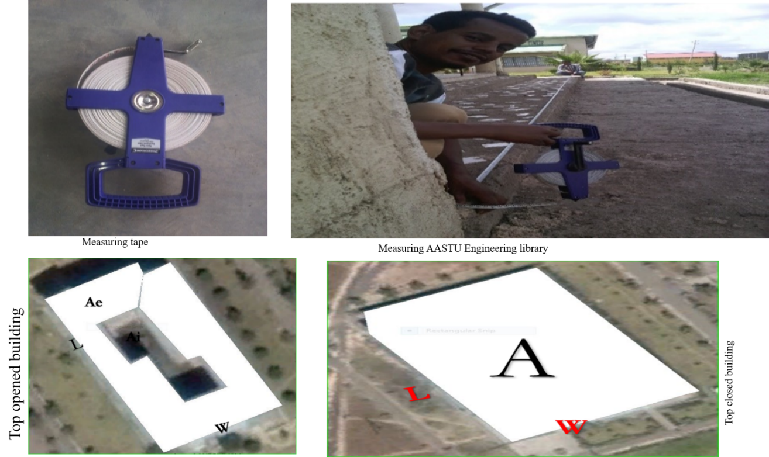

Figure Measuring AASTU building’s roof top area by using ground area method and different shapes of building

Most AASTU buildings have irregular shapes, making direct measurement difficult. For accurate calculations, internal sections are subtracted for top-open buildings, and external areas are added for closed buildings. The internal and external areas are represented as Ai and Ae, respectively. Using the ground measurement method, 32 buildings were measured, totaling 61,555.644 m² for rooftop catchment area. Measurements were taken with a tape, and areas were calculated based on building section types.

$$Area of bldg= A total–A internal$$

For Example: Building number seven (B-7) area calculated as follows.

|  |  |  |  |  |  |  |  |  |  |
| --- | --- | --- | --- | --- | --- | --- | --- | --- | --- |
| *Regular part* | | *Area(A* | *Internal* | | *2Ai* | *External* | | *2Ae* | *Total Area* |
| L | W |  | L | W |  | L | W |  | At=A-2Ai+2Ae |
| **44.5** | **25.6** | **1139.2** | **13.8** | **9.15** | **252.54** | **6** | **4.2** | **50.4** | **937.06** |

Area for Rectangle is the product length and width, for Circle square of radius multiple by Pi (Π)

The Google Earth and ArcGIS method combines satellite imagery with Geographic Information Systems (GIS) to calculate rooftop catchment areas. Google Earth provides 2D and 3D visualizations of the earth's surface, with imagery resolutions ranging from 15 meters to 15 centimeters. Using Google Earth, the area is selected, and a KML file is exported to ArcGIS for analysis. The total rooftop catchment area for AASTU calculated via this method is 67,786.56 m². This method is cost-effective, time-saving, and efficient for large-scale calculations.

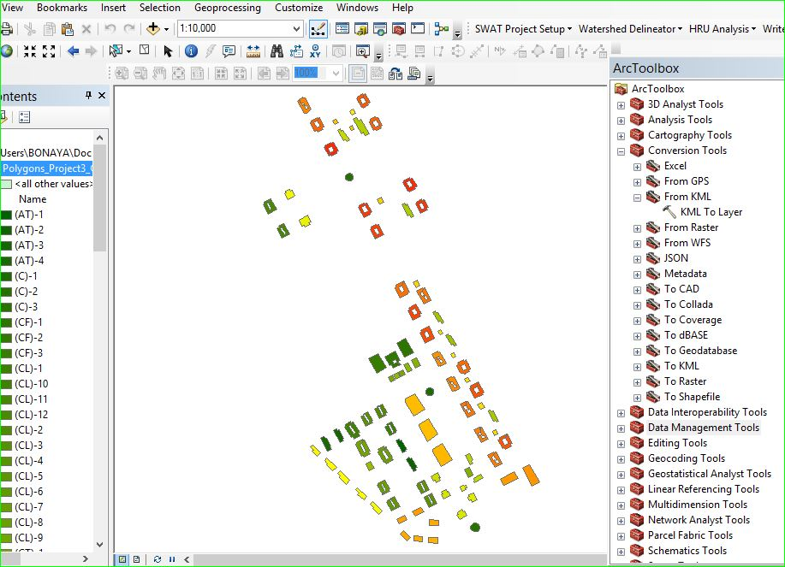

Figure Google Earth delineated ArcGIS application process

Source (Own data)

### Catchment area Calculation

As try to explain in the methodology part roof top area (catchment area) calculated both by ArcGIS and ground measurement.

Table catchment area measurement of AASTU buildings

|  |  |  |  |
| --- | --- | --- | --- |
| Building Type | Sample and Code | Measured (m2) | GIS (m2) |
| Dormitory | ®-1 | 937.06 | 989.9912 |
| Rectangular type (7) | ®-2 | 939.57 | 961.1096 |
| (L)-1 | 523.2 |  |
| L-shape (8) | 489.7866 |
| (L)-2 | 525.1 | 474.5807 |
| (L)-3 | 523.5 | 518.0995 |
| White House Type (14) | (W)-1 | 780.82 | 973.9228 |
| (W)-2 | 780.82 | 1097.238 |
| (W)-3 | 985 | 985.0242 |
| (W)-4 | 1061 | 1094.501 |
| Clinic Type (7) | (CT)-1 | 238.68 | 257.9339 |
| (CT)-2 | 237.15 | 264.1241 |
| (CT)-3 | 236.36 | 483.0348 |
| Cafe type (3) | (CF)-1 | 1580.315 | 1570.403 |
| Class Type (12) | (CL)-1 | 693.06 | 257.9339 |
| (CL)-2 | 686.928 | 264.1241 |
| (CL)-3 | 696.35 | 483.0348 |
| Administration Type (4) | (AT)-1 | 684 | 644.9455 |
| (AT)-2 | 684.1 | 655.488 |
| Lecture Theatre (7) | (LT)-1 | 614.76 | 481.7134 |
| (LT-2) | 621.36 | 488.8686 |
| Museum Type (6) | (MT)-1 | 437.9 | 429.1614 |
| (MT)-2 | 440.8 | 459.2833 |
| Circular Lounge (3) | ©-1 | 480.81 | 257.9339 |
| ©-2 | 490.625 | 264.1241 |
| Laboratory (5) | (Lab)-1 | 648.74 | 554.01341 |
| (Lab)-2 | 641.68 | 497.95144 |
| Library (3) | (Lib)-1 | 2086.92 | 2246.371 |
| (Lib)-2 | 2088.8 | 2271.984 |
| Laundry (10) | (Lau)-1 | 163.48 | 148.2076 |
| (Lau)-2 | 163.35 | 155.3525 |
| (Lau)-3 | 161.66 | 159.6115 |
| Metal work (2) | (Mw)-1 | 1256.96 | 1185.741 |

The rooftop area of AASTU buildings was calculated using both ground measurement (61,555.644 m²) and ArcGIS (67,786.567 m²). Since measuring all 91 buildings by the ground method was challenging, a trend line equation was developed from the 32 measured buildings. Using this equation, the total rooftop catchment area was estimated to be 68,195.74 m². Additionally, 45 vehicles were categorized into service buses, ambulances, and land cruisers to estimate water demand.

Table Addis Ababa Science and Technology University transports type

|  |  |  |  |  |  |  |
| --- | --- | --- | --- | --- | --- | --- |
| R.L | Type | Quantity | Washed cars per week | Frequency | Need water in Litter | Required demand per week in (L) |
| 1 | Ambulance type | 10 | 3 | 3 | 30 | 270 |
| 2 | Land Cruses Type | 28 | 6 | 2 | 30 | 360 |
| 3 | Services bus | 7 | 7 | 3 | 100 | 2100 |
| Total |  | 45 | 16 |  | 110 | 2730 |

AASTU uses potable water for campus greening, as it is a new university under construction. In 2014, 2015, and 2016, 5,000, 3,000, and 20,000 seedlings were planted, respectively. Each seedling requires 10-15 liters of water daily, totaling 862.5 m³ per week, assuming a 30 cm radius and 45 cm rooting depth for water application.

Table AASTU plants with their type and needed water demand per week

|  |  |  |
| --- | --- | --- |
| Year | Types of plants | Quantity in Numbers |
| 2016 | Yellow wood | 800 |
|  |  |
| Olive | 2100 |
| Dire Dawa tree  (pistachio) | 2300 |
| Ebony | 500 |
| NIMI | 1250 |
| Jacaranda | 1650 |
| Shewashew | 2000 |
| Grave Lia | 3000 |
| Bottlebrush | 1350 |
| Amedula | 2000 |
| Spatodia | 2150 |
| Deciduous | 900 |
| 2015 | All type | 3000 |
| 2014 | All type | 5000 |
| Tot |  | 28000 |

AASTU applies 350 m³ of water per week for plants, costing 1,575 ETB/day. With 47 cars and 28,000 plants (23,000 needing water), the total water demand is 865,230 liters/week. The monthly water demand is 3,749,330 liters, equating to 44,991.96 m³/year. Rooftop rainwater harvesting can reduce potable water usage.

### Water harvesting potential analysis

To analyze the water potential, monthly rainfall data from Akaki was utilized. This secondary data, obtained from the Addis Ababa Meteorology Agency, was statistically analyzed as shown in the following table.

Table 4 Akaki annual average rainfall data for eleven years.

|  |  |  |  |  |  |  |  |  |  |  |  |  |  |
| --- | --- | --- | --- | --- | --- | --- | --- | --- | --- | --- | --- | --- | --- |
| year | Jan | Feb | Mar | Apr | May | June | July | Aug | Sep | Oct | Nov | Dec | Sum |
| 2006 | 0.95 | 2.54 | 2.69 | 3.1 | 1.58 | 3.69 | 9.52 | 9.34 | 5.66 | 2.1 | 0.9 | 0.9 | 42.970 |
| 2007 | 1.97 | 1.36 | 1.7 | 4.13 | 2.95 | 5.28 | 8.68 | 8.03 | 5.53 | 1.09 | 0.94 | 0.87 | 42.530 |
| 2008 | 0.87 | 0.93 | 0.89 | 2.04 | 2.01 | 4.67 | 8.18 | 8.14 | 6.38 | 0.23 | 2.16 | 0 | 36.500 |
| 2009 | 1.94 | 0 | 0.32 | 3.96 | 1.54 | 2.12 | 7.84 | 10.4 | 2.38 | 1.06 | 0.13 | 0.54 | 32.230 |
| 2010 | 0 | 2.28 | 4.07 | 5.67 | 3.07 | 5.49 | 11.15 | 5.48 | 5.14 | 0.17 | 0.49 | 0.25 | 43.260 |
| 2011 | 0 | 0.09 | 1.46 | 0.69 | 4.15 | 2 | 6.59 | 9.81 | 6.48 | 0 | 0.16 | 0 | 31.430 |
| 2012 | 0 | 0 | 0.97 | 2.03 | 0.87 | 2.69 | 7.35 | 7.87 | 4.1 | 0 | 0 | 0 | 25.880 |
| 2013 | 0 | 0 | 2.48 | 2.97 | 2.37 | 3.6 | 5.79 | 7.82 | 4.75 | 0.66 | 0 | 0.01 | 30.450 |
| 2014 | 0 | 1.41 | 2.45 | 0.46 | 0 | 1.75 | 5.89 | 9.08 | 3.84 | 1.69 | 0 | 0 | 26.570 |
| 2015 | 0 | 0 | 0.44 | 0 | 3.11 | 5.27 | 6.06 | 7.98 | 2.26 | 0 | 0.48 | 0 | 25.600 |
| 2016 | 0 | 0 | 1.4 | 6.15 | 4.33 | 3.52 | 7.55 | 5.93 | 3.77 | 0.52 | 0.3 | 0 | 33.470 |
| Avg | 0.52 | 0.78 | 1.72 | 2.84 | 2.36 | 3.64 | 7.69 | 8.18 | 4.57 | 0.68 | 0.51 | 0.23 | 33.720 |

Source (National meteorology Agency, Ethiopia)

### Calculating Crop Water Requirements

As discussed in the literature review, the Blaney-Criddle method is the simplest and most effective for estimating reference evapotranspiration using temperature data. AASTU has 23,000 plants, requiring water due to their recent planting in 2016. The canopy method calculates the area between plants covered by evapotranspiration (see figure 3). The mean daily percentage of annual daytime hours (P) is determined using a table based on the area’s latitude.

Table Mean daily percentage of annual day time hours for different latitude in North hemisphere

|  |  |  |  |  |  |  |  |  |  |  |  |  |
| --- | --- | --- | --- | --- | --- | --- | --- | --- | --- | --- | --- | --- |
| Latitude | Jan  July | Feb  Aug | Mar  Sept | Apr  Oct | May  Nov | June  Dec | July  Jan | Aug  Feb | Sept  Mar | Oct  Apr | Nov  May | Dec  June |
| 60o | 0.15 | 0.20 | 0.26 | 0.32 | 0.38 | 0.41 | 0.40 | 0.34 | 0.28 | 0.22 | 0.17 | 0.13 |
| 55 | 0.17 | 0.21 | 0.26 | 0.32 | 0.36 | 0.39 | 0.38 | 0.33 | 0.28 | 0.23 | 0.18 | 0.16 |
| 50 | 0.19 | 0.23 | 0.27 | 0.31 | 0.34 | 0.36 | 0.35 | 0.32 | 0.28 | 0.24 | 0.20 | 0.18 |
| 45 | 0.20 | 0.23 | 0.27 | 0.30 | 0.34 | 0.35 | 0.34 | 0.32 | 0.28 | 0.24 | 0.21 | 0.20 |
| 40 | 0.22 | 0.24 | 0.27 | 0.30 | 0.32 | 0.34 | 0.33 | 0.31 | 0.28 | 0.25 | 0.22 | 0.21 |
| 35 | 0.23 | 0.25 | 0.27 | 0.29 | 0.31 | 0.32 | 0.32 | 0.30 | 0.28 | 0.25 | 0.23 | 0.22 |
| 30 | 0.24 | 0.25 | 0.27 | 0.29 | 0.31 | 0.32 | 0.31 | 0.30 | 0.28 | 0.26 | 0.24 | 0.23 |
| 25 | 0.24 | 0.26 | 0.27 | 0.29 | 0.30 | 0.31 | 0.31 | 0.29 | 0.28 | 0.26 | 0.25 | 0.24 |
| 20 | 0.25 | 0.26 | 0.27 | 0.28 | 0.29 | 0.30 | 0.30 | 0.29 | 0.28 | 0.26 | 0.25 | 0.25 |
| 15 | 0.26 | 0.26 | 0.27 | 0.28 | 0.29 | 0.29 | 0.29 | 0.28 | 0.28 | 0.27 | 0.26 | 0.25 |
| **10** | **0.26** | **0.27** | **0.27** | **0.28** | **0.28** | **0.29** | **0.29** | **0.28** | **0.28** | **0.27** | **0.26** | **0.26** |
| **5** | **0.27** | **0.27** | **0.27** | **0.28** | **0.28** | **0.28** | **0.28** | **0.28** | **0.28** | **0.27** | **0.27** | **0.27** |
| 0 | 0.27 | 0.27 | 0.27 | 0.27 | 0.27 | 0.27 | 0.27 | 0.27 | 0.27 | 0.27 | 0.27 | 0.27 |

The studied area’s latitude is between 5° and 10° North, specifically at 8°53'06" North, 38°48'35.63" East, with an elevation of 2,148m above sea level. The value of P in Table 8 is calculated using the interpolation method.

Table Annual day time hours for Akaki Area

|  |  |  |  |  |  |  |  |  |  |  |  |  |  |  |
| --- | --- | --- | --- | --- | --- | --- | --- | --- | --- | --- | --- | --- | --- | --- |
| Month |  |  | Jan | Feb | Mar | Apr | May | June | July | Aug | Sep | Oct | Nov | Dec |
| P (at latitude 8) |  |  | 0.26 | 0.27 | 0.27 | 0.28 | 0.28 | 0.28 | 0.28 | 0.28 | 0.28 | 0.27 | 0.26 | 0.26 |

To calculate the total water requirements for AASTU plants:

1. ETo is calculated using Equation (1).
2. Kc is derived from the average of three plants with known Kc values (see table).
3. ETc is the product of ETo and Kc.
4. Monthly irrigation water demand is ETc minus 50% of rainfall.
5. Total monthly irrigation requirement per plant is the product of monthly demand and its area coverage.

The total rooftop area of AASTU is 68,195.74m², with a potential to harvest 662,273.4m³/year. From 1m², the volume of water that can be harvested is 0.026976m³/day based on the average annual rainfall in the Akaki area.

Area (m2)

Figure Rooftop potential versus area

# **4. Results and Discussions**

## 4.1 Quantifying Catchment Area

The catchment area of AASTU buildings was calculated using both ground measurement and ArcGIS methods (see Table 2, Chapter 3). A sample of 32 out of 91 buildings was measured, while the remaining buildings' areas were estimated using a trend line equation derived from the combination of both methods and represented in a scatter chart.

Figure Ground area simulation and trend line equation

The linear equation y = 0.9948x represents the trend between ground measurement and ArcGIS methods, with an accuracy of 90.68%, indicating a 10% error. This error results from factors such as rough ground surfaces, measurement inaccuracies, unclear satellite imagery, and topographical variations. The area of 32 measured buildings is 24,971.37 m², and using the trend line equation, the total rooftop catchment area for rainwater harvesting at AASTU is calculated to be 68,195.74 m².

## 4.2 Harvested Water Potentials from Rooftop Catchments

The best method for calculating roof rainwater harvesting potential is the Gould and Nissen formula (1999). Based on the calculated mean and median monthly rainfall, the harvested water from the AASTU roof catchment is determined. The mean rainfall is calculated using the formula:

*Calculate the mean of rainfall*

$\overline{x}=\frac{(x_{1}+x_{2}+…x_{n})}{n}$

Where, $\overline{x}$ = mean of xi

= is each of the value of the data

n = the number of data points

|  |  |  |  |  |  |  |  |  |  |  |  |  |
| --- | --- | --- | --- | --- | --- | --- | --- | --- | --- | --- | --- | --- |
|  | **Jan** | **Feb** | **Mar** | **Apr** | **May** | **June** | **July** | **Aug** | **Sep** | **Oct** | **Nov** | **Dec** |
| mean | 0.522 | 0.783 | 1.716 | 2.836 | 2.363 | 3.643 | 7.691 | 8.170 | 4.572 | 0.636 | 0.479 | 0.234 |
| med | 0.00 | 0.089 | 1.458 | 2.97 | 2.368 | 3.597 | 7.545 | 8.026 | 4.750 | 0.232 | 0.157 | 0.000 |

Figure 8 Mean and Median monthly rainfall at Akaki Area

The mean rainfall method is more effective than the median for short-term rainwater harvesting. For example, in January and December, the median value is nearly zero, while the mean rainfall is positive, making the mean method more reliable. Both methods show high rainfall in July and August. However, for long-term rainfall analysis, the median method is preferred because it:

* Avoids exaggerating high rainfall events from a few days.
* Reflects months with frequent rainfall.
* Is more conservative and suitable for rooftop rainwater harvesting design.

*Calculate potential of rooftop rainwater harvesting*

The monthly mean harvested rainfall from roof top of AASTU was calculated as follows:

$Q = R x A x. C$------------------------------see equation (*)

$$Q=\frac{33.72mm}{day}*\left(\frac{1m}{1000mm}\right)*\frac{30day}{month}* 68195.74m2*0.8=55,189.45m3/month$$

## 4.3 Demand Analysis

### 4.3.1 non-domestic use

The monthly water demand for plants and car washes at AASTU was 3,749.33 m³. Implementing this rainwater harvesting system reduced the demand for potable water, creating a surplus for other uses.

$$\frac{\left(\frac{55,189.45.m3}{month}-\frac{3749.33m3}{month}\right)}{\frac{3749.33m3}{month}}*100\%=1371.98\%$$

Similarly, the yearly harvested rooftop rain water from the AASTU was 662273.4m3/year.

(

### 4.3.2 Crop water requirements

For example, the water required for Olive, Dire Dawa tree and Deciduous for January, 2016 calculated as follows

Table 7 Crop water requirements calculation for some trees in AASTU campus

|  |  |  |  |  |  |
| --- | --- | --- | --- | --- | --- |
| Plants | Kc | Area b/n plants (m2) | ETo(mm/d) | ETc(m/d) | Qtot(m3/d) |
| Deciduous tree | 0.73 | 12.5 | 5.3 | 0.00387 | 0.048363 |
| Olive tree | 0.6 | 12.5 | 5.3 | 0.00318 | 0.03975 |
| Dire dawa tree | 0.58 | 12.5 | 5.3 | 0.00307 | 0.038425 |

Kc average for all AASTU plants according to this research paper is:

$$Kcavg = (0.73+0.6+0.58+0.5)/4 =0.6025$$

Table 8 Overall monthly Crop water requirements of AASTU plants

|  |  |  |  |  |  |  |  |  |  |  |  |  |
| --- | --- | --- | --- | --- | --- | --- | --- | --- | --- | --- | --- | --- |
| Month | Jan | Feb | Mar | Apr | May | June | July | Aug | Sep | Oct | Nov | Dec |
| T min | 12.3 | 14.6 | 17.6 | 17.3 | 15.8 | 18.5 | 17.7 | 17.4 | 15.7 | 14.5 | 14.6 | 12.2 |
| T max | 29.2 | 29.4 | 32.0 | 27.0 | 51.3 | 30.4 | 24.5 | 23.9 | 27.9 | 26.1 | 25.9 | 25.8 |
| T mean | 20.7 | 22.0 | 24.8 | 22.1 | 33.6 | 24.4 | 21.1 | 20.6 | 21.8 | 20.3 | 20.3 | 19.0 |
| P | 0.264 | 0.27 | 0.27 | 0.28 | 0.28 | 0.286 | 0.286 | 0.28 | 0.28 | 0.27 | 0.264 | 0.264 |
| ET0(mm/d) | 4.63 | 4.89 | 5.24 | 5.09 | 6.56 | 5.50 | 5.06 | 4.90 | 5.05 | 4.68 | 4.57 | 4.42 |
| KC | 0.60 | 0.60 | 0.60 | 0.60 | 0.60 | 0.60 | 0.60 | 0.60 | 0.60 | 0.60 | 0.60 | 0.60 |
| ETC(mm/m) | 83.4 | 88.1 | 94.3 | 91.6 | 118.2 | 99.0 | 91.2 | 88.2 | 90.9 | 84.3 | 82.3 | 79.5 |
| RF(mm/m) | 16.2 | 21.9 | 53.2 | 85.1 | 73.2 | 109.3 | 238.4 | 253.3 | 137.1 | 19.7 | 14.4 | 7.2 |
| plant no | 23000 | 23000 | 23000 | 23000 | 23000 | 23000 | 23000 | 23000 | 23000 | 23000 | 23000 | 23000 |
| area(m2) | 12.5 | 12.5 | 12.5 | 12.5 | 12.5 | 12.5 | 12.5 | 12.5 | 12.5 | 12.5 | 12.5 | 12.5 |
| Irrigation water Dm (mm/m) | 75.27 | 77.14 | 67.67 | 49.10 | 81.53 | 44.39 | 0 | 0 | 22.34 | 74.43 | 75.10 | 75.92 |
| ***Qtotal(m3)or Ig*** | ***21641.28*** | ***22176.71*** | ***19455.37*** | ***14116.99*** | ***23440.25*** | ***12760.9*** | ***0*** | ***0*** | ***6422.62*** | ***23398.02*** | ***21592.32*** | ***21825.87*** |

Source (own data)

Month

ETo and ETc (mm)

Figure 9 Plants (crop) water requirements verse reference evapotranspiration

As shown in Figure 9 and Table 11, ETo and ETc were directly proportional. In May, evapotranspiration was highest, resulting in increased water requirements for plants, while in December, the water demand was lower.

Figure AASTU gross irrigation

Figure 10 indicated that as effective rainfall increased, irrigation water demand decreased, and vice versa. When irrigation demand reached zero, effective rainfall matched the plants' water requirements. The highest irrigation demand occurred in May. From May to July, irrigation demand decreased, while it increased from August to December. The total irrigation water demand for AASTU’s plants was 184,830.33 m³/year, whereas the drinking water estimated by the GSO was 44,850 m³/year. Water stress was calculated by subtracting the GSO's water allocation from the irrigation demand.

$$Water stress per month =((\frac{15402.53m3}{month}-\frac{3737.5m3}{month})/15402.53))*100\%=75.73\%$$

The drinking water losses due to non-domestic use at AASTU were insufficient for the campus plants, resulting in visible wilting of some plants. This research provided the following design parameters:

* The total water required for car washing was 131.04 m³/year, based on data from the AASTU General Service Office.
* The study established that 0.026976 m³ of rainwater can be harvested per square meter of rooftop area in the Akaki region. This design parameter can be used for rooftop rainwater harvesting in the area.

# **5. CONCLUSION AND RECOMMENDATION**

## Conclusion

This study focused on rooftop water harvesting at Addis Ababa Science and Technology University (AASTU), based on rainfall and catchment area. The catchment areas of AASTU buildings were evaluated using both ground measurement and ArcGIS techniques. ArcGIS was found to be the most efficient method for evaluating large or remote areas, saving time and costs. However, for smaller areas, ground measurement remained essential.

The total catchment area of AASTU buildings was 68,195.74 m². The highest water collection occurred between July and September, with a total potential of 55,189.45 m³ per month and 662,273.4 m³ per year. Despite the loss of 44,991.96 m³ of potable water for planting and car washes, this amount did not fully meet the irrigation needs for campus plants.

The total irrigation water demand for AASTU plants was 184,830.32 m³ per year, indicating a surplus of harvested water that could be used for other purposes.

## 5.2 Recommendations

To enhance the efficiency and sustainability of water usage at AASTU, the following key recommendations are made based on the findings of this study:

1. Prioritize rooftop rainwater harvesting to reduce dependency on potable water for non-domestic uses.
2. Implement a combination of ArcGIS and ground measurement methods for accurate catchment area evaluation.
3. Install a rain gauge at AASTU for precise rainfall data to improve water management strategies.

# **REFERENCES**

(n.d.)., C.-D. (2024). *. Retrieved from https://en.climate-data.org/africa/ethiopia/addis-ababa/addis-abeba-532/.* Addis Abeba Climate (Ethiopia).

Data, O. W. (2023). *A look at global freshwater distribution and how we can save it. .* World Economic Forum. .

Gazeta., F. N. (2000). *Ethiopian Water Resources Management Proclamation No. 197/2000. Federal Negarit Gazeta.*

Sharma, B. R. (1988). *Rooftop rainwater harvesting for water conservation and environmental management. Environmental Management Journal, 12(2), 112-118.*

water, R. (2020). *A Review of Roof and Pond Rainwater Harvesting Systems for Water. (2020). Water, 12(11), 3163. https://doi.org/10.3390/w12113163.*

# **APPENDIX**

## Appendix 1: Akaki high and low yearly average rainfall of eleven year both by table and graph.

|  |  |  |  |  |  |  |  |  |  |  |  |
| --- | --- | --- | --- | --- | --- | --- | --- | --- | --- | --- | --- |
| **Jan** | **Feb** | **Mar** | **Apr** | **May** | **June** | **July** | **Aug** | **Sep** | **Oct** | **Nov** | **Dec** |
| 0.95 | 2.54 | 2.69 | 3.10 | 1.58 | 3.69 | 9.52 | 9.34 | 5.66 | 2.10 | 0.90 | 0.90 |
| 1.97 | 1.36 | 1.70 | 4.13 | 2.95 | 5.28 | 8.68 | 8.03 | 5.53 | 1.09 | 0.94 | 0.87 |
| 0.87 | 0.93 | 0.89 | 2.04 | 2.01 | 4.67 | 8.18 | 8.14 | 6.38 | 0.23 | 2.16 | 0.00 |
| 1.94 | 0.00 | 0.32 | 3.96 | 1.54 | 2.12 | 7.84 | 10.40 | 2.38 | 1.06 | 0.13 | 0.54 |
| 0.00 | 2.28 | 4.07 | 5.67 | 3.07 | 5.49 | 11.15 | 5.48 | 5.14 | 0.17 | 0.49 | 0.25 |
| 0.00 | 0.09 | 1.46 | 0.69 | 4.15 | 2.00 | 6.59 | 9.81 | 6.48 | 0.00 | 0.16 | 0.00 |
| 0.00 | 0.00 | 0.97 | 2.03 | 0.87 | 2.69 | 7.35 | 7.87 | 4.10 | 0.00 | 0.00 | 0.00 |
| 0.00 | 0.00 | 2.48 | 2.97 | 2.37 | 3.60 | 5.79 | 7.82 | 4.75 | 0.66 | 0.00 | 0.01 |
| 0.00 | 1.41 | 2.45 | 0.46 | 0.00 | 1.75 | 5.89 | 9.08 | 3.84 | 1.69 | 0.00 | 0.00 |
| 0.00 | 0.00 | 0.44 | 0.00 | 3.11 | 5.27 | 6.06 | 7.98 | 2.26 | 0.00 | 0.48 | 0.00 |
| 0.00 | 0.00 | 1.40 | 6.15 | 4.33 | 3.52 | 7.55 | 5.93 | 3.77 | 0.00 | 0.00 | 0.00 |
| 5.74 | 8.61 | 18.87 | 31.20 | 25.99 | 38.58 | 84.60 | 89.87 | 50.29 | 6.99 | 5.27 | 2.57 |
| 0.52 | 0.78 | 1.72 | 2.84 | 2.36 | 3.64 | 7.69 | 8.17 | 4.57 | 0.64 | 0.48 | 0.23 |
| 0.99 | 1.27 | 1.87 | 3.08 | 2.16 | 1.87 | 2.68 | 2.46 | 2.11 | 1.05 | 1.08 | 0.45 |

## Appendix 2: Ground Method measurement of AASTU buildings with respect to their type

|  |  |  |  |  |  |  |  |  |  |  |  |  |  |  |  |
| --- | --- | --- | --- | --- | --- | --- | --- | --- | --- | --- | --- | --- | --- | --- | --- |
|  | | Length | width | Area |  | Internal area | | area*1 | External Area |  |  | area*2 | Tot Area | Avg A | AtRF |
| BLd | NS |  |  |  | L | W |  |  | L | w |  |  |  |  |  |
| R(7) | 1 | 44.5 | 26 | 1139 | 13.8 | 9.15 | 126 | 252.5 | 6 | 4.2 | 25 | 50.4 | 937 |  |  |
|  | 2 | 44.4 | 26 | 1132 | 13.5 | 9.1 | 123 | 245.7 | 6.1 | 4.35 | 27 | 53.1 | 940 | 939 | 6575 |
|  | 3 | 45 | 25 | 1143 | 13.6 | 9.25 | 126 | 251.6 | 6 | 4.1 | 25 | 49.2 | 941 |  |  |
|  | 4 | 44.3 | 26 | 1139 | 13.7 | 9 | 123 | 246.6 | 6 | 4 | 24 | 48 | 940 |  |  |
| L(8) | 1 | 44.6 | 12 | 535.2 | 4 | 1.5 | 6 | 12 |  |  | 0 | 0 | 523 |  |  |
|  | 2 | 45 | 12 | 535.5 | 4 | 1.3 | 5.2 | 10.4 |  |  | 0 | 0 | 525 | 524 | 4191 |
|  | 3 | 44.5 | 12 | 534 | 4.3 | 1.5 | 5.7 | 10.5 |  |  | 0 | 0 | 524 |  |  |
| W(14) | 1 | 36.4 | 33 | 1183 | 19.2 | 13.5 | 259 | 259.2 | 6.5 | 4 | 26 | 52 |  |  |  |
|  |  |  |  |  |  |  |  |  | 19 | 1.3 | 25 | 49.9 | 1026 |  |  |
|  | 2 | 35.9 | 33 | 1192 | 19 | 13.2 | 251 | 250.8 | 6.8 | 3.8 | 23 | 45 |  |  |  |
|  |  |  |  |  |  |  |  |  | 19 | 1.3 | 24 | 47 | 1033 |  |  |
|  | 3 | 36.2 | 31 | 1122 | 18 | 12.9 | 232 | 232.2 | 6.4 | 3.5 | 24 | 48 |  | 1026 | 14366 |
|  |  |  |  | 0 |  |  | 0 | 0 | 18 | 1.25 | 24 | 47 | 985 |  |  |
|  | 4 | 37 | 34 | 1240 | 19.4 | 14 | 272 | 271.6 | 7 | 3.75 | 23 | 45.8 |  |  |  |
|  |  |  |  |  |  |  |  |  | 19 | 1.28 | 24 | 47 | 1061 |  |  |
| Lib(3) | 1 | 56.1 | 37 | 2087 |  |  |  |  |  |  |  |  |  |  |  |
|  | 2 | 56 | 37 | 2089 |  |  |  |  |  |  |  |  |  | 2088 | 6264 |
| CL(12) | 1 | 33.4 | 27 | 895.1 | 27.1 | 4.1 | 111 | 222.2 | 3.2 | 3.15 | 10 | 20.2 | 693 |  |  |
|  | 2 | 33.6 | 27 | 893.8 | 27 | 4.2 | 113 | 226.8 | 3.2 | 3.12 | 10 | 20 | 687 |  |  |
|  | 3 | 33.5 | 27 | 894.5 | 27.2 | 4 | 109 | 217.6 | 3.3 | 3 | 9.8 | 19.5 | 696 | 697 | 8363 |
|  | 4 | 34 | 27 | 924.8 | 27.5 | 4.25 | 117 | 233.8 | 3.2 | 3.2 | 10 | 20.2 | 711 |  |  |
|  |  |  |  |  |  |  |  |  |  |  |  |  |  |  |  |
| AT(4) | 1 | 43.2 | 15 | 643.7 |  |  |  |  | 4.8 | 4.2 | 20 | 40.3 | 684 |  |  |
|  | 2 | 43.1 | 15 | 646.5 |  |  |  |  | 4.7 | 4 | 19 | 37.6 | 684 | 684 | 2052 |
| LT(7) | 1 | 27.6 | 15 | 416.8 |  |  |  |  | 17 | 6 | 99 | 99 | 516 |  |  |
|  | 2 | 27.5 | 15 | 418 |  |  |  |  | 16 | 6.2 | 102 | 102 | 520 | 518 | 3624 |
| Lab(5) | 1 | 28 | 12 | 324.8 |  |  |  |  | 12 | 4 | 46 | 92.8 |  |  |  |
|  |  |  |  |  |  |  |  |  | 20 | 14.7 | 288 | 576 |  |  |  |
|  |  |  |  |  |  |  |  |  | 15 | 10.5 | 152 | 305 | 649 |  |  |
|  | 2 | 28 | 12 | 330.4 |  |  |  |  | 11 | 4.5 | 50 | 99 |  |  |  |
|  |  |  |  |  |  |  |  |  | 19 | 14.6 | 282 | 564 |  | 324 | 1622 |
|  |  |  |  |  |  |  |  |  | 15 | 10.6 | 155 | 310 | 642 |  |  |
| MT(6) | 1 | 29 | 15 | 437.9 |  |  |  |  |  |  |  |  |  |  |  |
|  | 2 | 29 | 15 | 440.8 | 439.4 | 2636 |  |  |  |  |  |  |  |  |  |
| CF(3) | 1 | 48.7 | 32 | 1580 | 1580 | 4741 |  |  |  |  |  |  |  |  |  |
| CT(7) | 1 | 15.6 | 15 | 238.7 |  |  |  |  |  |  |  |  |  |  |  |
|  | 2 | 15.5 | 15 | 237.2 | 237.4 | 1662 |  |  |  |  |  |  |  |  |  |
|  | 3 | 15.6 | 15 | 236.4 |  |  |  |  |  |  |  |  |  |  |  |
| Lau(10) | 1 | 13.4 | 12 | 163.5 |  |  |  |  |  |  |  |  |  |  |  |
|  | 2 | 13.5 | 12 | 163.4 | 162.8 | 1628 |  |  |  |  |  |  |  |  |  |
|  | 3 | 13.7 | 12 | 161.7 |  |  |  |  |  |  |  |  |  |  |  |
| C(3) |  | radius | rad |  |  |  |  |  |  |  |  |  |  |  |  |
|  | 1 | 12.4 | 3.1 | 482.8 |  |  |  |  |  |  |  |  |  |  |  |
|  | 2 | 12.5 | 3.1 | 490.6 | 486.7 | 1460 |  |  |  |  |  |  |  |  |  |
| Mw(2) | 1 | 45.6 | 26 | 1186 | 1186 | 2371 |  |  |  |  |  |  |  |  |  |

## Appendix 3 Mean and median average rain fall

|  |  |  |  |  |  |  |  |  |  |  |  |  |
| --- | --- | --- | --- | --- | --- | --- | --- | --- | --- | --- | --- | --- |
| year | **Jan** | **Feb** | **Apr** | **May** | **June** | **July** | **Aug** | **Sep** | **Oct** | **Nov** | **Dec** | **sum** |
| 2006 | 0.00 | 0.00 | 0.00 | 0.00 | 1.75 | 5.79 | 5.48 | 2.26 | 0.00 | 0.00 | 0.00 | 5.74 |
| 2007 | 0.00 | 0.00 | 0.46 | 0.87 | 2.00 | 5.89 | 5.93 | 2.38 | 0.00 | 0.00 | 0.00 | 8.61 |
| 2008 | 0.00 | 0.00 | 0.69 | 1.54 | 2.12 | 6.06 | 7.82 | 3.77 | 0.00 | 0.00 | 0.00 | 31.20 |
| 2009 | 0.00 | 0.00 | 2.03 | 1.58 | 2.69 | 6.59 | 7.87 | 3.84 | 0.00 | 0.00 | 0.00 | 25.99 |
| 2010 | 0.00 | 0.00 | 2.04 | 2.01 | 3.52 | 7.35 | 7.98 | 4.10 | 0.17 | 0.13 | 0.00 | 40/07 |
| 2011 | 0.00 | 0.09 | 2.97 | 2.37 | 3.60 | 7.55 | 8.03 | 4.75 | 0.23 | 0.16 | 0.00 | 84.60 |
| 2012 | 0.00 | 0.93 | 3.10 | 2.95 | 3.69 | 7.84 | 8.14 | 5.14 | 0.66 | 0.48 | 0.01 | 89.87 |
| 2013 | 0.87 | 1.36 | 3.96 | 3.07 | 4.67 | 8.18 | 9.08 | 5.53 | 1.06 | 0.49 | 0.25 | 50.29 |
| 2014 | 0.95 | 1.41 | 4.13 | 3.11 | 5.27 | 8.68 | 9.34 | 5.66 | 1.09 | 0.90 | 0.54 | 6.99 |
| 2015 | 1.94 | 2.28 | 5.67 | 4.15 | 5.28 | 9.52 | 9.81 | 6.38 | 1.69 | 0.94 | 0.87 | 5.27 |
| 2016 | 1.97 | 2.54 | 6.15 | 4.33 | 5.49 | 11.15 | 10.40 | 6.48 | 2.10 | 2.16 | 0.90 | 2.57 |
| mean | 0.52 | 0.78 | 2.84 | 2.36 | 3.64 | 7.69 | 8.17 | 4.57 | 0.64 | 0.48 | 0.23 | 31.92 |
| med | 0.00 | 0.09 | 2.97 | 2.37 | 3.60 | 7.55 | 8.03 | 4.75 | 0.23 | 0.16 | 0.00 | 29.75 |

## 

## Appendix 4 ArcGIS and Ground Measurement of some buildings in AASTU

|  |  |  |
| --- | --- | --- |
|  | GIS(m2) | Measured(m2) |
| ®-1 | 989.9912 | 937.06 |
| ®-2 | 961.1096 | 939.57 |
| ®-3 | 986.1535 | 940.6 |
| ®-4 | 952.2154 | 939.91 |
| (L)-1 | 489.7866 | 523.2 |
| (L)-2 | 474.5807 | 525.1 |
| (L)-3 | 518.0995 | 523.5 |
| (W)-1 | 973.9228 | 780.82 |
| (W)-2 | 1097.238 | 780.82 |
| (CT)-1 | 257.9339 | 238.68 |
| (CT)-2 | 264.1241 | 237.15 |
| (CT)-3 | 483.0348 | 236.36 |
| (CF)-1 | 1570.403 | 1580.315 |
| (CL)-1 | 257.9339 | 693.06 |
| (CL)-2 | 264.1241 | 686.928 |
| (CL)-3 | 483.0348 | 696.35 |
| (AT)-1 | 644.9455 | 684 |
| (AT)-2 | 655.488 | 684.1 |
| (LT)-1 | 481.7134 | 614.76 |
| (LT-2) | 488.8686 | 621.36 |
| (MT)-1 | 429.1614 | 437.9 |
| (MT)-2 | 459.2833 | 440.8 |
| ©-1 | 257.9339 | 480.81 |
| ©-2 | 264.1241 | 490.625 |
| (Lab)-1 | **554.01341** | 648.74 |
| (Lab)-2 | **497.95144** | 641.68 |
| (Lib)-1 | 2246.371 | 2086.92 |
| (Lib)-2 | 2271.984 | 2088.8 |
| (Lau)-1 | 148.2076 | 163.48 |
| (Lau)-2 | 155.3525 | 163.35 |
| (Lau)-3 | 159.6115 | 161.66 |
| (Mw)-1 | 1185.741 | 1256.96 |

## 

## Appendix 5 Roof catchment of all current buildings in AASTU by ArcGIS

|  |  |  |  |
| --- | --- | --- | --- |
| **R.N** | **Type** | **shape length** | **GISA(m2)** |
| **1** | **(Lib)-1** | **191.2201** | **2246.371** | **31** | **(W)-12** | **218.6802** | **933.4523** | **61** | **(CT)-7** | **85.22457** | **436.8803** |
| **2** | **(Lib)-2** | **191.6275** | **2271.984** | **32** | **(W)-13** | **240.8009** | **963.6937** | **62** | **(MT)-1** | **86.15216** | **429.1614** |
| **3** | **(Lib)-3** | **192.16726** | **2257.623** | **33** | **(W)-14** | **238.2044** | **1019.249** | **63** | **(MT)-2** | **89.27046** | **459.2833** |
| **4** | **(C)-1** | **82.084494** | **481.6573** | **34** | **(L)-1** | **111.43** | **489.7866** | **64** | **(MT(-3** | **93.30134** | **507.4882** |
| **5** | **(C)-2** | **77.265187** | **438.7756** | **35** | **(L)-2** | **112.0924** | **474.5807** | **65** | **(MT)-4** | **87.73398** | **430.3558** |
| **6** | **(C)-3** | **86.884574** | **589.142** | **36** | **(L)-3** | **114.3008** | **518.0995** | **66** | **(MT)-5** | **88.48456** | **457.0365** |
| **7** | **(R)-1** | **225.52296** | **989.9912** | **37** | **(L)-4** | **131.5234** | **669.8871** | **67** | **(MT)-6** | **92.9885** | **499.0285** |
| **8** | **(R)-2** | **241.24276** | **961.1096** | **38** | **(L)-5** | **166.8979** | **1065.645** | **68** | **(LT)-3** | **97.81527** | **544.3116** |
| **9** | **(R)-3** | **229.89705** | **986.1535** | **39** | **(L)-6** | **91.59983** | **398.9222** | **69** | **(LT)-1** | **94.4786** | **481.7134** |
| **10** | **(R)-4** | **237.13486** | **952.2154** | **40** | **(L)-7** | **86.4952** | **361.7626** | **70** | **(LT)-2** | **94.11391** | **488.8686** |
| **11** | **(R)-5** | **238.80607** | **911.7084** | **41** | **(L)-8** | **119.0793** | **576.6507** | **71** | **(LT)-4** | **95.821716** | **488.00339** |
| **12** | **(R)-6** | **242.19049** | **997.0607** | **42** | **(Lau)-1** | **49.1759** | **148.2076** | **72** | **(LT)-5** | **66.34447** | **239.41281** |
| **13** | **(R)-7** | **246.55709** | **1004.525** | **43** | **(Lau)-2** | **50.21239** | **155.3525** | **73** | **(LT)-6** | **121.91445** | **779.91639** |
| **14** | **(AT)-1** | **118.98633** | **644.9455** | **44** | **(Lau)-3** | **50.67253** | **159.6115** | **74** | **(LT)-7** | **103.42772** | **607.61888** |
| **15** | **(AT)-2** | **122.91925** | **655.488** | **45** | **(Lau)-4** | **64.60034** | **257.3866** | **75** | **(Lab)-1** | **111.64659** | **554.01341** |
| **16** | **(AT)-3** | **118.51212** | **655.9171** | **46** | **(Lau)-5** | **52.38267** | **171.2589** | **76** | **(Lab)-2** | **108.87459** | **497.95144** |
| **17** | **(AT)-4** | **124.86545** | **707.9665** | **47** | **(Lau)-6** | **63.57732** | **250.8794** | **77** | **(Lab)-3** | **121.02697** | **704.78225** |
| **18** | **(Mw)-1** | **147.1473** | **1185.741** | **48** | **(Lau)-7** | **62.1317** | **240.8813** | **78** | **(Lab)-4** | **114.28365** | **575.35789** |
| **19** | **(Mw)-2** | **175.581** | **1601.695** | **49** | **(Lau)-8** | **45.2145** | **126.835** | **79** | **(Lab)-5** | **100.34921** | **469.64129** |
| **20** | **(W)-1** | **218.6371** | **973.9228** | **50** | **(Lau)-9** | **52.49583** | **170.2777** | **80** | **(CL)-1** | **194.29035** | **734.38871** |
| **21** | **(W)-2** | **221.7639** | **1097.238** | **51** | **(Lau)-10** | **53.31835** | **177.0784** | **81** | **(CL)-2** | **196.61837** | **795.67598** |
| **22** | **(W)-3** | **225.7623** | **985.0242** | **52** | **(CF)-1** | **162.5199** | **1570.403** | **82** | **(CL)-3** | **196.25423** | **799.51836** |
| **23** | **(W)- 4** | **237.3093** | **1094.501** | **53** | **(CF)-2** | **221.9545** | **1276.438** | **83** | **(CL)-4** | **210.69589** | **772.40761** |
| **24** | **(W)-5** | **227.6591** | **981.6288** | **54** | **(CF)-3** | **169.5866** | **1721.172** | **84** | **(CL)-5** | **207.3078** | **772.40938** |
| **25** | **(W)-6** | **223.3794** | **834.1333** | **55** | **(CT)-1** | **64.26235** | **257.9339** | **85** | **(CL)-6** | **219.98418** | **912.35979** |
| **26** | **(W)-7** | **215.7528** | **827.1607** | **56** | **(CT)-2** | **65.13307** | **264.1241** | **86** | **(CL)-7** | **210.73302** | **859.20152** |
| **27** | **(W)-8** | **215.0695** | **840.118** | **57** | **(CT)-3** | **89.85337** | **483.0348** | **87** | **(CL)-8** | **264.25343** | **1233.2891** |
| **28** | **(W)-9** | **221.0157** | **937.8437** | **58** | **(CT)-4** | **90.41393** | **493.3863** | **88** | **(CL)-9** | **256.2666** | **1236.14** |
| **29** | **(W)-10** | **228.213** | **1002.325** | **59** | **(CT)-5** | **87.19588** | **452.3934** | **89** | **(CL)-10** | **251.4571** | **1202.743** |
| **30** | **(W)-11** | **215.7331** | **820.6643** | **60** | **(CT)-6** | **63.14444** | **248.2622** | **90** | **(CL)-11** | **210.048** | **852.1713** |
|  | | | | | | | | **91** | **(CL)-12** | **216.234** | **934.1595** |
| **Total Area** | | | **67786.56** |

## Appendix 6 Conversion ArcGIS measured area to ground measurement by trend line equation

|  |  |  |  |  |  |  |  |  |
| --- | --- | --- | --- | --- | --- | --- | --- | --- |
| No | GIS(m2)=Y | X=Y/0.9448 | No | GIS(m2)=Y | X=Y/0.9448 | No | GIS(m2)=Y | X=Y/0.9448 |
| 1 | 2246.37 | 2259.93 | 31 | 933.45 | 939.09 | 61 | 436.88 | 439.52 |
| 2 | 2271.98 | 2285.70 | 32 | 963.69 | 969.51 | 62 | 429.16 | 431.75 |
| 3 | 2257.62 | 2271.25 | 33 | 1019.25 | 1025.40 | 63 | 459.28 | 462.06 |
| 4 | 481.66 | 484.56 | 34 | 489.79 | 492.74 | 64 | 507.49 | 510.55 |
| 5 | 438.78 | 441.42 | 35 | 474.58 | 477.45 | 65 | 430.36 | 432.95 |
| 6 | 589.14 | 592.70 | 36 | 518.10 | 521.23 | 66 | 457.04 | 459.80 |
| 7 | 989.99 | 995.97 | 37 | 669.89 | 673.93 | 67 | 499.03 | 502.04 |
| 8 | 961.11 | 966.91 | 38 | 1065.65 | 1072.08 | 68 | 544.31 | 547.60 |
| 9 | 986.15 | 992.11 | 39 | 398.92 | 401.33 | 69 | 481.71 | 484.62 |
| 10 | 952.22 | 957.96 | 40 | 361.76 | 363.95 | 70 | 488.87 | 491.82 |
| 11 | 911.71 | 917.21 | 41 | 576.65 | 580.13 | 71 | 488.00 | 490.95 |
| 12 | 997.06 | 1003.08 | 42 | 148.21 | 149.10 | 72 | 239.41 | 240.86 |
| 13 | 1004.53 | 1010.59 | 43 | 155.35 | 156.29 | 73 | 779.92 | 784.62 |
| 14 | 644.95 | 648.84 | 44 | 159.61 | 160.57 | 74 | 607.62 | 611.29 |
| 15 | 655.49 | 659.44 | 45 | 257.39 | 258.94 | 75 | 554.01 | 557.36 |
| 16 | 655.92 | 659.88 | 46 | 171.26 | 172.29 | 76 | 497.95 | 500.96 |
| 17 | 707.97 | 712.24 | 47 | 250.88 | 252.39 | 77 | 704.78 | 709.04 |
| 18 | 1185.74 | 1192.90 | 48 | 240.88 | 242.34 | 78 | 575.36 | 578.83 |
| 19 | 1601.70 | 1611.36 | 49 | 126.84 | 127.60 | 79 | 469.64 | 472.48 |
| 20 | 973.92 | 979.80 | 50 | 170.28 | 171.31 | 80 | 734.39 | 738.82 |
| 21 | 1097.24 | 1103.86 | 51 | 177.08 | 178.15 | 81 | 795.68 | 800.48 |
| 22 | 985.02 | 990.97 | 52 | 1570.40 | 1579.88 | 82 | 799.52 | 804.34 |
| 23 | 1094.50 | 1101.11 | 53 | 1276.44 | 1284.14 | 83 | 772.41 | 777.07 |
| 24 | 981.63 | 987.55 | 54 | 1721.17 | 1731.56 | 84 | 772.41 | 777.07 |
| 25 | 834.13 | 839.17 | 55 | 257.93 | 259.49 | 85 | 912.36 | 917.87 |
| 26 | 827.16 | 832.15 | 56 | 264.12 | 265.72 | 86 | 859.20 | 864.39 |
| 27 | 840.12 | 845.19 | 57 | 483.03 | 485.95 | 87 | 1233.29 | 1240.73 |
| 28 | 937.84 | 943.50 | 58 | 493.39 | 496.36 | 88 | 1236.14 | 1243.60 |
| 29 | 1002.33 | 1008.38 | 59 | 452.39 | 455.12 | 89 | 1202.74 | 1210.00 |
| 30 | 933.45 | 939.09 | 60 | 248.26 | 249.76 | 90 | 852.17 | 857.32 |
|  |  |  |  |  |  | 91 | 934.16 | 939.80 |
|  |  |  |  |  |  | sum | 67786.56 | 68195.74 |