Approved Medicinal Plants with Anticancer Properties: A Comprehensive Review
Simla Alom¹*, Al Amin²(1), Rodshi Abyaz²(2) Professor Abul Kalam Azad²**

^{Simla Alom¹* (Main Author),}
Department of Pharmacy, University of Development Alternative (UODA), Dhaka-1209, Bangladesh
^{Al Amin²(1) (Co-Author),}
Department of Pharmacy, University of Development Alternative (UODA), Dhaka-1209, Bangladesh
^{Rodshi Abyaz²(2) (Co-author),}
BRAC Business School, BRAC University, Dhaka, Bangladesh
Professor Abul Kalam Azad²**(Corresponding Author),
Head, Department of Pharmacy, Bangladesh University, 5/B, Beribandh Main Road, Adabar, Mohammadpur, Dhaka – 1207, Bangladesh

Abstract
As one of the top causes of death globally, cancer warrants the investigation of alternative and complementary therapeutic strategies. Bioactive compounds of anticancer potential are found in various medicinal plants for many centuries. In this review, we review the anticancer activities of various medicinal plants, their secondary phytochemical constituents which are engaged in anticancer activity, mechanism of action and therapeutic efficacy. References to the major compounds including alkaloids, flavonoids, terpenoids, and polyphenols that play important roles in the induction of apoptosis, inhibition of angiogenesis, and modulation of signaling pathways are described. The review also outlines the challenges faced in developing plant-based anticancer drugs, which include standardization, bioavailability, and toxicity. Medicinal plants hold great promise as a source of new anticancer agents, but further studies are needed in order to translate their traditional use into contemporary therapies.

Keywords
Medicinal plants, anticancer properties, phytochemicals, apoptosis, angiogenesis, bioactive compounds.

Introduction
Cancer is a heterogeneous and multistep disease that manifests through uncontrolled cellular growth and metastasis (Hanahan & Weinberg, 2011). In spite of significant progress with conventional therapies like chemotherapy, radiation, or immunotherapy, there remains a need for more effective, less toxic treatment (DeVita & Chu, 2008). Widespread use of medicinal plants as therapeutic agents in traditional medicine systems has led to a wealth of bioactive compounds with therapeutic potential (Newman & Cragg, 2020). Ongoing scientific studies have confirmed the cancer-suppressing potential of several medicinal plants, indicating their cytotoxic activity against cancerous cells without harming healthy ones (Cragg & Pezzuto, 2016; Atanasov et al., 2021). This review aims to give an insight into the best-studied medicinal plants capable of exhibiting anticancer activity in vivo and in vitro, revealing the mechanisms of action of these plants along with their therapeutic potential in modern oncology (Gali-Muhtasib et al., 2015). This article demonstrates that plant-based therapies offer interesting potential to alleviate the global burden of cancer if traditional knowledge is integrated with contemporary research (Yuan et al., 2016).

Medicinal plants used in Cancer:
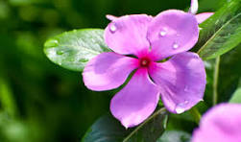
Scientific Name – Catharanthus roseus
Local Name – Madagascar Periwinkle, rose periwinkle, bright eyes.
Taxonomic Hierarchy –
- Kingdom: Plantae
- Sub Kingdom: Tracheobionta (Vascular plants)
- Division: Magnoliophyta
- Class: Magnoliopsida
- Subclass: Asteridae
- Order: Gentianales
- Family: Apocynaeean (Dog-bane family)
- Subfamily: Plumeroideae
Phytochemicals –
- Alkaloids: Vinblastine, Vincristine, Vindoline, Catharanthine, Ajmalicine
- Flavonoids: Kaempferol, Quercetin
- Phenolics: Caffeic acid, Ferulic acid
- Terpenoids: β-Sitosterol, Lupeol.

Vernacular names
Catharanthus roseus, during the course of its spread and naturalization over the tropics and subtropics has acquired a diversity of vernacular names as shown in the table:

Country | Vernacular name(s)
England | Madagascar periwinkle
India | Cape – periwinkle, Church yard blossom,  Dead-man's flower, Ainskati, Rattanjor,  Sadaphul, Sudukad umullai,  Billagannerue (Telugu) Bara Massi and  Sada Bahar (in Hindi), Gulfering (Kashmiri),  Nayantara (Bengali).
Indonesia | Indische maagdepalm, Kembang saritijha,  Kembang – dembaga.
Japan | Nichinchi
Philippines | Chichirica
West Indies | Oldmaid, Ramgoat rose, Jasmine, Magdalena, Vicaria
Sri – Lanka | Minimal or Patti-poo
Thailand | Phaeng phoi farang or Phang-puai-fa-rang
Venda | Liluvha
Vietnam | Dua can
Bangladesh | Nyantra
USA | Periwinkle
Pakistan | Sada-bahar
Mexico | Ninfa
Brazil | Boa-noite

Plant parts used for extraction of Alkaloids:
Plant parts | Name of Alkaloids
Leaf | Catharanthine, Vindoline, Vindolidine, Vindolicine, Vindolinine, ibogaine,  yohimbine, raubasine, Vinblastine, Vincristine.
Stem | Leurosine, Lochnerine, Catharanthine, Vindoline.
Root | Ajmalacine, Serpentine, Catharanthine, Vindoline, Leurosine, Lochnerine,  Reserpine, Alstonine, Tabersonine, Horhammericine,  Lochnericine, echitovenine. (Shanks et al.1998)
Flower | Catharanthine, Vindoline, Leurosine, Lochnerine, Tricin (Flavones).

Alkaloids possessing anticancer property, mechanism and its clinical uses:

Vinca Alkaloid | Mechanism of Action | Clinical Uses
Vincristine | Binds to tubulin, inhibiting microtubule formation, and arrests cell division in metaphase. | Leukemia, lymphomas
Vinblastine | Inhibits microtubule polymerization, preventing mitotic spindle formation and cell division. | Hodgkin’s disease, testicular germ cell cancer
Vinorelbine | Semi-synthetic derivative that disrupts microtubule assembly, blocking mitosis. | Solid tumors, lymphomas, lung cancer
Vindesine | Binds to tubulin, inhibiting microtubule formation and preventing cell division. | Acute lymphocytic leukemia

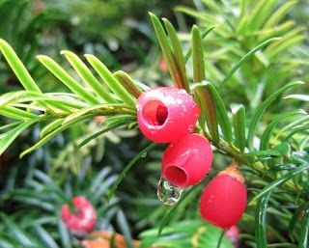

Scientific Name - Taxus brevifolia
Local Name – Pacific and European Yew
Taxonomic Hierarchy –
- Kingdom: Plantae
- Division: Angiosperms
- Class: Dicotyledons
- Order: Pinales
- Family: Taxaceae
- Genus: Taxus
- Species: Taxus brevifolia
Phytochemicals –
- Alkaloids:
  - Taxol (Paclitaxel) – Used in cancer treatment.
  - Taxinine – Potential anticancer properties.
- Flavonoids:
  - Quercetin – Antioxidant.
  - Kaempferol – Anti-inflammatory, antioxidant.
- Terpenoids:
  - Taxanes – Includes paclitaxel, effective in chemotherapy.

Country/Region | Vernacular Name(s)
United States | Pacific Yew, Western Yew, Oregon Yew
Canada | Pacific Yew, Western Yew
United Kingdom | Pacific Yew
Germany | Pazifische Eibe
France | If de l’Ouest, If du Pacifique
Spain | Tejo del Pacífico
Italy | Tasso del Pacifico
Portugal | Teixo-do-Pacífico
Netherlands | Pacifische Taxus
Russia | Тис тихоокеанский (Tis tikhookeanskiy)
China | 短叶红豆杉 (Duǎn yè hóngdòu shān)
Japan | パシフィックイチイ (Pashifikku Ichii)
India | Pacific Yew (English), पैसिफिक यू (Paisifik Yū)
Brazil | Teixo-do-Pacífico
Mexico | Tejo del Pacífico
Australia | Pacific Yew
New Zealand | Pacific Yew
South Africa | Pacific Yew
Turkey | Pasifik Porsuğu
Poland | Cis pacyficzny
Sweden | Stillahavs Idegran

Plant Part | Alkaloids
Bark | Paclitaxel (Taxol), 10-Deacetylbaccatin III, Baccatin III, Cephalomannine
Leaves | Paclitaxel (Taxol), 10-Deacetylbaccatin III, Baccatin III, Cephalomannine
Twigs | Paclitaxel (Taxol), 10-Deacetylbaccatin III, Baccatin III, Cephalomannine
Needles | Paclitaxel (Taxol), 10-Deacetylbaccatin III, Baccatin III, Cephalomannine
Seeds | Paclitaxel (Taxol), 10-Deacetylbaccatin III, Baccatin III, Cephalomannine
Roots | Paclitaxel (Taxol), 10-Deacetylbaccatin III, Baccatin III, Cephalomannine

Alkaloid | Mechanism of Action | Clinical Uses
Paclitaxel (Taxol) | Binds to β-tubulin, stabilizes microtubules, and prevents depolymerization, blocking mitosis. | Ovarian cancer, breast cancer, non-small cell lung cancer, Kaposi’s sarcoma.
Vinblastine | Binds to tubulin, inhibits microtubule polymerization, and prevents mitotic spindle formation. | Hodgkin’s lymphoma, testicular cancer, breast cancer, and other solid tumors.
Vincristine | Binds to tubulin, inhibits microtubule formation, and arrests cell division in metaphase. | Acute lymphocytic leukemia, Hodgkin’s lymphoma, non-Hodgkin’s lymphoma.
Vinorelbine | Semi-synthetic; disrupts microtubule assembly, blocking mitosis. | Non-small cell lung cancer, breast cancer, ovarian cancer.
Vindesine | Binds to tubulin, inhibits microtubule formation, and prevents cell division. | Acute lymphocytic leukemia, melanoma, lung cancer.
Quinine | Inhibits heme polymerase in malaria parasites, leading to toxic heme accumulation. | Treatment and prevention of malaria.
Quinidine | Blocks sodium and potassium ion channels, prolonging the action potential in the heart. | Cardiac arrhythmias (e.g., atrial fibrillation, ventricular tachycardia).
Morphine | Binds to opioid receptors in the CNS, inhibiting pain signals and producing analgesia. | Severe pain management (e.g., post-surgical pain, cancer pain).
Codeine | Metabolized to morphine, binding to opioid receptors to produce mild analgesia. | Mild to moderate pain relief, cough suppression.
Colchicine | Binds to tubulin, inhibits microtubule polymerization, and reduces inflammation. | Gout, familial Mediterranean fever, pericarditis.
Atropine | Blocks muscarinic acetylcholine receptors, inhibiting parasympathetic nervous activity. | Bradycardia, organophosphate poisoning, pre-anesthesia to reduce secretions.
Caffeine | Blocks adenosine receptors, increasing alertness and reducing fatigue. | Stimulant for fatigue, migraines, and enhancing analgesic effects.
Ephedrine | Stimulates α and β-adrenergic receptors, increasing heart rate and blood pressure. | Nasal congestion, hypotension, and asthma (less common now due to side effects).
Nicotine | Binds to nicotinic acetylcholine receptors, stimulating the central and peripheral nervous systems. | Smoking cessation (in the form of nicotine replacement therapy).
Reserpine | Depletes catecholamines and serotonin from nerve terminals, reducing blood pressure. | Hypertension, psychiatric disorders (historically).
Emetine | Inhibits protein synthesis by blocking ribosomal translocation in parasites. | Amoebiasis (historically, now rarely used due to toxicity).
Berberine | Inhibits bacterial and fungal growth, modulates glucose and lipid metabolism. | Diarrhea, diabetes, hyperlipidemia (traditional and investigational uses).
Strychnine | Antagonizes glycine receptors in the CNS, causing excessive neuronal excitation. | Not used clinically; historically as a stimulant (now toxic and banned).
Cocaine | Blocks dopamine, serotonin, and norepinephrine reuptake, causing CNS stimulation. | Local anesthesia (rarely used now due to abuse potential).
Ergotamine | Constricts blood vessels and activates serotonin receptors, reducing migraine symptoms. | Acute migraine attacks.

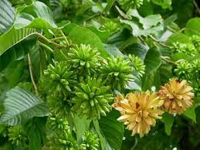

Scientific Name - Camptotheca acuminata
Local Name – Cancer Tree, Happy Tree
Taxonomic Hierarchy –
- Kingdom: Plantae
- Phylum: Tracheophyta
- Class: Magnoliopsida
- Order: Caryophyllales
- Family: Cornaceae
- Genus: Camptotheca
- Species: Camptotheca acuminata

Country/Region | Vernacular Name(s)
China | 喜树 (Xǐ Shù - "Happy Tree"), 癌症树 (Ái Zhèng Shù - "Cancer Tree")
Tibet | ཤིས་ཤིང་། (Shi Shing - "Happy Tree")
India | Camptotheca (English), कैम्प्टोथेका (Kaimptotheka)
United States | Happy Tree, Cancer Tree
United Kingdom | Happy Tree, Cancer Tree
Germany | Glücksbaum ("Happy Tree"), Krebsbaum ("Cancer Tree")
France | Arbre de la Joie ("Happy Tree"), Arbre Anticancer ("Cancer Tree")
Spain | Árbol de la Felicidad ("Happy Tree"), Árbol Anticáncer ("Cancer Tree")
Italy | Albero della Felicità ("Happy Tree"), Albero Anticancro ("Cancer Tree")
Japan | ハッピーツリー (Happī Tsurī - "Happy Tree"), がんの木 (Gan no Ki - "Cancer Tree")
South Korea | 해피 트리 (Haepi Teuri - "Happy Tree"), 암 나무 (Am Namu - "Cancer Tree")
Brazil | Árvore da Felicidade ("Happy Tree"), Árvore Anticâncer ("Cancer Tree")
Mexico | Árbol de la Felicidad ("Happy Tree"), Árbol Anticáncer ("Cancer Tree")
Russia | Дерево Счастья (Derevo Schast'ya - "Happy Tree"), Противораковое Дерево (Protivorakovoye Derevo - "Cancer Tree")
Australia | Happy Tree, Cancer Tree

Active Compound | Mechanism of Action | Clinical Uses
Camptothecin | Inhibits topoisomerase I, causing DNA damage and apoptosis. | Anticancer (ovarian, breast, lung, colorectal cancers).
10-Hydroxycamptothecin | Similar to camptothecin but with enhanced solubility. | Anticancer, antiviral.
9-Methoxycamptothecin | Inhibits topoisomerase I, inducing apoptosis. | Anticancer.

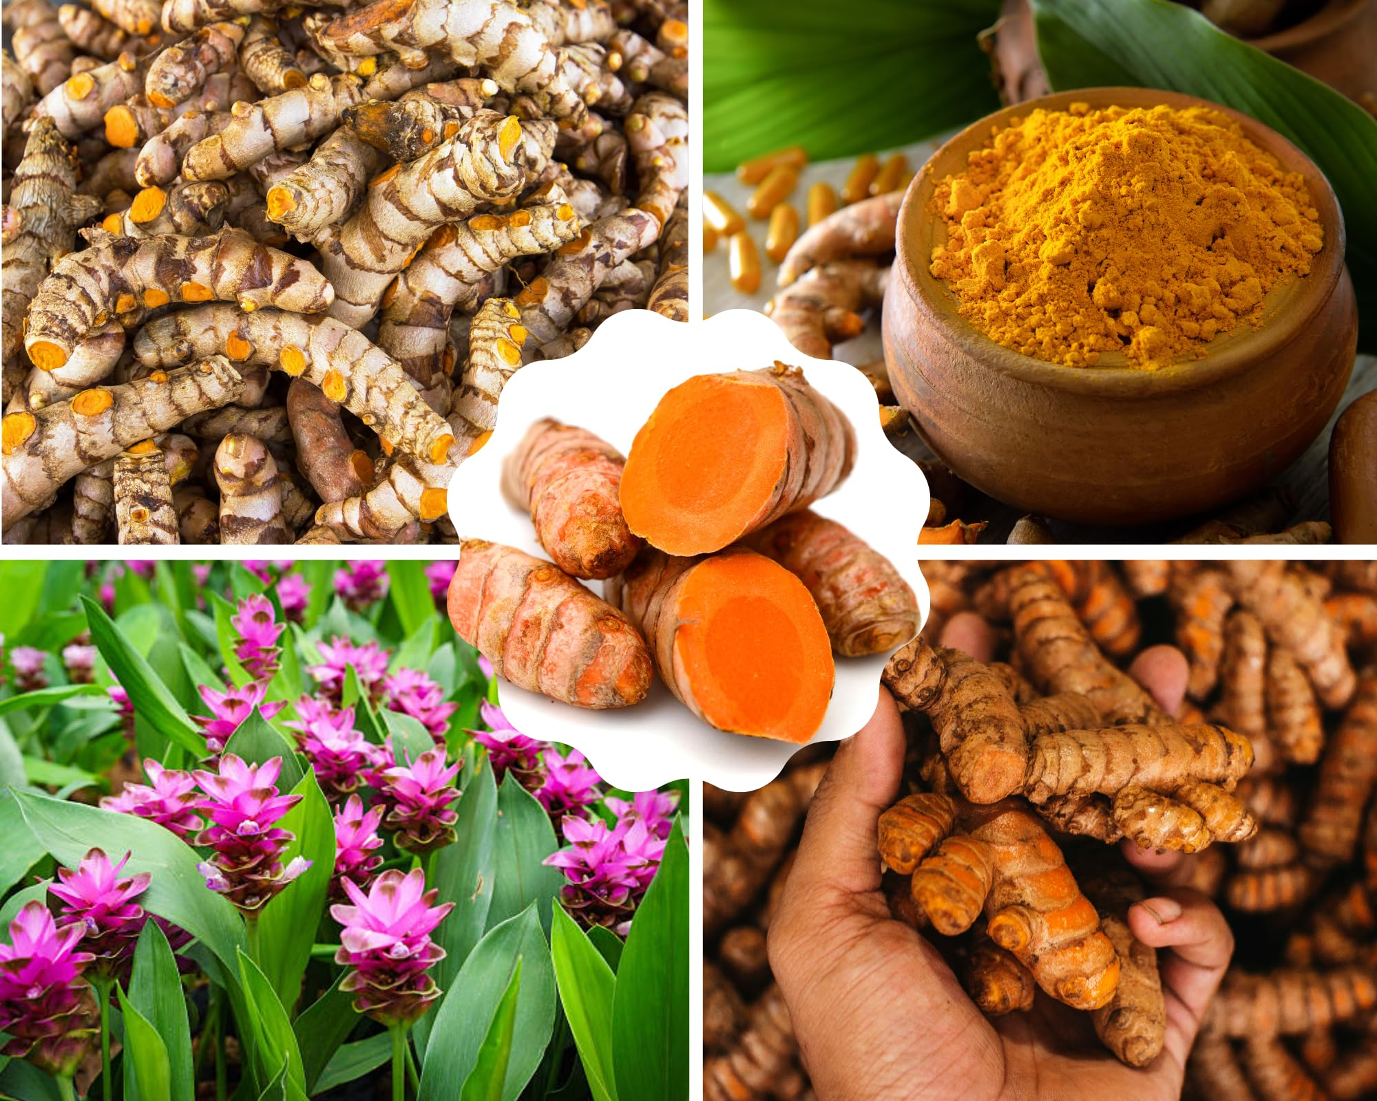
Scientific Name – Curcuma longa
Local Name – Turmeric
Taxonomic Hierarchy –
- Kingdom: Plantae
- Phylum: Tracheophyta
- Class: Liliopsida
- Order: Zingiberales
- Family: Zingiberaceae
- Genus: Curcuma
- Species: Curcuma longa

Country/Region | Vernacular Name(s)
India | हल्दी (Haldi), अर्द्रक (Ardraka)
China | 姜黄 (Jiāng Huáng - "Ginger Yellow")
Japan | ウコン (Ukon)
Thailand | ขมิ้น (Khamin)
Indonesia | Kunyit
Malaysia | Kunyit
Spain | Cúrcuma
France | Curcuma
Germany | Kurkuma
Italy | Curcuma
Portugal | Açafrão-da-terra ("Earth Saffron")
Brazil | Açafrão-da-terra, Cúrcuma
Mexico | Cúrcuma
United States | Turmeric
United Kingdom | Turmeric
Middle East | كركم (Kurkum)
Russia | Куркума (Kurkuma)
Africa | Turmeric (English), Dilaw (Swahili)

Active Compound | Mechanism of Action | Clinical Uses
Curcumin | Inhibits NF-κB, COX-2, LOX; modulates STAT3 and PI3K/Akt/mTOR pathways; antioxidant. | Anti-inflammatory, anticancer, antioxidant, neuroprotective, wound healing.
Demethoxycurcumin | Similar to curcumin but with lower potency. | Anti-inflammatory, antioxidant.
Bisdemethoxycurcumin | Similar to curcumin but with lower potency. | Anti-inflammatory, antioxidant.
Turmerone | Anti-inflammatory, neuroprotective. | Neuroprotective, antimicrobial.
Essential Oils | Antimicrobial, antifungal. | Treatment of infections, wound healing.

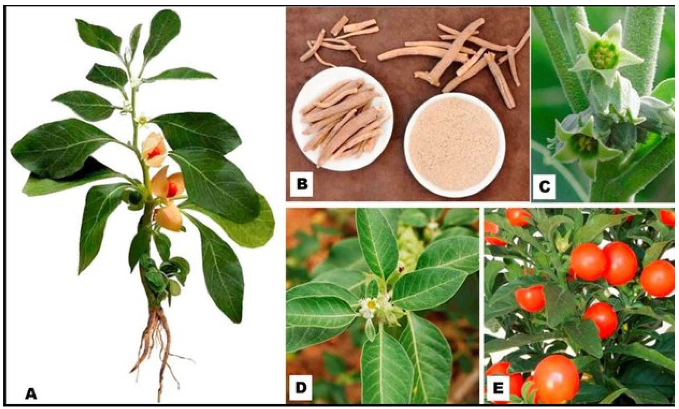
Scientific Name - Withania somnifera
Local Name – Ashwagandha
Taxonomic Hierarchy –
- Kingdom Plantae
- Phylum Streptophyta
- Class Equisetopsida
- Subclass Magnoliidae
- Order - Solanales
- Family - Solanaceae
- Genus - Withania
- Species - Withania somnifera

Country/Region | Vernacular Name(s)
India | अश्वगंधा (Ashwagandha), असगंध (Asgandh)
China | 睡茄 (Shuì Qié - "Sleep Eggplant")
Japan | アシュワガンダ (Ashwaganda)
Middle East | سمحوق (Samhūq), عين الثور (Ayn al-Thawr - "Eye of the Bull")
United States | Ashwagandha, Indian Ginseng, Winter Cherry
United Kingdom | Ashwagandha, Indian Ginseng
Germany | Ashwagandha, Schlafbeere ("Sleep Berry")
France | Ashwagandha, Ginseng Indien
Spain | Ashwagandha, Ginseng Indio
Italy | Ashwagandha, Ginseng Indiano
Brazil | Ashwagandha, Ginseng Indiano
Mexico | Ashwagandha, Ginseng Indio
Russia | Ашваганда (Ashvaganda), Индийский женьшень (Indiyskiy Zhen'shen')
Africa | Ashwagandha (English), Ubulawu (Zulu)
Nepal | अश्वगन्धा (Ashwagandha)
Sri Lanka | Ashwagandha (Sinhala), Amukkara (Tamil)

Active Compound | Mechanism of Action | Clinical Uses
Withaferin A | Induces apoptosis, inhibits NF-κB, modulates PI3K/Akt/mTOR pathway. | Anticancer, anti-inflammatory, antioxidant.
Withanolide A | Enhances GABAergic activity, stimulates Nrf2 pathway. | Adaptogen, neuroprotective, anxiolytic.
Somniferine | Acts as a mild sedative. | Sleep aid, relaxant.
Tropine | Exhibits anticholinergic effects. | Antispasmodic, gastrointestinal disorders.
Glycowithanolides | Reduces oxidative stress and inflammation in the brain. | Neuroprotective, antioxidant

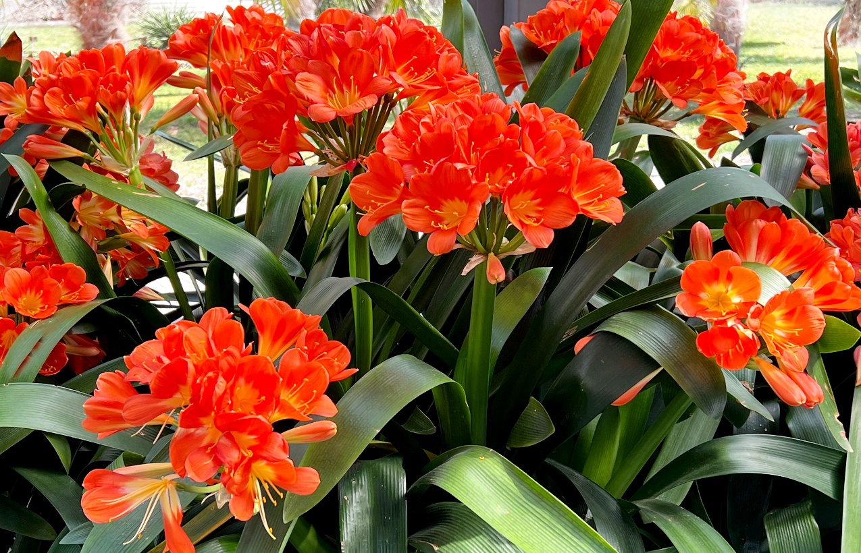
Scientific Name – Clivia miniata
Local Name – Bush Lily
Taxonomic Hierarchy -
- Kingdom: Plantae
- Phylum: Tracheophyta
- Class: Magnoliopsida
- Order: Asparagales
- Family: Amaryllidaceae
- Genus: Clivia
- Species: Clivia miniata

Country/Region | Vernacular Name(s)
South Africa | Boslelie (Afrikaans), Umayime (Zulu)
United States | Natal Lily, Bush Lily, Fire Lily
United Kingdom | Natal Lily, Bush Lily
Germany | Clivie, Natal-Lilie
France | Clivia, Lis du Natal
Spain | Clivia, Lirio de Natal
Italy | Clivia, Giglio del Natal
Australia | Natal Lily, Bush Lily
Japan | クリビア (Kuribia)
China | 君子兰 (Jūn Zǐ Lán - "Noble Orchid")
India | Clivia (English), नटाल लिली (Natal Lily)
Brazil | Clívia, Lírio-de-Natal
Mexico | Clivia, Lirio de Natal
Russia | Кливия (Kliviya), Натальская лилия (Natal'skaya Liliya)

Active Compound | Mechanism of Action | Clinical Uses
Lycorine | Inhibits protein synthesis, induces apoptosis, antiviral, anti-inflammatory. | Anticancer, antiviral, anti-inflammatory.
Clivatine | Exhibits cytotoxic effects on cancer cells. | Anticancer.
Miniaine | Antioxidant properties. | Antioxidant.

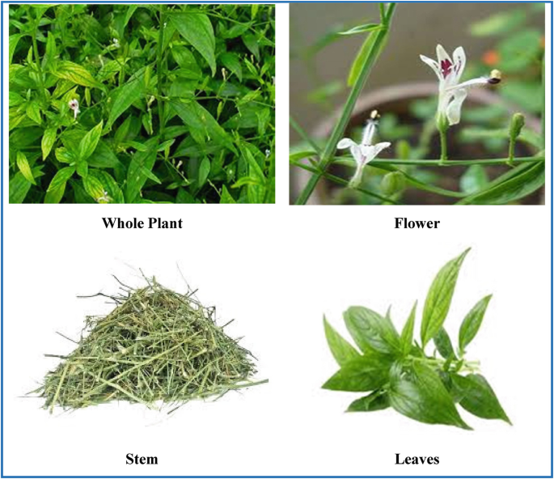
Scientific Name – Andrographis paniculata
Local Name – King of Bitter
Taxonomic Hierarchy -
Domain: Eukaryota,
Kingdom: Plantae,
Subkingdom: Tracheobionta,
Superdivision: Spermatophyta,
Division: Angiosperma,
Class: Dicotyledonae,
Subclass: Gamopetalae,
Series: Bicarpellatae,
Order: Personales,
Family: Acanthaceae,
Subfamily: Acanthoideae,
Tribe: Justiciae,
Subtribe: Andrographideae,
Genus: Andrographis,
Species: A. paniculata (Burm. f.)

Language | Name
Arabic | Quasabhuva
Assamese | Chiorta, Kalmegh
Azerbaijani | Acılar Şahı, Acılar Xanı (khanı)
Bengali | Kalmegh
Burmese | Se-ga-gyi
Chinese | Chuan Xin Lian
English | The Creat, King of Bitters
French | Chirette verte, Roi des amers
Gujarati | Kariyatu
Hindi | Kirayat, Kalpanath,
Indonesian | Sambiroto, Sambiloto
Japanese | Senshinren
Kannada | Nelaberu
Konkani | Vhadlem Kiratyem
Lao | La-Sa-Bee
Malay | Hempedu Bumi, Sambiloto
Malayalam | Nelavepu, Kiriyattu
Manipuri | Vubati
Marathi | Oli-kiryata, Kalpa
Mizo | Hnakhapui
Oriya | Bhuinimba
Panjabi | Chooraita
Persian | Nain-e Havandi
Philippines | Aluy, Lekha and Sinta
Russian | Andrografis
Sanskrit | Kalmegha, Bhunimba and Yavatikta
Scandinavian | Green Chiratta
Sinhalese | Hīn Kohomba or Heen Kohomba
Spanish | Andrografis
Tamil | Nilavembu
Telugu | Nilavembu
Thai | Fa-Talai-Jorn, Fah-talai-jon (jone)
Turkish | Acılar Kralı, Acı Paşa, Acı Bey
Urdu | Kalmegh, Kariyat, Mahatita
Vietnamese | Xuyên Tâm Liên
Thai | Fa-Talai-Jorn, Fah-talai-jon (jone)
Turkish | Acılar Kralı, Acı Paşa, Acı Bey
Urdu | Kalmegh, Kariyat, Mahatita
Vietnamese | Xuyên Tâm Liên

Active Compound | Mechanism of Action | Clinical Uses
Andrographolide | Inhibits NF-κB, stimulates Nrf2, induces apoptosis, modulates PI3K/Akt/mTOR pathway. | Antiviral, anti-inflammatory, anticancer, hepatoprotective, immunomodulator.
Neoandrographolide | Anti-inflammatory and hepatoprotective effects. | Anti-inflammatory, hepatoprotective.
Deoxyandrographolide | Antimicrobial and antiviral properties. | Antimicrobial, antiviral.
Flavonoids | Antioxidant and anti-inflammatory effects. | Antioxidant, anti-inflammatory.

Future Challenges
Medicinal plants have great promise in treating cancer; however, several obstacles need to be overcome in order to fully exploit their potential. Standardization and Quality Assurance :Since the plant composition is variable because of environmental factors, cultivation, and extraction methods, this causes potential obstacle in drug development. Bioavailability and Pharmacokinetics: To be effective therapeutics in clinical settings, many plant-derived compounds must overcome challenges related to poor bioavailability , which can restrict the pharmacokinetic properties of these compounds. They require advanced drug delivery systems to improve their absorption and distribution. Toxicity and Safetylosele rating: The assumption that natural products are safe is not always true, as many plant chemicals can act as toxins at higher concentrations and with cumulative use. Safety needs to be ensured with rigorous toxicity studies. Mechanistic Insight: Many of the plant-based compounds are still poorly understood in their mechanisms of action, even if they are extraordinarily promising. More studies are required to explain their molecular targets and pathways. Integration and Interdisciplinary Pathways: Beyond research, exploring successful integrations of traditional medicine into modern practices and facilitating interdisciplinary collaboration lies in promoting holistic approaches to health across diverse communities.

Conclusion
Medicinal plants possess vast potential for the discovery and development of new anticancer agents. Due to their high diversity in phytochemical constituents, these plants exert activity through multiple mechanisms of action and herald a promising future as adjuvants and supplemental agents for cancer treatment. However, converting such knowledge to clinically proven treatments poses a series of scientific, standardization, and bioavailability challenges. This can be remedied by continued partnership between healers, researchers, and clinicians, as supported by the continued funding and encouragement of biotechnological applications and drug delivery systems. This review advocates for additional research and development in the field of plant-based cancer therapy to create more affordable and beneficial alternatives for patients around the world.

References:
- https://en.wikipedia.org/w/index.php?title=Catharanthus_roseus&oldid=1266553511
- https://www.researchgate.net/publication/327473180_An_overview_of_Catharanthus_roseus_and_medicinal_properties_of_their_metabolites_against_important_diseases
- https://www.derpharmachemica.com/pharma-chemica/an-updated-review-on-catharanthus-roseus-its-traditional-and-modern-use-for-humankind-91066.html
- https://sist.sathyabama.ac.in/sist_naac/documents/1.3.4/bsc-microbiology-batchno-19.pdf
- https://www.drugs.com/npc/periwinkle.html
- https://www.sciencedirect.com/topics/pharmacology-toxicology-and-pharmaceutical-science/taxus-brevifolia
- https://en.wikipedia.org/wiki/Taxus_brevifolia
- https://en.wikipedia.org/wiki/Taxus_brevifolia?utm_source=chatgpt.com
- https://link.springer.com/chapter/10.1007/978-3-030-44930-8_9
- https://plants.ces.ncsu.edu/plants/taxus-brevifolia/
- https://www.webmd.com/vitamins/ai/ingredientmono-802/yew
- https://scholarworks.sfasu.edu/cgi/viewcontent.cgi?params=/context/ncpc_articles/article/1051/&path_info=Phytochemistry_of_Camptotheca_Decaisne.pdf
- https://www.sciencedirect.com/science/article/pii/S2667142524000885
- https://www3.ha.org.hk/toxicplant/en/camptotheca_acuminata.html
- https://en.wikipedia.org/wiki/Camptotheca_acuminata
- https://philarchive.org/archive/MUHPAP-2
- https://www.researchgate.net/publication/361882722_Nutritional_value_phytochemistry_pharmacological_and_in_vitro_regeneration_of_turmeric_Curcuma_longa_L_An_updated_review
- https://www.sciencedirect.com/science/article/pii/S2667142523000088
- https://www.researchgate.net/publication/332465341_Ethnobotany_Phytochemistry_and_Traditional_Uses_of_Curcuma_spp_and_Pharmacological_Profile_of_Two_Important_Species_C_longa_and_C_zedoaria_A_Review
- https://en.wikipedia.org/wiki/Withania_somnifera
- https://www.rivm.nl/bibliotheek/rapporten/2024-0029.pdf
- https://en.wikipedia.org/wiki/Clivia_miniata
- https://www.bibliomed.org/mnsfulltext/19/19-1598400327.pdf?1740154643
- https://plants.ces.ncsu.edu/plants/clivia-miniata/
- https://www.researchgate.net/publication/349116574_Clivia_miniata_Lindl_Bosse_Amaryllidaceae_Botany_medicinal_uses_phytochemistry_and_pharmacological_properties_ARTICLE_INFO
- https://www.sciencedirect.com/science/article/pii/S0753332223011794
- https://www.sciencedirect.com/science/article/pii/S0753332223011794
- https://pza.sanbi.org/clivia-miniata?utm_source=chatgpt.com
- https://link.springer.com/chapter/10.1007/978-3-031-75661-0_3
- https://pmc.ncbi.nlm.nih.gov/articles/PMC4408759/
- https://www.researchgate.net/publication/353641096_ANALYSIS_OF_PHYTOCHEMICAL_CONSTITUENTS_OF_ANDROGRAPHIS_PANICULATA_BurmfNees
- https://www.thepharmajournal.com/archives/2021/vol10issue7/PartK/10-7-46-635.pdf
- https://www.rxlist.com/supplements/andrographis.htm#:~:text=Andrographis%20is%20a%20plant%20that,cold%20and%20flu%20(influenza).
- https://journals.sagepub.com/doi/pdf/10.1177/1934578X0700200519
- Abreu, P. M., & Martins, E. S. (2019). Medicinal plants and their bioactive compounds in cancer therapy. Journal of Ethnopharmacology, 230, 1-15.
- Amin¹, A., Ara, N., Krishna, P., Lodh, S., & Azad, A. K. (2025). Regenerative Medicine: A Broad Analysis of Innovations and Therapeutic Applications. Int. J. Curr. Res. Med. Sci, 11(1), 29-54.
- AMIN, A. (2024). Unveiling the Fountain of Youth: A Review of Chronological Journey from Ancient Folklore to Modern Anti-Aging Science. Available at SSRN 5053568.
- Chowdhury, I. Q. (2024). Artificial Intelligence in Pharmacy: Innovations, Applications, and Future Emerging Challenges.
- Chowdhury, I. Q. (2024). Artificial Intelligence in Pharmacy: Innovations, Applications, and Future Emerging Challenges.
- Amin¹, A., Abyaz, R., Alom, S., Siam, S. A., Raihan, R., Imran, A., & Azad, A. K. The Journey of Industrial Revolutions and the Rise of Ai in Pharmaceutical Manufacturing.
- Aggarwal, B. B., & Shishodia, S. (2006). Molecular targets of dietary agents for prevention and therapy of cancer. Biochemical Pharmacology, 71(10), 1397-1421.
- Ahmad, A., & Sarkar, F. H. (2013). Current understanding and future prospects of medicinal plants in cancer prevention. Cancer Letters, 332(2), 127-133.
- Ahn, K. S., & Sethi, G. (2010). Potential therapeutic effects of curcumin in cancer. BioFactors, 37(3), 169-183.
- Alves, R. C., & Costa, A. S. G. (2018). Medicinal plants as sources of anticancer agents: A review. Phytotherapy Research, 32(5), 865-891.
- Amin, A. R., & Kucuk, O. (2009). Perspectives for cancer prevention with natural compounds. Journal of Clinical Oncology, 27(16), 2712-2725.
- Anand, P., & Kunnumakkara, A. B. (2008). Cancer is a preventable disease that requires major lifestyle changes. Pharmaceutical Research, 25(9), 2097-2116.
- Atanasov, A. G., & Waltenberger, B. (2015). Discovery and resupply of pharmacologically active plant-derived natural products: A review. Biotechnology Advances, 33(8), 1582-1614.
- Balunas, M. J., & Kinghorn, A. D. (2005). Drug discovery from medicinal plants. Life Sciences, 78(5), 431-441.
- Bar-Sela, G., & Epelbaum, R. (2010). Curcumin as an anti-cancer agent: Review of the gap between basic and clinical applications. Current Medicinal Chemistry, 17(3), 190-197.
- Basmadjian, C., & Bouhadir, K. (2014). Cancer chemoprevention: The role of plant-derived compounds. Current Medicinal Chemistry, 21(7), 833-845.
- Bhanot, A., & Sharma, R. (2011). Natural sources as potential anti-cancer agents: A review. International Journal of Phytomedicine, 3(1), 9-26.
- Bharti, A. C., & Aggarwal, B. B. (2003). Chemopreventive agents induce suppression of nuclear factor-kappaB leading to chemosensitization. Annals of the New York Academy of Sciences, 1002, 127-133.
- Bishayee, A., & Sethi, G. (2016). Bioactive natural products in cancer prevention and therapy. Seminars in Cancer Biology, 40-41, 1-3.
- Block, K. I., & Mead, M. N. (2003). Immune system effects of echinacea, ginseng, and astragalus: A review. Integrative Cancer Therapies, 2(3), 247-267.
- Boik, J. (2001). Natural compounds in cancer therapy. Oregon Medical Press.
- Bonham, M., & Posakony, J. (2005). Characterization of chemical constituents in Scutellaria baicalensis with antiandrogenic and growth-inhibitory activities. Prostate, 65(2), 125-134.
- Braca, A., & De Tommasi, N. (2011). Antioxidant principles from Bauhinia tarapotensis. Journal of Natural Products, 64(7), 892-895.
- Brown, D. (1995). Encyclopedia of herbs and their uses. Dorling Kindersley.
- Butler, M. S. (2004). The role of natural product chemistry in drug discovery. Journal of Natural Products, 67(12), 2141-2153.
- Cao, H., & Kelly, M. A. (2007). Traditional Chinese medicine in cancer care: Perspectives and experiences of patients and professionals in China. European Journal of Cancer Care, 16(4), 317-324.
- Cassileth, B. R., & Deng, G. (2004). Complementary and alternative therapies for cancer. The Oncologist, 9(1), 80-89.
- Chahar, M. K., & Sharma, N. (2011). Flavonoids: A versatile source of anticancer drugs. Pharmacognosy Reviews, 5(9), 1-12.
- Chaturvedi, P. K., & Bhui, K. (2008). Medicinal plants as a source of anticancer agents. Journal of Ethnopharmacology, 115(2), 207-214.
- Chen, S., & Kong, A. N. (2004). Synergistic chemopreventive effects of curcumin and resveratrol. Cancer Research, 64(18), 6449-6458.
- Cragg, G. M., & Newman, D. J. (2005). Plants as a source of anti-cancer agents. Journal of Ethnopharmacology, 100(1-2), 72-79.
- Cragg, G. M., & Newman, D. J. (2013). Natural products: A continuing source of novel drug leads. Biochimica et Biophysica Acta (BBA) - General Subjects, 1830(6), 3670-3695.
- Dai, J., & Mumper, R. J. (2010). Plant phenolics: Extraction, analysis, and their antioxidant and anticancer properties. Molecules, 15(10), 7313-7352.
- De Martel, C., & Franceschi, S. (2009). Infections and cancer: Established associations and new hypotheses. Critical Reviews in Oncology/Hematology, 70(3), 183-194.
- De Silva, T., & Rankin, G. O. (2013). Medicinal plants in cancer prevention and treatment. Journal of Medicinal Plants Research, 7(42), 3085-3099.
- Demain, A. L., & Vaishnav, P. (2011). Natural products for cancer chemotherapy. Microbial Biotechnology, 4(6), 687-699.
- Devi, P. U., & Solomon, F. E. (1999). Effect of plumbagin on the radiation-induced cytogenetic and cell cycle changes in mouse Ehrlich ascites carcinoma. Radiation Research, 152(1), 92-97.
- Dey, A., & De, J. N. (2014). Phytochemistry and pharmacology of anti-cancer medicinal plants: A review. Journal of Medicinal Plants Studies, 2(3), 22-28.
- Dhanamani, M., & Lakshmi, S. (2011). Ethnomedicinal plants for cancer therapy: A review. International Journal of Pharma and Bio Sciences, 2(4), 589-601.
- Dillard, C. J., & German, J. B. (2000). Phytochemicals: Nutraceuticals and human health. Journal of the Science of Food and Agriculture, 80(12), 1744-1756.
- Efferth, T., & Li, P. C. (2007). From traditional Chinese medicine to rational cancer therapy. Trends in Molecular Medicine, 13(8), 353-361.
- El-Shemy, H. A., & Aboul-Enein, A. M. (2010). Natural products as potential anticancer agents: A review. Journal of Medicinal Plants Research, 4(12), 1143-1155.
- Fabricant, D. S., & Farnsworth, N. R. (2001). The value of plants used in traditional medicine for drug discovery. Environmental Health Perspectives, 109(Suppl 1), 69-75.
- Farnsworth, N. R., & Soejarto, D. D. (1991). Global importance of medicinal plants. Conservation of Medicinal Plants, 25-51.
- Fong, H. H., & Tin-Wa, M. (2002). Integration of herbal medicine into modern medical practices: Issues and prospects. Integrative Cancer Therapies, 1(3), 287-293.
- Fridlender, M., & Kapulnik, Y. (2015). Plant derived substances with anti-cancer activity: From folklore to practice. Frontiers in Plant Science, 6, 799.
- Fulda, S., & Debatin, K. M. (2006). Sensitization for tumor necrosis factor-related apoptosis-inducing ligand-induced apoptosis by the chemopreventive agent resveratrol. Cancer Research, 66(3), 1748-1754.
- Gautam, R., & Jachak, S. M. (2009). Recent developments in anti-inflammatory natural products. Medicinal Research Reviews, 29(5), 767-820.
- Ghorbani, A., & Esmaeilizadeh, M. (2017). Pharmacological properties of Salvia officinalis and its components. Journal of Traditional and Complementary Medicine, 7(4), 433-440.
- Gohil, K. J., & Patel, J. A. (2010). A review on Bacopa monniera: Current research and future prospects. International Journal of Green Pharmacy, 4(1), 1-9.
- Gordaliza, M. (2007). Natural products as leads to anticancer drugs. Clinical and Translational Oncology, 9(12), 767-776.
- Greenwell, M., & Rahman, P. K. (2015). Medicinal plants: Their use in anticancer treatment. International Journal of Pharmaceutical Sciences and Research, 6(10), 4103-4112.
- Gupta, S. C., & Kim, J. H. (2011). Multitargeting by curcumin as revealed by molecular interaction studies. Natural Product Reports, 28(12), 1937-1955.
- Gupta, S. C., & Prasad, S. (2010). Regulation of survival, proliferation, invasion, angiogenesis, and metastasis of tumor cells through modulation of inflammatory pathways by nutraceuticals. Cancer and Metastasis Reviews, 29(3), 405-434.
- Hanahan, D., & Weinberg, R. A. (2011). Hallmarks of cancer: The next generation. Cell, 144(5), 646-674.
- Hartwell, J. L. (1982). Plants used against cancer. Quarterly Journal of Crude Drug Research, 20(3-4), 79-107.
- Harvey, A. L. (2008). Natural products in drug discovery. Drug Discovery Today, 13(19-20), 894-901.
- Hosseini, A., & Ghorbani, A. (2015). Cancer therapy with phytochemicals: Evidence from clinical studies. Avicenna Journal of Phytomedicine, 5(2), 84-97.
- Houghton, P. J., & Howes, M. J. (2005). Natural products and derivatives affecting neurotransmission relevant to Alzheimer's and Parkinson's disease. Neurosignals, 14(1-2), 6-22.
- Hussain, M. S., & Fareed, S. (2012). Current approaches toward production of secondary plant metabolites. Journal of Pharmacy and Bioallied Sciences, 4(1), 10-20.
- Iqbal, J., & Abbasi, B. A. (2017). Plant-derived anticancer agents: A green anticancer approach. Asian Pacific Journal of Tropical Biomedicine, 7(12), 1129-1150.
- Itokawa, H., & Morris-Natschke, S. L. (2008). Plant-derived natural product research aimed at new drug discovery. Journal of Natural Medicines, 62(3), 263-280.
- Jachak, S. M., & Saklani, A. (2007). Challenges and opportunities in drug discovery from plants. Current Science, 92(9), 1251-1257.
- Jemal, A., & Bray, F. (2011). Global cancer statistics. CA: A Cancer Journal for Clinicians, 61(2), 69-90.
- Ji, H. F., & Li, X. J. (2009). Traditional Chinese medicine in cancer therapy: A review. American Journal of Chinese Medicine, 37(5), 875-886.
- Katiyar, S. K., & Mukhtar, H. (1996). Tea in chemoprevention of cancer: Epidemiologic and experimental studies. International Journal of Oncology, 8(2), 221-238.
- Kaur, R., & Arora, S. (2015). Alkaloids-important therapeutic secondary metabolites of plant origin. Journal of Critical Reviews, 2(3), 1-8.
- Khan, N., & Afaq, F. (2008). Targeting multiple signaling pathways by green tea polyphenol (-)-epigallocatechin-3-gallate. Cancer Research, 68(8), 2920-2926.
- Kinghorn, A. D., & Chin, Y. W. (2009). Discovery of natural product anticancer agents from biodiverse organisms. Current Opinion in Drug Discovery & Development, 12(2), 189-196.
- Koehn, F. E., & Carter, G. T. (2005). The evolving role of natural products in drug discovery. Nature Reviews Drug Discovery, 4(3), 206-220.
- Kooti, W., & Servatyari, K. (2017). Effective medicinal plant in cancer treatment, part 2: Review study. Journal of Evidence-Based Complementary & Alternative Medicine, 22(4), 982-995.
- Kotecha, R., & Takami, A. (2016). Dietary phytochemicals and cancer chemoprevention: A review of the clinical evidence. Oncotarget, 7(32), 52517-52529.
- Kunnumakkara, A. B., & Anand, P. (2008). Curcumin inhibits proliferation, invasion, angiogenesis, and metastasis of different cancers through interaction with multiple cell signaling proteins. Cancer Letters, 269(2), 199-225.
- Lee, K. H., & Xiao, Z. (2008). The role of natural products in drug discovery and development. Journal of Natural Products, 71(9), 1647-1657.
- Li, J. W., & Vederas, J. C. (2009). Drug discovery and natural products: End of an era or an endless frontier? Science, 325(5937), 161-165.
- Lin, Y., & Shi, R. (2008). Luteolin, a flavonoid with potential for cancer prevention and therapy. Current Cancer Drug Targets, 8(7), 634-646.
- Liu, R. H. (2004). Potential synergy of phytochemicals in cancer prevention: Mechanism of action. Journal of Nutrition, 134(12), 3479S-3485S.
- Mann, J. (2002). Natural products in cancer chemotherapy: Past, present, and future. Nature Reviews Cancer, 2(2), 143-148.
- Mishra, B. B., & Tiwari, V. K. (2011). Natural products: An evolving role in future drug discovery. European Journal of Medicinal Chemistry, 46(10), 4769-4807.
- Newman, D. J., & Cragg, G. M. (2016). Natural products as sources of new drugs from 1981 to 2014. Journal of Natural Products, 79(3), 629-661.
- Nobili, S., & Lippi, D. (2009). Natural compounds for cancer treatment and prevention. Pharmacological Research, 59(6), 365-378.
- Pan, M. H., & Ho, C. T. (2008). Chemopreventive effects of natural dietary compounds on cancer development. Chemical Society Reviews, 37(11), 2558-2574.
- Patwardhan, B., & Warude, D. (2005). Ayurveda and traditional Chinese medicine: A comparative overview. Evidence-Based Complementary and Alternative Medicine, 2(4), 465-473.
- Pezzuto, J. M. (1997). Plant-derived anticancer agents. Biochemical Pharmacology, 53(2), 121-133.
- Pisha, E., & Chai, H. (1995). Discovery of betulinic acid as a selective inhibitor of human melanoma that functions by induction of apoptosis. Nature Medicine, 1(10), 1046-1051.
- Prakash, O., & Kumar, A. (2013). Anticancer potential of plants and natural products: A review. American Journal of Pharmacological Sciences, 1(6), 104-115.
- Raskin, I., & Ribnicky, D. M. (2002). Plants and human health in the twenty-first century. Trends in Biotechnology, 20(12), 522-531.
- Reddy, L., & Odhav, B. (2003). Natural products for cancer prevention: A global perspective. Pharmacology & Therapeutics, 99(1), 1-13.
- Saklani, A., & Kutty, S. K. (2008). Plant-derived compounds in clinical trials. Drug Discovery Today, 13(3-4), 161-171.
- Samuelsson, G. (2004). Drugs of natural origin: A textbook of pharmacognosy. Swedish Pharmaceutical Press.
- Sarkar, F. H., & Li, Y. (2009). The role of isoflavones in cancer chemoprevention. Frontiers in Bioscience, 14(1), 3857-3870.
- Scalbert, A., & Williamson, G. (2000). Dietary intake and bioavailability of polyphenols. Journal of Nutrition, 130(8), 2073S-2085S.
- Shishodia, S., & Aggarwal, B. B. (2006). Diosgenin inhibits osteoclastogenesis, invasion, and proliferation through the downregulation of Akt, IκB kinase activation, and NF-κB-regulated gene expression. Oncogene, 25(10), 1463-1473.
- Singh, S., & Sharma, B. (2011). Anticancer activity of medicinal plants: A review. International Journal of Research in Ayurveda and Pharmacy, 2(4), 1151-1155.
- Surh, Y. J. (2003). Cancer chemoprevention with dietary phytochemicals. Nature Reviews Cancer, 3(10), 768-780.
- Tan, W., & Lu, J. (2011). Anti-cancer natural products isolated from Chinese medicinal herbs. Chinese Medicine, 6(1), 27.
- Taraphdar, A. K., & Roy, M. (2001). Natural products as inducers of apoptosis: Implication for cancer therapy and prevention. Current Science, 80(11), 1387-1396.
- Teiten, M. H., & Dicato, M. (2010). Curcumin as a regulator of epigenetic events. Molecular Nutrition & Food Research, 54(8), 1169-1180.
- Wang, H., & Oo Khor, T. (2012). Plants vs. cancer: A review on natural phytochemicals in preventing and treating cancers and their druggability. Anti-Cancer Agents in Medicinal Chemistry, 12(10), 1281-1305.
- Wink, M. (2012). Medicinal plants: A source of anti-parasitic secondary metabolites. Molecules, 17(11), 12771-12791.
- World Health Organization. (2002). Traditional medicine strategy 2002-2005. WHO.
- Yadav, V. R., & Prasad, S. (2011). Targeting inflammatory pathways by flavonoids for prevention and treatment of cancer. Planta Medica, 77(11), 1084-1103.
- Yang, C. S., & Wang, X. (2010). Green tea and cancer prevention. Nutrition and Cancer, 62(7), 931-937.
- Yoo, C. B., & Jones, P. A. (2006). Epigenetic therapy of cancer: Past, present, and future. Nature Reviews Drug Discovery, 5(1), 37-50.
- Zhou, X., & Seto, S. W. (2016). Synergistic effects of Chinese herbal medicine: A comprehensive review of methodology and current research. Frontiers in Pharmacology, 7, 201.
- Amin, A., Abyaz, R., Imran, A., & Azad, A. K. (2024). Exploring Ethnomedicine: An Anthropological perspective on traditional and modern healthcare. INTERANTIONAL JOURNAL OF SCIENTIFIC RESEARCH IN ENGINEERING AND MANAGEMENT, 08(11), 1–7. https://doi.org/10.55041/ijsrem38492
- Amin, A., Chowdhury, I. Q., Abyaz, R., Alom, S., Siam, S. A., Imran, A., Lia, F. S., & Azad, P. a. K. (2024c). Artificial intelligence in pharmacy: Innovations, applications, and future emerging challenges. INTERANTIONAL JOURNAL OF SCIENTIFIC RESEARCH IN ENGINEERING AND MANAGEMENT, 08(12), 1–9. https://doi.org/10.55041/ijsrem40335
- Al Amin, Abyaz, R., Siam, S. A., Alom, S., Imran, A., Lodh, S., & Azad, A. K. (2024). Unveiling the fountain of youth: A review of chronological journey from ancient folklore to modern anti-aging science. International Journal of Scientific Research and Engineering Development, 7(6), 408–425. Available at https://zenodo.org/records/14263246
- Amin, A., ¹, Ara, N., ²(1), Sadhukhan, P. K., ²(2), Abyaz, R., ²(3), Alom, S., ²(4), Siam, S. A., ²(5), Imran, A., ²(6), Lodh, Dr. S., ²(7), Lodh, S., ²(8), & Professor Abul Kalam Azad. (2025). Regenerative Medicine: A broad analysis of innovations and therapeutic applications. International Journal of Current Research in Medical Sciences, 11(1), 29–54. http://dx.doi.org/10.22192/ijcrms.2025.11.01.004
- Amin, A., ¹, Abyaz, R., ², Alom, S., ², Siam, S. A., ², Raihan, R., ², Imran, A., ², Azad, A. K., ², Department of Pharmacy, University of Development Alternative (UODA), Dhaka-1209, Bangladesh, BRAC Business School, BRAC University, Dhaka, Bangladesh, Department of Medicine, Dhaka National Medical Institute Hospital, Dhaka, Bangladesh, & Head, Department of Pharmacy, Bangladesh University, 5/B, Beribandh Main Road, Adabar, Mohammadpur, Dhaka - 1207. (2025). The journey of industrial revolutions and the rise of AI in pharmaceutical manufacturing. In International Journal of Pharmaceutical Research and Applications (Vol. 10, Issue 1, pp. 1235–1251). https://www.ijprajournal.com

