**Three Phase Transmission line fault detection and analysis system**

**Author Name**

1. Nehalika Mohadikar 2 Swapnil Kulsange 3 Shubham Rohankar 4 Gokul Upare 5 Rishabh Singh 6. Prof Ashwini Walde Student(EE) NIETM , Student(EE) NIETM , Student(EE) NIETM , Student(EE) NIETM , Student(EE) NIETM , HOD(EE) NIETM ,

***Abstract - Transmission line is the most important part of the power system. Transmission lines a principal amount of power. The requirement of power and its allegiance has grown up exponentially over the modern era, and the major role of a transmission line is to transmit electric power from the source area to the distribution network. The exploded between limited production, and a tremendous claim has grown the focus on minimizing power losses. Losses like transmission loss and also conjecture factors as like as physical losses to various technical losses, Another thing is the primary factor it has a reactive power and voltage deviation are momentous in the long-range transmission power line. In essentially, fault analysis is a very focusing issue in power system engineering to clear fault in short time and re-establish power system as quickly as possible on very minimum interruption. However, the fault detection that interrupts the transmission line is itself challenging task to investigate fault as well as improving the reliability of the system.[1]***

***Keyword : - IOT, ESP8266, Arduino, Relay, GPS Module, etc.***

**Introduction** As we seen our surrounding the fault occurred in the transmission line is very common in rainy season and it is very dangerous for us. The electrical power system is growing in size and complexity in all sectors such as generation, transmission, distribution, distribution so in this complex network fault is happened which results in several economic losses and reduce reliability of electrical system. We take care to resolve this fault as soon as possible, if we failed to resolve this then it can cause complete black our or grid failure. Generally the 70% to 90% of faults on overhead lines, most of the faults occurred due to lighting smiles, storm, flashover these is very harmful for the society. In transmission line this type of faults line to line faults line to ground fault there are many types of faults. Due to faults power failure and also damage the electric equipment.[2]

**Classification of Faults**: Symmetric faults In a three-phase system, if a fault affects all three phases equally, it is called a symmetric or a balanced fault. Generally symmetric faults constitute about 5% of the total faults. Asymmetric faults An unbalanced fault or asymmetric fault results in unequal effect of fault on each of the three phases. Asymmetric faults are further classified as LL or Line to Line fault, LG or Line to Ground fault and LLG or Double Line to Ground fault.

• LL fault is a short circuit between two lines, caused by ionization of air, or when lines come into physical contact, for example due to a broken insulator.

• LG Fault is a short circuit between one line and ground due to physical contact caused by lightning or storm.

• LLG fault occurs when two lines come in contact with the ground and each other. This is mainly caused by storm damage. Transient faults In a system, if a fault diminishes when power is disconnected for a short period of time and then restored, the fault is referred as a transient fault. A transient fault may also be an insulation fault that temporarily affects a device’s dielectric properties. Transient faults may be caused due to momentary tree contact, animal contact, lightning strike, etc.[3]

**Major Components Used**

**Arduino Uno Controller**: Arduino Uno controller is the main element of the mission. All sensors are connected to Arduino and it controls all sensors through giving instructions. by using the use of Arduino we can do all things at low price. Arduino has analog and virtual pins through which we will manage the challenge by way of giving inputs in analog in addition to digital form. Current Sensor: On this task we have used

**Node MCU**: Node MCU is the open supply IoT based platform. The wireless firmware included on this, which runs on ESP8266 WiFi The version of Node MCU used in this challenge is 1.0 carries ESP-12E in which E stands for more advantageous.

**IoT Cloud Platform:** The IoT cloud is a large community that supports IoT gadgets and programs. The platform consists of the underlying infrastructure, servers and garage, it wished for actual time operations and processing.[6]

**Block Diagram**

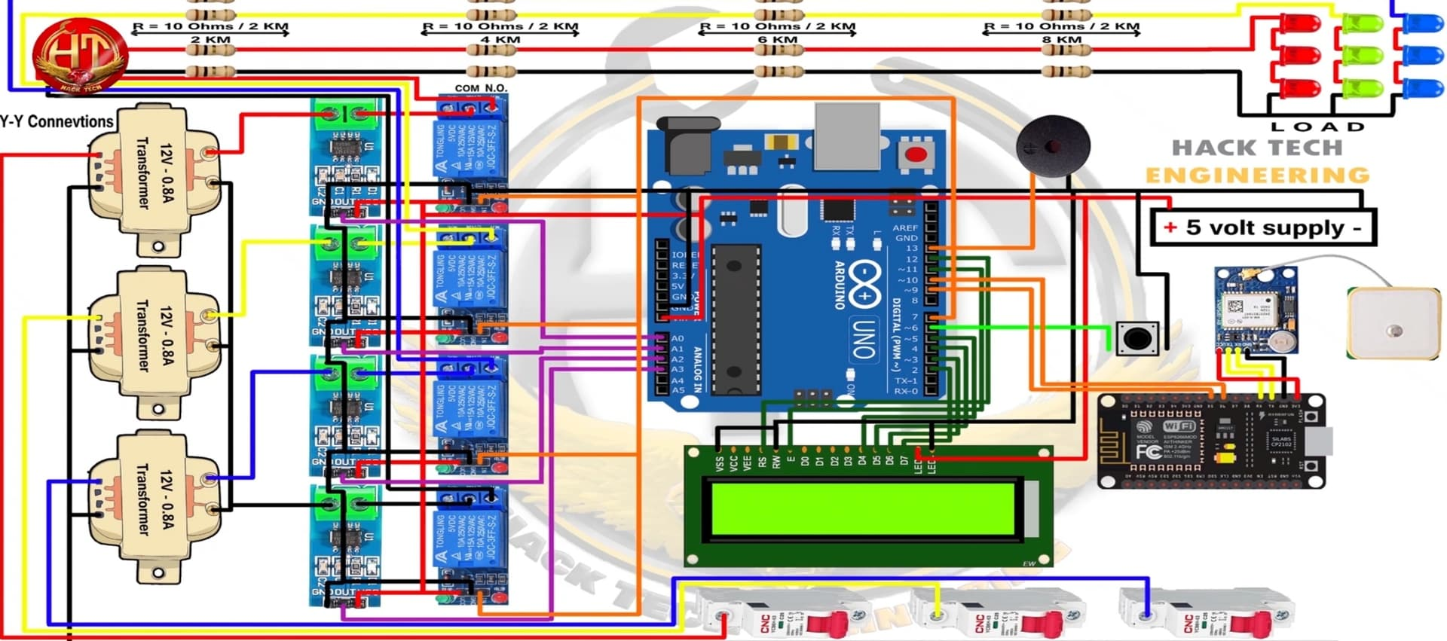

**Working**: The objective of this project is to determine the distance of line to ground and line to line fault from base station in kilometers using an Arduino board over IOT. This system is a common practice followed in many urban areas. While a fault occurs for some reason, at that time the repairing process related to that particular cable is difficult due to not knowing the exact location of the cable fault. The proposed system is to find the exact location of the fault.  
The project uses the standard concept of Ohms law i.e., when a low DC voltage is applied at the feeder end through a series resistor (Cable lines), then current would vary depending upon the location of fault in the cable. In case there is a short circuit (Line to Ground/ Line to Line)  
The project is assembled with a set of resistors representing cable length in KM’s and fault creation is made by a set of switches to cross check the accuracy of the same. The fault occurring at a particular distance and the respective phase is displayed on a LCD interfaced to the Arduino board

Further this project can be enhanced by using capacitor in an ac circuit to measure the impedance which can even locate the open circuited cable, unlike the short circuited fault only using resistors in DC circuit as followed in the above proposed project.

**Advantages:** The major advantage of the project is, it is not only save the appliance but it will also show the type of fault that has been occurred in the system so it will be easy for the operator to solve the problem easily. It will also check whether the fault is permanent or temporary fault.

**Conclusion** :This paper concludes that the Wifi technology used for the fault detection of three phase line through messages is provided to the In-charges of that location, by the means of communication protection schemes. The Messages of fault location will send to the In-charge at by the internal programming of Arduino connected toWifi Module. To get the exact faulty phase under abnormal condition has been occurred, the RYB Indicators are also provided for faulty phase indication purpose. Also this project helps to detect transformer temperature, when temperature rise to certain level transformer is automatically isolated from the system. If this system is implemented, our system will become reliable and faultless, which is our main vision in the project.[12]

**FutureScope:**  
We can have a global positioning system (GPS) connected to it so it will send accurate location (latitude and longitude) of fault occur in transmission line. In future we can used appropriate programming for finding distance of fault from substation.

**References:**

[1], Geeta S. Metkar, D. R. Pisal, Prof. A. P. Kinge,” Three Phase Transmission Line Fault Detection and Analysis System” International Journal of Advances in Engineering and Management (IJAEM) Volume 5, Issue 1 Jan. 2023

[2| Krushna Nikam, Vishakha Baviskar, Prafulla Desale,” Three Phase Transmission Line Fault Detection by Using Aurdino” ] International Research Journal of Engineering and Technology (IRJET) e-ISSN: 2395-0056 Volume: 08 Issue: 07

[3] Abhijeet Lad *, Ajaykumar Khopkar*, Sahil Lad* ,Vaishnavi Kalaskar*, AS Yadav*,” Three Phase Transmission Line Fault Detection & Protecton” -ISSN: 2582-5208 International Research Journal of Modernization in Engineering Technology and Science ( Peer-Reviewed, Open Access, Fully Refereed International Journal ) Volume:04/Issue:06/June-2022 Impact Factor- 6.752

[4]Raunak Kumar,” Three Phase Transmission lines fault Detection, Classification and Location” International Journal of Science and Research (IJSR) ISSN (Online): 2319-7064 Index Copernicus Value (2013): 6.14 | Impact Factor (2013)

# [5]  Praveena Anaji, Anjum Banu, Abhilasha S, Niveditha P A, Shafiya Sharm,” hree Phase Fault Analysis and Detection in Transmission Line based on IoT”,IJERT,een M S,IJERT, [ICEI – 2022 (Volume 10 – Issue 11)](https://www.ijert.org/icei-2022-volume-10-issue-11)

# [6] Sourabh Patil , Sai Sawant , Shubham Gaikwad , Onkar Patil , Prof. P. J. Yadav,” Three Phase Transmission Line Fault Detection, Analysis And Monitoring” Vol-8 Issue-6 2022 IJARIIE-ISSN(O)-2395-4396 18780 www.ijariie.com

# [7]Mr. Nilesh S.Wani, Dr. R. P. Singh,” Transmission Line Faults Detection- A REVIEW” International Journal of Electrical Engineering & Technology (IJEET) Volume 7, Issue 2, March-April, 2016,”

# [8] Sonam Chopade , Chetan Gedam , Abhishek Anturkar , Shrutika Gajbhiye , Honey Kamble , Amol Manker,” Survey Paper on IoT Based Three Phase Fault Detection System with Web Dashboard” International Journal ofAdvanced Research in Science, Communicationand Technology (IJARSCT) Volume 2, Issue 1, February 2022

# [9]Mr. S. Surendiran , D. Naveen Kumar , S. Palraj , S. Sankar , K. Vignesh ,” Iot Based Transmission Line Multiple Fault Detection And Indication “www.ijcrt.org © 2021 IJCRT | Volume 9, Issue 5 May 2021 | ISSN: 2320-2882

[10] Pooja.P, Preethi.K.R, Prof. Chetan H R, Prof. Nandish B M,” Three Phase Transmission Line Fault Analysis Using Matlab Simulink” ] ISSN: 2455-2631 © May 2016 IJSDR | Volume 1, Issue 5 IJSDR1605073 International Journal of Scientific Development and Research (IJSDR)

[11] Mr Vimal , Prof. Ashok L. Vaghamshi , Prof. Dhiraj Matang,” Analysis Of Transmission Line Fault Detection And Location Using Fuzzy Logic” International Journal For Technological Research In Engineering Volume 4, Issue 8, April-2017 ISSN (Online): 2347

[12] Lakshmikant M. Bopche, Priti Manware, Vaibhao S. Borkar, Prajakta M. Patil,” Protection of 3-Phase Distribution Line Fault and Detection of Rise in Temperature of Transformer by using GSM Technique” IJSRD - International Journal for Scientific Research & Development| Vol. 6, Issue 04, 2018 | ISSN (online): 2321-0613

[13] Mr. Manish Puthran , Mr. Mohmed Hilal,” Fault identification: Three phase fault detection using IOT” International Journal of Research in Engineering and Science (IJRES) ISSN (Online): 2320-9364, ISSN (Print): 2320-9356

[14] KV Lalitha ,D.DevrajSai ,A. Meghana , K.Yamini Lakshmi , B. Amarnadh,” A Novel Transmission Line Fault Detection using GSM Technology” International Journal for Modern Trends in Science and Technology, 8(S05):89-94, 2022 Copyright © 2022 International Journal for Modern Trends in Science and Technology ISSN: 2455-3778

[15] Prof. Vikramsingh R. Parihar* , Shivani Jijankar , Anand Dhore , Arti Sanganwar, Kapil Chalkhure,” Automatic Fault Detection in Transmission Lines using GSM Technology” IJIREEICE ISSN (Online) 2321–2004 ISSN (Print) 2321–5526 International Journal of Innovative Research in Electrical, Electronics, Instrumentation and Control Engineering ISO 3297:2007 Certified Vol. 6, Issue 4, April 2018