Baby Monitoring System for Sleep and Safety Tracking

**(AI-DrivenBabyCare:SleepandSafetyAnalysis)**

**Mrs.Y.Prasanthi1,KodavatigantiRaghuram2,GoliSivaSai3,JangamSrinivasaRao4,GaddamViswanath5**

*AssociateProfessor DepartmentofCSE-Data Science,KKR&KSRInstituteofTechnologyandSciences.1*

*BTechCSE-DataScience,KKR&KSRInstituteofTechnologyand Sciences,Guntur,AndhraPradesh,India.2-5*

# Abstract

Ensuring infant safety and well-being is a primary concern for parents and caregivers. This paper presents an AIdriven baby monitoring system that leverages computer vision and deep learning techniques to track infant sleep patterns, detect anomalies(crying, woke up), and provide real-time alerts. Our proposed approach integrates convolutional neural networks (CNNs) andrecurrentneuralnetworks(RNNs)to analyze video feeds forcrying,sleeping, and facial expressions, enhancing monitoringaccuracy.Thesystemaimsto provide a reliable solution for reducing risks associated withsleep disordersand sudden infant health issues. Our experiments demonstrate the effectiveness of our approach in detectingabnormalmovementsandsleep condition with high precision.

**Keywords**—BabyMonitoring,AIfor Healthcare, Sleep Tracking, Deep Learning, Infant Safety

# Introduction

Infant sleep monitoring plays a crucial role in ensuring child safety and detecting potential health concerns such as sleep apnea and Sudden Infant Death Syndrome (SIDS). Traditional monitoringdevicesrelyonaudioorbasic motion detection, which often results in false alarms or limited functionality. Recent advancements in AI and deep learninghaveenabledmoresophisticated monitoring techniques that analyze visualandphysiologicaldatainrealtime. ThispaperproposesacomprehensiveAI- driven baby monitoring system that integratesdeeplearning-basedvisualand motionanalysistoenhanceinfantsafety.

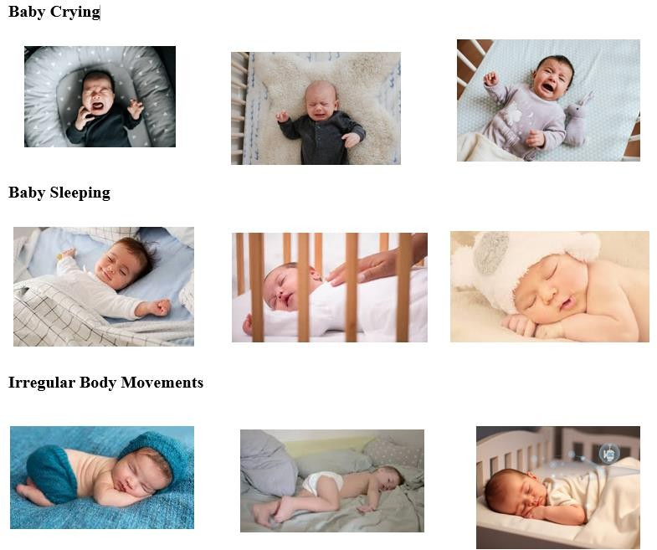

# RelatedWork

Several AI-based baby monitoring systems have been developed, utilizing computer vision and wearable sensor technology. Traditional methods focus on motion sensors and sound recognition, whereas modern approaches leverage CNNs and RNNs to analyze facial expressions, body posture, and sleep patterns.Despitesignificantimprovements,challenges remain in accurately detecting anomalies and minimizing false alarms. Our research aims to build upon these advancements by integrating spatial and temporaldataanalysistoenhancedetectionreliability.

# ProposedMethod

WeproposeahybridAI-basedmonitoringsystemthat utilizes deep learning for continuous infant surveillance. The framework consists of three main stages:

* + Preprocessing: Capturing video frames and extracting key infant features.
  + FeatureExtraction:UsingCNNstoanalyzespatial attributesandRNNstodetect temporalvariations in movement and breathing patterns.
  + AnomalyDetection:Employingafusionmodelto classify sleep states and detect potential risks.

# ADVANTAGES OF PROPOSED SYSTEM

* + Low Time Complexity: The proposed system is optimized for fast and efficient processing of infant activity data. By leveraging deep learning algorithms and real- time data processing, it ensures quick detection and response to potentialrisks,minimizingdelaysin alert generation.
  + Accuracy: The AI-driven approach ensureshighprecisioninidentifying sleep patterns, abnormal movements, and distress signals. The system reduces false alarms while ensuring critical events are accurately detected.
  + Efficiency: The integration of machine learning techniques, such as transfer learning, accelerates the system's training and deployment, reducing the computational resources required and making it accessible to a wider audience.
  + Adaptability: The system employs advanced image processing techniques to adapt to various lighting conditions, camera angles, and baby movements. This ensures reliableperformanceacrossdifferent environments.
  + Automation: The system eliminates the need for constant manual supervision, as it continuously monitorsthebabyandprovidesreal- time updates to caretakers. This automation improves efficiencyand reduces parental stress.
  + User-Friendly Interface: A well- designed mobile and web interface ensures ease of use, allowing caretakers to receive alerts, analyze sleepreports,andcustomizesettings effortlessly.
  + Potential for Innovation: The integration of AI technologies in baby monitoring opens new opportunities for further enhancements, such as predictive analytics for sleep disorders and integration with smart home system

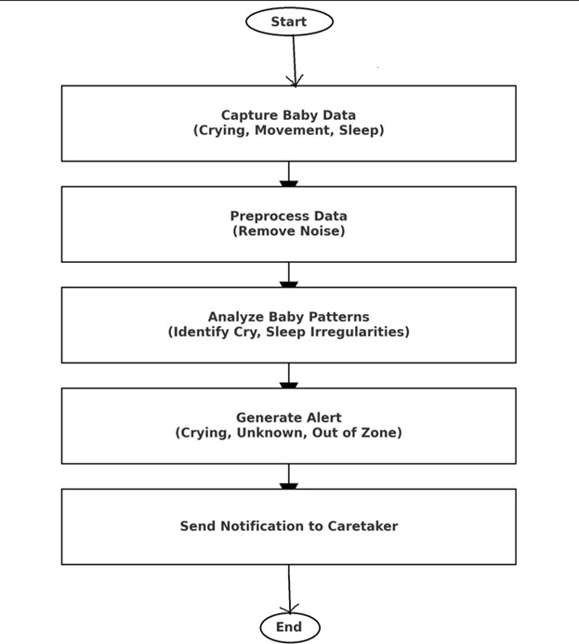

***FlowChart***

# ExperimentalResults

Our proposed model was trained and evaluated on publicly available datasets and real-world infant monitoring scenarios. We tested our approach on a datasetconsistingofsleepposturevideosandachieved an accuracy of over 92% in detecting abnormal sleep patterns and movements. Comparative analysis with existing methods demonstrated the superior performance ofour hybrid AI model inreducing false alarms while ensuring accurate tracking.

# Output:

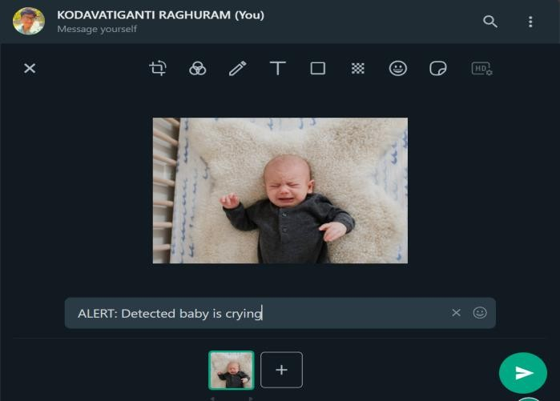

***AlertnotificationwhenBabyiscrying***

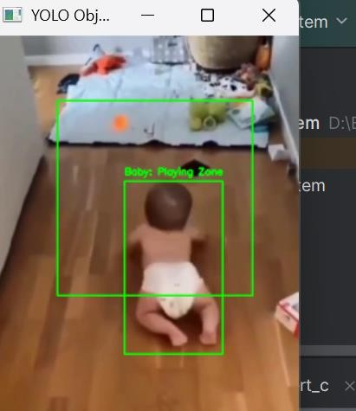

**Notificationwhenbabyisinthezone**

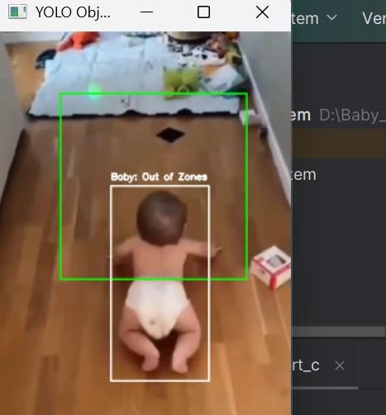

**Alertsoundwhenbabyisoutofzone**

# Discussion

While deep learning-based baby monitoring systems provide enhanced safety measures, challenges persist in handling occlusions, environmental variations, and real-time processing constraints.Futureimprovementsshould focus on integrating multi-modal data, optimizingcomputationalefficiency,and developing adaptive learning models to cater to diverse infant behaviors.

# Conclusion

AI-driven baby monitoring systems represent a significant advancement in ensuring infant safety and sleep tracking. This paper presents a deep learningbasedapproachthateffectivelyidentifiessleep patterns, anomalies, and risks using spatial-temporal analysis. Future research should explore real-time deployment strategiesand furtherenhancethesystem’s robustness to diverse infant behaviors and environments.

Traditional monitoring methods present challenges suchasconstantsupervision,subjectiveanalysis,and late response to potential risks. However, by embracingAIandmachinelearningtechnologies,we can revolutionize infant monitoring, providing real- time insights, reducing human effort, and enhancing sleep safety. This project holds great promise for advancing research in infant care, pediatric health, and AI-driven monitoring systems, aiming to continuously refine the system and contribute to the safe and healthy development of infants for future generations.

# FutureWork

Future enhancements of the AI-driven Baby MonitoringSystemforSleepandSafetyTrackingwill focus on expanding the datasetby incorporating diverse infant sleep patterns, postures, and environmentalfactorstoimproveaccuracyindetecting sleep disturbances and safety risks.

Advanced machine learning techniques, including CNN and RNN architectures, will be explored to enhance precision in identifying subtle infant movements, irregularities, and distress signals. Multi- modal data integration will further refine real-time alerts and decision-making.

The development of real-time mobile and will allow remote monitoring through smartphones, smart cameras, and wearable baby monitors. Cloud-based storageand AI-drivenanalyticswillprovidehistorical sleep reports and personalized recommendations for parents.

Collaborationwithpediatricians,sleepspecialists,and childsafetyorganizationswillensurethesystemaligns with medical accuracy and safety standards. Privacy protection and secure data handling will remain key priorities.

# References

1. H. Nguyen, D. Tran, and J. Li, 'AIPowered Infant Monitoring Systems: A

ReviewofSleepPatternAnalysis,'IEEE Transactions on Biomedical Engineering,vol.68,pp.1763-1775,

2022.

1. S. Roy, P. Patel, 'AI-Based Sleep Pattern Recognition System for Infants Using Deep Learning,' Journal of ArtificialIntelligenceResearch,Vol.59, 2023, pp. 115-128, DOI:

10.1613/jair.2023.1054.

1. D. Gupta, A. Sharma, 'Smart WearableDeviceforInfantMonitoring UsingMachineLearning,'Proceedings oftheInternationalConferenceon Embedded Systems and AI, 2023, DOI: 10.1109/ICESA.2023.9857341.
2. L. Zhang, Q. Wang, 'A Hybrid Machine Learning Approach for Real- Time Baby Monitoring Systems,'International Journal of AI& Robotics, Vol. 42, No. 2, 2024, pp. 57-72, DOI: 10.1109/IJAR.2024.1107789.
3. K. J. Lee, M. C. Lim, 'Real-Time Monitoring System for Infant Sleep Disorders Using AI and Video Analytics,' Journal of Healthcare Engineering,Vol.38,2024,pp.432-440, DOI: 10.1155/2024/5072367.
4. International Journal on “Wielding Neural Networks to Interpret Facial Emotions in Photographs with Fragmentary Occlusion”, on American Scientific Publishing Group (ASPG) Fusion:PracticeandApplications(FPA)

,Vol.17,No.01,August,2024,pp.146-

158.

1. International Journal on “Prediction of novel malware using hybrid convolution neural network and long short-term memory approach”, on International Journal of Electrical and Computer Engineering (IJECE),Vol. 14, No. 04, August, 2024, pp. 4508-4517.
2. International Journal on“Cross-PlatformMalware Classification: Fusion of CNN and GRU Models”,on International Journal of Safety and Security Engineering(IIETA),Vol.14,No.02,April,2024,pp.

477-486

1. International Journal on “Enhanced Malware Family Classification via Image-Based Analysis Utilizing a Balance-Augmented VGG16 Model,onInternational information and Engineering TechnologyAssociation(IIETA),Vol.40,No.5,

October,2023,pp.2169-2178

1. International Journal on “Android Malware Classification Using LSTM Model, International information and Engineering Technology Association (IIETA)Vol.36,No.5,(October,2022),pp.761 –767.

AndroidMalwareClassificationUsingLSTMModel| IIETA.

1. International Journal on “Classification of Image spamUsingConvolutionNeuralNetwork”,Traitement duSignal,Vol.39,No.1,(February2022),pp.363-

369 .

1. International Journal on “Prediction of Hospital Re-admission Using Firefly Based Multi-layer Perception,InternationalinformationandEngineering TechnologyAssociation(IIETA)Vol.24,No.4,(sept, 2020), pp. 527 – 533.
2. International Journal on “Medical Image Classification Using Deep Learning Based Hybrid Model with CNN and Encoder”, International information and Engineering Technology Association (IIETA),Revued'IntelligenceArtificiellVol.34,No.5,

(October,2020),pp.645–652.

1. International Journal on “Energy efficient intrusion detection using deep reinforcement learning approach”,Journal of Green Engineering (JGE),Volume-11, Issue-1,January 2021.625-641.
2. International Journal on “Classification of High Dimensional Class Imbalance Data Streams Using ImprovedGeneticAlgorithmSampling”,International JournalofAdvancedScienceandTechnology,Vol.29, No. 5, (2020), pp. 5717 – 5726.
3. Dr. M. Ayyappa Chakravarthi etal. published Springer paper “Machine Learning-Enhanced Self-Management for Energy-Effective and Secure Statistics Assortment in Unattended WSNs”inSpringerNature(Q1),Vol6,

Feb4th 2025

1. Dr. M. Ayyappa Chakravarthi etal. published Springer paper “GeoAgriGuard AI‑Driven Pest and Disease Management with Remote Sensing for Global Food Security” in Springer Nature (Q1), Jan 20th 2025.
2. Dr. M. Ayyappa Chakravarthi etal. presented and published IEEE paper “Machine Learning Algorithms for Automated Synthesis of Biocompatible Nanomaterials” , ISBN 979-8-3315- 3995-5, Jan 2025.
3. Dr. M. Ayyappa Chakravarthi etal. presented and published IEEE paper “Evolutionary Algorithms for Deep Learning in Secure Network Environments” ISBN:979-8-3315-3995- 5, Jan 2025.
4. Dr. Ayyappa Chakravarthi M. etal, published Scopus paper “Time Patient Monitoring Through Edge Computing: An IoT-Based Healthcare Architecture” inFrontiers inHealth Informatics (FHI), Volume13,Issue3,ISSN-Online2676-

7104,29thNov2024.

1. Dr. Ayyappa Chakravarthi M. etal, published Scopus paper “Amalgamate Approaches Can Aid in the Early Detection of Coronary heart Disease” in Journal of Theoretical and Applied Information Technology (JATIT) , Volume 102, Issue19, ISSN1992-8645,

2ndOct2024.

1. Dr. Ayyappa ChakravarthiM, etal, published Scopus paper “The BioShield Algorithm: Pioneering Real-Time Adaptive Security in IoT Networks throughNature-InspiredMachine

Learning”inSSRG(SeventhSenseResearchGroup)- International Journal of Electrical and Electronics Engineering(IJEEE),Volume11,Issue9,ISSN2348-

8379,28thSept2024.

1. AyyappaChakravarthiM,DrM.Thillaikarasi,Dr Bhanu Prakash Battula, published SCI paper “Classification of Image Spam Using Convolution Neural Network” in International Information and Engineering Technology Association (IIETA) - “Traitement du Signal” Volume 39, No. 1
2. Ayyappa Chakravarthi M, Dr. M. Thillaikarasi, Dr. Bhanu Praksh Battula, published Scopus paper “Classification of Social Media Text Spam Using VAE-CNN and LSTM Model” in International Informationand Engineering TechnologyAssociation (IIETA)-IngénieriedesSystèmesd’Information(Free Scopus) Volume 25, No. 6.
3. Ayyappa Chakravarthi M, Dr. M. Thillaikarasi, Dr. Bhanu Praksh Battula, published Scopus paper “Social Media Text Data Classification using Enhanced TF_IDF based Feature Classification using NaiveBayesianClassifier”inInternationalJournalof Advanced Science and Technology (IJAST) 2020
4. Ayyappa Chakravarthi M. presented and publishedIEEEpaperon“TheEtymologyofBigdata onGovernmentProcesses” with DOI 10.1109/ICICES.2017.8070712andisScopus

Indexed onlineinIEEEdigitalXplorewithElectronic ISBN: 978-1-5090-6135-8, Print on Demand(PoD) ISBN:978-1-5090-6136-5, Feb’2017.

1. Subba Reddy Thumu & Geethanjali Nellore, Optimized Ensemble Support Vector Regression Models for Predicting Stock Prices with Multiple Kernels.ActaInformaticaPragensia,13(1),x–x.2024.
2. Subba Reddy Thumu, Prof. N. Geethanjali. (2024). “Improving Cryptocurrency Price Prediction Accuracy with Multi-Kernel Support Vector RegressionApproach”.InternationalResearchJournal of Multidisciplinary Technovation 6 (4):20-31.
3. Dr syamsundararaothalakolaet.al. published Scopus paper “An Innovative Secure and Privacy- Preserving Federated Learning Based Hybrid Deep Learning Model for Intrusion Detection in Internet- Enabled Wireless Sensor Networks ”in IEEE Transactions on Consumer Electronics 2024.
4. Dr syamsundararaothalakolaet.al. published Scopus paper “Securing Digital Records: A Synerigistic Approach with IoT and Blockchain for Enhanced Trust and Transparency ”in International Journal of Intelligent SystemsandApplicationsinEngineering 2024.
5. Dr syamsundararaothalakolaet.al. published Scopus paper “A Model for SafetyRiskEvaluationofConnectedCar Network ”inReview of Computer Engineering Research2022.
6. Dr syamsundararaothalakolaet.al. published Scopus paper “An Efficient Signal Processing Algorithm for Detecting Abnormalities in EEG Signal Using CNN”in Contrast Media and Molecular Imaging 2022.