**Let’s Unlearn:**

**An innovative breakthrough to expunge outdated learning and**

**Optimize new learning**

Kinjal Chakraborty*1, Dr. Abhijit Halder*2

*1Student, Department of Education, University of Kalyani, Kalyani, Nadia, WB, India.

*2Faculty of Education, Department of Education, Plassey College, Plassey, Nadia, WB, India.

**Abstract**

Unlearning is a critical but often overlooked process that allows individuals and organizations to adapt to changing environments by discarding outdated knowledge, beliefs, and behaviors. This paper explores the concept of unlearning, its importance, and its role in fostering personal and organizational growth in the context of rapid technological, social, and cultural change. Drawing from key theories in organizational learning and education, it highlights the cognitive and emotional challenges of unlearning and offers strategies to facilitate its effective implementation, including self-reflection, feedback, experimentation, and collaborative learning. The paper concludes by emphasizing the need for a culture that embraces unlearning as a necessary component of continuous development, innovation, and adaptation in today’s dynamic world.

**Keywords**

**Unlearning, organizational learning, personal development, cognitive flexibility, adaptation, feedback, innovation, educational practices, double-loop learning, growth mindset.**

Top of Form

Bottom of Form

**Introduction**

In an era defined by rapid technological advancements, shifting societal norms, and dynamic global challenges, the concept of unlearning has garnered significant attention. Unlearning, as a deliberate process of letting go of outdated knowledge, beliefs, or behaviors, is increasingly recognized as essential for personal, professional, and organizational growth. This process goes beyond the passive act of forgetting; it is an active cognitive and emotional effort that requires individuals and organizations to reassess and redefine their understanding of the world. As organizations face ever-evolving market demands and individuals encounter new complexities in their personal lives, unlearning offers a pathway to greater adaptability and sustained success. This paper delves into the nature of unlearning, its importance in various contexts, and strategies that can facilitate its effective implementation. Education has traditionally focused on the acquisition of knowledge and skills, often neglecting the equally important process of unlearning—an intentional act of discarding or challenging preconceived notions, outdated beliefs, and unproductive habits. In an ever-changing world, where new information, technologies, and ideologies continuously emerge, it is essential to recognize that unlearning plays a key role in adapting to these shifts. Rather than merely adding new layers of knowledge, unlearning allows individuals to recalibrate their understanding and embrace new perspectives, fostering a more dynamic, adaptive, and reflective educational experience.

Unlearning in education is not merely the absence of learning but a proactive, reflective process of reevaluating previous knowledge and adjusting one's cognitive framework to accommodate new insights. By integrating unlearning into educational practices, both teachers and students can engage in a more comprehensive learning journey, one that prepares learners not just for a changing world but for the constant evolution of knowledge and society.

**Understanding Unlearning**

Unlearning is often defined in opposition to learning; while learning emphasizes the acquisition of new knowledge or behaviors, unlearning involves the discarding or transformation of previously held beliefs and practices. The term “unlearning” is more than a simple process of forgetting outdated information or incorrect facts. According to **Argyris (1999)**, unlearning involves the challenging of deeply ingrained assumptions, habitual behaviors, and outdated paradigms that no longer serve one’s current or future needs. This conscious effort of cognitive dissonance can be seen as a process of double-loop learning, in which individuals or organizations not only correct mistakes but also reassess the underlying beliefs that led to those mistakes in the first place.

In his seminal work, **Senge (1990)** posits that organizations capable of learning from their experiences will also need to unlearn outdated processes and practices that hinder growth. He argues that, without unlearning, organizations will become trapped in the “business-as-usual” mindset, where previously successful practices are no longer relevant due to shifting environments.

Furthermore, unlearning is a necessary complement to learning in environments of complexity and uncertainty. **Brown and Duguid (2000)** suggest that unlearning plays an essential role in fostering innovation because it opens space for the introduction of new ideas, methods, and technologies. By shedding obsolete ways of thinking, organizations and individuals are better positioned to adopt and integrate new knowledge that addresses the ever-changing realities of the world around them. Unlearning, as a concept, has been studied primarily in organizational learning and personal development contexts. However, its relevance to education is becoming more evident, especially as educators and theorists begin to acknowledge the limitations of traditional, rigid educational systems. In his seminal work on unlearning, Argyris (1991) described it as the "reduction of cognitive biases, habits, or knowledge that impede learning." For students, this could involve challenging long-held misconceptions or deconstructing previously ingrained methods of problem-solving that no longer serve them.

Unlearning does not imply the abandonment of all previous knowledge but rather a selective re-evaluation of what is useful and what needs to be revised or replaced. In education, it means creating opportunities for students to critically assess the knowledge they have acquired, question its validity in different contexts, and identify when it no longer holds relevance.

## How to Unlearn and Relearn: A Three-Step approach

We face several obstacles when trying to unlearn and relearn based on our upbringing or biases. Resistance to change, fear of failure, and cognitive biases make abandoning old ways of doing things difficult. Most importantly, we must overcome the [sunk cost fallacy](https://time.com/5347133/sunk-cost-fallacy-decisions/) – our tendency to continue investing in past choices even if they don’t bring the expected results.

In his book [Unlearn](https://www.amazon.com/Unlearn-Success-Achieve-Extraordinary-Results/dp/1260143015), Barry O’Reilly invites us to let go of past success. To achieve positive results in life and at work, you need to abandon what helped you succeed in the past. Unlearning takes courage. You must stretch beyond your comfort zone and test out new solutions.

The author outlines the Cycle of Unlearning, a three-phase cycle to let go of what no longer serves you. This doesn’t mean dismissing wisdom you’ve gained from previous experiences. It’s about recognizing what’s obsolete and discovering fresh ideas and solutions.

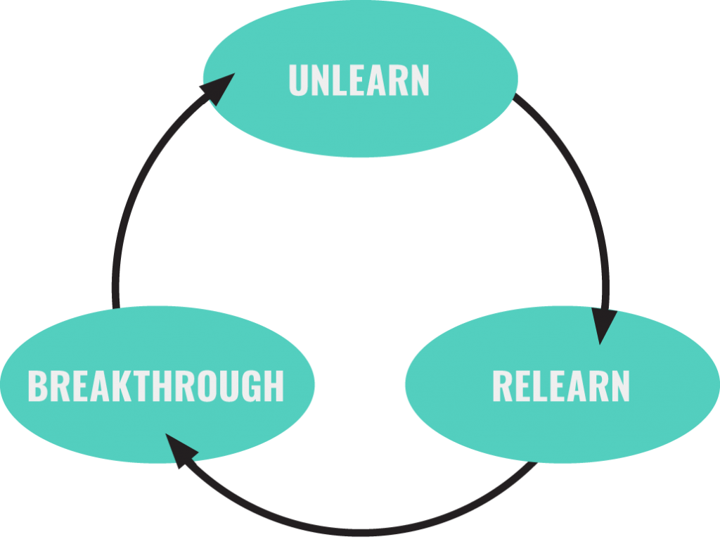

**Source:** https://barryoreilly.com/explore/blog/the-power-of-unlearning/

**The Need for Unlearning in the Modern World**

The modern world is characterized by rapid and often unpredictable change, driven largely by advancements in technology, globalization, and social transformation. In this environment, what was once considered best practice can quickly become irrelevant. Consider the technological revolution in the business sector. Companies that were once market leaders, such as Blockbuster and Kodak, failed to unlearn outdated business models and practices in the face of disruptive technologies, ultimately leading to their downfall. **Christensen (1997)**, in his work on disruptive innovation, highlights how companies that fail to unlearn obsolete practices are unable to adapt to new market demands and innovations.

Individuals, too, face challenges in unlearning outdated knowledge or beliefs. For instance, many traditional educational practices and systems are based on approaches that emphasize rote memorization rather than critical thinking or problem-solving. The rapid pace of technological innovation and global interconnectedness calls for a shift away from rigid educational paradigms. In a world where new discoveries and perspectives continuously emerge, individuals must be willing to unlearn established knowledge to ensure they remain relevant and capable of responding to new information. As **Dewey (1933)** argues, true education is not about the mere transfer of knowledge but about cultivating critical thinking skills that allow individuals to adapt to the evolving world.

Unlearning is also essential in social contexts, particularly when it comes to addressing ingrained biases and prejudices. Societies that seek justice, equality, and inclusion must engage in a collective process of unlearning harmful stereotypes, discriminatory practices, and outdated social norms. This unlearning process enables individuals to overcome deeply rooted societal conditioning and to contribute to a more inclusive and equitable society.

**Unlearning in the Organizational Context**

In the organizational context, unlearning is not only an individual endeavor but also a collective challenge. Organizations must create environments that foster unlearning, enabling individuals to challenge old assumptions, question established practices, and make space for new ideas and innovations. **Argyris (1999)** identifies two types of organizational learning: single-loop and double-loop. While single-loop learning involves fixing problems without questioning the underlying assumptions, double-loop learning requires unlearning outdated beliefs and norms in order to generate fundamental change.

In **Senge’s (1990)** concept of the “learning organization,” he emphasizes the importance of systems thinking, which allows organizations to examine their internal processes and identify areas where unlearning is necessary. By doing so, organizations can improve their adaptability and align themselves with emerging trends and innovations.

However, unlearning within organizations is not without its challenges. One significant barrier to unlearning is the human tendency to resist change. People often feel attached to their past knowledge or ways of working, particularly when those methods have led to past successes. **Kegan and Lahey (2009)** discuss the “immunity to change,” a psychological phenomenon that hinders individuals from letting go of outdated beliefs or practices. Organizations, too, often develop entrenched systems, cultures, and procedures that are resistant to change.

To overcome these challenges, organizations must cultivate a culture that values continuous learning and improvement. This can be achieved through strategies such as **feedback loops**, where employees receive regular, constructive input about their performance, and **reflective practices**, such as retrospectives or after-action reviews, where teams assess their methods and identify areas of improvement. Furthermore, creating a psychologically safe environment where employees feel comfortable questioning the status quo and suggesting new ways of working is crucial for fostering unlearning.

Additionally, **Brown and Duguid (2000)** argue that organizations must focus on the social aspects of unlearning. Informal networks, collaborative environments, and open communication channels can help organizations challenge outdated beliefs and engage in more flexible, adaptive decision-making. By promoting a culture of dialogue and shared learning, organizations can create an atmosphere where individuals feel empowered to question existing practices and experiment with new approaches.

**Unlearning in Education**

In educational contexts, unlearning is just as vital as it is in the professional world. The traditional approach to education often emphasizes the rote memorization of facts and the adherence to established methodologies. However, in a rapidly changing world, this approach may fail to prepare students for real-world challenges. **Dewey (1933)** advocates for an education system that encourages learners to engage in reflective thinking, to question assumptions, and to adopt new perspectives—essentially a process of unlearning outdated ideas and embracing a more dynamic and critical approach to knowledge.

Educational institutions must actively foster environments where unlearning is not seen as a threat but as a necessary step in personal and intellectual growth. This can involve creating spaces where students are encouraged to question established norms, to critique traditional methodologies, and to embrace diverse viewpoints. This process can also extend to unlearning historical biases, stereotypes, and ideologies that have been perpetuated through curricula.

Moreover, as technology continues to reshape the landscape of education, unlearning becomes crucial in addressing issues such as digital literacy and the ability to engage with new forms of information. Teachers and students alike must be prepared to unlearn traditional educational paradigms in favor of more flexible, collaborative, and technology-enhanced learning strategies. This includes unlearning outdated pedagogical methods and embracing more student-centered, experiential learning models.

**Strategies for Effective Unlearning**

Unlearning is a challenging process, but it can be facilitated by several key strategies:

1. **Self-reflection:** Engaging in regular self-reflection helps individuals identify outdated beliefs, biases, and practices. Journaling, mindfulness, and structured self-assessments can all aid in the process of recognizing when unlearning is necessary.
2. **Feedback and Constructive Criticism:** Receiving feedback from peers, mentors, or supervisors can provide valuable insights into areas where unlearning is needed. Feedback can serve as a mirror, reflecting patterns of behavior that may be hindering progress.
3. **Openness to Failure and Experimentation:** Creating an environment that celebrates experimentation, risk-taking, and learning from failure is crucial in promoting unlearning. Individuals and organizations must be willing to embrace failure as part of the learning journey, rather than viewing it as a setback.
4. **Collaborative Learning:** In both organizational and educational settings, collaborative learning environments encourage individuals to engage with new ideas, challenge assumptions, and learn from others’ experiences. Peer-to-peer interactions, team-based problem-solving, and cross-functional collaboration can accelerate the unlearning process.
5. **Leadership Support:** Leaders must model and encourage unlearning by creating an environment where questioning the status quo is encouraged and supported. **Kegan and Lahey (2009)** emphasize the importance of leadership in overcoming the immunity to change, as leaders can help individuals reframe their understanding of change and the benefits of unlearning.

**Conclusion**

Unlearning is an essential skill in an age of constant change. Whether in personal development, organizational growth, or educational practices, the ability to let go of outdated knowledge, habits, and assumptions is critical for adaptation and innovation. By cultivating self-reflection, openness to feedback, and a growth mindset, individuals and organizations can embrace unlearning as a powerful tool for creating new possibilities and achieving sustained success.

**References**

Argyris, C. (1999). *Double-loop learning in organizations*. *Harvard Business Review*.

Brown, J. S., & Duguid, P. (2000). *The social life of information*. *Harvard Business Press*.

Christensen, C. M. (1997). *The innovator's dilemma: When new technologies cause great firms to fail*. *Harvard Business Press*.

Dewey, J. (1933). *How we think*. *D.C. Heath and Company*.

Kegan, R., & Lahey, L. L. (2009). *Immunity to change: How to overcome it and unlock the potential in yourself and your organization*. *Harvard Business Press*.

Senge, P. M. (1990). *The fifth discipline: The art and practice of the learning organization*. *Doubleday*.