**ADVANCES IN POLYMERS CHEMISTRY FOR BIODEGRADABLE PLASTICS**

# Miss. Mhaske Rajashree R 1, Miss. Kakade Madhuri R2, Mr. Mengal Mahendra A 3,

# Mr. Gaikwad Rakesh V 4

1,2,3,4 Lecturer, Department of Science & Humanities, Santosh N Darade Polytechnic, Yeola, Maharashtra, India.

# ABSTRACT

The rising significance of the field of biopolymers has driven the rapid progress of this

Distinctive class of polymeric materials in the past decades. Biodegradable polymers have acquired

Much attention because they play an essential role in humans’ lives due to their specific tunable

Electrical conductivity and biodegradability characteristics, making them fascinating in many

Applications. Herein, we debated the recent progress in developing biodegradable polymers and their Applications. Initially, we introduce the basics of conducting and biodegradable polymers, trailed by debates about the effective strategies currently used to develop biopolymers. Special importance will focus on the uses of biodegradable polymers in drug delivery and tissue engineering, as well as wound healing, demonstrating the recent findings, and uses of several biodegradable polymers in modern biological uses. In this review, we have provided comprehensive viewpoints on the latest progress of the challenges and future prospects involving biodegradable polymers’ advancement and commercial applications.

**Keywords:** biopolymers, polymeric materials, Biodegradable polymer

# INTRODUCTION

Nowadays, plastics are a vital part of human society in our daily lives and are widely used in countless industries, such as packaging, building materials, textiles, transportation, healthcare, and so on Furthermore, plastics are considered moisture-resistant, bendable, durable, and, specifically, more economical than any other material. Particularly, utilization and manufacturing have considerably upsurge for nearly half a century due to their features. After that, 8.3 billion metric tons of plastic materials have been manufactured globally, with plastic materials occupying a ubiquitous role in our daily lives notably, worldwide plastic production almost reached 370 million tons in 2019 and it is anticipated to substantially evolve over the coming decade. More importantly, plastic material has considerably impacted the areas of medicine, space programs, transportation, and life-saving devices such as incubators, helmets, ventilators, and carriers for safe drinking water. Excessive quantities of plastic waste are produced in both developing and developed countries. Furthermore, plastic materials’ resilience and non-biodegradable features have allowed them to remain in the ecosystem over a more extended period, instigating the most stable waste product over other methods of waste. However, the continual need, miss handling, and littering of plastics became destructive. More importantly, petro chemically derived plastics damage the environment even after disposal. Polyethylene, polypropylene, polyvinyl chloride (PVC), polystyrene, polycarbonate, and polymethyl methacrylate can be cast under a thermal process and labeled as plastics. Notably, plastic materials tend to contain harmful chemicals, so land and water accretion instigate severe ecological damage.

Generally, plastics are derived from petrochemical origins, contributing to greenhouse releases. As plastic materials are developed for flexibility, durability, and non-degradability, they have damagingly affected every part of the ecological system, killing plant life and posturing risks to local animals and human communities.

Nowadays, ecological alertness and environmental impact related to fossil-based plastics assets have led to more studies and research into developing bio-derived plastic materials. The term is labeled by European Bio plastic materials as either biodegradable plastics and/or plastics created from renewable sources. Currently, bio plastics account for almost 1% of the total plastics manufactured yearly, but according to estimates about future progress, the total production capacity of six million tons will be reached in the coming years [Biodegradable polymers are generally derivatives of renewable resources and are considered abundant. Biopolymers have several benefits over conventional plastics due to their non-toxic nature, biocompatibility, degradability, sustainability, and extreme hydrophobicity. The chief growth drivers in biopolymers are polyhydroxyalkanoates (PHAs) and polylactide (PLA)

Biodegradable polymers can be applied in the medicinal arena and are mainly classified into drug delivery systems wound healing products and surgical implant devices. The advancement of bio polymeric drug delivery systems now at- trains remarkable interest, especially in controlled delivery. More importantly, drug de- livery inside humans can be regulated through biodegradable capsules. Particularly, biodegradable polymers are used to prepare novel formulations, and the high permeability of buccal mucosa is an appropriate target for drug delivery. In this regard, drug delivery combined with biopolymers and buccal routes is shielding, safe, and rapidly functioning. Similarly, in the case of wound healing, bioresorbable non-woven to substitute human tissue repair and simple sutures, staples, or meshes, are accessible. Comparatively, the usage of biological resorb able scaffolds for tissue engineering is worth revealing. Further, biodegradable polymers are renewable, cost-effective, and found in various varieties. Notably, biodegradable polymers are considered an exceptional candidate for wound healing due to their bioactive features, facilitating cell growth and re- generation potential, and providing antimicrobial conditions and immunomodulation. In addition, biodegradable polymers are a probable candidate for wound care because they can absorb a massive amount of water. In recent years, these polymers are capable of releasing drugs at the site of damage and making them appropriate for healing applications. Many biopolymers have good film-forming features, making them applicable for conventional commodity applications notably, they are used in foodstuff containers (bottles, jars), soil retention sheeting, farming film, garbage bags, and wrapping material. Additionally, biodegradable polymers in non-woven form can be used in farming, filtration, hygiene, and protecting wear. This discovery was the turning point in the upsurge of research works into biodegrade- able polymer; although it has not been completely utilized in different applications. Particularly, biodegradable polymers are mainly used in drug delivery applications and are very stimulating because of compatibility concerns of biopolymers with tissue and release kinetics of these polymer particles. More importantly, the drug release is determined by the depletion features of the polymer’s drug release. Furthermore, these biopolymers break down and are removed from the human body after they have performed their projected work. Mainly, biopolymers must be destroyed at a rate comparable to the healing and regeneration process. The biodegradable polymer features have been shown to possess desirable and tenable mechanical features. The biodegradable polymers must possess biocompatibility features and must not elicit immune reactions. Moreover, the degraded products must be non-toxic, metabolized, and eradicated simply. The fabricated polymers must be easy to synthesize and keep significant durability to withstand the fabrication process.

In the meantime, significant research works have been dedicated to developing biodegradable polymers such as PHA, PLA, starch, cellulose pulp, and others.

In past decades, these biodegradable materials have been examined for biological applications, and the number of publications counts is nearly equal to or higher than what existed before. As for biodegradable polymers, PHAs are applied in households, farming, industrialized, and medicinal arenas due to their physicochemical features of water insolubility, UV light resistance, and a good barrier from oxygen penetration. Furthermore, Figure 1 shows the number of research works in biodegradable polymers from 2010–2022, based on the Web of Science search using the keyword “biodegradable polymers”.

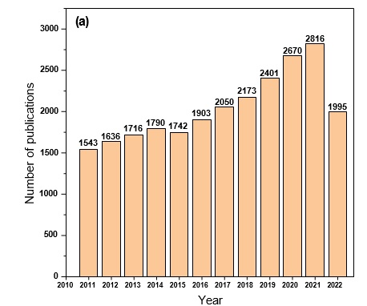

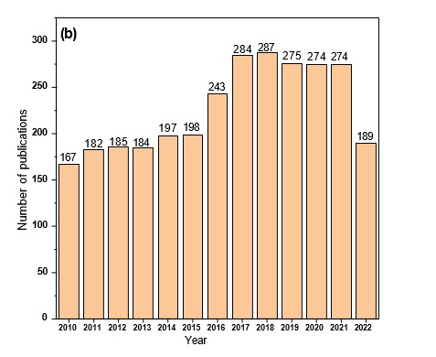

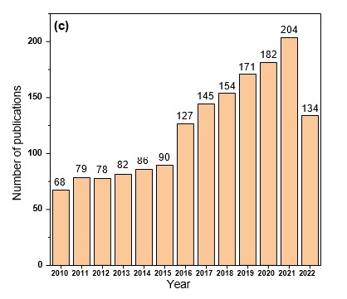

**Figure 1.** The number of studies from 2010 to 20 October 2022 on (**a**) biodegradable polymers,

(**b**) Biodegradable polymers and drug delivery, and (**c**) biodegradable polymers and biological applications from the web of science database.

This list of promising applications of these biopolymers is by no means comprehensive. Indeed, the quantity of potential uses is almost infinite. It also has to be stated that most of the uses involve the biodegradable nature of biopolymers. Biopolymers along with their significance in different applications are summarized in Table 1. Biological applications have been selected as a focus area for biodegradable polymer use because they retain their greater entity impacts. Biodegradable polymers are being gradually applied to medical applications, particularly in medical implant applications. More importantly, biopolymers can be used as surgical sutures, offering admirable durability and sturdiness; they can be applied in tissue regeneration applications. Additionally, the biopolymers suture materials can be easily removed or permitted to readily disappear from the body. For instance, Poly- (glycolic acid) (PGA), poly-(L-lactic acid) (PLA), and their composite materials are widely applied as sutures as they provide reliant knot steadiness and remarkable flexibility.

# CATEGORIZATION OF BIODEGRADABLE POLYMERS

The biopolymers are degraded to low-molecular-weight compounds under the action of micro- and/or microorganisms or enzymes. Biopolymers such as PCL and PLA, amide- rich biopolymers, polyurethanes (PU), and most natural biopolymers have heteroatoms, which are possibly liable to hydrolytic cleavage of the ester group, and amide groups. Based on the source of raw ingredients (obtained through natural sources, sugar, starch, cellulose, and fossil oil), biodegradable polymers can be classified into three sets, namely

(1) Natural; (2) synthetic; and (3) microorganism built biodegradable polymers. Natural biopolymers are made from natural resources, whereas synthetic polymers are from petroleum sources. Mostly, we stated the most commonly explored aliphatic polyesters and usual natural macromolecules. In particular, the chemical structures of particular biopolymers are presented in Figure 2. Typically, the chemical structure of natural macromolecules and their major source are shown in Figure 2. For instance, lignin and polysaccharides are the most extensively explored natural macromolecules. The case of polysaccharides mostly involves cellulose, chitin, lignin, chitosan, sodium alginate, and so on

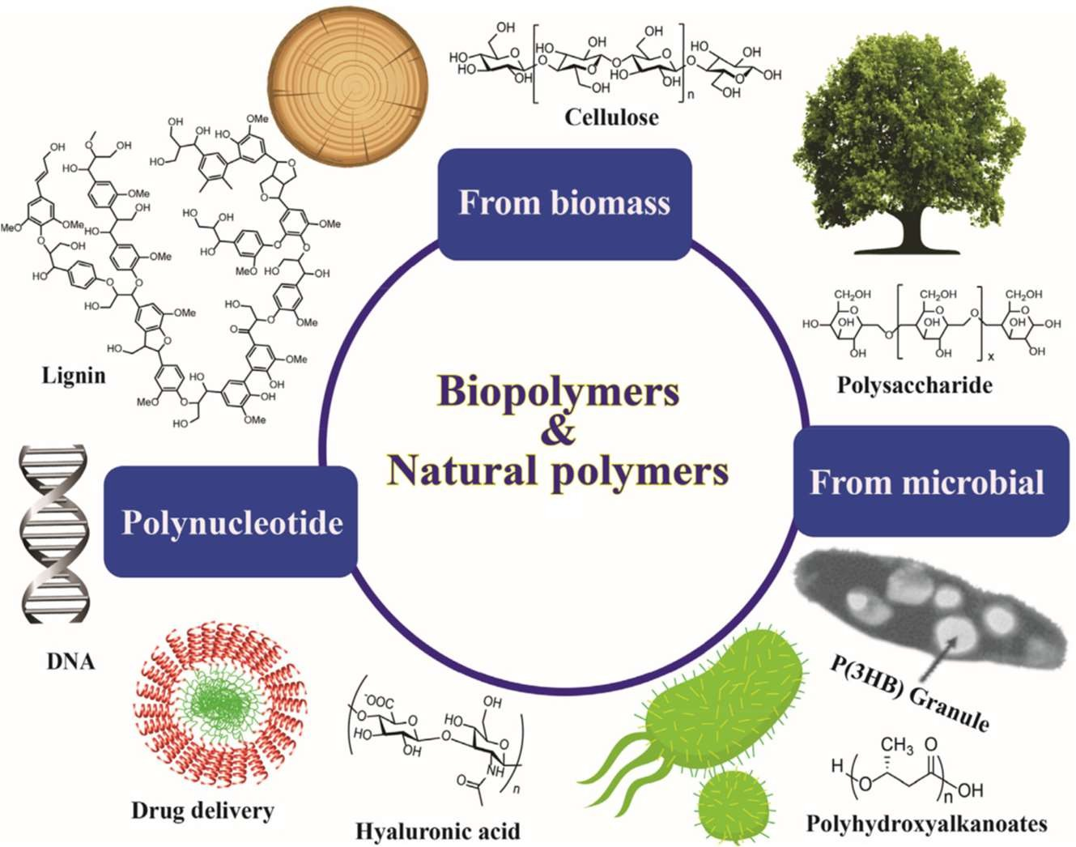We consider that with continual research efforts, each natural macromolecule will be significantly advanced, involving sources, extraction, and filtration setup. They will be obtained through their adaptation and product development; and natural macromolecules will certainly assist humans in various fields. Further, other types of biodegradable polymers, such as biodegradable PU, amide-rich polymers, such as polypeptide and thermal polyaspartate and so on generally, polypeptides, DNA, and protein are the research areas in the arena of life science, and they are hardly applied in the environmental aspects (Figure 2).

**Figure 2.** Chemical structures of the selective biopolymers and their classifications.

1. **PROMISING AREAS OF BIOPOLYMER APPLICATIONS**

The usage of biopolymers is rapidly emerging with a worldwide economy worth many billions of dollars yearly. A varied series of areas where uses for biodegradable polymers have been applied involve medicinal, packaging, farming, and the automotive industry. In addition, biodegradable polymers that can be applied in packaging continue to gain more consideration than those used for other applications. It is projected that 41% of plastics are used in packaging and that nearly half of that volume applies to wrap food materials. The reusable and degradable features of biopolymers are what make them tempting for inventive use in packaging. In particular, biopolymers are generally used in different industrialized applications, such as food wrapping, cosmetics, and medicine. Biodegradable polymers have a lower solubility in water and a very imperative water uptake, thereby they can be applied as absorbent candidates in biological, healthcare, horticulture, and farming applications. Particularly, biodegradable polymers have been used in certain applications in which plastics cannot be used, such as making artificial tissue. These uses might demand biomaterial features such as biocompatibility, environmental responsiveness, and biodegradable candidates with sensitivity to variations in pH and physicochemical and thermal variations generally, biopolymers display poor thermal and mechanical features (tensile strength and brittleness), chemical resistance, and process ability than synthetic polymers. Particularly, to make them appropriate for specific uses, they can be reinforced with fillers that drastically enhance these features.

Biodegradable polymers play valuable roles in several human body functions, such as embracing cells to create tissues and signaling the cells to regulate their features. They also moderate the skin’s hydration and elasticity to keep its natural state. Additionally, they enable all joints and gastrointestinal tracts to be flexible through lubrication and protection from pathogens by accumulating into the mucus gel covering the human eyes and respiratory tract. This section debates the favorable areas for using biodegradable polymers and their composite materials with setbacks, state-of-the-art methods, and innovation in carriers.

# WOUND HEALING APPLICATIONS

Biodegradable polymeric materials are recognized as appropriate candidates for wound healing applications. It is well known that biopolymers have a wide-ranging usage in wound dressing relating to injury owing to their biocompatibility features and biodegradable nature, and their similarity to extracellular matrices The major origin of these natural healing candidates is living things such as fungi (chitin), algae (alginate), bacteria, plants, and animals (chitosan, collagen) . A sequence of reiterating parts held by diverse covalent bonds forms these biodegradable polymers, namely monomers of amino acids, nucleotides, monosaccharide’s, etc. Further, these biodegradable polymers can quickly be saturated with biological fluids concerning their three-dimensional net- work structure. These ingrained curing features make them an appropriate material for pharmaceutical and medicinal uses, specifically for wound healing applications, tissue engineering using drug delivery, and implants Different kinds of chitosan-based material dressings also exist globally. Deltaic and dextrose have hemostatic and antibiotic features. Optical is applied for partial and thicker wounds, first and second-grade burns, diabetic foot ulcers, pressure ulcers, medical wounds, donor sites, and arterial and leg ulcers. Additionally, other kinds of biodegradable polymers, namely starch, glycan, dextran, and silk, have reported their applications in wound healing.

However, these improved methods are reasonably effective and need to be regularized for patients with chronic wounds for advanced and efficient wound healing. Generally, we anticipate that an improved classification approach for different wounds, the improvement of novel and developed approaches for finding cellular alteration and diversity, as well as other technical developments, will benefit in attaining promising, active, and clinically substantial wound healing treatments. The full potential of these materials and their ability to aid wound healing need more comprehensive examination.

# MEDICAL AND HYGIENE

Biodegradable polymeric materials are considered for medicinal purposes for suture- covering, fixation, isolation, organized drug delivery, contact inhibition, and tissue guidance. PLA, poly-(glycolic acid), and copolymers are generally applied in suturing owing to their exceptional flexibility and reliance on knot strength Poly (orthocenter) and poly-hydroxyl sets are mainly involved in drug delivery treatments. Further, PU materials have flexibility and more substantial wear and tear characteristics, which are highly required for grafting scaffolds assisting synthetic blood vessels Notably, PEA materials have decent thermo-mechanical features and enable drug delivery, hydrogel, and tissue engineering uses. More importantly, hospitals mostly engage in hygiene and health-related materials like surgical masks/gowns, gloves, sterile napkins, diapers, bed- ding, medical scrubs, nursing uniforms, antimicrobial textiles, wipes, etc. Bio based PET can be used in surgical gowns in place of conservative cotton, polyester, and PE. In addition, PLA makes gowns, caps, and masks Thermoplastic starch is applied for creating disposable diapers owing to their super absorbent features. Furthermore, biodegradable materials, including alginate fibers, catgut, collagen, chitosan, and super absorbent polymer, are applied mostly for medical and hygiene uses. Illustrates the different kinds of uses of biodegradable polymers in the medicinal and hygiene arenas. It is expected that these numerous regenerative medicine strategies will translate from ‘bench to bedside’ in the future. Although, significant research works are required to improve the mechanical features of biomaterials that are essential for this type of biological application. Notably, the ability of biodegradable polymers has been examined by several researchers for various kinds of biomedical uses credited to their physiochemical features, such as biocompatibility and biological safety. Lastly, it might be anticipated that humans will remarkably benefit from nanotechnology-based nan medicines in the coming years for the management and treatment of fatal diseases, particularly in cancer therapy.

# FUTURE IMPROVEMENTS

Substantial research works have been dedicated to the development of biopolymers over the past decades. Mainly, the advancement of biodegradable polymers and their composite has been gaining amazing limelight, however, it is still in earlier phases. The requirement for new kinds of candidates from future manufacturers of biodegradable polymers is irresistible. In particular, while there occurs a grave requirement for a colossal array of sustainable products, poor performance features, and high development costs drop their production in relation to classical synthetic polymers. Renewed ecological norms focused on resolving eco-centric trepidations have caused improvements toward the development of modern polymeric materials and processes that are agreed to obey the welfare of normal habitats. However, it is necessary to develop highly active biodegradable polymer products and exploit the ecological, social, and industrial benefits. One of the key setbacks of biopolymers obtained from renewable resources is their rapid rate of degradation owing to their hydrophilic nature and, in definite conditions, low mechanical features, particularly in water environments. However, obtained biopolymers have several benefits since they are acquired from a wide range of plant components. Notably, in recent years, bio-derived polyesters have been receiving much consideration based on biodegradability as well as probable medical applications. Explicit features such as biodegradation methodologies, biocompatibility, operating conditions, and potential usages in medicine, ecological protection, and agro-chemistry have expected a lot of attention. The biological safety of developed biopolymers and the non-safety of their composite continue to be insignificant. This novel perception emphasizes expecting, assessing, and demonstrating possible concerns related to advanced polymer usage. In the future, major setbacks of biodegradable polymers must be associated with managing primary materials, the performance of bio-derived materials, and their production cost. Furthermore, commercial manufacturing will be another challenge for the manufacturing of bio-derived monomers and bio-derived polymers from renewable sources. Constructing industrial plants can be demanding due to the lack of experience in new technologies and the assessment of stock/demand balance. Although new kinds of bio-derived polymers are developed on an industrialized scale, there are still various issues that need to be determined for the long-standing feasibility of biodegradable polymers. It is anticipated that there will be feedstock competition as a global requirement for food and energy to upsurge over time.

# CONCLUSIONS

Herein, we provided a comprehensive overview of the recent advances in the bio- logical applications of biodegradable polymers. Eco-friendly biopolymers are favorable candidates for the development of emergent applications with the merits of biodegrade- ability and biocompatibility. Still, biopolymers reveal supremacy as they can be eroded into small trashes and can effortlessly be expelled out of the human body. In recent years, significant biodegradable polymeric drug delivery systems have been realized in biological applications However, more detailed research efforts must be performed for the development to choose appropriate drug delivery methods with greater reliability. However, the in-depth understanding of the mechanistic features and time taken for the drug delivery system for a tissue related to their objective is acute. These are the setbacks in addressing the uncertain medical need over time. In the future, implementing differ- Ent kinds of biodegradable polymeric methods in therapeutic uses, including scaling up with organized and targeting activities, might be a considerable stage as the appropriate nan carrier materials are mandatory to transport the genetic material to the target-specific region. In this regard, a highly active synthetic approach for developing such biodegradable polymeric systems must be highlighted as they will be applied more in biological methods. All the available methods arise with demerits when applied to explore biodegradable polymers. To conclude, this is a timely evaluation to debate biodegradable polymers and critically explore their significance and their applications.

# REFERENCES

1. Ct, N.L.L. Biodegradable polymers as biomaterials Prog Polym Sci 32762 2007. 61. Nair, LS, and Laurencin, CT Biodegradable polymers as biomaterials. *Prog. Polym. Sci.* **2007**, *32*, 762.
2. Vu, D.H.; Åkesson, D.; Taherzadeh, M.J.; Ferreira, J.A. Recycling strategies for polyhydroxyalkanoate-based waste materials: An overview. *Bioresour. Technol.* **2020**, *298*, 122393. [[CrossRef](http://doi.org/10.1016/j.biortech.2019.122393)]
3. Saxena, A.; Tiwari, A. Polyhydroxyalkonates: Green plastics of the future. *Int. J. Biomed. Adv. Res.* **2011**, *2*, 356–367. [[CrossRef](http://doi.org/10.7439/ijbar.v2i9.48)]
4. Tian, H.; Tang, Z.; Zhuang, X.; Chen, X.; Jing, X. Biodegradable synthetic polymers: Preparation, functionalization and biomedical application. *Prog. Polym. Sci.* **2012**, *37*, 237–280. [[CrossRef](http://doi.org/10.1016/j.progpolymsci.2011.06.004)]
5. Hirvikorpi, T.; Vähä-Nissi, M.; Harlin, A.; Salomäki, M.; Areva, S.; Korhonen, J.T.; Karppinen, M. Enhanced water vapour barrier properties for biopolymer films by polyelectrolyte multilayer and atomic layer deposited Al2O3 double-coating. *Appl. Surf. Sci.* **2011**, *257*, 9451–9454. [[CrossRef](http://doi.org/10.1016/j.apsusc.2011.06.031)]
6. Shi, Y.; Sun, X.; Zhang, L.; Sun, K.; Li, K.; Li, Y.; Zhang, Q. Fc-Modified exenatide-loaded nanoparticles for oral delivery to improve hypoglycemic effects in mice. *Sci. Rep.* **2018**, *8*, 726. [[CrossRef](http://doi.org/10.1038/s41598-018-19170-y)]
7. Martins, L.G.; Mainardes, R.M. PLGA nanoparticles and polysorbate-80-coated PLGA nanoparticles increase the in vitro antioxi- dant ctivity of melatonin. *Curr. Drug Del.* **2018**, *15*, 554–563. [[CrossRef](http://doi.org/10.2174/1567201814666170719112535)]
8. Wu, S.T.; Fowler, A.J.; Garmon, C.B.; Fessler, A.B.; Ogle, J.D.; Grover, K.R.; Mukherjee, P. Treatment of pancreatic ductal adenocarcinoma with tumor antigen specific-targeted delivery of paclitaxel loaded PLGA nanoparticles. *BMC Cancer* **2018**, *18*, 457. [[CrossRef](http://doi.org/10.1186/s12885-018-4393-7)]