Digital Bell With Timetable Display

Anushka Ganesh Dambir
Electronics and Telecommunication
MVP’S KBTCOE
Nashik,India
anushkadambir@gmail.com
Rutuja Kailas Dhage
Electronics and Telecommunication
MVP’S KBTCOE
Nashik,India
rutujadhage1508@gmail.com
Sakshi Sudam Karad
Electronics and Telecommunication
MVP’S KBTCOE
Nashik,India
sakshikarad10@gmail.com

Abstract– The digital bell system with a timetable display is an innovative solution designed to enhance time management in educational institutions. This system combines an automated bell mechanism with a visual timetable, providing a clear and efficient way to manage transitions between periods. Currently available systems on the market such as Schlage Digital Bell System and Honeywell Digital Bell Timer, often rely on traditional mechanism. They are expensive, complex, and prone to errors with limitations in customization. Open-source solutions like Raspberry Pi Digital Bell require programming expertise and incur hardware costs.. These existing solutions typically have disadvantages such as limited functionality, difficulty in programming, and the inability to update schedules dynamically. In contrast, our system utilizes the STM32 microcontroller, which offers significant advantages, including high processing speed, low power consumption, and extensive peripheral support. It reduce manual errors, enhance customization, and provide a cost-effective solution. This enables time management, and clear display of class schedules.
Keywords- Digital bell, STM32 Microcontroller, LED display, Timetable display, Audio Output, RTC Module

Introduction- The traditional manual bell system used in schools and colleges has several drawbacks. For one, it requires a significant amount of manpower and resources. After every class, a staff member must be present to ring the bell, which can be time-consuming and prone to errors. Moreover, manual bell systems can be disruptive, especially for students with classes in adjacent rooms. This is where the automatic college bell system comes in - a innovative solution designed to address these challenges. At the heart of this system is a Real-Time Clock (RTC) module, specifically the DS1307. This module tracks the current time and compares it to the pre-set bell-ringing time. When the two times match, the transistor for the bell is activated, and the bell rings. The real-time clock is displayed on an LCD screen, providing a clear and visual representation of the current time and the time table. This feature is particularly useful for students and staff who need to keep track of the time and schedule. The automatic college bell system offers several benefits. For one, it increases accuracy by eliminating human error and display the time table. The system automates the bell-ringing process, ensuring that the bell rings at the correct time every time. This also improves efficiency, as staff are freed up to focus on other tasks. Additionally, the system enhances accessibility by providing a visual representation of the time and the name of the lecture on the LCD display. This makes it easier for students with hearing impairments to keep track of the schedule. Finally, the system reduces disruptions to classes, creating a more conducive learning environment .The automatic college bell system is also highly customizable. The system can be programmed to ring the bell at specific times, display the lecture name and can even be integrated with existing school management software. This makes it easy to manage the system and make changes as needed. Additionally, the system is highly reliable and requires minimal maintenance. This makes it a cost-effective solution for schools and colleges looking to upgrade their bell systems.
Motivation- The development of the digital bell with a timetable display aims to improve school operations and enhance the learning experience for students. A reliable and automated school bell system is essential for maintaining a well-structured schedule. By eliminating the reliance on manual operation, this project addresses common issues such as delays and confusion when bells ring at incorrect times. An automated system ensures that classes can start and end precisely as scheduled, creating a more organized environment. Additionally, providing real-time information about current and upcoming classes through a display enhances students' ability to manage their time effectively. This advancement supports a smoother educational experience, allowing everyone in the school to focus on learning and teaching. In today's technology-driven world, it is important for educational institutions to adopt modern solutions that benefit both students and staff.
Objectives-
1)To design and develop an automated digital bell with real time, Time Table display
The system will utilize a real-time clock to accurately keep track of time and automatically ring the bell at scheduled intervals. Additionally, the system will display the current time and timetable on an LED screen, providing students and staff with a clear and visual representation of the schedule..
2)To implement reliable LED panel display for real time date.
The LED panel will utilize a real-time clock (RTC) module to accurately keep track of time and display the current date and time in a clear and visible format. The panel will be designed to be energy-efficient, durable, and easy to read, providing a reliable and accurate display of real-time information
3)To design customize buzzer system for audible alert.
The system will utilize a programmable buzzer module to produce tones for class changes and breaks. The system will be designed to be adjustable in terms of volume and tone, allowing for customization to meet specific needs and preferences.

Block Diagram-
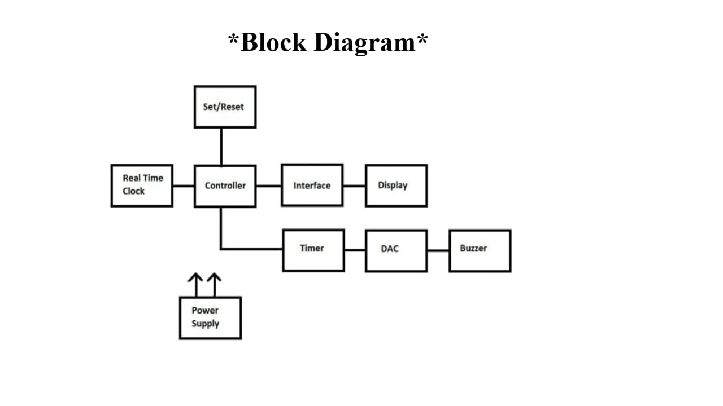

Flowchart-
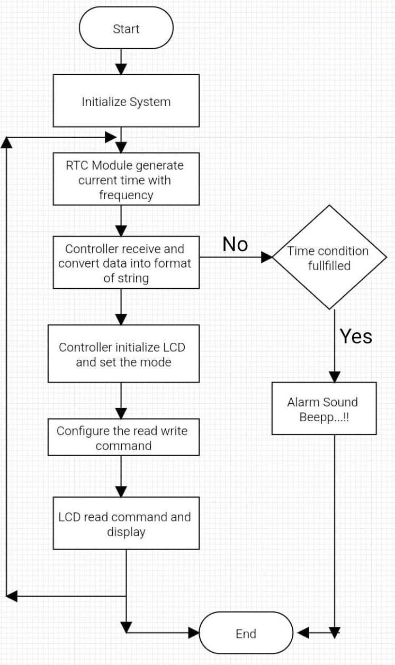
Working- A digital bell with timetable display is an innovative system that streamlines time management in institutions. The system consists of a central control unit, display screen, speakers, network connectivity, and power supply.The STM32 microcontroller initializes and reads the current time from the Real-Time Clock (RTC) module. The RTC module maintains accurate timekeeping using a 32.768 kHz crystal oscillator. The STM32 then retrieves the stored timetable data from its internal memory and displays it on the LED display .Four set/reset buttons interface with the STM32, allowing users to select modes (setup/normal), adjust time and acknowledge alarms. In setup mode, users can program the timetable, which is stored in the STM32’s memory. In normal mode, the STM32 periodically updates the display with the current time and upcoming schedule. The STM32 configure timer then timer generate digital signal. DAC convert that digital signal to analog signal .Buzzer receive analog signal from DAC, that produces sound at a frequency of 1-4 kHz. The buzzer’s duration can be adjusted through software.

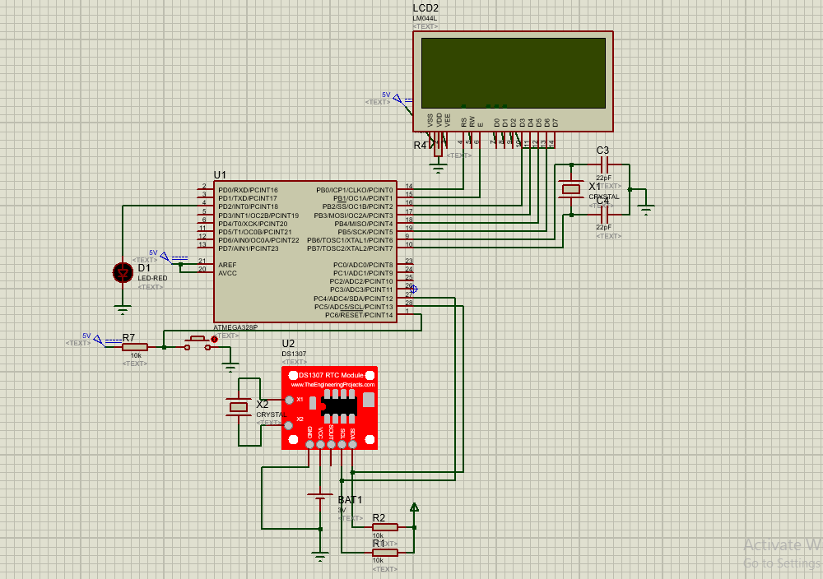

The STM32 also updates the RTC time periodically to ensure accuracy.. The system's power supply provides 5V to the STM32, LED display, RTC module, and buzzer. The system can receive real-time updates from the network, allowing for changes to the timetable or bell schedules. It also sends alerts and notifications to users, such as teachers or administrators, to remind them of upcoming events or schedule changes. Overall, the digital bell with timetable display automates time management, improving punctuality, efficiency, and communication within institutions.

Conclusion- In conclusion, the digital bell with a timetable display using STM32 has proven to be an effective solution for managing school schedules. The project successfully integrated a reliable bell system with an intuitive timetable interface, allowing for efficient signaling of class changes. The STM32 microcontroller provided the necessary processing power and flexibility, ensuring that the system operates smoothly and accurately. The project not only enhances time management but also contributes to a more organized learning environment. The feedback received during testing highlighted its reliability and ease of use, confirming that the system meets its intended objectives. Feedback from testing indicated that the system significantly improved time management within the school environment.

Future Scope-
• The concept of a digital bell with a timetable display has a lot of potential for the future, especially in educational institutions and workplaces.
• This system could include synchronization with smart boards, projectors, and personal devices to ensure everyone is aware of the schedule.
• Future developments could focus on creating more interactive and user-friendly interfaces. Touch screens or mobile app integrations could allow users to easily navigate their schedules and receive notifications.
• Add voice assistant for hand free control
• Future digital bells could be designed to using solar power or low-energy consumption features, which is an important consideration for sustainability.
• An advanced digital bell system could collect data on attendance
• This technology could also be adapted for use in hospitals, corporate offices, and public spaces, enhancing communication and organization.

Reference--
1. “Automatic Microcontroller Based Smart College Electric Bell System with Time Display” (2023) International Journal of Research Publication and Reviews, Vol 4, no 9, 3. Dr. N. Sambasiva Rao , S. Jareena , Mrs. S. Ramayaka , M. Reshma ,A. Dhanista.
2. “Automatic college bell with user defined time schedule” International Research Journal of Modernization in Engineering Technology and Science, Volume:05/Issue:02/February-2023, O.K Wadne, Tushar Wakade, Yash Bhandari, Vibhawari Kamble.
3. “Design and implementation of microcontroller based low cost automatic college bell ringing system”International Research Journal of Modernization in Engineering, Technology and Science,Volume:05/Issue:03/March-2023, Sruthi.P, Dr.C.Periasamy, V.Krishnapriya, Nirmin Raheem . 4. “Implementation of automatic college bell system using arduino”,International journal of current engineering and scientific research,(2018), . Burgoji Santhosh Kumar.
5. “Automatic School Bell with User defined Time Schedule”, International Journal of Advanced Research in Electrical, Electronics and Instrumentation Engineering, Vol. 6, Issue 2, February 2017, Syed Naveed Uddin, Mohd Omer Nawaz, T.Kalinga Raj.
6. “Real-Time Digital Bell System with Automated Scheduling using STM32 Microcontroller and LCD Display” (2023), International journal of engineering and technology, M.K.Singh,A.K.Singh.

