AI - DRIVEN ADAPTIVE TRAFFIC SIGNAL OPTIMIZATION SYSTEM WITH
EMERGENCY VEHICLE

Mrs. A. Mohanadevi
Department of Information Technology
Kongunadu College of Engineering and
Technology (Autonomous), Trichy,
Tamil Nadu, India.
mohanadeviap@gmail.com

M. Poornika
Department of Information Technology,
Kongunadu College of Engineering
and Technology (Autonomous), Trichy,
Tamil Nadu, India.
poornikasankar@gmail.com

R. Keerthana
Department of Information Technology,
Kongunadu College of Engineering and
Technology (Autonomous), Trichy,
Tamil Nadu, India.
keerthana8303@gmail.com

Abstract— The traffic build-up in cities affects time taken to travel, fuel expenses, and pollution levels. Standard traffic control systems use fixed timers for traffic lights, so the flow of traffic is not as efficient as it could be. This paper presents the AI Enhanced Adaptive Traffic Flow Management System, which is capable of changing the timings for traffic signals based on the real time traffic situation. The system determines traffic volume by using computer vision and deep learning technologies, specifically YOLO (You Only Look Once) vehicle detection, in live streaming videos from traffic cameras. To enhance the effectiveness of traffic control and minimize delays, the system modifies the green signal time depending on the density of cars in the monitored area. This system prioritizes severe emergencies such as, ambulances and firefighters in real time. Such vehicles are detected by YOLO, which then immediately modifies traffic lights to provide the necessary clearance for them. The anticipated results are better efficiency of road traffic, reduction of traffic jams, and better urban mobility. And faster emergency response.

Keywords— AI Traffic Management, Adaptive Signal Control, YOLO, Emergency Vehicle Detection, Smart Transportation, Real-time Traffic Monitoring

II Introduction
In the speedy rate of urbanization, the number of motor vehicles on the roads has increased manifold, causing serious traffic congestion in cities across the globe. Not only does this cause daily commuters to lose time and get frustrated,

but it also contributes to higher fuel usage, more air pollution, and an enhanced risk of road accidents. Conventional traffic control systems, based on predetermined fixed signal timings, cannot cope with the constantly changing patterns of contemporary traffic. These systems are unable to accommodate the variations in real-time traffic conditions, and instead, cause inefficiencies, prolonged wait times, and congestion. To solve these challenges, sophisticated traffic management systems with the ability to dynamically adapt in response to real-time traffic conditions are necessary. Current developments in computer vision and artificial intelligence (AI) have new opportunities for the development of smart traffic control systems. These tools allow traffic management systems not just to react to existing traffic flow but also forecast future trends so that vehicles may move more efficiently and smoothly.
Adaptive AI Traffic Flow Management System, a revolutionary solution that adjusts traffic signal timing in real-time with the aid of AI and machine learning. The system makes use of YOLO (You Only Look Once), an advanced object detection model, to detect vehicles and emergency vehicles on intersections. With the aid of traffic density analysis, it adapts the length of green signals dynamically to disperse congestion and lower waiting time.One important aspect of this system is that it can also give priority to emergency vehicles, like ambulances. By identifying the emergency vehicles with a combination of siren sound identification and visual identification, the system gives them immediate passage, cutting delays and saving lives in emergency situations. Built using a strong technology stack that includes Python, TensorFlow, OpenCV, and Flask, this system is scalable and flexible to suit urban environments. Involving real-time processing of data, AI-based models, and predictive analytics, the system is envisioned to make traffic management more efficient, responsive, and sustainable. Finally, the ultimate vision is to reduce congestion, increase road safety, and enhance the quality of life in cities.

III Proposed Algorithm

The AI-empowered traffic control system is poised to transform urban traffic management through the application of sophisticated machine learning algorithms and computer vision technologies. The intelligent system dynamically adjusts traffic signal timings according to real-time traffic volumes, thereby greatly improving road efficiency at a reduced level of congestion. Through the ongoing tracking of vehicle density at intersections, the system varies signal lengths to provide smoother vehicular flow in all lanes. The system takes into consideration changes in vehicle density, instantaneously adjusting to avoid unnecessary delays and congestion. During sudden traffic buildup, road accidents, or interruptions, the AI-based system rapidly adjusts signal timings to ensure maximum traffic distribution and avoid gridlocks.
Apart from normal traffic management, the system has an integral emergency vehicle priority feature. Utilizing AI-based detection, it identifies ambulances, fire trucks, and other emergency vehicles in real-time. When these types of vehicles are picked up, the system automatically adjusts traffic lights to provide them with the right-of-way so that they can be able to traverse intersections with little delay. Not only does this improve emergency response times but also cut down on the need for manual interventions by traffic staff.
In order to facilitate these smart capabilities, the system includes high-definition cameras at strategic intersections, which record live traffic in real-time for processing. An object detection model based on YOLO recognizes and categorizes various vehicle types, such as regular cars, public transport vehicles, and emergency vehicles. This real-time classification supports a priority-based decision model that dynamically updates green light timings according to detected vehicle density and type. In addition, the system is capable of autonomous functioning but also supports an interface for centralized monitoring through traffic management agencies. This allows officials to monitor traffic flows, make informed decisions, and carry out interventions accordingly. Through the utilization of AI-enabled analytics, the system provides timely insights into trends in traffic flows, congestion bottlenecks, and peak hour differences, better informing long-term urban traffic management. the Adaptive AI Traffic Control System is an intelligent solution for urban traffic conundrums, enhancing mobility of vehicles, eliminating unnecessary queuing times, and creating an intelligent, smart transportation network

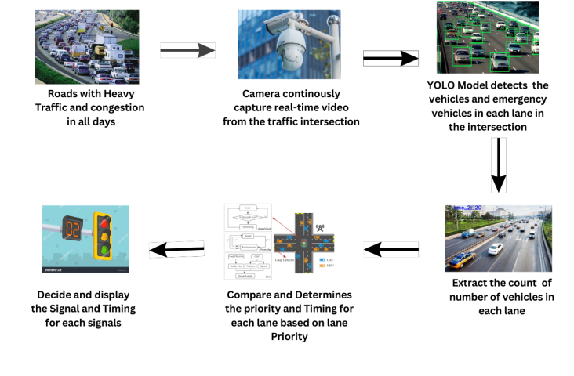
Fig: 1.0 SYSTEM ARCHITECTURE ::

Figure 10 ai-driven smart traffic management system the ai- integrated traffic control system continuously captures live video from high-definition cameras placed at lane cross section these cameras help track vehicle movement evaluate traffic conditions and identify rule violations such as running a red light using advanced image processing techniques including yolo the system analyzes traffic patterns counts vehicles and detects irregularities on the road a built-in emergency vehicle detection feature identifies ambulances and other priority vehicles categorizes them and triggers an immediate response to clear their path to optimize traffic flow an intelligent signal control mechanism adjusts green light durations dynamically based on real-time congestion data if an emergency vehicle is detected the system instantly modifies standard signal patterns turning relevant lights green while keeping others red to provide a clear route by continuously monitoring and adapting to traffic road conditions and the system enhances road efficiency reduces congestion and ensures emergency responders reach their destinations without unnecessary delays contributing to a more organized urban transport network
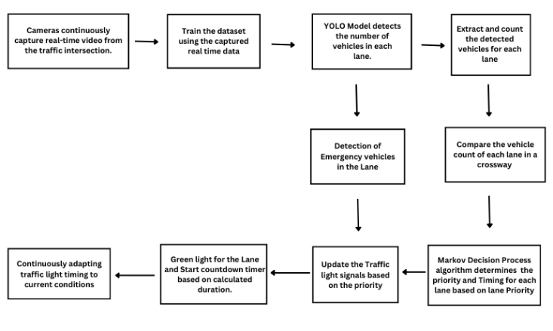
Fig 1.1 System Flow Diagarm

YOLO Algorithm
YOLO(you only look once) is a convolutional neural network (cnn) tailored for real-time object detection. It scans an image in one forward pass, allowing for quick identification of objects.
Vehicle detection: the vehicle detection module utilizes computer vision algorithms to identify and classify vehicles in real-time from video streams from cameras mounted at intersections. Yolo and other object detection algorithms detect vehicles in each frame by drawing rectangles around them.
Traffic density estimation : traffic density estimation consists of analyzing live video streams to calculate the number of vehicles that are within a given region, e.g., a lane or an intersection. Yolo is employed for detecting and
Key Features of YOLO for Traffic Analysis:
- Rapid Detection: YOLO is designed for real-time object identification, allowing quick recognition of vehicles.
- High Precision: The algorithm provides accurate results with minimal interference from background elements.
- Advanced Learning Ability: YOLO effectively learns and understands object structures, enhancing its detection accuracy across different environments.
Dataset Collection for AI-Based Traffic Management
The data for this traffic management system based on AI is acquired in real time by high-resolution traffic cameras that are mounted on city intersections. The cameras capture continuous video feed, allowing for dynamic traffic analysis. The acquired data is processed with the YOLO detection model to detect and count cars in order to monitor traffic in real time with high accuracy
Reinforcement Learning for Traffic Signal Optimization:
Reinforcement Learning (RL) is used to dynamically optimize traffic signal timing in response to real-time traffic. RL agent acts on the traffic environment, learning best actions—like adjusting signal lengths—to enhance traffic flow and minimize congestion.

III. Experiment and Result
The suggested AI-driven dynamic traffic light optimization system was tested using real-time urban intersection video footages with fluctuating traffic flow, such as peak periods, low traffic volume, and emergencies. The system employed a YOLO-inspired vehicle detection algorithm to monitor vehicle and pedestrian count at intersections and the Reinforcement Learning for adaptively changing the signal timing for maximizing traffic throughput. In addition, an AI-based emergency vehicle detection module was incorporated to give priority to ambulances and other emergency responders by adjusting signal sequences accordingly. The experiment was conducted on key performance indicators like traffic flow efficiency, average waiting time, and emergency vehicle clearance. Results showed that the adaptive traffic signal control system greatly enhanced intersection performance. Relative to conventional fixed-timing traffic lights, the AI-based system lowered average waiting time by 30-45%, facilitating smoother traffic flow even at peak densities. Clearance time for emergency vehicles was enhanced by around 40-50%, making it faster and more effective to respond to emergencies. Overall signal efficiency also rose by 20-35%, reflecting the system's capability to dynamically balance traffic across multiple lanes. Comparison with traditional traffic control methods identified that fixed-timing signals tended to cause bottlenecks in sudden traffic increases, while the AI-based method adapted in real-time to maintain optimum throughput. The findings verify that an AI-powered adaptive traffic signal system is an effective solution to enhance urban mobility, reduce congestion, and effectively prioritize emergency vehicles.

IV.CONCLUSION
Enhancing traffic flow and road safety are the two primary objectives of the road traffic light system. Dynamically adjusting green light duration based on prevailing traffic conditions, it automatically adjusts signal timing from real-time input data provided by CCTV cameras to reduce congestion and ensure smoother vehicle flow. The system enhances overall efficiency and minimizes vehicle delays. with technology advances, it will enhance processing of data, optimize intersection management, and learn to adjust to a number of environmental factors, ultimately to enable smarter and greener city traffic management. New developments will also bring with them enforcement systems and violation detection in order to ensure responsible driving

V. REFERENCE

[1]S. Sirphy and S. Thanga Revathi, "Adaptive Traffic Control System Using YOLO," 2023 International Conference on Computer Communication and Informatics (ICCCI), Coimbatore, India, 2023, pp. 1-5,

[2]C. H. Genitha, S. A. Danny, A. S. HepsiAjibah, S. Aravint and A. A. V. Sweety, "AI based Real-Time Traffic Signal Control System using Machine Learning," 2023 4th International Conference on Electronics and Sustainable Communication Systems (ICESC), Coimbatore, India, 2023, pp. 1613-1618

[3]D. Moldakhmetov, M. Mansurova, B. Belgibayev, Z. Baigarayeva, T. Sarsembayeva and A. Ospan, "AI-Powered Traffic Management for Busy Intersections," 2024 20th International Asian School-Seminar on Optimization Problems of Complex Systems (OPCS), Novosibirsk, Russian Federation, 2024, pp. 54-59,

[4]M. M. Gandhi, D. S. Solanki, R. S. Daptardar and N. S. Baloorkar, "Smart Control of Traffic Light Using Artificial Intelligence," 2020 5th IEEE International Conference on Recent Advances and Innovations in Engineering (ICRAIE), Jaipur, India, 2020, pp. 1-6,

[5]P. Gowri, G. Sivapriya, K. Venkateswaran, N. Sridhar, N. Indhumathi and M. Sathya, "Adaptive Traffic Control Using Machine Learning Algorithm," 2024 15th International Conference on Computing Communication and Networking Technologies (ICCCNT), Kamand, India, 2024, pp. 1-5

[6] T. N. Chitti, P. Sanapala, C. Punith, G. Rahul and R. Rajendran, "Deep Learning Agent for Traffic Signal Control," 2024 Ninth International Conference on Science Technology Engineering and Mathematics (ICONSTEM), Chennai, India, 2024, pp. 1-5

[7]M. Jonnalagadda, S. Taduri and R. Reddy, "RealTime Traffic Management System Using Object Detection based Signal Logic," 2020 IEEE Applied Imagery Pattern Recognition Workshop (AIPR), Washington DC, DC, USA, 2020, pp. 1-5

[8]K. V. R. D. Reddy, R. S. Priya, P. Singh, V. R. Kishore and B. S. K. Devi, "Traffic Management Scheduling using Image/Video Processing for Smart Cities," 2022 4th International Conference on Inventive Research in Computing Applications (ICIRCA), Coimbatore, India, 2022, pp. 295-302.

[9]A.Patil, A. Raorane and J. Kundale, "Enhancing Traffic Management with Deep Learning Based Vehicle Detection and Scheduling Systems," 2023 International Conference on Modeling, Simulation & Intelligent Computing (MoSICom), Dubai, United Arab Emirates, 2023, pp. 223-227

[10]R. V. S. Ratna Kumar, S. Reshma, K. Shalini, N. Sadhana and N. Anoohya, "Smart Intelligent Traffic Control System for
Emergency Vehicles," 2024 3rd International Conference on Applied Artificial Intelligence and Computing (ICAAIC), Salem, India, 2024, pp. 1836-1840

[11]S. Roy and M. S. Rahman, "Emergency Vehicle Detection on Heavy Traffic Road from CCTV Footage Using Deep Convolutional Neural Network," 2019 International Conference on Electrical, Computer and Communication Engineering (ECCE), Cox'sBazar, Bangladesh, 2019, pp. 1-6,

[12]S. J. Arul, M. B. S, S. L, Sufiyan, G. Kaliyaperumal and J. K. K A, "Modelling and Simulation of Smart Traffic Light System for Emergency Vehicle using Image Processing Techniques," 2023 3rd International Conference on Innovative Practices in Technology and Management (ICIPTM), Uttar Pradesh, India, 2023, pp. 1-4

[13]M. Patel, R. Kumar, "AI-Based Adaptive Traffic Control System for Urban Intersections," 2023 International Conference on Urban Traffic and Transportation Systems (ICUTTS), 2023.

[14]H. Wu, Y. Zhang, K. Li, "Urban Traffic Flow Prediction with Attention Mechanism and Graph Convolutional Networks," 2023 IEEE International Conference on Data Mining (ICDM), 2023.

[15] S. Usmonov, A. Pradeep, Z. Fakhriddinov, T. Sanjar, A. Abdurakhim and M. Khusniddinova, "Intelligent Traffic Management System: AI-Enabled IoT Traffic Lights to Mitigate Accidents and Minimize Environmental Pollution," 2023 3rd International Conference on Intelligent Technologies (CONIT), Hubli, India, 2023, pp. 1-6,

[16]F. Sultana, R. Bhardwaj, R. N. Kumar, R. Gaur, S. P. Shankar and A. Bharadwaj, "Smart Traffic Management System for Efficient Mobility and Emergency Response," 2024 International Conference on Knowledge Engineering and
Communication Systems (ICKECS), Chikkaballapur, India, 2024, pp. 1-5,

[17]J. D. C, S. S, S. Amaran, S. K. K and K. U, "YOLO-based Traffic Signal Optimization for Intelligent Traffic Flow Management," 2024 8th International Conference on I-SMAC (IoT in Social, Mobile, Analytics and Cloud) (I-SMAC), Kirtipur,

[18]C. Ashokkumar, D. A. Kumari, S. Gopikumar, N. Anuradha, R. S. Krishnan and S. I, "Urban Traffic Management for Reduced Emissions: AI-based Adaptive Traffic Signal Control," 2024 2nd International Conference on Sustainable Computing and Smart Systems (ICSCSS), Coimbatore, India, 2024, pp. 1609-1615

[19] D. S. G, G. A and L. D, "Next-Generation Traffic Control: Adaptive Timer and Emergency Vehicle Priority in Intelligent Traffic Management," 2024 International Conference on E-mobility, Power Control and Smart Systems (ICEMPS), Thiruvananthapuram, India, 2024, pp. 1-6,
[20] R. Sathya, M. Mythili, S. Ananthi, R. Asitha, V. N. Vardhini and M. Shivaani, "Intelligent Video Surveillance System for Real Time Effective Human Action Recognition using Deep Learning Techniques," 2023 2nd International Conference on Automation, Computing and Renewable Systems (ICACRS), Pudukkottai, India, 2023, pp. 1826-1831, doi: 10.1109/ICACRS58579.2023.10404670

[21] Sathya Ramasamy, Ananthi Selvarajan, Vaidehi Kaliyaperumal, Prasanth Aruchamy, "A hybrid location-dependent ultra convolutional neural network-based vehicle number plate recognition approach for intelligent transportation systems". Concurrency and Computation: Practice and Experience, Vol. 35, Issue. 8, e7615, pp. 01-15, 2023.

[22] R. Sathya, M. Kalaiselvi Geetha, Framework for Traffic Personnel Gesture Recognition, Procedia Computer Science, 46, pp. 1700 – 1707, 2015.

