**E-BIKE SPEED CONTROL SYSTEM**

# Mr. Wagh Krushna B 1, Mr. Avhad Deepak R 2, Mr.Shinde Sarthak K 3,

# Mr.Shinde Vishal S 4

1, 2 Lecturer, Department of Electrical Engineering, Santosh N Darade Polytechnic, Yeola,Maharashtra, India.

3,4 Students, Department of Electrical Engineering, Santosh N Darade Polytechnic, Yeola,Maharashtra, India.

# ABSTRACT

E-bike is designed with Turbo boost BLDC Motors that can be operated at higher speeds. Suspension systems must support both road holding/handling and ride quality which are at odds with each other. The tuning of suspensions involves finding the right compromise. It is important to control speed based on the bumpy roads for the suspension to keep the road wheel in contact with the road surface as much as possible because all the road or ground forces acting on the vehicle do so through the contact patches of the tires. Our Project, The Spring less Suspension System Combines a differential mechanism and an oscillating system that will support the E-bikes with relative speed control in bumpy and terrain areas. A differential is a gear train with three drive shafts that have a property such that the rotational speed of one shaft is the average speed of the others or a fixed multiple of that average, and Oscillation is the repetitive or periodic variation of an object. The Frame of the system is mostly made of Mild steel. The frame that holds the tires oscillates freely. The same frame is connected to the differential. A motor is connected to a gear in the differential mechanism, thereby making it the driving gear. The driving gear is connected by a bevel gear on both sides. Each gear is connected to two wheels on each side. Each wheel is driven by an individual motor. The motor makes sure that the gears and the wheels are in motion and the oscillating property makes sure that the vehicle is moving forward even in rough terrain. Through this Differential auto bevel mechanism speed control with load balance on E- bikes can be maintained.

# Keywords:- E-bike, BLDC Motors, Suspension System, speed control with load balance.

1. **INTRODUCTION**

All are living in the future. With time, technology has improved our lives. Nowadays,

Most countries are using electric bicycles. The use of cycles over vehicles is always green for the environment, but an E-bike is the biggest adoption of green transportation of the decade. Just think of E-bikes in place petrol operated scooters rather than normal bikes. An E-bike uses rechargeable batteries that can travel up to 25 to 45 Kmph. As a result, it is faster than the normal cycle to reach your destination quicker and in better shape. In this blog, we are going to learn about E-bike technology, its types, and its advantages there are two main types of E-bikes- throttle assist and pedal assist.

An E-bike motor works by automatically switching on the (quiet) motor when you pedal or throttle. A pedal-operated E-bike is the most popular option. As you pedal the bike, the motor gets powered, and it works. In comparison, a throttle-assist E-bike is similar to a normal motorbike. It operates as you accelerate the throttle. Electric bicycles are available in many styles, from commuter bikes to full-suspension mountain bikes. The power output of these pedal-operated motors is typically governed by regulations. Mostly, they are available with an output power of around 250 watts. Bikes fitted with a throttle-based motor system have slightly different output regulations. It can be available with a maximum power of around 200 watts, while speed remains limited to 25 kmph.

In transportation we have developed quite a lot by the range of hi-tech vehicles we have, still the importance of bicycle cannot be neglected. Bicycle is popular in all groups because it is easy to handle by its light weight, and do not cost money to operate as it does not require fuel to run, still very efficient in small distant traveling. It has many distinct qualities, which make it even special over other vehicles, like they do not require registration fees, insurance, or driving license. Similarly it has less prone to heavy casualties, thereby making it a safer transportation. Besides it has health benefits, just the same way as in any physical exercises. Similar to this, e-bike on the other hand is a modified version of the same. In e-bikes the difference comes by the application of the motor system, use of the controller to control the motor system, and also with battery to Power it. The motor is used in order to give external power to make the ride comfortable. E-bike is better than the normal bike because rider can get additional power when it is required, if it is used like that. In this the rider has the choice when he is less of power and unable to drive forward easily, usually when there appears an uphill or strenuous long road, he can switch on the battery, and thereby activates the motor. Then motor compensates the required power and this way ride becomes smoother all the way. It is up to the rider as when he wants to switch on the power. He can choose motor to propel all the way for his support, or use it when he actually needs. There are again various levels which the rider can choose depending upon the condition of the road, and the amount of speed that is desired in riding. Similarly, there is throttle to make riding adjustable, either compensating speed for less strain, or get speed for high strain, this is absolutely on the choice of the riders’ strength and selection. When we try to address the best feature of e-bike, then we can say that as there is almost no strain while riding e-bike that we notice in normal bike driving uphill, therefore it is easy to sum up that when there is less strain, rider can travel a long distance very easily, there is also less perspiration making user tidier again, giving possibilities for wide range users. We should understand, e-bike has a standard specification to meet, so that it does not come in the same category as a motorbike. The standard is varied from place to place, but in Europe especially Sweden, the present limit is 250 W maximum continuous power and 40 kg/88 lb. maximum weight with no limit on the peak power1 . Whereas in the United States this limitation is 750 W. Though the use of e-bike is a new concept in Europe, but in India and China it is growing quite fast, just in China, e-bike at this time has increased by the amount that it is outnumbering cars by four to one.

Electric bikes, or e-bikes, are a form of bicycle that are powered by an electric motor. The motor assists the rider in pedaling, making it easier to travel long distances or climb hills. The e-bike system control is the brain of the electric bike, managing the motor, battery, and other components to provide a smooth and efficient riding experience.

The e-bike system control typically consists of several components, including the motor, battery, controller, sensors, and display. These components work together to provide power to the motor and control the speed and performance of the e-bike.

Smart cities represent a hot research topic both for academia and industry. The main purpose of smart cities is to make use of city facilities (buildings, infrastructure, transportation, energy, etc.) in order to improve people’s quality of life while creating a sustainable environment. In this context, smart transportation, as a fundamental dimension of smart cities, relates to both intelligent and “green” transportation solutions. Cycling is considered to be one of the most sustainable and green forms of transportation. Therefore, it is not surprisingly that cycling occupies an important place among smart transportation initiatives in particular and smart cities initiatives in general. For instance, promoting cycling is listed as main objective of initiative on smart cities. In recent times, the permanent magnet synchronous motors have been increasingly employed to substitute brush DC motors as actuators for scooters. However, the latter possess many merits, such as simple in motor structure and power converter, better control technology, having excellent torque generating capability etc. Storing of energy is the key factor in EV or HEV model, so appropriate secondary batteries must be opted as they are the main source of energy for successful operation of EV’s. These days, bi-directional converter used in electric vehicles offer energy storing in battery as well as charging feature. The non-isolated converters are classified into buck, boost and buck boost types, which are economical, compacted, without transformer and simple control mechanism since it has a common ground. With proper selection of current controller time delay and the corner frequency of PI controller can be determined. For proper operation, the rotor frequency must be designed to be working in the specified range. By tuning controller parameters, the range of the operating speed can be appropriately implemented, not only speed up the design but also reduces the time in implementing speed controller E-bike is an Eco-friendly electric and power- assisted bike. It is one of the fastest-growing technology of the bicycle industry. We all are living in the future. With time, technology has improved our lives. Nowadays, most of the countries are using electrical bicycles. The use of cycle than vehicles is always green to the environment, but an E-bike is the biggest adoption of green transportation of the decade. Just think of E-bike in place petrol operated scooters rather than a normal bike. An E Bike uses rechargeable batteries which can travel up to 25 to 45 kmph. As a result, it is faster than the normal cycle to reach your destination quicker and in better shape. In this blog, we are going to learn about E bike technology, its types and advantages’-bike is an electric and power-assisted bike which is one of the fastest-growing technology of the bicycle industry. This bicycle uses an electric motor to help you along. So you can ride it like a normal bicycle, but with less effort. There are two main types of E-bike- throttle assist and pedal assist. An E-bike motor works by automatically switching on the (quiet) motor when you pedal or throttle. A pedal-operated E-bike is the most popular option. As you pedal the bike, the motor gets powered, and it works. In comparison, a throttle- assist E-bike is similar to a normal motorbike. It operates as you accelerate the throttle. Electric bicycles are available in many styles, from commuter bikes to full-suspension mountain bikes. The power output of these pedal-operated motors is typically governed by regulations. Mostly, they are available with an output power of around 250 watts. Bikes fitted with a throttle based motor system has slightly different output regulations. It can be available. Here, we’re going to compare an E-bike to a regular bike rather than a motorbike. In this article, we will look at how E-bike differs from the regular bike. An E-bike is an eco-friendly bike. It is just like our normal bicycle. However, E-bike runs on electricity rather than liquid fuel; it doesn’t produce any harmful emissions into the atmosphere. For the same reason, electric bikes don’t generate more noise. If you are using a pedal-operated E-bike, then it is very healthy. When you turn the pedals, your whole body works. So you are getting exercise when you ride an E-bike you can ride the E-bike with speeds up to 25 kmph in motor assistance mode. This speed is quite enough to ride on city streets and everywhere else. This is the maximum speed allowed by government law; otherwise, the bike will ride too fast. You can reach the fast speed as per the motor power, but motor manufacturers limit the speed for you. The “Speed Pedicels” e-bikes are faster. They can go up to 30 miles per hour, or more but you need to register for that. A normal E-bike system can take the current starts from 10 Amp, increasing along with the motor capacity. Generally, in E-bike, lithium-ion batteries are used. Depending on the battery and charger, it can take around 3 to 8 hours to recharge fully. If the battery gets discharged while using it in a pedal-assisted E-bike, you can still ride it just like riding a normal bicycle through continuing pedaling. It will not stop like fuel operated bikes. Use of a battery is necessary for throttle assisted E-bike. Riding up hills or mountains is difficult for an inactive person. Therefore, one of the main advantages of an e-bike is that it is easy to ride when climbing hills or mountains. An electric bike can easily tackle those nasty headwinds. Bikes are available in various types with several brands. Nowadays, almost all regular bicycle manufacturers produce electric bikes too. So, you will all types of bicycles in the market from both regular to special ones. E-bikes are available as city bikes, road bikes, mountain bikes, folding bikes, cargo, and family bikes, and many others. The weight of an E-bike is more than a normal bike. It is around up to 25 kg or more. The heavier part of the E-bike is the motor and battery, but it is not difficult to work. However, these bikes are harder to transport because of their weight. Generally, Electric bicycles don’t require any maintenance. To keep it clean, lubricate the drive system and regularly check the chain and wheels. But still, if you get any problem, it is easy to repair as like our ordinary bicycle. You don’t need a license to ride the E-bike. Also, there is no tax on this. Only, you have to comply with motor law, though as you would riding a regular bicycle. If your bike is more powerful or faster, you will need to register for a license and other documents.

1. **OBJECTIVES**
2. To auto-control the speed of E-bikes through differential bevel gears.
3. To increase the system suspension differential balance between the cob joint during speed control.
4. To increase friction activity during sudden speed control.
5. To main the data log of the road activity during speed control on the regular road study.
6. To analyze the behavior and physical parameter of the road to initiate turbo start.
7. **EXISTING SYSTEM AND PROPOSED METHODOLOGY**

**3**.**1 EXISTING SYSTEM OF E-BIKE SPEED CONTROL**

No Proper Battery Sage current calculations are made during Mode switching. Speed control is manual not on sensor data. Data log is not maintained for battery service and fuel ability calculation. CAN-based centralized controllers are not specially designed which is even our projects' future scope to handle day-to-day data. GPS tracking is not powered by free energy we can modulate the mode speed to recharge the system based on the reverse suspension effect.

**3.2 PROPOSED SYSTEM OF E-BIKE SPEED CONTROL**

Here we developed this project with 24v solar panel which acts as a storage device for electricity and power that is regenerated with solar panel is stored in the 12v rechargeable batteries. Previously the project is dependent on single 12battery, now we had used two 12v rechargeable batteries which have the capacity to store more power. In previously they used gear to control speed. But in our project we use certain speed .By this way we reduce the battery usage and increase the capacity and it will help to increase the millage of e-bike

**3.3Advantages of the Proposed System**

1. Upcoming key points are the current drawbacks that still exist in the following methods. In our proposal, we came across sorting out the listed errors
2. Segregation process is only implemented in our system
3. Bundling and package part will be developed in our future plans
4. Monitoring of data on the cloud required the power of the internet and separated server space
5. But when compared to the entire profit of the project this system loss is negligible
6. 24x7 power backup must be maintained for proper updates
7. **BLOCK DIAGRAM OF PROPOSED E-BIKE SPEED CONTROL:**

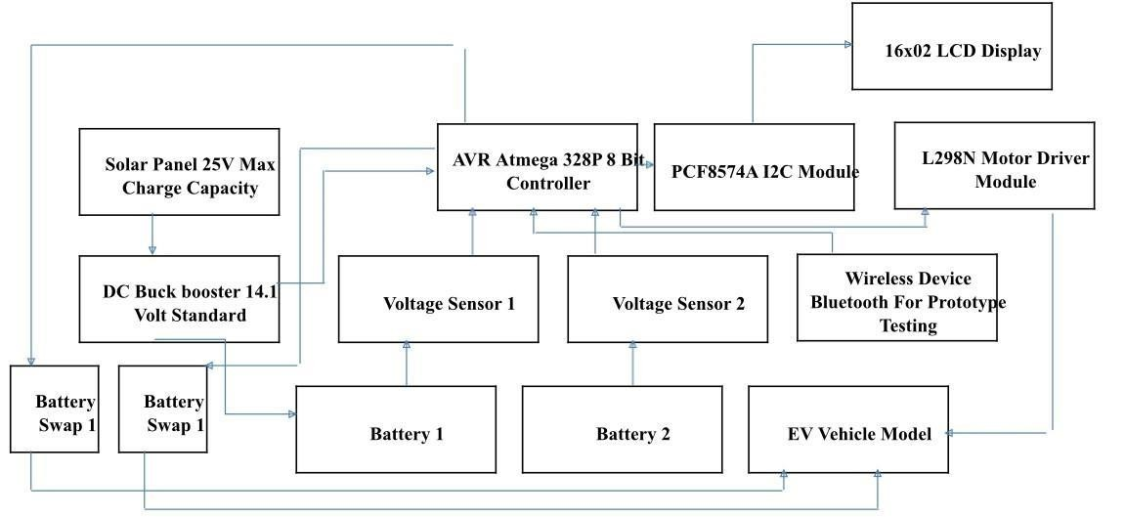

***Fig : BLOCK DIAGRAM***

1. **ALGORITHM OF OUR WORKING MODEL:**

**PHASE 1 – E-Bike BLDC PWM Tooth Generator**

* This Phase deals with the BLDC Rotation control from the bevel connectors
* Based on the Duty cycles released from the throttle the modes can be changed into three operations such Normal mode, Economy, and Sports Mode.
* Based on this mode selection BLDC will be coupled with the internal Centrifugal load transmitters
* Without proper PWM signals mode selection is not possible to rotate the gears
* As per our approximation system speed varies from 30kmp – 120kmp

## PHASE 2 – Vibration Sensor Activity Log Calculator

* Based on the Road Condition data log will be generated for a safe ride.
* Sport mode will not be activated in the vibration data from the CAN bus is high.
* This prominently helps us to increase the stability of the system.

## PHASE 3 – Battery Charge Cut-off

* On Manual tripping this engine system can attain full load and full speed
* Bevel transmissions will not take into data activity
* In such cases high usage of the battery will reduce the battery life and create a lot of system failures
* So, it is mandated to check the battery drain rate based on the consumption ratio

### Architecture

In gear transmissions, vibration causes noise and malfunction. In actual applications, misalignments contribute to intensifying the destructive effect of vibrations. In this project, the nonlinear dynamics of a spiral bevel gear pair, with a small helix angle, considering different misalignments, are deeply investigated. Axial misalignment, radial misalignment, and the combination of these two types are considered in this study. The governing equation is numerically solved through an implicit Range–Kata scheme. Since the main goal of this study is the analysis of the dynamic scenario, the mesh stiffness of the gear pair is obtained from the literature. The dynamical system is nonlinear and time-varying; it is analyzed through time responses, phase portraits, Poincare maps, and bifurcation diagrams. Results show that among the considered three cases with different types of misalignments, the spiral bevel gear with axial misalignment is the worst destructive case; aperiodic, sub harmonic, and multiperiod responses are observable for this case. It is interesting that the chaotic responses for the case, having both types of Misalignments, are less likely for the case with axial misalignment. These are the list of alternatives that must be changed to control the speed of BLDC motors based on the Physical Road conditions.

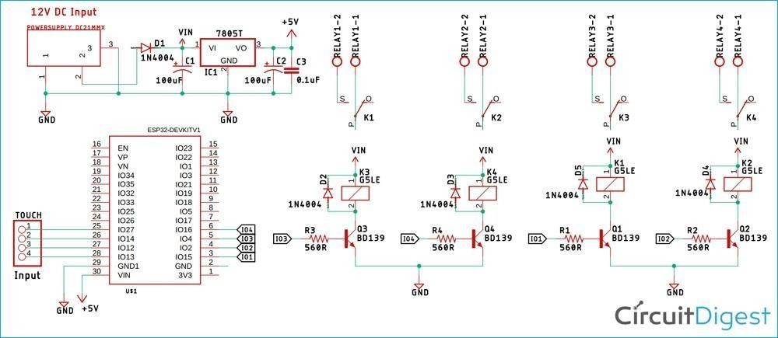

***Fig: Architecture of Mode Switching on E-Bike***

## APPLICATIONS

* They are used for traveling long distances.
* They are the future mode of transport and they can even replace other pollution-causing mobility systems like Petrol Engine Bikes and Diesel Engine Cars too.
* Electric Bicycles are better for older people due to its less pedal force applications.
* They are used in large industries and manufactures to travel across industry area

## CONCLUSION

In conclusion, the E-bike speed control system is an essential component of electric bicycles that helps riders maintain a safe and comfortable speed while riding. The system employs various technologies, such as torque sensors, pedal- assist sensors, and throttle controls, to regulate the motor's speed and power output. The E-bike speed control system offers several benefits to riders, including increased safety, improved battery life, and enhanced performance. With the increasing popularity of electric bicycles, the development of more advanced and efficient E-bike speed control systems is expected to continue, improving the overall riding experience, and making E-bikes an even more viable alternative to traditional bicycles and motorized vehicles.

In addition to enhancing the overall riding experience, the E-bike speed control system also plays a critical role in ensuring compliance with local regulations and laws. The system enables manufacturers to set maximum speed limits for their electric bicycles to meet the legal requirements of different regions. By adhering to these speed limits, riders can avoid potential fines or legal consequences for violating local laws. Moreover, the speed control system's ability to regulate the motor's output makes E-bikes more accessible to a broader range of riders, including those who may not have the strength or ability to ride a traditional bicycle. As such, the E-bike speed control system represents a significant advancement in personal transportation technology, providing a safer, more eco-friendly, and efficient alternative to traditional modes of transportation.

# REFERENCES

1. Aikenhead, G. S.,"Bicycle Applications for On-Board Solar Power Generation",

pp. 9-10, 2011.

1. Barve, D. S.,"Design and Development of Solar Hybrid Bicycle", International Journal of Current Engineering and Technology, pp. 377-380, 2016.
2. Barve, D. S.,"Design and Development of Solar Hybrid Bicycle", International Journal of Current Engineering and Technology, pp. 378-379, 2016.
3. Barve, D. S.,"Design and Development of Solar Hybrid Bicycle", International Journal of Current Engineering and Technology, pp. 380, 2016.
4. FOGELBERG, F.,"Solar Powered Bike Sharing System", Goteberg,Sweden: Viktoria Swedish ICT, 2014.
5. FOGELBERG, F.,"Solar Powered Bike Sharing System with", Goteborg, sweden: Viktoria Swedish ICT, 2014.
6. GOODMAN, J. D.,"An Electric Boost for Bicyclists", The New York Times, 2010.
7. Prof. Palak Desai, P. D.,"Design And Fabrication Of Solar TRI Cycle", International Journal of Engineering Sciences & Research, pp. 664, 2016.
8. T.Bhavani,"Novel Design of Solar Electric Bicycle with Pedal", International Journal & Magazine of Engineering, pp. 108, 2015.