**THE HUMAN MICROBIOME**

**M**icrobiome is An Invisible Guardian of Health.

**Did you know that your body is home to trillions of tiny microscopic organisms that play a crucial role in your health?**

These tiny organisms, known as microbes, together known as the human microbiome, that live in and on the human body. Most microbes are found in different parts of the body including the skin, mouth, lungs, reproductive organs, and gut (also known as the intestines).

A Unique Microbiome in Every Part of the Body.

Each part of the body contains a unique microbiome with important functions.

**1.Skin**: The skin helps to protect against infections.

**2.Mouth**: The mouth impacts digestion and oral health.

**3.Lungs**: The lungs play a role in immune system modulation and pathogen defense.

**4.Reproductive organs**: The reproductive organs help to maintain the vaginal microbiome, which supports vaginal health and prevents infections.

**5.Guts**: Guts plays a crucial role in digestion, nutrient absorption, immune function, and overall health.

How the microbiome contributes health

The microbiome helps the body with digestion by breaking down food and aiding in nutrient absorption. Vitamin biosynthesis allows these microbes to naturally produce essential nutrients, contributing to overall health. The immune system support provided by the microbiome helps protect against harmful microbes. Finally, the microbiome plays a role in metabolism, influencing weight regulation and energy levels.

Maintenance of a healthy microbiome:

For a healthy microbiome, we should consume fibre-rich foods like vegetables, fruits, and whole grains. Including fermented foods such as yogurt and kimchi is also beneficial. Additionally, getting enough sleep and managing stress are essential for maintaining a healthy and balanced microbiome.

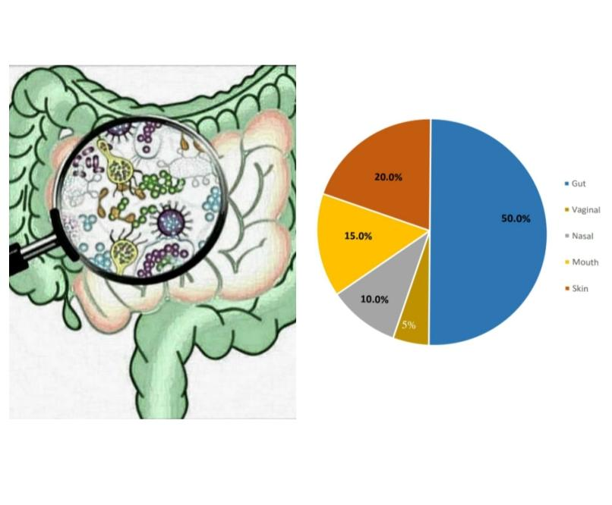

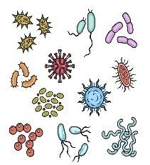

**Microbiome**

**Lung disease**

•

High microbial density

•

Low microbial diversity

**Healthy**

**disease**

**se**

•

Low

microbial density

•

High

microbial diversity