Microbial Mediated Anaerobic Wastewater Treatment : A Sustainable Approach for Organic Pollutant Removal
P.Chandrakalaª, Dr. P. Raja Rao^{b}
a.Full Time Research Scholar, Dept of Technology ,University College of Technology, OU Hyderabad
b.Professor, Dept of Technology , University College of Technology, OU Hyderabad
Abstract:Anaerobic wastewater treatment is a sustainable approach for removing organic pollutants from wastewater. Microbial-mediated anaerobic processes have gained significant attention in recent years due to their ability to efficiently degrade organic pollutants. This study reviews the microbial-mediated anaerobic wastewater treatment processes, including the mechanisms of organic pollutant removal, the role of microorganisms, and the factors influencing the treatment efficiency. The results show that anaerobic treatment systems can achieve high removal efficiencies for organic pollutants, and the integration of microorganisms can enhance the treatment efficiency. The study also identifies the challenges and limitations of anaerobic treatment systems and provides recommendations for future research and development. Overall, this study demonstrates the potential of microbial-mediated anaerobic wastewater treatment as a sustainable approach for organic pollutant removal. The primary aim of this research is to develop and optimize a microbial-mediated anaerobic wastewater treatment system that efficiently removes organic pollutants from wastewater, providing a sustainable and environmentally-friendly solution for wastewater management.
Keywords
Anaerobic wastewater treatment, microbial-mediated, organic pollutant removal, sustainability, environmental remediation.

1.Introduction:The rapid industrialization and urbanization of modern society have led to a significant increase in wastewater generation, posing a major threat to environmental sustainability and public health. Wastewater contains a complex mixture of organic pollutants, including industrial chemicals, agricultural runoff, and domestic waste, which can have devastating effects on aquatic ecosystems and human health if not properly treated.
Conventional wastewater treatment technologies, such as activated sludge and trickling filters, have several limitations, including high energy consumption, sludge production, and incomplete removal of organic pollutants. In contrast, microbial-mediated anaerobic wastewater treatment offers a sustainable and efficient approach for organic pollutant removal.
Anaerobic wastewater treatment harnesses the power of microorganisms to break down organic pollutants in the absence of oxygen, producing biogas (a mixture of methane and carbon dioxide) as a valuable byproduct. This approach has several advantages, including low energy consumption, minimal sludge production, and the potential for energy recovery.
Despite its benefits, microbial-mediated anaerobic wastewater treatment still faces significant challenges, including low efficiency, instability, and limited understanding of the microbial communities involved. Therefore, this research aims to explore the potential of microbial-mediated anaerobic wastewater treatment for sustainable organic pollutant removal.
1.1. Objectives:
- 1. To investigate the microbial communities involved in anaerobic wastewater treatment and identify key microorganisms responsible for organic pollutant degradation.
- 2. To optimize the operating conditions (e.g., temperature, pH, retention time) for enhanced microbial activity and organic pollutant removal.
- 3. To evaluate the efficiency of the microbial-mediated anaerobic wastewater treatment system in removing a range of organic pollutants, including recalcitrant compounds.
- 4. To assess the sustainability and environmental impact of the proposed treatment system, including energy requirements, greenhouse gas emissions, and sludge production.
1.2.Principles of Anaerobic Wastewater Treatment:
- Absence of Oxygen: Unlike aerobic processes that rely on oxygen for microbial metabolism, anaerobic treatment occurs in an oxygen-free environment. Anaerobic microorganisms, primarily methanogenic bacteria, carry out biochemical reactions to degrade organic compounds.
- Anaerobic Digester: The core component of anaerobic treatment systems is the anaerobic digester. This is a sealed tank or reactor where wastewater is processed under controlled conditions to promote anaerobic microbial activity. The digester provides an environment conducive to the growth and metabolism of anaerobic bacteria.
- Microbial Consortia: Anaerobic digestion involves a diverse community of microorganisms, including acidogens and methanogens. Acidogenic bacteria break down complex organic matter into simpler organic acids, alcohols, and hydrogen. Methanogenic archaea then convert these intermediates into methane (CH4) and carbon dioxide (CO2).
- Temperature and pH Control: Temperature and pH are critical factors influencing the efficiency of anaerobic digestion. Mesophilic conditions (around 35-40°C) are commonly used, though thermophilic (50-60°C) and psychrophilic (15-25°C) conditions may also be employed depending on the specific microbial species and wastewater characteristics.
1.3. Processes Involved:

Hydrolysis: Large organic molecules (e.g., carbohydrates, proteins, lipids) are broken down into smaller molecules (e.g., sugars, amino acids, fatty acids) by enzymes produced by microorganisms.
Complex organic compounds → Amino acids, sugar, fatty acids.
C₆H₁₀O₄ + 2H₂O → C₆H₁₂O₆ + 2H₂ --------(1)

Acidogenesis: The smaller molecules produced during hydrolysis are converted into volatile fatty acids (VFAs) and other organic acids by acidogenic microorganisms.
Amino acids, sugar, fatty acids →Intermediate compounds( propionate, butyrate, ethanol etc).
C₆H₁₂O₆ ↔ 2 CH₃CH₂OH + 2CO₂ .…….(2)
C₆H₁₂O₆ + 2H₂ ↔2CH₃CH₂COOH + 2 H₂O --------(3)

Acetogenesis: The VFAs produced during acidogenesis are converted into acetate and other organic compounds by acetogenic microorganisms. the conversion of propionate to acetate.
CH₃CH₂COO⁻+H₂O ↔ CH₃COO⁻+H⁺ + HCO₃⁻ + 3H₂ ------(4)

Methanogenesis: The acetate and other organic compounds produced during acetogenesis are converted into methane (CH4) and carbon dioxide (CO2) by methanogenic microorganisms.
CH₃CH₃OH +CO₂ ↔ 2 CH₃ COOH + CH₄ --------(5)
CH₃COOH ↔ CH₄ + CO₂ --------(6)
CH₃OH+H₂↔CH₄+H₂O --------(7)
CO₂ + 4H₂ ↔ CH₄ + 2H₂O -------(8)

Biogas Production: The methane and carbon dioxide produced during methanogenesis are collected as biogas, which can be used as a renewable energy source.

Sludge Reduction: The anaerobic treatment process reduces the amount of sludge produced, minimizing the need for sludge disposal and treatment.

Pathogen Removal: The anaerobic treatment process can also remove pathogens and other microorganisms that can cause disease.

Microorganisms Involved

Bacteria: Hydrolytic bacteria, acidogenic bacteria, acetogenic bacteria, and methanogenic bacteria are all involved in the anaerobic treatment process.

Archaea: Methanogenic archaea are responsible for the production of methane during the methanogenesis step.

1.4Operating Conditions

Temperature: The optimal temperature range for anaerobic treatment is between 20°C and 40°C.

pH: The optimal pH range for anaerobic treatment is between 6.5 and 8.5.

Retention Time: The retention time of the wastewater in the anaerobic treatment system can range from a few days to several weeks.

Organic Loading Rate: The organic loading rate of the anaerobic treatment system can range from 0.5 to 5 kg COD/m³/day.

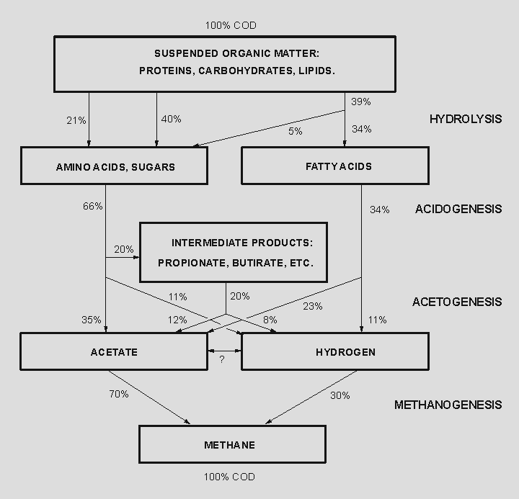
Fig1.: Anaerobic Digestion Process
1.5.Materials & Methods
The materials and methods for anaerobic wastewater treatment typically involve several key components and steps to ensure effective operation and reliable results. Here’s an outline of the general materials and methods used in anaerobic wastewater treatment:

a)Materials:
- Anaerobic Digester: This is the central component where anaerobic microorganisms degrade organic pollutants. Anaerobic digesters come in various designs such as completely mixed reactors, upflow anaerobic sludge blanket (UASB) reactors, and anaerobic baffled reactors (ABRs). The choice of digester depends on factors like wastewater characteristics, treatment goals, and operational preferences.
- Wastewater Feed: The wastewater feedstock includes influent from industrial processes or municipal sewage systems. It contains organic compounds that need to be treated.
- Inoculum: This is the source of anaerobic microorganisms necessary for initiating and maintaining digestion processes. Inoculum can come from existing anaerobic digesters or specialized cultures to optimize treatment performance.
- pH and Temperature Control Systems: Anaerobic microorganisms are sensitive to pH and temperature fluctuations. Control systems are used to maintain optimal conditions (typically around neutral pH and specific temperature ranges depending on mesophilic, thermophilic, or psychrophilic conditions).

b)Methods:
- Inoculation: The anaerobic digester is initially inoculated with anaerobic sludge or microbial cultures to establish a robust microbial community capable of organic degradation.
- Startup and Acclimatization: The system is gradually started up with a controlled feed of wastewater to allow microorganisms to acclimatize and establish stable digestion processes.
- Operation and Monitoring: The digester operates continuously or in batch mode, depending on the specific design. Process parameters such as temperature, pH, hydraulic retention time (HRT), and organic loading rate (OLR) are monitored regularly to optimize performance.

Analytical Methods:
- Chemical Analysis: Monitoring of influent and effluent quality for parameters such as biochemical oxygen demand (BOD), chemical oxygen demand (COD), total suspended solids (TSS), and nutrient concentrations.
- Gas Analysis: Measurement of biogas composition (methane, carbon dioxide, hydrogen sulfide) to assess biogas quality and digester performance.
- Microbiological Analysis: Assessment of microbial activity and diversity within the digester through microbial sampling and analysis techniques.
c)Block Diagram
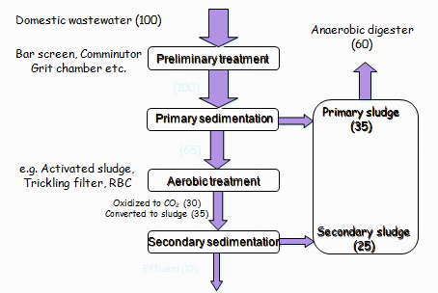
2.Experimental Methodology
2.1Working principle of high rate digester:
The digester was designed according to the organic loading rate and hydraulic retention time. A conventional single stage anaerobic digester and high rate digester operated at different organic loading rate. The total volume of the both digester was 1 cubic meter. A unique system for intense mixing of slurry inside the digester is the main feature in digester design. This was accomplished by differential pressure created by biogas across two vertical compartments connected hydraulically. No mechanical moving parts were used for accomplishing mixing and almost no power is consumed. Entire mixing process was controlled by an on-off control system using a motorized valve that control the differential pressure exerted by biogas across the two compartments. Manual valve also can be used for a less expensive model. The vertical compartmental design and other internal fittings enable retention of solids and prevent flushing even during hydraulic shock loads. Scum formation and choking were completely eliminated by using customized overflow weirs, provided as internal fittings. A wave motion took place inside the digester due to intermittent pressure swing takes place across the compartment results in breaking the scum into fragments. Pipes were also avoided for transporting slurry in order to avoid choking and overflow weirs are provided for this purpose.
Multistage digestion was accomplished by a twin tank design. The first tank performs as feed tank and hydrolytic and acetogenic bacteria prevail in this chamber. It is open to air but anaerobic zones are prevalent in this tank. The hydrolysed feed or rich VFA fraction leached down into main digester and undergoes methanogenic step. A gas receiver was used for collecting gas before filling into gas bullets. The gas handling was controlled by a simple process control system assisted by a level switch connected to the floating gas holder and a hermetic compressor. The pressure swing that took place during mixing process enabled a self discharge system for digested slurry. A simple gravity filter was used for dewatering digested slurry and filtrate is safe to discharge into drainage.
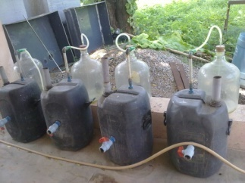
Fig 2 High rate digestersusing oilcake
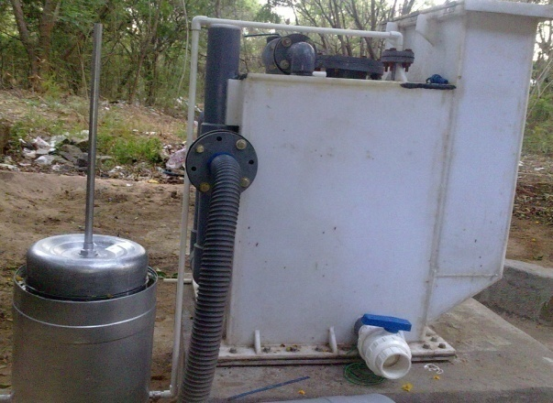
Fig 3 High rate digester using canteen waste

The present compact digesters available in India are just sealed tanks holding cow dung slurry with a floating gas holder .No scientific principles are applied in its engineering The present compact digesters available in India are just sealed tanks holding cow dung slurry with a floating gas holder. No scientific principles are applied in its engineering design in order to improve efficiency. Pre-fabricated compact digesters by M/s Biotech, Sintex, ARTI or many other similar agencies use different material of construction but basically design is same. Manual operations involved in its use make it inconvenient and it is also associated with serious operational problems. The basic design of it was first developed by Khadi and Village Industries Commission (KVIC) around 50 years ago and it is called KVIC digesters and popularly known as gober gas plant. Feeding these digesters is a difficult proposition because the waste needs to be fed through a 4 inches dia. pipe after external homogenisation using a grinder. Choking is another major problem and surroundings become dirty due to overflow. Discharge of secondary effluents from the digester with high amount of solids is another difficulty. Loading rate in a conventional 1000 lit. digester is less than 2 kg/day and hence it is suitable only for a single household. Whereas potential customers of a compact digester are restaurants, apartments, canteens, housing colonies, small scale food processing units/centres and small agro farms. The prefabricated compact digester proposed here as a new concept is based on high rate biomethanation technology and it is designed to overcome the drawback of conventional digesters. The new equipment has almost 15 times more loading rate with increased treatment efficiency and short retention time compared to conventional digester. No operational difficulties are associated with this new variant of high rate compact digester.
This study utilized and aim to develop an high rate, two-stage reactor and phase-separation was employed to limit the reactions of anaerobic digestion to occur simultaneously in order to optimize the process. The same pilot-scale reactor is designed and fabricated, is installed at canteen to analyze the real time problem at user site.
2.2 BMP test procedure
The lab-scale experimental procedure is briefly illustrated in figure 3.1. Moreover, figure 3.2 clearly indicates the four substrates for BMP test with common blank reactors. Nevertheless, figure 3.3 illustrates the BMP test gas sampling.
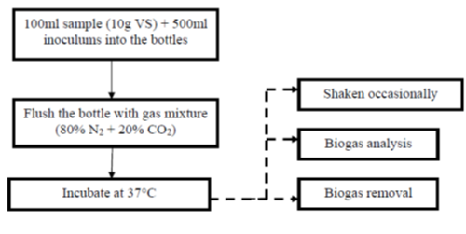
Fig 4.: Schematic representation of lab-scale (BMP test) procedure
2.3Mechanism of combined process:
The solid waste was digested in high-solids single-reactor in batch mode and undergoes a combined anaerobic digestion process followed by reaeration stage. It is said to be a combined process because all the reactions involved in anaerobic digestion takes place in single digester. Figure 3.4 illustrates the anaerobic digestion system used in this experiment.
As described, anaerobic digestion is the biomethanization of organic waste which can be roughly separated into two main steps, the pre-stage that involves liquefaction and acidification and the main stage that consist of methane generation. In order to enhance the process, phase separation and leachate recirculation is imperative. The following statement explains the concept of combined process:
Initially, flushing the fresh waste bed with water can wash-out the dissolve organic compounds and biodegradable materials present in the digester. Eventually, this could remove and reduce the possibility of VFA accumulation. The water produced after flushing the waste is known as leachate. Since this leachate will carry some fractions of VFA, it is said to be acidified.
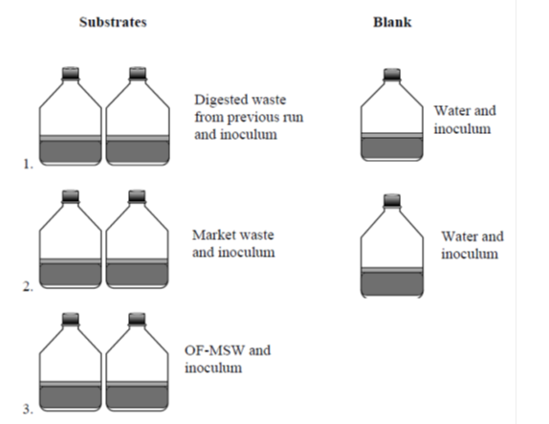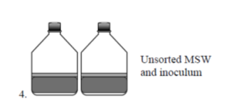
Fig 5 Different substrates used in BMP analysis.
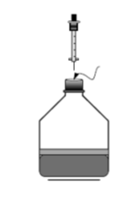
Fig 6. General illustration of the reactor for BMP test sampling
2.4.Feed stock and inoculum preparation:
As the moisture content in organic fraction of oil cake was very high, the feed stock was comprise of solid and liquid phase. The amount of solid to be added was determined by the formulae
HRT = V/Q
HRT = Volume of the digester/feeding rate, where HRT and volume is fixed. The percentage of inoculum for the fermentation of solid waste is approximately 30% (Carriero et al 2006). The cowdung was added to the reactor initially to enhance the start up process.

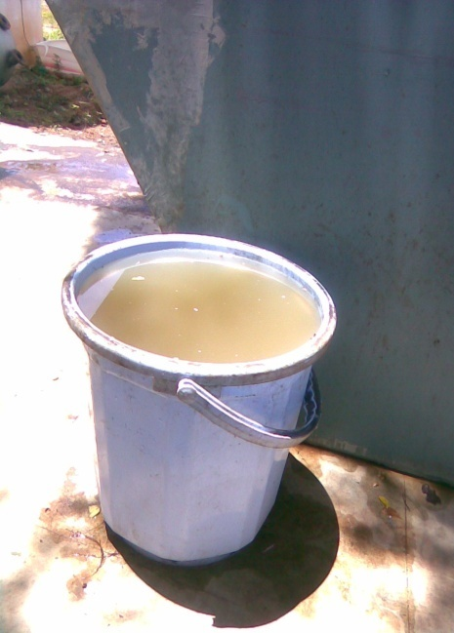
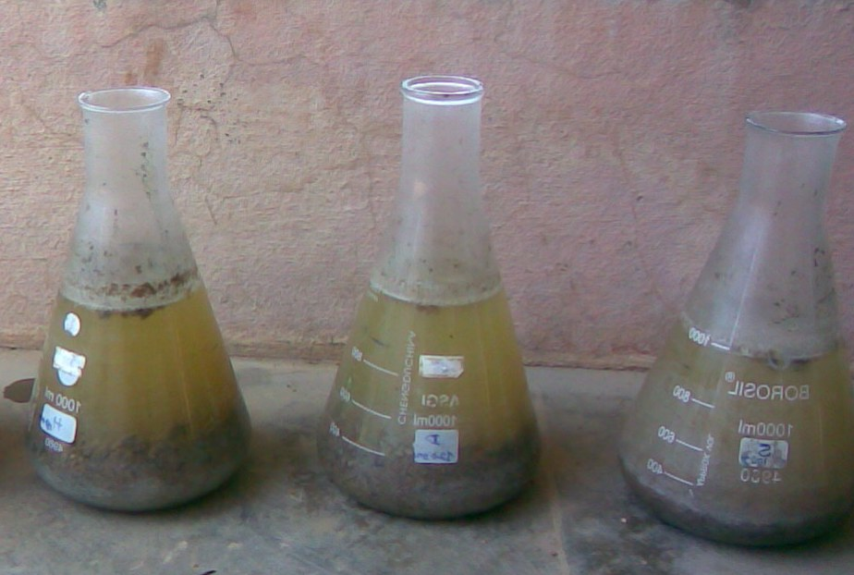
Fig 7. feed stock preparation
- Feed with 10 % total solids:
2kg’s Castor de-oiled cake was soaked in 18 liters of water over night to accomplish the first stage of digestion that is hydrolysis,so as to make the digestion a multistage process.
- Feed with 12% total solids:2.4kg’s castor de-oiled cake was soaked in 17.6 liters of water over night to accomplish the first stage of digestion that is hydrolysis,so as to make the digestion a multistage process.
- Feed with 15% total solids:
3 kg castor de-oiled cake was soaked in 17 liters of water over night to accomplish the first stage of digestion that is hydrolysis, so as to make the digestion a multistage
3.Results & Discussion
3.1Biogas generation and quality:
One of the main ojective of this research was to determine the performance of the AD process when operated at different loading rates. Due to this, it is highly important to evaluvate the biogas production and methane content to various organic loading rate. The experimental results showed that during the loading rate of 2, the biogas production was very high as compared to 1 and the decline of biogas production started during the loading rate of 3 . The gas production was high when it started because of entrapped air inside the reactor, but the methane percentage was found to be very low. When the start –up reached methanogenesis, it was found to be high methane content. The biogas production increased with increase in organic loading rate to an extent and started declining after the optimum organic loading rate. The highest volume of biogas produced (1200 l/d) during the period of 15- 20 days and highest methane production (67%) was found to be these days. The biogas production rate fell after 20th day indicating exhausting of readily accessible substrate for biogas production. The reactor allowed to run until the gas production peaked and then dropped below 300 L per day. The biogas production of conventional digesters were also analyzed. The biogas production reached to the maximum of 500L in the case of conventional digesters. The fig.4.1 shows variation of biogas production at different loading rate.

Fig 8 Daily biogas production of high rate digester
The biogas production of conventional digesters were also analyzed. The biogas production reached to the maximum of 500L in the case of conventional digesters. The fig. shows variation of biogas production of conventional digesters at different loading rate.
Fig9. Biogas production from conventional digester.
3.2METHANE PRODUCTION:
The concentration of methane in biogas was observed maximum of 67% during the period of 15th-20th day of digestion in the case of high rate digester. Intially the methane content was less due to the formation of acids but it gradually increased with in 3-5 days. Because of the less efficiency it was found that the percentage of methane present produced by conventional digesters are very less compared to the production of high rate digesters. The fig. 4.3 shows the analysis of variation in the production of methane.
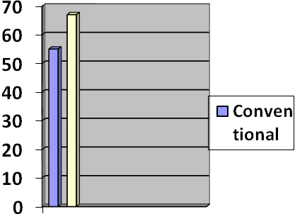
Fig: 10shows methane concentration of two reactors.
3.3 BMP test (lab-scale)
BMP test was conducted on four different substrates giving emphasize to the results of castrol oil cake and canteen waste. Other substrates such as stabilized (digested) oil cake and karanja oil cake were also included to investigate the methane potential of the waste.
It is important to emphasize that in this study, incubation at mesophilic temperature (37°C) for 100 days was found sufficient to ensure full degradation of degradable organic matter contained in the waste. The BMP test is not dependent on temperature, incubating at lower temperature may influence the incubation time but the BMP of the waste would just be the same.
Fig 11 Daily and cumulative biogas produced

Castrol de-oiled cake –daily gas
canteen waste - daily gas
Castrol de-oiled cake –cumulative gas
canteen waste – cumulative gas
Fig 12 Biogas produced between Castrol de-oiled cake and canteen waste
(canteen waste) (castrol de-oiled cake)
(canteen waste) (castrol de-oiled cake)
Fig 13. variation between cantten waste and castrol de-oiled cake in terms of CH₄ content and total biogas produced per kilogram of waste
Fig13 Represent the methane potential of different waste together with the blank reactor. The cumulative volume of methane at STP is presented. The blank sample which includes water and inoculum represent the gas production produced by the inoculum itself. The methane production from the inoculum was subtracted from the methane production of the waste samples. The results thus represent only the methane production from the waste and not from the inoculum. Figure 4.38 Illustrates the corrected methane production generated by the waste sample in terms of milliliters of CH4/g VS at STP
digested castrol de-oiled cake
castrol de-oiled cake
blank
canteen waste
karanja de-oiled cake
Fig 14 cumulative methane production(lab scale)

Digested de-oiled cake canteen waste
castrol de-oiled cake karanja de-oiled cake
Fig 15 corrected cumulative methane production(lab- scale run)

The final results after 100 days of mesophilic incubation showed that for each kg of VS of Castrol de-oiled cake, around 400 L of methane could be produced. Nguyen (2004) who conducted BMP test on fresh market waste obtained a value of around 300 L CH4/kg V Safter 40 days of incubation. The result was higher than the previous study and the difference may be attributed with the length of incubation time. It can be said that in order to ensure full degradation of waste, 100 days of incubation period is suitable and enough to determine the biochemical methane potential of the waste under mesophilic condition. Among the substrate used in this test, the castrol de-oiled cake showed the highest yield of methane. Also, the digested castrol de-oiled cake was included in this lab-scale run and implied that that around 35% of methane can be retained in the waste after digestion. However, it should be noted that the digested waste used here was obtained from the previous experiment . It is important to mention that more than 60% of the organicmatter can be converted into biogas, in which if the process conversion can be optimize, higher conversion efficiency can be achieved likewise.
Table1:Overall assessment of pre-stage(flushing and acidification)
Table2 :Overall assessment of main stage
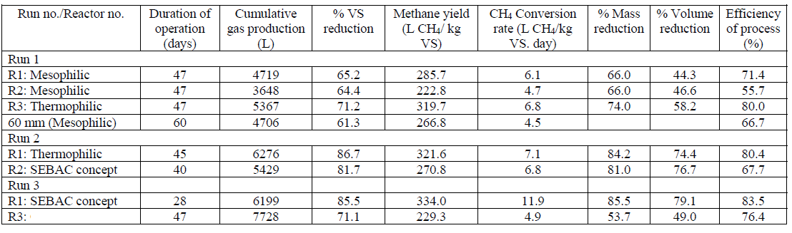
Results and discussions from anaerobic wastewater treatment studies typically focus on several key aspects to evaluate the effectiveness and efficiency of the treatment process. Here’s an outline of what would typically be included in the results and discussion sections:

4.Results:
- Effluent Quality Analysis:
Reduction in Organic Pollutants: Quantitative data on the removal efficiencies of biochemical oxygen demand (BOD), chemical oxygen demand (COD), total organic carbon (TOC), and other relevant parameters from influent to effluent.
Nutrient Removal: Concentrations of nitrogen (ammonia, nitrate, nitrite) and phosphorus in the effluent before and after treatment.
Pathogen Reduction: Evaluation of pathogen levels in the effluent to assess the treatment's effectiveness in microbial reduction.

- Biogas Production and Composition:
Biogas Yield: Quantitative data on the volume of biogas produced per unit of wastewater treated.
Biogas Composition: Percentage composition of methane (CH4) and carbon dioxide (CO2) in the biogas, often compared to theoretical values or regulatory standards.
Biogas Quality: Analysis of impurities such as hydrogen sulfide (H2S) and siloxanes, which can affect biogas utilization and require removal.
- Process Parameters:
Temperature and pH: Recorded values throughout the study period to ensure optimal conditions for microbial activity.
Hydraulic Retention Time (HRT): Actual retention time of wastewater in the digester, which influences treatment efficiency.
Organic Loading Rate (OLR): Rate at which organic matter is fed into the digester, impacting microbial growth and digestion rates.
- Microbial Analysis:
Microbial Community Dynamics: Changes in microbial populations (acidogens, acetogens, methanogens) over time or in response to operational changes.
Microbial Activity: Quantitative or qualitative assessments of microbial activity through enzymatic assays or molecular techniques.
- Energy Balance:
Energy Recovery Efficiency: Calculation of the energy output from biogas utilization (electricity, heat) compared to the energy input required for operation (e.g., mixing, heating).
5.Summary and Conclusions:
Anaerobic processes are inherently one of the energy efficient means for stabilizing organic solid waste. As an additional benefit they have the potential of capturing over 70-80% of the biochemical energy potential in the form of methane gas. In this study, pilot scale anaerobic digestion of oil cake was conducted. An inclined high rate anaerobic reactor having differential pressure based self mixing was designed and operated under continuous mode. An attempt to optimize the process was done by increasing organic loading rate at intervals. An effective start up of the anaerobic digestion with inoculums and substrate acclimization was done successfully. It was possible to achieve 70% solid reduction in high rate digester where as it was 45-50%in conventional digesters. High degree of solids reduction essentially leads to higher amount of biogas production. It was found that very short hydraulic retention time is only required for these digesters, typically in the range of 15 to 20 days as against 50 to 60 days in conventional digesters. It was possible to increase the organic loading rate from 5-10 kg per cu.m per day. From this investigations it is concluded that solid wastes can be anaerobically digested and thus minimized the organic fraction of solid wastes going to land fill and also can be produced some eco-friendly products. High rate biomethanation technology has dominance over the conventional digesters by giving the result of enhancement of biogas production. The rate of biogas production observed in conventional digester declined due to the limited ability of the digester to thoroughly mix the contents and the production of scum layers, choking, inconvenient feeding system, effluent generation and low organic loading rate, make the digester uneconomical for the commercial application. The mixing ability of the pilot scale digester exceeded the mixing ability of commonly designed digesters, indicating that new developments in high rate digester are needed for successful digestion of solid wastes. Due to higher treatment efficiency, operational problems are also minimized in high rate digesters and at the same time solids obtained after digestion is more stabilized. The methane content in biogas found to be higher in high rate digesters than conventional digesters. It was also found that high rate digester with additives results better treatment efficiency and methane production.

6.Future Work
Outline specific plans for future work based on the ongoing findings and areas requiring further investigation or refinement. This may include adjustments to experimental parameters, additional data collection, or validation studies.
7.References
- Adhikari, R (2006). Sequential batch and continuous anaerobic digestion of municipal solid waste in pilot scale digesters.(Master thesis, No. EV-06-33, Asian Institute of Technology, 2006). Bangkok: Asian Institute of Technology.
- Angeladki, I & Sanders, W. (2004).Assessment of the anaerobic biodegradability of macropollutants. Environmental Science and Biotechnology, 3, 117-129.
- Angelidaki, I, Ahring, B.k, (1994). Anaerobic thermophilic digestion of manure at different ammonia loads: effect of temperature. Water research, 28(3), 727-731.
- Ayalan, O, Avimelech, Y., & Snechter, M. (2000).Alternative MSW management options to reduce global green house emissions- the Israeli examples. Waste Management and Research, 18, 534-544.
- Bogner, J. and Spokas, K. (1993). Land fill CH4: rates, fates and role in global carbon cycle. Chemosphere, 26, 369-386.
- Bouallagui, H., Haouari, O., Touhami, Y., Cheikh, B. R., Marouani, L., and Hamdi, M.(2004). Effect of temperature on the performance of an anaerobic tubular reactor treating fruit and vegetable waste. Process Biochemistry, 39, 2143-2148.
- Bouallagui, H., Houhami, Y., Cheikh, R.B., and Hamdi, M.(2005). Bioreactor performance in anaerobic digestion of fruit and vegetable waste. Process Biochemistry, 40, 989-995.
- Braber,K.(1995). Anaerobic digestion of municipal solid waste: a modern waste disposal option on the verge of break through. Biomass and Bioenergy, 9, 365-376.
- Buyukkamaci, N. and Filibeli, A. (2004). Volatile fatty acid in an anaerobic hybrid reactor. Process Biochemistry, 39, 11, 1491-1494.
- Castillo, M.E.F., Cristancho, D.E. & Arellano, V. A. (2006). Study the operational condition for anaerobic digestion of urban solid wastes. Waste Management, 26, 546-556.
- Chaya, W. and Cheewala, S.h. (2007). Life cycle assessment of SW-to –energy schemes in Thailand. Journal of Cleaner Production, 15, 1463-1468.
- Chavez-Vazquez, M. & Bagely, D.M. (2002). Evaluation of the performance of different anaerobic digestion technologies for solid waste. Csce/Ewri of ASCE Environmental Engineering Conference.
- Davidsson, A., Gruvberger, C., Christensen, T.H., Hansen, T.L., Jansen J.C. (2007). Methane yield in source-sorted organic fraction of municipal solid wastes and agricultural wastes.Waste management, 27, 406-414.
- Evans, G.(2001). Biowaste and Biological Waste Treatment. The Cromwell press. ISBN: 1-902916-08-5.
- Friends of the Earth (2007).Briefing anaerobic digestion.UK’s Influential national environmental compaigning organization.
- Gunaseelan, N.V. (1997). Anaerobic digestion of biomass for methane production: a review. Biomass and Bioenergy, 13, 83-114.
- Hansen, T.l., Schmidt, J.E., Angeladaki, I., Marca, E., Jansen, J.C. Mosbxk, H., Christensen, T.H. (2004). Method of determination of methane potentials of solid organic waste. Waste Management, 24, 393-400.
- Hu Hu, Z. and Yu, H.Q. (2006).Anaerobic digestion of cattail by rumen cultures. Waste management, 26, 1222-1228.
- IEA (International Environmental Agency) (2001). Biogas and more: systems and markets over review of anaerobic digestion. Retrieved on 5 August, 2007.

