AI in HealthCare & Safety

Simra Khan#1, Ayesha Ansari#2, Zubiya Ansari#3, Zainab Khan#4

*Department of Information Technology*

*M.H.Saboo Siddik Polytechnic, India*

1[simrakcolumbian.9c30@gmail.com](mailto:simrakcolumbian.9c30@gmail.com)

2[ayesha140406@gmail.com](mailto:ayesha140406@gmail.com)

3[zubiyaansari417@gmail.com](mailto:zubiyaansari417@gmail.com)

**4**[khanzainab6002@gmail.com](mailto:khanzainab6002@gmail.com)

Abstract—**Artificial Intelligence (AI) is revolutionizing healthcare by enabling predictive analytics, real-time monitoring, and enhanced patient safety. This paper explores the integration of AI in healthcare infrastructure, focusing on health prediction, mood relaxation, and emergency response systems. AI-powered applications such as user health prediction, stress management, and women's safety tools contribute to a smarter and safer healthcare ecosystem. The study discusses various AI models, their implementation, challenges, ethical concerns, and future prospects in healthcare infrastructure.**

Keywords—**Smart Healthcare = AI-driven health monitoring**

**and prediction**

**Predictive Analytics = Data driven forecasting in**

**healthcare**

**Ethical AI= Responsible and bias free AI in**

**Healthcare**

1. Introduction
   1. *Definition*

The emergence of AI in healthcare has led to the development of innovative smart infrastructure solutions. AI-driven health prediction, mood relaxation, and emergency response systems enhance patient care and safety. With the integration of machine learning and IoT, healthcare infrastructure is evolving towards automation, efficiency, and reliability. The use of AI in healthcare allows for real-time monitoring, predictive analytics, and automated decision-making, ensuring a proactive approach to medical treatment and patient management. AI also contributes to optimizing hospital workflows, reducing wait times, and providing personalized recommendations based on patient history and current health status [4][2].

.

II. HISTORY

AI's role in healthcare can be traced back to the early 1950s when initial developments in computer-assisted diagnostics were introduced. During the 1970s and 1980s, expert systems like MYCIN and INTERNIST-I were created to assist medical professionals in diagnosing and recommending treatments for diseases. The advent of deep learning and big data in the 21st century has further revolutionized AI applications in healthcare, enabling highly accurate predictions, robotic-assisted surgeries, and AI-driven telemedicine services. The continuous advancement in AI technology is paving the way for a fully interconnected and intelligent healthcare ecosystem, ensuring better patient outcomes and streamlined medical operations [1].

The history of AI in healthcare dates back to the 1950s, when early rule-based expert systems were developed to assist in medical decision-making. Over the decades, advancements in computing power and deep learning have enabled AI to revolutionize healthcare applications, from disease prediction to robotic-assisted surgeries. This paper examines various AI applications in healthcare that improve diagnosis, patient monitoring, and emergency response mechanisms [5].

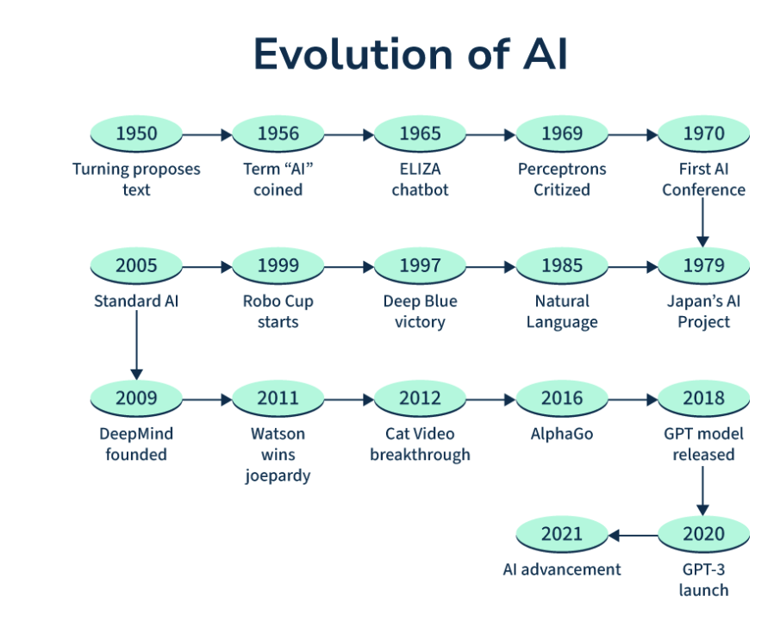

Fig 1: Evolution of AI

III. ROLE OF AI IN NEW AGE SMART INFRASTRUCTURE

* 1. *Applications of AI in Smart Health Infrastructure*

AI is a crucial component of the new age of smart infrastructure, particularly in healthcare. It facilitates automation, real-time decision-making, and seamless data integration. Some key roles AI plays in smart healthcare infrastructure include:

1. **Enhanced Data Processing:** AI can analyze vast amounts of patient data efficiently, improving diagnosis accuracy.
2. **Predictive Maintenance:** AI helps hospitals and healthcare centers maintain medical equipment by predicting failures before they occur.
3. **Remote Patient Monitoring:** AI-driven IoT devices continuously monitor patients, reducing hospital visits.
4. **Smart Hospital Management:** AI optimizes hospital resource allocation, scheduling, and patient management.
5. **AI-Enabled Robotics:** Robotic surgeries and AI-assisted medical procedures enhance precision and efficiency in treatment.

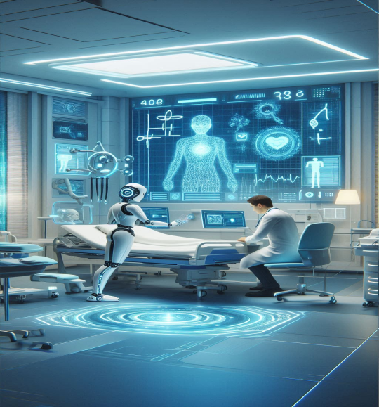

Fig 2: AI in Healthcare

* 1. *Advantages*

1. **Enhanced Healthcare Efficiency**: AI-driven automation improves hospital management, optimizes resource allocation, and enhances patient monitoring. Predictive analytics reduces hospital readmissions by identifying high-risk patients early.
2. **Improved Patient Safety and Emergency Response**: AI-powered user detection systems provide real-time monitoring of vital signs and trigger alerts in case of medical emergencies. AI enhances women’s safety through GPS tracking, automated alerts, and distress signal mechanisms.
3. **Cost Reduction and Accessibility**: AI-integrated telemedicine reduces healthcare costs by enabling remote consultations and diagnostics. AI-powered chatbots provide instant healthcare advice, reducing dependency on physical consultations.
4. **Integration with Emerging Technologies**: AI combined with IoT and 5G enables seamless real-time data sharing and remote monitoring. Blockchain-based AI ensures secure and transparent medical data management.
   1. *Disadvantages*
5. **Data Privacy and Security Risks**: AI systems collect large amounts of sensitive patient data, making them vulnerable to cyber threats and unauthorized access. Ensuring compliance with global data protection regulations remains a challenge.
6. **Algorithm Bias and Ethical Concerns**: AI models trained on biased datasets can lead to inaccurate predictions and disparities in healthcare outcomes. Ethical concerns arise over AI-driven decision-making, particularly in critical medical situations.
7. **Regulatory and Legal Barriers**: AI implementation in healthcare is subject to varying regulations across countries, hindering widespread adoption. The lack of standardized AI frameworks for healthcare applications complicates approval processes.
8. **Integration with Traditional Healthcare Systems**: Healthcare professionals require proper training to effectively use AI tools, increasing the learning curve.

IV. RELATED WORK

Several studies have explored the application of AI in healthcare. Research in predictive analytics has shown significant improvements in disease diagnosis and early detection. For instance, deep learning models have been used to detect diabetic retinopathy with higher accuracy than traditional diagnostic methods. AI-based chatbots are being implemented for mental health support, providing real-time assistance to users experiencing stress and anxiety. Emergency response AI has been deployed in wearable technology, allowing automatic detection of distress signals and immediate alert transmission. Despite advancements, there is a gap in integrating these technologies into a cohesive smart healthcare infrastructure [3][6].

V. FEASIBILITY OF AI IN NEW AGE SMART INFRASTRUCTURE

1. **Technological** **Feasibility:** AI-driven healthcare solutions are technologically viable due to advancements in machine learning, IoT, and cloud computing. The integration of AI with wearable devices, smart sensors, and blockchain enhances security, reliability, and efficiency in medical diagnostics and emergency response. AI-powered health prediction models have demonstrated high accuracy in disease detection and treatment recommendations, proving their effectiveness in real-world applications.
2. **Economic Feasibility:** AI reduces healthcare costs by minimizing hospital visits, optimizing resource allocation, and automating administrative tasks. The initial implementation of AI infrastructure may require substantial investment, but long-term benefits such as cost savings, increased efficiency, and improved patient outcomes make it economically viable. The growing adoption of AI-powered telemedicine and remote patient monitoring services reduces the burden on healthcare facilities while making medical services more accessible [5].
3. **Operational Feasibility:** AI-driven smart infrastructure can be seamlessly integrated with existing healthcare systems, improving efficiency and decision-making. AI-powered emergency response and women’s safety features enhance security and provide real-time alerts, ensuring practical usability. Healthcare professionals and users require training to effectively utilize AI applications, but user-friendly AI interfaces and automation simplify operational challenges.
4. **Social Feasibility:** AI-driven healthcare solutions enhance accessibility, particularly in remote and underserved areas, by enabling telemedicine and remote diagnostics. AI applications for stress management, emergency response, and women’s safety increase public trust and acceptance of smart healthcare technologies. Continuous awareness programs and user education can help overcome resistance to AI adoption, ensuring a smooth transition into AI-powered healthcare systems [2].



Fig 3: Feasibility

VI. AI BASED HEALTH PREDICTION SYSTEM

AI-driven health prediction systems analyze patient data to predict potential health risks. These systems utilize machine learning models trained on datasets containing vital parameters such as glucose levels, BMI, and blood pressure. The implementation of AI in health prediction includes:

1. **User Input Prediction:** AI models process user-provided health data to generate predictions and recommendations.
2. **Health Tips & Chatbots:** AI-based chatbots assist users by providing healthcare tips, diet plans, and standard medical guidelines.
3. **Doctor’s Recommendation System:** AI suggests possible treatments and connects users with medical professionals based on predictive analysis.

VII. USER DETECTION AND EMERGENCY RESPONSE

AI-powered user detection systems play a crucial role in ensuring patient safety and emergency handling. These systems are designed to:

1. **Detect Symptoms in Real-Time:** AI monitors health parameters such as heart rate to detect abnormalities.
2. **Trigger Alarms:** When irregular health patterns are detected, system can trigger an emergency alert.
3. **Automated Emergency Contacting:** AI systems can send messages, and share live locations with emergency contacts or healthcare providers in case of medical distress.

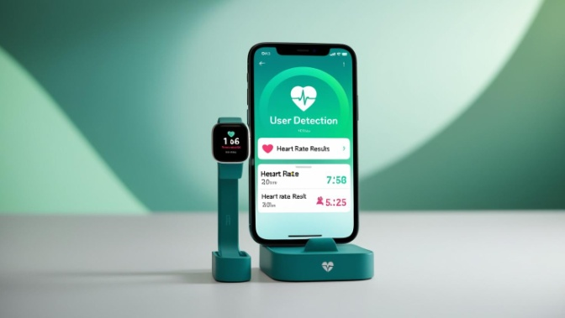

Fig 4: User Detection

VIII. WOMEN SAFETY

AI plays a vital role in enhancing women’s safety by providing advanced security features such as:

1. **AI-Enabled Emergency Alerts:** Devices allow users to send distress signals.
2. **Live GPS Tracking:** AI-integrated GPS tracking ensures that a user’s location is continuously monitored and shared with trusted contacts.
3. **Automated Alert:** If a critical situation is detected, AI systems can directly alert to the emergency contacts, ensuring immediate assistance.



Fig 5: Women Safety

IX. CURRENT SCENARIOS AND CHALLENGES

The adoption of AI in healthcare is growing, with hospitals and clinics implementing AI-powered diagnostic tools and virtual assistants. However, challenges such as data privacy, regulatory compliance, and algorithm biases hinder widespread deployment. Ensuring the security of sensitive patient data is a primary concern, as cyber threats continue to pose risks to healthcare institutions. Moreover, the integration of AI with traditional healthcare systems requires extensive validation and adaptation to ensure accurate and ethical use of AI.

X. TECHNOLOGY BASED ON NEW AGE INFRASTRUCTURE

1. **Cloud Computing in Healthcare:** Cloud-based AI platforms provide scalable computing power to analyze medical data efficiently.
2. **Blockchain for Data Security:** AI integrated with blockchain technology ensures data integrity and prevents unauthorized access.
3. **5G and IoT Integration:** The use of 5G technology enhances real-time monitoring and communication in smart hospitals.
4. **Edge AI Computing:** AI models embedded in wearable devices enable real-time health tracking without relying on cloud computing.



Fig 6: Cloud Computing

XI. FUTURE ASPECTS

The future of AI in healthcare aims to enhance personalization and accessibility. Advancements in AI algorithms will allow for more precise disease prediction and treatment recommendations. AI-powered robotic surgeries and virtual healthcare assistants are expected to redefine patient care, making medical services more efficient and widespread. Additionally, the integration of AI with blockchain technology could improve data security, ensuring patient information remains protected. Future research will focus on minimizing AI biases, improving model transparency, and creating AI-driven healthcare solutions that cater to diverse populations [6][1] .

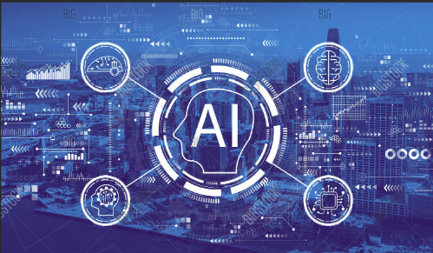

Fig 7: Artificial Intelligence

XII. CONCLUSION

AI-driven healthcare infrastructure is transforming medical diagnostics, stress management, emergency response, and women’s safety. By leveraging AI, healthcare systems can become more predictive, responsive, and efficient. The continued evolution of AI in healthcare promises improved patient care and safety, making healthcare smarter and more accessible. As AI continues to develop, its ethical implementation and seamless integration with healthcare practices will remain key areas of focus.

ACKNOWLEGEMENT

The authors sincerely thank their colleagues and professors at M.H. Saboo Siddik Polytechnic for their valuable insights and support throughout this research. Special appreciation goes to the Department of Information Technology for providing the necessary resources and a supportive environment that greatly contributed to the success of this study.

REFERENCES

1. Rahul Kejriwal; Mohana - Artificial Intelligence (AI) in Medicine and Modern Healthcare Systems. ISBN Information: Electronic ISBN:978-1-6654-8962-1 DOI: 10.1109/ICAISS55157.2022.10010939
2. "AI in Healthcare: A Primer." Stanford Medicine. [https://online.stanford.edu/programs/artificial intelligence-healthcare.](https://online.stanford.edu/programs/artificial%20intelligence-healthcare.)
3. "The Role of Artificial Intelligence in Health Care: A Review." Journal of Medical Internet Research [https://link.springer.com/article/10.1186/s12911 021-01488-9.](https://link.springer.com/article/10.1186/s12911%20021-01488-9.)
4. "AI in Health: How Artificial Intelligence is Reshaping the Future of Healthcare." Harvard BusinessReview. [https://nihcm.org/publications/future-of ai#:~:text=Health%20outcomes%20could%20improve%20by,Harvard%20School%20of%20Public% 20Health\](https://nihcm.org/publications/future-of%20ai%23:~:text=Health%20outcomes%20could%20improve%20by,Harvard%20School%20of%20Public%25%2020Health/)
5. Jimma BL (2023-01-16). "[Artificial intelligence in healthcare: A bibliometric analysis](Artificial%20intelligence%20in%20healthcare:%20A%20bibliometric%20analysis)". Telematics and Informatics Reports. 9: 100041. doi:10.1016/j.teler.2023.100041.

Email: [balegesse@gmail.com](mailto:balegesse@gmail.com)

1. Liyanage H, Liaw ST, Jonnagaddala J, Schreiber R, Kuziemsky C, Terry AL, et al. (August 2019). "[Artificial Intelligence in Primary Health Care: Perceptions, Issues, and Challenges](Artificial%20Intelligence%20in%20Primary%20Health%20Care:%20Perceptions,%20Issues,%20and%20Challenges)". Yearbook of Medical Informatics. 28 (1): 41–46. doi:10.1055/s-0039-1677901. PMC 6697547. PMID 31022751.

Email[h.s.liyanage@surrey.ac.uk](mailto:h.s.liyanage@surrey.ac.uk)