**IoT BASED PORT MANAGEMENT SYSTEM**

**Nishanth Augustine1, Athmana M2, Deva Nanda S N3, Gopika S Gopan4, Shwetha Roy5**

1Assistant Professor, Department of ECE, LBSITW (Affiliated to APJ KTU)

2,3,4,5B. Tech Student, Department of ECE, LBSITW (Affiliated to APJ KTU)

**ABSTRACT**

The exponential growth of global trade and shipping has necessitated the development of intelligent and efficient port management systems capable of handling increasing volumes of containers, ships, and cargo. Traditional port management systems rely on manual processes, fragmented data, and lack real-time visibility, leading to inefficiencies such as congestion, delays, increased costs, and environmental pollution. The growing complexity of global supply chains and the demand for sustainability further highlight the need for innovative solutions. This project proposes a smart port management system leveraging IoT, AI, and big data analytics to enhance operational efficiency, reduce environmental impact, and improve real-time data accessibility. The system integrates ship, container, and port operations, enabling real-time monitoring, predictive maintenance, automated container tracking, and data-driven decision-making. It facilitates real-time data exchange and predictive analytics to optimize port operations. The results demonstrate the system’s potential in transforming conventional port management by enhancing efficiency, sustainability, and resilience. This project provides valuable insights for policymakers, port operators, and industry stakeholders, contributing to the advancement of smart port systems. The successful implementation of such systems can significantly impact the global maritime industry, driving innovation and sustainable development in port operations.

**Keywords**: Smart Port, IoT, AI, Big Data Analytics, Real-time Monitoring, Predictive Maintenance, Automated Container Tracking, Port Management, Sustainability, Supply Chain Optimization, Maritime Industry.

1. **INTRODUCTION**

The rapid increase in the global trade and the increasing complexity of modern supply chains have claimed an urgent need for more intelligent and efficient port management systems. Traditional port operations are likely to be damaged by inefficiencies like delays in container handling, inaccuracy in berth allocation, and inefficient real-time tracking of important environmental conditions within the containers. These challenges lead to huge operational costs, compromised security, and reduced customer satisfaction, and ultimately have an effect on overall maritime logistics efficiency. As global trade volumes continue to rise, the ports must satisfy with the leading-edge technologies in order to achieve smooth and sustainable operations.

The Smart Port Management System proposed here surmounts these challenges through the integration of Internet of Things (IoT) technology, advanced sensors, and real-time data processing in order to enhance efficiency, security, and decision-making in port operations. The system focuses on three key domains of port management: container monitoring, ship guidance, and berth allocation. In the container management part, IoT sensors monitor environmental conditions such as temperature, humidity, and smoke in containers in real-time thereby ensuring cargo safety and quality during shipping. For ship management, features such as GPS-based real-time tracking, water level sensing, obstacle detection, and an emergency alert system is made available through a mobile app to enhance navigation security and emergency response. In port management, berth availability is detected by ultrasonic sensors, optimizing berth allocation and thereby reducing the docking delays in a web-enabled real-time monitoring system.

Its primary aims are the implementation of a real-time monitoring mechanism to help to ensure the safeguarding of ships and commodities, automation in berth allocation helps to improve operational efficiency, and the establishment of an easy-to-use mobile and web interface to facilitate effective communication among ships and authorities in the ports. Through the use of IoT and real-time data analysis, this port management system is set for the transformation of conventional port operations into more efficient, smooth, and sustainable ones and contribute to the overall development of smart maritime logistics.

1. **SYSTEM DESIGN**

**2.1 CONTAINER MANAGEMENT SYSTEM:**

The container management system mainly aims to maintain the environmental conditions and ensure the safety of goods. It uses DHT11 sensor to monitor temperature and humidity levels within the containers thereby providing real-time data to prevent damage. The MQ5 gas sensor is also integrated to detect the presence of harmful gases, which can detect gas leaks and can prevent fire hazards. Data from these sensors are collected by the ATmega328 microcontroller, which processes and sends the information to a central Firebase cloud-based system via the NodeMCU ESP8266 Wi-Fi module. This ensures continuous, real-time monitoring of the container's internal conditions and alerts stakeholders to potential hazards.

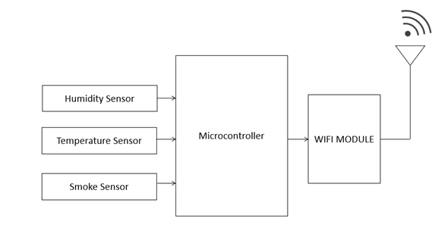

**2.2 SHIP MANAGEMENT SYSTEM:**

The ship management system gives all the information needed to sail the ship safely and prevent collisions. The NEO6M GPS module provides real-time location tracking of the ship. The HCSR04 ultrasonic sensor detects obstacles in front of the ship which help to avoid collisions with nearby objects. A water level sensor is used to measure the depth of the water underneath the ship. The ATmega328 microcontroller processes all the sensor data and sends it to a cloud-based platform for monitoring. This makes ship management easier and safer.

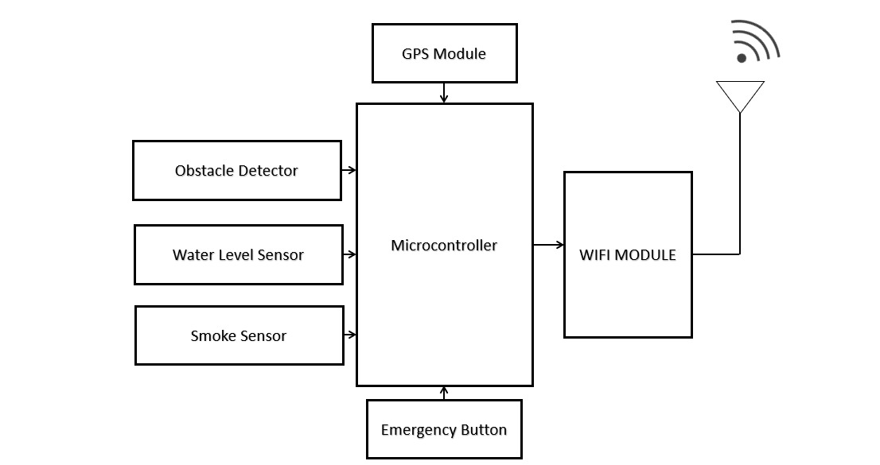

**2.3 PORT MANAGEMENT SYSTEM:**

The port management system detect berth availability and allocates dock spaces optimally, which optimizes port operations. Ultrasonic sensors are integrated within the berths to sense ship proximity and indicate berth availability. When a ship is approaching, these sensors collect data and transmit it to a central cloud-based system, enabling port authorities to allocate docking spaces. The system facilitates resource allocation and minimizes delays, improving the performance of port operations. The data processed is shown on web and mobile app, making it easily accessible to port authorities.

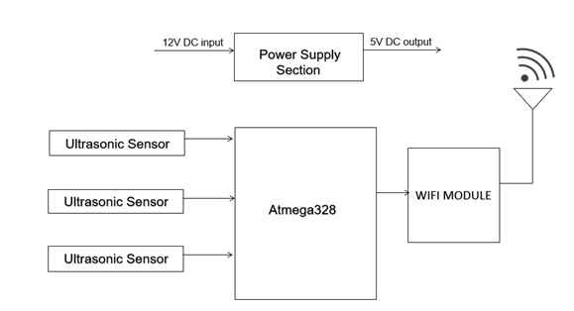

1. **METHODOLOGY**

**3.1 DESCRIPTION OF THE HARDWARE AND SOFTWARE**

The Smart Port Management System uses a combination of hardware components and software platforms to enable seamless real-time monitoring, decision-making, and operational efficiency. The system's architecture consists of microcontrollers, sensors, IoT modules, power supply components, and software platforms for firmware development, IoT integration, and user interfaces.  
In the hardware framework, microcontrollers form the base for data processing and communication. The ATmega328 and ATmega2560 microcontrollers are used for managing sensor inputs, processing data, and controlling the operations in real time. These microcontrollers are chosen for their sufficient input and output pins, improved processing capabilities, and compatibility with multiple sensor modules. The Wi-Fi module, ESP8266 is combined for the wireless data transmission to the cloud to allow IoT based monitoring.

A range of sensors is used for monitoring key parameters across the port, ship, and container environments. The DHT11 sensor measures temperature and humidity inside containers to ensure cargo safety. To detect fire hazards, an MQ2 gas sensor identifies the presence of smoke or hazardous gases. The ultrasonic sensor (HCS4R04) is utilized for berth availability detection at the port and obstacle detection on ships, enhancing navigational safety. A water level sensor is employed to measure ocean depth, assisting in safe sailing. A GPS module (NEO6M) provides real time tracking of ship locations, enabling precise route optimization and monitoring.

To support IoT connectivity, the NodeMCU module, which integrates the ESP8266 Wi-Fi module, is used to establish a connection between the sensor nodes and the Firebase real-time database. This system allows continuous data transmission for real-time monitoring. A 12V to 5V DC converter powers the hardware components and thereby attaining stability and efficiency.

The software architecture is designed to facilitate firmware development, cloud connectivity, and user interaction. Embedded C programming is used to integrate the microcontrollers and sensors for data acquisition and processing. Arduino IDE and Visual Studio Code act as development platforms for firmware programming, debugging, and uploading code to the microcontrollers.  
For IoT implementation, Firebase is used as the real time cloud database, providing efficient data storage, recover, and synchronization across multiple devices. The mobile and web applications form the user interface for system interaction. A Flutter based mobile application which is developed using Dart, provides ship captains with real-time ship monitoring, emergency alert transmission, and berth availability tracking. At the same time, a web based application built using the Streamlit framework enables port authorities to monitor berth availability, track container conditions, and manage real-time alerts. The incorporation of Python and HTML within Streamlit allows a dynamic and interactive user experience, for perfect system control and decision-making

**3.2 MICROCONTROLLERS AND IOT PLATFORM INTEGRATION.**

The ESP8266 microcontroller plays a crucial role in enabling wireless IoT communication within the system. As a low cost, low power microcontroller, the ESP8266 is responsible for making connections between the sensor modules and the cloud database. It ensures that sensor readings, including temperature, humidity, GPS location, and obstacle detection, are transmitted in real time for effective monitoring and decision making. The microcontroller communicates with Firebase providing effective data exchange and updates

Firebase, a cloud-based real-time database, acts as the central hub for sensor data storage and management. Its NoSQL architecture ensures scalability, allowing for future expansions with additional sensors and devices. Firebase allows quick data updates and making the real time information available on both mobile and web app, thereby taking appropriate actions by the port authorities and the ship captains. The integration with the Firebase using ESP8266 provides low latency communication, enabling immediate response to berth availability status, emergency alerts, and container conditions. Additionally, Firebase enables automated alert notifications, ensuring that port authorities and ship operators receive critical updates on berth allocation and safety concerns.

By using improved combination of hardware components, IoT enabled communication, and cloud-based data management, the Smart Port Management System offers a strong, scalable solution for efficient port operations.

1. **RESULT**

The smart port prototype has been successfully developed and tested, integrating IoT-based container, ship, and port management systems. The functionality of each module has been tested through real time reading from sensors and by analyzing system performance .  
  
**5.1 CONTAINER MONITORING SYSTEM**  
The container module included a temperature and humidity sensor (DHT11), a smoke sensor (MQ2/MQ60), and a Wi-Fi-enabled microcontroller (ESP8266) for real-time data transmission. Sample sensor readings collected during testing are as follows:

|  |  |  |  |
| --- | --- | --- | --- |
| **Parameter** | **Observed Value** | **Threshold Value** | **Status** |
| Temperature | 28.5°C | < 35°C | Normal |
| Humidity | 60% | < 80% | Normal |
| Smoke Level | 150 ppm | < 300 ppm | Safe |

The data was successfully transmitted to the Firebase database and displayed in the web application, ensuring real-time monitoring and alert generation.

**5.2 SHIP MANAGEMENT SYSTEM**

The ship module was equipped with a GPS module for real time tracking, an ultrasonic sensor for obstacle detection, a water level sensor for measuring depth, and an alert system for sending emergency messages to port and ship's captain . The key findings include:

**GPS Tracking**: The ship's location in real time was shown on the web app.

**Obstacle Detection**: The ultrasonic sensor identified obstacles with a precision of 50 cm and sent out alert messages.

**Water Level Sensor**: Readings were recorded at various points to ensure navigation safely.

**Emergency Alerts**: On pressing the emergency button, an instant alert was sent to the port authorities through the mobile app.

**5.3 PORT BERTH MANAGEMENT SYSTEM**

The port management system used ultrasonic sensors (HCSR04) to identify berth availability. The following results were obtained:

|  |  |  |
| --- | --- | --- |
| **Berth Number** | **Distance Measured** | **Availability Status** |
| Berth 1 | 250 cm | Occupied |
| Berth 2 | 400 cm | Available |
| Berth 3 | 380 cm | Available |

The data was successfully processed and shown in the web application, enabling port authorities to make real-time docking decisions.  
  
**5.4 SYSTEM PERFORMANCE AND RELIABILITY**

The system has been tested against different environmental conditions and the following observations were made:  
**Accuracy**: The sensors maintain an average accuracy of a maximum of ±2%, thus enabling believable monitoring.  
**Response Time**: The data transmitted through IoT has a delay of not more than 3 seconds.  
**Real-Time Monitoring**: The web and mobile applications showcased the sensors' readings in real-time with no observable delay.

**5.5 IMAGES OF THE PROTOTYPE**

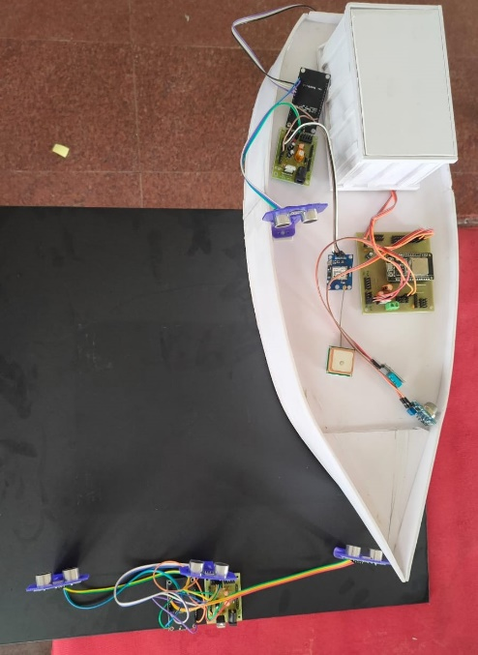

Final prototype

The final prototype effectively demonstrated a functioning smart port management system, integrating IoT for real-time monitoring; automation, and increased efficiency of operations.

1. **CONCLUSION**

The implementation of an integrated ship, container and port management system ensures efficient, secure, and sustainable port operations. By using IoT and automation, smart port allows optimized resource management and ensure real time monitoring of environmental parameters such as temperature, pressure, humidity, smoke etc. These advancement results lead to a more sustainable shipping industry, thereby improving overall productivity and operational efficiency. Additionally, smart port solution reduces congestion, human errors and can also minimize delays than that of traditional port management systems. As global trade increases, adopting such automation systems plays a crucial role in reducing environmental impact and maintain competitiveness in maritime industries.

1. **REFERENCE**
2. Kamolov, A., & Park, S. (2019, November 26). "An IoT-based ship berthing method using a set of ultrasonic sensors." *International Journal of Smart Port Research*, 14(2), 45-52.
3. Al-Fatlawi, H. A., & Motlak, H. J. (2023). Smart ports: towards a high performance, increased productivity, and a better environment. *International Journal of Electrical & Computer Engineering (2088-8708)*, *13*(2).
4. Yau, K. L. A., Peng, S., Qadir, J., Low, Y. C., & Ling, M. H. (2020). Towards smart port infrastructures: Enhancing port activities using information and communications technology. *Ieee Access*, *8*, 83387-83404.
5. Yang, Y., Zhong, M., Yao, H., Yu, F., Fu, X., & Postolache, O. (2018). Internet of things for smart ports: Technologies and challenges. *IEEE Instrumentation & Measurement Magazine*, *21*(1), 34-43.
6. Hahn, A., & Faculty of Informatics. "Sensor integration for ship motion analysis." *Journal of Sensor Technologies*, 11(3), 67-78.
7. Karaś, A. (2020). Smart port as a key to the future development of modern ports. *TransNav: International Journal on Marine Navigation and Safety of Sea Transportation*, *14*(1).
8. Zhang, Y., Yang, K., & Wang, J. (2022). "Digital twin-enabled smart maritime logistics management in the Industry 4.0 era." *IEEE Transactions on Industrial Informatics*, 18(8), 5648-5657.
9. Panagopoulos, Y., Papadopoulos, A., Poulis, G., Nikiforakis, E., & Dimitriou, E. (2021). "Assessment of an ultrasonic water stage monitoring sensor operating in an urban stream." *Sensors*, 21(14), 4689.
10. Salah, K., Alfalasi, A., Alfalasi, M., Alharmoudi, M., Alzaabi, M., Alzyeodi, A., & Ahmad, R. W. (2020, January). "IoT-enabled shipping container with environmental monitoring and location tracking." In *2020 IEEE 17th annual consumer communications & networking conference (CCNC)* (pp. 1-6). IEEE.