**SURVEILLANCE ROBOT USING VIRTUAL TELEPRESENCE**

**Prof Mohammed Shaffi J1, Anarkha A2, Ardra S Nair3, Athulya C Kumar4, Karthika Sunil5**

1Assistant Professor, Department of ECE, LBSITW (Affiliated to APJ KTU)

2,3,4,5B. Tech Student, Department of ECE, LBSITW (Affiliated to APJ KTU)

**ABSTRACT**

Ensuring safety in chemical gas industries requires effective monitoring and spontaneous response to hazardous gas leakage. This proposal presents a novel virtual telepresence robot system for increasing safety and surveillance in chemical gas industries. The system focuses on the critical need for rapid and effective hazardous gas leakage detection and response, minimizing human exposure to dangerous environments. This consists of a network of gas sensors connected to an ESP8266 Wi-Fi module, which continuously checks the environment for harmful gases. When a leakage or abnormal gas concentration is detected, the ESP8266 sends an alert message to the operator through Raspberry Pi. This real-time alert message activates the telepresence functionality of the system. An operator who is situated remotely away from the hazardous area, can then take control of a mobile robot equipped with a camera and communication tools to the hazardous area. This operation allows the operator to visually inspect the affected area, thereby evaluates the severity of the leakage, and collect information without entering the dangerous environment. The combination of real-time gas detection and remote robotic navigation system significantly enhances industrial safety protocols. This approach not only improves the speed and efficiency of monitoring but also facilitates risk management by providing operators with timely information to make decisions and take appropriate actions, eventually minimizing the risk of accidents and safeguarding personnel. The proposal outlines the system's architecture, including the sensor network, communication protocols, and robotic platform, and explores its potential effects on industrial safety practices.

**Keywords:** Virtual Telepresence, surveillance, ESP8266, Raspberry Pi, gas detection.

1. **INTRODUCTION**

Chemical gas industries usually deal with dangerous chemicals that can pose serious threats to workers and infrastructure. Gas leaks or exposure to poisonous atmospheres, if not detected, can result in serious health complications, operational shutdowns, and dangerous accidents. Conventional gas detection systems give warnings, but they tend to need human action for additional inspection, putting workers at risk of harm. To meet this challenge, the incorporation of telepresence robotics with gas detection technology is a safer and more effective approach. A telepresence robot mounted with gas sensors can independently survey industrial settings, identify toxic gases, and alert operators in real-time. It also offers live video streaming using the assistance of VR headset and camera integrated into the Raspberry Pi. Raspberry Pi is the central processing unit of our robot that is interfaced with servo motor, GPS and gas sensor. The robot movement is controlled using an Atmega328p microcontroller. In case a dangerous situation is detected, the operator can steer the robot remotely to the point of danger, perform real time visual inspection and determine the magnitude of the danger without exposure to toxic gases. This system improves industrial safety by minimizing human intervention in danger zones and facilitating real-time monitoring and decision-making. With the integration of gas sensing technology with Bluetooth controlled robot, this system seeks to enhance workplace safety, reduce risks, and enhances operating efficiency in chemical gas industries.

1. **PROBLEM STATEMENT**

Factories, laboratories, and enclosed environments like underground tunnels and storage facilities are usually prone to leaks of poisonous gases, which may result in severe health threats, explosion, or ecological injury. Physical inspection of these locations is unsafe and cumbersome, risking lives of people. To solve this problem, a Surveillance Robot with Virtual Telepresence for Gas Leakage Detection is introduced. The robot will move autonomously in industrial spaces, identify dangerous gas leaks with onboard sensors, and send real-time video and data transmission to a remote operator through virtual telepresence. The system is intended to increase safety by facilitating remote monitoring, limiting human exposure to toxic gases, and allowing fast response to potential threats. This project aims at developing and applying a robotic system with gas sensors, a camera module, and wireless communication for enhancing industrial efficiency and safety.

1. **SCOPE AND RELEVANCE**

Industrial gas leakage causes serious risks to workers, infrastructure, and the environment, requiring immediate detection and response. A Surveillance Robot with Virtual Telepresence can increase safety by navigating to hazardous areas, detecting gas leakages, and providing real-time video and sensor data to remote operators. With the help of gas sensors, cameras, and wireless communication, the robot can identify leakages, evaluate risk levels, and transmit live video feeds for situational awareness. The virtual telepresence feature allows operators to remotely control the robot, inspect areas visually, and make decisions without causing personnel dangerous situations. This system improves industrial safety, thereby reduces human exposure to toxic environments, and enables quick emergency response.

1. **OBJECTIVE**

The primary objective of this virtual telepresence robot system is to improve safety and monitoring in chemical gas industries by facilitating quick detection and remote inspection of dangerous gas leaks. This general aim can be divided into a number of major objectives:

* Real-time Hazardous Gas Detection: To monitor continuously the environment for the presence and level of toxic gases via a sensor network and to give prompt notifications on detection of anomalies.
* Minimization of Human Exposure: To minimize the requirement for people to access potentially hazardous zones by offering remote inspection and evaluation capabilities.
* Remote Visual Inspection: To allow operators to remotely drive a mobile robot with a camera to visually inspect the damaged area and collect vital information regarding the leak.
* Improved Response Time: To ensure quick action on gas leaks by providing real-time alerts and remote visualization of the affected area, facilitating immediate intervention and mitigation efforts.
* Enhanced Monitoring Effectiveness: To improve the efficiency of industrial monitoring through automated gas detection and a centralized platform for control and oversight.
* Active Risk Management: To aid in proactive risk management by delivering timely information to operators, enabling informed decision-making and appropriate actions to prevent incidents from escalating and to minimize potential damage.
* Technological Integration: Merging gas detection technology, wireless communication, and robotics into a cohesive system to boost safety and surveillance.

1. **METHODOLOGY**

The surveillance robot is designed to operate in hazardous or restricted environments using virtual telepresence and real-time monitoring. This system integrates Raspberry Pi, ESP8266 (Wi-Fi module), gas sensors, GPS, camera, and a VR headset, allowing remote users to control and navigate the robot effectively. The primary objective is to detect hazardous gases, send alerts, and enable users to navigate the robot towards the incident location for real-time assessment and response.

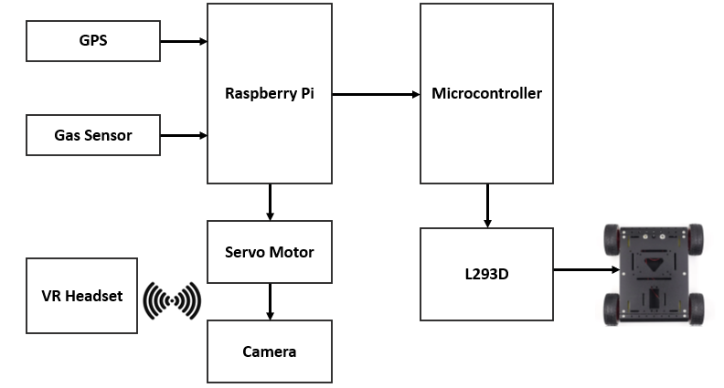

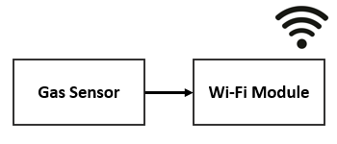

The surveillance robot consists of multiple interconnected components. The Raspberry Pi serves as the central processing unit, managing video streaming, sensor data, and user communication. The ESP8266 Wi-Fi module is responsible for receiving gas sensor data and transmitting alerts to the Raspberry Pi. The gas sensor continuously monitors air quality, triggering an alert when dangerous gases are detected. A camera module provides real-time video streaming, which is displayed in a VR headset for immersive remote monitoring.

For movement, the robot is equipped with an L293D motor driver, which controls the motors, allowing navigation based on user inputs. A servo motor is used to adjust the camera angle, improving the field of view. The GPS module tracks the robot’s real-time location, enabling precise movement control. Communication is handled wirelessly through Wi-Fi, ensuring seamless data transmission between the user and the robot.

**Working Methodology**

The process of the surveillance robot starts with gas detection and sending alerts. The gas sensor, attached to the ESP8266 Wi-Fi module, continuously senses the air quality. When a toxic gas is detected, the ESP8266 triggers an alert to the Raspberry Pi, which further processes the alert and sends a notification to the user through a remote interface. This helps ensure that the user is instantly alerted to any threats. The user can then choose to move the robot towards the location of the incident once they get the alert from the Raspberry Pi. The robot is operated remotely by the user via a web-based or mobile platform, which sends motor movement instructions to the microcontroller powering the L293D motor driver. The motors move the robot towards the incident location in a safe and efficient manner. As the robot travels, real-time video images are transmitted by the camera to the VR headset, and the user is given an immersive sight of the environment. The headset contains motion sensors, including a gyroscope and accelerometer, which pick up on the user's head movement in real-time. These movement signals are then wirelessly sent to the Raspberry Pi, which interprets the input and sends respective control signals to the servo motor fitted to the camera. When the user tilts their head to the left, right, top, or bottom, the robot-mounted camera accordingly changes its position and orientation automatically, giving an uninterrupted, live view of the surroundings. The battery is interfaced with the dc voltage sensor and the data is gathered using the microcontroller, giving battery level monitoring.

1. **COMPONENTS REQUIRED**

**6.1 HARDWARE COMPONENTS:**

* **Raspberry Pi 3** acts as the main processing unit. It coordinates data flow between the GPS, camera, Wi-fi module, and VR headset.
* **Atmega328p** interfaces with the L293D motor driver, sending signals to control the direction and speed of the DC motors. This allows the robot to move forward, backward, and turn as commanded.
* **VR headset** Simulates real-time visual presence in the robot’s location
* **USB Camera** is connected to Raspberry Pi via servo motor to provide real time video streaming.
* **Bluetooth module**: Connect to the microcontroller for controlling the movement of the robot through a mobile app.
* **ESP8266:** It is a low-cost Wi-Fi microcontroller used to send alert messages to the user.
* **Voltage sensor** measures the battery voltage by converting it into a proportional electrical signal, which is then processed and output as a digital or analogue representation of the battery's state of charge.
* **L293D motor driver** enables robot movement by controlling the direction and speed of DC motors, allowing for forward, backward, left, and right movements through PWM (Pulse Width Modulation) signals from a microcontroller.
* **MQ-2 gas sensor** detects combustible gases, such as LPG, propane, and hydrogen, by changing its electrical resistance in response to gas concentrations, sending an analogue output signal to a microcontroller for further processing.

**6.2 SOFTWARE:**

* **Raspbian OS** is a Linux-based operating system optimized for the Raspberry Pi hardware, providing a user-friendly interface and support for programming languages.
* **Python**: The primary programming language used for Raspberry Pi which is pre-installed in the Raspbian OS. Used for developing the control logic, sensor management, and camera functionalities.
* **Arduino IDE (Arduino Integrated Development Environment)** is used to program the microcontroller. It is used for movement of robot and reading voltage sensor value.

**Streaming:**

In the surveillance robot project, two distinct code segments collaborate to facilitate real-time communication and monitoring through video streaming and data reception. The first segment employs Flask and OpenCV to establish a real-time video streaming system from the robot’s camera. The generate_frames() function captures frames from a USB camera using OpenCV’s VideoCapture(0) method. Each frame is encoded in JPEG format and converted into bytes for continuous streaming. The Flask route /video_feed serves this stream, ensuring a smooth and uninterrupted feed. A simple web page is rendered through the root route (/), showcasing the live video with an HTML <img> tag that continuously retrieves frames from the /video_feed endpoint. This configuration allows the operator to remotely monitor the robot’s surroundings via a web browser, providing real-time video access with minimal latency. The second segment sets up a UDP communication system using Python’s socket library. It initializes a UDP socket to receive data transmitted over the network, binding to a specific IP address (192.168.1.40) and port (5555). The socket is configured to permit address reuse and broadcast reception for flexible and efficient communication. The code listens for incoming data packets in an infinite loop using the recvfrom() method Each message is printed to the console with a slight delay to optimize processing. In the project, this code enables real-time reception of control commands, GPS data, or sensor information, ensuring seamless communication between the robot and the remote controller.

1. **RESULT**

The telepresence robot, built based on virtual telepresence technology, was shown to have efficient operation in far-field monitoring and control. The two core parts of the system include the robotic component and the interface, which are well-designed to work in harmony with each other. The robot has a four-wheeled platform that is equipped with a GPS module and a video camera to monitor the environment in real-time. The users can monitor the position of the robot and guide its movement via a smartphone interface. The camera system provided live video streaming with little latency, giving clear image for effective monitoring. The system exhibits good potential to be used in dangerous zones, offering real-time monitoring where a human presence is impossible.

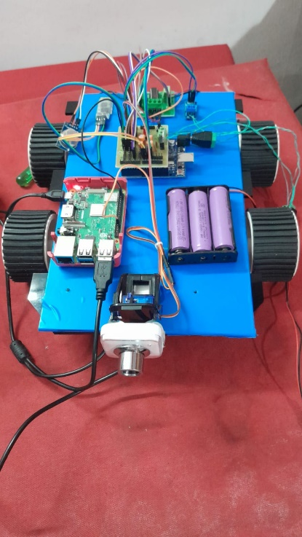

*Final Prototype*

1. **CONCLUSION**

The virtual telepresence surveillance robot is a novel solution to surveillance of risky environments, with real-time remote control, immersive visualization, and automatic gas detection. The integration of Raspberry Pi, ESP8266, gas sensors, a camera, and a VR headset makes the system effective for efficient hazard detection and quick situational awareness, minimizing the dangers involved in human intervention within risky locations. The synchronized camera movement with the VR headset provides user-friendly control, while the GPS module supports accurate navigation. The system is highly reliable and adaptive, and hence it can be applied in industrial safety, disaster relief, and surveillance. In the future, AI-based anomaly detection, autonomous navigation, and multi-sensor fusion can be added to further improve its features. The advocated solution helps in promoting robotics, IoT, and telepresence technologies towards more intelligent and efficient surveillance solutions.

1. **REFERENCE**
2. Pushpa, S. Ewins Pon, et al. "IOT Based Virtual Telepresence Robot." *2024 Third International Conference on Intelligent Techniques in Control, Optimization and Signal Processing (INCOS)*. IEEE, 2024.
3. Meddeb, Houda, Zouhaira Abdellaoui, and Firas Houaidi. "Development of surveillance robot based on face recognition using Raspberry-PI and IOT." *Microprocessors and Microsystems* 96 (2023): 104728.
4. Du, Jianhao, Ha Manh Do, and Weihua Sheng. "Human–robot collaborative control in a virtual-reality-based telepresence system." *International Journal of Social Robotics* 13.6 (2021): 1295-1306.
5. Dhanraj, Akshaya. "Virtual Telepresence Robot Using Raspberry Pi." *International Journal of Research in Engineering, Science and Management* 3.7 (2020): 365-368.
6. Bhadwal, N., Madaan, V., Agrawal, P., Shukla, A., & Kakran, A. (2019, April). Smart border surveillance system using wireless sensor network and computer vision. In *2019 international conference on Automation, Computational and Technology Management (ICACTM)* (pp. 183-190). IEEE.
7. Nayyar, Anand, et al. "Smart surveillance robot for real-time monitoring and control system in environment and industrial applications." *Information Systems Design and Intelligent Applications: Proceedings of Fourth International Conference INDIA 2017*. Springer Singapore, 2018.