**The future of laser therapy in physical rehabilitation**

**Toychieva A.A*1,Sunil Kumar Adelin Joanna*2,Raj Sowmiya*3, Rajan Sharma *4, Zain ul Abaden muhammad*5**

*1 Practical Teacher, department of physiotherapy, Madurai medical college, Madurai, Tamil nadu, India

*2 5th year student, Madurai medical college, Madurai, Tamil Nadu, India

*3 5th year student, Madurai medical college, Madurai, Tamil Nadu, India

*4 5th year student, Madurai medical college, Madurai, Tamil Nadu, India

*5 5th year student, Madurai medical college, Madurai, Tamil Nadu, India

**ABSTRACT**

Challenges and Barriers to the adoption of laser therapy in physio rehabilitation for future emerging trends. Cost and accessibility of advanced laser therapy also plays a major role in upcoming days. There will be a need for more Clinical research And regulatory approvals regarding this therapy is mandatory and also training requirements for physiotherapists to integrate with the new Laser technologies which can be used for Patients welfare.

**Keywords**: laser therapy , future, tissue regeneration, RICE protocol, Bio stimulation

**1. INTRODUCTION**

Laser therapy is a non-invasive treatment that uses focused light to promote healing, reduce pain, and accelerate recovery. How laser therapy is used these days (pain management, tissue repair, inflammation reduction).Types of laser therapy are as follows (Low-Level Laser Therapy - LLLT, High-Intensity Laser Therapy - HILT)[1] Effectiveness of these laser therapy by recent research shows a dynamical future. Emerging Technologies in Laser Therapy like AI and Smart Laser Devices; Wearable Laser Therapy; Multi-Wavelength Lasers; Integration with Robotics & Physiotherapy Machines are designed as per the convenience. [2] Advancements in Treatment using these Techniques like Bio stimulation Innovations for Faster recovery with enhanced cellular repair; Combining Laser Therapy with Regenerative Medicine which is Used in stem cell therapy and Platelet-Rich Plasma(PRP);Hybrid Physiotherapy Approaches in which Laser therapy is combined with electrotherapy, ultrasound, and manual therapy[10].

**2.RESULTS AND DISCUSSION**

**2.1Results**

Future Prospects and Potential use of laser therapy will be expected to be more in need conservatively[3]. How laser therapy might evolve in the next 10-20 years is predicted

based on the widespread use in hospitals, clinics, and home care in each country.

The possibility of laser therapy becoming a mainstream alternative to medication for pain management is highly recommended for the grand future.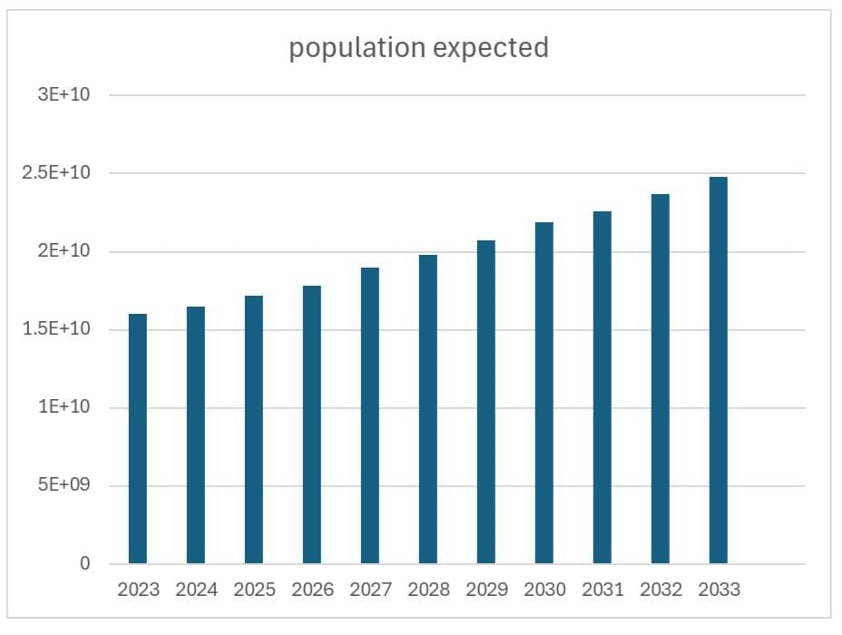

This flowchart shows the predictions of patients who are going to be an active part of laser therapy for the next 10 years.

**2.2Discussion**

Here comes a case study of a patient named David.A with Accelerated tissue regeneration using laser therapy in physiotherapy for partial Achilles Tendon tear due to a sports injury (football-related)[4].symptoms like sharp pain, swelling, stiffness, difficulty In walking and balancing was Seen. Previous Initial RICE protocol (Rest, Ice, Compression, Elevation)was made and NSAIDs for pain management was also given as a primary Treatment[5].

Case Study: Accelerated Tissue Regeneration Using Laser Therapy in Physiotherapy[6].Treatment Plan: David’s physiotherapist developed a comprehensive rehabilitation program integrating with Low-Level Laser Therapy. Laser Therapy Protocol:- Device Used is High-power Class IV laser .Wavelength: 809 nm for deep tissue penetration. Dosage: 6-11 J/cm² per session, targeting the Achilles tendon which was injured[9].Session Frequency: 4 times a week ;Duration: 7 weeks. Additional Rehabilitation Techniques are also used for a positive and speedy recovery which are as follows: Manual Therapy: Soft tissue mobilization in order to reduce stiffness[7].Progressive Strength Training to rebuild the tendon strength. Stretching & Mobility which is focused on restoring the dorsiflexion and plantar flexion of foot[8].At last Gait Training for Relearning proper walking in order to prevent re-injury.

**3.Conclusion**

This case study supports laser therapy as an effective and non-invasive tool in field of sports injury rehabilitation and musculoskeletal healing. Laser therapy significantly accelerates tissue regeneration, reducing the expected healing time from 11–15 weeks to just weeks. This shows the greater potential of laser therapy in upcoming future. The combination of LLLT and physiotherapy optimized recovery by enhancing collagen, reducing the inflammation, and improving greater circulation.

**4. References**

[1] Usmedrehab.com

[2] Bmchealthservres.biomedcentral. com

[3] Physio-pedia.

[4] Combmjopen.bmj.com

[5] Reflexphysiobc.com

[6] Cda-amc.ca

[7] Rehabindia .org

[8] Mdpi.com

[9] Physio-pedia.com.

[10] Sprypt.com.